High-voltage activated calcium channel

Comparison from current traces in (Bruhl, 1999)
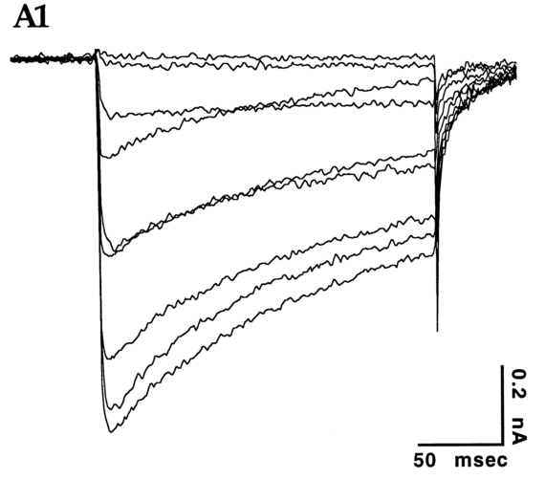
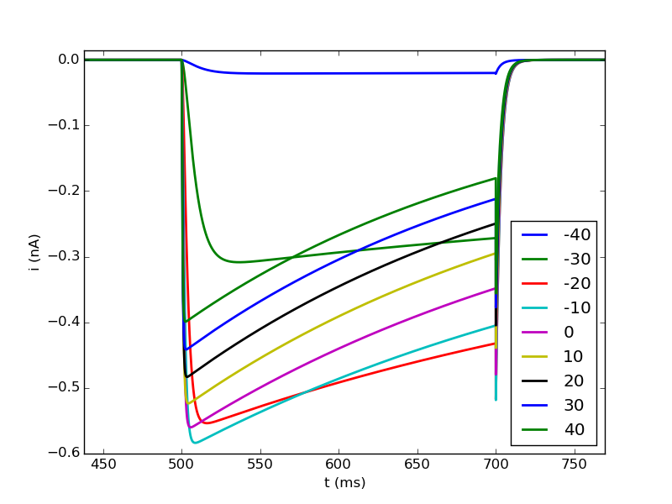
→ model traces have higher activation after -40 mV than experimental traces
→ -30 mV trace has slow rise and more block like appearance, -20 mV trace also has slower rise

Higher temperature (celsius = 36°C)
