Low threshold activated calcium current

Comparison with current traces in (Bruehl, 1998)
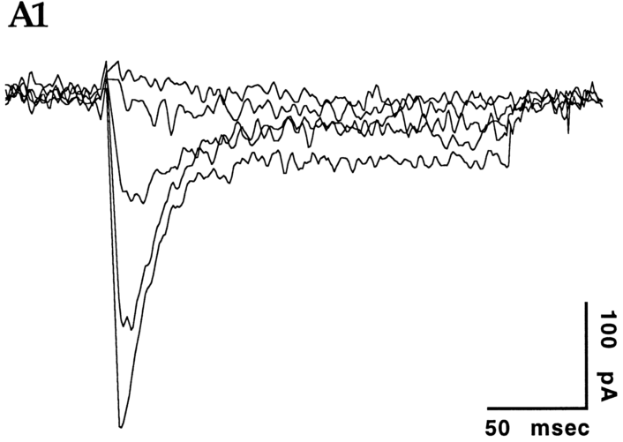
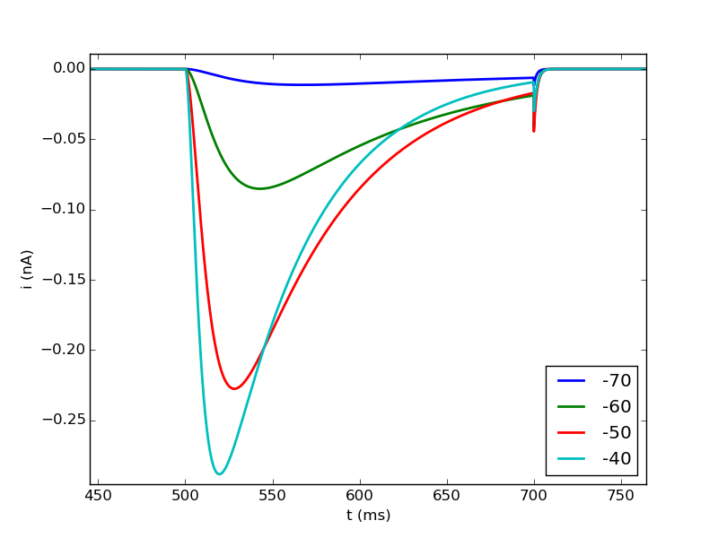

→ broader peaks in the model , but looks quite ok

Effect of higher temperature (celsius=36°C)

