HCN

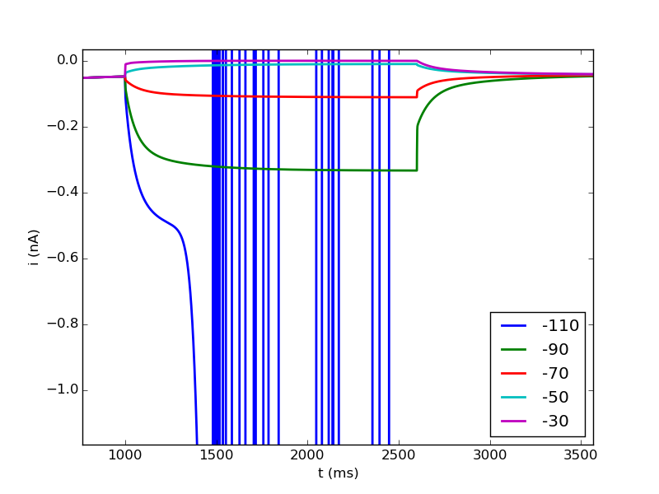
Replication of the results in (Fransens, 2004)

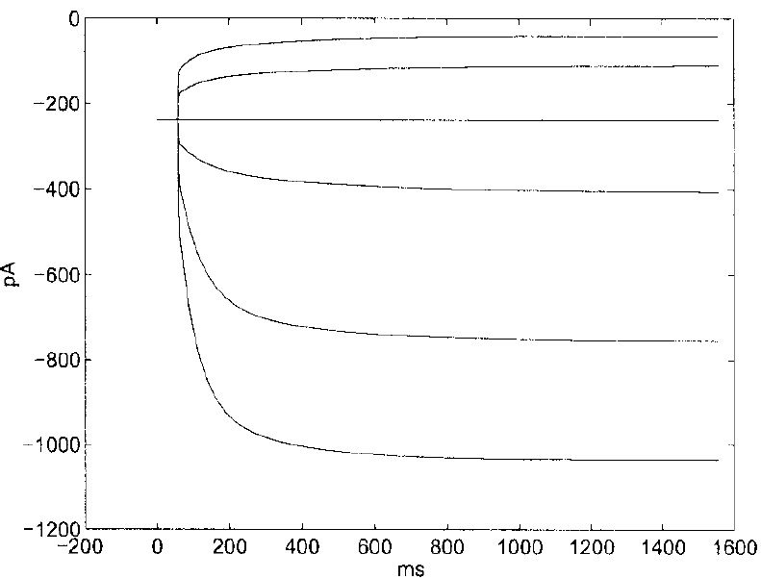
→ results are shifted upwards (less negative currents)
→ voltage step at -110 (mV) is disrupted probably by the spiking of the cell
→ in the beginning needs a lot of time to reach a stable current at the holding voltage
note: upper trace is -40 in Fransen and -30 in the model

Comparison to Dickson
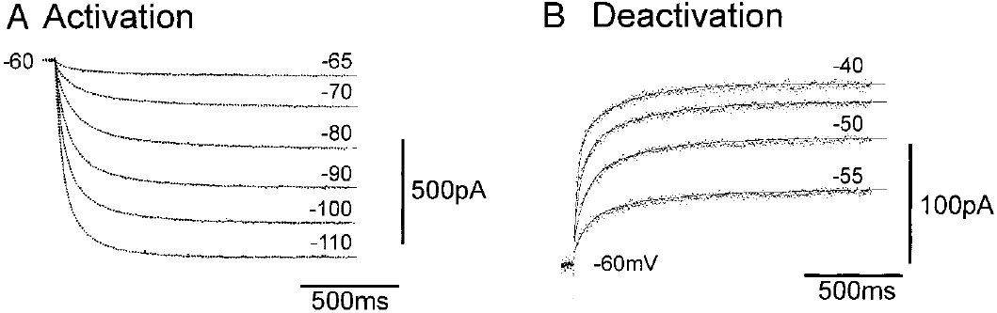
→ current traces in Fransen's model have a similar shape and magnitude as Dickson's traces

Voltage steps in single compartment model with only ih
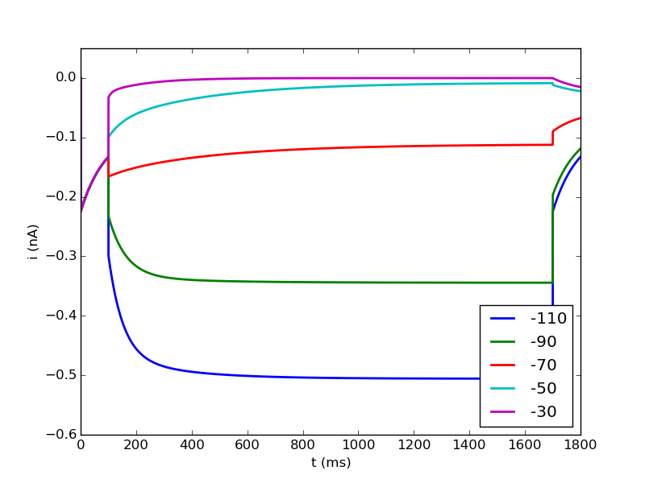

Voltage steps single compartment model with temperature adjustment (celsius = 36)
