A-type potassium current

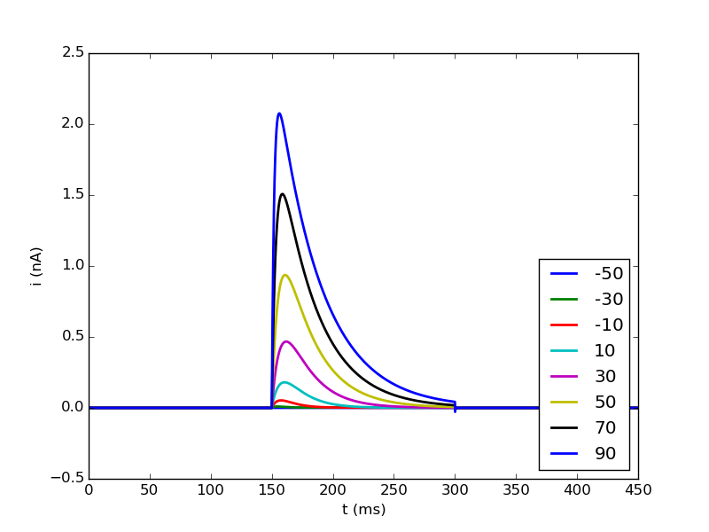
Comparison to current traces in (Eder, 1996)

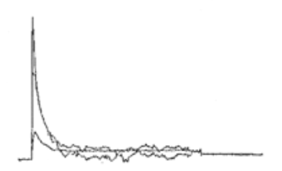
→ slower rise and decay as experimental data

Behavior at different temperature (celsius = 36°C)

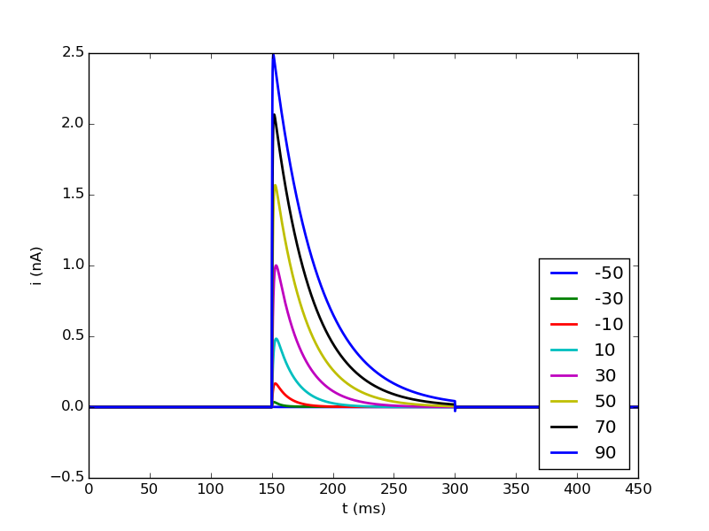

→ faster rise, but decay is still to slow (could be because temperature adjustment is just for rise time constant)

