Calcium activated potassium channel

Compare to current traces in (Khawaja, 2007)
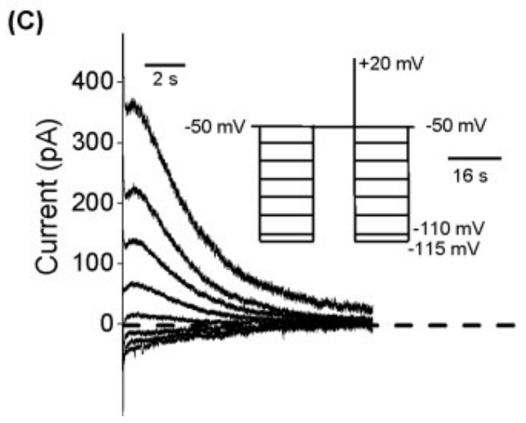
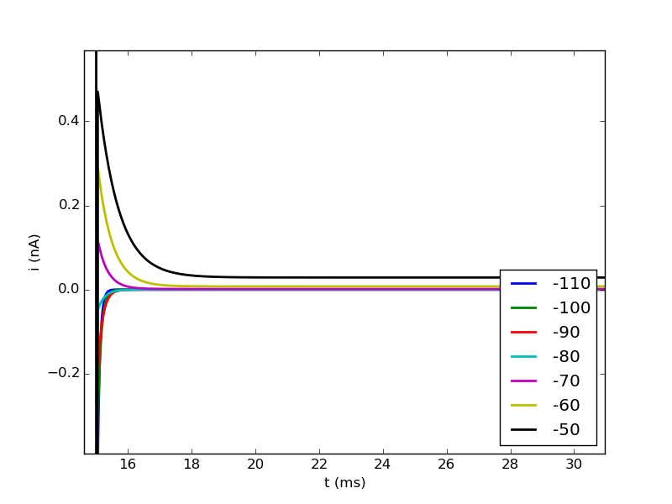

→ model does not show peak (rise and fall) at the beginning but just decays
→ model decays faster
note: to plot we need a cai concentration, therefore comment out useion ca statement

Temperate (celsius=36°C)
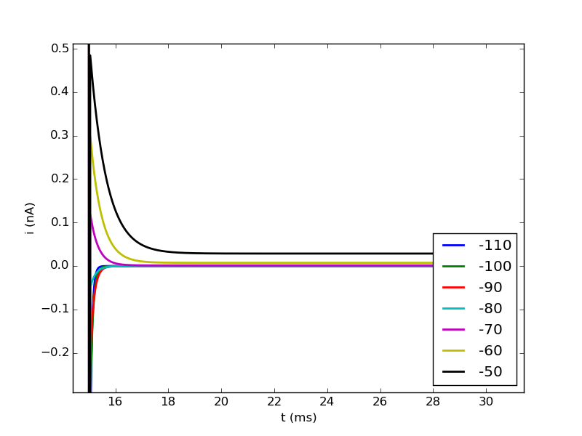

→ increase in current amplitude, rest seems similar

