Delayed rectifier potassium current

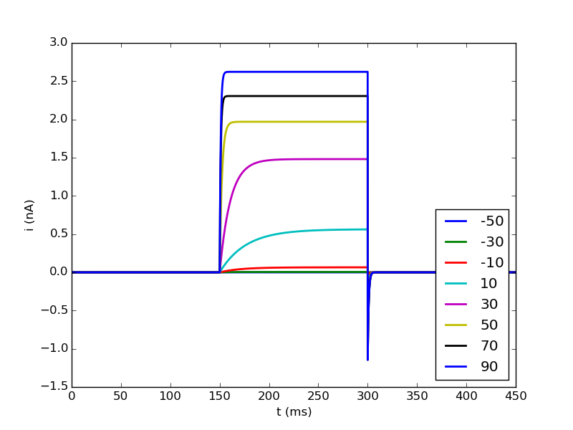
Comparison with current traces from voltage clamp experiments (Eder, 1996)

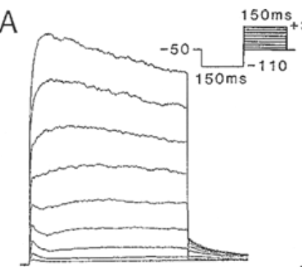

→ model is rather box-shaped: does not show initial rise and slow decay
→ for lower voltages the rise is much slower than the experimental current traces

Current trace for increased temperature (celsius = 36°C)
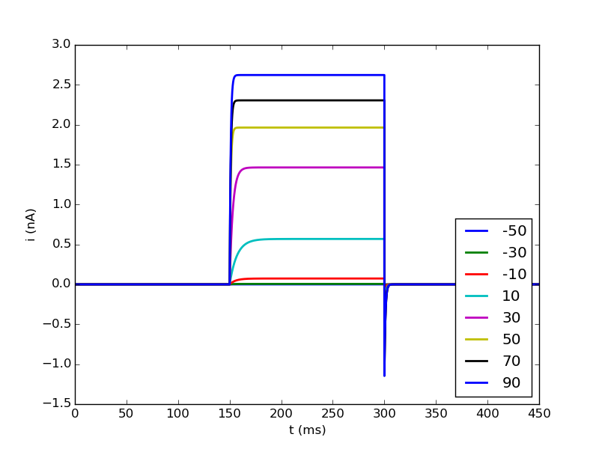

→ no visible change in amplitude, but faster rise

