Leak potassium current

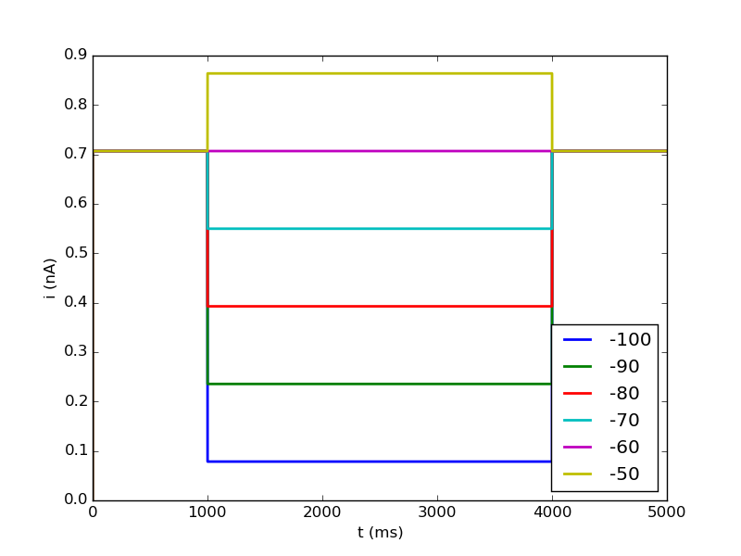
Compare voltage step data to (Garden, 2008)
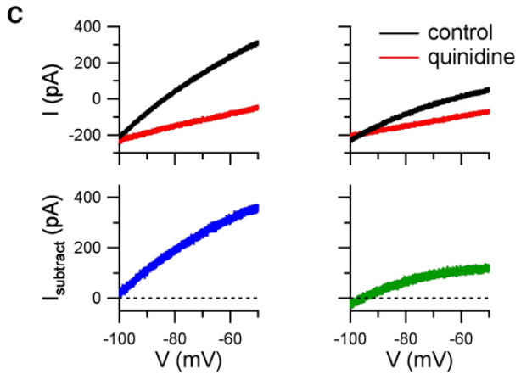

→ Modeled leak current increases linearly with holding potential whereas experimental data shows that with increasing holding potential (x-axis) the current saturates at some point (left are more dorsal stellate cells, right more ventral)

