Persistent sodium channel

Comparison to voltage steps in (Magistretti, 1999)
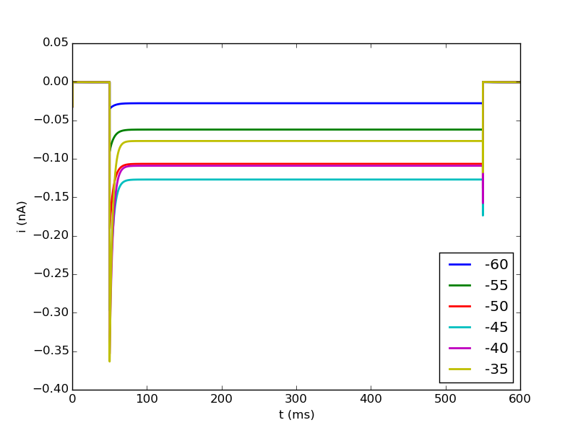
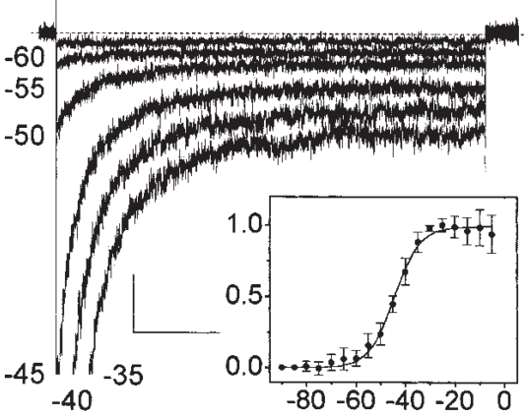

→ persistent current is well visible
→ decay is much more abrupt in the model
→ traces for higher voltage steps (-40, -35) cut current traces of lower voltages which is not seen in experimental data
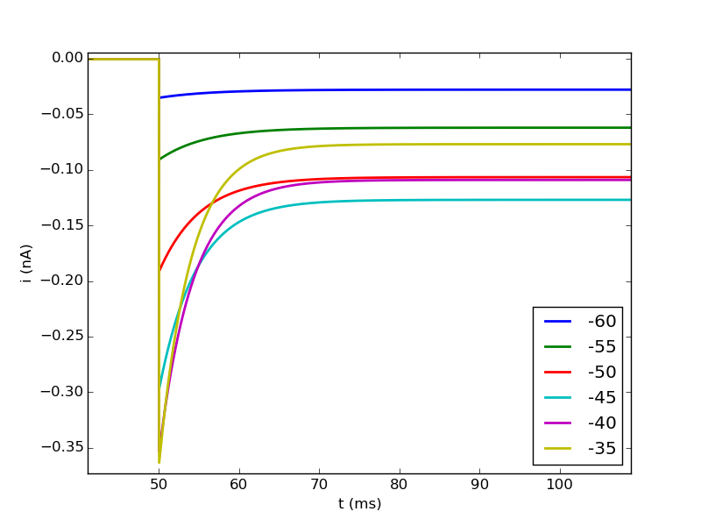

With temperature at 36°C
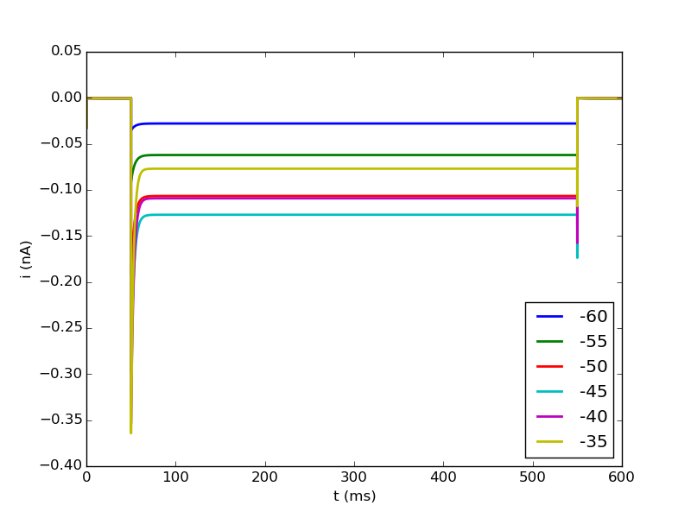

→ no big change compared to 22°C

