Sodium channels

channels:
nax: https://senselab.med.yale.edu/ModelDB/ShowModel.cshtml?model=2796&file=/ca1/nax.mod
hh2: https://senselab.med.yale.edu/ModelDB/ShowModel.cshtml?model=279&file=/dendtc/hh2.mod
nafast: https://senselab.med.yale.edu/ModelDB/ShowModel.cshtml?model=2487&file=/mit4/nafast.mod
na: https://senselab.med.yale.edu/ModelDB/ShowModel.cshtml?model=2488&file=/patdemo/na.mod

Compare to voltage step response in (Magistretti, 1999) and (Huguenard, 1888)
Experimental data:
Left: Magistretti 1999 (stellate cells) Right: Huguenard 1888 (pyramidal cell)
v_steps: np.arange(-80, -5, -5) v_steps: np.arange(-100, -20, -10)
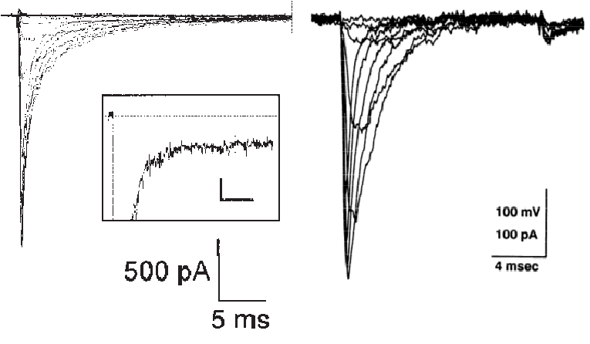

hh2: nat:
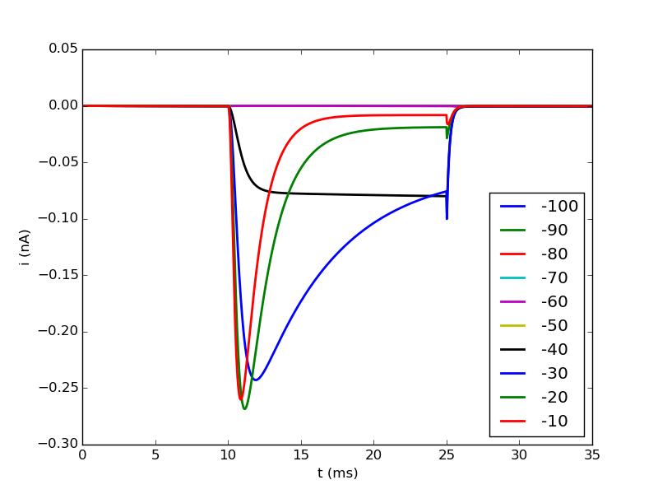
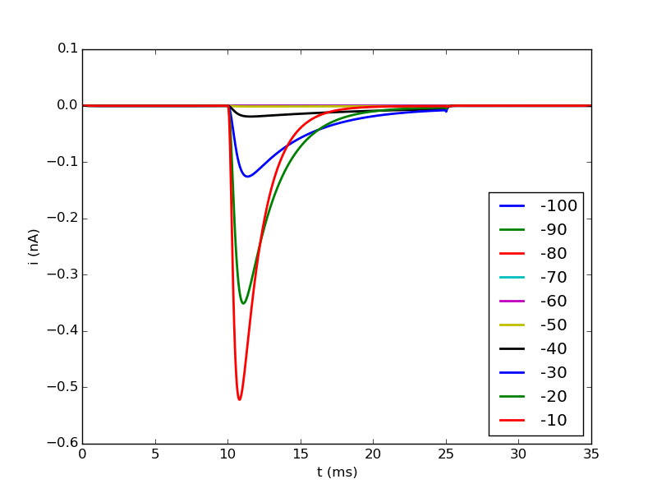

nafast: nax:
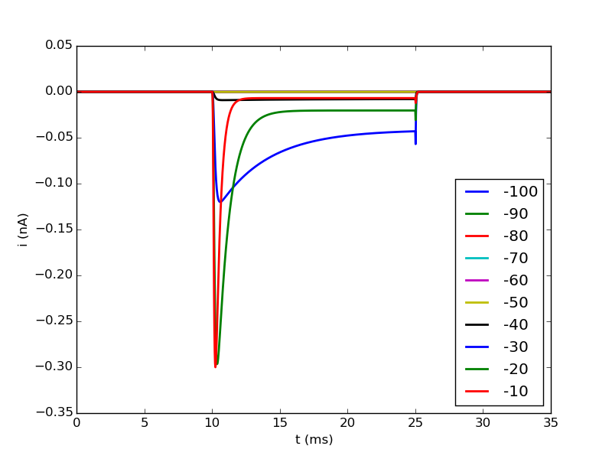
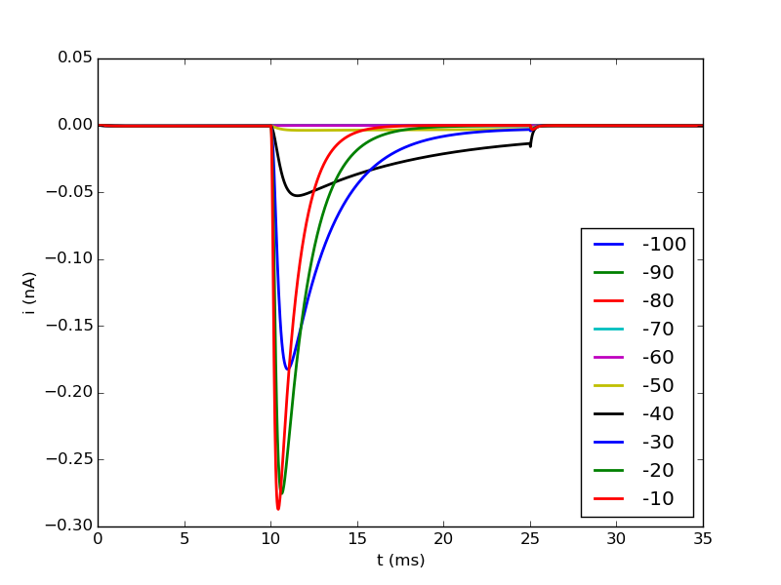

conductance value:
channels = ["hh2", "nat", "nafast", "nax"]
gbars = [0.01, 100, 0.005, 0.003]

→ na comes closest to the data from Huguenard, nax also gives a good fit
→ hh2 has a strong persitive component and some artefact at the end
→ nafast also has a strong persistive component for higher voltages
→ channels need different conductance values, difference can be of 1 order of magnitude (note na has unit (pS/um² instead of S/cm²))

How does the difference of the channels affect AP shape?
- pas and hh (with gnabar = 0.0) inserted
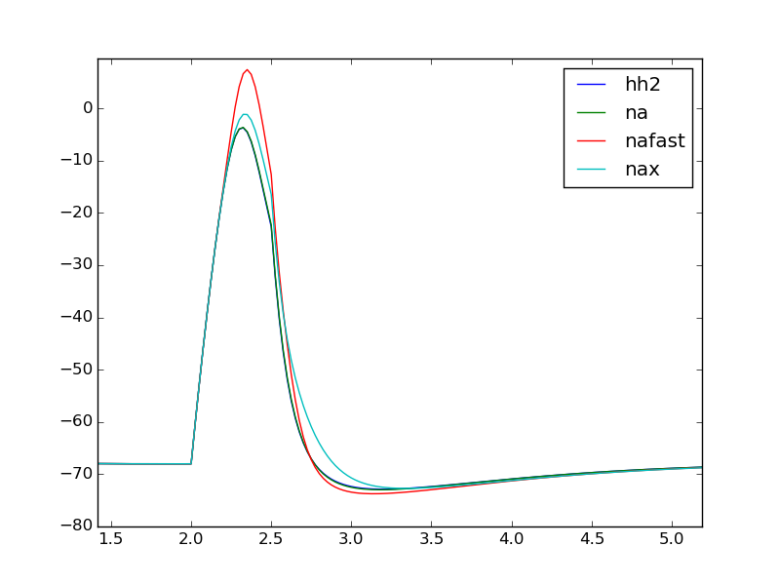

→ AP is nearly the same for all channels (especially the rising phase)
→ nax and nafast have higher amplitudes and decay differs

Temperature dependence of the nat channel
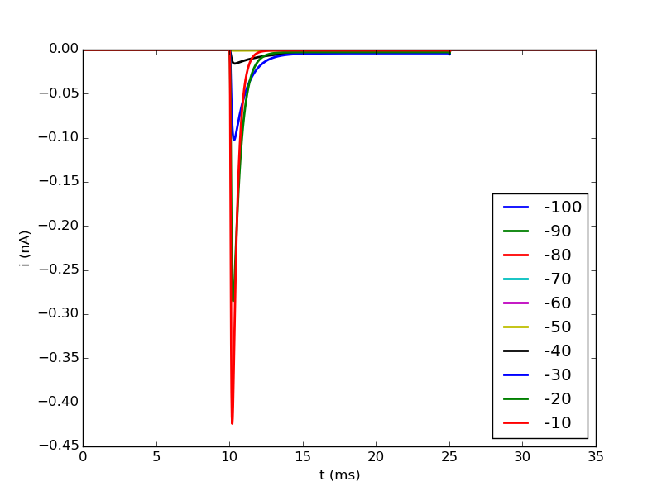

→ slight decrease of the amplitude
→ faster rise and decay
→ earlier version of the channel contained also adjustment of the conductance gbar by tadj (gbar * tadj) this lead to an increase in current amplitude

