# Introduction

Continuous Glucose Monitoring (CGM) has revolutionized the management of diabetes, offering a dynamic way to track blood glucose levels in real-time. This technology is becoming increasingly central to the management of both Type 1 Diabetes (T1D) and Type 2 Diabetes (T2D), where maintaining optimal glucose levels is key to preventing complications. CGM devices provide a wealth of data, enabling patients and healthcare providers to make informed decisions about diet, medication, and lifestyle.

However, the extensive data generated by CGM devices presents a unique challenge. While the quantity of data is beneficial, it can be overwhelming, especially for individuals without technical expertise. The ability to analyze and interpret this data effectively is essential for it to be used to its full potential in diabetes management.

Several tools are currently available for CGM data analysis [ref], each with varying degrees of complexity and functionality. Commonly used platforms offer basic data visualization and analysis, but they often lack the flexibility needed for detailed examination. Many of these tools require a certain level of technical know-how, which can be a barrier for non-technical users, including many researchers, patients and healthcare providers.

Moreover, these existing solutions often fall short in allowing users to analyze specific periods of interest within the CGM data. This limitation can hinder the ability to draw meaningful insights from the data, particularly in understanding the impact of specific events or interventions on blood glucose levels.

In response to these challenges, Diametrics emerges as a novel web application designed to bridge the gap in CGM data analysis. Diametrics is tailored to offer both flexibility and depth in analysis, without the need for coding or advanced technical skills. Its standout feature is the ability to analyze specific periods within the CGM data, allowing users to focus on time frames that are most relevant to their needs or research questions.

In this study, we aim to introduce and validate Diametrics, a novel web application for advanced CGM data analysis. We focus on showcasing Diametrics' unique features, particularly its user-friendly, no-code environment for analyzing specific periods of CGM data. Additionally, we aim to validate its performance and user experience against IGLU [ref], an established tool in the field. Through this, we seek to demonstrate Diametrics' potential to enhance diabetes management and research by making CGM data analysis more accessible and comprehensive.

# Methods

## Software

Diametrics was developed using Python 3.9, chosen for its robustness and versatility in handling large datasets. The application's architecture is designed using Dash [ref] to be user-friendly, ensuring ease of navigation and interaction for users with varying levels of technical expertise. Diametrics is also made available as an open-source tool, encouraging collaboration and continuous improvement from the global community.

We were keen to have these features…

## Validation

In our validation process, we utilized data from three distinct studies, totalling 418 participants. The Motivate Study involved 118 individuals with Type 2 Diabetes (T2D) from the UK and Canada, who were equipped with the FreeStyle Libre CGM system and participated in a prescribed exercise program. We analyzed two weeks of CGM data from this study. Additionally, the T1-DEXI Study, conducted by the JAEB Center, focused on 150 randomly selected individuals with Type 1 Diabetes (T1D) who used the Dexcom G6 CGM system for 28 days. The primary aim of this study was to investigate the impact of exercise on T1D management. Lastly, the T1-DEXIP Study, also by the JAEB Center, paralleled the T1-DEXI study but concentrated on a pediatric population aged 12-18 years with T1D, using the Dexcom G6 for 10 days. This study aimed to explore the effects of exercise in a younger demographic with T1D, and for our validation purposes, 150 participants were randomly selected from this cohort.

The validation process involved comparing the results of 13 different metrics. These were average glucose, SD, CV, eA1c, AUC, HBGI, LBGI, percentage time in normal range (70-180 mg/dL), percentage time below 70 mg/dL, percentage time below 54 mg/dL, percentage time above 180 mg/dL, percentage time above 250 mg/dL, and percentage active wear (data sufficiency).The metrics analyzed for validation purposes included all those listed in the international consensus, with the exception of the number of hypo- and hyper-glycemic events. This exclusion was based on the documentation provided by the authors, which indicated ambiguity in the methodology for calculating these specific metrics.

The validation process involved a detailed comparison of the metrics calculated by Diametrics with those obtained from the IGLU software. The Pearson correlation coefficients were used to quantitatively assess the degree of correlation between the two sets of results, thereby providing a robust measure of Diametrics' accuracy and reliability in analyzing CGM data across different studies and devices.

## Case studies

To showcase the capabilities of Diametrics to perform in-depth data analysis into specific time windows, we present two illustrative examples using real CGM data from anonymized participants. The periods of interest in these examples are constructed for demonstration purposes to highlight different functionalities of the software.

To the best of our knowledge, this cannot be done on any other available platform without technical ability and/or significant data processing by the user.

### Example 1: Glycemic Control During and After Exercise

In this example, we use data from two FreeStyle Libre files to examine glycemic control during exercise, the subsequent four hours post-exercise, and the night following the exercise from 11pm to 7am. This case study is designed to demonstrate Diametrics' ability to analyze CGM data over shorter, specific periods, as well as its functionality in extending the analysis to predefined periods following the primary event. This example effectively illustrates how users can leverage Diametrics to gain insights into glycemic responses to short-term events, such as physical exercise.

### Example 2: Glycemic Control Across Menstrual Cycle Phases

The second example employs data from three Dexcom G6 files, with the analysis focusing on different phases of the menstrual cycle, adding in a custom time in range threshold of 90-180 mg/dL. This example serves to show how Diametrics can be used to explore longer-term trends and patterns in CGM data. It highlights the software's utility in segmenting and analyzing data over extended periods, providing valuable insights into how physiological changes over time, such as those occurring during a menstrual cycle, might influence glycemic control.

# Results

## Web App Functionality

### Data Upload

To effectively utilize Diametrics, the process begins with users uploading their continuous glucose monitoring (CGM) data into the application's first tab. The platform is designed to be compatible with various file formats, including CSV, Excel, and text files, and supports data from popular CGM devices like Abbott (FreeStyle Libre), Dexcom, and Medtronic. Users have the flexibility to upload multiple files for analysis, provided these files are consistent in terms of device type, measurement units, and date-time format. Diametrics imposes no restrictions on the size or quantity of files uploaded, catering to extensive datasets.

After uploading CGM data, Diametrics allows users to review and edit their files in a user-friendly table format. Users can easily adjust the start and end dates of their data analysis period directly within the table. The platform automatically updates relevant information to reflect these changes. If any adjustments result in invalid data entries, these are promptly highlighted, signaling to the user that the data in its current form cannot be used for analysis.

In line with the International Consensus, Diametrics highlights entries in orange if the data covers less than the recommended minimum of two weeks or falls below the 70-80% data sufficiency threshold. While this serves as a caution to users, it does not restrict them from proceeding with their analysis, allowing for flexibility in research scenarios where data limitations are present.

### Metrics of glycemic control

The metrics calculated by Diametrics with the international consensus established by the American Diabetes Association (ADA), ensuring the inclusion of all essential metrics outlined in the consensus, along with several other commonly utilized metrics (Table X). A further breakdown of how these metrics are calculated can be found in Supplementary Table X. The software presents these metrics in a user-friendly table format, with metrics as column headings and participant IDs as the index. This design allows for efficient data sorting and filtering based on specific columns, enhancing the ease of data analysis.

Furthermore, we have integrated a feature in Diametrics that enables users to toggle columns, allowing them to focus on relevant metrics and exclude any that are not pertinent to their analysis. Additionally, the software is equipped to display metrics in either mmol/L or mg/dL, independent of the units used in the original CGM files and provides a breakdown of these metrics for day and night times.

Once users have adjusted the table to their preferences, including sorting, filtering, and column toggling, they can download it. The downloaded table mirrors the exact configuration as displayed on the screen, ensuring that all customizations are retained in the final output.

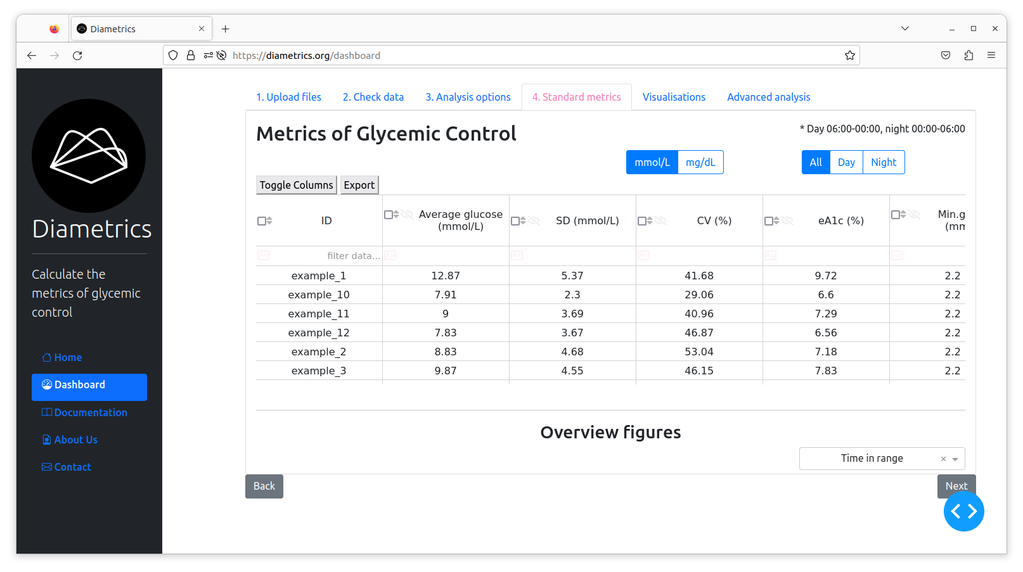

### Flexible analysis options

### We included an analysis options tab to give users the opportunity to adjust the features to suit their needs, if these differ from those set out by the ADA [ref]. This includes the ability to fill gaps in data, as highlighted in relevant literature. Users can adjust day/night settings by defining specific time frames for day and night periods. Diametrics extends the standard ADA glucose range classifications by allowing users to set custom thresholds, including a split of the normal range into tight range (3.9-7.8mmol/L), and the addition of any non-standard range of interest. Furthermore, the tool provides customizable definitions for glycemic events, aligning with the International Consensus but allowing adjustments to the duration and thresholds for hypo- and hyperglycemic episodes.

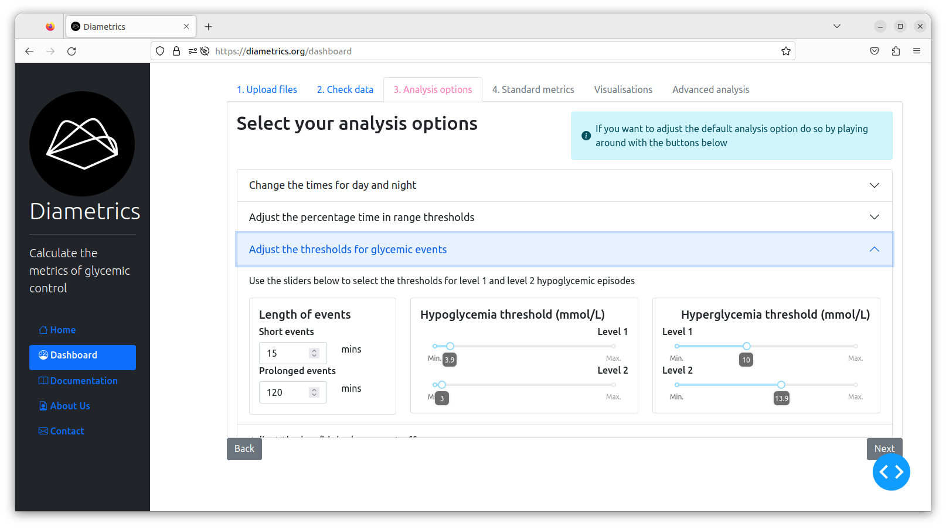

### Periodic analysis

This feature gives users the ability to analyze specific periods of interest within the CGM data, for example mealtimes or exercise. Users need to generate an external file delineating specific time periods for analysis, which is then uploaded to the application. This file includes participant IDs, start and end times of the selected periods, and customizable labels for easy identification. We designed the date-time format to be flexible, accommodating various input formats such as date and time, enhancing ease of integration with diverse data sources. Users can utilize labels without restrictions on number or naming conventions, allowing for personalized categorization of periods of interest.

Additionally, Diametrics enables users to examine time windows surrounding these specified events, a functionality that is very useful for analyzing glycemic control during short-term occurrences like exercise or meals. Users can adjust these windows up to twelve hours before and after the event using range sliders, with the default setting aligning with the event's duration. The software also offers the option to calculate standard metrics for a full 24-hour period following the event as well as the night after the event, based on predefined or user-specified night-time settings.

The resulting table displays comprehensive metrics of glycemic control for each defined period, reflecting any modifications made in the analysis options. A 'data sufficiency' column indicates the availability of data for each period, with N/A values for periods lacking data. This metrics table, akin to the standard metrics table, is fully manipulable, allowing for tailored data analysis and interpretation.

### Visualizations

The visualization capabilities of Diametrics are a key aspect, offering intuitive and interactive graphs and charts. These visualizations aid in the easy interpretation of data, making it accessible for users to identify patterns and anomalies in glucose levels. All figures can be downloaded and manipulated using the toolbar available in all of Plotly’s plots.

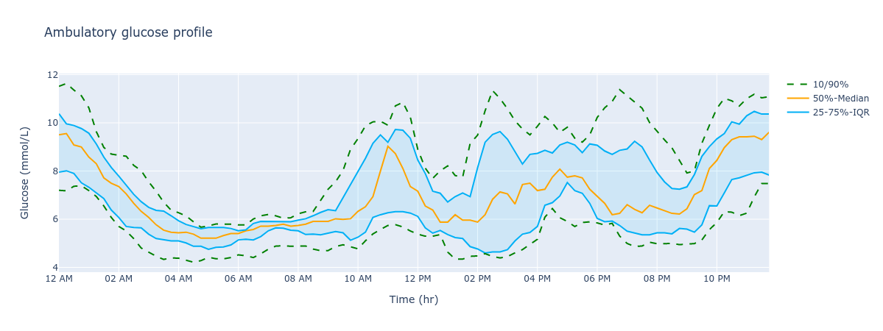

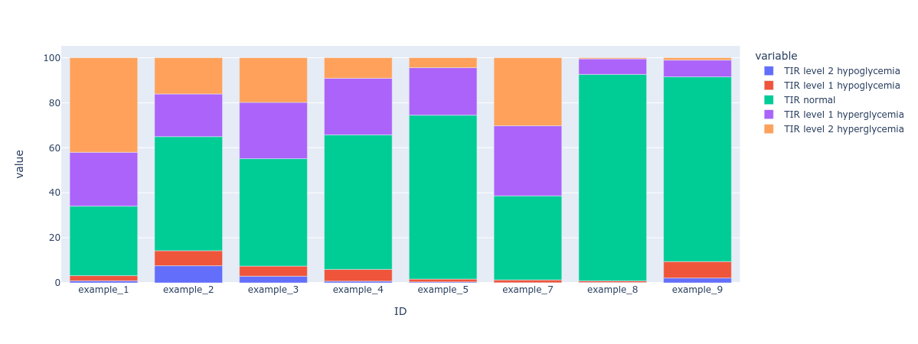

### Comprehensive documentation

There is written documentation accompanied by video instructions for each section of the Web App, making it extremely accessible and user friendly.

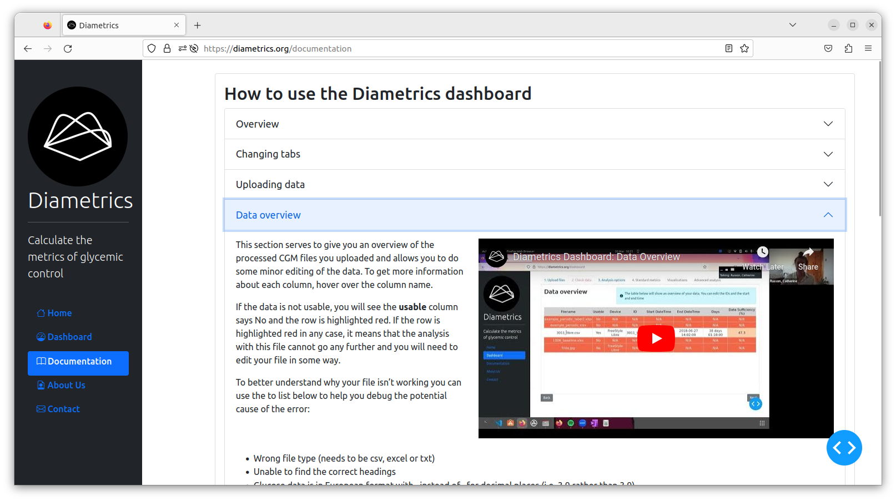

## Validation

The metrics for the participants in the study For 11 out of the 13 metrics, Diametrics matched the IGLU software results exactly, with Pearson correlation coefficients of 1. The metrics AUC and data sufficiency showed minor discrepancies across the studies. However, these differences were minimal. The correlation remains consistent across all three studies.

|  | **Study** | | |
| --- | --- | --- | --- |
| **Metric** | **Motivate** | **T1-DEXI** | **T1-DEXIP** |
| Average glucose (mg/dL) | 1.000 | 1.000 | 1.000 |
| SD (mg/dL) | 1.000 | 1.000 | 1.000 |
| CV (%) | 1.000 | 1.000 | 1.000 |
| eA1c (%) | 1.000 | 1.000 | 1.000 |
| AUC (mg h/dL) | 0.999 | 0.998 | 0.996 |
| HBGI | 1.000 | 1.000 | 1.000 |
| LBGI | 1.000 | 1.000 | 1.000 |
| TIR normal (%) | 1.000 | 1.000 | 1.000 |
| TIR hyper | 1.000 | 1.000 | 1.000 |
| TIR level 2 hyperglycemia (%) | 1.000 | 1.000 | 1.000 |
| TIR hypo | 1.000 | 1.000 | 1.000 |
| TIR level 2 hypoglycemia (%) | 1.000 | 1.000 | 1.000 |
| Data Sufficiency (%) | 1.000 | 0.999 | 0.999 |

Table 1: Pearson Correlation Coefficients for Metric Comparison

## Case studies

### Example 1: Glycemic Control During and After Exercise

The worked example is available in Supplementary Video 1.

To begin, we upload the relevant CGM files to the first tab of the Diametric dashboard and check that the files are usable. Next, we will use the Analysis Options tab to adjust the night time period from the standard settings. Instead, we will look at 11pm to 7am (Figure XA). We will proceed to calculate the metrics of glycemic control for the overall data for each participant.

Next, we move to the Advanced Analysis tab to begin the analysis for our periods of interest. For this, we need to upload an external file, either in Excel or CSV format, to specify the periods we want to analyze. This file should include a start date and time for each period, and either an end date and time or the duration. It's important that the file has an ID column, and these IDs must match exactly with those from the files uploaded earlier in the app. Users can also add optional labels to their file to help differentiate between the periods of interest in their own further analysis. In this example, we use an excel file with the ID, start datetime and duration to give us the period of interest, and two labels - type of exercise and the borg score for intensity (Figure XB) (Supplementary Table X).

The next section in the Advanced Analysis allows users to look at the windows around the event. The two tick boxes let you choose if you want to see the standard metrics for the whole 24 hours after the period of interest and if you want to see the night after the event. The range sliders below give you the chance to customize the window you are interested in around the periods you’ve entered. For this example, we will use the slider to select four hours after the exercise and check the night after the event box (Figure XC).

We click the ‘Calculate Metrics’ button which provides us with the results table with all of the available metrics which can be explored in the web app and downloaded for further analysis (Figure XD).

### Example 2: Glycemic Control Across Menstrual Cycle Phases

The worked example is available in Supplementary Video 2.

As before, the CGM files for the participants must be uploaded and checked. Next, in the Analysis Options tab, we add a new threshold from 90-180 mg/dL (Figure XA).

We then calculate the overall metrics and proceed through the Diametrics dashboard to the Advanced Analysis tab. For this example, we have used a csv file with the ID, start datetime and end datetime to give the periods of interest, and two labels for the ovarian cycle phase and uterine cycle phase (Supplementary Table X).

Since we are not including any windows around the events, we will leave the ‘_’ section blank and click the calculate metrics button to provide us with our results table, which includes all the standard metrics and our additional

# Discussion

In this study, we introduced and validated Diametrics, a novel web application designed for advanced analysis of Continuous Glucose Monitoring (CGM) data. Key results from our validation process, involving data from three distinct studies with a total of 418 participants, demonstrated that Diametrics accurately replicated established metrics in CGM data analysis. Specifically, for 11 out of 13 metrics, Diametrics matched the results of the IGLU software with perfect Pearson correlation coefficients of 1. Minor discrepancies were observed in the Area Under Curve (AUC) and data sufficiency metrics, but these were minimal and did not significantly impact the overall reliability of the tool. Additionally, the application's unique feature of analyzing specific periods within CGM data was showcased through illustrative case studies, highlighting its potential to provide detailed insights into glycemic control during specific events such as exercise and across different phases of the menstrual cycle. These results underscore Diametrics' potential as a versatile and accurate tool for CGM data analysis, catering to both research and clinical needs in diabetes management.

#### **Interpretation of Results**

The study has demonstrates that Diametrics could offer a useful addition to the tools available for CGM data analysis. Its primary feature, the ability to analyze specific periods within CGM data, addresses a need for more targeted analysis in diabetes management. This functionality may assist in gaining insights into the effects of specific activities or events on blood glucose levels, which could be beneficial for both patients and healthcare providers.

Diametrics is designed to be user-friendly, making it more accessible to individuals without extensive technical expertise. This aspect could be particularly valuable in a clinical setting, where healthcare providers may need to quickly interpret CGM data without delving into complex data analysis processes.

The analysis options enable a more nuanced and personalized analysis of CGM data, catering to diverse research and clinical needs in diabetes management.

The validation demonstrates the high accuracy of Diametrics in replicating established results. Differences in AUC and data sufficiency come from slight discrepancy in the way of calculating these metrics. The consistency of these results across different studies (Motivate, T1-DEXI, and T1-DEXIP) underscores the robustness of Diametrics. This is particularly noteworthy given the variety of participants and devices involved in these studies.

#### **Potential Impact on Diabetes Research and Management**

Diametrics, with its specific period analysis feature, could impact diabetes research and management by providing more nuanced insights into glucose level fluctuations. For researchers, this tool could facilitate more detailed studies on the impact of various factors like diet, exercise, and medication on blood glucose levels. For clinicians and patients, it could aid in tailoring diabetes management plans based on more precise data interpretation.

The application's ease of use could also encourage more patients and healthcare providers to engage actively with CGM data, potentially leading to better self-management practices in diabetes care.

#### **Limitations and Future Directions**

While Diametrics shows promise, it's important to acknowledge its limitations. The validation process, though thorough, was limited to specific datasets and may not cover all potential use cases. Future studies could expand the range of data and scenarios tested to ensure broader applicability. Additionally, as with any software tool, there is a need for continuous updates and improvements based on user feedback and technological advancements. Future versions of Diametrics could incorporate more advanced analytics features or integrate machine learning algorithms to predict glucose level trends, enhancing its utility in diabetes management.

# Conclusions

In conclusion, Diametrics appears to be a promising tool for CGM data analysis, potentially aiding in more personalized and effective diabetes management. However, ongoing development and broader testing are essential to fully realize its potential and ensure its applicability in diverse scenarios.