Nous: Adversarial Testing of a Dependency-Free Memory-and-Activation Substrate for Cognitive Architectures
An Engineering and Methodology Case Study
Cagan Caliskan | 2026

Abstract
This report describes Nous, a dependency-free Python prototype of a memory-and-activation substrate for a cognitive architecture, and — more centrally — the software-engineering methodology used to build it. Nous comprises four layers: a graph substrate store of concept nodes and weighted “roads”; a deterministic spreading-activation engine; a multi-source activation field; and a thin end-to-end perceive → activate → form coalitions → select a thought slice. The lower two layers are verified, by an adversarial property-style test suite, for three concrete properties: determinism (identical output across process runs, confirmed in fresh interpreters under randomized hash seeds), integrity (graph indices stay mutually consistent across every mutation), and purity (reads never mutate stored state). The upper two layers are exploratory: they run and are deterministic, but their cognitive meaningfulness is explicitly not claimed — and on clustered real input the end-to-end slice produces an incoherent “thought,” recorded as an asserted negative result / known limitation, not a contribution. The central finding is a recurring failure mode — a component that passes on a friendly, hand-chosen input and fails on an adversarial or system-generated one — and the two practices that caught it: adversarial/property-based testing (including cross-process determinism and read-purity checks) and loop-closure (driving each stage with system-generated rather than hand-placed inputs). Together they exposed six distinct structural bugs that ordinary happy-path tests pass over. The artifact’s verified totals: 130 assertions across 56 test functions, all passing, in five suites.

1. Introduction
Most write-ups of ambitious systems describe what the system is meant to become. This one separates that aspiration from what was actually built and proven, and reports the engineering discipline in between. The subject is a cognitive-architecture prototype; the contribution is the testing methodology applied to it.
Motivation. Cognitive-architecture components — graph memories, spreading activation, clustering into “coalitions” — are easy to implement in a way that looks correct on a hand-built example and is quietly wrong in structure: it double-counts, it depends on iteration order, it bakes the answer into the input. These are bugs in the shape of the algorithm, and they survive happy-path tests. This project answers in the affirmative whether a disciplined, adversarial, property-oriented test process can surface such bugs early and force honest scoping.
Aspiration vs. built reality. Nous began as a large design vision. Those original vision documents are retained verbatim under docs/design/, but are quarantined as aspiration: a disclaimer there states plainly that their grand language (“AGI,” “a real brain,” “mind”) describes intent, not the built code, and that of the thirteen documents only the two layer-plan files correspond to anything implemented. This report concerns only the built artifact.
Scope and non-claims (binding).
- Nous is an engineering prototype and a testing-methodology case study.
- It is not a mind, consciousness, AGI, or a validated cognitive model, and makes no claim of machine cognition.
- The substrate store and spreading-activation engine are proven deterministic, integrity-preserving, and pure — claims about mechanism.
- The field, coalition, and “thought” layers are exploratory. Their cognitive meaningfulness is not established; the incoherent-thought behavior on clustered real input is an honest negative result, not a feature.
- Named neuroscience and cognitive theories are conceptual inspiration only. Nothing here implements or reproduces them, and no biological fidelity is claimed.
Contributions (methodology first).
- A software-engineering experience report showing that adversarial/property-based testing — determinism verified across process hash seeds, and read-purity verified by hammering reads — and loop-closure caught a sequence of six structural bugs in a memory/activation substrate.
- A verified substrate: a graph store and a spreading-activation engine that are deterministic, integrity-preserving, and pure, with the verification shipped as runnable tests.
- An honestly-scoped exploratory cognitive layer, including an asserted known-limitation test that encodes a negative result as a standing, checkable claim.
- A reusable discipline: transferable lessons about how “passes on a friendly input” recurs and how to design tests and inputs that defeat it.

2. Background and related work
The following bodies of work inspired the design’s vocabulary and structure. Nous does not implement, validate, or reproduce any of them, and claims no biological fidelity; each is named to position the prototype, not to assert a result.
Complementary Learning Systems (CLS). The fast/slow split between a rapidly-learning episodic system and a slowly-consolidating semantic one [1], updated for intelligent-agent design in [2], inspires Nous’s separation of activation (what lights up now) from consolidation (what is later reinforced). In the prototype this is only a strict rule — spreading activation is a pure read and never strengthens what it touches.
Synaptic Tagging and Capture (STC). The hypothesis that a weak event sets a local tag that can capture plasticity-related products from a nearby strong event [3, 4] inspires the framing of reinforcement as a gated, budgeted event, which is why Nous keeps activation read-only; it does not model tagging dynamics.
Global Workspace Theory (GWT). The idea that specialized processes form coalitions that compete, and a winner is broadcast globally [5, 6], is the source of Nous’s coalition vocabulary. Only coalition formation exists in the code; the competition/broadcast step is an explicit, unbuilt placeholder.
LIDA cognitive cycle. LIDA’s systems-level perceive → attend → broadcast cycle [7] loosely shapes the staging of the end-to-end slice, which realizes only the early stages.
Cognitive architectures. ACT-R’s integrated theory of cognition [8] and SPAUN’s large-scale functional brain model [9] are referenced for positioning: Nous is far smaller and makes no behavioral or biological claims; it is a substrate-and-method study, not an architecture in their sense.
Spreading-activation theory. Nous’s activation engine is a deterministic, engineered variant of spreading activation in the sense of Collins & Loftus [10]; the convergence-sums property is from that lineage, while the hop-layered single-expansion is an engineering choice made for determinism.
Arousal and plasticity. The Yerkes–Dodson inverted-U relating arousal to performance [12] appears in the design notes as motivation for emotion-modulated plasticity; in the code this is only charge-modulated strengthening and is best read as design-level aspiration.
Semantic priming. Semantic priming [10, 11] is named here because it is the worked example for future validation: an effect whose direction is known independently of Nous.

3. System architecture (as built)
Nous is pure-Python standard library, organized bottom-up; each layer reads the one below through its public surface only. Figure 1 makes the honest boundary visual; the figures that follow detail the data model, the read/write paths, and the end-to-end slice.
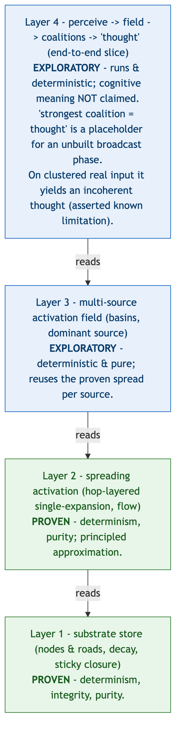
Figure 1 — The four-layer stack and the honest boundary. Layers 1–2 (substrate store, spreading activation) are PROVEN (determinism, integrity, purity); layers 3–4 (multi-source field, end-to-end slice) are EXPLORATORY. It establishes where verification stops; it does NOT claim the exploratory layers are cognitively meaningful.

3.1 Substrate store (nous_store.py, 548 lines)
The only component that mutates the graph; it holds no cognitive logic.
- Nodes and roads. A Node is an always-neutral unit of information with a stable identity and content. A Road is a directed edge source → target carrying a scalar strength (a new road starts at 0.05) and a multi-valued emotional life charges (named feelings → intensity in [-1, 1]), from which an aggregate valence is derived. One road per (source, target) pair; the reverse is a distinct road.
- Stable identity vs. ordering. Every node and road has a stable uuid4 identity and is never addressed by position; a stale handle resolves to NotFound, never to a wrong object. Formation order is a separate integer creation_seq, kept distinct from identity so ordering never falls back to a uuid.
- Lazy, pure-read decay. Roads decay with elapsed time, but decay is computed on access as a read-only view: a read returns a copy carrying decayed values and never writes. The strength time-constant scales steeply with strength, so a highway is far more stable than a dirt track. This purity is load-bearing (finding a).
- Sticky closure. A strongly-negative crossing (or one-shot trauma) closes a road; closure is re-evaluated only on an active crossing, never by a read or by time, and only an active positive crossing reopens it.
- Pin guard and integrity. remove_node refuses to delete a pinned node; adjacency, dedup, and designation consistency are asserted incrementally on every mutation, with a full-graph scan available offline.
- Atomicity. Every mutation is a synchronous method with no await inside, making each mutation atomic by construction under single-threaded asyncio.
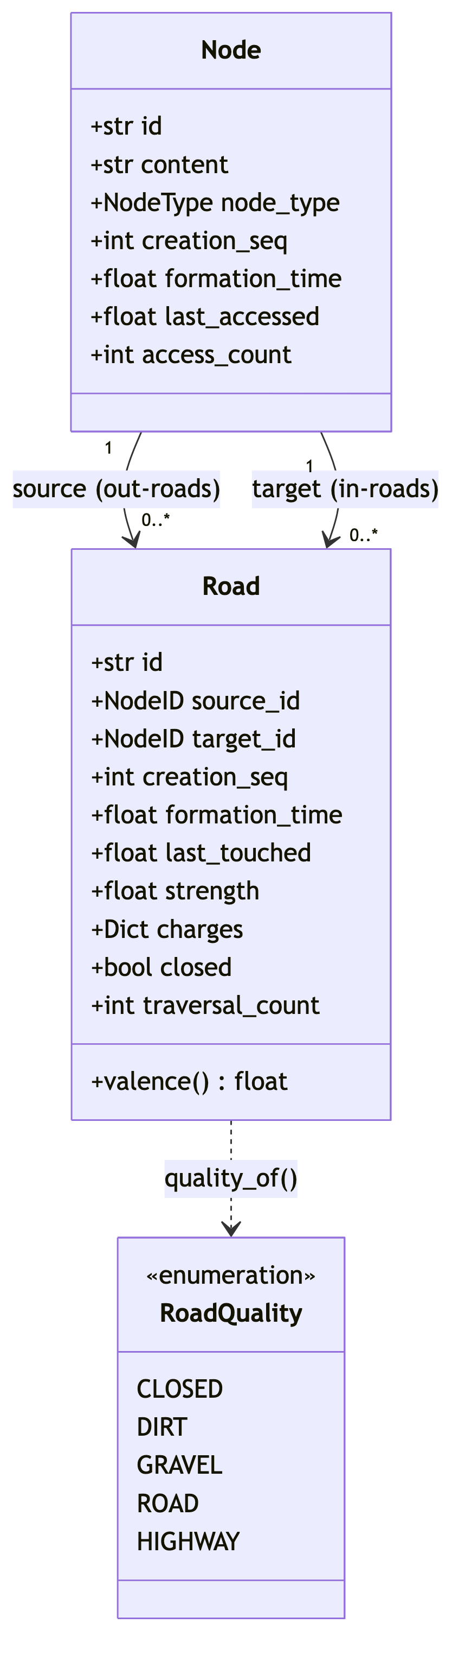
Figure 2 — Substrate data model. The Node and Road fields; identity (uuid4) is deliberately separate from ordering (creation_seq). Describes the data structures only.
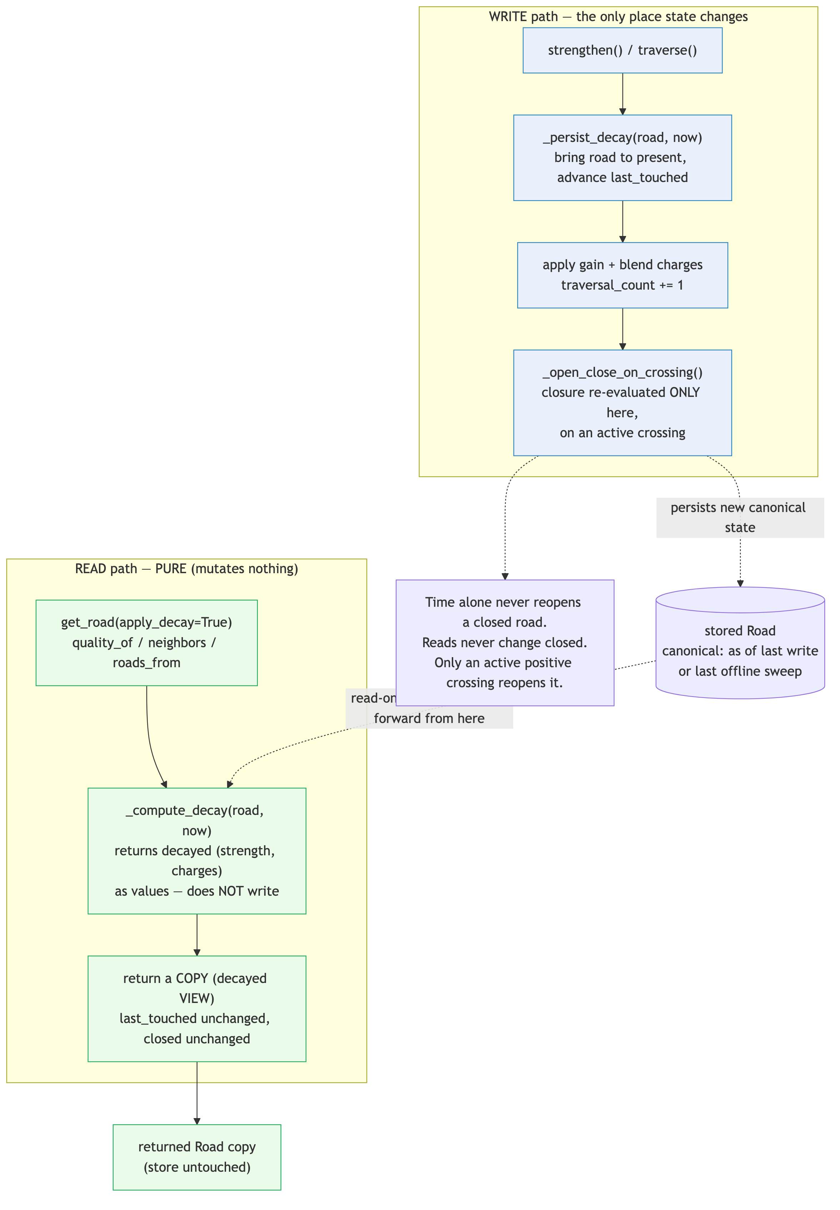
Figure 3 — Read vs. write paths (the purity invariant). Reads compute decay into a copy and never mutate; only writes persist decay; closure changes only on an active crossing. Visualizes finding (a); it proves a mechanism property, not anything about cognition.

3.2 Spreading activation (nous_activation.py, 281 lines)
The first operation that reads across the graph: radiate activation from a seed along directed out-roads and report what lit up. Pure read.
- Convergence sums. Activation arriving at a node from several paths is summed.
- Hop-layered single-expansion. The wave expands in hop layers; all hop-k contributions accumulate before any hop-k node expands, each node expands exactly once, and a per-layer frozen snapshot is used so same-hop edges cannot leak iteration order into the result. Equal-length convergence is exact, and the algorithm is a deterministic function of store state. This replaced an earlier priority-frontier design (findings b, c).
- Two attenuators. Transmitted activation is outgoing × road.strength × decay_per_hop: road.strength is edge conductance; decay_per_hop is a global distance penalty. Kept separate deliberately.
- Leaky closure. A single swappable policy governs closed roads: below a breakthrough threshold nothing crosses; above it, a small attenuated fraction leaks through and is logged. The constants are uncalibrated guesses on probation; tests pin only the qualitative regime.
- Flow recording. The engine records, per edge, the activation actually transmitted (flow), distinct from static topology. Downstream consumers read flow, not raw edges.
- Locality. A hop budget and an activation floor keep the spread local, which makes it affordable in pure Python.

3.3 Multi-source activation field (nous_field.py, 161 lines)
Runs the proven single-source spread once per source and assembles a field: each node’s activation from each source, the summed total, and the dominant source (the node’s basin). Dominant-source ties break on the stable creation_seq, so the field is deterministic given store state. Pure read. It exists because a single seed yields one activation peak, so any segmentation keys off distance rather than community structure (finding e); multiple sources yield multiple genuine peaks.

3.4 Coalitions and the end-to-end slice (nous_coalitions.py 324; nous_perceive.py 162)
- Coalition formation. Coalition formation groups co-activated nodes via a flow-cut segmentation of a single spread or a group-by-basin path for the multi-source field. Every output-affecting order is an explicit total order over intrinsic keys (activation, then creation_seq), never set-iteration order.
- Perception. Perception turns text into sources: tokens (length ≥ 3) are matched by substring against node content, and matched nodes become sources with energy scaled by match count. Minimal — no embeddings — but it makes sources input-derived rather than hand-placed.
- The slice. The slice (think) runs perceive → build field → form coalitions by basin → select the strongest coalition as “the thought.” The final step is an explicit placeholder for an unbuilt workspace-competition/broadcast phase. The slice is pure and deterministic; what it produces is not claimed to be meaningful (finding f).
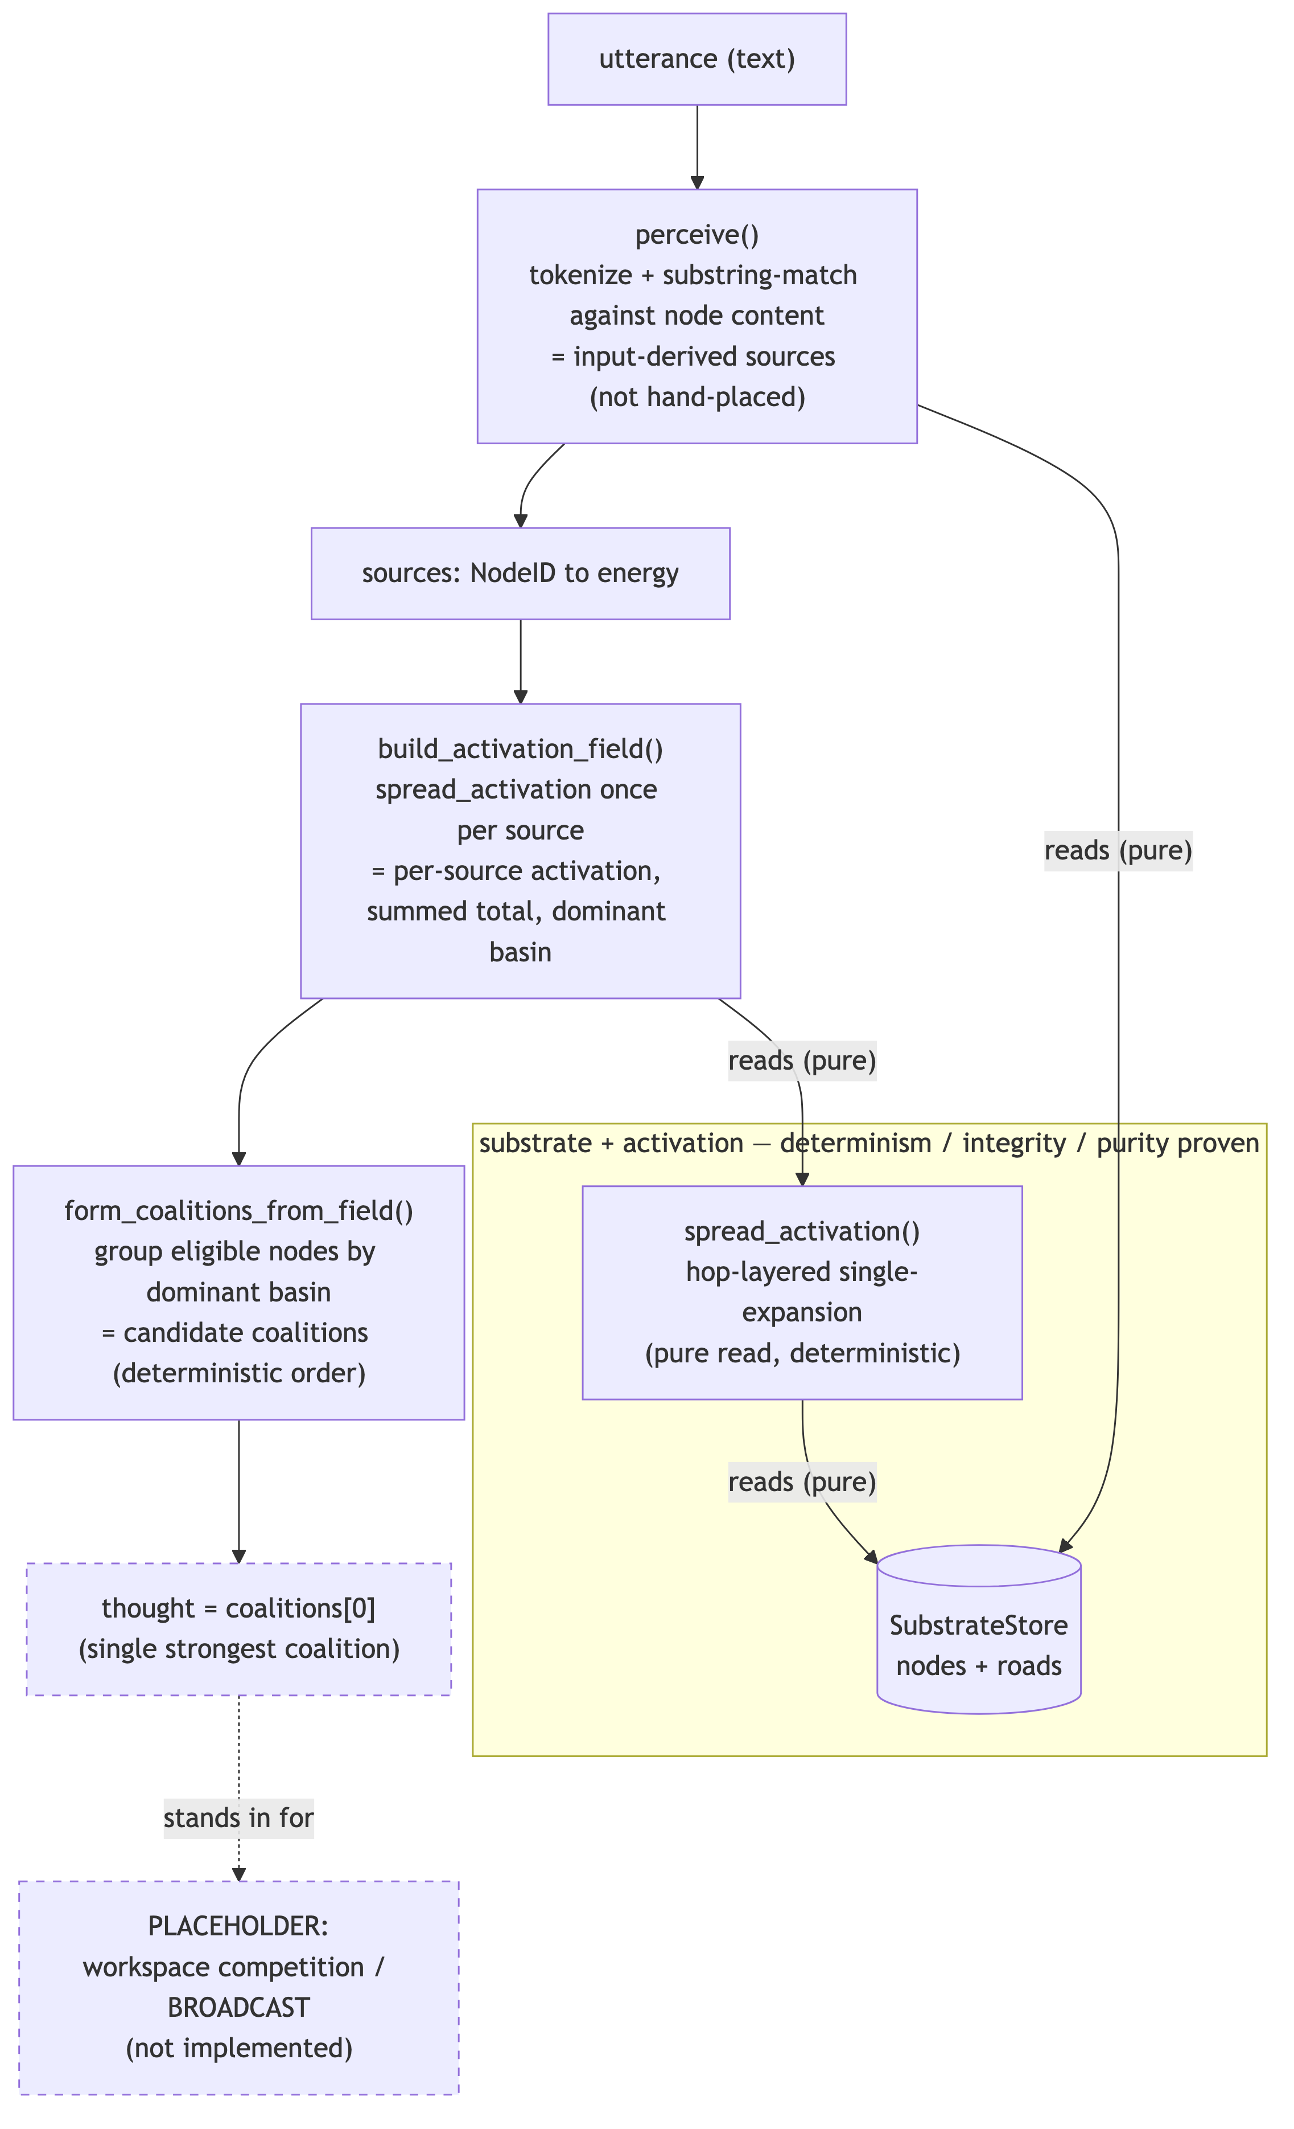
Figure 4 — End-to-end ‘thought’ slice. text → perceive → field → coalitions → thought. The final ‘strongest coalition = thought’ step is a placeholder for an unbuilt broadcast phase; the figure shows data flow, not that the resulting ‘thought’ is meaningful.

4. Methodology
The thesis is that the test process — not the prototype — is the contribution. Two properties were treated as first-class and verified directly.
Property-based / adversarial testing. Each component ships with tests written to break its central claim, not confirm it on an easy case: lopsided edge strengths, intra-layer edges, equal-activation rings, and a two-dense-communities-joined-by-a-thin-bridge graph built to defeat distance-based segmentation.
Determinism across processes. The natural implementations leak set-iteration order over uuid4 keys into their results. Within a single process the hash seed is fixed, so this cannot be seen; the determinism tests spawn fresh interpreters with different PYTHONHASHSEED values and compare output byte-for-byte. The activation suite uses seeds {0, 1, 3, 7, 42}; the coalition and field suites use {0, 1, 2, 3, 7, 42, 123, 999} (eight seeds); the slice uses {0, 1, 2, 7, 42, 999}.
Read-purity as an asserted invariant. Read-only operations are run in tight loops and the full canonical (un-decayed) store state is asserted byte-equal before and after, in every layer.
The harness, and a deliberate non-use of pytest. The suites use a tiny built-in harness: each check / expect_raises increments a counter, and the suite prints “RESULT: N passed, M failed” and exits non-zero on any failure. They are intentionally not pytest tests: pytest would collect the test_* functions but would not register a logical check(False, ...) as a failed assertion, so it could report green on a real failure. The honest runner is run_tests.py, which sets an absolute PYTHONPATH (required so the determinism subprocesses resolve their imports) and propagates non-zero exit codes.

5. Findings overview
Read findings (b)–(f) together and one shape repeats: a component passes on a friendly, hand-chosen input and fails on an adversarial or system-generated one. Each fix had two parts — write the test that tries to break the claim, and make the inputs system-generated rather than hand-chosen. The six findings are each presented as: claim under test → bug → root cause → fix → the specific test that now locks it. Reported magnitudes the shipped artifact does not let one reproduce are omitted rather than asserted.
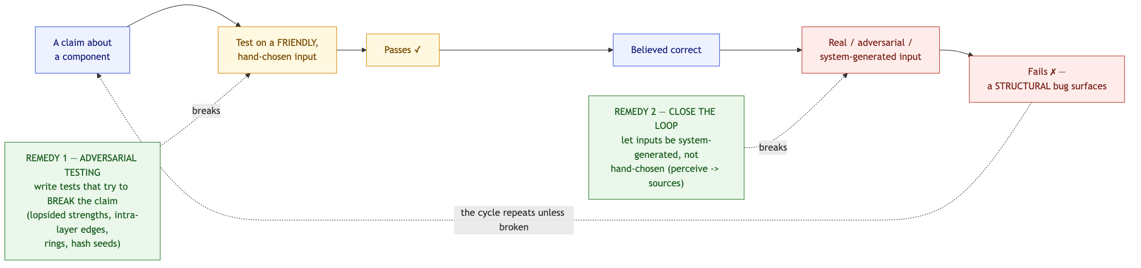
Figure 5 — The recurring ‘friendly-input’ failure mode, and the two remedies. Conceptual: the loop shared by findings (b)–(f), broken by adversarial testing and by closing the loop. It illustrates the method; it asserts no measurement.

6. The six structural findings
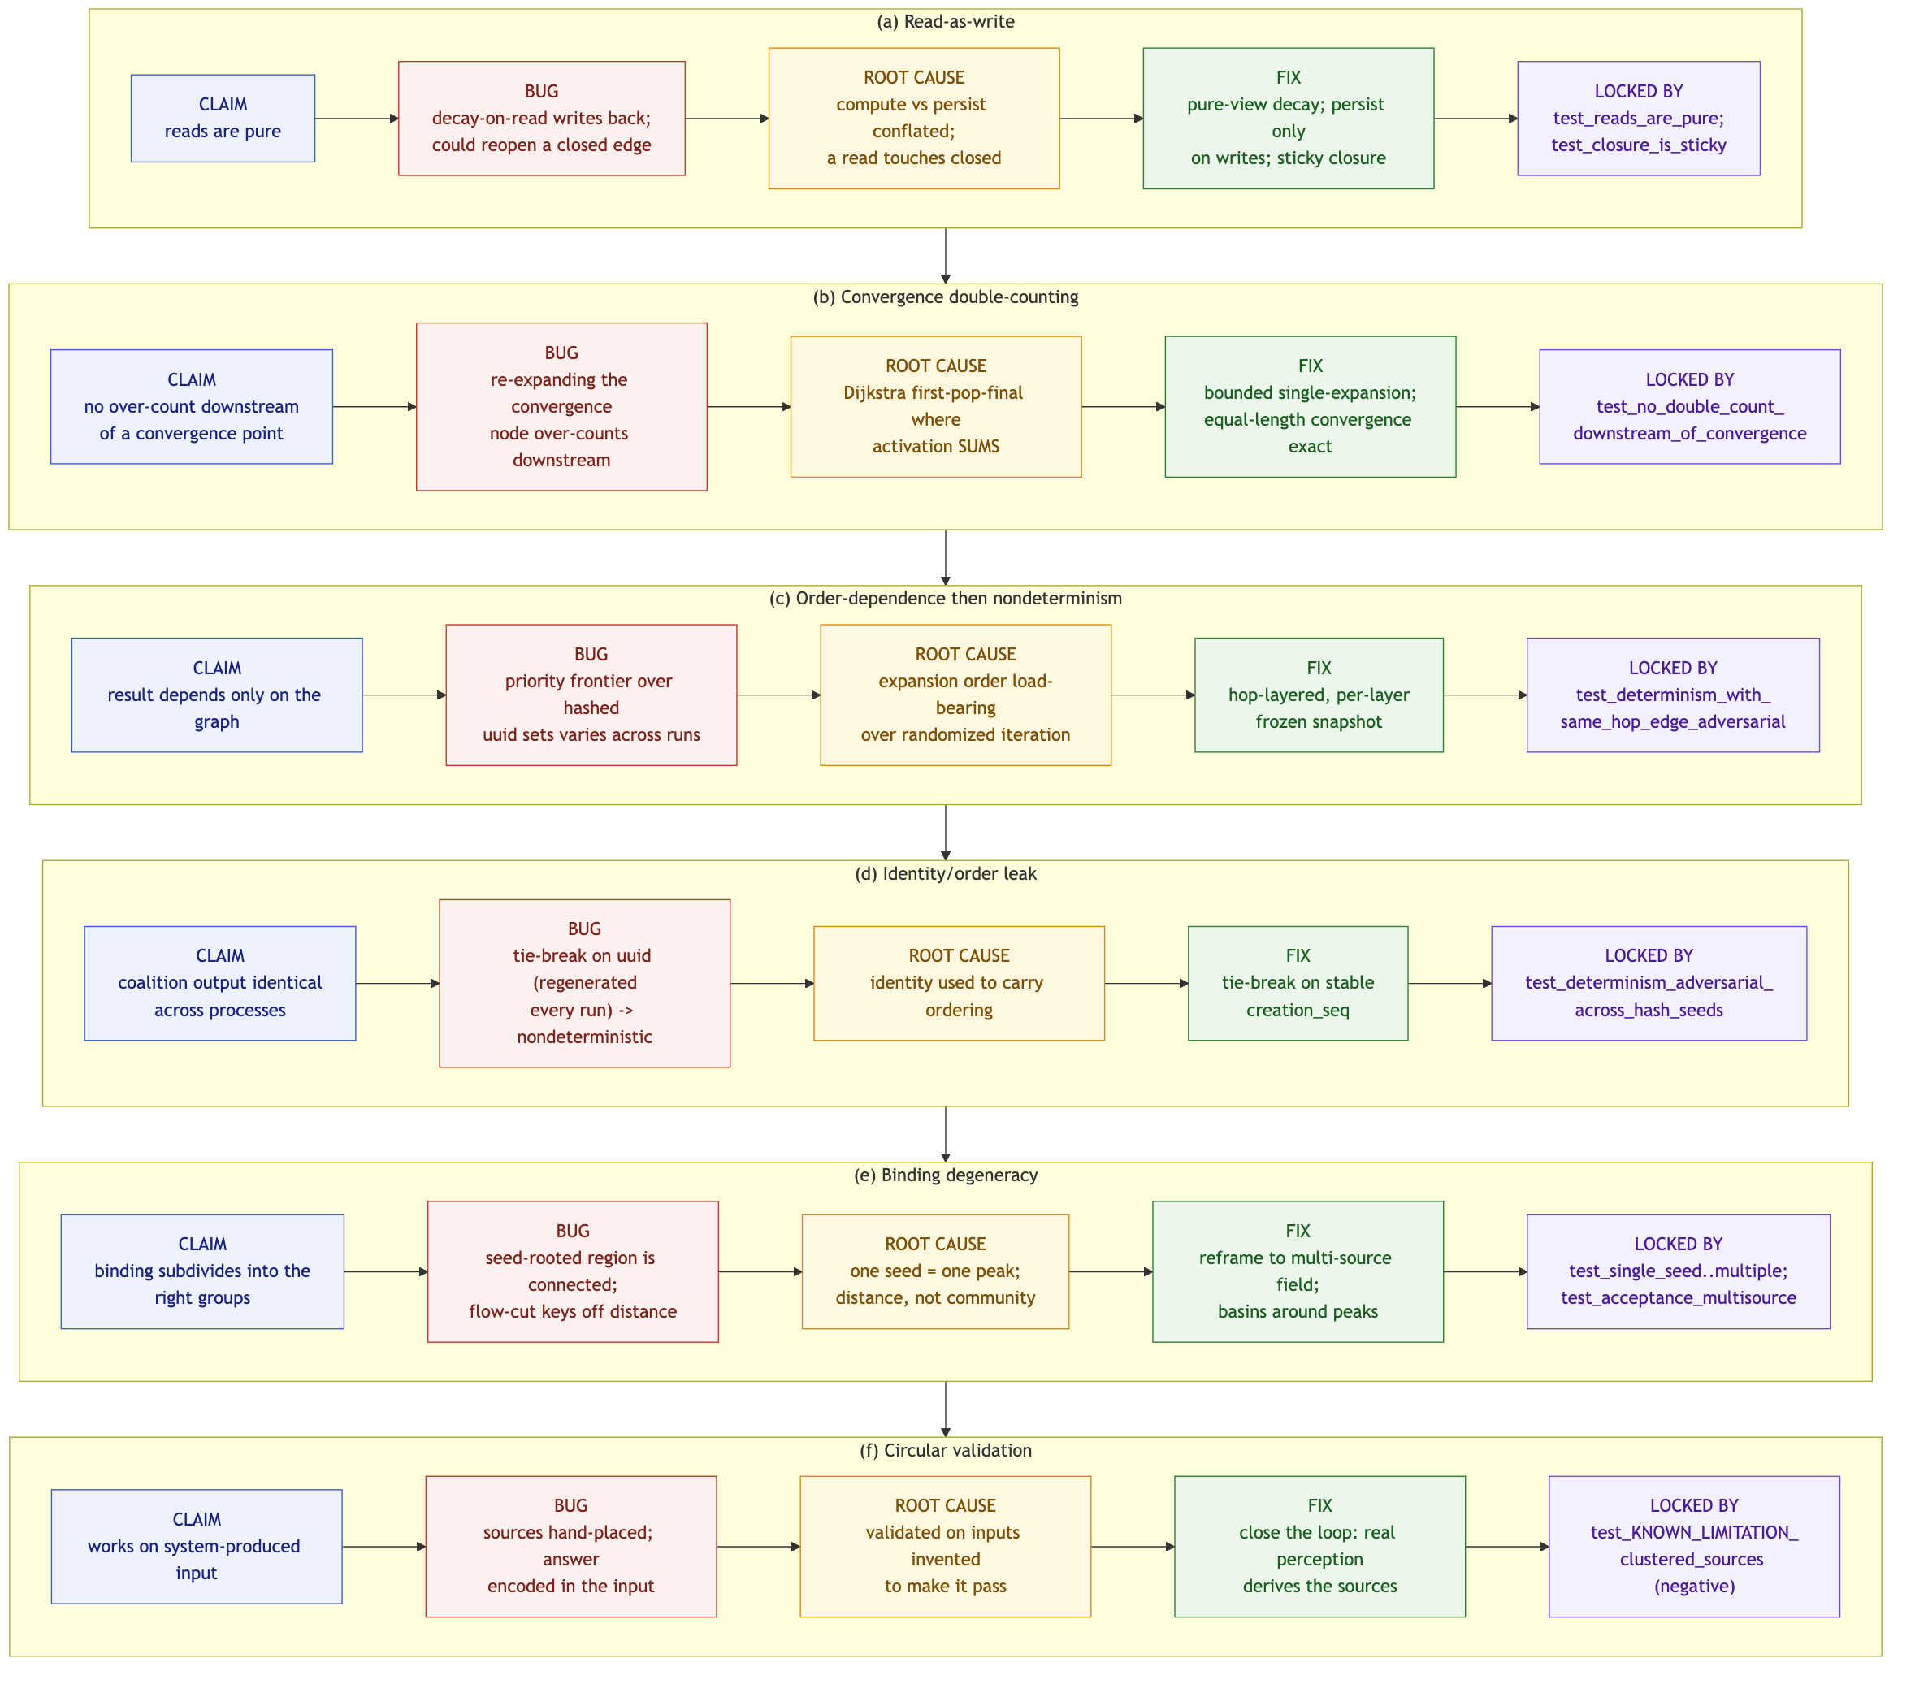
Figure 6 — The six structural findings at a glance. Each row: claim → bug → root cause → fix → locking test. Every cell traces to a module docstring and a named test; no error magnitudes are asserted.

(a) Read-as-write: a read that could silently re-open a closed wound
Claim under test: reads are pure; stored state changes only on writes.
Bug: the natural implementation applies time-decay on access and writes it back, so every read mutates the store; worse, if decay also re-evaluated closure, repeated reads over time could let a closed (traumatic) edge drift back open with no crossing reopening it.
Root cause: conflating “compute the current value” with “persist the current value,” and letting a passive read touch state (closed) that should change only on an active event.
Fix: split decay into a pure view (_compute_decay returns decayed values without mutating; get_road returns a copy) and a persisting write (_persist_decay, called only by writes/offline). Decay never touches closed; closure is sticky.
Locked by: test_reads_are_pure; test_lazy_decay; test_closure_is_sticky (time + repeated reads do not reopen a closed road; only an active positive return does).
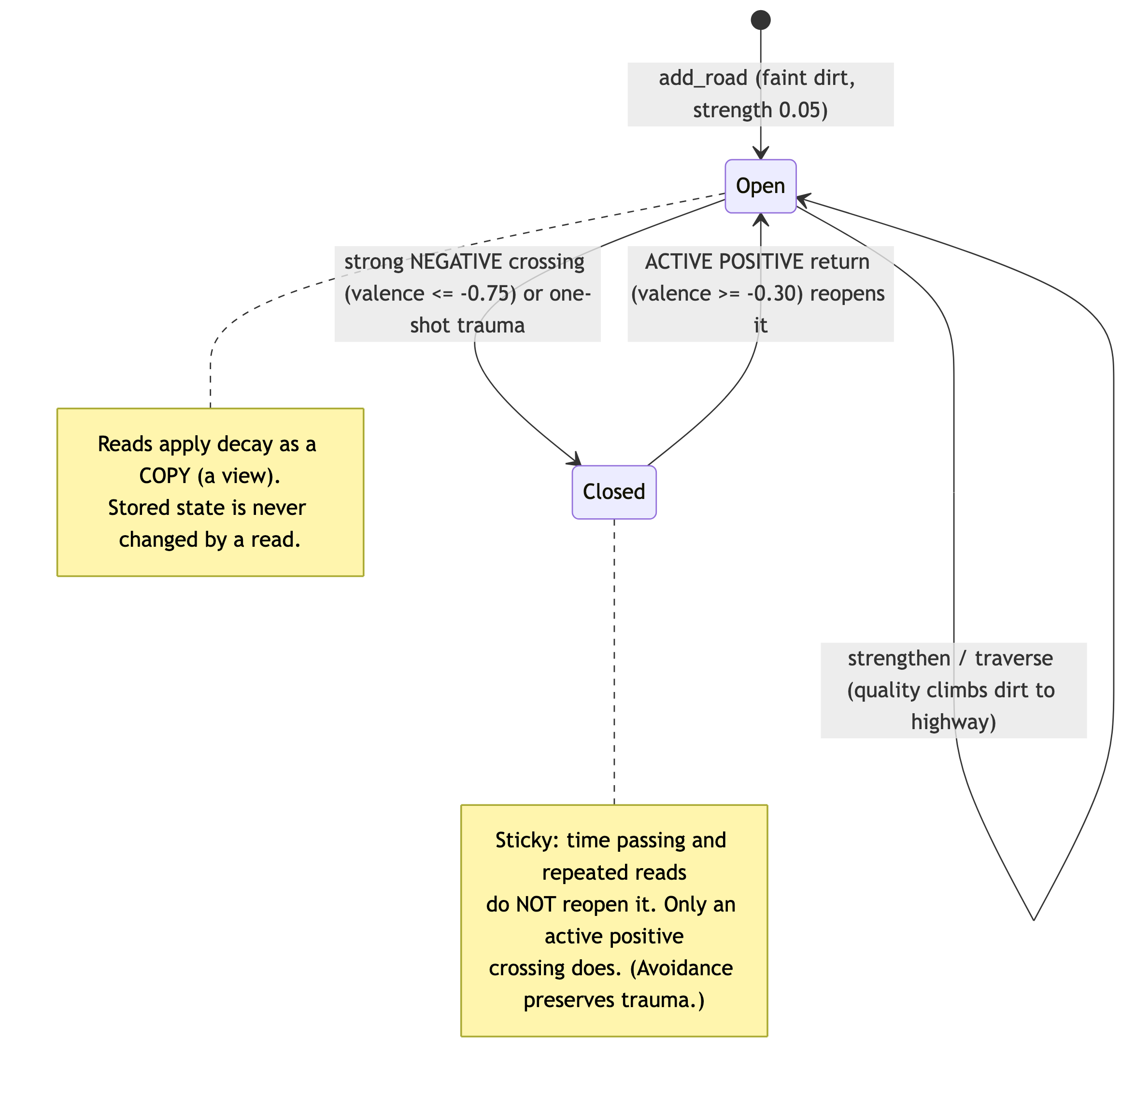
Figure 7 — A road’s closure lifecycle (finding (a) invariant). Open/Closed transitions happen only on active crossings; time passing and reads never reopen a closed road. A mechanism property, asserted by test_closure_is_sticky.

(b) Convergence double-counting: “first-pop-final” where activation sums
Claim under test: a node downstream of a convergence point is not over-counted.
Bug: when activation converges from several paths it must sum, but re-expanding the convergence node as later paths raise its value counts everything downstream multiple times.
Root cause: importing Dijkstra’s “first-pop-final” intuition into an algorithm where activation accumulates rather than being a shortest-path minimum.
Fix: bounded single-expansion, hop-layered — each node expands exactly once carrying the full sum of paths of length ≤ its settle hop; equal-length convergence is exact.
Locked by: test_no_double_count_downstream_of_convergence, which uses deliberately lopsided edge strengths to prove the result does not depend on them and guards that it is strictly below additive re-expansion; test_convergent_activation_sums.
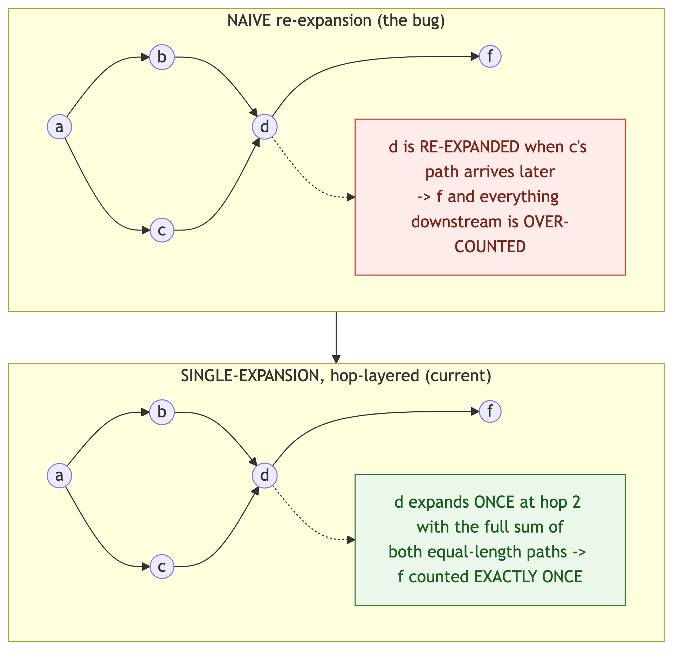
Figure 8 — Convergence double-counting, before/after (finding (b)). Structural schematic of the diamond-with-tail: naive re-expansion over-counts everything downstream of the convergence node; single-expansion counts it once. No magnitudes are shown (the report omits them as not reproducible).

(c) Order-dependence, then nondeterminism: a priority frontier over hashed sets
Claim under test: post-convergence activation depends only on the graph, never on expansion order or process hash seed.
Bug: an activation-priority frontier made which late ripple was dropped depend on incidental edge-strength ordering; and with same-hop edges, which sibling expanded first was decided by iterating a set of uuids — order randomized per process by PYTHONHASHSEED — so results swung across runs.
Root cause: letting expansion order be load-bearing for the result, over a container whose iteration order is intentionally randomized.
Fix: hop-layered expansion with per-layer frozen values: a layer’s expansion snapshot is fixed before any node in it expands, so an intra-layer edge’s contribution propagates only in the next layer.
Locked by: test_expansion_is_deterministic_under_edge_strength, and the decisive test_determinism_with_same_hop_edge_adversarial, which builds an intra-layer edge and re-runs the spread in fresh interpreters under PYTHONHASHSEED in {0,1,3,7,42}, asserting byte-identical results.

(d) Identity/order leak: tie-breaking on a uuid regenerated every run
Claim under test: coalition output (partition, ordering, representatives) is identical across processes.
Bug: coalition ordering and representative selection tie-broke on the node id — but ids are uuid4, regenerated every run, so any tiebreak falling back to the id was nondeterministic across processes even when the structure was identical.
Root cause: using identity (intentionally non-stable across runs) to carry ordering.
Fix: tie-break on the stable creation_seq integer; representative() orders by (-activation, creation_seq) and the coalition sort key is (-strength, -size, min creation_seq).
Locked by: test_determinism_adversarial_across_hash_seeds, which builds a ring of equal-activation nodes plus tie-strength singletons, serializes by stable keys (content + creation_seq, never uuid), and asserts identity across 8 hash seeds; test_representative_is_most_active_deterministically.

(e) Binding degeneracy: components on a graph connected by construction
Claim under test: coalition binding subdivides a co-activated region into the right groups.
Bug: (1) connectivity binding is structurally degenerate: a seed-rooted spread’s co-activated subgraph is connected by construction, so connected-components always yields one coalition. (2) flow-magnitude cutting does subdivide, but for a single seed the only strong signal is distance from the seed, and flow magnitude is even anti-correlated with community membership near the seed.
Root cause: a single seed produces one activation peak and monotonically-decaying flow; any segmentation keys off distance, not community.
Fix: keep flow-cut as the single-seed segmenter (it does yield more than one coalition) but recognize the real problem is upstream and reframe to a multi-source field: multiple sources → multiple genuine peaks → basins around peaks.
Locked by: test_single_seed_spread_yields_multiple_coalitions; test_acceptance_multisource_recovers_communities (the field recovers exactly the two communities on the adversarial bridge graph that single-seed segmentation could not).
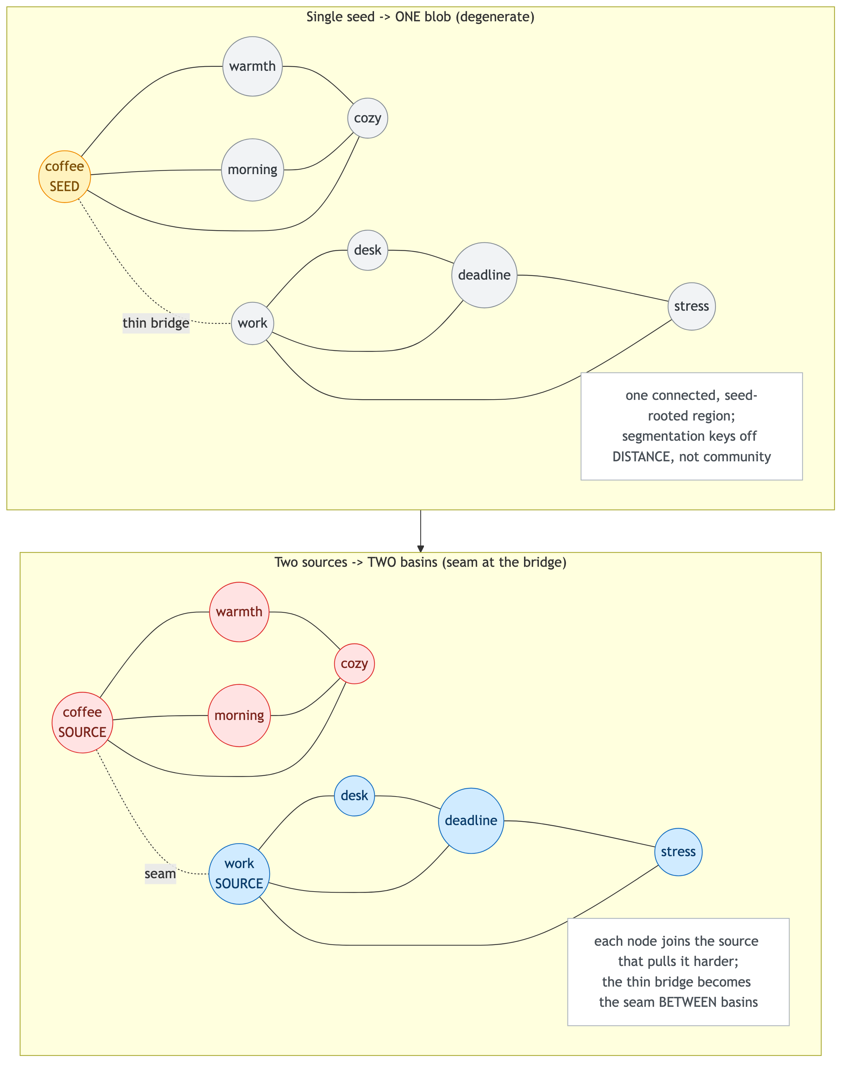
Figure 9 — Single-seed degeneracy vs. multi-source basins (finding (e)). The same two-communities-with-a-thin-bridge graph: one seed yields a single distance-keyed blob; two sources yield two basins with the bridge as the seam. The multi-source recovery is the asserted acceptance test — in which the two sources are placed one per community (see finding (f) for why that matters).

(f) Circular validation: the answer hand-encoded in the input
Claim under test: the cognitive layer works on input the system produced, not input chosen to make it work.
Bug: every layer above the substrate had been validated against a fiction of what would feed it. Sources were hand-placed, culminating in the field acceptance test recovering two communities only because one source was hand-placed at the center of each — the answer was encoded in the input. (test_acceptance_multisource_recovers_communities does place one source per community by hand; it is honest as a mechanism test and would be dishonest if read as evidence the system finds communities on its own.)
Root cause: validating a stage against inputs invented to produce the desired output.
Fix: close the loop with the thinnest real slice (nous_perceive.py), where which nodes become sources is decided by the input matched against the substrate, not by the test. On real clustered input the field then produces an incoherent thought: basins collapse, one source over-swallows across domains, and same-domain sibling sources strand as singletons.
Locked by: test_KNOWN_LIMITATION_clustered_sources_give_poor_basins, which asserts the failure on purpose and is written to flip to green only when source-grouping is fixed (a negative result, not a contribution).
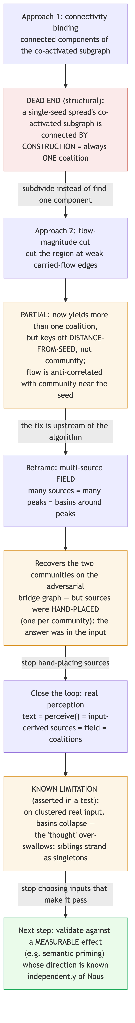
Figure 10 — The cognitive-layer arc and its dead-ends. connectivity binding → flow-cut → multi-source field → closed-loop, and what each step revealed (findings e, f), ending at the known limitation. It documents the development path, not a working capability.

6.7 What the six have in common
(b)–(f) are all instances of “passes on a friendly input.” (a) is the dual lesson for invariants: a property (purity) that an easy test trivially satisfies can be violated by an interaction (decay × closure × time) that only a purpose-built test exercises. In every case the bug was structural and the catching test was adversarial or loop-closing.

6.8 Transferable lessons
- Test the property, not the example — assert purity, determinism, and “no double-count” directly and across processes, not by spot-checking outputs.
- Randomize what you assume is fixed — running under multiple PYTHONHASHSEED values is what makes uuid-set nondeterminism observable.
- Close the loop — let a stage’s inputs be produced by the stage below it; hand-chosen inputs hide both degeneracy and circularity.
- Encode known limitations as asserted tests — a negative result written as a failing-on-purpose assertion is a standing, checkable claim, not a comment that rots.

7. Results

7.1 Verified properties (the positive results)
For the substrate store and the spreading-activation engine, the test suite establishes, as runnable checks: determinism (identical output across process runs, confirmed in fresh interpreters under the hash seeds in §4); integrity (graph indices stay mutually consistent across every mutation; a full scan finds no drift); and purity (reads never mutate stored state). These are claims about mechanism — the code does exactly and only what it says, reproducibly — not that the mechanism reproduces any cognitive phenomenon.
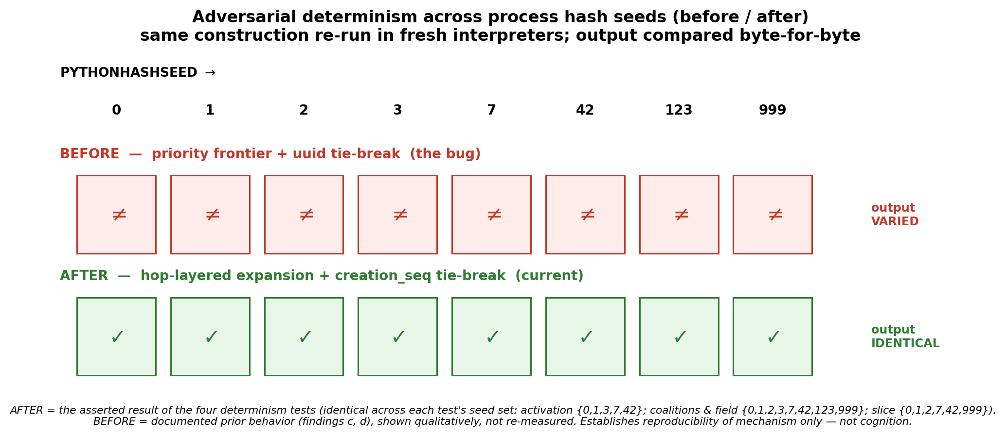
Figure 11 — Adversarial determinism across process hash seeds (before/after). AFTER is the asserted, byte-identical result of the four determinism tests (each across its own seed set); BEFORE is the documented prior bug (findings c, d), shown qualitatively and NOT re-measured. Reproducibility of mechanism only — not cognition.

7.2 Test suite
All figures below are taken verbatim from docs/TEST_OUTPUT.txt (CPython 3.13.2, Darwin 24.5.0 arm64) and re-confirmed by python3 run_tests.py for this report. Every suite passes with zero failures.
Suite | Layer | Checks passed
test_nous_store.py | substrate store | 45
test_nous_activation.py | spreading activation | 35
test_nous_coalitions.py | coalition formation | 19
test_nous_field.py | multi-source field | 13
test_nous_perceive.py | perception + end-to-end slice | 18
Total |  | 130 passed, 0 failed
The total is 130 assertions executed across 56 test functions, including the cross-process determinism checks and one explicitly-asserted known-limitation test. The verbatim run is in Appendix A.
 | Files | Lines (wc -l) | Non-blank, non-comment
Source modules (src/) | 5 | 1,476 | 1,058
Test suites (tests/) | 5 | 1,555 | 1,223
Python total | 10 | 3,031 | 2,281
Per module (wc -l): nous_store.py 548, nous_activation.py 281, nous_coalitions.py 324, nous_field.py 161, nous_perceive.py 162.
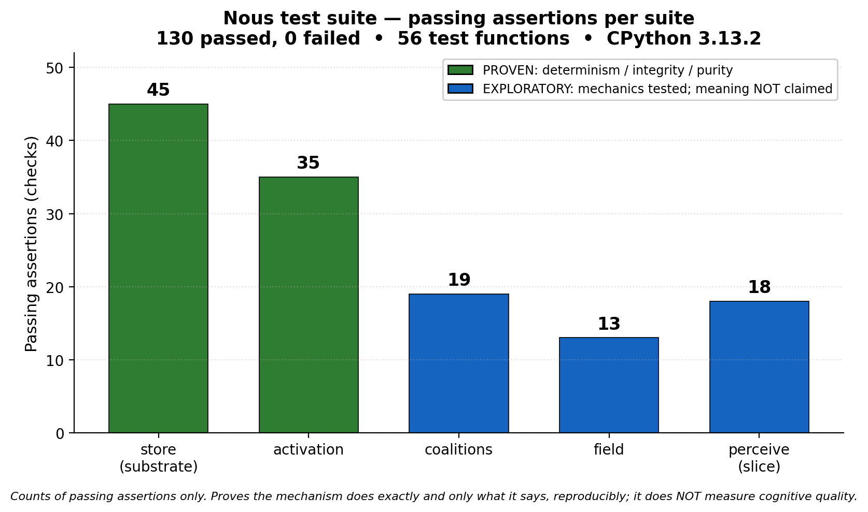
Figure 12 — Passing assertions per suite (130 total, 0 failed). Counts taken verbatim from docs/TEST_OUTPUT.txt. Proves mechanism (and the mechanics of the exploratory layers); it does NOT measure cognitive quality. The proven/exploratory colouring matches Figure 1.

7.3 The incoherent-thought known limitation (an asserted negative result)
On clustered real input the end-to-end slice does not produce coherent coalitions. When perception lights up several nodes in the same domain, basins collapse: one source over-swallows across domains while same-domain siblings strand as singletons. This is asserted on purpose by test_KNOWN_LIMITATION_clustered_sources_give_poor_basins, which passes today because the failure holds; it is written to flip only when the underlying source-grouping problem is solved. It is reported here as a negative result, not a contribution.
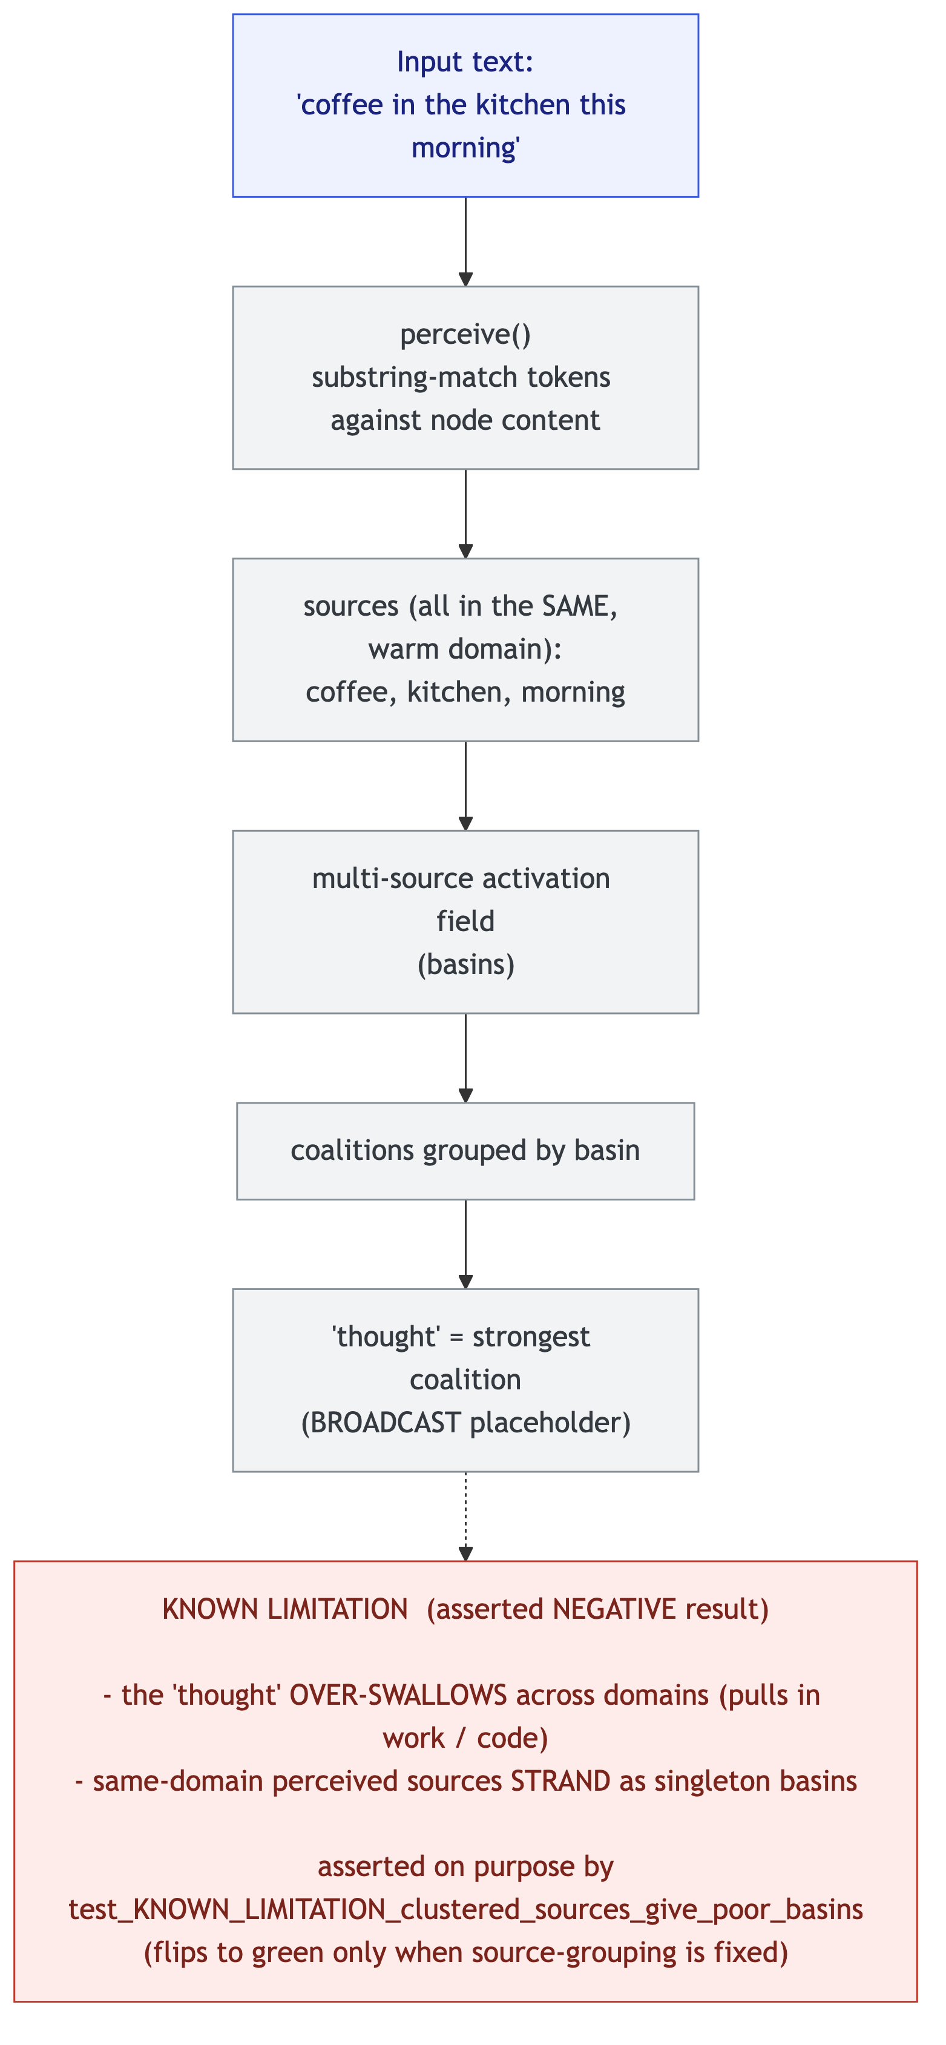
Figure 13 — The closed-loop slice and its honest failure (finding (f); asserted NEGATIVE result). On the real input ‘coffee in the kitchen this morning,’ the ‘thought’ over-swallows across domains (pulls in work/code) and same-domain perceived sources strand as singleton basins, asserted by test_KNOWN_LIMITATION_clustered_sources_give_poor_basins. A documented known limitation, not a capability.

7.4 What these results do and do not establish
They establish that the substrate and activation engine are correct, deterministic, integrity-preserving, and pure, and that the cognitive layers run deterministically and purely. They do not establish that any “thought” the cognitive layers produce is cognitively meaningful; on the contrary, the one end-to-end behavioral probe on real input is a documented failure. “The mechanism is correct and deterministic” and “the mechanism reproduces a cognitive phenomenon” are different claims; this work earns the first and explicitly does not claim the second.

8. Limitations and threats to validity
- Cognitive meaningfulness is unestablished. The field/coalition/thought layers are exploratory; the only end-to-end behavioral result on real input is the negative one above.
- Uncalibrated constants on probation. The closed-road breakthrough threshold/leak fraction and the coalition flow-cut fraction are first-pass guesses; tests pin only the qualitative regime, and nothing downstream may depend on the magnitudes.
- Perception is exact/substring matching only. No embeddings or fuzzy semantics.
- Out-roads-only spread (v1). Backward spread along in-roads is a deliberate later addition.
- Determinism is “given store state,” not over the abstract graph. The proven property is that output is a deterministic function of the store’s state, where state includes the integer creation_seq assigned in build order. Two stores isomorphic as abstract graphs but built in a different order can differ in creation_seq and, where ties break on it, can produce different (but each individually deterministic and reproducible) tie-break orderings. Determinism here means reproducibility across process runs of the same construction, not invariance under graph isomorphism.
- Scale is unverified. All tests are small graphs; the prototype makes no scaling claims.

9. Future work
The natural next step is to stop validating the cognitive layer against hand-built inputs and instead validate it against a measurable cognitive effect whose direction is known independently of Nous. Semantic priming is the worked example: in human studies, recognizing a target word is faster when preceded by a related prime than an unrelated one [11], which the spreading-activation account explains via pre-activation spreading to related concepts [10]. A priming-style protocol for Nous would pre-activate a related concept and test whether the target’s activation is measurably raised relative to an unrelated control — a directional prediction made before running the system, so the input is no longer chosen to make the answer come out right. Two further items follow directly from the findings:
- The source-grouping problem (from finding f). Same-domain perceived sources must be grouped or merged before basins are meaningful; solving it is the condition under which the known-limitation test would flip to green.
- A real broadcast/competition phase. The “strongest coalition = thought” placeholder should be replaced by an actual workspace competition, at which point the uncalibrated constants can begin to be calibrated against a running cycle rather than guessed.

10. Conclusion
What was earned is concrete and modest: a correct, deterministic, integrity-preserving, and pure memory-and-activation substrate, built in dependency-free Python and shipped with the tests that prove those properties across process hash seeds — and, above it, an honestly-scoped exploratory layer whose one end-to-end behavioral probe is a documented negative result. The larger contribution is the method: adversarial/property-based testing and loop-closure caught six structural bugs that happy-path testing passes over, and the same discipline drew the boundary the project refuses to cross — proving mechanism while explicitly declining to claim cognition. What remains open is exactly what the method recommends next: evaluate the cognitive layer against an effect whose direction is known independently, fix the source-grouping degeneracy, and build the competition phase that would make the constants calibratable.

11. References
Note to the author: this list is curated and the bibliographic details are believed correct, but verify exact page numbers, volumes, and DOIs against the primary sources before submission.
[1] McClelland, J. L., McNaughton, B. L., & O’Reilly, R. C. (1995). Why there are complementary learning systems in the hippocampus and neocortex. Psychological Review, 102(3), 419–457.
[2] Kumaran, D., Hassabis, D., & McClelland, J. L. (2016). What learning systems do intelligent agents need? Complementary Learning Systems theory updated. Trends in Cognitive Sciences, 20(7), 512–534.
[3] Frey, U., & Morris, R. G. M. (1997). Synaptic tagging and long-term potentiation. Nature, 385, 533–536.
[4] Redondo, R. L., & Morris, R. G. M. (2011). Making memories last: the synaptic tagging and capture hypothesis. Nature Reviews Neuroscience, 12, 17–30.
[5] Baars, B. J. (1988). A Cognitive Theory of Consciousness. Cambridge University Press.
[6] Dehaene, S., & Changeux, J.-P. (2011). Experimental and theoretical approaches to conscious processing. Neuron, 70(2), 200–227.
[7] Franklin, S., Madl, T., D’Mello, S., & Snaider, J. (2014). LIDA: A systems-level architecture for cognition, emotion, and learning. IEEE Transactions on Autonomous Mental Development, 6(1), 19–41.
[8] Anderson, J. R., Bothell, D., Byrne, M. D., Douglass, S., Lebiere, C., & Qin, Y. (2004). An integrated theory of the mind. Psychological Review, 111(4), 1036–1060.
[9] Eliasmith, C., Stewart, T. C., Choo, X., Bekolay, T., DeWolf, T., Tang, Y., & Rasmussen, D. (2012). A large-scale model of the functioning brain. Science, 338(6111), 1202–1205.
[10] Collins, A. M., & Loftus, E. F. (1975). A spreading-activation theory of semantic processing. Psychological Review, 82(6), 407–428.
[11] Meyer, D. E., & Schvaneveldt, R. W. (1971). Facilitation in recognizing pairs of words. Journal of Experimental Psychology, 90(2), 227–234.
[12] Yerkes, R. M., & Dodson, J. D. (1908). The relation of strength of stimulus to rapidity of habit-formation. Journal of Comparative Neurology and Psychology, 18(5), 459–482.

Appendix A — Verbatim test output
The captured run from docs/TEST_OUTPUT.txt (per-suite result lines; the complete capture, including every check label and the KNOWN LIMITATION note, is that file in the repository).
NOUS SUBSTRATE STORE -- TEST SUITE (Layer 1) -> RESULT: 45 passed, 0 failed [exit 0]
NOUS SPREADING ACTIVATION -- TEST SUITE -> RESULT: 35 passed, 0 failed [exit 0]
NOUS COALITION FORMATION -- TEST SUITE -> RESULT: 19 passed, 0 failed [exit 0]
NOUS MULTI-SOURCE FIELD + FIELD COALITIONS -> RESULT: 13 passed, 0 failed [exit 0]
NOUS PERCEPTION + END-TO-END SLICE -- TEST SUITE -> RESULT: 18 passed, 0 failed [exit 0]
TOTAL: 130 passed, 0 failed

Appendix B — Reproduction
# all five suites (handles the absolute PYTHONPATH for the determinism subprocesses):
python3 run_tests.py
# a single suite directly:
PYTHONPATH="$PWD/src" python3 tests/test_nous_store.py
Pure standard library; no dependencies (developed and captured on CPython 3.13.2). The suites use a built-in harness and must be run as scripts, not under pytest.

Appendix C — Figure index and sources
All figures are embedded inline in the sections above. Their editable sources and presentation-resolution renders live in the repository: Mermaid diagrams as docs/diagrams/*.mmd (rendered to docs/diagrams/rendered/*.png; the .mmd files also render crisply at mermaid.live or via mmdc), and data charts as docs/diagrams/figures/*.py (matplotlib; run them to regenerate the PNGs at dpi=200).
Fig | Section | Asset (in docs/diagrams/) | Kind
1 | §3 | architecture_stack | Mermaid
2 | §3.1 | data_model | Mermaid
3 | §3.1 | substrate_read_write | Mermaid
4 | §3.4 | pipeline | Mermaid
5 | §5 | friendly_input_loop | Mermaid
6 | §6 | six_findings | Mermaid
7 | §6.1 | sticky_closure_state | Mermaid
8 | §6.2 | convergence_before_after | Mermaid
9 | §6.5 | single_seed_vs_multisource | Mermaid
10 | §6.7 | cognitive_evolution | Mermaid
11 | §7.1 | figures/determinism_seeds.py | matplotlib
12 | §7.2 | figures/test_suite_bars.py | matplotlib
13 | §7.3 | closed_loop_known_limitation | Mermaid
14 | this appendix | repo_map | Mermaid
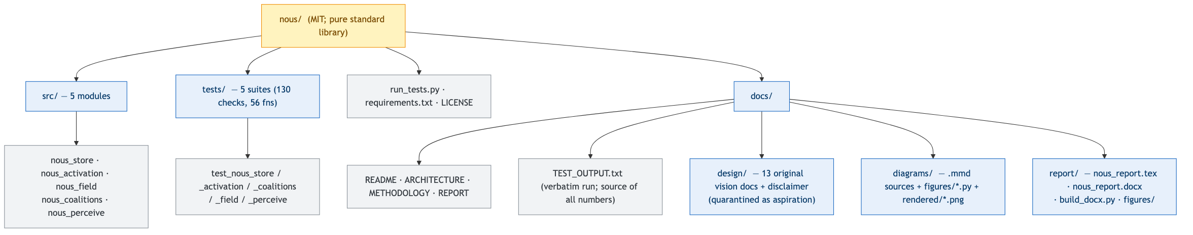
Figure 14 — Repository / asset map. Orientation only; it shows the package layout, not behavior.

