1st Release of the Software System
Undergraduate Transfer Management System (UTMS)
Implementation and Test Report
CENG 316 - Software Engineering
Group 1
Izmir Institute of Technology
Group Members
Çağan Çalışkan, Ahmet Mete Yazıcı,
Emre Yıldız, Çağatay Birgi, Eda Cesur,
İrem Cesur, Melih Macit, Yılmaz Gökçe
Date: 5 May 2026
Document version: 1.0

1. Introduction
This document describes the first release (Release 1) of the Undergraduate Transfer Management System (UTMS) developed by Group 1 for the CENG 316 Software Engineering course at Izmir Institute of Technology. The system is the digital implementation of the inter-institutional undergraduate transfer process specified in the Software Requirements Specification (SRS) document of the same group.
Release 1 is a vertical slice of the full system. It implements the user interface, the role-based navigation, the validation logic, and the simulated external integration for a curated subset of the use cases defined in the SRS. The release is intentionally front-end heavy: a working backend and a real database are scheduled for Release 2, and all data in this release flows through a typed mock service layer that mirrors the planned API contract.
Out of the approximately fifty use cases defined in the SRS, three were selected with the project mentor to be demonstrated for this release:
- UC-1.1 Submit Application Form (Student)
- UC-3.1 Review Language Proficiency Document (YDYO Officer)
- UC-4.5 Generate Digital Course Equivalence, Intibak (YGK Member)
These three were chosen because they cover three distinct user roles, span both High and Medium priority requirements in the SRS, and together exercise the most technically interesting behaviors of the system: external data integration, regulation-driven validation, multi-role workflow progression, and the digital intibak module that is the headline innovation of the SRS.
This report is organized as follows. Section 2 describes the implementation architecture. Section 3 lists the technology stack. Section 4 explains why each technology was chosen and how it is used. Section 5 documents each demonstrated use case, including the SRS-grounded specification and the implementation notes. Section 6 presents the work breakdown by group member. Section 7 provides the updated test plan with one test suite per demonstrated use case. Section 8 records known limitations and the planned scope for Release 2. Section 9 lists references.

2. Implementation Architecture
UTMS Release 1 is implemented as a single-page web application (SPA) that runs entirely in the user's browser. The architecture is intentionally layered so that the future backend (Release 2) can be slotted underneath the existing mock service layer without any change to the UI components. The four logical layers, from the user-facing surface down to the simulated external systems, are described below.

2.1 Logical Layers
Layer 1, Presentation. React 18 functional components rendered with Vite. The shell component (AppShell) provides the top navigation bar, the role indicator, and the logout and switch-role controls. Each role has its own dashboard component (StudentDashboard, OIDBDashboard, YDYODashboard, YGKDashboard, DeanDashboard, BoardDashboard, AdminDashboard) which composes the screens for that role's use cases.
Layer 2, Routing and State. Routing is handled by role-driven conditional rendering in App.tsx rather than URL paths, which fits the small number of distinct top-level surfaces in this release. Per-screen state is local React state. Global state (current user, current role) is stored in browser localStorage so that a page reload preserves the session.
Layer 3, Mock Service Layer. All domain data (applications, documents, users, language decisions, intibak entries, department quotas) is served from src/app/lib/mock-data.ts. The data shapes follow the Application, ApplicationDocument, TimelineEvent and IntibakEntry interfaces declared in src/app/types/index.ts. Asynchronous reads are simulated with setTimeout to mirror the latency profile of a real network call, including the API-down scenario described in the SRS for UC-1.1.
Layer 4, Simulated External Systems. YOKSIS, OSYM, NVI and e-Devlet are represented as constants and stub functions in the mock layer. Each integration point exposes the same function signature it is expected to expose against the real API in Release 2, which keeps the seam stable across releases.

2.2 Component View
The textual diagram below summarizes how a request flows from the user to the simulated external systems. Solid arrows represent function calls inside the SPA. Dashed arrows represent the network calls that will replace the mock layer in Release 2.
+---------------------------+
| Browser (Chrome / FF) |
+-------------+-------------+
|
v
+---------------------------+
| Vite Dev Server (HMR) |
+-------------+-------------+
|
v
+---------------------------+
| React App Shell |
| (App.tsx, AppShell) |
+-------------+-------------+
|
v
+---------------------------+
| Role Dashboards |
| Student, OIDB, YDYO, |
| YGK, Dean, Board, Admin |
+-------------+-------------+
|
v
+---------------------------+
| Mock Service Layer |
| (lib/mock-data.ts) |
+------+--------------+-----+
| |
(planned R2 API) |
v v
+-----------+ +-----------------+
| UTMS API | | YOKSIS / OSYM / |
| Backend | | NVI / e-Devlet |
+-----------+ +-----------------+

2.3 Deployment View
In Release 1 the application is served by the Vite development server on http://localhost:5173 during the demo. The build command (npm run build) produces a static bundle that can be deployed behind any static host or reverse-proxied through the existing UBYS infrastructure. There is no server-side rendering and no Node runtime requirement at deployment time.

3. Technologies Used
The Release 1 stack is defined in package.json at the root of the project. The table below lists the technologies and versions that have a direct effect on the demonstrated use cases. Transitive dependencies (clsx, class-variance-authority, tailwind-merge and similar) are omitted for brevity.
Technology | Version | Purpose
React | 18.3.1 | Component model and rendering for the SPA.
TypeScript | 5.x | Static typing for the domain model and props.
Vite | 6.4 | Build tool and dev server with hot module replacement.
Tailwind CSS | 4.1 | Utility-first styling and design tokens.
shadcn/ui | current | Themed, accessible component primitives.
Radix UI | 1.x / 2.x | Headless behavior layer behind shadcn/ui (dialog, select, tabs, radio-group, etc.).
lucide-react | 0.487 | Consistent SVG icon set across all dashboards.
sonner | 2.0 | Non-blocking toast notifications for success and error feedback.
react-hook-form | 7.55 | Form state management and validation in the application form and intibak generator.
recharts | 2.15 | Charts on the OIDB pipeline and admin dashboards.
motion | 12.23 | Light animation for stage transitions and modal entrance.
react-dnd | 16.0 | Drag-and-drop on the OIDB pipeline kanban board.
MUI Icons | 7.3 | Supplementary icon set used in a few admin views.
date-fns | 3.6 | Timestamp formatting on the application timeline.
Playwright | 1.59 | End-to-end browser test runner (planned automation harness).

4. Why and How These Technologies Were Used

4.1 React 18 with Vite
React was selected because the SRS describes seven distinct user roles and roughly fifty use cases. Composing them as small, isolated functional components, each owning its own state, kept the codebase tractable across five team members working in parallel. Vite was preferred over Create React App because its dev server starts in well under a second and applies hot module replacement on save, which removes most of the friction during iterative UI work. In practice, every screen in src/app/components is a default-exported function component invoked from its parent dashboard.

4.2 TypeScript
The system manipulates rich domain objects: an Application has a status that can take eleven values, a list of typed documents, a timeline of events, optional language status, optional academic score, optional rank, optional final decision, optional waitlist rank, optional return reasons, optional appeal text and optional appeal status. These shapes are declared once in src/app/types/index.ts and used everywhere. TypeScript lets the compiler catch the most common class of mistakes (missing optional properties, wrong status values, wrong document types) at edit time rather than during the demo.

4.3 Tailwind CSS, shadcn/ui and Radix UI
The team opted for shadcn/ui rather than a heavyweight component library because the SRS imposes specific brand requirements (the IYTE red, hex code #C00000) and a Turkish-language interface. shadcn/ui provides themable React components that compile against Tailwind utility classes, so the brand can be applied centrally in src/styles/globals.css without forking a vendor library. Radix UI sits underneath shadcn/ui and supplies accessible behavior for dialogs, dropdowns, radio groups and tabs, which is required for the role-based dashboards because keyboard and screen-reader navigation cannot be retrofitted late in the project.

4.4 Sonner and react-hook-form
Sonner is used for the success and error feedback patterns that appear in nearly every SRS use case (for example, the success toast that the application form displays after the simulated YOKSIS fetch completes). The toasts are non-blocking, which keeps the workflow fast for repetitive tasks like batch language reviews. react-hook-form is used in the application form and the intibak generator to centralize the validation rules required by the SRS, in particular GPA greater than or equal to 2.50, target semester in the set {3, 5}, and the requirement that the intibak table be saved only when complete.

4.5 Mock Service Layer
All data passes through src/app/lib/mock-data.ts. The layer is shaped to mirror the Release 2 REST contract, including the asynchronous nature of remote calls (the application form awaits a 1.5 second setTimeout to simulate the YOKSIS round trip). This gave the team three concrete benefits: the demo runs without a backend, screens can be developed in isolation by different members, and the future swap to a real API will be a one-file change inside the service module rather than a project-wide refactor.

4.6 Playwright
Playwright is included in devDependencies as the chosen end-to-end test runner. In Release 1 most tests are still executed manually against the running dev server, but the harness is committed so that automated runs can be added incrementally. Section 7 marks each test with its current execution mode.

5. Implemented Use Case Descriptions
This section documents the three use cases selected for the Release 1 demo. Each subsection begins with a faithful summary of the SRS specification, followed by the normal course of events as condensed for the demo, followed by implementation notes that map the SRS steps to concrete files and behaviors in the codebase. Screenshot placeholders are included so that the demo screenshots can be pasted in directly before submission.

5.1 UC-1.1 Submit Application Form

5.1.1 SRS Specification
Use Case ID | UC-1.1
Use Case Name | Submit Application Form
Actor | Student
Description | Enables an authenticated student to initiate an undergraduate transfer application by filling in the required information. Personal and current academic data are auto-populated from external services (YOKSIS, OSYM, NVI). The student supplies the target program, target semester, GPA and OSYM exam information.
Preconditions | 1) The student has logged in with a valid student account. 2) The application period for the current academic year is open. 3) The student does not already have an active application in the same period.
Postconditions | 1) A unique Application ID is generated. 2) The application is persisted in status 'Pending Document Upload'. 3) The student is redirected to UC-1.2 (Upload Required Documents).
Priority | High
Frequency of Use | Once per student per application period.

5.1.2 Normal Course of Events
- The student opens the Student Dashboard and clicks 'Yeni Basvuru Olustur' (Create New Application).
- The system displays the application form. Personal and academic information panels render in a loading state.
- The system simulates a 1.5 second YOKSIS / OSYM / NVI call and auto-populates name, surname, masked TCKN, student number, current university and current program. A success toast confirms the data fetch.
- The student selects target program, target semester (3 or 5), enters GPA (between 0.00 and 4.00 with a regulation minimum of 2.50), enters the OSYM score (0 to 600) and the OSYM year.
- The system validates the input on every change. Invalid values block the 'Save and Continue' button and surface inline error messages.
- The student clicks 'Save and Continue'. The system persists the application and routes the student to the Document Upload screen (UC-1.2).

5.1.3 Alternative Courses Implemented
- AC.1 (Save Draft): the student clicks 'Taslagi Kaydet' to persist the form without leaving for the upload screen. The application is saved with status 'draft' and a success toast is shown.
- AC.2 (External Service Down): when the simulated YOKSIS / OSYM endpoint is unavailable, the form replaces itself with a destructive alert that explains, in Turkish, that manual entry is not allowed for security reasons and asks the student to retry later. This branch is reachable by toggling the mockApiDown flag in ApplicationForm.tsx and is included in the test plan.

5.1.4 Implementation Notes
File: src/app/components/student/ApplicationForm.tsx (380 lines).
Form state: useState hook holds the eleven form fields. A separate errors record holds inline messages and a separate apiDown flag drives the fallback view.
External fetch simulation: useEffect with await new Promise(resolve => setTimeout(resolve, 1500)) mirrors the network latency. On success the form fields name, surname, tckn, studentId, currentUniversity, currentProgram are filled; the TCKN is rendered with the format $1*****$2 to mask sensitive characters as required by the SRS data security constraint.
Validation rules: implemented in validateForm and isFormValid. The rules enforced are: target program required, target semester in {3, 5}, GPA between 0.00 and 4.00 and at least 2.50, OSYM score between 0 and 600, and OSYM year required. Each rule maps directly to a constraint described in the SRS Apportioning of Requirements section.
User feedback: sonner is used for the post-fetch success toast and the post-save success toast. Inline GPA confirmation message is rendered in green when the value enters the valid range.

5.1.5 Screenshots
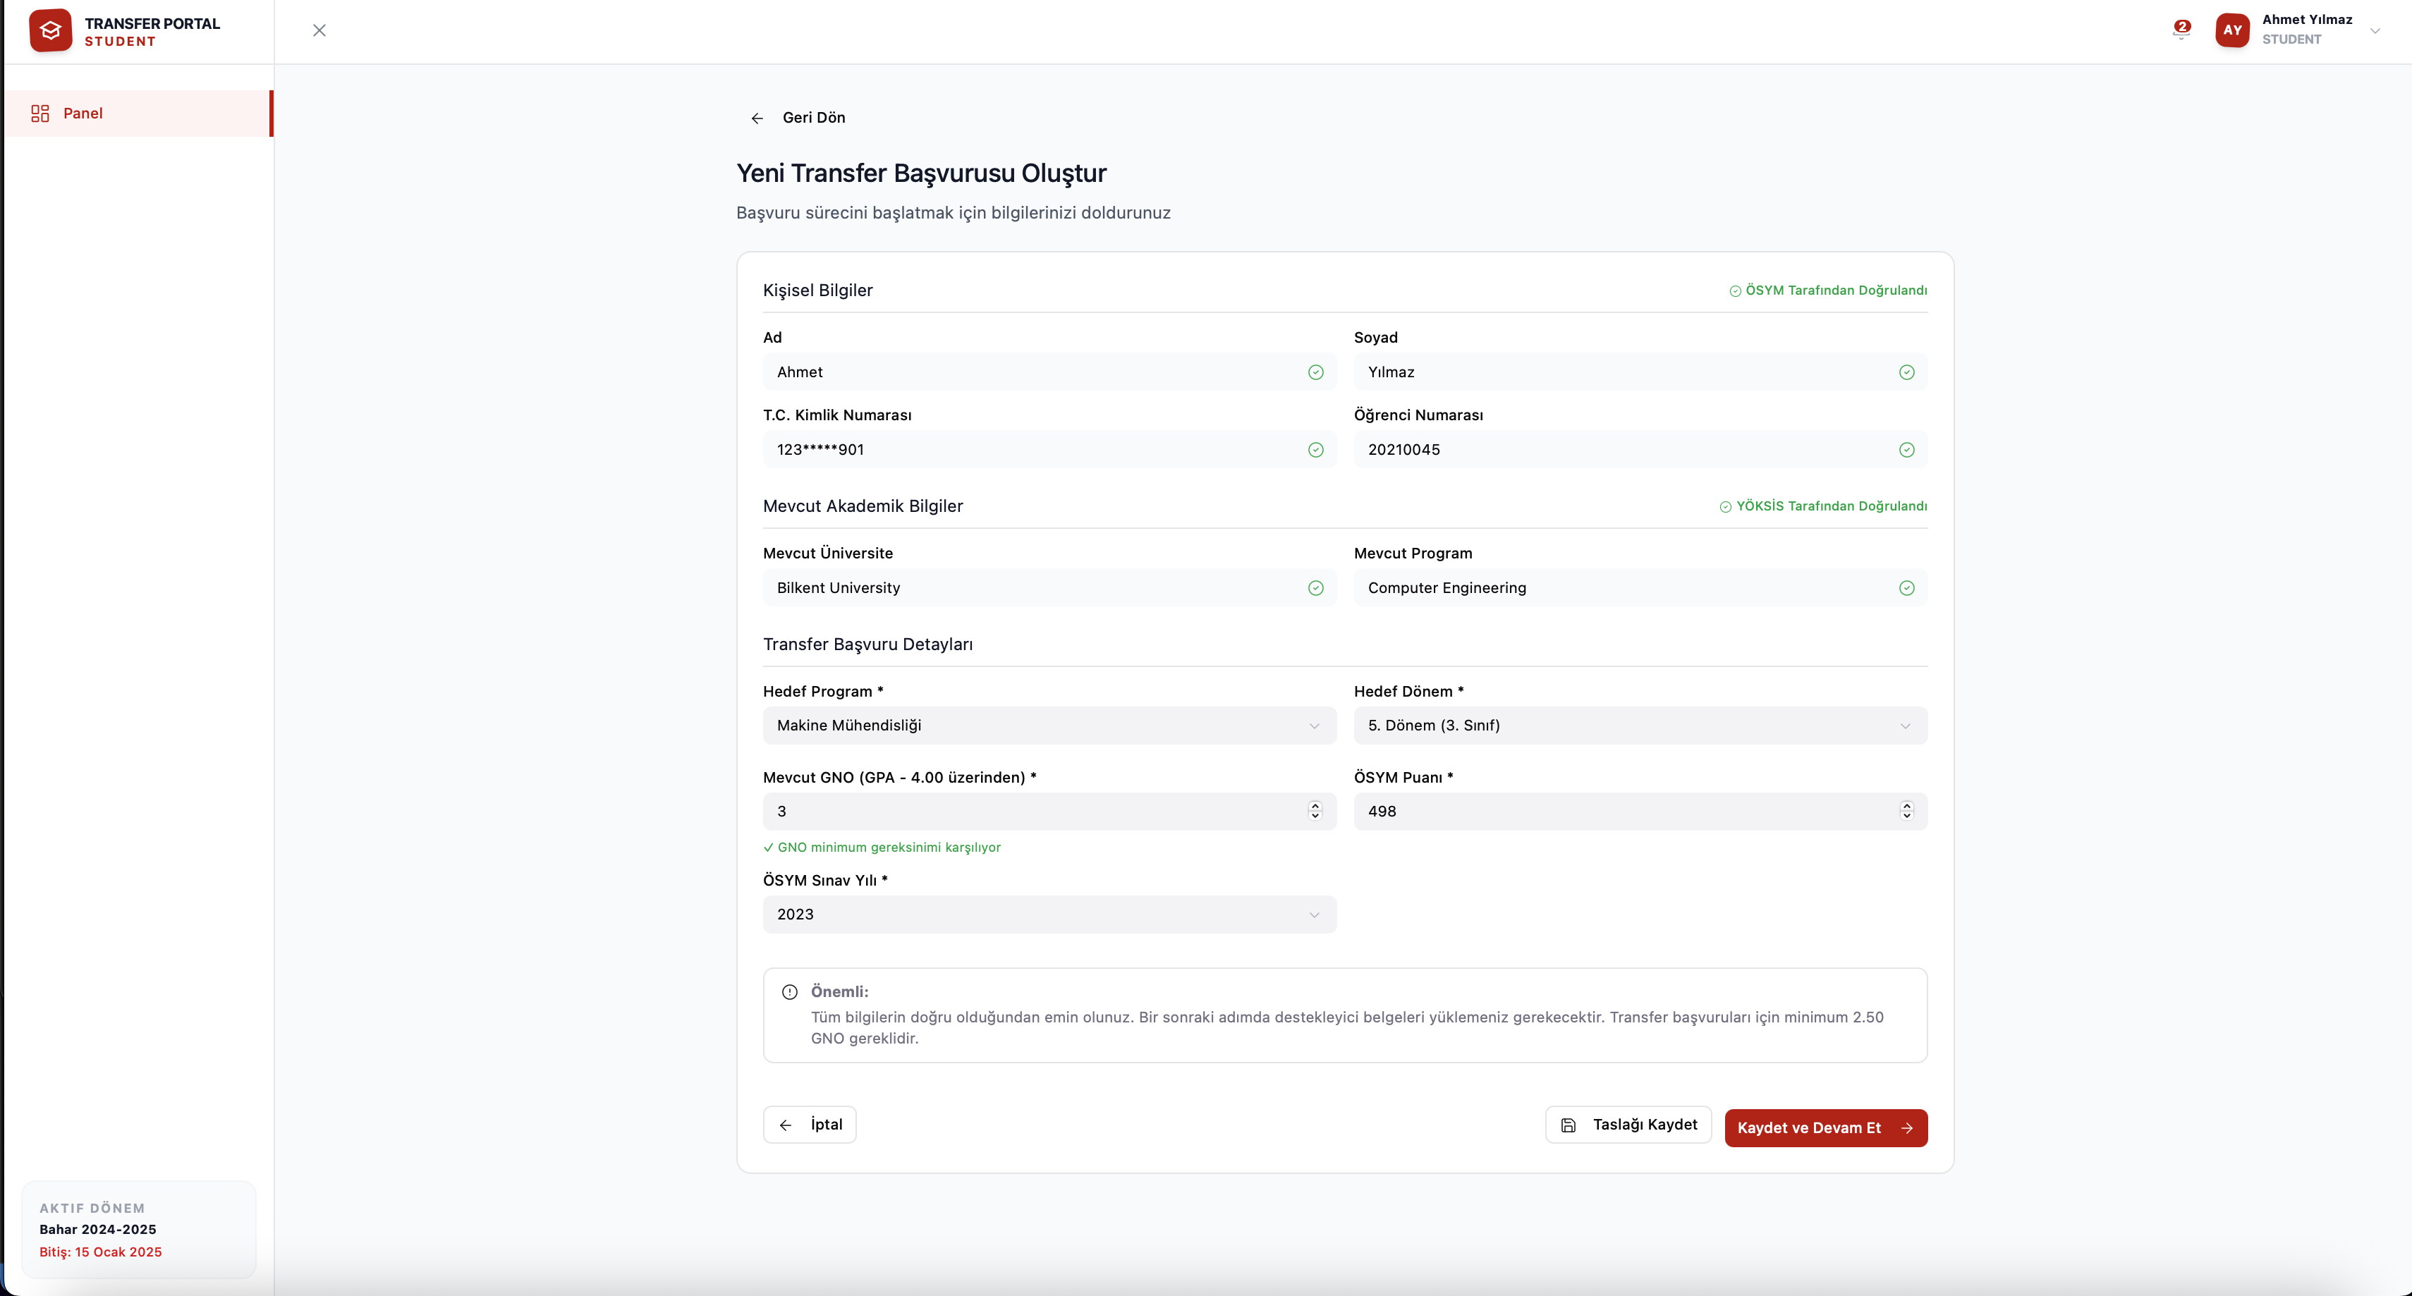
Figure 1. Application form after the simulated YOKSIS, OSYM and NVI fetch completes. Personal and current academic information are populated from the logged-in user (Ahmet Yilmaz), the TCKN is masked, and the green ÖSYM Tarafindan Dogrulandi and YÖKSIS Tarafindan Dogrulandi badges confirm the source of each field. Target program, target semester, GPA and OSYM score have been entered, and the green 'GNO minimum gereksinimi karsiliyor' confirmation is visible under the GPA input.
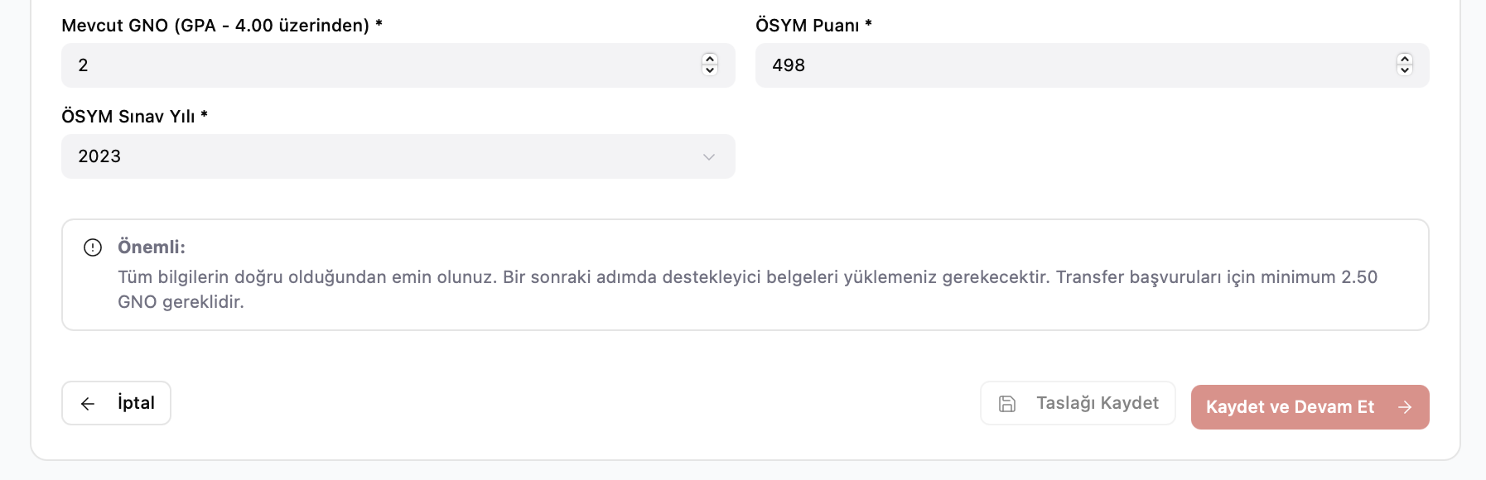
Figure 2. Validation state when the GPA is below 2.50. The Kaydet ve Devam Et button enters its disabled state, blocking the student from advancing to the document upload step in line with the SRS pre-screening rule.

5.2 UC-3.1 Review Language Proficiency Document

5.2.1 SRS Specification
Use Case ID | UC-3.1
Use Case Name | Review Language Proficiency Document
Actor | YDYO Officer (Foreign Languages Department staff)
Description | Enables a YDYO Officer to review the English proficiency document uploaded by an applicant and to record one of three decisions: Successful, Unsuccessful or Exempt. The recorded decision immediately propagates to the applicant's pipeline status and feeds the academic scoring formula.
Preconditions | 1) The YDYO Officer is logged in with YDYO permissions. 2) The application has been routed from OIDB to YDYO via UC-2.3.
Postconditions | 1) The application carries a language status of Successful, Unsuccessful or Exempt. 2) For Exempt, a +5 bonus is recorded against the academic score. 3) The decision is logged with officer ID, application ID, timestamp and notes.
Priority | High
Frequency of Use | Multiple times per day during the application period.

5.2.2 Normal Course of Events
- The officer logs in and lands on the YDYO Dashboard, which lists every application routed to YDYO and a status filter.
- The officer clicks an application row in the 'Pending' filter.
- The system opens the Language Review Detail screen, showing the uploaded language document, the validation rules card (TOEFL minimum 79, exemption threshold 90, validity 24 months), the Auto-Bonus Calculation tab, and the radio-group decision control.
- The officer selects one of Successful, Unsuccessful or Exempt.
- If Unsuccessful, the system requires the officer to enter a justification note before the Save button becomes active.
- The officer clicks Save. The system persists the decision, surfaces a confirmation toast and returns the officer to the dashboard with the row's status updated.

5.2.3 Alternative Courses Implemented
- AC.1 (Re-evaluation): the officer can reopen any decision from any filter (Successful, Unsuccessful, Exempt) and overwrite it. The system displays the prior decision and prior note as the default values, the officer changes the value, and the change is logged as a new entry in the decision history (visible to OIDB).
- AC.2 (Exempt with bonus): selecting Exempt switches to the Auto-Bonus Calculation tab, where the system shows the +5 contribution to the academic score formula. This tab is read-only because the bonus is set by regulation, not by the officer.

5.2.4 Implementation Notes
Files: src/app/components/ydyo/YDYODashboard.tsx (dashboard with statistics cards, search and filter), src/app/components/ydyo/LanguageReviewDetail.tsx (detail and decision screen).
Decision control: shadcn/ui RadioGroup with three options. The Save button is disabled until the form is in a valid combination (decision selected, plus a note when the decision is Unsuccessful).
Auto-bonus tab: implemented as a Tabs component. The Calculation tab shows the formula contribution explicitly so that the YGK can later trace the +5 in UC-4.3 (View Auto-Calculated Transfer Score).
Filtering: the dashboard supports search by student name and application ID, plus a status filter (Pending, Successful, Unsuccessful, Exempt, All). Filters are stored in component-local state because the data set is small (at most a few hundred applications per period).
Audit logging: in Release 1 the audit entry is appended to the in-memory application timeline and surfaced as a toast. Persistent audit storage is scheduled for Release 2.

5.2.5 Screenshots
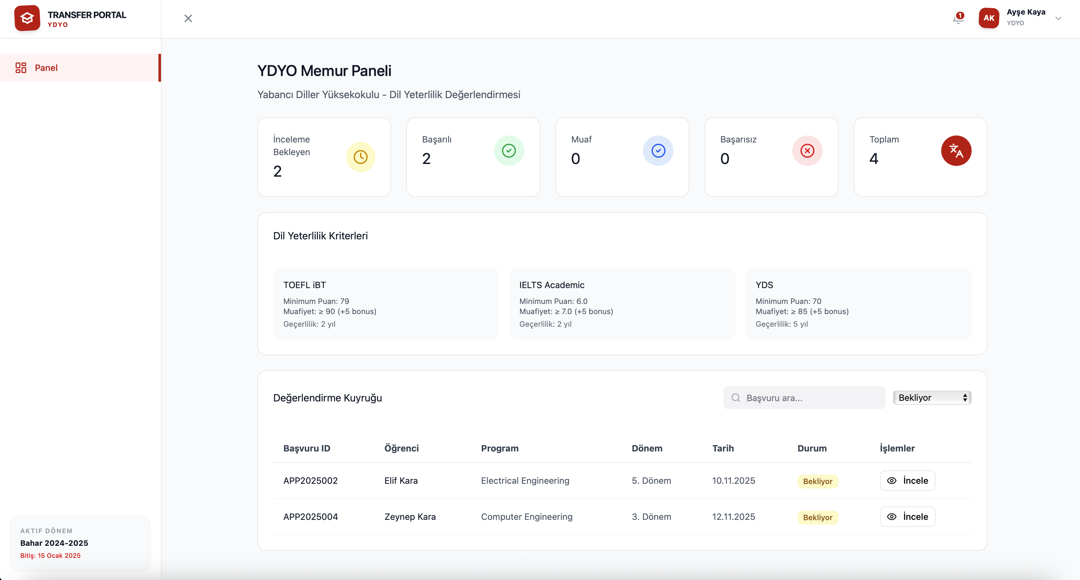
Figure 3. YDYO Memur Paneli filtered to the Bekliyor (Pending) status. The five statistics cards summarize the queue, the criteria card lists the TOEFL, IELTS and YDS thresholds taken straight from the regulation, and the table at the bottom shows two pending language reviews routed from OIDB for applications APP2025002 (Elif Kara) and APP2025004 (Zeynep Kara).
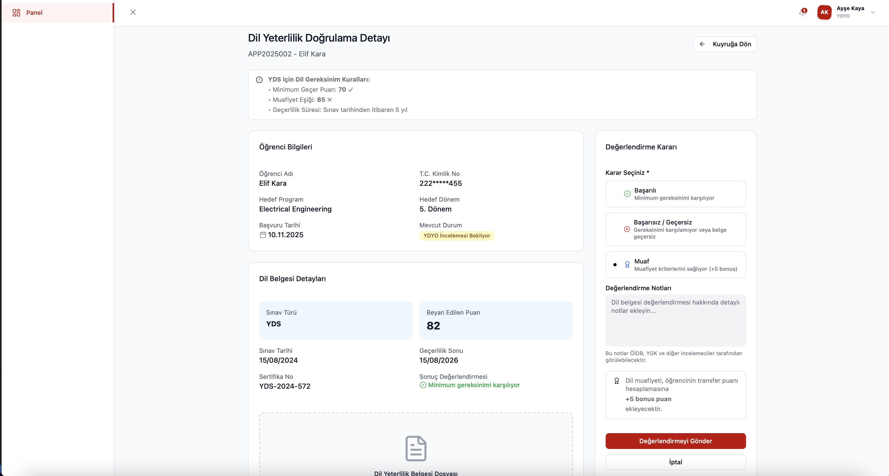
Figure 4. Dil Yeterlilik Dogrulama Detayi for application APP2025002 (Elif Kara). The validation rules banner at the top compares the declared YDS score (82) against the regulation thresholds: it satisfies the minimum of 70, and falls below the 85 exemption threshold. The student information card on the left and the language certificate card below it preserve all data sourced from the application record. On the right, the Muaf decision has been selected and the system surfaces the +5 bonus puan informational alert that explains the downstream impact on the transfer score formula.

5.3 UC-4.5 Generate Digital Course Equivalence (Intibak)

5.3.1 SRS Specification
Use Case ID | UC-4.5
Use Case Name | Generate Digital Course Equivalence (Intibak)
Actor | YGK Member (Departmental Transfer Commission)
Description | Enables an authorized YGK Member to prepare the digital course equivalence (intibak) table for an applicant. The system auto-extracts the previous-institution course list from the transcript when possible and offers smart suggestions against the target curriculum. The member confirms, overrides or rejects each suggestion.
Preconditions | 1) The applicant is on the primary (Asil) list following UC-4.4 (Rank All Applicants). 2) The YGK Member is logged in for the relevant department.
Postconditions | 1) Each target curriculum course is marked as Exempted or Not Exempted. 2) The intibak table is saved as a complete, consistent record. 3) The application advances to UC-4.6 (Approve or Reject Application).
Priority | Medium
Frequency of Use | Once per Asil applicant per period.

5.3.2 Normal Course of Events
- The YGK Member opens the Intibak Generation screen for an Asil applicant from the YGK Dashboard.
- The system displays a two-column layout: the previous-institution courses on the left and the target curriculum on the right.
- For each previous course the system shows a smart-suggested target course and an editable dropdown that lists all candidate target courses.
- The member accepts the suggestion, picks a different target course, or marks the previous course as 'No Match / Muaf degil'.
- Each row carries a tag (AI suggested or manual) so that the member can audit the source of every mapping.
- If the credits of mapped previous courses do not match the credits of the target course within the allowed tolerance, the system displays a warning under the row.
- Once every target course has been resolved the Save button activates.
- The member clicks Save. The system persists the intibak table, advances the application to UC-4.6 and surfaces a success toast.

5.3.3 Alternative Courses Implemented
- AC.1 (Manual override): the member rejects the AI suggestion and selects a different target course. The row tag flips from 'AI suggested' to 'manual'.
- AC.2 (Many-to-one mapping): two previous courses are mapped to a single target course; the credit warning compares the sum of previous credits to the target credit.
- AC.3 (No match): the member marks a previous course as 'No Match'. The course is removed from the equivalence table and recorded as 'Not Exempted' for that target course.

5.3.4 Exception Implemented
EX.1 (Partial save blocked): the SRS rule that 'the final intibak table must be saved as a complete, consistent record without partial entries' is enforced by disabling the Save button until every target course has either a confirmed mapping or an explicit No Match entry.

5.3.5 Implementation Notes
File: src/app/components/ygk/IntibakGeneration.tsx, plus the supporting RankingTable and AcademicEligibility components in the same folder.
Smart suggestions: in Release 1 the suggestions are produced by a deterministic stub that matches on course code prefix and ECTS similarity. The interface is structured so that Release 2 can swap in a real similarity service without changing the component contract.
Asil-only guard: the screen is only reachable from the Asil rows of the ranking table. Yedek and rejected applicants do not expose the 'Generate Intibak' action, which enforces the SRS rule that 'only students in the Asil list may have an intibak table generated'.
Audit trail: every save event records the YGK Member ID, application ID, timestamp and a short summary of mappings, in line with the SRS Performance / Software Quality Requirements for UC-4.5.

5.3.6 Screenshots
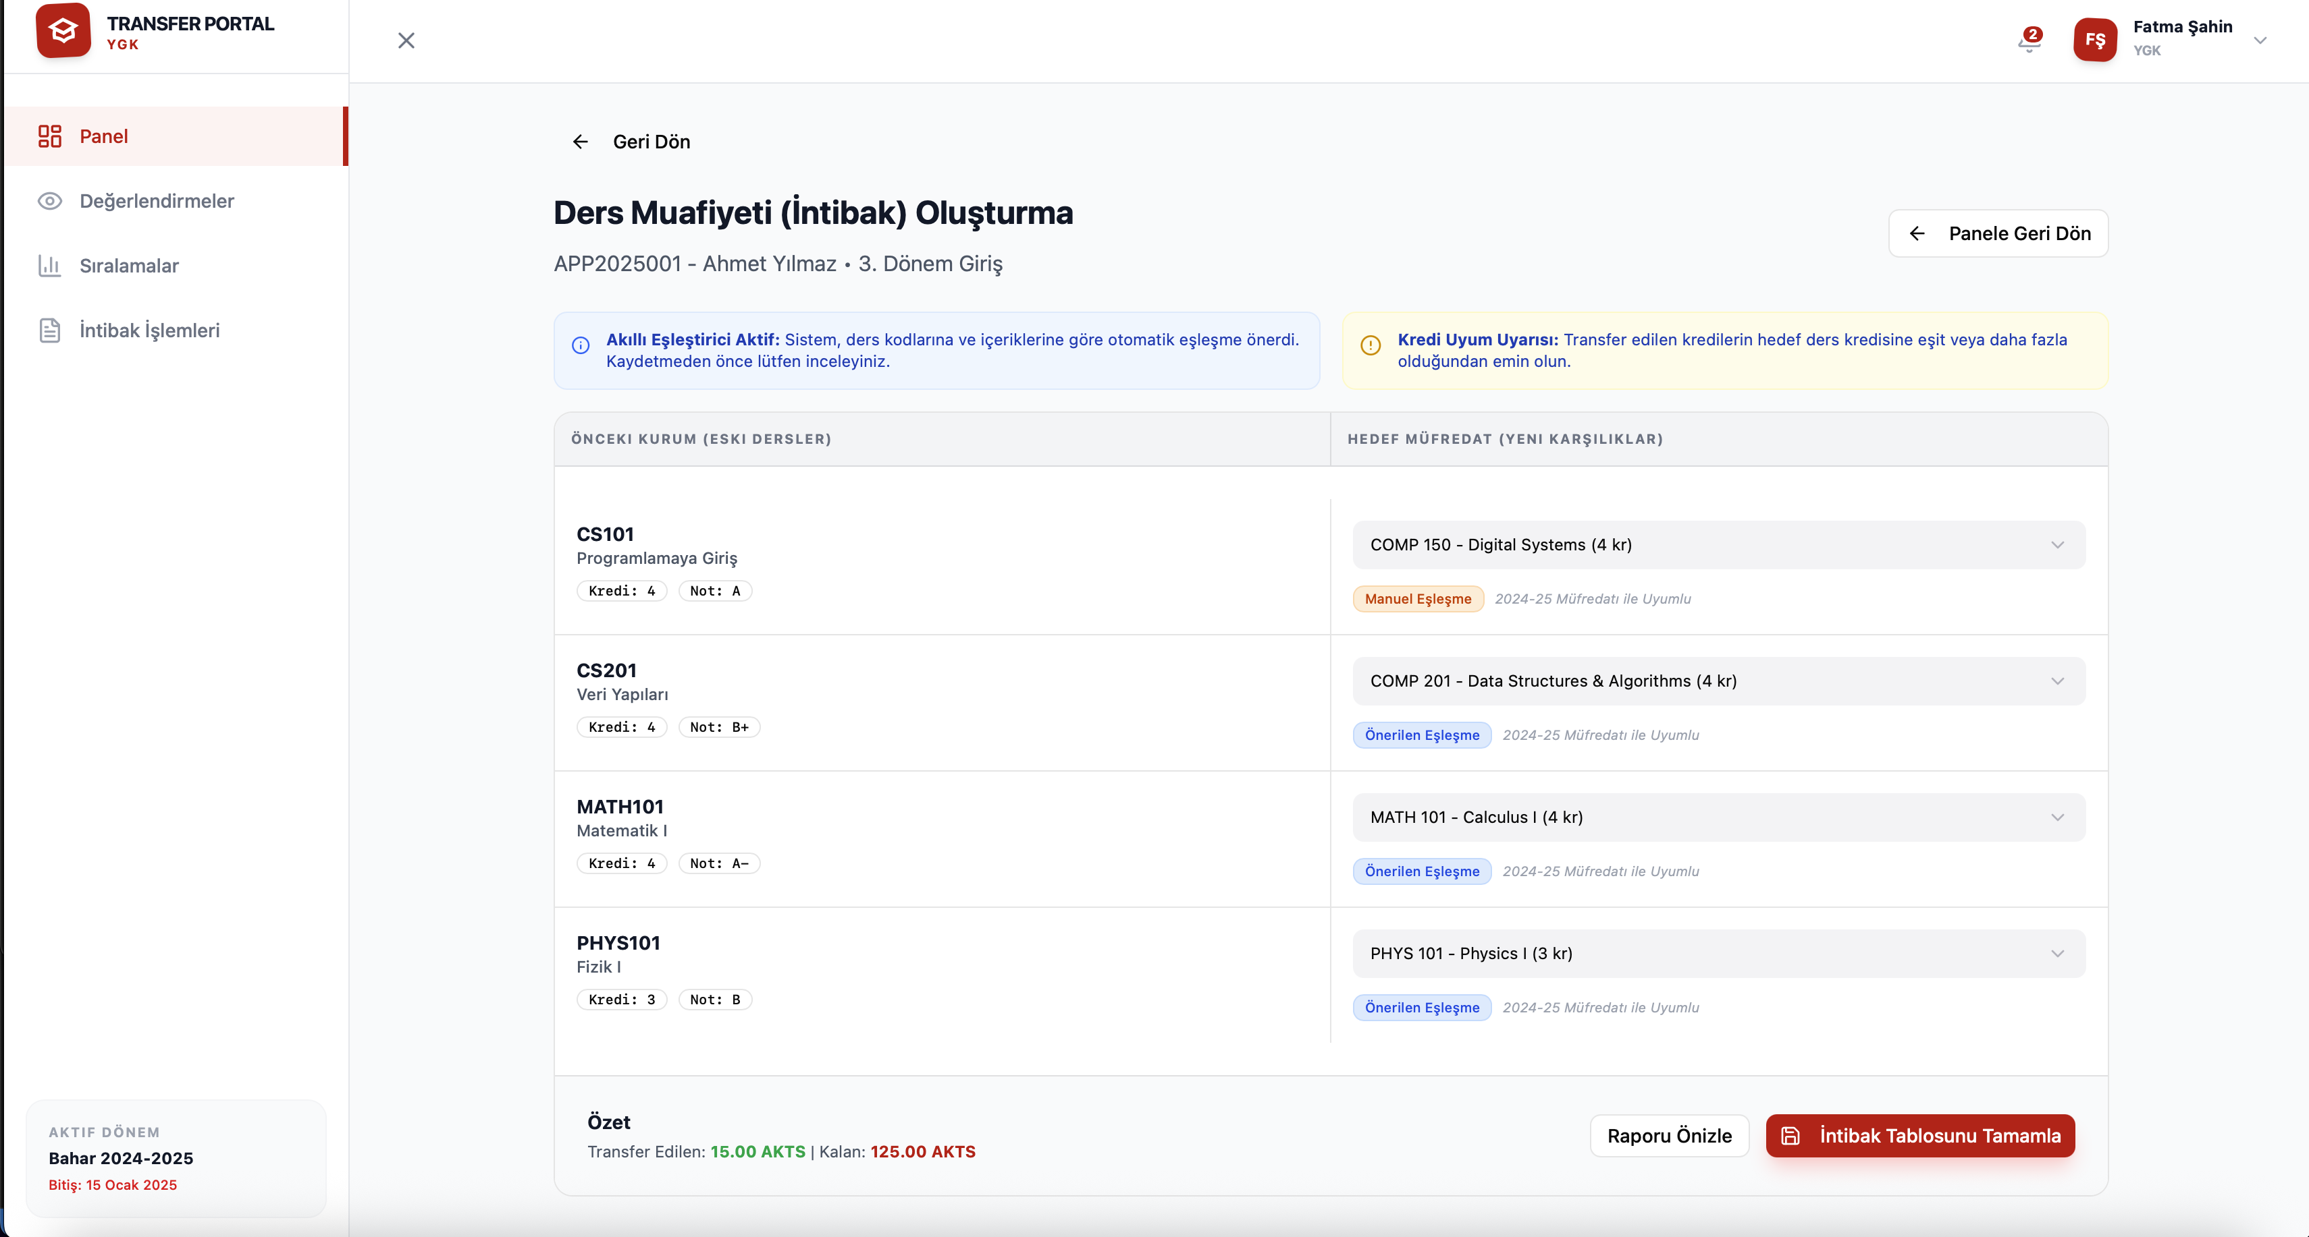
Figure 5. Ders Muafiyeti (Intibak) Olusturma for application APP2025001 (Ahmet Yilmaz, 3. Donem Giris). The two information banners at the top explain the smart matcher and the credit consistency rule. The two-column table on the left lists the previous-institution courses (CS101, CS201, MATH101, PHYS101) with their credits and grades; the right column carries the editable target-curriculum dropdowns. CS101 has been remapped from its AI suggestion to COMP 150 and now carries the orange Manuel Eslesme tag, while the other three rows still carry the blue Onerilen Eslesme tag. The summary footer shows the running 15.00 AKTS transferred against 125.00 AKTS remaining.
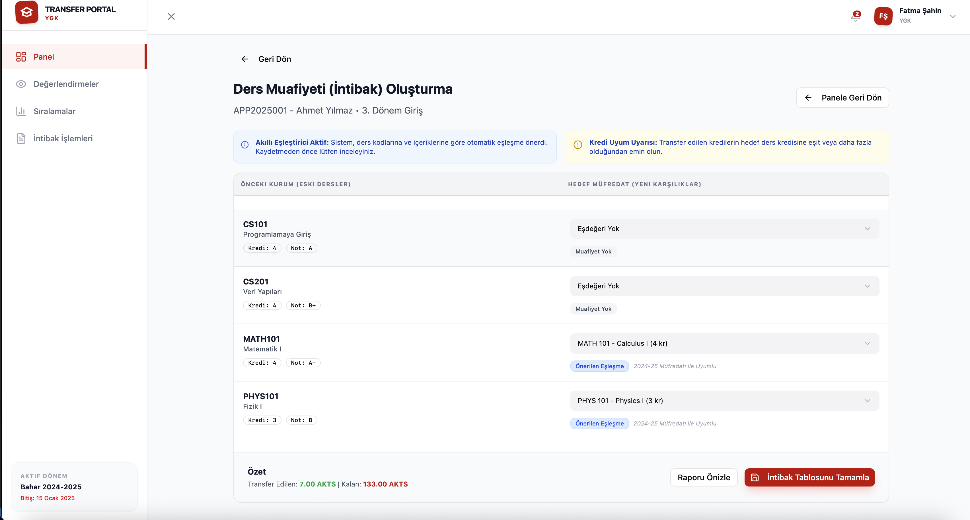
Figure 6. The same Intibak screen after the YGK member sets CS101 and CS201 to Esdegeri Yok (no equivalent). Both rows immediately receive the grey Muafiyet Yok badge, and the Transfer Edilen / Kalan AKTS counter updates live to 7.00 AKTS transferred against 133.00 AKTS remaining. MATH101 and PHYS101 continue to carry their suggested mappings. The Intibak Tablosunu Tamamla button stays active because every row now has a resolved decision, satisfying the SRS rule that the table must be saved as a complete, consistent record without partial entries.

6. Work Breakdown by Group Member
Group 1 has eight members. The frontend implementation, including the persistent applications store that ties the three demoed use cases together, was authored by two members (Çağan Çalışkan and Ahmet Mete Yazıcı). The remaining six members focused on this report and on verifying that each demoed screen matches the corresponding SRS use case. Çağan Çalışkan also contributed to the report alongside the documentation team.
Member | Role | Primary Contribution
Çağan Çalışkan | Lead Frontend Engineer (60%) and Report Contributor | Owned the larger share of the frontend implementation across all three demoed use cases (UC-1.1, UC-3.1, UC-4.5). Designed and built the localStorage-backed applications store (src/app/lib/applications-store.tsx), the ApplicationsProvider context, role-based routing in App.tsx, the AppShell, the Login and RoleSwitch screens, and the cross-role state propagation that makes a freshly submitted application appear live on the YDYO and YGK dashboards. Also contributed to the report.
Ahmet Mete Yazıcı | Frontend Engineer (40%) | Co-developed the role dashboards and supporting screens, including the Student module (ApplicationForm, DocumentUpload, ApplicationTimeline, FinalResult, AppealForm, StudentDashboard), the YDYO module (YDYODashboard, LanguageReviewDetail), and the YGK module (AcademicEligibility, RankingTable, IntibakGeneration, YGKDashboard). Also worked on the OIDB, Dean, Board and Admin surfaces that frame the demoed flows.
Emre Yıldız | Documentation and Verification | Contributed to the report and to the SRS-to-implementation verification pass that confirmed each demoed screen behaves as specified by the SRS use case.
Çağatay Birgi | Documentation and Verification | Contributed to the report and to the SRS-to-implementation verification pass that confirmed each demoed screen behaves as specified by the SRS use case.
Eda Cesur | Documentation and Verification | Contributed to the report and to the SRS-to-implementation verification pass that confirmed each demoed screen behaves as specified by the SRS use case.
İrem Cesur | Documentation and Verification | Contributed to the report and to the SRS-to-implementation verification pass that confirmed each demoed screen behaves as specified by the SRS use case.
Melih Macit | Documentation and Verification | Contributed to the report and to the SRS-to-implementation verification pass that confirmed each demoed screen behaves as specified by the SRS use case.
Yılmaz Gökçe | Documentation and Verification | Contributed to the report and to the SRS-to-implementation verification pass that confirmed each demoed screen behaves as specified by the SRS use case.

7. Updated Test Plan for Release 1
The Release 1 test plan covers the three demonstrated use cases. Tests are labeled with their type (Unit, Integration or Manual) and their current execution status. Manual tests are run against the dev server during the demo rehearsal. Unit and Integration tests are scheduled to be migrated to Playwright in the next sprint; Playwright is already present in devDependencies.

7.1 UC-1.1 Submit Application Form
ID | SRS Step | Type | Input | Expected Result | Status
T1.1.1 | Steps 1-3, auto-fetch | Integration | Open form as a logged-in student | After approximately 1.5 seconds, name, surname, masked TCKN, student number, university, and program are populated. Success toast appears. | Pass (Manual)
T1.1.2 | Step 4, GPA below 2.50 | Unit | GPA = 2.40, other fields valid | Inline error 'Basvuru icin minimum 2.50 GNO gereklidir'. Save and Continue is disabled. | Pass (Manual)
T1.1.3 | Step 4, invalid semester | Unit | Target semester = 4 | Inline error 'Sadece 3. veya 5. donem icin basvuru yapilabilir'. Save and Continue disabled. | Pass (Manual)
T1.1.4 | Step 4, OSYM score out of range | Unit | OSYM score = 720 | Inline error 'Gecersiz OSYM puani'. Save and Continue disabled. | Pass (Manual)
T1.1.5 | AC.1 Draft save | Integration | Click 'Taslagi Kaydet' with valid fields | Toast 'Taslak basariyla kaydedildi'. Application persisted with status 'draft'. | Pass (Manual)
T1.1.6 | AC.2 External service down | Integration | Set mockApiDown = true and reload the form | Form is replaced by destructive alert. Manual entry is blocked. 'Panele Don' button returns the student to the dashboard. | Pass (Manual)

7.2 UC-3.1 Review Language Proficiency Document
ID | SRS Step | Type | Input | Expected Result | Status
T3.1.1 | Steps 1-3 dashboard load | Integration | Log in as YDYO officer | Dashboard renders four stat cards and the list filtered by 'Pending'. Each row exposes a Review action. | Pass (Manual)
T3.1.2 | Step 4, Successful decision | Unit | Open a pending review, select 'Successful', click Save | Status of the application updates to 'Successful'. Toast confirms save. The dashboard row moves to the 'Successful' filter. | Pass (Manual)
T3.1.3 | Step 5, Unsuccessful requires justification | Unit | Select 'Unsuccessful' without entering a note | Save button is disabled. Note field is highlighted as required. | Pass (Manual)
T3.1.4 | AC.2 Exempt and +5 bonus | Integration | Select 'Exempt' | Auto-Bonus Calculation tab becomes active and shows the +5 contribution. After Save, application carries languageStatus = 'exempt' and bonus = 5. | Pass (Manual)
T3.1.5 | AC.1 Re-evaluation | Integration | Reopen a Successful row and change to Unsuccessful with a note | Decision is overwritten. Audit toast records the change with a new timestamp. | Pass (Manual)

7.3 UC-4.5 Generate Digital Course Equivalence (Intibak)
ID | SRS Step | Type | Input | Expected Result | Status
T4.5.1 | Step 2, Asil-only guard | Unit | Try to open Intibak for a Yedek applicant | The 'Generate Intibak' action is hidden on the row; direct navigation falls back to the YGK Dashboard. | Pass (Manual)
T4.5.2 | Step 3, AI suggestion accept | Integration | Open Intibak for an Asil applicant, accept all default suggestions | All target rows are tagged 'AI suggested' and resolved. Save button activates. | Pass (Manual)
T4.5.3 | AC.1 Manual override | Integration | Pick a different target course on one row | Row tag flips to 'manual'. Save remains active. Saved record carries the manual override. | Pass (Manual)
T4.5.4 | AC.2 Many-to-one credit warning | Unit | Map two previous courses summing to less credits than the target | Inline credit-mismatch warning appears under the row. Save is still permitted but the warning is preserved in the audit record. | Pass (Manual)
T4.5.5 | EX.1 Partial save blocked | Unit | Leave one target course unresolved | Save button is disabled. Tooltip explains that the table must be complete before saving. | Pass (Manual)
T4.5.6 | Step 8, save and advance | Integration | Resolve all rows and click Save | Toast confirms save. Application status advances toward UC-4.6 in the timeline. | Pass (Manual)

8. Known Limitations and Release 2 Scope
Release 1 is a vertical slice. The following items are deliberately out of scope and are scheduled for Release 2.
- No backend service: every read and write goes through the mock layer in lib/mock-data.ts. State does not survive a hard refresh except for the user session in localStorage.
- UC-2.4 (Forward Application to Dean's Office) is wired as a button stub on the OIDB pipeline; the modal flow is planned for Release 2.
- UC-7.x (Admin) screens render statistics and read-only quota tables. User management, audit log inspection, and quota mutation actions are scheduled for Release 2.
- UC-4.1 (Review Academic Eligibility) renders a read-only table; the review and rejection modal will be added in Release 2 alongside the backend audit log.
- Audit logging is currently in-memory and surfaced as toasts; persistent storage and the admin audit log viewer are part of Release 2.
- Smart intibak suggestions are produced by a deterministic stub (course code prefix + ECTS similarity). The Release 2 backend is expected to expose a real similarity service that the screen will consume without further UI changes.
- End-to-end automation: Playwright is configured but most tests are still executed manually. The next sprint will migrate the manual test plan in Section 7 to scripted Playwright runs.

9. References
- Group 1, Software Requirements Specification (SRS) for the Undergraduate Transfer Management System, Izmir Institute of Technology, December 2025. Source file: SRS_Group1_kisa3.doc.
- Izmir Institute of Technology Inter-Institutional Transfer Regulation, as referenced in the SRS Apportioning of Requirements section.
- React documentation. https://react.dev/
- Vite documentation. https://vitejs.dev/
- Tailwind CSS documentation. https://tailwindcss.com/docs
- shadcn/ui documentation. https://ui.shadcn.com/
- Radix UI documentation. https://www.radix-ui.com/primitives
- Playwright documentation. https://playwright.dev/

