 | ÇANKAYA UNIVERSITY  Software Engineering Department | 

SENG 491 – 492 Graduation Project
Software Requirements
Specification

BUDDY-AI Driven Pet Disease-Diagnosis-Treatment Manager Tool

Tanayça Ünlütürk- 202128203
Çağan Sezim- 202128020
Eda Kocaman- 202028003
Dila Tümür- 202028024

Version 1.3

Table of Contents
1 Introduction 1
1.1 Purpose 1
1.2 Scope 1
1.3 Definitions, acronyms, and abbreviations 2
1.4 Overview 2
1.5 Version History 2
2 Overall description 3
2.1 Product perspective 3
2.1.1 System interfaces 3
2.1.2 User interfaces 3
2.1.3 Hardware interfaces 4
2.1.4 Software interfaces 4
2.1.5 Communications interfaces 4
2.1.6 AI Diagnosis System 5
2.1.7 System Components 5
2.1.8 Data Management 5
2.1.9 Performance Requirements 6
2.1.10 Memory constraints 6
2.1.11 Operations 6
2.1.12 Site adaptation requirements 6
2.2 Product functions 6
2.3 User characteristics 6
2.4 Constraints 7
2.4.1 Hardware Constraints 7
2.4.2 Regulatory Constraints 7
2.4.3 Communication Constraints 7
2.5 Assumptions and dependencies 7
3 Specific Requirements 8
3.1 External Interface Requirements 8
3.1.1 User Interfaces 8
Mobile Interfaces 8
3.2 Functional Requirements 16
3.2.1 Detailed Description of Each Function 16
Mobile Application (Pet Owner) 16
Login 16
Sign-Up 17
Update Profile 18
Change Password 19
Fill in Survey 20
Take Pictures 20
Record Video 21
Create Pet 21
Update Pet 22
Delete Pet 23
Create Appointment 24
Update Appointment 25
Adopt Pet 26
View Pet Food Store 27
View Clinic 28
View Pet Friendly Taxi 29
Add Pet to Adoption List 30
Remove Pet from Adoption List 31
View AI Diagnosis 32
View Adoption Pool 33
View My Adoption List 33
Accept/Reject Adoption Request 34
Web Application (Veterinarian) 35
Login 35
Sign Up 36
Edit Profile 36
Delete Vet 37
View Pet Record 38
Update Record 39
Accept/Reject Appointment 40
Create Vet Diagnosis 41
Update Pet Owners 42
View AI Diagnosis 43
Add Pet to Adoption List 44
Remove Pets from Adoption List 45
View Adoption Pool 46
View Clinic’s Adoption List 46
Admin 47
Login 47
Update Profile 48
Update User 49
Configure Application 50
Configure AI API 51
Add Vet Clinic 52
Add Pet Friendly Taxi 53
Add Pet Food Store 54
Delete Vet Clinic 55
Delete Taxi 56
Delete Pet Food Store 57
Delete User 58
3.2.2 Use Case 59
3.3 Performance requirements 62
3.4 Logical database requirements 62
3.5 Design constraints 62
3.5.1 Performance constraints 62
3.5.2 Legal and ethical constraints 62
3.5.3 Usability constraints 63
3.5.4 Standards compliance 63
3.6 Software system attributes 63
3.6.1 Reliability 63
3.6.2 Availability 63
3.6.3 Security 63
3.6.4 Maintainability 63
3.6.5 Portability 64
4 References 64

Introduction

Purpose
The purpose of this Software Requirements Specification (SRS) is to outline the functional and non-functional requirements for the development of a web and mobile application that integrates artificial intelligence (AI) to assist pet owners and veterinarians. This document will serve as a comprehensive reference for the developers, testers, and stakeholders involved in the project.
The system is explicitly designed to cater to cats and dogs, offering tailored functionalities for these two pet species. This limitation ensures precise and reliable services for common pet health issues and services relevant to these species.
The intended audience for this SRS includes software developers, project managers, veterinarians, pet owners, and any other stakeholders associated with the project.,

Scope
The software product to be developed consists of a web-based platform for veterinarians and veterinary clinics and a mobile application for pet owners. The web component will allow veterinarians to manage patient information, access appointment schedules, update health records, and view AI-generated diagnoses exclusively for cats and dogs.
The mobile component will focus exclusively on functionalities related to cats and dogs, including AI-driven health issue predictions, appointment scheduling, and additional services such as pet-friendly taxis and pet food stores.
The system will:
- Provide AI-driven health issue predictions from images or videos of cats and dogs.
- Enable pet owners to access AI-generated preliminary diagnoses and receive information on potential health issues affecting their cats or dogs.
- Allow pet owners to locate and schedule appointments with nearby veterinary clinics specializing in cats and dogs.
- Offer additional features like pet adoption, pet food stores, and taxi information.
- Enable veterinarians to access and update patient records and interact with AI diagnoses exclusively tailored for cats and dogs.
- The system will not provide direct medical treatments or emergency services. Its primary role is to serve as an advisory and scheduling tool for pet owners and veterinarians.
The primary objectives of the software are to:
- Simplify the process of diagnosing common health issues for cats and dogs.
- Facilitate better communication and scheduling between pet owners (of cats and dogs) and veterinarians.
- Enhance convenience with integrated services like pet taxis and pet food stores, specifically focused on cats and dogs.

Definitions, acronyms, and abbreviations
- AI: Artificial Intelligence.
- SRS: Software Requirements Specification.
- Vet: Veterinarian.
- Pet Owner: End-users who own pets and use the mobile application.
- Admin: System administrators responsible for managing backend settings and data.
- Clinique: Veterinary Clinic.
- Buddy: AI Driven Pet Disease-Diagnosis-Treatment Manager Tool

Overview
The rest of this SRS document is structured to provide a detailed description of the software system, its components, and its requirements:
- Section 2 - Overall Description: This section provides a high-level overview of the product, including its interfaces, hardware and software dependencies, memory constraints, operations, and site adaptation requirements. It also outlines the system's functions, user characteristics, and any assumptions, dependencies, and constraints.
- Section 3 - Specific Requirements: This section delves into the detailed requirements of the system, including external interface requirements, functional requirements, and performance-related criteria. It covers the needs of various user classes and describes the logical database, design constraints, and system attributes such as reliability, security, and portability, specifically in the context of cats an.
- Section 4 - References: This section lists all the documents and sources referenced in this SRS, providing the necessary details for sourcing them.
The document is organized to first present an overall picture of the system before diving into more specific functional and technical requirements. Each section builds upon the previous chapter to offer a comprehensive understanding of the software product being developed.

Version History
Version No | Description of change | Date
1.0 | Initial Release | 15.10.2024
1.1 | Additional Changes | 01.12.2024
1.3 | Wireframe, Activity Diagram Update | 25.12.2024
1.4 | Finalize SRS | 29.12.2024

Overall description

Product perspective
Buddy is a multi-platform tool designed for easier pet diagnostic using AI technologies. All functionalities, including AI diagnoses, reminders, and adoption processes, are designed exclusively for cats and dogs.
Some of these aspects can be listed such as:

- Possible Diseases: Buddy software will list some possible diseases that may be associated with pet’s current vitals/ images using our AI tool. This ability may reveal hidden or unseen diseases before to be revealed. This can benefit especially the pet owners that are easy to worry by giving them quick information about their pets and preparing them for upcoming possibilities.

- Improved Communication: Buddy software will allow pet owners to interact with industry professionals faster than ever before. We achieve this by eliminating the need for other tools such as google maps or phone books by including critical and up-to-date information at user’s reach.

- Time & Money Savings: Buddy will allow its pet owners to see historical data on various treatment costs and compare prices of similar pet goods.

- Important Reminders: Buddy will alert their users about incoming patients, orders or important dates about their upcoming vet visits, appointments. This will make it easier for users to keep track of everything.

Our product will be available on mobile and web for its users that are available for use at any given time when there is internet access.

System interfaces
This system is designed as an integrated solution that leverages AI functionalities to enhance [e.g., data analysis, pre-diagnosis, and post-diagnosis]. It interacts with an AI model, which is essential for its core operations, positioning it as a system that relies on external AI integration to achieve its intended functionalities effectively.

User interfaces
Buddy’s user interfaces are designed with simplicity and ease of use for user needs.
Application will be available on mobile and web platforms. User interfaces will be user friendly and easy to navigate. Different user types are expected to use different platforms, specifically everyone except Pet Owners are expected to use web browser to access buddy to fully benefit its value.

Hardware interfaces
he system of buddy will not require any specific hardware interfaces beyond mobile devices with internet access, computer with internet access that is able to use a modern web browser and a standard server with high bandwidth internet access and adequate resources. These types of devices are high in variety and differ a lot in their own categories

Software interfaces
The system will require a mobile phone Android operating system version 10+ with internet access for pet owners and a computer with internet access that is able to use a modern web browser. These devices which can satisfy these requirements will be able to use our system with no problem since they already have enough hardware resources for requirements.

Communications interfaces
User Interface (UI):
- It represents the interface through which users will interact with the application.
- Users can interact with various elements to perform their desired tasks.

Map Service API:
- Defines for accessing the map service provider (Google Maps API).
- It is used to retrieve vet clinic, taxi and pet shop locations for users.

Admin Interface:
- Represents the interface that administrators will use to manage the application and view/edit user data or permissions.

Web Services:
- It defines web services for sharing data with other systems included in buddy such as AI service and Login service.

Database Interfaces:
- Defines the application for interaction with the database.
- Database interfaces are used to store user and their pets data, store and retrieve diagnosis data, store and retrieve taxi and pet shop data and store and retrieve up for adoption pet data.

AI Diagnosis System
The AI Diagnosis System supports pet owners and veterinarians in identifying potential diseases and health issues in pets. It operates in two stages, leveraging AI models to deliver predictions and insights.
First Diagnosis: User-Initiated Diagnosis
When a pet owner clicks the "What's Wrong with My Pet?" button, the system guides them through a survey to collect details about symptoms, environment, and behavior. Users can also upload photos and videos to improve the diagnosis quality. The AI processes this data, including images, videos, and text descriptions, to analyze the symptoms. The system generates:
- A ranked list of possible diseases with probability scores.
- A comparison of symptoms against known disease profiles.
- Insights based on similar cases.
- Pet owners can review these results and decide whether to schedule a veterinary appointment.
Second Diagnosis: Veterinarian-Assisted Diagnosis
This stage refines the AI's preliminary diagnosis during a veterinary appointment. Using a map-based interface, pet owners book an appointment. During the consultation, veterinarians input clinical observations and test results, which the AI combines with prior data for a refined diagnosis. The final output includes:
- Updated disease predictions and probabilities.
- Comparative insights from similar cases.
Veterinarians review these results to finalize a treatment plan, which is logged into the system.

System Components
AI Models
- Photo Analysis Model: Processes images to detect physical abnormalities.
- Video Analysis Model: Analyzes video inputs for behavioral patterns.
- Survey Analysis Model: Evaluates survey data for symptom classification.
- Comprehensive Diagnostic AI Model: Synthesizes all data sources for final diagnosis.

Data Management
Input Data Sources
- Survey data from pet owners (images, videos, text).
- Veterinarian inputs (clinical observations, test results).
Output Data
- Disease predictions and probabilities.
- Comparative insights and analysis.
- Data Storage and Privacy
- Data is securely stored following privacy regulations.

Performance Requirements
Results are delivered efficiently, ensuring a seamless user experience. The system is designed to handle multiple users simultaneously.

Memory constraints
The software must efficiently utilize memory resources on the respective platforms:
- Mobile Application: Maximum of 500 MB RAM usage due to resource-intensive tasks such as taking and storing pictures/videos for AI diagnosis.
- Web Application: Maximum of 300 MB RAM usage as fewer resources are needed for client-side operations.

Operations
The software operates in two distinct modes:
- Active Mode: Users interact with the system's UI in real time.
- Background Mode: Users receive notifications about important activities such as upcoming appointments or vaccine dates.

Site adaptation requirements
Buddy’s site will use JWT or similar token for user identification and its user interactions will be based on this system. Web page will be developed using .NET and necessary libraries.

Product functions
AI Driven Diagnosis
Buddy will be able to predict if there is any diseases affecting pet using image/video and information survey to help inform pet owners about possible problems.
Suggestions Based on AI Diagnosis
Buddy will help pet owners with veterinaries that specialize in predicted problem or simply by having them connect faster with veterinaries close to their area.
Pet Schedule Reminders
Buddy will alert pet owners and veterinarians for upcoming pet appointments or scheduled vaccine dates.
Adopting Animals
Buddy will have a section specifically for animals that are up for adoption and make that adoption process easier.
Time & Money Savings
Buddy will allow its pet owners to see historical data on various treatment costs and compare prices of similar pet goods.

User characteristics
Pet Owners
- Must own a smartphone with a camera.
- Should understand Turkish or English.
- Must comply with KVKK regulations and provide necessary permissions.

Veterinarians
- Must own an internet-enabled device capable of running the website in desktop mode.
- Should understand Turkish or English.
- Must comply with KVKK regulations and provide necessary permissions.
- Require a valid veterinary certificate or equivalent from an authorized agency.
- Must have at least one active veterinarian and a registered place of business.

Constraints

Hardware Constraints
- Mobile app requires devices running Android 10+ with at least 2GB RAM.
- Web application supports modern browsers such as Chrome and Opera.
- Servers must handle 200 simultaneous users and have expandable storage starting at 1TB.

Regulatory Constraints
- Users must accept terms of use, including anonymous processing of user and pet health data.

Communication Constraints
- Web services must include necessary certificates to ensure user trust.
- Online interactions must use secure protocols and encryption to protect sensitive data.
- Servers require sufficient bandwidth (minimum 100 Mbps upload and download).

Assumptions and dependencies
The system depends on two servers:
- Front-End Server: Handles web/mobile requests and API calls.
- AI Server: Runs AI models and requires higher GPU and memory resources.
Apportioning of requirements
- Additional user types such as Taxi, Taxi Driver, Pet Shop
- Additional payment options
- Ability to sell Pet Shop Products
- Ability to pay for taxi fare with using buddy

Specific Requirements

External Interface Requirements

User Interfaces

Mobile Interfaces

Start Page
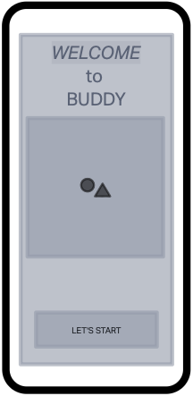
Figure 1- Start Page
Login Page
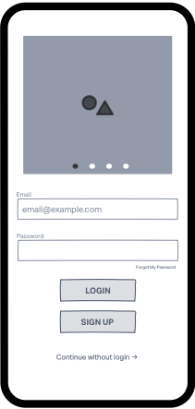
Figure 2- Login Page

Sign up Page
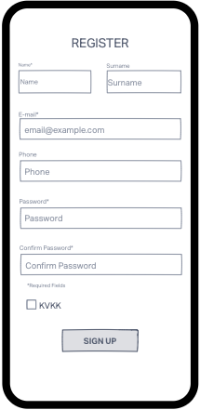
Figure 3- Sign Up Page
Dashboard
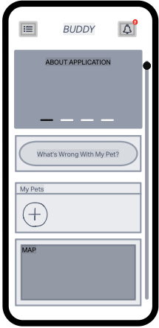
Figure 4- Dashboard 1

Navigation Bar
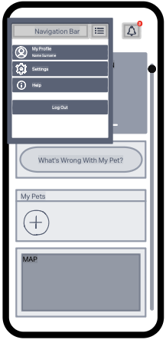
Figure 5- Navigation Bar

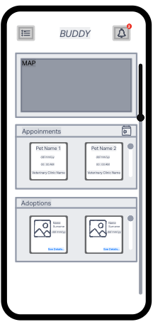
Figure 6- Dashboard 2

Notification Bar
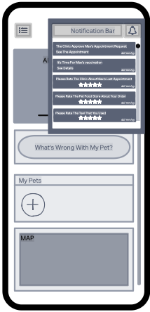
Figure 7- Notification Bar
My Pets Page
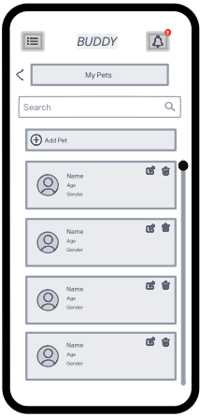
Figure 8- Pet List Page

Pet Profile Page
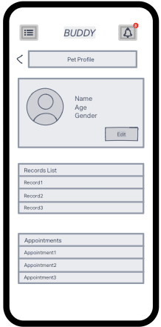
Figure 9- Pet Profile Page
Records List Page
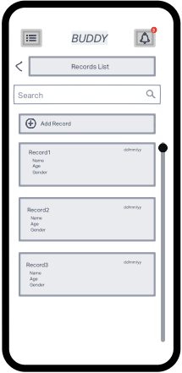
Figure 10- Records List Page

Record Page
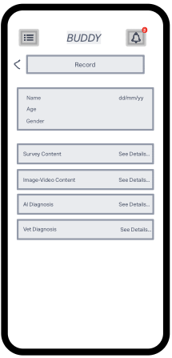
Figure 11- Record Page
Survey Content Page
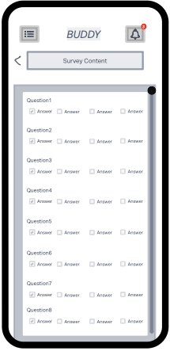
Figure 12- Survey Content Page

Image / Video Content Page
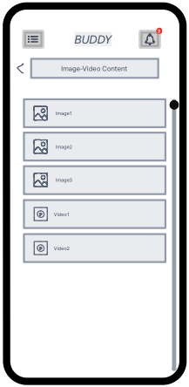
Figure 13- Image/Video Content Page
AI Diagnosis Page
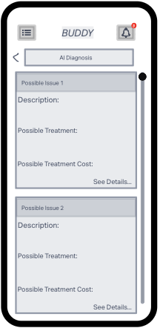
Figure 14- AI Diagnosis Page

Vet Diagnosis Page
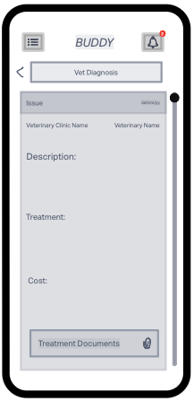
Figure 15- Vet Diagnosis Page
Appointments Pages
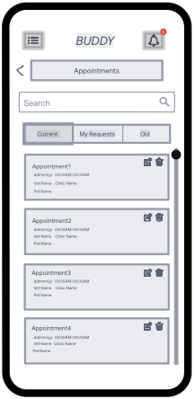
Figure 16- Current Appointments Page

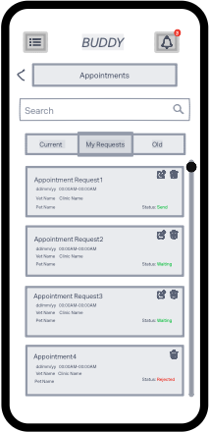
Figure 17- Requested Appointments Page

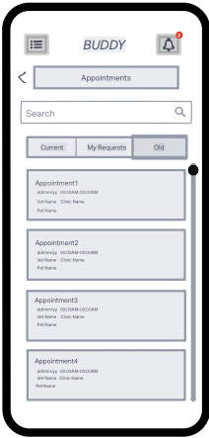
Figure 18- Old Appointments Page

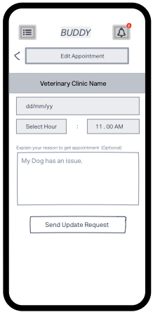
Figure 19- Edit Appointment Page

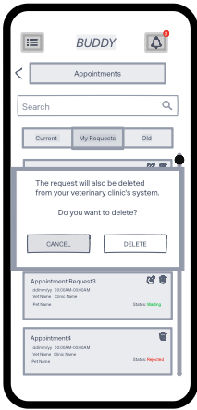
Figure 20- Delete Appointment Request

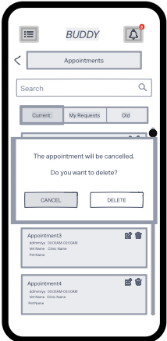
Figure 21- Cancel Appointment

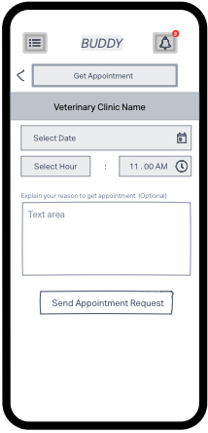
Figure 22- Get Appointment

My Profile Page
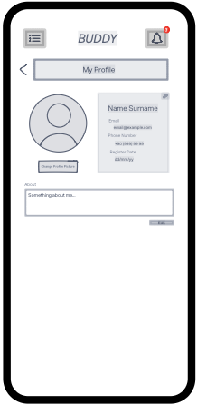
Figure 23- My Profile Page

Settings Page
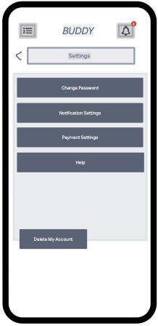
Figure 24- Settings Page

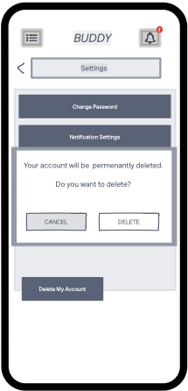
Figure 25- Delete My Account Pop-up

Change Password Page
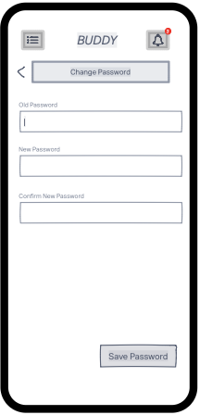
Figure 26- Change Password Page

Adoptions Page
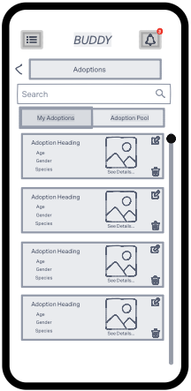
Figure 27- My Adoptions Page

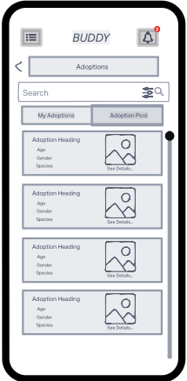
Figure 28- Adoption Pool Page

Map Pages
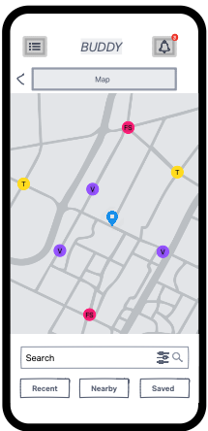
Figure 29- Map Page

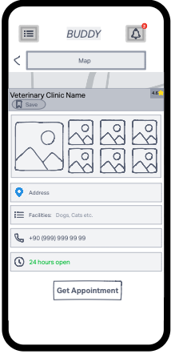
Figure 30- Vet Clinic Map

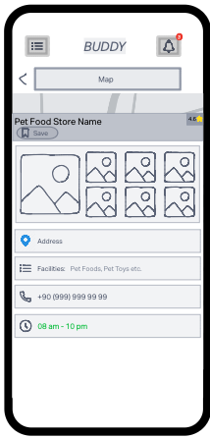
Figure 31- Pet Food Store Map

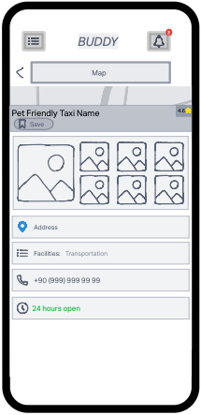
Figure 32- Taxi Map

What is Wrong with My Pet
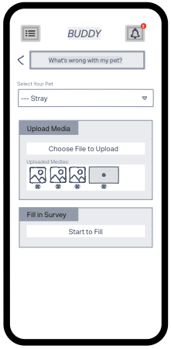
Figure 33- What is Wrong with My Pet 1

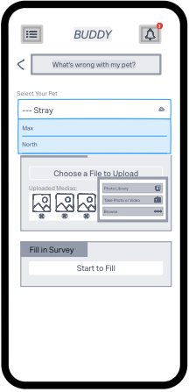
Figure 34- What is Wrong with My Pet

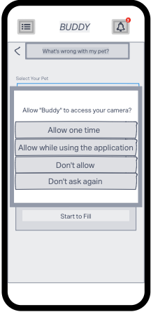
Figure 35- Granted Permission

Take Picture
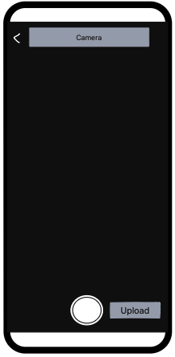
Figure 36- Take Picture Page

Record Video
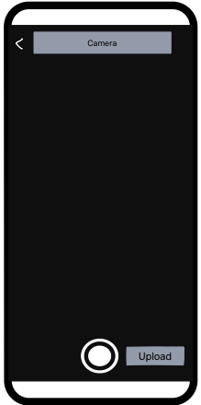
Figure 37- Record Video Page

AI Diagnosis
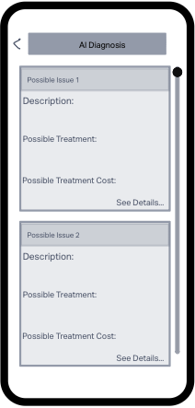
Figure 38- AI Diagnosis Result Page 1

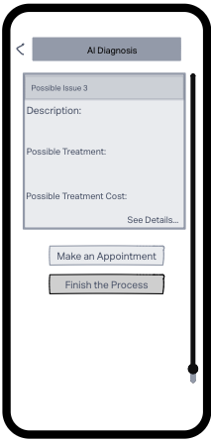
Figure 39- AI Diagnosis Result Page
Fill Survey
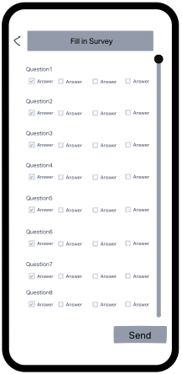
Figure 40- Fill Survey Page

Web Interfaces
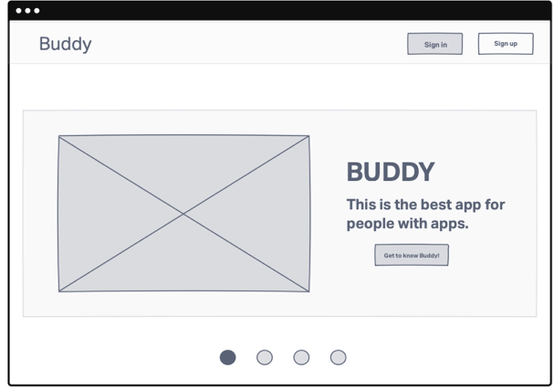
Figure 41-Start Page
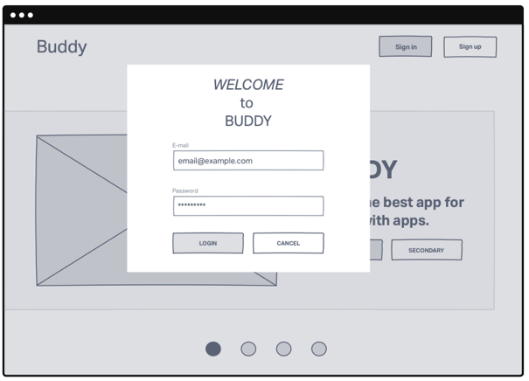
Figure 42- Login Page
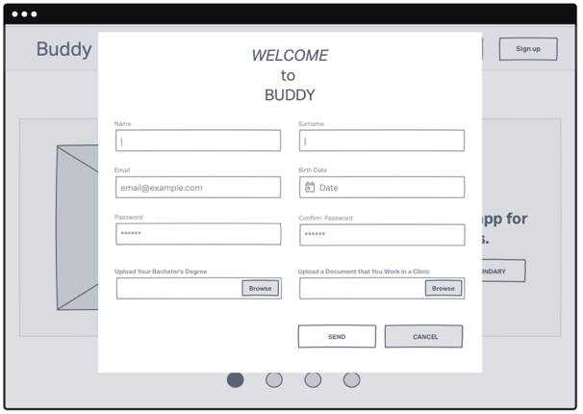
Figure 43- Sign-up Page
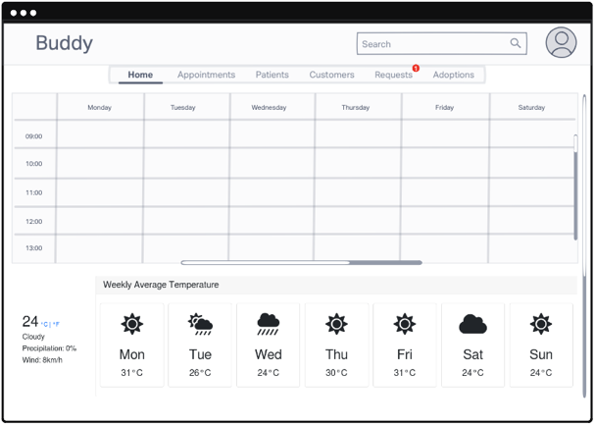
Figure 44- Vet Home

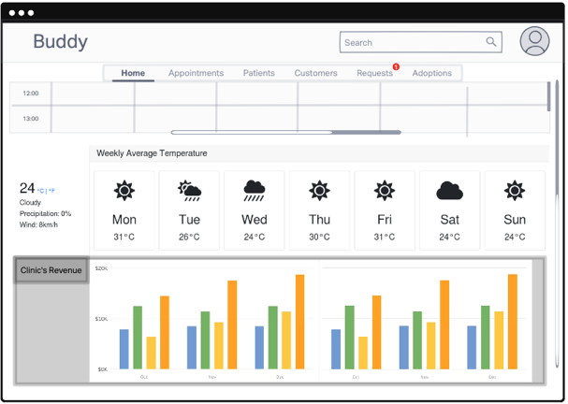
Figure 45- Vet Home2
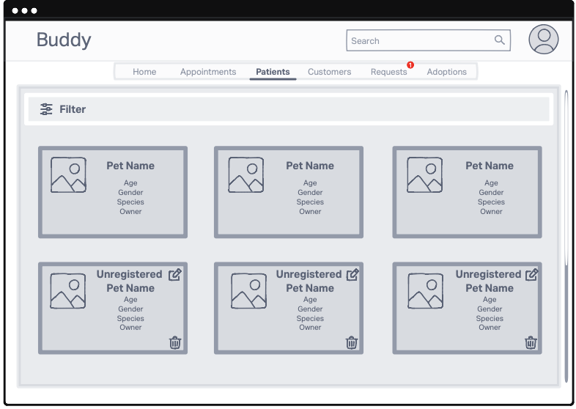
Figure 46- Vet Patients Page
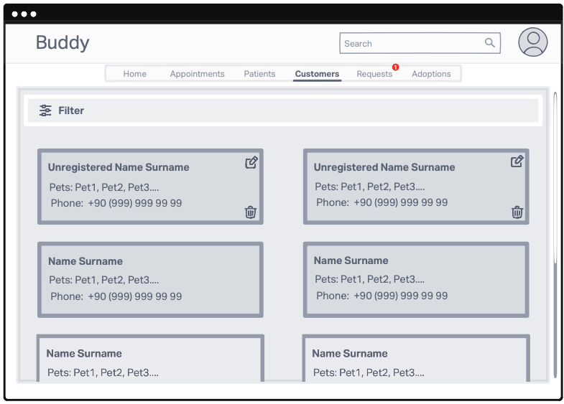
Figure 47- Costumers Page
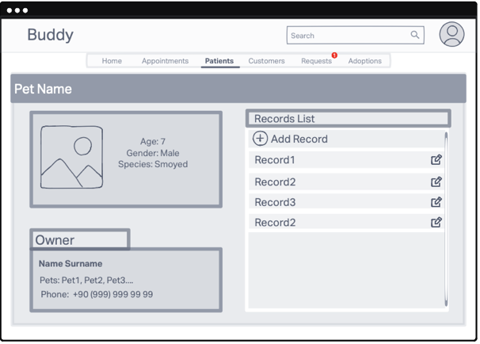
Figure 48- Vet Pet Profile Page
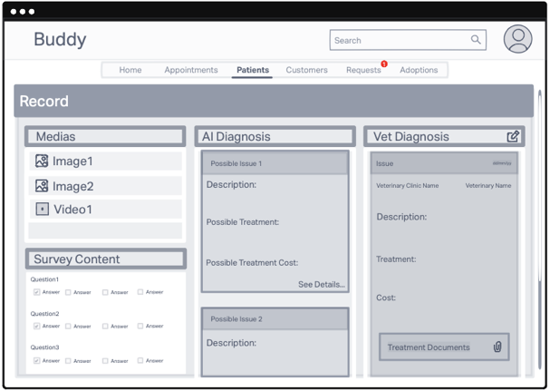
Figure 49- Vet Pet Record Page
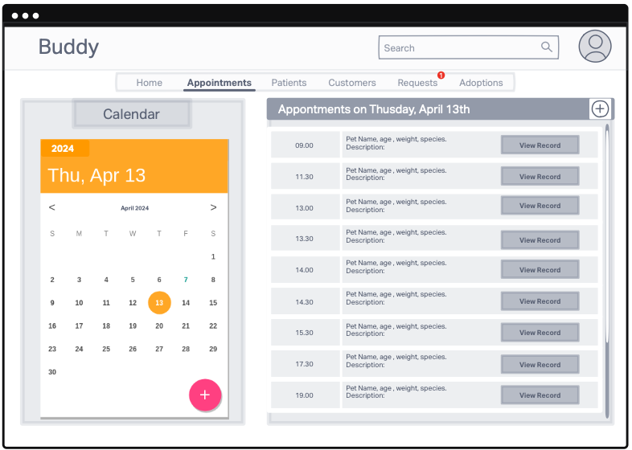
Figure 50- Vet Appointments Page
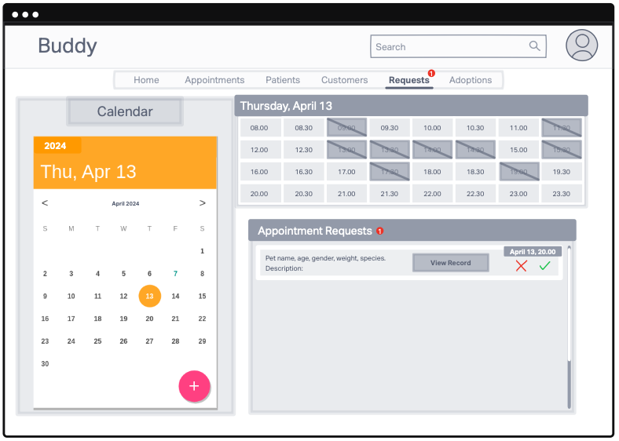
Figure 51- Vet Requests Page
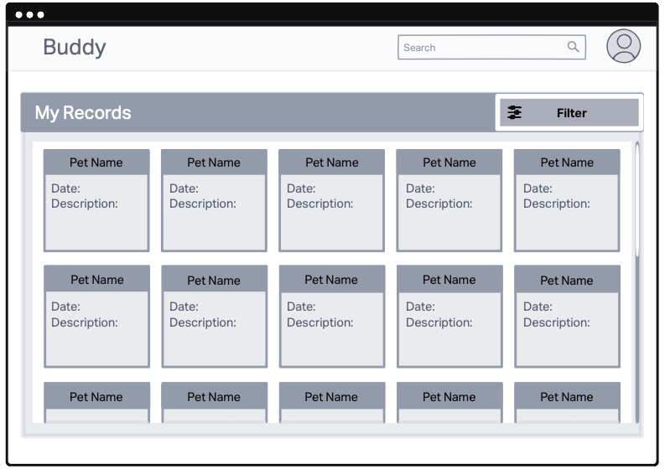
Figure 52- Vet My Records Page
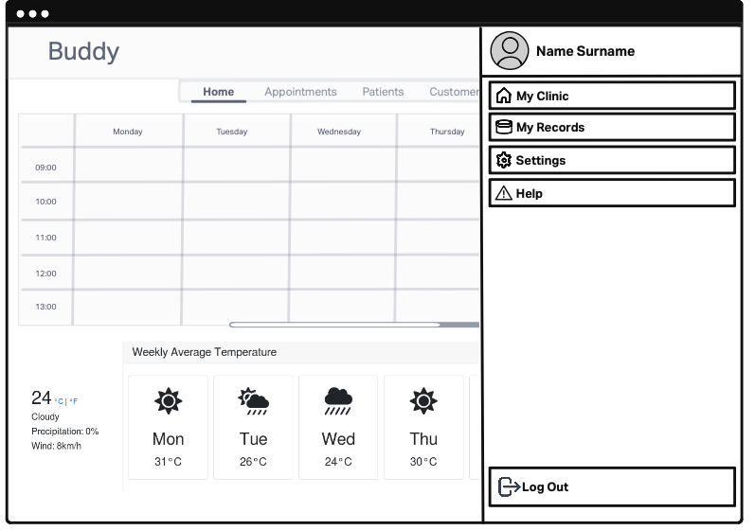
Figure 53- Vet Navigation Bar
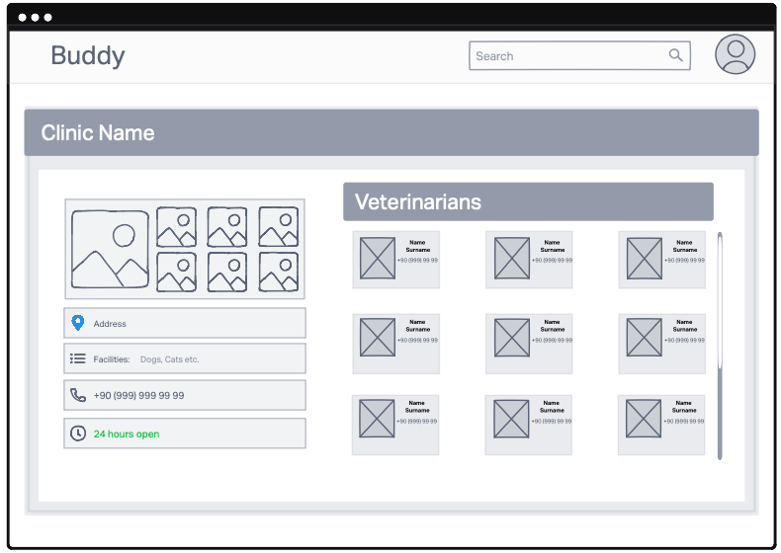
Figure 54- Vet My Clinic Page
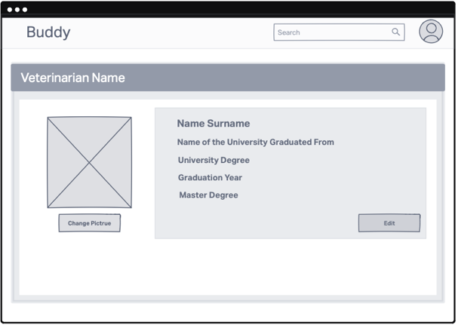
Figure 55- Vet Profile Page
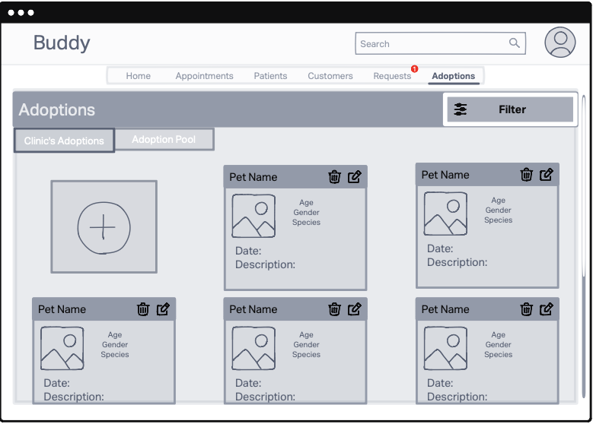
Figure 56- Vet Clinic's Adoptions
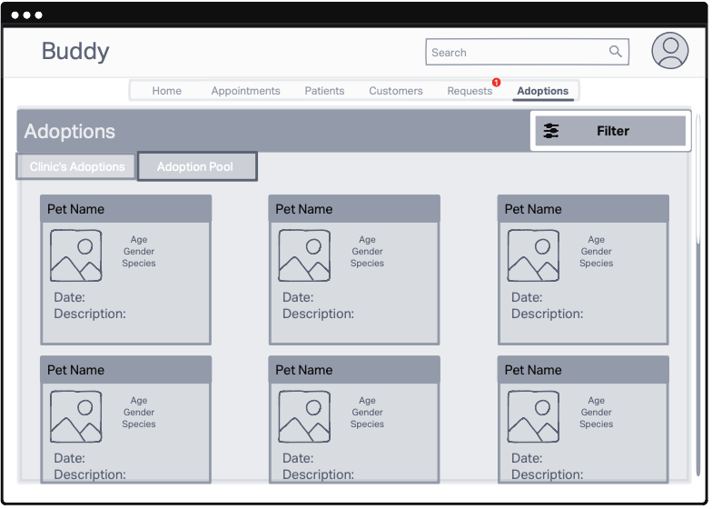
Figure 57- Vet Adoption Pool Page
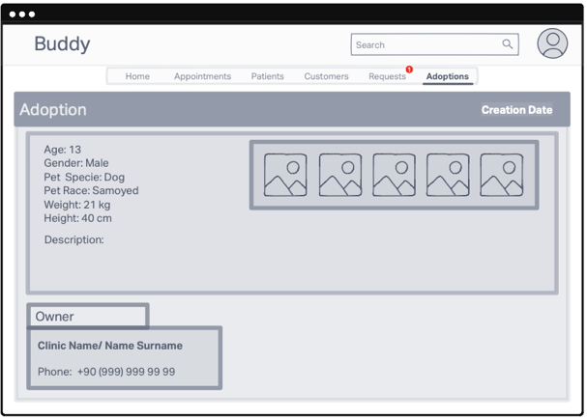
Figure 58- Vet Adoption Profile Page
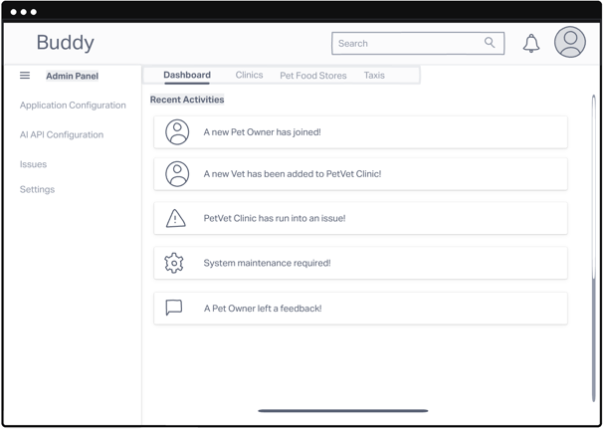
Figure 59- Admin Dashboard
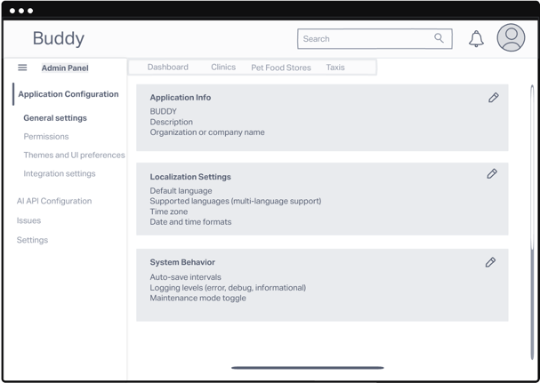
Figure 60- Admin Application Configuration Page
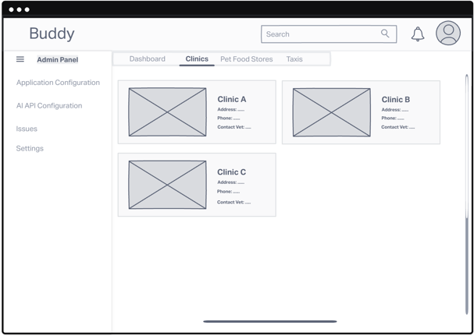
Figure 61- Admin Clinics Page
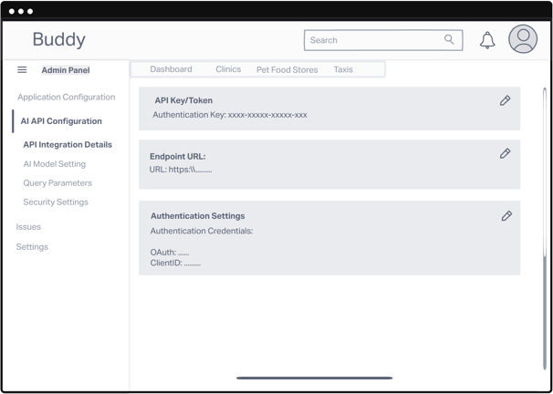
Figure 62- Admin API Configuration Page

Functional Requirements

Detailed Description of Each Function

Mobile Application (Pet Owner)

Login
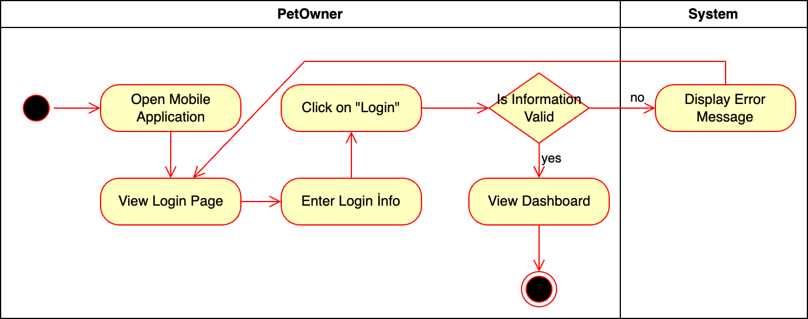
Figure 63- Activity Diagram for Login

Introduction/Purpose of feature:
The "Login" feature allows Pet Owners to securely access their personalized dashboard within the application. This ensures only registered users with valid credentials can manage pet-related data, schedule appointments, and access resources. It safeguards personal information while providing a seamless entry point to the system's features.

Stimulus/Response sequence:
- Pet Owner enters login credentials.
- Pet Owner clicks the "Login" button.
- The system authenticates credentials and redirects to the dashboard.

Associated functional requirements:
FR.1: The system shall display a login page that prompts Pet Owners to enter their login credentials (username/email and password).
FR.2: The system shall validate the entered credentials and determine if the Pet Owner is registered.
FR.3: If the Pet Owner is registered, the system shall redirect them to their personalized dashboard.
FR.4: If the Pet Owner is not registered, the system shall display an option to register.
FR.5: If the Pet Owner chooses to register, the system shall redirect them to the registration page.
FR.6: The system shall provide a Forgot Password option to assist veterinarians in recovering or resetting their login credentials if needed.
FR.7: If the Pet Owner declines registration, the system shall redirect them to a survey page.
FR.8: The system shall maintain session management to ensure Pet Owners remain logged in during active sessions.

Sign-Up
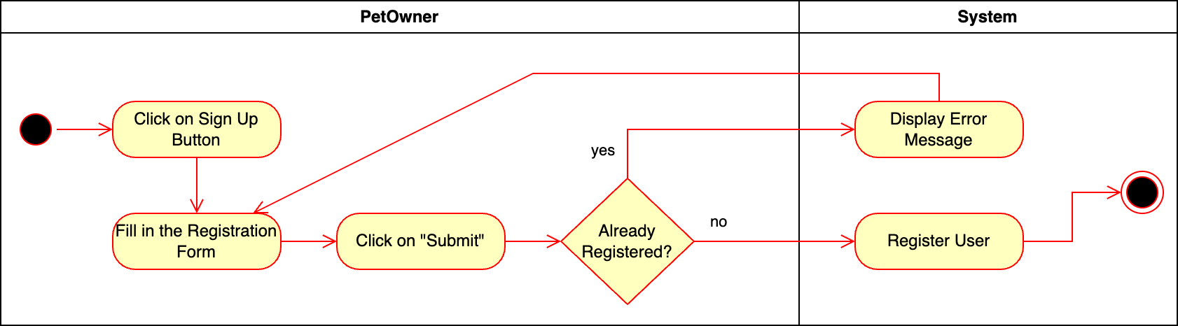
Figure 64- Activity Diagram for Sign Up

Introduction/Purpose of feature:
The “Sign-Up” feature allows new Pet Owners to register and create an account within the application. This feature is essential for onboarding Pet Owners, allowing them to access the platform’s functionalities, such as managing pet records, booking appointments, and receiving health recommendations. By collecting necessary Pet Owner information, the Sign-Up Page helps establish a secure, personalized experience for Pet Owners.

Stimulus/Response sequence:
- Pet Owner enters registration details.
- Pet Owner clicks “Sign-Up” button.
- The system creates a new account for the Pet Owner, stores user information, and displays a confirmation message.

Associated functional requirements:
- The system shall display a Sign-Up Page with fields for Pet Owner registration, including name, email, and password.
- The system shall validate the entered information to ensure all required fields are correctly filled and meet formatting standards.
- The system shall ensure the email provided by the Pet Owner is unique and not associated with any existing account.
- The system shall require a secure password that adheres to predefined security criteria (e.g., minimum length, special characters).
- The system shall create and store a new Pet Owner account upon successful registration.
- The system shall display a confirmation message upon successful registration and redirect the Pet Owner to the Login Page or dashboard.
- The system shall display error messages for any incomplete or incorrect entries and allow the Pet Owner to make necessary corrections.

Update Profile
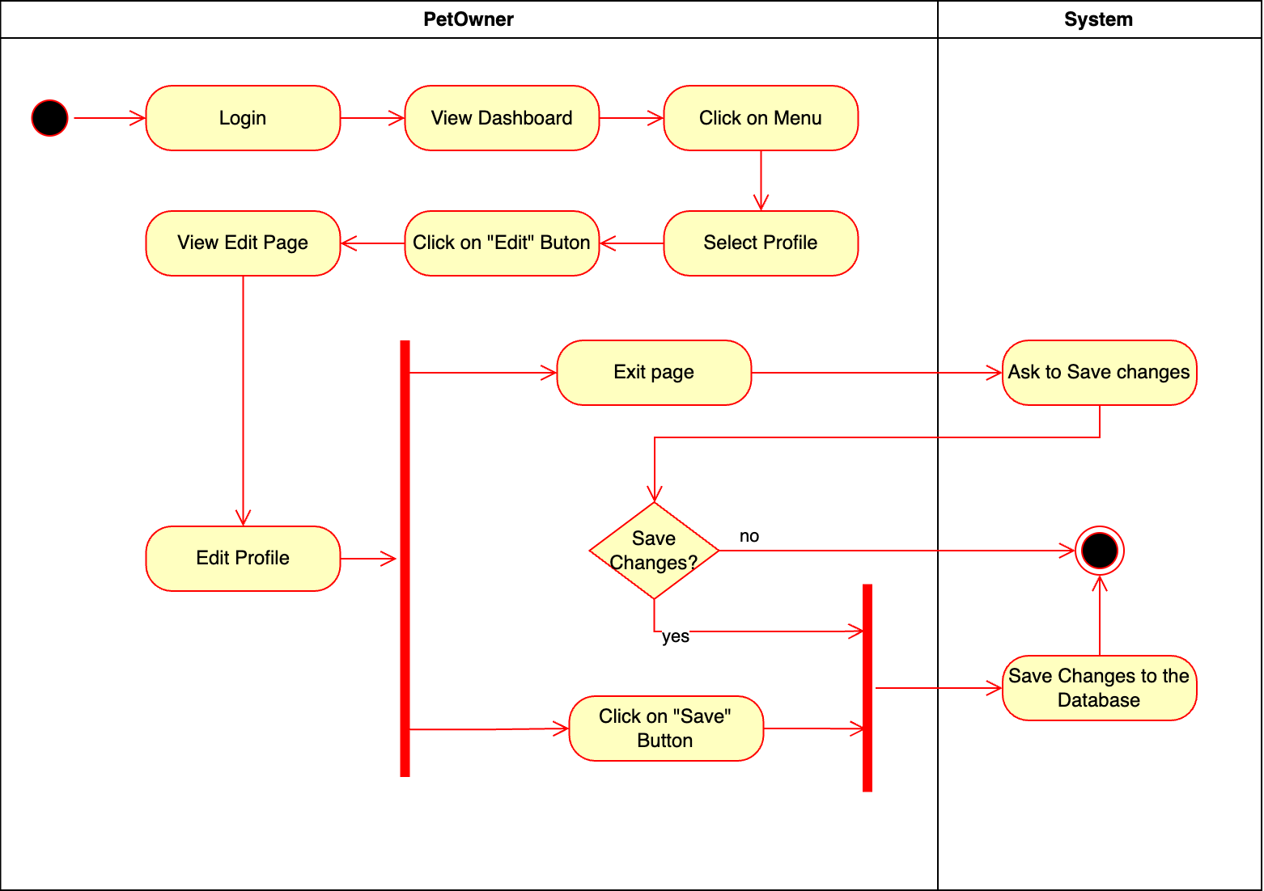
Figure 65- Activity Diagram for Update Profile

Introduction/Purpose of feature:
The “Update Profile” feature allows Pet Owners to view and edit their personal information within the application. This feature is essential for maintaining up-to-date Pet Owner details, enabling information such Pet Owners to modify as contact details or profile preferences. The purpose of this feature is to provide flexibility and ensure that the Pet Owner's profile is accurate and current, improving the quality of communication and personalization within the system.

Stimulus/Response sequence:
- Pet Owner selects "My Profile" from the menu.
- The system displays the profile page.
- Pet Owner clicks "Edit", makes changes, and clicks "Save".
- The system saves changes and confirms the update.

Associated functional requirements:
- The system shall allow the Pet Owner to access their profile from the dashboard.
- The system shall provide an Edit button on the profile page to enable profile modification.
- The system shall display an editable profile page with fields that the Pet Owner can update.
- The system shall allow the Pet Owner to save changes to their profile information.
- If the Pet Owner attempts to exit without saving, the system shall prompt the Pet Owner to confirm whether they would like to save changes.
- If the Pet Owner selects "Yes" when prompted to save changes, the system shall save the changes to the database.
- The system shall provide a confirmation message after successful profile updates.
- The system shall discard changes if the Pet Owner exits without saving and chooses "No" when prompted.

Change Password
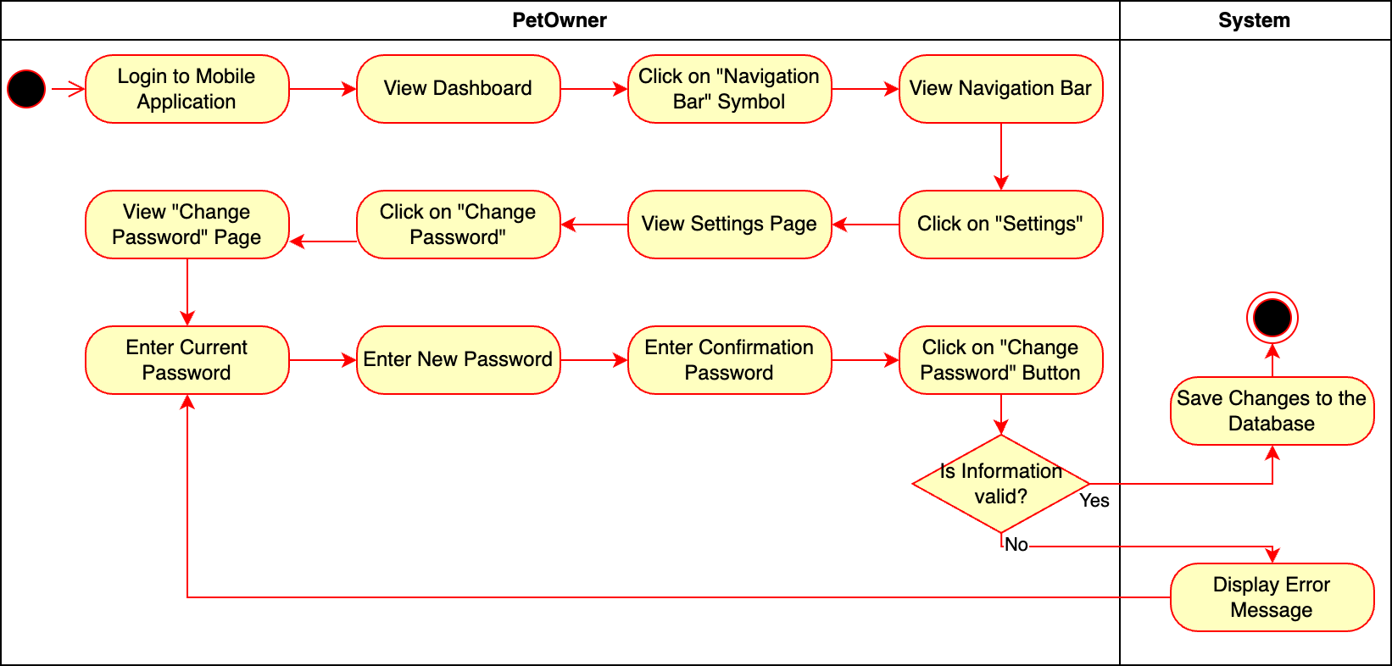
Figure 66- Activity Diagram for Change Password

Introduction/Purpose of feature
The "Change Password" feature enhances security by enabling users to update their passwords whenever needed.

Stimulus/Response sequence:
- Pet Owner logs in and navigates to "Settings".
- Pet Owner selects "Change Password" and enters current and new passwords.
- The system validates inputs, updates the password, and confirms the change.

Associated functional requirements:
- The system shall display the dashboard upon successful login.
- The system shall display the navigation bar when the pet owner clicks on the "Navigation Bar" symbol.
- The system shall display the "Settings" page when the pet owner selects "Settings" from the navigation options.
- The system shall display the "Change Password" page when the pet owner selects "Change Password."
- The system shall validate the entered current password, new password, and confirmation password when the pet owner attempts to change their password.
- The system shall display an error message if the entered information is invalid.
- The system shall save the new password to the database if the information is valid.
- The system shall confirm the password change to the pet owner after successfully updating the password in the database.
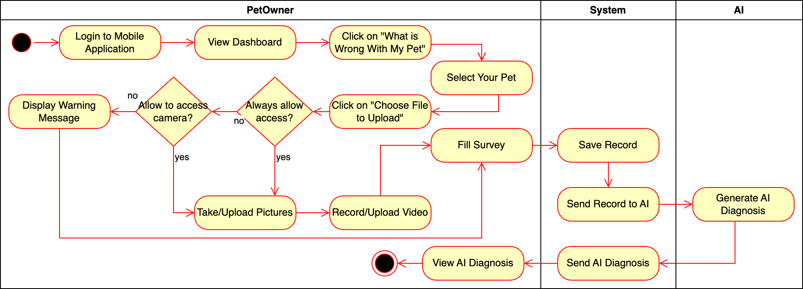
Figure 67- Activity Diagram for Create Record

Fill in Survey

Introduction/Purpose of feature:
The "Fill Survey" feature enables pet owners to provide detailed information about their pet’s symptoms and conditions. This data is crucial for the AI system to generate accurate diagnoses and health predictions.

Stimulus/Response sequence:
- Pet Owner clicks on the "What is Wrong with My Pet?" button, selects their pet, and then clicks on "Choose File to Upload."
- The system prompts the user to complete a survey about their pet’s condition.
- Pet Owner fills out and submits the survey.
- The system saves the survey data, sends it to the AI module.
- AI uses the information to generate an AI diagnosis.

Associated functional requirements:
- The system must display a structured survey form with predefined questions about the pet's symptoms, age, and recent behavior.
- The system must validate survey inputs before submission.
- The system must save the survey data to the pet's medical record.
- The system must securely send the survey data to the AI module for diagnosis generation.

Take Pictures

Introduction/Purpose of feature:
The "Take Pictures" feature allows pet owners to capture or upload photos of their pet’s physical condition (e.g., injuries or visible symptoms). These images support the AI system in making an accurate diagnosis.

Stimulus/Response sequence:
- The system requests camera access or file upload.
- Pet Owner captures/uploads pictures and confirms.
- The system stores images in the pet’s record and sends them for analysis.

Associated functional requirements:
- The system must request permission to access the device’s camera and storage.
- The system must allow users to capture new pictures or upload existing ones.
- The system must store images in the corresponding pet’s record.
- The system must securely transmit images to the AI module for further processing.

Record Video

Introduction/Purpose of feature:
The "Record Video" feature enables pet owners to capture or upload videos of their pet’s behavior or symptoms. Videos provide dynamic context for the AI to evaluate the pet's condition effectively.

Stimulus/Response sequence:
- The system requests camera access or file upload.
- Pet Owner records/uploads videos and confirms.
- The system stores videos in the pet’s record and sends them for analysis.

Associated functional requirements:
- The system must request permission to access the device’s camera and storage.
- The system must allow users to record new videos or upload existing ones.
- The system must store videos in the corresponding pet’s record.
- The system must securely transmit videos to the AI module for further analysis.

Create Pet
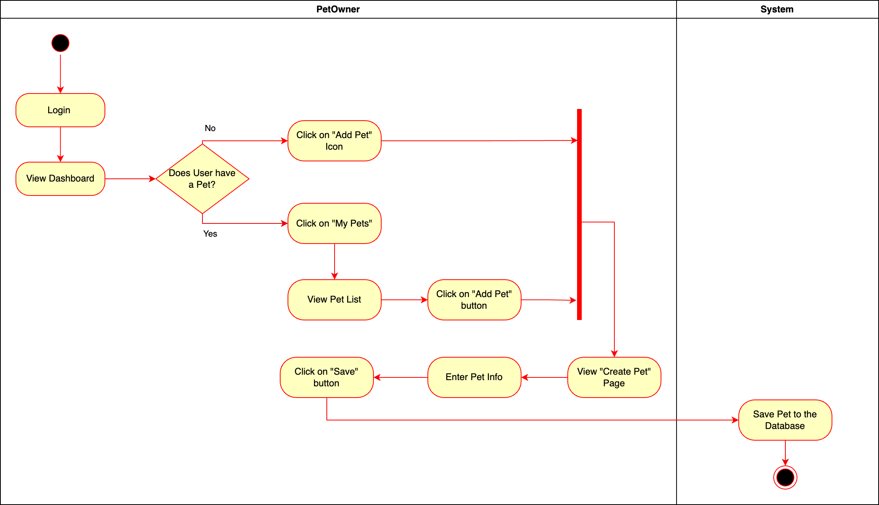
Figure 68- Activity Diagram for Create Pet

Introduction/Purpose of feature:
The “Create Pet” feature allows Pet Owners to add information about their pets to the system. This feature is essential for maintaining pet-related data, enabling the application to personalize services, provide pet health recommendations, and offer other pet-centric functionalities. By allowing Pet Owners to add and save pet details, this feature facilitates a more customized experience and ensures that the application can track and manage pet information accurately.

Stimulus/Response sequence:
- Pet Owner selects "Add Pet", enters details, and clicks "Save".
- The system validates and stores the pet's information.

Associated functional requirements:
- The system shall display an option for Pet Owners to add a new pet if no pets are currently registered.
- The system shall allow Pet Owners to view their existing pet list under the My Pets section.
- The system shall display a Create Pet page with fields for pet information, such as name, breed, and age.
- The system shall allow Pet Owners to enter pet information on the Create Pet page.
- The system shall provide a Save button that enables Pet Owners to confirm and save the pet details.
- The system shall validate the pet information before saving it to ensure data accuracy and completeness.
- The system shall save the pet information to the database upon successful entry and validation.
- The system shall display a confirmation message once the pet has been successfully added to the database.

Update Pet
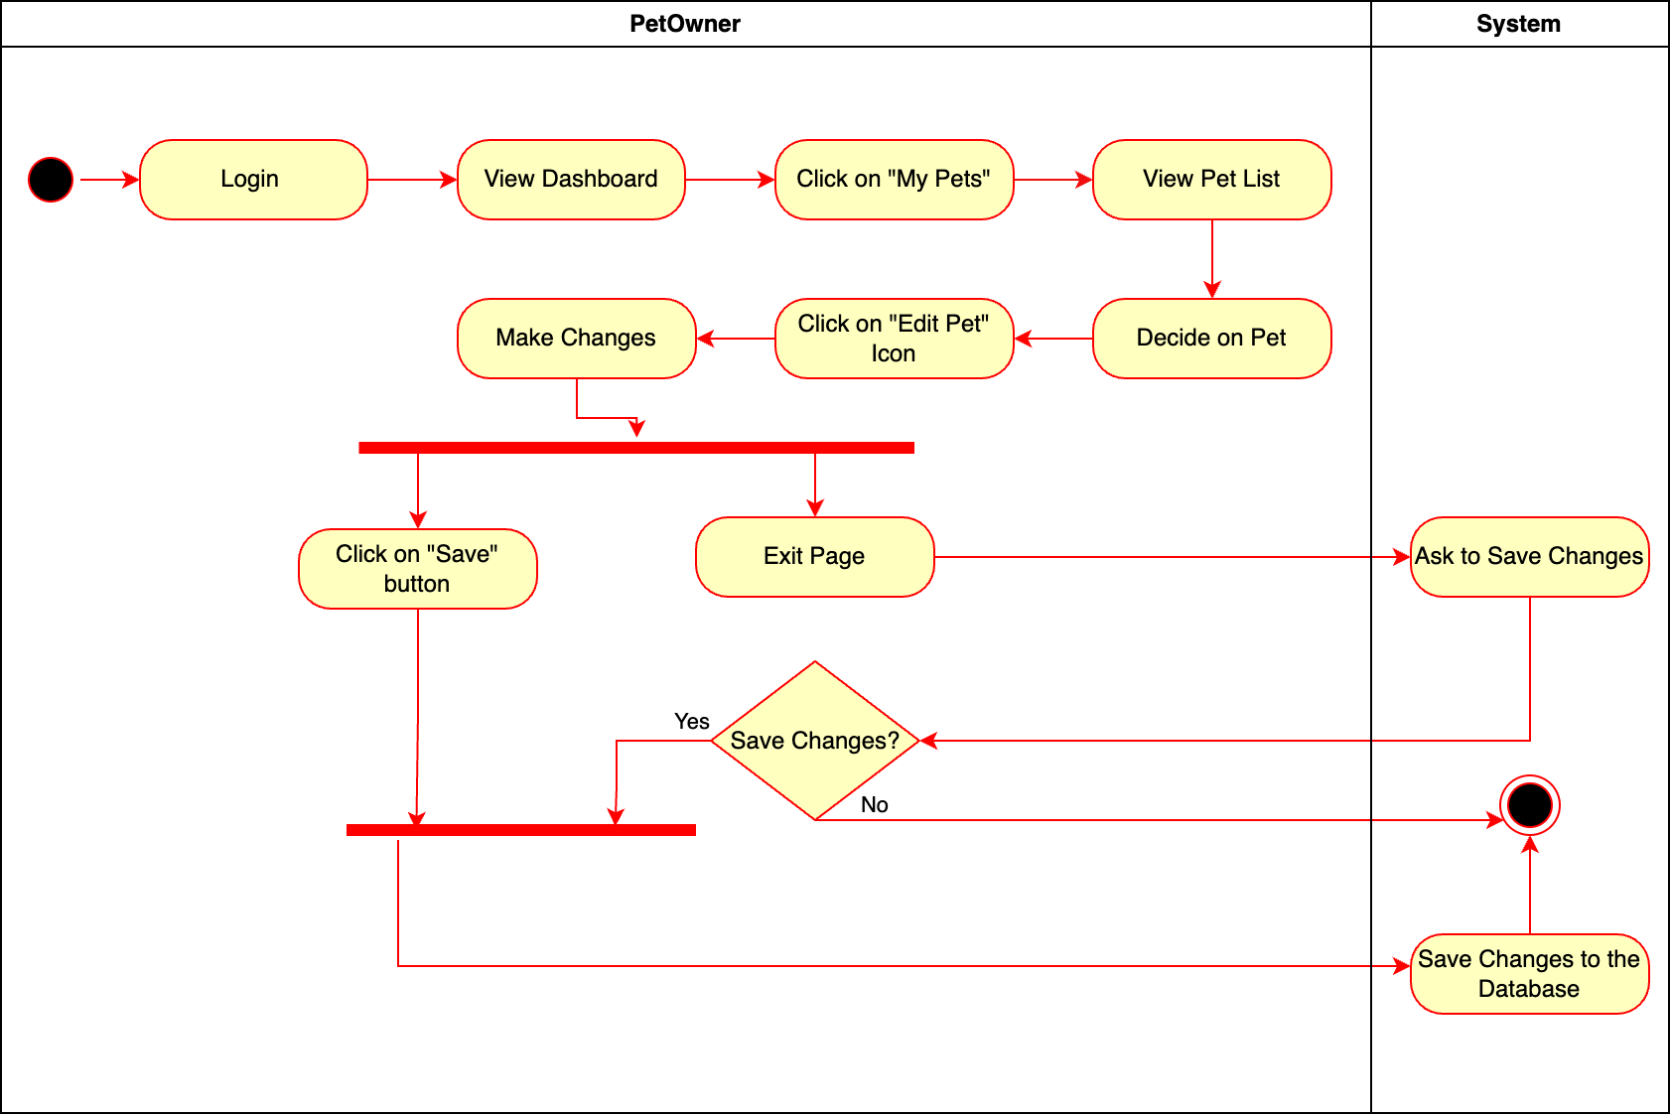
Figure 69- Activity Diagram for Update Pet

Introduction/Purpose of feature:
The “Update Pet” feature allows Pet Owners to modify information related to their pets in the system. This feature is essential for maintaining up-to-date pet data, enabling the application to provide accurate recommendations and services tailored to each pet. The purpose of this feature is to offer flexibility for Pet Owners to update details like the pet's health status, age, or other important information, ensuring that the records remain current.

Stimulus/Response sequence:
- Pet Owner selects a pet, edits information, and clicks "Save".
- The system validates changes and updates the database.

Associated functional requirements:
- The system shall provide a My Pets option on the dashboard that allows Pet Owners to view and select their pets.
- The system shall display an Edit button for each pet in the My Pets list to enable editing of pet information.
- The system shall present an Edit Pet page with editable fields for the pet's details.
- The system shall allow the Pet Owner to update information on the Edit Pet page.
- The system shall provide a save button for the Pet Owner to confirm changes.
- If the Pet Owner attempts to exit without saving, the system shall prompt the Pet Owner to confirm whether they would like to save changes.
- The system shall save updated pet information to the database if the Pet Owner chooses to save.
- The system shall display a confirmation message upon successfully saving updated pet information.
- The system shall discard changes if the Pet Owner exits without saving and chooses "No" when prompted.

Delete Pet
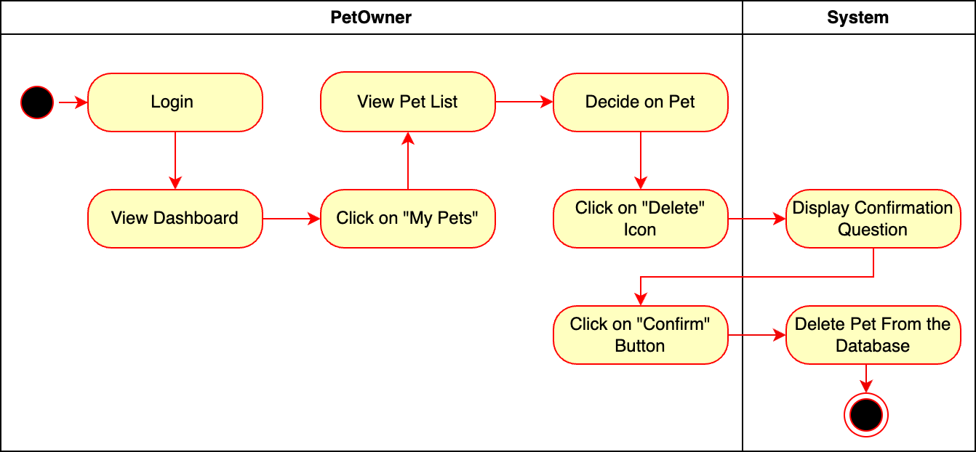
Figure 70- Activity Diagram for Delete Pet

Introduction/Purpose of feature:
The “Delete Pet” feature allows Pet Owners to remove a pet's information from the system permanently. This feature is useful for cases where a pet is no longer under the Pet Owner's care or if the information is no longer relevant. By enabling Pet Owners to delete a pet's profile, this feature helps maintain accurate and current records in the system, ensuring that only active and relevant pet profiles are displayed in the application.

Stimulus/Response sequence:
- Pet Owner clicks "My Pets".
- Pet Owner clicks “Delete” icon.
- The system generates confirmation message.
- Pet Owner confirms the message.
- The system deletes pet information.

Associated functional requirements:
- The system shall provide a My Pets option on the dashboard that allows Pet Owners to view their registered pets.
- The system shall display a delete button for each pet listed under My Pets, enabling Pet Owners to initiate the deletion process.
- The system shall prompt the Pet Owner with a confirmation message before proceeding with the deletion.
- If the Pet Owner confirms the deletion, the system shall permanently remove the pet’s information from the database.
- The system shall display a success message to confirm that the pet’s information has been successfully deleted.
- If the Pet Owner cancels the deletion, the system shall retain the pet’s information and return the Pet Owner to the pet list page.

Create Appointment
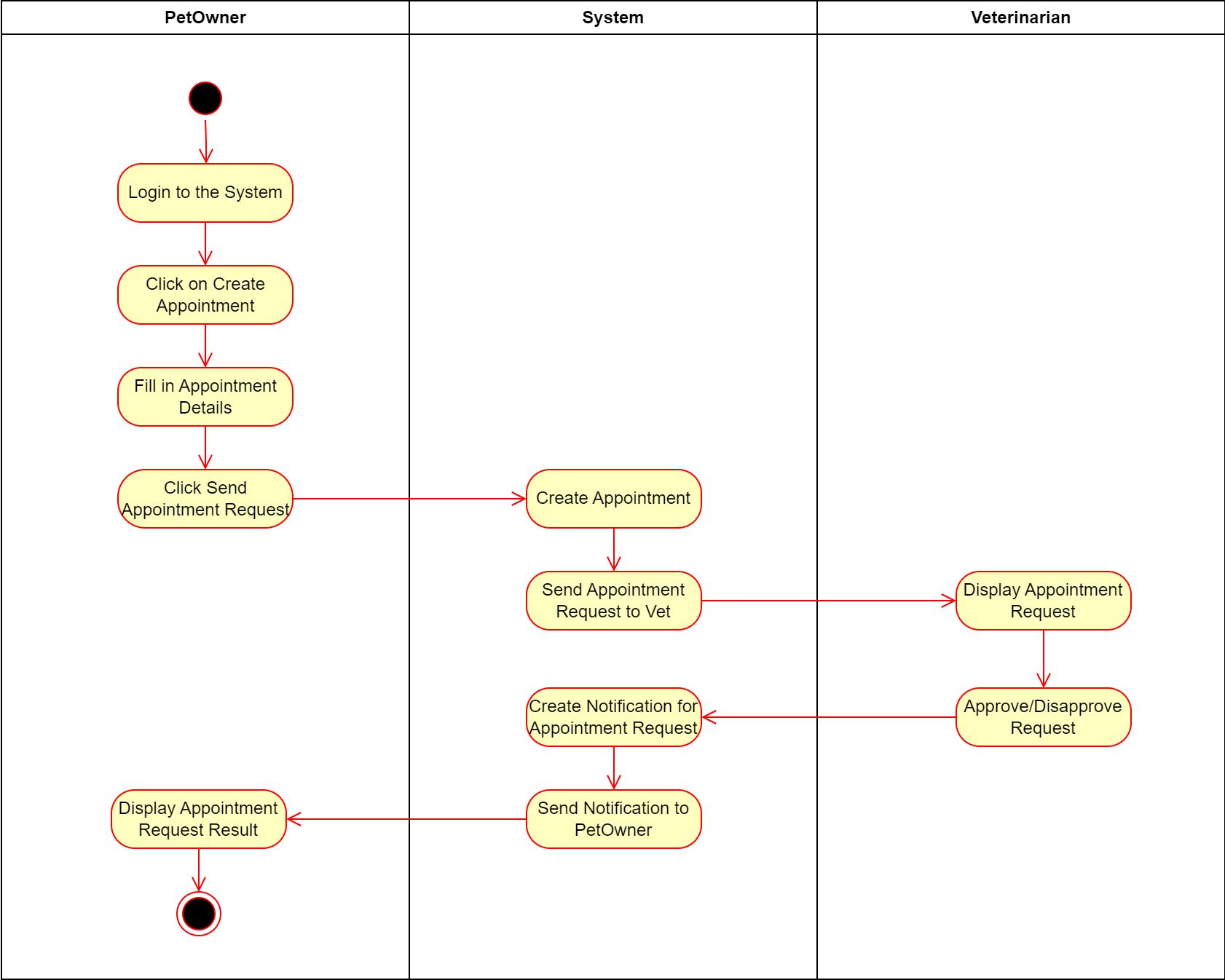
Figure 71- Activity Diagram for Create Appointment

Introduction/Purpose of feature:
The system will allow users to get an appointment from a Veterinary Clinic or a chosen Veterinarian in a Clinic.

Stimulus/Response sequence:
- Pet Owner clicks on create an appointment, fills in appointment details.
- The system generates an appointment and sends it to Veterinarian to approve.
- Veterinarian approves or disapproves the appointment request.
- The system generates notification according to Vet's response, sends it to Pet Owner.
- Pet Owner receives notification.

Associated functional requirements:
- The Pet Owner should be able to create an appointment request, fill in appointment details on the system.
- The system should be able form an appointment request and send it to the veterinarian.
- The Vet should be able to respond to appointment requests on the system.
- The system should be able to generate notifications according to the Vet’s response.
- The Pet Owner should be able to receive the notifications about their appointment request.

Update Appointment
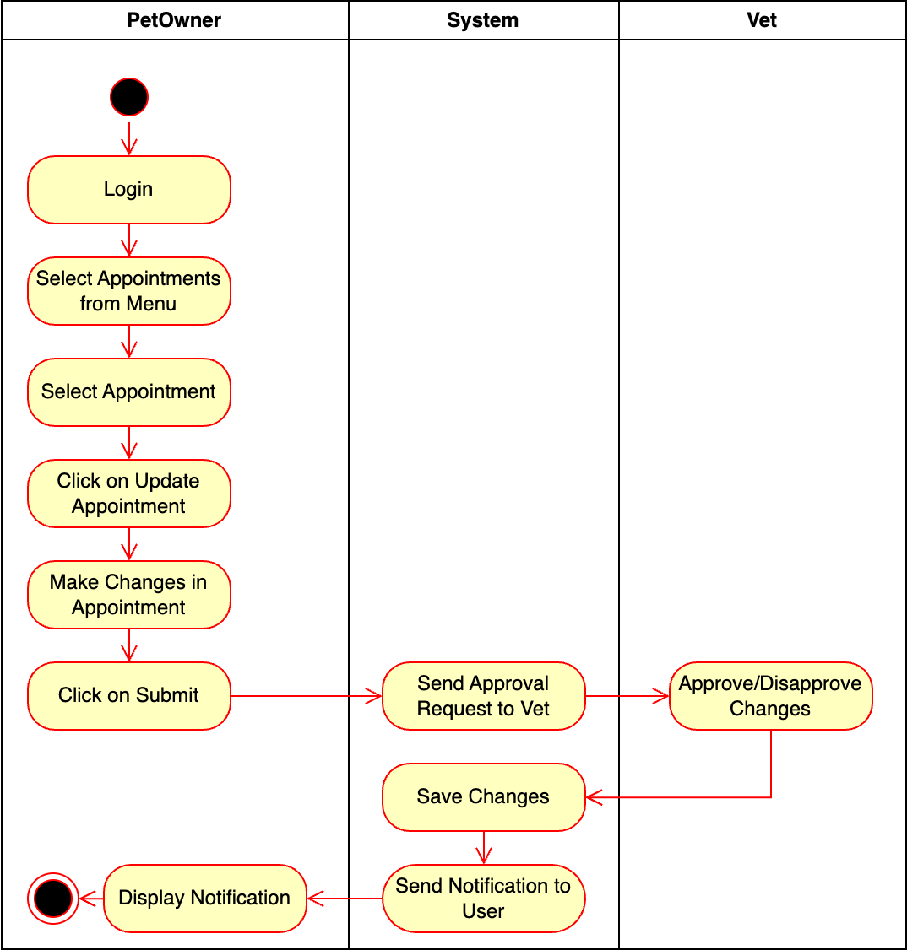
Figure 72- Activity Diagram for Update Appointment

Introduction/Purpose of feature:
The system should allow Pet Owners to update their appointment request.

Stimulus/Response sequence:
- Pet Owner updates appointment details and submits changes.
- The system notifies the veterinarian for approval and updates the appointment upon confirmation.

Associated functional requirements:
- The system should be able to allow Pet Owners to make changes to their appointments.
- The Pet Owner should be able to make changes to their appointments
- The system should be able to send approval requests to the Vet.
- The Vet should be able to respond to approval requests.
- The system should be able to generate notifications according to the Vet’s response.
- The Pet Owner should be able to receive notifications the system generates.

Adopt Pet
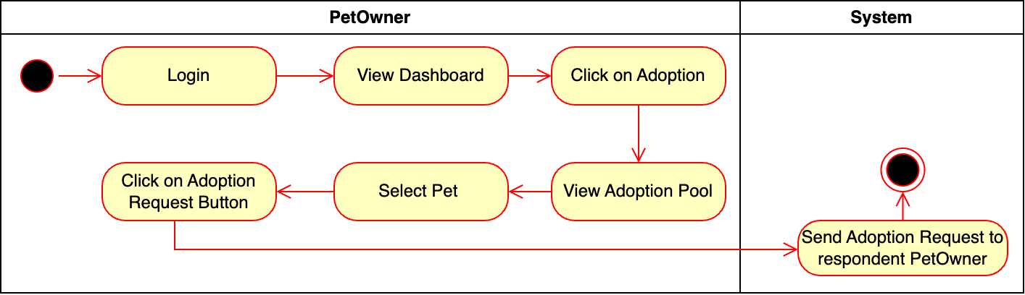
Figure 73- Activity Diagram for Adopt Pet

Introduction/Purpose of feature:
The system should allow Pet Owners to adopt pets.

Stimulus/Response sequence:
- Pet Owner views adoption listings and submits an adoption request.
- The system notifies the pet’s current owner of the request.

Associated functional requirements:
- The Pet Owner should be able to click on adoption under the menu, see adoption list and send adoption requests.
- The system should be able to send adoption request to respondent party.

View Pet Food Store
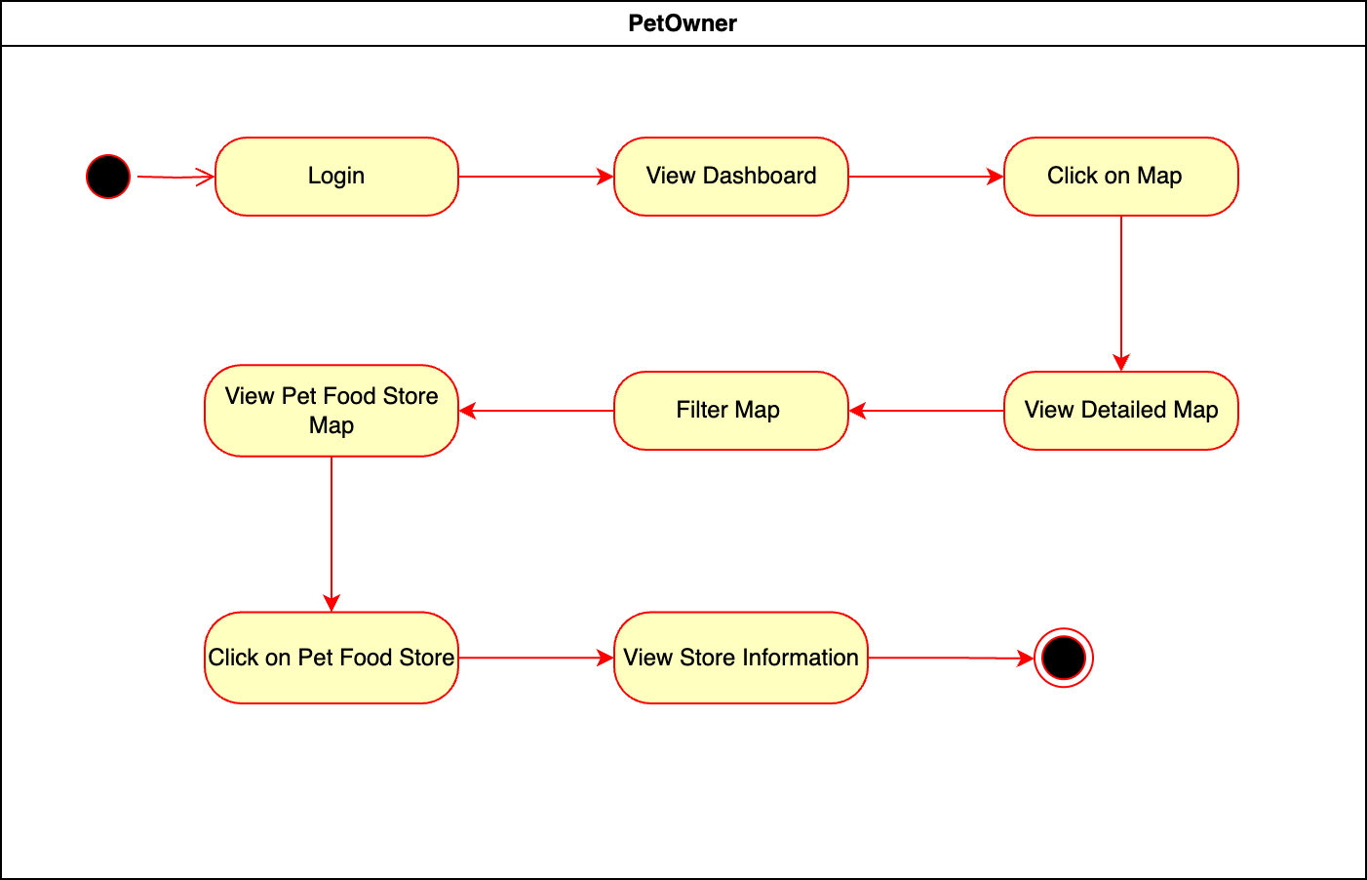
Figure 74- Activity Diagram for View Pet Food Store

Introduction/Purpose of feature:
The “View Pet Food Store” feature allows Pet Owner to view the locations of pet food stores on an interactive map within the application. This feature helps Pet Owners easily find nearby stores, ensuring they can quickly locate pet food and supplies for their pets.

Stimulus/Response sequence:
- Pet Owner clicks map. Filters Pet Food Store. Chooses Pet Food Store. Sees Pet Food Store information.

Associated functional requirements:
- The system must access the device's GPS or allow Pet Owners to input a location to display the map and nearby pet food stores.
- The system must integrate with a map service (e.g., Google Maps or a similar map API) to show real-time, accurate pet food store locations.
- The system must allow Pet Owners to zoom, pan, and interact with the map interface to view different locations.
- The system must provide store details upon selection, including the name, address, phone number, operating hours, and services offered by the pet food store.
- The system should allow filtering or searching for specific pet food store types based on preferences (e.g., 24/7 availability, specific product types).
- The system must ensure Pet Owner privacy by requesting location data only with Pet Owner consent and not storing location history without explicit permission.
- The map should be visually clear, with distinguishable markers for pet food stores and a responsive design for mobile and tablet use.
- The system must handle errors gracefully, such as if location services are unavailable or if there are no pet food stores in the area.

View Clinic
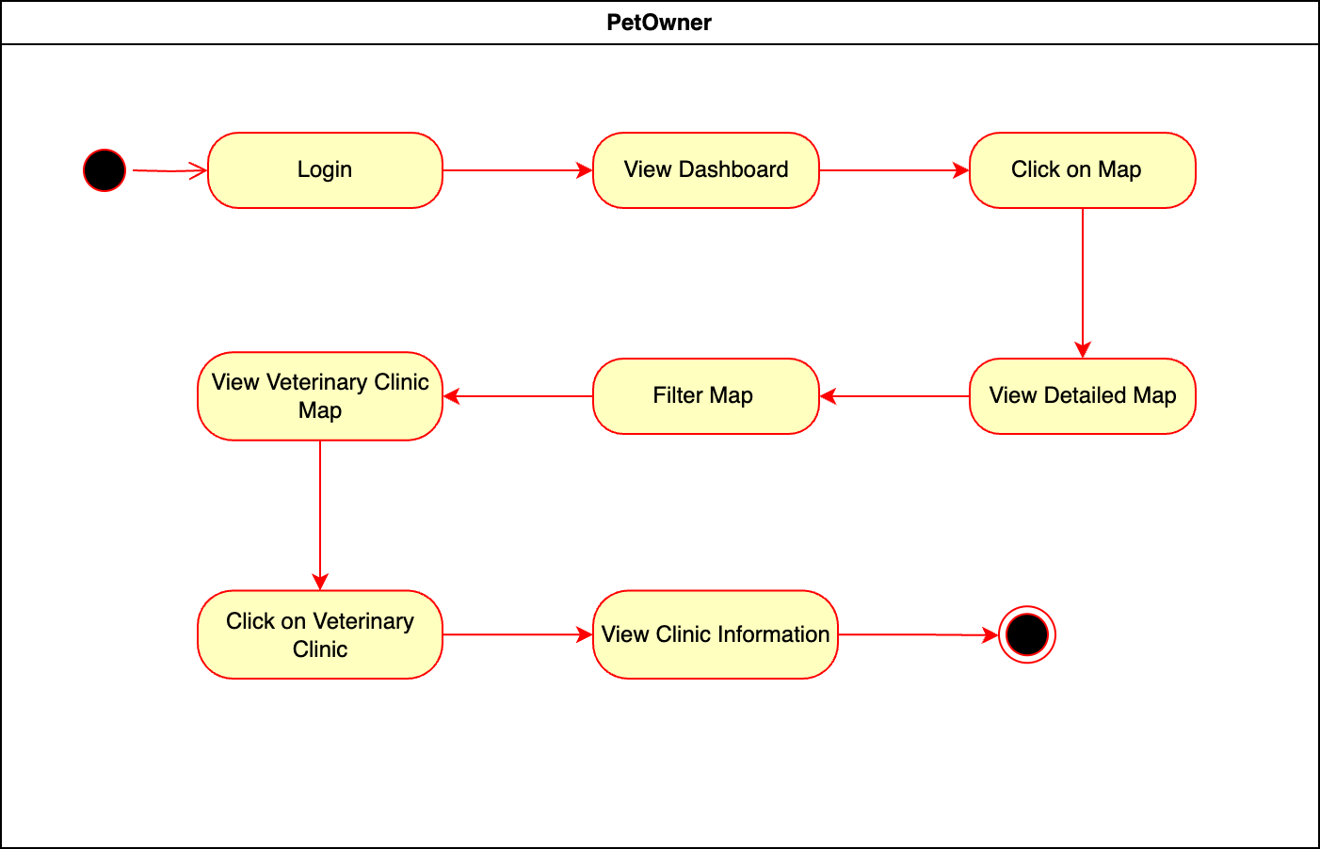
Figure 75- Activity Diagram for View Clinic

Introduction/Purpose of feature:
The “View Vet Clinic” feature allows Pet Owner to view the locations of nearby veterinary clinics on an interactive map within the application. This feature helps Pet Owners quickly find and access veterinary services for their pets in case of emergencies or routine checkups.

Stimulus/Response sequence:
- Pet Owner clicks map. Filters vet clinic. Chooses vet clinic. Sees vet clinic information.

Associated functional requirements:
- The system must access the device's GPS or allow Pet Owners to input a location to display the map and nearby vet clinics.
- The system must integrate with a map service (e.g., Google Maps or a similar map API) to show real-time, accurate vet clinic locations.
- The system must allow Pet Owners to zoom, pan, and interact with the map interface to view vet clinics in different areas.
- The system must provide vet clinic details upon selection, including the clinic name, address, phone number, operating hours, and services provided (e.g., emergency services, specialized care, etc.).
- The system should allow Pet Owners to filter or search for specific types of vet clinics based on preferences (e.g., emergency care, specific pet types, 24/7 availability).
- The system must ensure Pet Owner privacy by requesting location data only with Pet Owner consent and not storing location history without explicit permission.
- The map should be visually clear, with distinguishable markers for vet clinics and a responsive design for mobile and tablet use.
- The system must handle errors gracefully, such as if location services are unavailable or if there are no vet clinics in the area.

View Pet Friendly Taxi
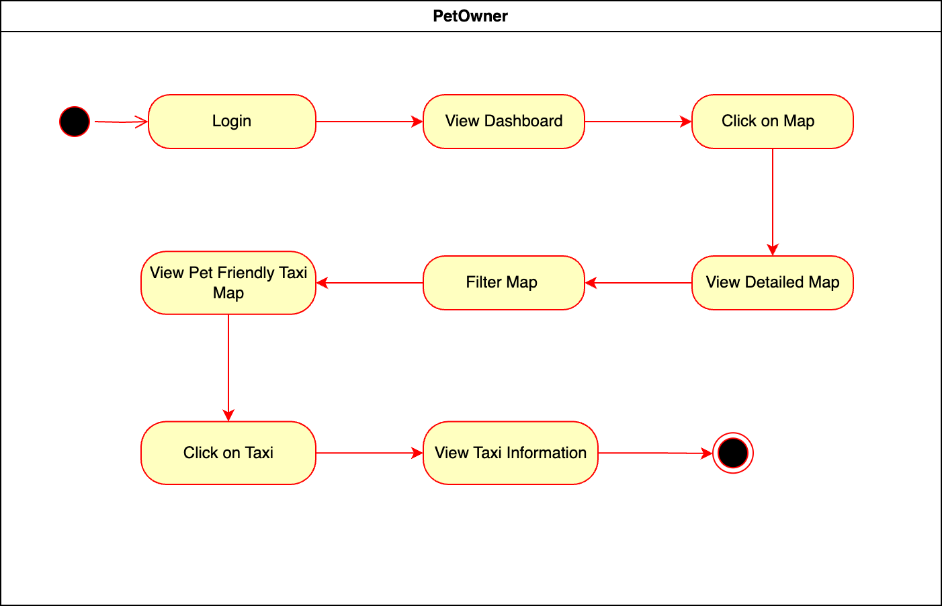
Figure 76- Activity Diagram for View Taxi

Introduction/Purpose of feature:
The “View Taxi” feature allows Pet Owner to view the locations of available taxi on an interactive map within the application. This feature enables Pet Owners to quickly find nearby taxi for transportation, making it easier to travel with pets to various destinations.

Stimulus/Response sequence:
- Pet Owner clicks map. Filters taxi. Chooses taxi. Sees taxi information.

Associated functional requirements:
- The system must access the device's GPS or allow Pet Owners to input a location to display the map and nearby taxi.
- The system must integrate with a map service (e.g., Google Maps or a similar map API) to show real-time, accurate taxi locations.
- The system must allow Pet Owners to zoom, pan, and interact with the map interface to view taxi in different areas.
- The system must display taxi details upon selection, including the taxi number, driver contact information, estimated time of arrival, and whether the taxi is pet friendly.
- The system should allow Pet Owners to filter or search for specific taxi types, such as pet-friendly taxi or those with larger vehicle options.
- The system must ensure Pet Owner privacy by requesting location data only with Pet Owner consent and not storing location history without explicit permission.
- The map should be visually clear, with distinguishable markers for taxi and a responsive design for mobile and tablet use.
- The system must handle errors gracefully, such as if location services are unavailable or if no taxi are available in the area.

Add Pet to Adoption List
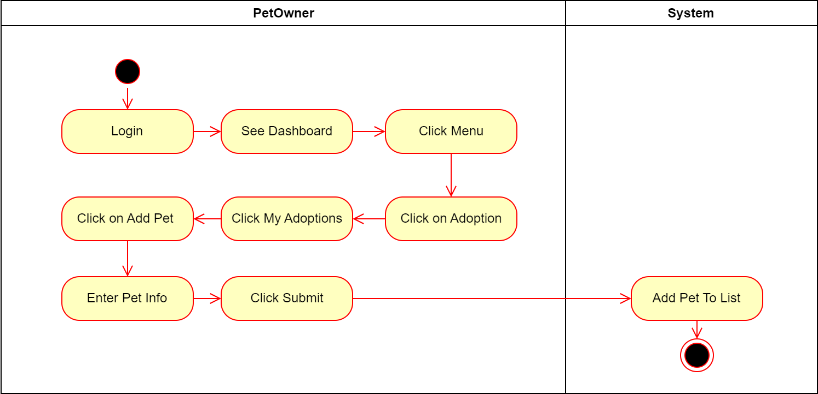
Figure 77- Activity Diagram for Add Pet to Adoption List

Introduction/Purpose of feature:
The Pet Owners and Vets should be able to put their pets up for adoption in the system.

Stimulus/Response sequence:
- Pet Owner selects adoption under the menu, clicks on my adoptions and add pet options. Then the Pet Owner enters the info of their pet and clicks on submit.
- The system adds pet to the adoption list and to database.

Associated functional requirements:
- The Pet Owner should be able to enter my adoptions under the adoption operation.
- The Pet Owner should be able to add pet to my adoption list and enter pet info.
- The system should be able to add pet to my adoption list, adoption list of the app and to database.

Remove Pet from Adoption List
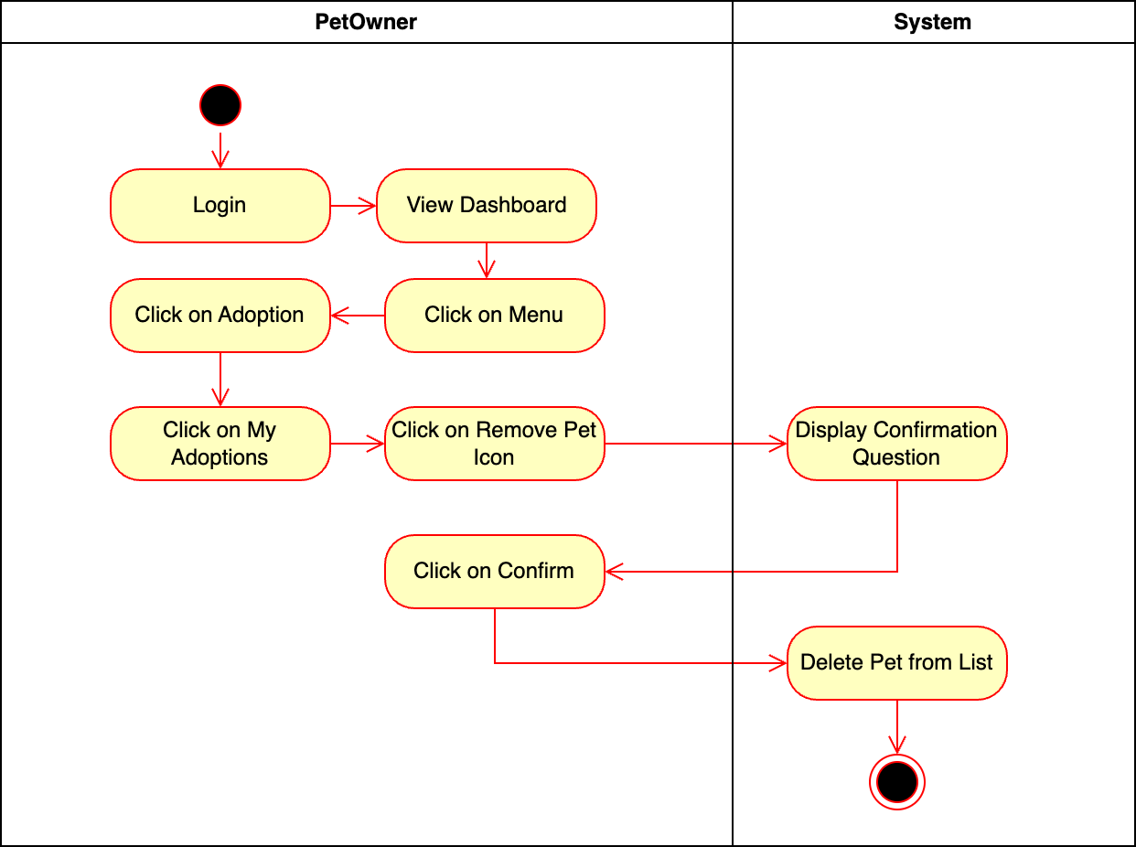
Figure 78- Activity Diagram for Remove Pet from Adoption List

Introduction/Purpose of feature:
The system shall allow Pet Owners and Vet to remove pet from adoption list.

Stimulus/Response sequence:
- Pet Owner selects my adoption under the menu, clicks on remove pet icon next to the pet.
- The system displays a confirmation message.
- Pet Owner approves the message.
- The system deletes the pet from my adoption list and adoption list of the app.

Associated functional requirements:
- The Pet Owner should be able to click on remove pet icon next to the pet.
- The system should be able to generate and display a confirmation message for deletion.
- The Pet Owner should be able to answer confirmation message for deletion.
- The system should be able to delete pet from my adoption list and adoption list of the app accordingly.

View AI Diagnosis
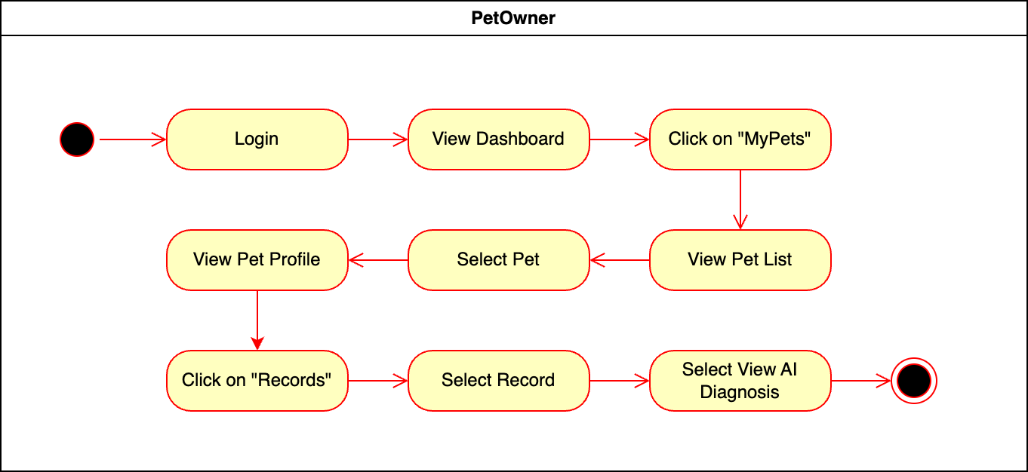
Figure 79- Activity Diagram for View AI Diagnosis

Introduction/Purpose of feature:
The “View AI Diagnosis” feature allows Pet Owner to view the diagnosis provided by the AI system for their pets. After selecting a pet from their pet list and accessing the pet's records, the Pet Owner can review previous diagnoses made by the AI. This feature helps Pet Owners monitor their pets' health and keep track of AI-assisted assessments over time.

Stimulus/Response sequence:
- Pet Owner selects "My Pet" and chooses a specific pet.
- Pet Owner clicks "Records" to access the record page.
- Pet Owner selects a specific record and clicks "View AI Diagnosis."

Associated functional requirements:
- The system must allow the Pet Owners to view a list of their pets and select a specific pet.
- The system must display all health records related to the selected pet in an organized format (e.g., by date or type of record).
- The system must retrieve and display the AI diagnosis linked to a specific record, clearly indicating the diagnosis and associated details.
- The system must ensure that AI-generated diagnoses are displayed in a clear and easily understandable format, including any additional information the AI has provided.
- The system must ensure that the records are securely stored and only accessible to the authorized Pet Owner of the pet.
- The system must allow the Pet Owner to navigate back to the pet list or records page seamlessly.
- The system must allow Pet Owners to view past AI diagnoses, including those from previous visits or health events.
- The system must be responsive, ensuring proper display on both mobile and tablet devices.
- The system must ensure that any changes to the pet’s health records, or AI diagnoses are updated in real time, maintaining consistency across the platform.

View Adoption Pool
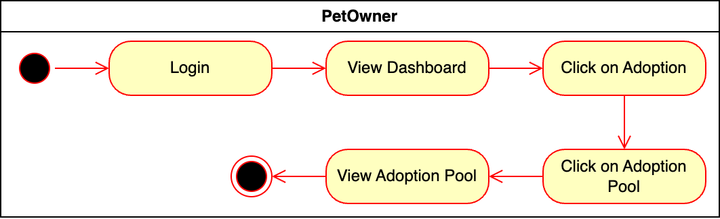
Figure 80- Activity Diagram for View Adoption Pool

Introduction/Purpose of feature:
The system should allow Pet Owners and Vets to view adoption list of the app.

Stimulus/Response sequence:
- Pet Owner selects "Adoption List" under the adoption menu.
- The system displays the adoption list.

Associated functional requirements:
- The Pet Owner should be able to view the adoption list of the app.
- The system should be able to display the adoption list of the app to the Pet Owners and the Vets.

View My Adoption List
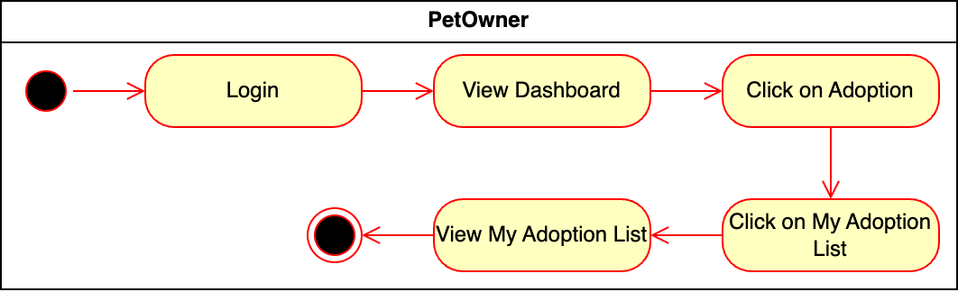
Figure 81- Activity Diagram for View My Adoption List

Introduction/Purpose of feature:
The system should allow the Pet Owners to view My Adoption List.

Stimulus/Response sequence:
- Pet Owner selects "My Adoption List" under the adoption menu.
- The system displays the user's adoption list.

Associated functional requirements:
- The Pet Owner should be able to select my adoption list under Adoption in menu.
- The system should be able to display my adoption list to the Pet Owner.

Accept/Reject Adoption Request
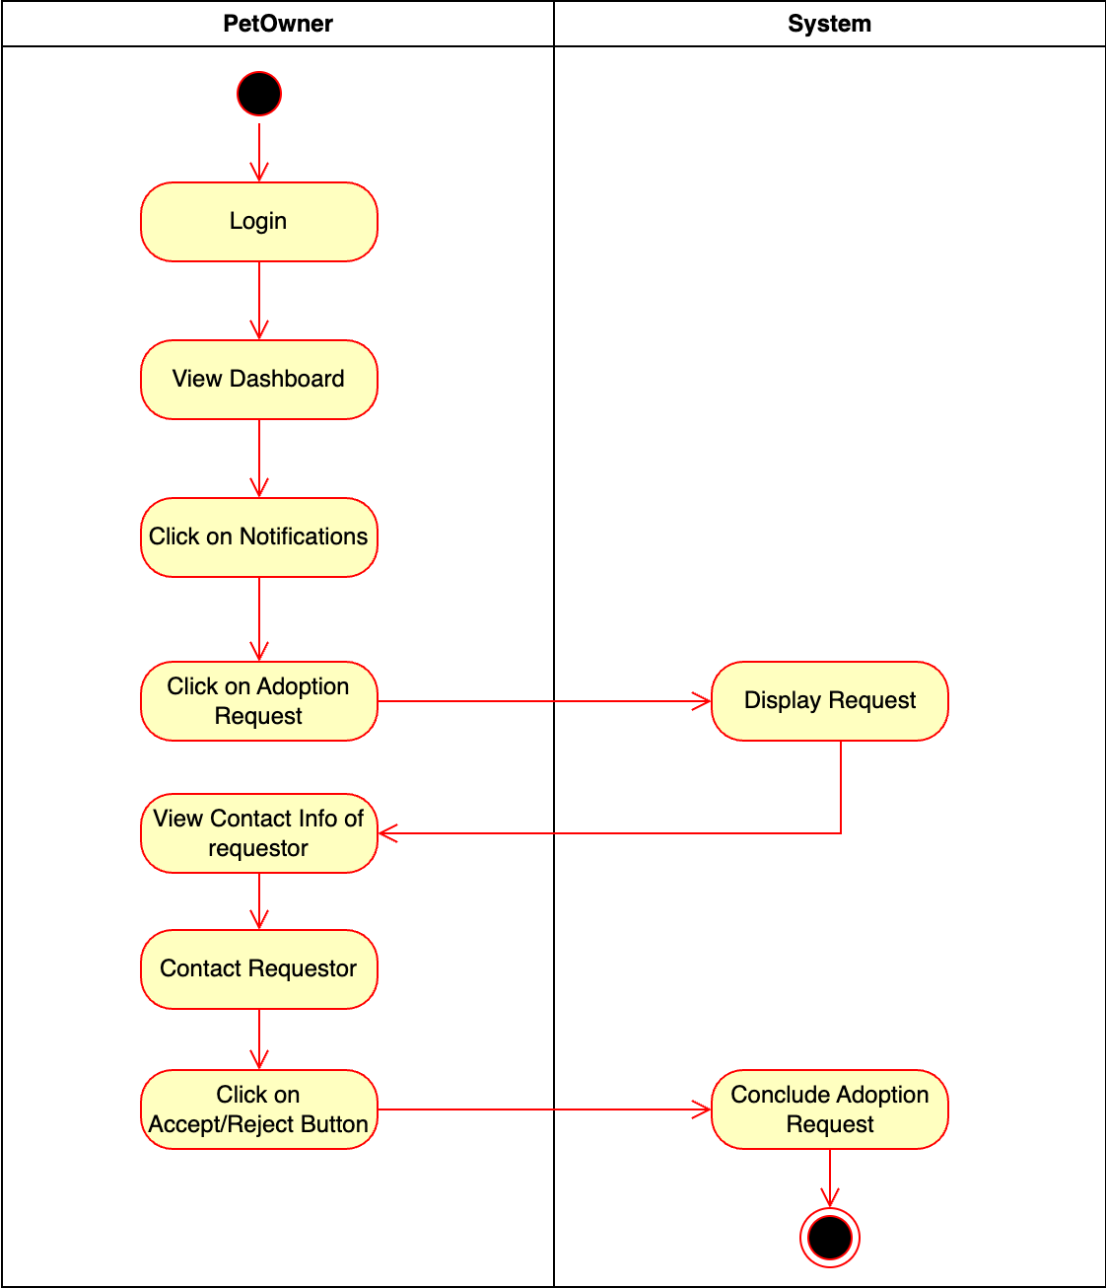
Figure 82- Activity Diagram for Accept/Reject Adoption Request

Introduction/Purpose of feature:
The Pet Owner should be able to accept or reject adoption requests.

Stimulus/Response sequence:
- Pet Owner selects "Adoption Request" under the notification icon.
- The system displays the adoption request.
- Pet Owner views the requestor's contact information and decides to accept or reject the request.
- The system updates the status as successful or unsuccessful based on the decision.

Associated functional requirements:
- The system should be able deliver the adoption request under the notification of the Pet Owner.
- The pet owner should be able to display the adoption request, view contact information of the requestor and accept or reject the adoption request.
- The system should be able to conclude the adoption request as successful or unsuccessful.

Web Application (Veterinarian)

Login
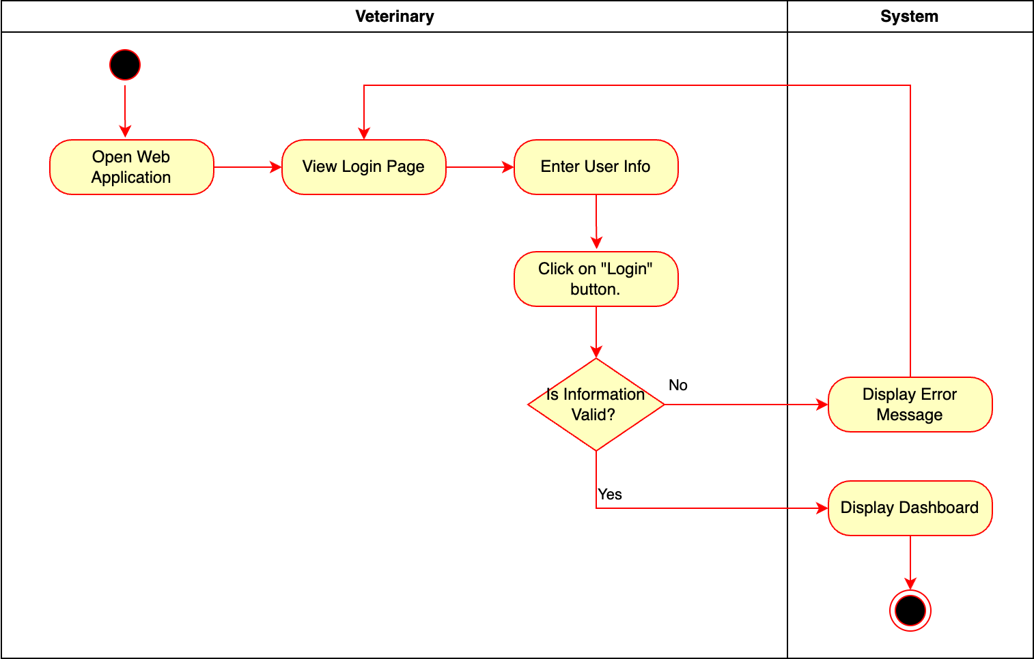
Figure 83- Activity Diagram for Login

Introduction/Purpose of feature:
The "Login" feature authenticates veterinarians, granting secure access to their “Home Page” for managing patient records, appointments, and other functionalities.

Stimulus/Response sequence:
- Veterinarian enters login credentials.
- Veterinarian clicks "Login."
- The system authenticates credentials and directs the user to the “Home Page”.

Associated functional requirements:
- The system shall provide a login page accessible to veterinarians, with fields for username and password entry.
- The system shall allow veterinarians to enter their credentials and click a Login button to initiate authentication.
- The system shall validate the entered username and password against stored credentials in the database.
- If the credentials are valid, the system shall grant access to the veterinarian and navigate them to the veterinary “Home Page”.
- If the credentials are invalid, the system shall display an error message and prompt the veterinarian to re-enter their credentials.
- The system shall provide a Forgot Password option to assist veterinarians in recovering or resetting their login credentials if needed.
- The system shall maintain session management to ensure Pet Owners remain logged in during active sessions.

Sign Up
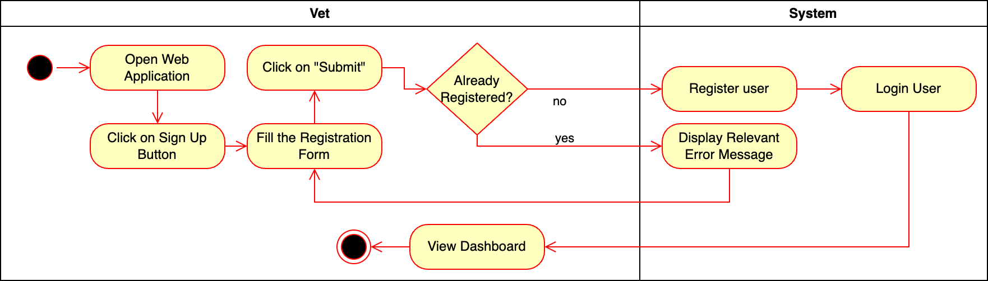
Figure 84- Activity Diagram for Sign Up

Introduction/Purpose of feature:
The "Sign-Up" feature facilitates veterinarian registration by capturing professional details and providing access to specialized functionalities tailored for their practice.

Stimulus/Response sequence:
- The veterinarian clicks on the "Sign Up" button.
- The system displays the registration form.
- The veterinarian fills in the registration form and clicks "Sign Up" button.
- The system registers the user as a vet and provides access to veterinarian-specific functionalities.

Associated functional requirements:
- The system shall provide a user-friendly registration form for initial user sign-up.
- The system shall validate whether a user is already registered and display relevant error messages for duplicate registrations.
- The system shall allow a logged-in user to select the "Register as a Vet" option.
- The system shall provide a dedicated veterinarian registration form to capture professional details such as license information and clinic details.
- The system shall verify the professional details submitted by veterinarians.
- The system shall grant veterinarians access to vet-specific features upon successful confirmation.
- The system shall securely store all user and veterinarian information in compliance with data protection regulations.

Edit Profile
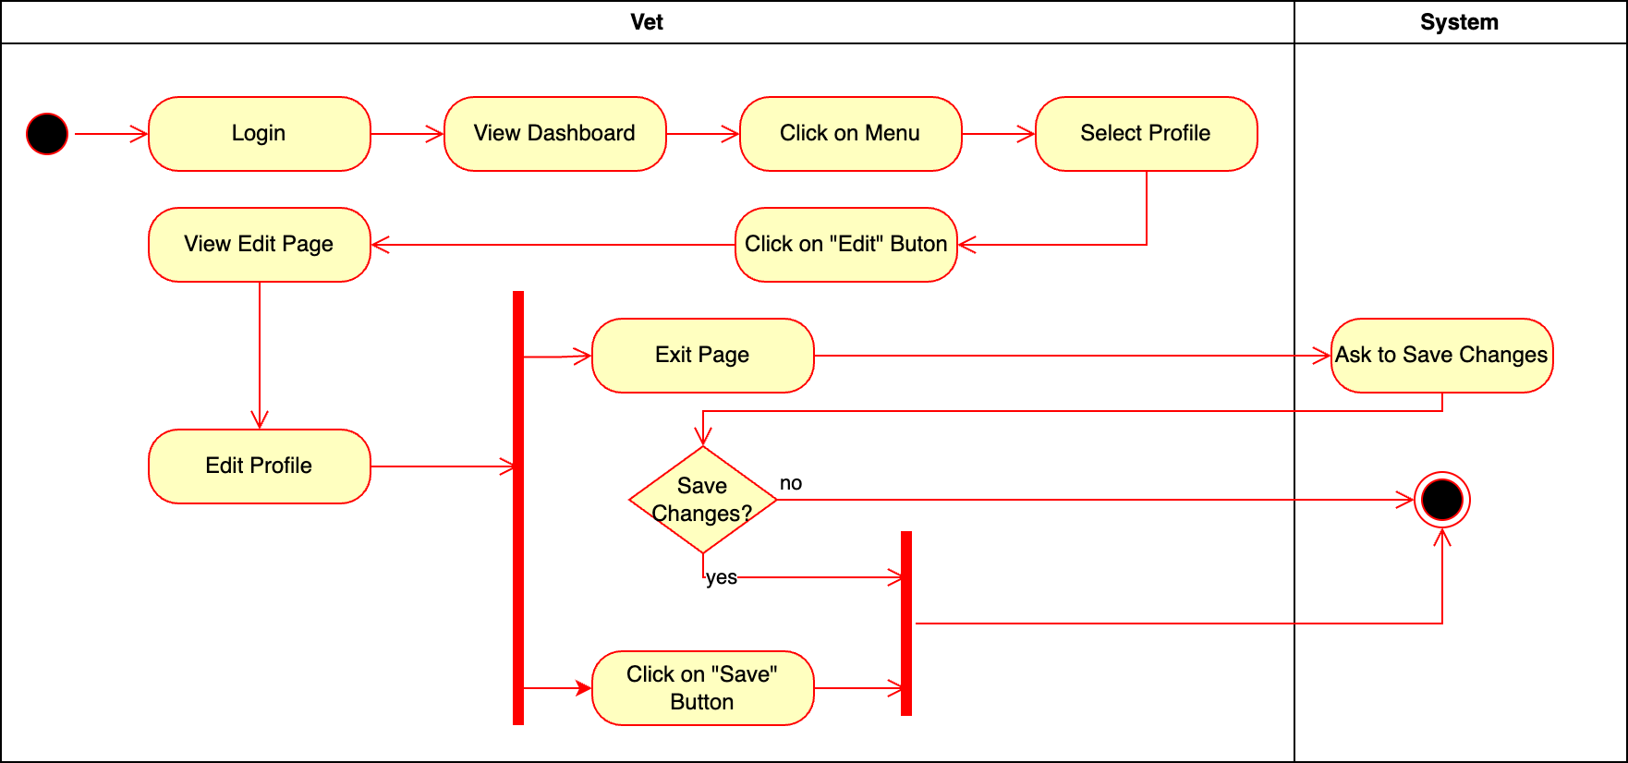
Figure 85- Activity Diagram for Edit Profile

Introduction/Purpose of feature:
The "Edit Profile" feature allows veterinarians to update their personal and professional information within their profiles. This ensures accurate and up-to-date records while providing an intuitive and secure way to manage their data. The system prompts veterinarians to save changes before exiting to prevent accidental data loss.

Stimulus/Response sequence:
- Veterinarian logs into the system and views the "Home Page."
- The system displays the main "Home Page."
- Veterinarian clicks the “Menu” symbol and selects "Profile."
- The system navigates to the profile page.
- Veterinarian clicks the "Edit" button.
- The system opens the edit profile page.
- Veterinarian edits profile details and clicks "Save" button.
- The system saves the updated information and exits the edit page.

Associated functional requirements:
- The system shall provide access to a profile section from the main menu on the “Home Page”.
- The system shall allow users to edit their profile details by navigating to an “Edit Profile Page”.
- The system shall enable the veterinarian to modify personal and professional information securely.
- The system shall prompt the user to save changes when attempting to exit the edit profile page with unsaved modifications.
- The system shall save the updated profile information upon confirmation or clicking the "Save" button.
- The system shall discard unsaved changes if the veterinarian chooses not to save them when prompted.
- The system shall notify the veterinarian when profile updates are successfully saved.

Delete Vet
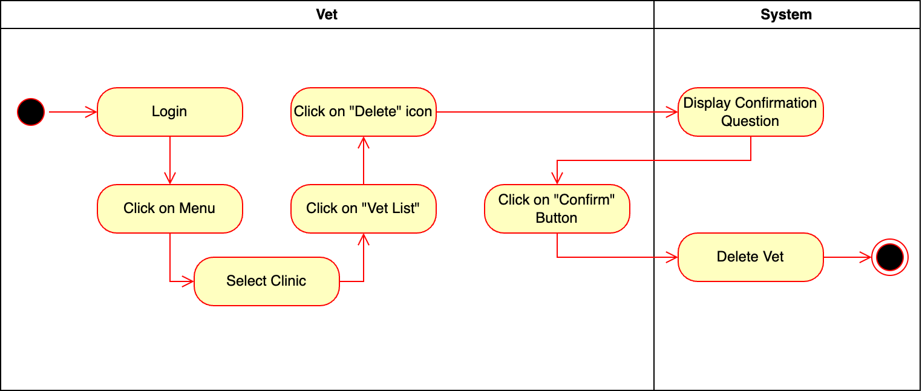
Figure 86- Activity Diagram for Delete Vet

Introduction/Purpose of feature:
The "Delete Vet" feature enables authorized veterinarians to remove other veterinarians from the system by selecting a vet from a clinic’s list and confirming the deletion action. This ensures accurate data management.

Stimulus/Response sequence:
- Veterinarian logs into the system.
- The system displays “Home Page”.
- Veterinarian clicks the “Manu “symbol and selects "My Clinic”.
- The system displays “My Clinic” page.
- Veterinarian selects the Vet that will be deleted.
- Veterinarian clicks the "Delete" icon next to a Vet’s entry.
- The system prompts for confirmation.
- Veterinarian confirms the deletion.
- The system removes the Vet’s data and displays a confirmation message.

Associated functional requirements:
- The system shall provide a login mechanism to ensure only authorized users can access the "Vet List" functionality.
- The system shall display a menu that includes the "Vet List" option for authorized users.
- The system shall display a list of clinics when the user selects the "Vet List" option.
- The system shall display a list of vets for the selected clinic.
- The system shall allow users to click on a "Delete" icon next to a vet's entry in the list.
- The system shall display a confirmation dialog when the user clicks the "Delete" icon.
- The system shall delete the vet's data from the database if the user confirms the deletion.
- The system shall provide feedback to the user confirming that the vet has been successfully deleted.

View Pet Record
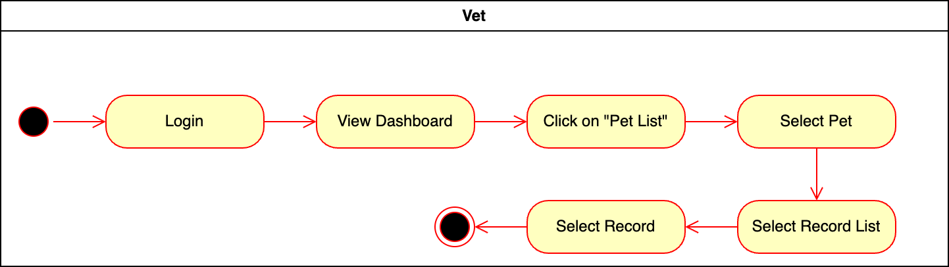
Figure 87- Activity Diagram for View Pet Record

Introduction/Purpose of feature:
The "View Pet Record" feature allows veterinarians to access medical records of pets by navigating through a pet list and selecting the desired record. This ensures efficient access to critical health information.

Stimulus/Response sequence:
- Veterinarian logs into the system.
- The system displays "Home Page."
- Veterinarian clicks "Patient ".
- The system displays a list of all Pets that are registered on the Clinic’s system.
- Veterinarian selects a specific pet from the list.
- The system displays a “Pet Profile Page”.
- Veterinarian selects a specific record.
- The system retrieves and displays the record details.

Associated functional requirements:
- The system shall provide a login mechanism to ensure only authorized users can access the "Pet List" functionality.
- The system shall display a “Home Page” after successful login, including the "Patient" option.
- The system shall display a list of pets when the vet clicks on the "Patient" option.
- The system shall allow the vet to select a specific pet from the list.
- The system shall display the record list for the selected pet.
- The system shall allow users to select a specific record from the displayed record list.
- The system shall retrieve and display the details of the selected record.

Update Record
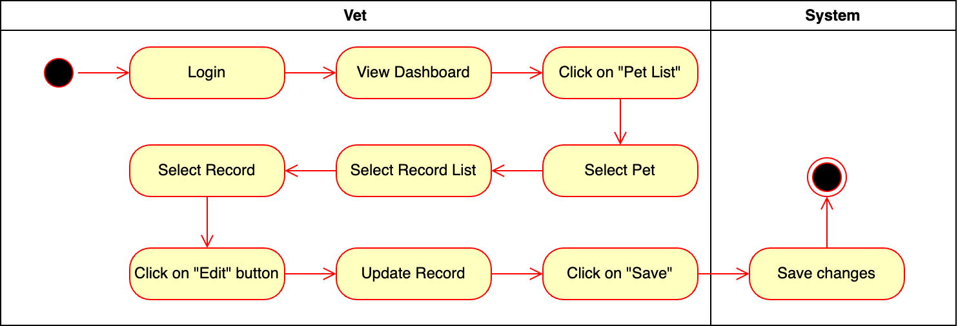
Figure 88- Activity Diagram for Update Record

Introduction/Purpose of feature:
The "Update Record" feature enables veterinarians to update the medical records of a selected pet by navigating through the pet list, selecting a specific record, making necessary changes, and saving the updates.

Stimulus/Response sequence:
- Veterinarian logs into the system.
- The system displays "Home Page."
- Veterinarian clicks “Menu” symbol.
- Veterinarian clicks “My Records” button.
- The system displays a list of patient records that are registered with the veterinarian.
- Veterinarian selects a specific record form the list.
- Veterinarian clicks the "Edit" button for the record.
- The system displays an editable form for the record’s “Vet Diagnosis” section.
- Veterinarian updates the record and clicks "Save” button.
- The system validates the inputs, saves the updated record, and displays a confirmation message.

Associated functional requirements:
- The system shall provide a login mechanism to ensure only authorized users can access the "Pet List" functionality.
- The system shall display the record list for the vet.
- The system shall allow vets to select a specific record from the displayed record list.
- The system shall provide an "Edit" button for each record, enabling vets to modify its “Vet Diagnosis” details.
- The system shall display an editable form for the selected record when vets click the "Edit" button.
- The system shall validate the updated record details before saving.
- The system shall save the updated record to the database upon successful validation.
- The system shall display a confirmation message to the user after successfully saving the updates.

Accept/Reject Appointment
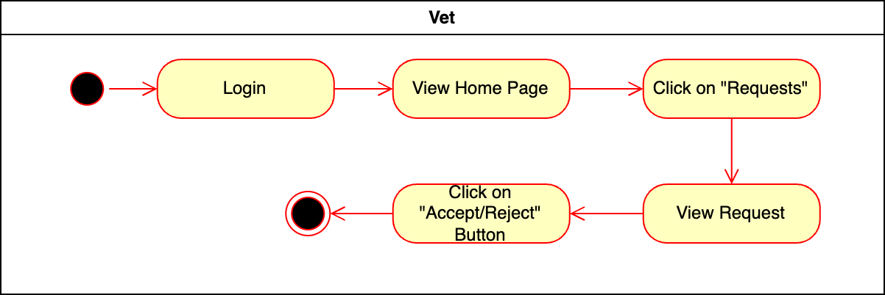
Figure 89- Activity Diagram for Accept/Reject Appointment

Introduction/Purpose of feature:
The "Accept/Reject Appointment" feature enables veterinarians to manage appointment requests by viewing, accepting, or rejecting requests efficiently.

Stimulus/Response sequence:
- Veterinarian logs into the system.
- The system displays "Home Page."
- Veterinarian clicks "Requests."
- The system displays a list of appointment requests.
- Veterinarian accepts or rejects the appointment clicking the related symbols right side of the request.
- The system processes the decision and updates the appointment status.
- The system send notification to the owner of the request.

Associated functional requirements:
- The system shall provide a login mechanism to ensure only authorized vets can access appointment requests.
- The system shall display a “Home Page” after successful login, including the "Requests" option.
- The system shall display a list of appointment requests when the vet selects the "Requests" option.
- The system shall allow the vet to view the details of an appointment request.
- The system shall provide "Accept" and "Reject" buttons for each appointment request.
- The system shall update the status of the appointment request based on the vet's decision.
- The system shall notify the vet of the successful processing of the appointment request.

Create Vet Diagnosis
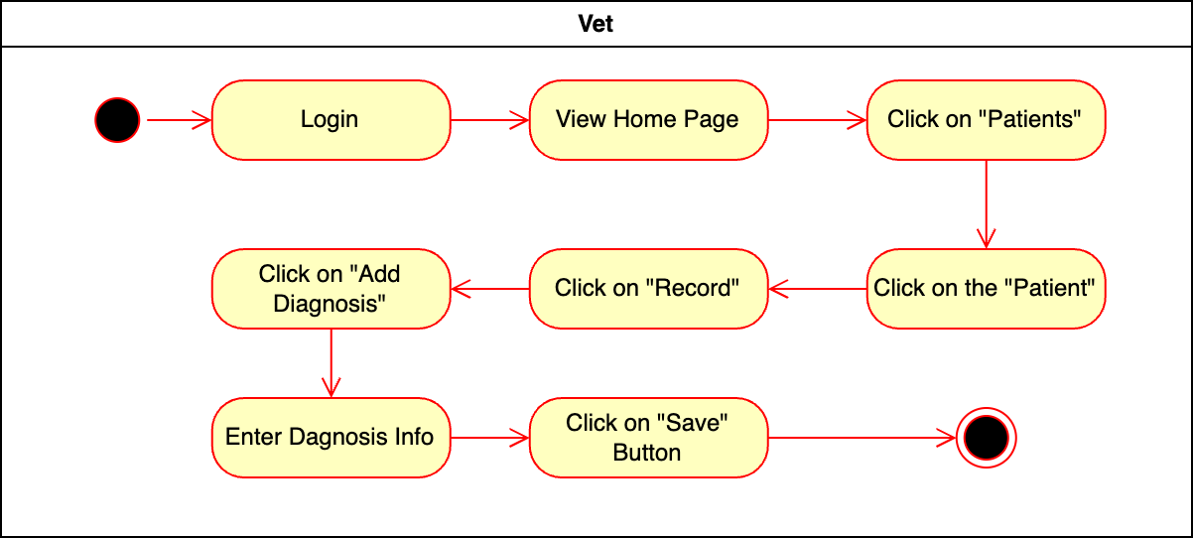
Figure 90- Activity Diagram for Create Vet Diagnosis

Introduction/Purpose of feature:
The "Create Vet Diagnosis" feature allows veterinarians to add a diagnosis to a patient’s record by navigating through the patient’s details and entering relevant information.

Stimulus/Response sequence:
- Veterinarian logs into the system.
- The system displays "Home Page."
- Veterinarian clicks "Patients."
- The system displays a list of patients.
- Veterinarian selects a specific patient.
- The system displays the patient’s record.
- Veterinarian clicks "Add Diagnosis."
- Veterinarian enters diagnosis details in the provided form.
- Veterinarian clicks "Save."
- The system saves the diagnosis information to the patient’s record and confirms the addition.
- The system sets the Veterinarian as the owner of the record.

Associated functional requirements:
- The system shall provide a login mechanism to ensure only authorized vets can access patient records.
- The system shall display a “Home Page” after successful login, including the "Patients" option.
- The system shall display a list of patients when the vet selects the "Patients" option.
- The system shall allow the vet to view detailed information for a specific patient.
- The system shall display the patient’s record when the vet selects the "Record" option.
- The system shall provide an "Add Diagnosis" option in the patient’s record.
- The system shall allow the vet to enter diagnosis information in a structured form.
- The system shall save the entered diagnosis information to the patient’s record when the vet clicks the "Save" button.
- The system shall confirm to the vet that the diagnosis has been successfully added to the record.

Update Pet Owners
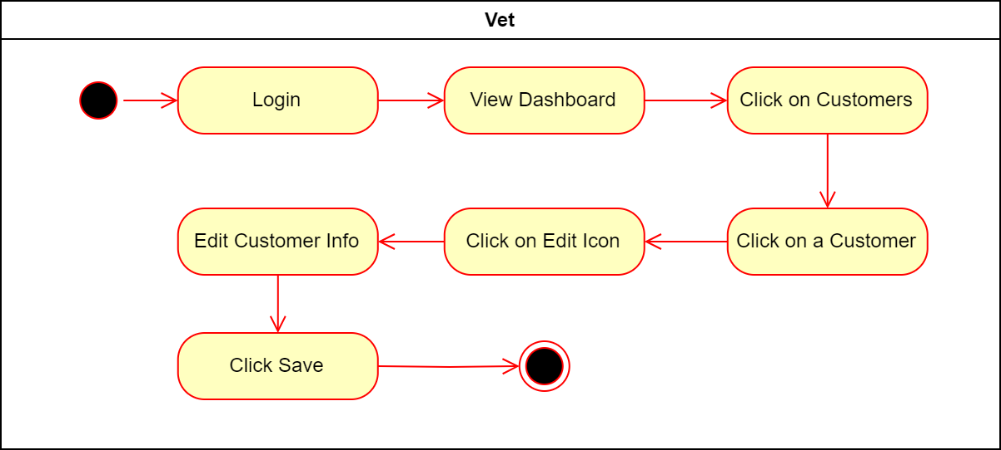
Figure 91- Update Pet Owners

Introduction/Purpose of feature:
The "Update Pet Owners" feature allows veterinarians to update unregistered customer information by navigating to the customer details, editing required fields, and saving changes.

Stimulus/Response sequence:
- Veterinarian logs into the system.
- The system displays "Home Page."
- Veterinarian clicks "Customers."
- The system displays a list of customers.
- Veterinarian selects a specific unregistered customer.
- Veterinarian clicks "Edit" symbol for the selected customer.
- Veterinarian edits customer information in the provided form.
- Veterinarian clicks "Save."
- The system validates and updates the customer information and confirms the changes.

Associated functional requirements:
- The system shall provide a login mechanism to ensure only authorized vets can access customer information.
- The system shall display a “Home Page” after successful login, including the "Customers" option.
- The system shall display a list of customers when the vet selects the "Customers" option.
- The system shall allow the vet to view detailed information for a specific customer.
- The system shall provide an "Edit" icon for each customer in the list.
- The system shall display a form pre-filled with the customer’s existing information when the vet clicks the "Edit" icon.
- The system shall allow the vet to edit the customer information in the form.
- The system shall validate the updated information for completeness and correctness.
- The system shall save the updated customer information when the vet clicks the "Save" button.
- The system shall confirm to the vet that the customer information has been successfully updated.
- The customer must be an unregistered Pet Owner to be an editable form.

View AI Diagnosis
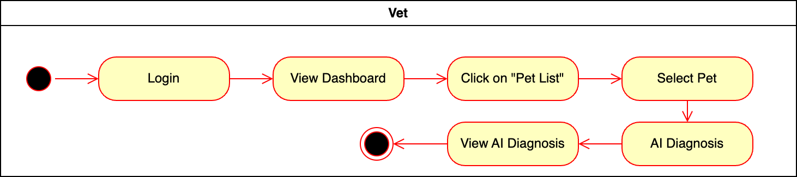
Figure 92- Activity Diagram for View AI Diagnosis

Introduction/Purpose of feature:
The "View AI Diagnosis" feature allows veterinarians to view AI-generated diagnoses for a selected pet by navigating to the pet’s details and accessing the AI Diagnoses section. This provides valuable insights to support clinical decision-making.

Stimulus/Response sequence:
- Veterinarian logs into the system.
- The system displays "Home Page."
- Veterinarian clicks "Patients".
- The system displays a list of pets.
- Veterinarian selects a specific pet from the list.
- The system displays “Pet Profile”.
- Veterinarian clicks "AI Diagnoses."
- The system displays AI-generated diagnoses for the selected pet.

Associated functional requirements:
- The system shall provide a login mechanism to ensure only authorized vets can access pet information.
- The system shall display a “Home Page” after successful login, including the "Pet List" option.
- The system shall display a list of pets when the vet selects the "Pet List" option.
- The system shall allow the vet to view detailed information for a specific pet.
- The system shall provide an "AI Diagnoses" option for each pet in the pet details view.
- The system shall display AI-generated diagnoses for the selected pet when the vet clicks on the "AI Diagnoses" option.
- The system shall ensure the AI-generated diagnoses are presented in an easily understandable format.
- The system shall confirm that the AI diagnoses data is up-to-date and accurate.

Add Pet to Adoption List
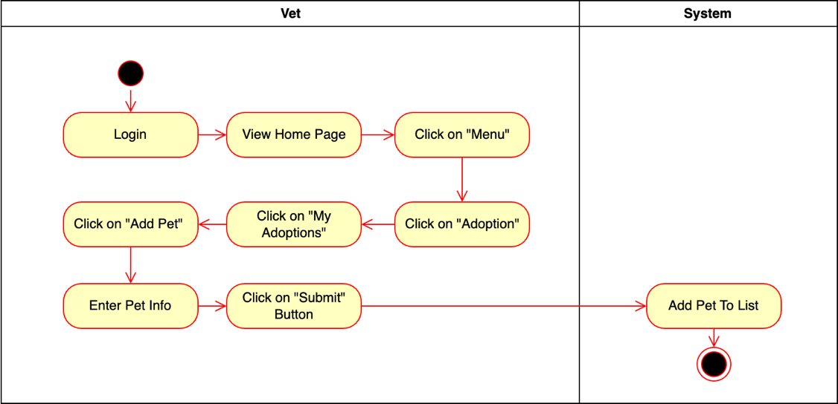
Figure 93- Activity Diagram for Add Pet to Adoption List

Introduction/Purpose of feature:
The "Add Pet to Adoption List" feature allows veterinarians to add pets to their adoption list by navigating through the adoption page, entering required pet details, and submitting the information.

Stimulus/Response sequence:
- Veterinarian logs into the system.
- The system displays the “Home Page” after login.
- Veterinarian selects the "Adoption" from navigation bar.
- Veterinarian clicks on "My Adoptions" from the adoption page.
- Veterinarian clicks on the "Add Pet" option.
- The system displays a form for entering pet information.
- Veterinarian fills in the required pet details in the form.
- Veterinarian clicks the "Submit" button to save the pet information.
- The system validates the entered information, adds the pet to the clinic's adoption list, and displays a confirmation message.

Associated functional requirements:
- The system shall provide a login mechanism to ensure only authorized users can access the adoption functionality.
- The system shall display a “Home Page” after successful login, including the menu options.
- The system shall allow users to access the "Adoption" page from the navigation bar.
- The system shall display the "My Adoptions" section when the user selects it from the “Adoption Page”.
- The system shall provide an "Add Pet" option within the "My Adoptions" section.
- The system shall display a form for entering pet details when the "Add Pet" option is selected.
- The system shall validate the pet information entered in the form to ensure all required fields are completed and properly formatted.
- The system shall add the pet to the user's adoption list upon successful submission of the form.
- The system shall display a confirmation message to the user after successfully adding the pet.

Remove Pets from Adoption List
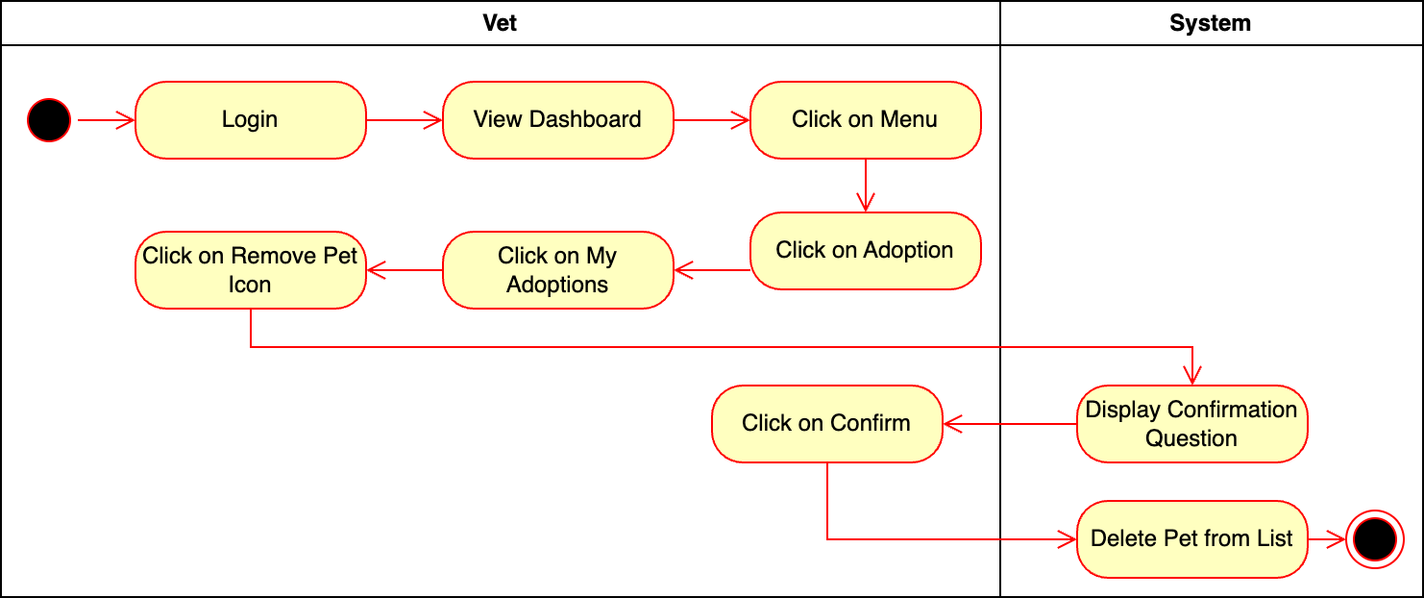
Figure 94- Activity Diagram for Remove Pet from Adoption List

Introduction/Purpose of feature:
The "Remove Pets from Adoption List" feature allows veterinarians to remove a pet from their adoption list by confirming the removal action.

Stimulus/Response sequence:
- Veterinarian logs into the system.
- The system displays "Home Page."
- Veterinarian selects "Adoption" from navigation bar.
- Veterinarian clicks "My Adoptions."
- Veterinarian clicks "Remove Pet" next to the desired pet.
- The system displays a confirmation dialog.
- Veterinarian confirms the removal.
- The system removes the pet from the adoption list and displays a confirmation message.

Associated functional requirements:
- The system shall provide a login mechanism to ensure only authorized vets can access the adoption functionality.
- The system shall display a “Home Page” after successful login, including the menu options.
- The system shall allow vets to access the "Adoption" from the navigation bar.
- The system shall display the "My Adoptions" section when the vet selects it from the adoption menu.
- The system shall provide a "Remove Pet" icon for each pet in the adoption list.
- The system shall display a confirmation dialog when the vet clicks on the "Remove Pet" icon.
- The system shall delete the pet from the adoption list upon vet confirmation.
- The system shall display a confirmation message to the vet after successfully removing the pet.

View Adoption Pool
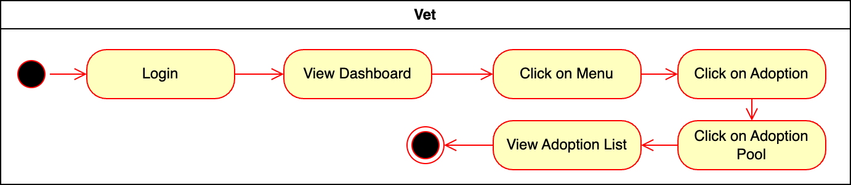
Figure 95- Activity Diagram for View Adoption Pool

Introduction/Purpose of feature:
The "View Adoption Pool" feature allows veterinarians to view the adoption list by navigating through the “Adoption” option from the navigation bar.

Stimulus/Response sequence:
- Veterinarian logs into the system.
- The system displays "Home Page."
- Veterinarian selects "Adoption" from the navigation bar.
- The system displays “Adoption Page” and “Clinic’s Adoption” option as dedault.
- Veterinarian clicks "Adoption Pool" option.
- The system displays the “Adoption Pool”.

Associated functional requirements:
- The system shall provide a login mechanism to ensure only authorized vets can access the adoption functionality.
- The system shall display a “Home Page” after successful login, including the menu options.
- The system shall allow the vet to access the "Adoption" option from the navigation bar.
- The system shall display the "Adoption Pool" option when the vet enters “Adoption Page”.

View Clinic’s Adoption List
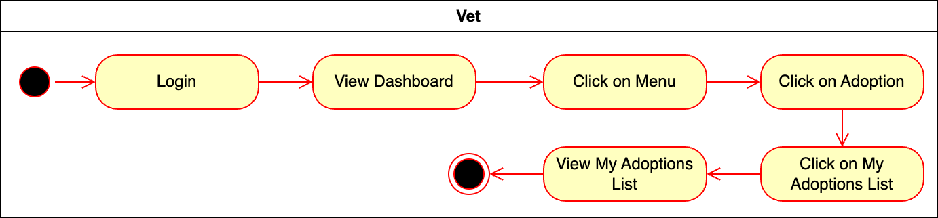
Figure 96- Activity Diagram for View My Adoption List

Introduction/Purpose of feature:
The "View Clinic’s Adoption List" feature allows veterinarians to view their clinic’s adoption list by navigating through the “Adoption”.

Stimulus/Response sequence:
- Veterinarian logs into the system.
- The system displays "Home Page."
- Veterinarian selects "Adoption" from the navigation bar.
- The system displays “Adoption Page”, and “Clinic’s Adoptions” is displayed as a default page.

Associated functional requirements:
- The system shall provide a login mechanism to ensure only authorized vets can access the adoption functionality.
- The system shall display a “Home Page” after successful login, including the navigation bar.
- The system shall display the "Adoption Page" with “Clinic’s Adoptions” option.
- The system shall display the “Clinic’s Adoption” as a default page when vet enters the “Adoption Page”.

Admin

Login
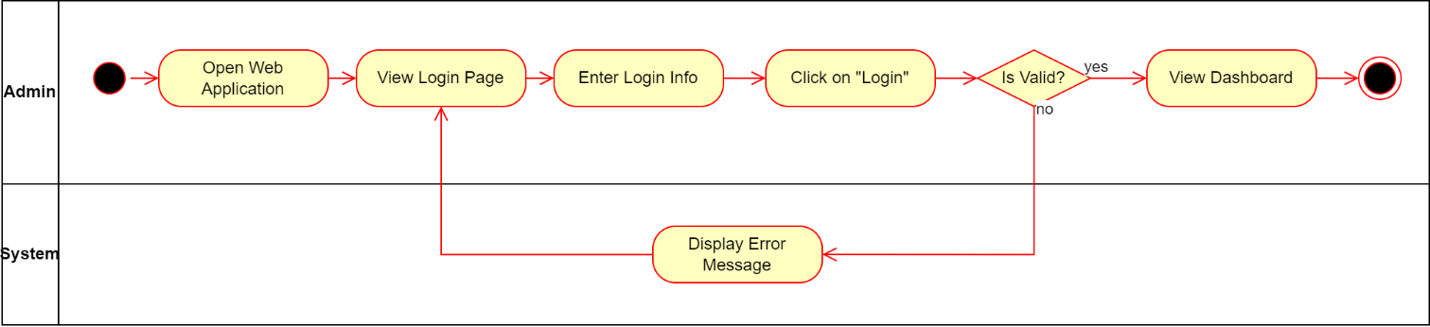
Figure 97- Activity Diagram for Login

Introduction/Purpose of feature:
The "Login" feature allows the administrator to securely access the application by entering valid credentials. This ensures only authorized personnel can manage and configure system settings.

Stimulus/Response sequence:
- Administrator opens the web application.
- The system displays the login page.
- Administrator enters login credentials (username and password).
- Administrator clicks "Login."
- The system validates the entered credentials:
- If valid: Grants access and displays the dashboard.
- If invalid: Displays an error message and returns to the login page for retry.

Associated functional requirements:
- The system shall display a login page when the web application is opened.
- The system shall provide input fields for the admin to enter their username and password.
- The system shall provide a "Login" button to submit the entered credentials.
- The system shall validate the admin’s login credentials.
- The system shall grant access to the admin and display the dashboard upon successful login.
- The system shall display an error message if the entered credentials are invalid.
- The system shall return the admin to the login page if the credentials are invalid, allowing for a retry.

Update Profile
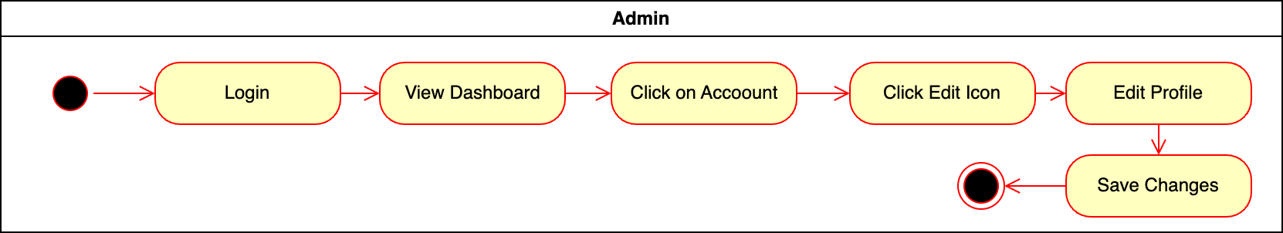
Figure 98- Activity Diagram for Update Profile

Introduction/Purpose of feature:
The "Update Profile" feature allows administrators to edit their account details, ensuring their profile information remains accurate and up to date.

Stimulus/Response sequence:
- Administrator logs into the system.
- The system displays the dashboard.
- Administrator clicks "Account" on the dashboard.
- Administrator clicks the "Edit" icon.
- Administrator edits profile details in the provided fields.
- Administrator clicks "Save Changes."
- The system validates and saves the updated profile information.
- The system confirms the changes were successfully saved.

Associated functional requirements:
- The system shall provide a login mechanism to ensure only authorized admins can access account settings.
- The system shall display a dashboard after successful login, including the "Account" option.
- The system shall provide an "Edit" icon in the account section for modifying profile details.
- The system shall allow the admin to edit profile details in a structured form.
- The system shall validate the edited profile details for completeness and correctness.
- The system shall save the updated profile information when the admin clicks the "Save Changes" button.
- The system shall confirm to the admin that the profile changes have been successfully saved.

Update User
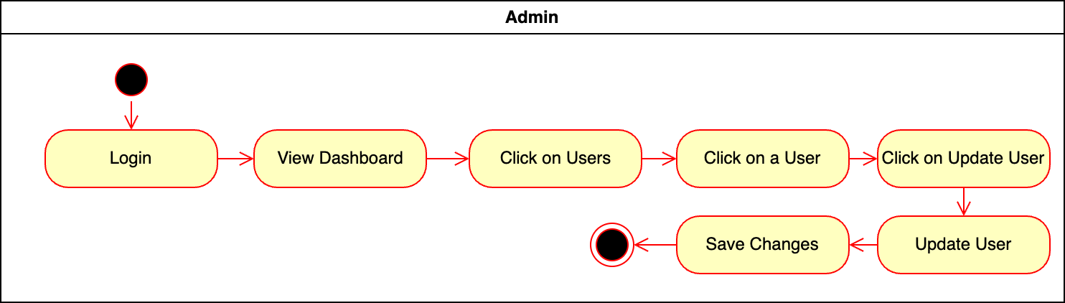
Figure 99- Activity Diagram for Update User

Introduction/Purpose of feature:
The "Update User" feature allows administrators to manage user details by selecting a specific user, editing their information, and saving changes.

Stimulus/Response sequence:
- Administrator logs into the system.
- The system displays the dashboard.
- Administrator clicks "Users."
- The system displays a list of users.
- Administrator selects a specific user.
- Administrator clicks "Update User."
- Administrator updates the user information in the provided form.
- Administrator clicks "Save Changes."
- The system validates and saves the updates.
- The system confirms the changes were successfully saved.

Associated functional requirements:
- The system shall provide a login mechanism to ensure only authorized admins can access user management features.
- The system shall display a dashboard after successful login, including the "Users" option.
- The system shall display a list of users when the admin selects the "Users" option.
- The system shall allow the admin to view details of a specific user.
- The system shall provide an "Update User" button for modifying user details.
- The system shall allow the admin to update user details in a structured form.
- The system shall validate the updated user details for completeness and correctness.
- The system shall save the updated user information when the admin clicks the "Save Changes" button.
- The system shall confirm to the admin that the user information has been successfully updated.

Configure Application
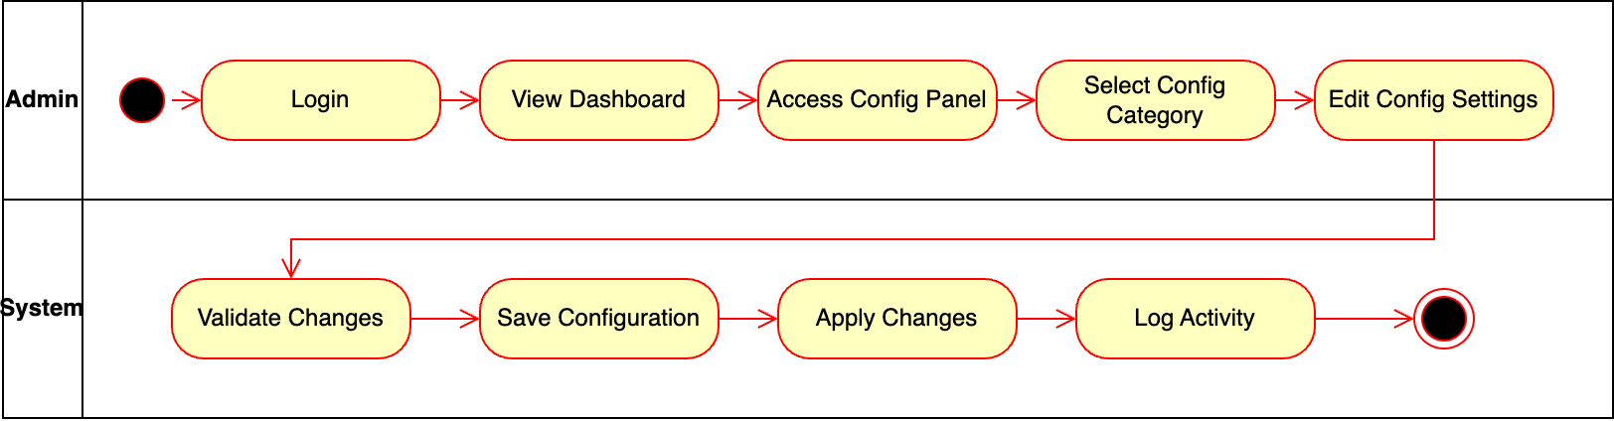
Figure 100- Activity Diagram for Configure Application

Introduction/Purpose of feature:
The "Configure Application" feature enables administrators to modify system settings via the configuration panel, ensuring operational efficiency and compliance.

Stimulus/Response sequence:
- Administrator logs into the system.
- The system displays the dashboard.
- Administrator accesses the "Configuration Panel."
- Administrator selects a configuration category.
- Administrator modifies the settings in the selected category.
- Administrator submits the changes.
- The system validates and saves the changes.
- The system applies the saved configuration settings.
- The system logs the activity for auditing.
- The system notifies the administrator of successful changes.

Associated functional requirements:
- The system shall provide a login mechanism to ensure only authorized admins can access the configuration panel.
- The system shall display a dashboard after successful login, including the "Configuration Panel" option.
- The system shall allow the admin to access a configuration panel from the dashboard.
- The system shall provide categorized configuration options within the configuration panel.
- The system shall allow the admin to edit settings in a selected configuration category.
- The system shall validate the modified configuration settings for correctness and consistency.
- The system shall save the validated configuration settings.
- The system shall apply the saved configuration settings immediately or as per predefined rules.
- The system shall log the configuration changes and the admin activity for auditing purposes.
- The system shall notify the admin upon successful application of the changes.

Configure AI API
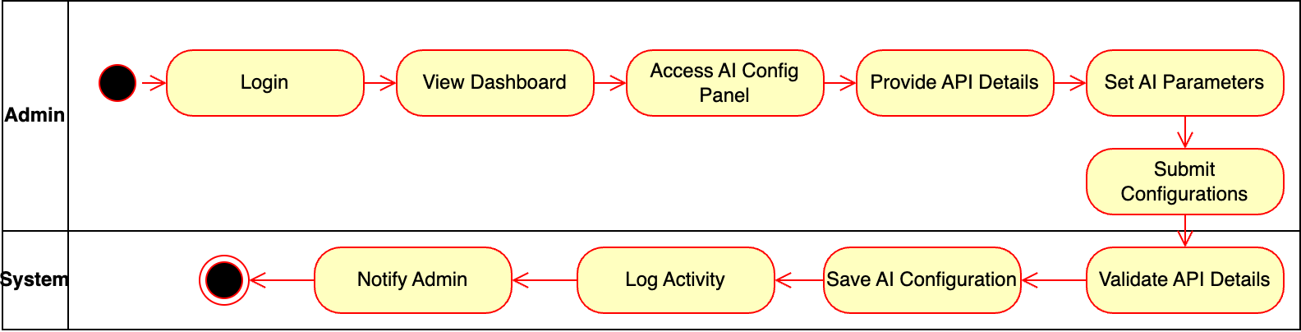
Figure 101- Activity Diagram for Configure AI API

Introduction/Purpose of feature:
The "Configure AI API" feature allows administrators to integrate AI services by entering API details, setting parameters, and applying configurations.

Stimulus/Response sequence:
- Administrator logs into the system.
- The system displays the dashboard.
- Administrator accesses the "AI Configuration Panel."
- Administrator provides API details (e.g., endpoint, key, credentials).
- Administrator sets AI parameters.
- Administrator submits the configuration.
- The system validates and saves the configuration.
- The system logs the activity for auditing.
- The system notifies the administrator of successful configuration.

Associated functional requirements:
- The system shall provide a login mechanism to ensure only authorized admins can access the AI configuration panel.
- The system shall display a dashboard after successful login, including the "AI Configuration Panel" option.
- The system shall allow the admin to access the AI configuration panel from the dashboard.
- The system shall provide input fields for the admin to enter API details.
- The system shall allow the admin to set AI-related parameters.
- The system shall validate the provided API details and AI parameters for correctness and compatibility.
- The system shall save the validated AI API configuration.
- The system shall log the configuration changes and the admin’s activity for auditing purposes.
- The system shall notify the admin of the successful saving and application of the AI API configuration.
- The system shall provide error messages if validation fails, allowing the admin to correct the information.

Add Vet Clinic
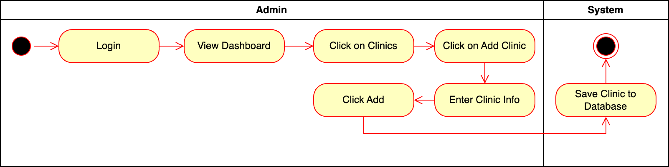
Figure 102- Activity Diagram for Add Vet Clinic

Introduction/Purpose of feature:
The "Add Vet Clinic" feature enables administrators to register new clinics by entering required details and saving them to the database.

Stimulus/Response sequence:
- Administrator logs into the system.
- The system displays the dashboard.
- Administrator clicks "Clinics."
- Administrator clicks "Add Clinic."
- Administrator enters clinic details in the provided form.
- Administrator clicks "Add."
- The system validates and saves the clinic details.
- The system confirms successful addition.

Associated functional requirements:
- The system shall provide a login mechanism to ensure only authorized admins can access clinic management features.
- The system shall display a dashboard after successful login, including the "Clinics" option.
- The system shall allow the admin to navigate to the clinics section by clicking on the "Clinics" option.
- The system shall provide an "Add Clinic" button in the clinics section.
- The system shall display a form for entering clinic information when the "Add Clinic" button is clicked.
- The system shall allow the admin to input the necessary clinic details in the form.
- The system shall save the clinic details to the database upon clicking the "Add" button.
- The system shall validate the clinic information for completeness and correctness before saving.
- The system shall notify the admin if the clinic is successfully added to the database.
- The system shall handle errors gracefully, notifying the admin if saving the clinic fails.

Add Pet Friendly Taxi
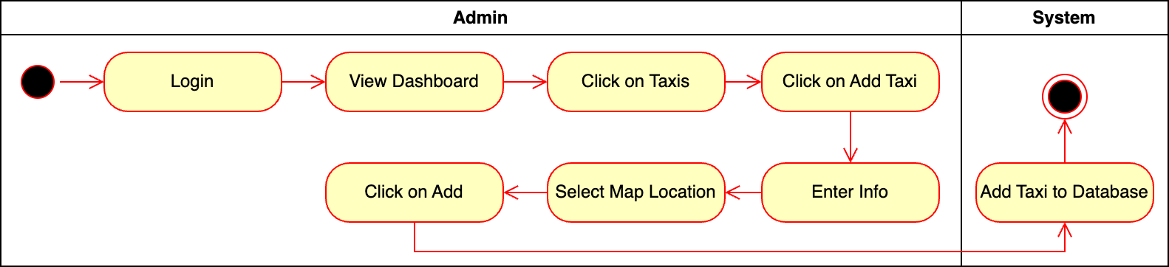
Figure 103- Activity Diagram for Add Taxi

Introduction/Purpose of feature:
The "Add Pet Friendly Taxi" feature allows administrators to register new taxis by entering details, setting locations, and saving them to the database.

Stimulus/Response sequence:
- Administrator logs into the system.
- The system displays the dashboard.
- Administrator clicks "Taxis."
- Administrator clicks "Add Taxi."
- Administrator enters taxi details in the provided form.
- Administrator sets the taxi’s location on a map.
- Administrator clicks "Add."
- The system validates and saves the taxi details.
- The system confirms successful addition.

Associated functional requirements:
- The system shall provide a login mechanism to ensure only authorized admins can access taxi management features.
- The system shall display a dashboard after successful login, including the "Taxis" option.
- The system shall allow the admin to navigate to the taxis section by clicking on the "Taxis" option.
- The system shall provide an "Add Taxi" button in the taxis section.
- The system shall display a form for entering taxi details when the "Add Taxi" button is clicked.
- The system shall allow the admin to select the taxi’s location using an interactive map.
- The system shall validate the taxi information and location for correctness and completeness.
- The system shall save the taxi details, including the map location, to the database upon clicking the "Add" button.
- The system shall notify the admin if the taxi is successfully added to the database.
- The system shall handle errors gracefully, notifying the admin if saving the taxi fails.

Add Pet Food Store
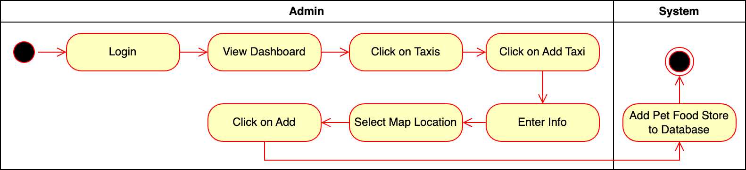
Figure 104- Activity Diagram for Add Pet Food Store

Introduction/Purpose of feature:
The "Add Pet Food Store" feature enables administrators to register new stores by entering required details and saving them to the database.

Stimulus/Response sequence:
- Administrator logs into the system.
- The system displays the dashboard.
- Administrator clicks "Pet Food Store."
- Administrator clicks "Add Store."
- Administrator enters store details in the provided form.
- Administrator clicks "Add."
- The system validates and saves the store details.
- The system confirms successful addition.

Associated functional requirements:
- The system shall provide a login mechanism to ensure only authorized admins can access pet food store management features.
- The system shall display a dashboard after successful login, including the "Pet Food Store" option.
- The system shall allow the admin to navigate to the pet food store section by clicking on the "Pet Food Store" option.
- The system shall provide an "Add Store" button in the pet food store section.
- The system shall display a form for entering pet food store details when the "Add Store" button is clicked.
- The system shall allow the admin to input the necessary pet food store details in the form.
- The system shall save the pet food store details to the database upon clicking the "Add" button.
- The system shall validate the pet food store information for completeness and correctness before saving.
- The system shall notify the admin if the pet food store is successfully added to the database.
- The system shall handle errors gracefully, notifying the admin if saving the pet food store fails.

Delete Vet Clinic
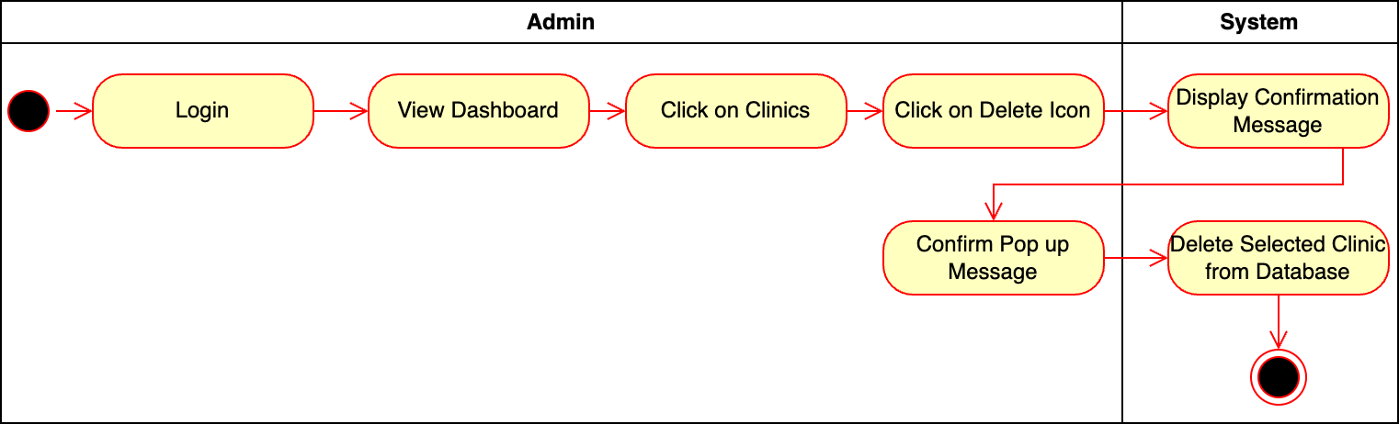
Figure 105- Activity Diagram for Delete Vet Clinic

Introduction/Purpose of feature:
The system shall allow the admin to delete a clinic by clicking on the delete icon, confirming the action via a confirmation message, and then removing the clinic from the database.

Stimulus/Response sequence:
- The admin logs into the system.
- The admin views the dashboard displayed after login.
- The admin clicks on the "Clinics" option in the dashboard.
- The admin clicks on the delete icon next to the clinic to be removed.
- The system displays a confirmation message asking the admin to confirm the deletion.
- The admin confirms the deletion action by clicking "Confirm" on the pop-up message.
- The system deletes the selected clinic from the database.

Associated functional requirements:
- The system shall provide a login mechanism to ensure only authorized admins can access clinic management features.
- The system shall display a dashboard after successful login, including the "Clinics" option.
- The system shall allow the admin to navigate to the clinics section by clicking on the "Clinics" option.
- The system shall display a delete icon next to each clinic in the clinics section.
- The system shall display a confirmation message when the delete icon is clicked.
- The system shall allow the admin to confirm the deletion by clicking a "Confirm" button in the pop-up message.
- The system shall delete the selected clinic from the database after confirmation.
- The system shall notify the admin if the clinic has been successfully deleted.
- The system shall handle errors gracefully, notifying the admin if the clinic deletion fails.

Delete Taxi
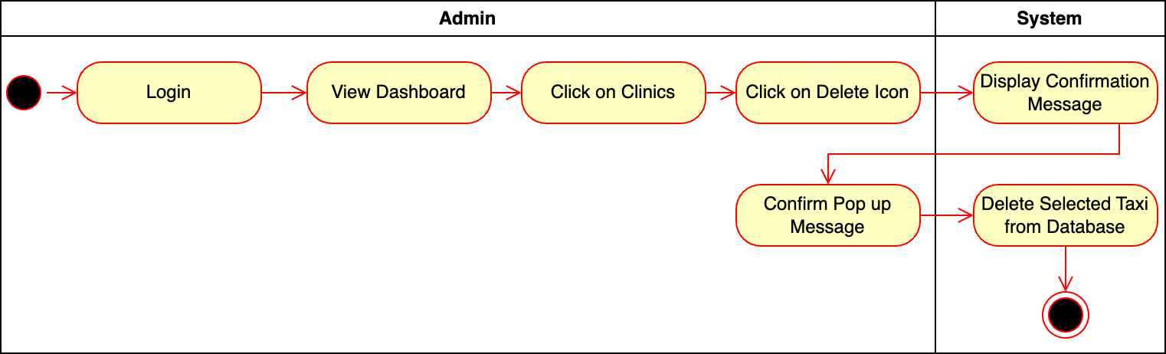
Figure 106- Activity Diagram for Delete Taxi

Introduction/Purpose of feature:
The "Delete Taxi" feature allows administrators to remove taxis by confirming the action and deleting them from the database.

Stimulus/Response sequence:
- Administrator logs into the system.
- The system displays the dashboard.
- Administrator clicks "Taxis."
- Administrator clicks the delete icon next to the desired taxi.
- The system displays a confirmation message.
- Administrator confirms the deletion by clicking "Confirm."
- The system deletes the selected taxi and notifies the administrator.

Associated functional requirements:
- The system shall provide a login mechanism to ensure only authorized admins can access taxi management features.
- The system shall display a dashboard after successful login, including the "Taxis" option.
- The system shall allow the admin to navigate to the taxis section by clicking on the "Taxis" option.
- The system shall display a delete icon next to each taxi in the taxis section.
- The system shall display a confirmation message when the delete icon is clicked.
- The system shall allow the admin to confirm the deletion by clicking a "Confirm" button in the pop-up message.
- The system shall delete the selected taxi from the database after confirmation.
- The system shall notify the admin if the taxi has been successfully deleted.
- The system shall handle errors gracefully, notifying the admin if the taxi deletion fails.

Delete Pet Food Store
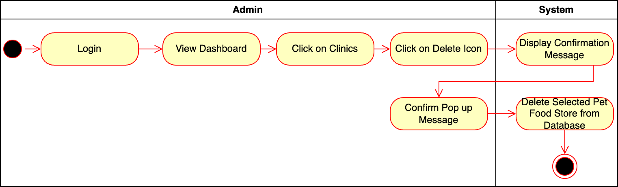
Figure 107- Activity Diagram for Delete Pet Food Store

Introduction/Purpose of feature:
The "Add Pet Food Store" feature enables administrators to register new stores by entering required details and saving them to the database.

Stimulus/Response sequence:
- Administrator logs into the system.
- The system displays the dashboard.
- Administrator clicks "Pet Food Store."
- Administrator clicks "Add Store."
- Administrator enters store details in the provided form.
- Administrator clicks "Add."
- The system validates and saves the store details.
- The system confirms successful addition.

Associated functional requirements:
- The system shall provide a login mechanism to ensure only authorized admins can access pet food store management features.
- The system shall display a dashboard after successful login, including the "Pet Food Stores" option.
- The system shall allow the admin to navigate to the pet food store section by clicking on the "Pet Food Stores" option.
- The system shall display a delete icon next to each pet food store in the pet food store section.
- The system shall display a confirmation message when the delete icon is clicked.
- The system shall allow the admin to confirm the deletion by clicking a "Confirm" button in the pop-up message.
- The system shall delete the selected pet food store from the database after confirmation.
- The system shall notify the admin if the pet food store has been successfully deleted.
- The system shall handle errors gracefully, notifying the admin if the pet food store deletion fails.

Delete User
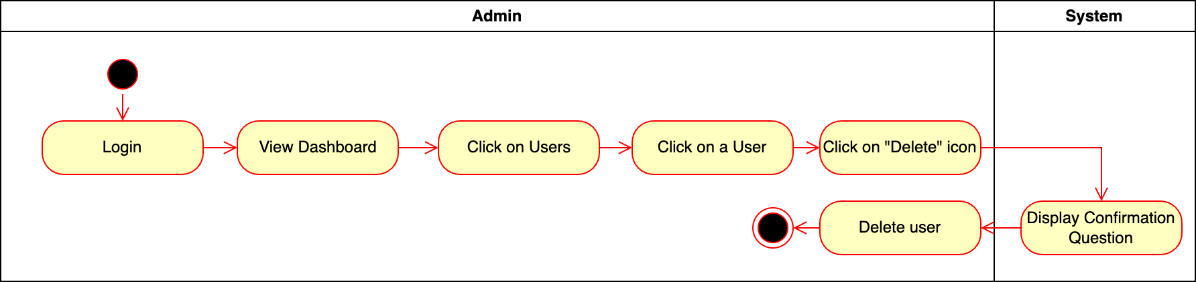
Figure 108- Activity Diagram for Delete User

Introduction/Purpose of feature:
The "Delete User" feature allows administrators to remove users from the system, ensuring that only active and authorized users remain. A confirmation dialog prevents accidental deletions.

Stimulus/Response sequence:
- Administrator logs into the system.
- The system displays the dashboard.
- Administrator clicks "Users."
- The system displays a list of users.
- Administrator clicks the "Delete" icon next to the desired user.
- The system displays a confirmation message.
- Administrator confirms the deletion by clicking "Confirm."
- The system deletes the selected user and updates the displayed list.

Associated functional requirements:
- The system must authenticate the admin during login and grant access to the dashboard upon successful authentication.
- The system must provide a section in the dashboard to display all registered users.
- The system must allow the admin to select a user and trigger a deletion action via a "Delete" icon.
- The system must display a confirmation dialog when the "Delete" icon is clicked to prevent accidental deletions.
- The system must remove the user permanently from the database upon confirmation and update the displayed user list.
- The system must handle errors, such as attempting to delete a user that no longer exists, gracefully and display appropriate error messages.

Use Case
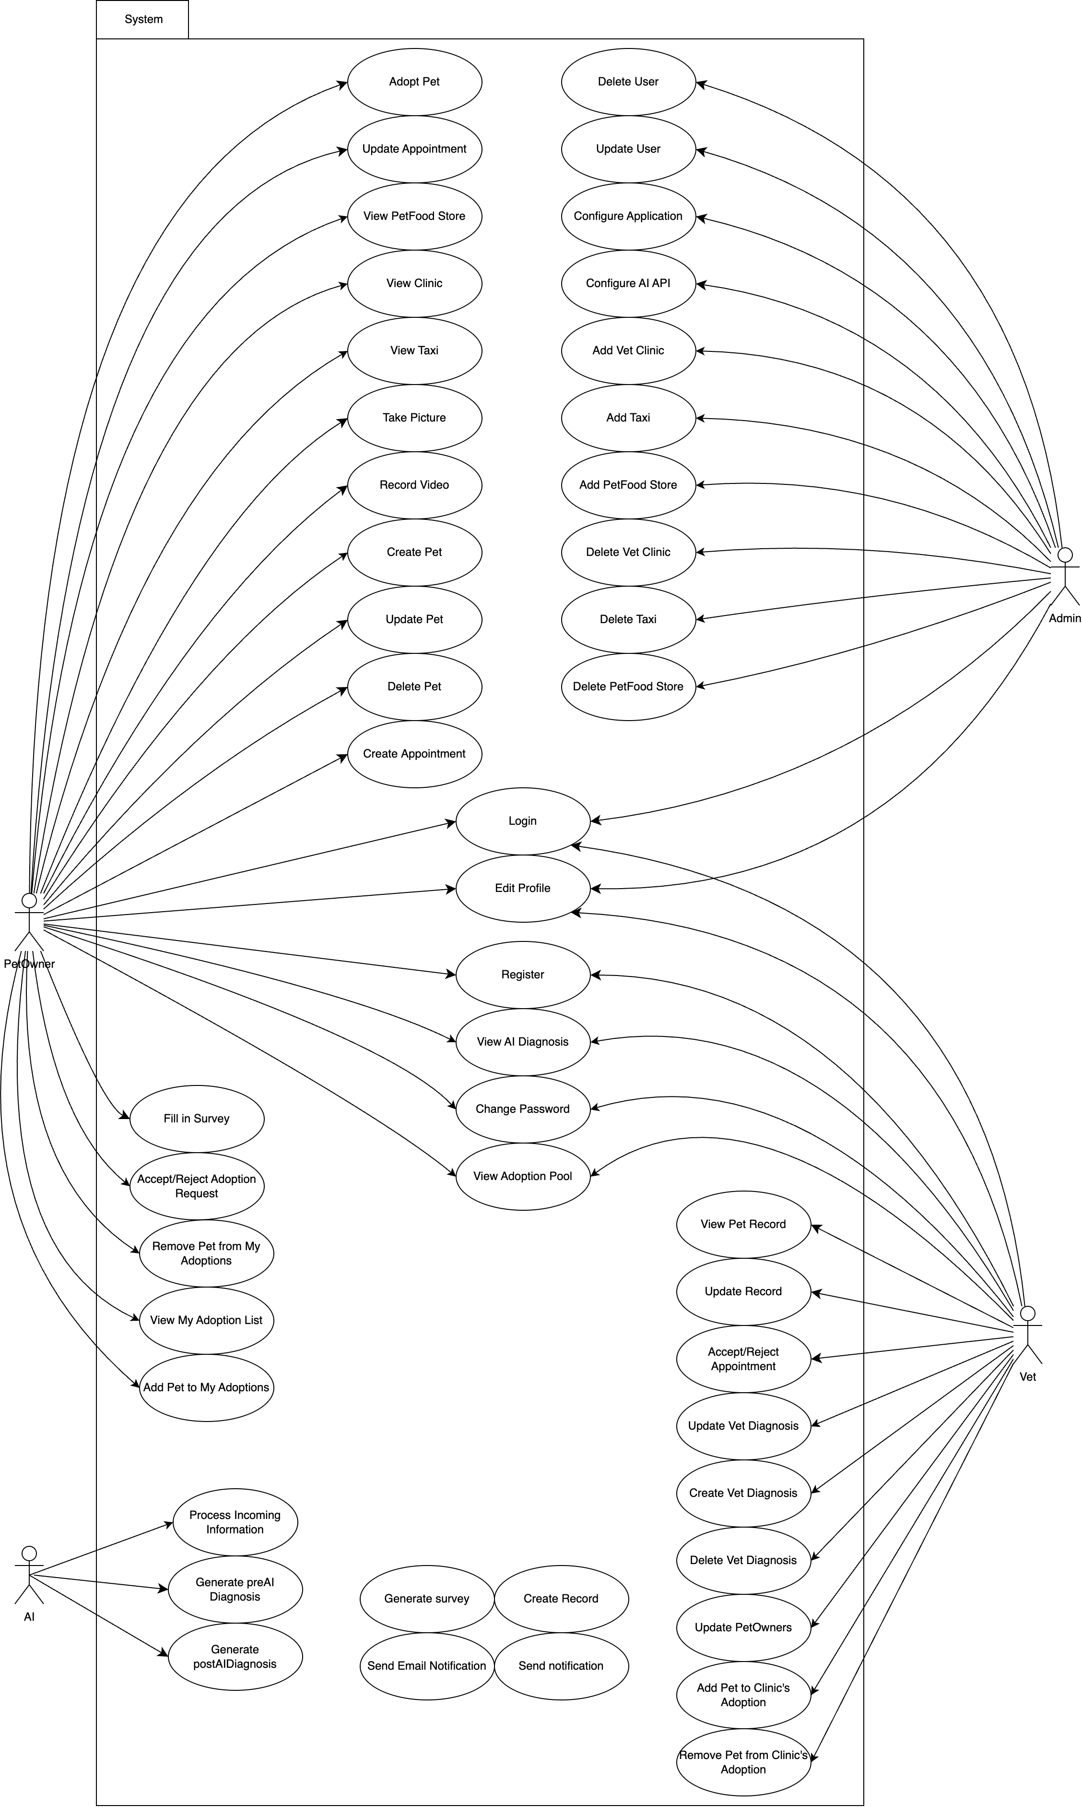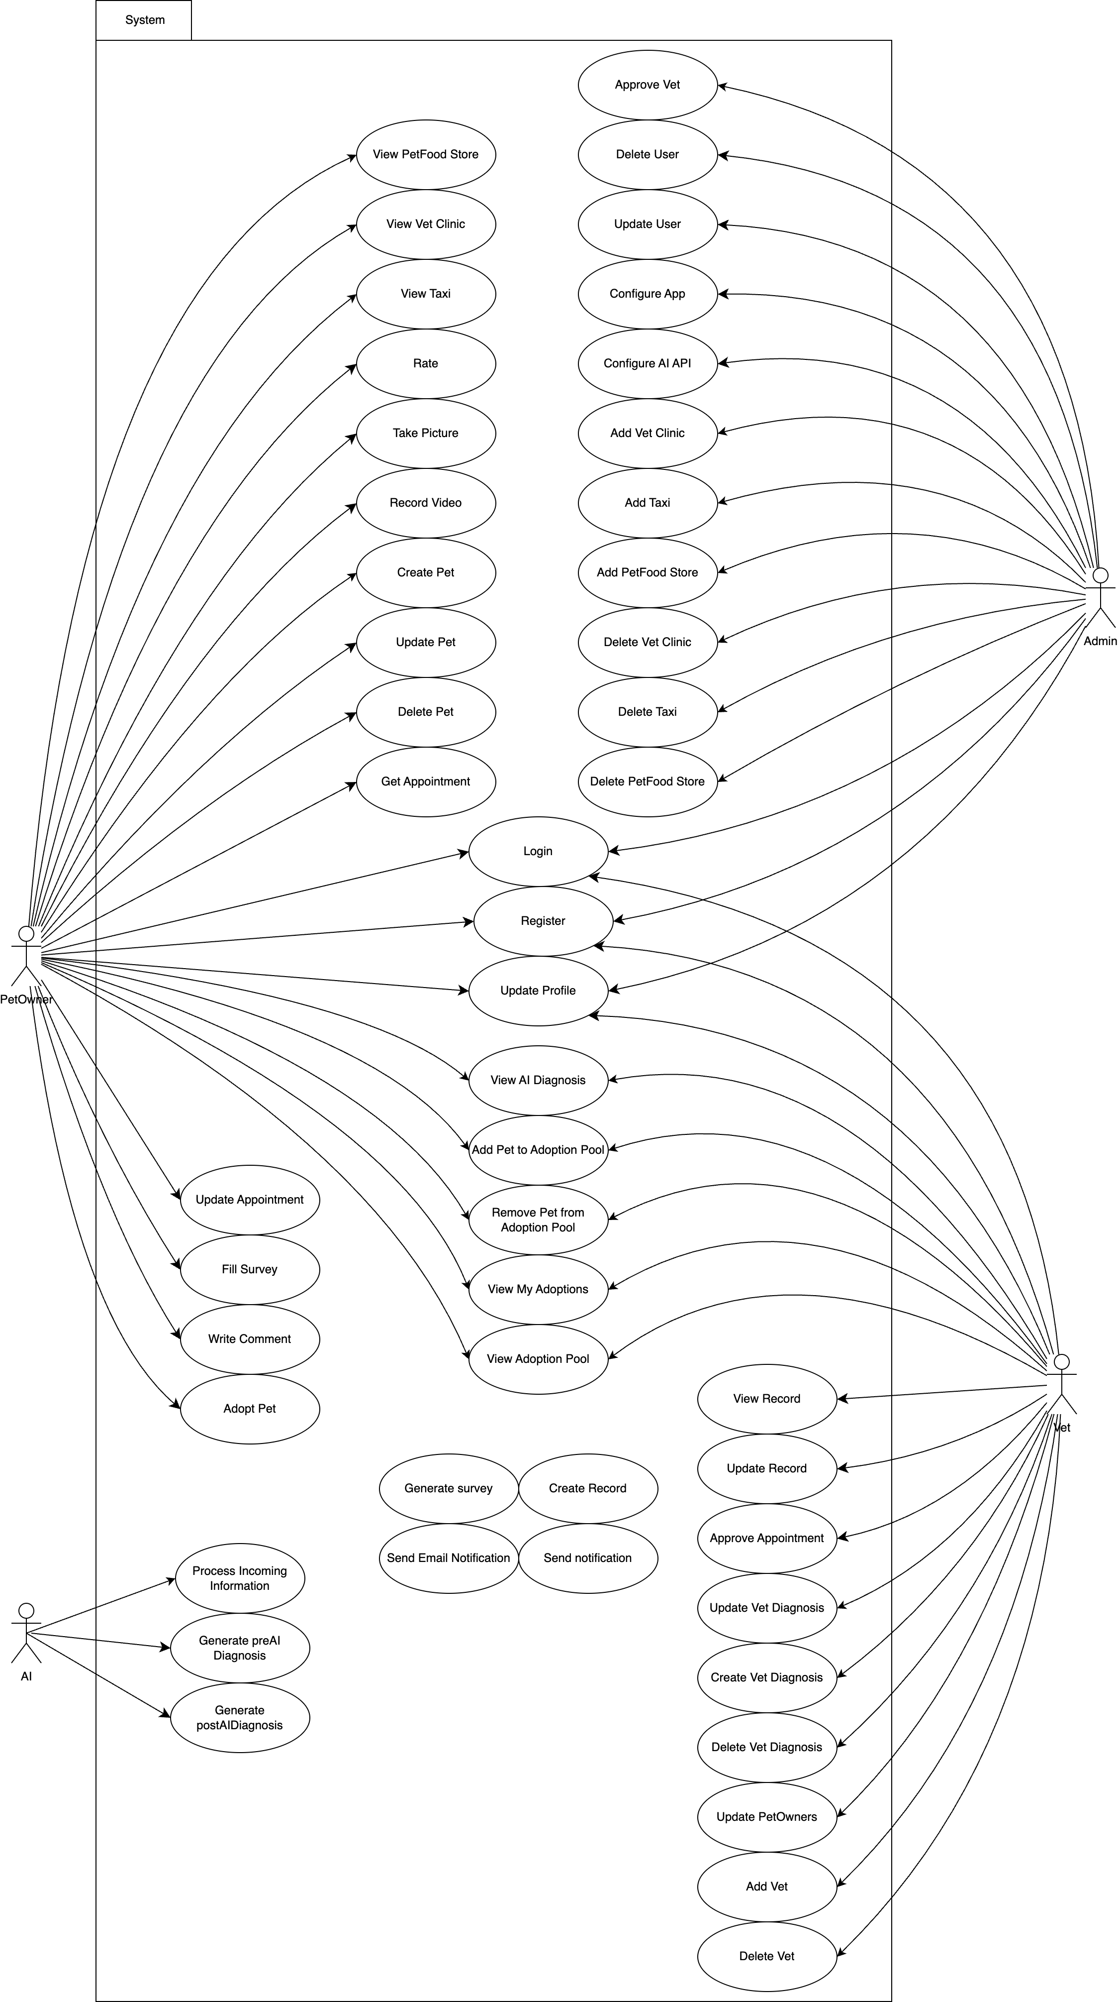
Figure 109- Use Case Diagram

Performance requirements
- Software must be able to handle 200 users at a given time without delays.
- Software must be able to start mobile application in under 5 seconds for at least %90 of devices that can run Android version 10.
- Software must be able to respond to user commands in under a second except file uploads for mobile application.
- Software must be using necessary resources for their respective platforms; 400MB ram usage at most for mobile application and 300 MB ram usage at most for web application.
- System must be able to respond to user’s request for pre-diagnosis in under 20 seconds excluding file uploads.

Logical database requirements
Database will contain various types of data and entities. Buddy’s database will consist of 2 relation networks basically. First for user specific interactions and second for everything else.

Design constraints

Performance constraints
Response Time:
- Diagnostic results (AI-based) must be generated and delivered to users within 2 seconds for small media inputs and 5 seconds for larger files (e.g., videos).
- Appointment booking must respond to user actions within 500 milliseconds.
Uptime:
- The system must maintain an uptime of 99.9%, ensuring high availability for users.
Throughput:
- The system must support at least 1,000 concurrent users without degradation in performance.
Error Handling:
- All modules must include mechanisms for handling failures gracefully (e.g., retries for failed API calls, informative error messages for users).

Legal and ethical constraints
Informed Consent:
- Users must provide explicit consent for:
- Storing their data.
- Using AI to process diagnostic results.
- Consent management must be traceable and revisable at any time.
Ethical AI:
- AI diagnostic results must include an explanation component (e.g., "The condition is likely based on symptoms A and B") to ensure transparency and user trust.

Usability constraints
User-Friendly Interfaces:
- Both web and mobile interfaces must follow WCAG 2.1 guidelines to ensure accessibility for users with disabilities.
- Navigation must be intuitive, with key functions (e.g., booking appointments, uploading media) accessible within 3 clicks.
Localization:
- The system must support multiple languages (e.g., English, Turkish) to cater to the target user base.
- Time zones must be automatically adjusted based on the user’s location.

Standards compliance
Data Privacy and Security Regulations:
- Buddy must comply with GDPR and CCPA standards to ensure the protection of user data.
- User input and diagnostic results must be encrypted both in transit and at rest to prevent unauthorized access.
Data Naming Conventions:
- All stored data must adhere to consistent naming conventions for easy retrieval and audit purposes (e.g., "Pet_Profile_ID_<unique_number>").

Software system attributes

Reliability
- System should be online for 7/24 except there is maintenance going on.
- Maintenance or updates should not surpass at most 1 Hour continuously and should be done between 23:00 UTC and 03:00 UTC.
- System must backup itself every week to ensure even if a disaster happens, it can recover most of it.

Availability
- System should be online for 7/24 except there is maintenance going on.

Security
Buddy’s server will use a hosting firm such as AWS for it system to protect itself from most attacks. In addition to this, Buddy’s all sent and received data will be encrypted. Even in case of database breach our data will not be valuable to parties since stored data also will be encrypted as well.

Maintainability
Modularity
The app will use a modular architecture to separate core components such as symptom input processing, AI diagnosis, user profile management, and report generation. This ensures that changes in one module do not affect others, simplifying maintenance.
Dependency Management
Third-party libraries and frameworks used must be documented and version-controlled to ensure compatibility and ease of updates.
Regular dependency checks will be performed to address deprecated or outdated packages.

Portability
- System will be able to go online on any platform that can host a web app and website.
- System’s database will be able to backup itself and restore from backup but due to its estimated size this ability will be the most time-consuming portability task.
- Due to online system being hosted on hosting services it will be easy to search for alternatives and continue the platform with a new service without delays.

References
The resources used to produce this document should be listed here and referenced in the relevant text of this document
[1] | Software Engineeering Department, "Graduation Projects," SENG, [Online]. Available: https://seng.cankaya.edu.tr/graduation-projects/. [Accessed 28 June 2024].
[2] IEEE Standard 830-1998 - IEEE Recommended Practice for Software Requirements Specifications: This standard was used as a guideline for structuring and formatting the SRS document.
[3] ISO/IEC 9126 - Software Engineering - Product Quality: This international standard was consulted to ensure the quality attributes and characteristics of the mobile app are properly defined and addressed.

