 | ÇANKAYA UNIVERSITY  Software Engineering Department | 

SENG 491 – 492 Graduation Project
Software Design
Description

BUDDY-AI Driven Pet Disease-Diagnosis-Treatment Manager Tool

Tanayça Ünlütürk- 202128203
Çağan Sezim- 202128020
Eda Kocaman- 202028003
Dila Tümür- 202028024

Version 1.1

Table of Contents
1 Introduction 1
1.1 Purpose 1
1.2 Scope 1
1.3 Definitions, acronyms, and abbreviations 1
1.4 Overview 1
1.5 Version History 1
2 Architecture 2
2.1 Clients 2
2.2 Web Application 2
2.3 Mobile Application 2
2.4 AI Component 3
2.5 Application Server 3
2.6 Database Server 3
3 User Interface 4
3.1 Mobile Interfaces 4
Start Page 4
Login Page 5
Sign-Up Page 5
Dashboard 6
Navigation Bar 7
Notification Bar 7
My Pets Page 8
Pet Profile Page 8
Records List Page 9
Record Page 9
Survey Content Page 10
Image/ Video Content Page 10
AI Diagnosis Page 11
Vet Diagnosis Page 11
Current Appointments Page 12
Requested Appointments Page 12
Old Appointments Page 13
Edit Appointment Page 13
Delete Appointment Request Pop-up 14
Cancel Appointment Pop-up 14
Get Appointment Page 15
My Profile Page 15
Settings Page 16
Delete Account Pop-up 16
Change Password Page 17
My Adoptions Page 18
Adoption Pool Page 18
Map Page 19
Vet Clinic Map 19
Pet Food Store Map 20
Pet Friendly Taxi Map 20
What is Wrong with My Pet Section 21
Fill Survey Page 22
Granted Permission Pop-up 22
Media Interaction Pages 23
AI Diagnosis Results Pages 24
3.2 Web Interfaces 25
Start Page 25
Login Page 26
Sign up Page 27
Home Pages 28
Navigation Bar 29
Appointments Page 30
Patients Page 31
Customers Page 32
Appointment Requests Page 33
Pet Profile Page 34
Pet Record Page 35
Vet Profile Page 36
My Records Page 37
My Clinic Page 38
Clinic’s Adoption Page 39
Adoption Pool Page 40
Adoption Profile Page 41
Admin Dashboard 42
Admin Application Configuration Page 43
Admin API Configuration Page 44
Admin Clinics Page 45
4 High Level Design 46
4.1 Web Module 46
4.2 Mobile Module 46
4.3 AI Module 46
4.4 Server Layer 47
4.5 Database 47
5 Low Level Design 47
5.1 AI Diagnosis Module 47
Step-by-step Description: 47
5.2 Appointment Management Module 48
Step-by-step Description: 48
5.3 User Management Module 49
Step-by-step Description: 49
6 Database Design 51
6.1 ER Diagram 51
6.2 Class Diagram 52
6.3 Tables 53
User Table 53
Admin Table 53
PetOwner Table 53
Veterinarian Table 1
Adoption Table 1
Appointment Table 1
Pet Table 1
Survey Table 55
Record table 55
Diagnosis Table 55
Vet_Diagnosis Table 55
AI_Diagnosis Table 55
Rating Table 55
Taxi_Rating Table 55
FoodStore_Rating Table 55
Clinic_Rating 55
Diagnosis Rating 55
Facility Table 55
Clinic Table 55
Taxi Table 55
PetFoodStore Table 55
Location Table 55
7 Work Breakdown Structure 55
8 References 56

Introduction

Purpose
The purpose of this Software Design Document (SDD) is to provide a comprehensive overview of the architectural and design decisions for the Buddy Platform. This platform consists of two key components: the Buddy Mobile Application, which leverages AI for diagnosing potential pet health issues through image, video, and survey context analysis, while also connecting pet owners with veterinarians and other related services; and the Buddy Web Application, which is designed specifically for veterinarians to efficiently manage their appointments, patient records, and other critical data. The web platform also empowers veterinarians to maintain their profiles, access statistical data, and perform essential administrative tasks. Both the mobile and web platforms are integrated with a unified database, ensuring consistent and synchronized data management across all services and features.
This document is intended for software architects, developers, testers, and other stakeholders involved in the development and deployment of Buddy.

Scope
This document covers the design of the Buddy platform, including software and hardware architectures, user interfaces, database design, system modules, and their interactions. It excludes detailed implementation code and testing specifications.

Definitions, acronyms, and abbreviations
- AI: Artificial Intelligence
- KVKK: Turkish Data Protection Law
- SRS: Software Requirements Specification
- SDD: Software Design Description
- Vet: Veterinarian.
- Pet Owner: End-users who own pets and use the mobile application.
- Admin: System administrators responsible for managing backend settings and data.
- Clinique: Veterinary Clinic.
- Buddy: AI Driven Pet Disease-Diagnosis-Treatment Manager Tool
- UI: User Interface
- JWT: JSON Web Token

Overview
The rest of this document contains the architectural design, hardware/software requirements, UI mockups, high-level design of modules, and detailed low-level design for individual components.
The document is structured into sections for introduction, architecture, UI, high-level design, and low-level design.

Version History
Version No | Description of change | Date
1.0 | Initial Release | 05.12.2024
1.1 | Finalize SDD | 29.12.2024

Architecture
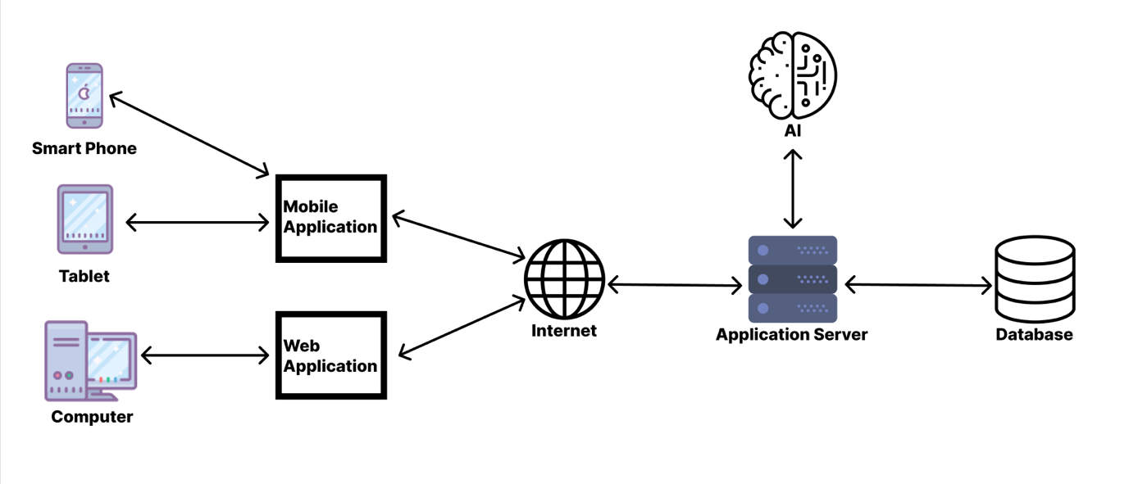

Clients
- Mobile Phones
  - OS: Android 10+, IOS 11+
  - Memory: Minimum 2 GB RAM
- Tablets
  - OS: Android 10+, iPadOS 14+
  - Memory: Minimum 2 GB RAM
- Personal Computers
  - OS: Windows 10 or macOS Mojave+
  - Memory: Minimum 4 GB RAM
  - Browser Compatibility: Chrome, Opera, Firefox, Safari

Web Application
The Web Application is designed for veterinarians to manage their clinic profiles, appointments, patient records, and clinic settings.
- Frontend: Built using HTML5, CSS3, JavaScript (React.js or Angular).
- Backend: Connected to the Application Server via RESTful APIs.
- Features:
  - Appointment management (view, edit, delete).
  - Patient record access and updates.
  - Clinic management tools.

Mobile Application
The Mobile Application is the primary client for pet owners to interact with Buddy services.
Features:
- Pet profile management.
- AI-powered health diagnosis via images, videos, and surveys.
- Appointment booking with veterinarians.
- Notifications and adoption pools.

AI Component
The AI component handles image/video analysis, symptom-based diagnosis, and prediction algorithms. It operates as a microservice or module within the overall architecture, with dedicated resources for real-time and batch processing tasks.
- AI Server
  - OS: Linux Ubuntu 20.04, Windows Server 2019+
  - Memory: Minimum 32 GB RAM
  - Processor: 16-core CPU
  - GPU: High-performance GPU (e.g., NVIDIA A100, RTX 3090)
  - AI Frameworks: TensorFlow 2.x, PyTorch 1.x
  - Storage: 1 TB SSD for model storage and temporary processing
- AI Features
  - Image/Video Analysis: Identify health issues from media content.
  - Symptom-Based Surveys: Use machine learning to correlate user input with likely diagnoses.
  - Result Delivery: Generate and share diagnosis results with the mobile or web client in real-time.
- AI Integration
  - APIs: RESTful APIs for seamless integration with mobile, web, and database servers.
  - Preprocessing: Raw data preprocessing (image scaling, video frame extraction).
  - Postprocessing: Formatting AI results for the application server.
- Deployment
  - The AI module can be containerized using Docker for scalability and compatibility across environments.

Application Server
- OS: Linux Ubuntu 20.04, Windows 10+, MacOS Mojave+
- Memory: Minimum 16 GB RAM
- Processor: 8-core CPU
- GPU: Dedicated GPU for AI processing

Database Server
- OS: Linux Ubuntu 20.04, Windows 10+, MacOS Mojave+
- Memory: Minimum 32 GB RAM
- Storage: 1 TB SSD (expandable)

User Interface

Mobile Interfaces
The Buddy Mobile Application offers a seamless and intuitive experience for pet owners, featuring the following pages:

Start Page
Title | Start Page
Welcome Message | A text label displaying "WELCOME to BUDDY" to greet users upon launching the app. This element establishes the branding and purpose of the application.
Logo/Icon Area | A placeholder representing the application's logo or main graphic to enhance visual appeal and identity.
Start Button | A button labeled "LET'S START" for user interaction. Clicking this button navigates the user to the main features or login page of the application.
Functionality | The welcome screen is the first interaction point for pet owners. It introduces the app and offers a simple and clean interface to begin the experience.  The "LET'S START" button triggers the transition to the main functionality of the app.
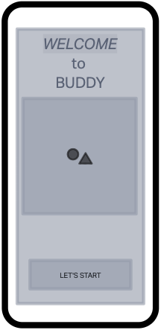
Figure 1

Login Page
Title | Login Page
Email | A text input field for pet owners to enter their registered email address.
Password | A secure text input field where pet owners can enter their account password. The input is masked for privacy.
Login | A button labeled "LOGIN" to submit the entered credentials.
Sign-up | A button labeled "SIGN UP," redirecting pet owners to the registration page to create a new account.
Continue without Login | A button redirects unregistered users to the "What’s Wrong with My Pet?" page.
Functionality | Allows pet owners to securely log in to their accounts by entering their email and password, granting access to their personalized dashboard and app features.
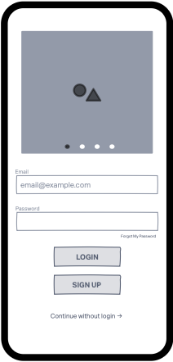
Title | Sig-up Page
Name | A textbox collects the pet owner’s first name for identification.
Surname | A textbox collects the pet owner’s last name.
E-mail | A textbox captures the pet owner’s email address for communication login credentials, and account verification.
Phone | A textbox gathers the pet owner’s phone number for verification, notifications, or recovery options.
Password | A textbox secures the pet owner’s account.
Confirm Password | A textbox ensures the pet owner correctly remembers their password by re-entering it.
KVKK | A checkbox ensures the pet owner agrees to terms and conditions and complies with legal data protection regulations.
Functionality | Enables pet owners to create a new account by providing their personal information, allowing them to access the app’s features and manage their pets effectively.
Figure 2

Sign-Up Page
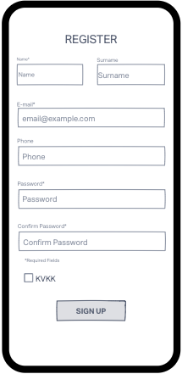
Figure 3

Dashboard
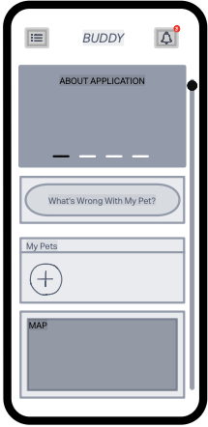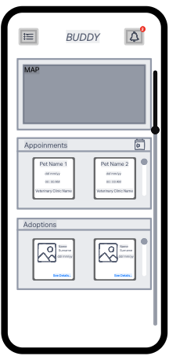
Title | Dashboard
About Application | A visual slideshow showcasing key features and information about the application.
What is Wrong with My Pet | A button that redirects pet owners to the "What’s Wrong with My Pet?" page.
My Pets | A section where pet owners can view their registered pets. By clicking on this section, users are redirected to the My Pet List page.
Map | A map feature that helps pet owners locate pet-friendly services, such as veterinary clinics, pet food stores and taxi nearby.
Appointments | A section where pet owners can view their active appointments for their pets. By clicking on this section, pet owners are redirected to the Appointments page.
Adoptions | A section where pet owners can view available pets for adoption from the adoption pool. By clicking on this section, pet owners are redirected to the Adoptions page.
Functionality | Serves as the main hub where pet owners can access key features, such as viewing pet information, appointments, and notifications, providing a centralized overview of their activities within the app.
Figure 4 Figure 5

Navigation Bar
Title | Navigation Bar
My Profile | A button that redirects pet owners to the My Profile page.
Settings | A button that redirects pet owners to the Settings page.
Help | A button that provides pet owners with access to assistance and support.
Log Out | A button that allows pet owners to log out of their account.
Functionality | Provides pet owners with quick access to key sections of the app, such as their profile, settings, help resources, and the option to log out, ensuring seamless navigation across the platform.
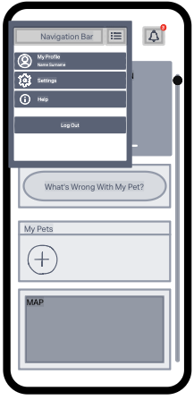
Figure 6

Notification Bar
Title | Notification Bar
Notifications | A list that displays notifications
Functionality | A section that displays important alerts and updates for pet owners. The notification bar shows real-time notifications such as upcoming appointments, messages, reminders, and app updates. It ensures pet owners stay informed about key events and actions related to their pets and account.
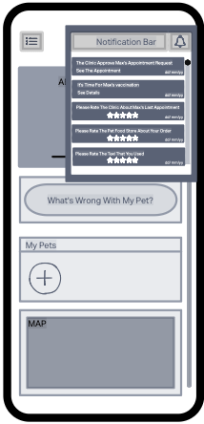
Figure 7

My Pets Page
Title | My Pets Page
Search Bar | A search bar that allows pet owners to search for specific pets within their My Pet List.
Add Pet | A button that enables pet owners to add a new pet to their account.
Pet | A section displaying detailed information about each pet. By clicking on this section, pet owners are redirected to the Pet Profile page, where they can view or edit further details.  The section also includes Delete and Edit icons, allowing pet owners to delete the pet's profile or edit its information as needed.
Functionality | A page where pet owners can manage and view details of their registered pets, with options to search, add, edit, or delete pet profiles.
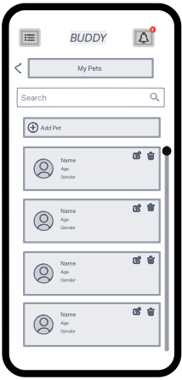
Figure 8
Title | Pet Profile Page
Pet | A section displaying detailed information about each pet.  The section also includes Edit icon, allowing pet owners to edit pet’s information as needed.
Record List | A section that displays the most recent records related to the pet, showing a few of the latest entries. Pet owners can click the Record List button to be redirected to the Record List Page.  By clicking on any specific record in the section, pet owners are redirected to the Record Page, where they can view detailed information about that record.
Appointments | A section that displays the most recent appointments related to the pet, showing a few of the latest entries. Pet owners can click the Appointments button to be redirected to the Appointments Page.  By clicking on any specific appointment in the list, pet owners are redirected to the Appointment Page, where they can view detailed information about that appointment.
Functionality | Allows pet owners to view detailed information about their pet, including basic details, recent records, and appointments.

Pet Profile Page
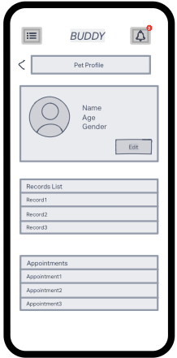
Figure 9

Records List Page
Title | Records List Page
Search | A search bar that allows pet owners to search for specific record within their Records List.
Add Record | A button that redirects pet owners to the “What’s Wrong with My Pet”.
Record | By clicking on a specific record, pet owners are redirected to the Record Page, where they can view the full details of that record
Functionality | Enables pet owners to view and manage all health records related to their pets, search for specific records, and add new ones. It provides quick access to detailed information for each record through the Record Page.
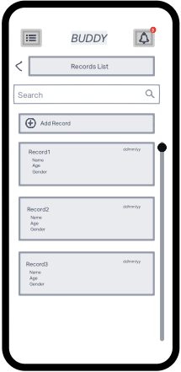
Title | Record Page
Pet Section | A section that provides brief information about the pet associated with the record, such as name, age, breed, and other basic details.
Survey Content | By clicking on this section, pet owners are redirected to the Survey Content Page, where they can view detailed survey responses.
Image-Video Content | Clicking on this section redirects pet owners to the Image-Video Content Page, where they can view the associated media files.
AI Diagnosis | By clicking on this section, pet owners are redirected to the AI Diagnosis Page, where they can view detailed diagnosis from the AI.
Vet Diagnosis | By clicking on this section redirects pet owners to the Vet Diagnosis Page, where they can see detailed feedback and diagnosis from the vet.
Functionality | Displays detailed information about a specific health record for a pet, including survey responses, images/videos, AI diagnosis, and vet diagnosis.
Figure 10

Record Page
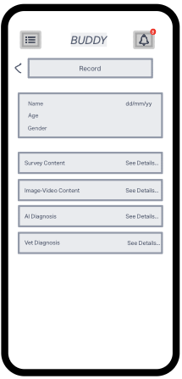
Figure 11

Survey Content Page
Title | Survey Content Page
Questions | A questions list that displays answered questions.
Functionality | A page where pet owners can view the survey information they provided while creating the record.
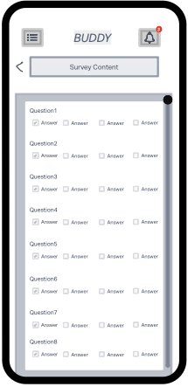
Figure 12

Image/ Video Content Page
Title | Survey Content Page
Image-Video | A section that lists the photos and videos uploaded by the pet owner while creating the record.
Functionality | A page where pet owners can view the survey information they provided while creating the record.
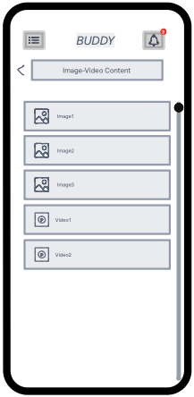
Figure 13

AI Diagnosis Page
Title | AI Diagnosis Page
Possible Issue | A section that displays a list of potential health issues identified by the AI based on the pet’s record data.
Functionality | A page where pet owners can view possible diagnoses generated by the AI based on the pet's health data from the record. This page lists potential health issues, with each diagnosis offering a brief description. By clicking on any diagnosis in the list, pet owners can view detailed information about the condition, including recommended actions and further insights.
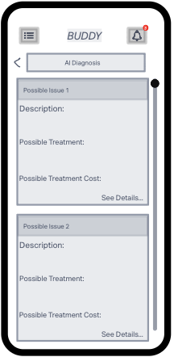
Figure 14

Vet Diagnosis Page
Title | Vet Diagnosis Page
Issue | A section that displays the diagnosis made by the veterinarian, outlining the pet’s health condition based on the examination and available data. This section provides detailed information about the identified issue, including symptoms, possible causes, and any relevant findings that assist in understanding the pet's health status.
Treatment Documents | A button that provides access to relevant medical documents, such as test results, lab reports, and other treatment-related documents for the pet. Pet owners can view or download these documents for further reference.
Functionality | Allows pet owners to access detailed insights into the veterinarian’s diagnosis and view associated treatment documents, ensuring they have all the information needed for their pet’s care.
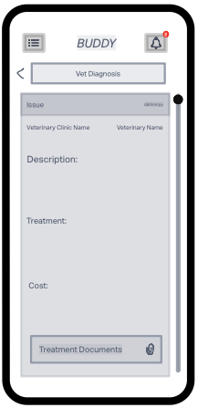
Figure 15

Current Appointments Page
Title | Current Appointments Page
Search | A search bar that allows pet owners to search through the list of appointments for specific pets or dates, making it easy to find a particular appointment among the current ones.
Current- My Requests- Old | Pet owners can switch between the current, my requests and old tabs
Appointment | A section that shows a summary of each appointment, including the date, time, and pet details. The Delete and Edit icons within this section enable pet owners to delete or modify any appointment if needed.
Functionality | A page where pet owners can view and manage all current appointments for their pets. It displays upcoming appointments with brief details, allowing pet owners to easily keep track of their pet’s scheduled visits.
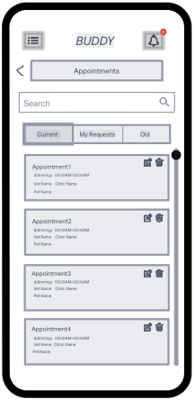
Figure 16

Requested Appointments Page
Title | Requested Appointments Page
Search | A search bar that allows pet owners to search for specific appointment requests based on pet names or dates, making it easier to find a particular request from the list.
Current- My Requests- Old | Pet owners can switch between the current, my requests and old tabs
Appointment Request | A section displaying the details of each appointment request, including the requested date, time, and reason for the appointment. Pet owners can click on the Edit or Delete icons within this section to modify or cancel their request if needed.
Functionality | Pet owners can view their pending appointment requests, track the status of each request, and manage them using the Edit and Delete icons. Once a request is approved by the veterinarian, it is moved to the Current Appointments Page for further management.
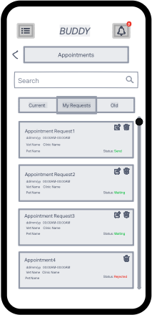
Figure 17

Old Appointments Page
Title | Old Appointments Page
Search | A search bar that allows pet owners to search through the list of past appointments based on pet names, dates, or other relevant details.
Current- My Requests- Old | Pet owners can switch between the current, my requests and old tabs
Appointment | A section that displays the details of each past appointment, such as the appointment date, time, pet, and veterinarian. Pet owners can view the summary of past appointments to track their pets' health history.
Functionality | Pet owners can view past appointments that have already occurred, helping them maintain a history of all completed appointments for their pets. Pet owners can search for specific appointments using the Search bar and access detailed information for record-keeping and reference. This page serves as a comprehensive history of completed visits.
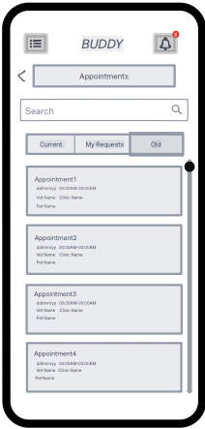
Figure 18

Edit Appointment Page
Title | Edit Appointment Page
Date | A Date Picker that allows pet owners to select a new appointment date, ensuring the schedule is updated with the correct time.
Hour | A field where pet owners can select a time for the appointment, ensuring they choose an available time slot.
Reason | A Text Box where pet owners can provide the reason for the appointment, explaining why they are requesting the visit.
Send Update Request | A button that, when clicked, submits the updated appointment details to the veterinarian for approval. Once the request is sent, the veterinarian will review and approve or reject the updated appointment.
Functionality | Pet owners can edit the date, time, and reason for an existing appointment using the Date Picker, Hour selection, and Text Box. Once the changes are made, clicking Send Update Request will send the updated details to the veterinarian for approval.
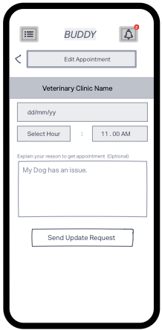
Figure 19

Delete Appointment Request Pop-up
Title | Delete Appointment Request Pop-up
Confirmation Message | A message that asks the pet owner to confirm their decision to delete the appointment request, ensuring they are aware of the action they are about to take.
Cancel | A button that allows the pet owner to cancel the deletion process and close the pop-up without making any changes to the appointment request.
Delete | A button that confirms the deletion of the appointment request. Clicking this button will permanently remove the request from the system.
Functionality | This pop-up allows pet owners to delete a requested appointment by confirming the action. The Cancel button lets them abort the process, while the Delete button completes the removal of the appointment request from the system.
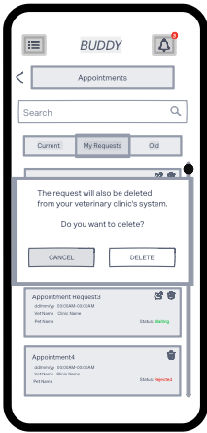
Figure 20

Cancel Appointment Pop-up
Title | Cancel Appointment Pop-up
Confirmation Message | A message that asks the pet owner to confirm their decision to cancel the appointment, ensuring they are aware of the action they are about to take.
Cancel | A button that allows the pet owner to cancel the cancellation process and close the pop-up without making any changes to the appointment.
Delete | A button that confirms the cancellation of the appointment. Clicking this button will remove the appointment from the system and mark it as canceled.
Functionality | This pop-up enables pet owners to cancel an appointment. The Cancel button lets them abort the process, while the Delete button completes the cancellation and removes the appointment from the system.
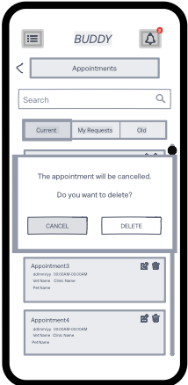
Figure 21

Get Appointment Page
Title | Get Appointment Page
Date | A Date Picker that allows pet owners to select a appointment date, ensuring the schedule is updated with the correct time.
Hour | A field where pet owners can select a time for the appointment, ensuring they choose an available time slot.
Reason | A Text Box where pet owners can provide the reason for the appointment, explaining why they are requesting the visit.
Send Appointment Request | A button that, when clicked, submits the updated appointment details to the veterinarian for approval. Once the request is sent, the veterinarian will review and approve or reject the updated appointment.
Functionality | Pet owners can edit the date, time, and reason for an existing appointment using the Date Picker, Hour selection, and Text Box. Once the changes are made, clicking Send Update Request will send the updated details to the veterinarian for approval.
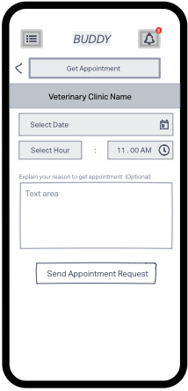
Figure 22
Title | My Profile Page
Info Section | A section contains details about the pet owner's profile, including personal information. Edit or icon within this section to modify their personal info if needed.
Profile Picture | A section that displays the pet owner’s profile picture, allowing them to visually personalize their account.
Change Profile Picture | A button that allows the pet owner to upload and change their profile picture, providing the option to update their image at any time.
About | A text field where pet owners can write and update a brief description about themselves, adding a personal touch to their profile.
Edit | A button below the About text field, allowing pet owners to modify the description they’ve written. Clicking this button enables them to update About section.
Functionality | Pet owners can view and edit their profile information. The Info Section displays the pet owner’s personal details, while the Profile Picture shows their current image. The Change Profile Picture button enables updating the profile picture, and the About text field allows the pet owner to write or edit their personal description.

My Profile Page
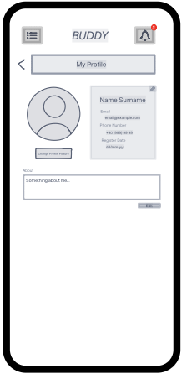
Figure 23

Settings Page
Title | Settings Page
Change Password | A button that redirects the pet owner to the Change Password page, where they can securely update their account password.
Notification Settings | A button that allows the pet owner to manage and adjust their notification preferences, enabling them to control which notifications they receive from the app.
Help | A button that provides access to help resources, allowing the pet owner to get assistance with the app, including troubleshooting and user guidance.
Delete My Account | A button that allows the pet owner to permanently delete their account, removing all personal information and associated data from the system.
Functionality | Pet owners can manage their account settings and customize their preferences.
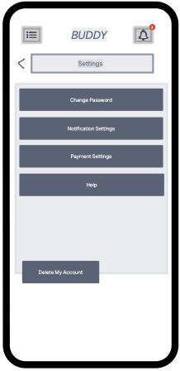
Figure 24

Delete Account Pop-up
Title | Delete Account Pop-up
Confirmation Message | A message that asks the pet owner to confirm their decision to delete the account, ensuring they are aware of the action they are about to take.
Cancel | A button that allows the pet owner to cancel the deletion process and close the pop-up without making any changes to the appointment request.
Delete | A button that confirms the deletion of the appointment request. Clicking this button will permanently remove the request from the system.
Functionality | This pop-up allows pet owners to delete an account by confirming the action. The Cancel button lets them abort the process, while the Delete button completes the removal of the appointment request from the system.
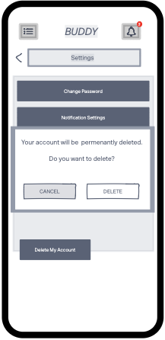
Figure 25

Change Password Page
Title | Change Password Page
Old Password | A text field where pet owners enter their current password to verify their identity before changing the password.
New Password | A text field where pet owners enter their new password. This password must meet the app's security criteria (e.g., length, special characters).
Confirm New Password | A text field where pet owners must re-enter their new password to confirm it matches the previous entry.
Functionality | This page allows pet owners to change their password. They must first enter their Old Password for authentication. Then, they can enter and confirm a New Password. Once both the new password fields match, they can submit the form to update their password securely.
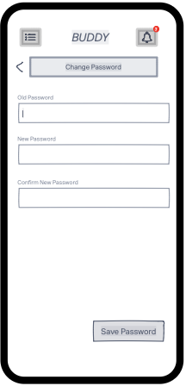
Figure 26
Title | My Adoptions Page
Search | A search bar that allows pet owners to search for specific pets within their My Adoptions list.
My Adoptions- Adoption Pool | Pet owners can switch between the My Adoptions tab, where they list their own pets for adoption, and the Adoption Pool tab, where they can explore available pets for adoption.
My Adoptions | A section that displays the list of pets the pet owner is looking to place for adoption. This section helps pet owners manage and review the pets they want to rehome.
Create Adoption | A button that pet owners can use to create a new adoption for one of their pets.
Adoption | A section that shows brief details about each pet available for adoption. Clicking on any pet will redirect the pet owner to the Adoption Profile Page, where more detailed information about the pet is provided. The section also includes Delete and Edit icons, allowing the pet owner to remove or modify their adoption preferences.
Functionality | The My Adoptions tab displays the pets the pet owner wishes to place for adoption. The Adoption section provides an overview of each pet, and clicking on a pet redirects the pet owner to the Adoption Profile Page. The Delete and Edit icons allow pet owners to modify or remove their adoption listings. Pet owners can seamlessly switch between the two tabs to manage pets they wish to adopt out or explore other available pets.

My Adoptions Page
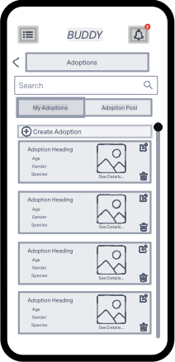
Figure 27
Title | Adoption Pool Page
Search | A search bar that allows pet owners to search for specific pets within their My Adoptions list.
My Adoptions- Adoption Pool | Pet owners can switch between the My Adoptions tab, where they list their own pets for adoption, and the Adoption Pool tab, where they can explore available pets for adoption.
Adoption Pool | A section that displays the complete list of all pets available for adoption within the system, allowing pet owners to explore and find pets they are interested in adopting.
Adoption | A section that shows brief details about each pet available for adoption. Clicking on any pet redirects the pet owner to the Adoption Profile Page, where more detailed information about the pet is provided.
Functionality | The My Adoptions tab displays the pets the pet owner wishes to place for adoption, while the Adoption Pool tab lets them explore other available pets. The Adoption section provides an overview of each listed pet, and clicking on a pet opens its detailed Adoption Profile Page.

Adoption Pool Page
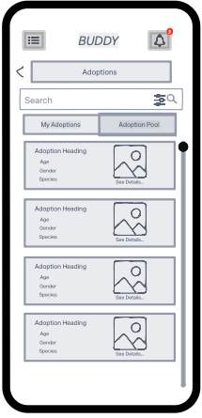
Figure 28

Map Page
Title | Map Page
Map | A general map that displays veterinary clinics, pet food stores and pet friendly taxi.
Search | A search bar that allows pet owners to search for veterinary clinics, pet food stores and pet friendly taxi.
Recent | A button for list pet owner’s recent searches on the map.
Nearby | A button for list nearby veterinary clinics, pet food stores and pet friendly taxi.
Saved | A button for list saved veterinary clinics, pet food stores and pet friendly taxi by pet owners.
Functionality | The map shows locations of veterinary clinics, pet food stores and pet friendly taxi. Search bar allows pet owners to search and filter. The buttons help pet owners to easily use the map.
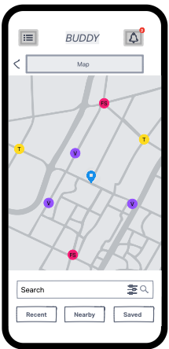
Figure 29

Vet Clinic Map
Title | Vet Clinic Map Page
Vet Clinic Name | A section that displays veterinary clinic’s name.
Photos | A section that displays veterinary clinic’s photos.
Address | A field that shows veterinary clinic’s address.
Facilities | A field that shows facilities about veterinary clinic.
Phone | A field that shows veterinary clinic’s phone.
Working Hours | A field that shows veterinary clinic’s working hours.
Get Appointment | By clicking on this button, pet owners are redirected to the Get Appointment.
Functionality | This page provides detailed information about a selected veterinary clinic from the map, including its name, address, facilities, and contact details. Pet owners can view photos of the clinic and check its working hours. The Get Appointment button enables pet owners to schedule an appointment with the clinic directly.
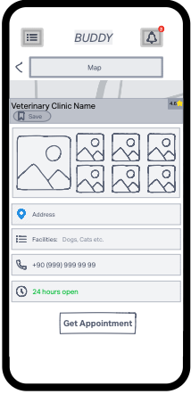
Figure 30

Pet Food Store Map
Title | Pet Food Store Map Page
Pet Food Store Name | A section that displays the name of the pet food store.
Photos | A section that showcases photos of the pet food store.
Address | A field that displays the address of the pet food store.
Facilities | A field providing information about the facilities and services available at the pet food store.
Phone | A field displaying the contact phone number of the pet food store.
Working Hours | A field showing the working hours of the pet food store.
Functionality | This page provides detailed information about a selected pet food store from the map, including its name, address, facilities, photos, contact details, and working hours. It helps pet owners easily locate and learn about pet food stores in their area.
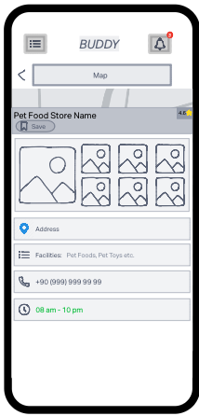
Figure 31

Pet Friendly Taxi Map
Title | Pet Friendly Taxi Map Page
Pet Friendly Taxi Name | A section that displays the name of the pet-friendly taxi service.
Photos | A section showcasing photos of the pet-friendly taxi vehicles or services.
Address | A field that provides the address or service area of the pet-friendly taxi.
Facilities | A field listing the facilities and features offered by the pet-friendly taxi service.
Phone | A field displaying the contact phone number for booking the pet-friendly taxi service.
Working Hours | A field showing the working hours during which the pet-friendly taxi service operates.
Functionality | This page provides detailed information about a selected pet-friendly taxi service from the map, including its name, photos, address, facilities, contact details, and working hours. It helps pet owners find and book transportation services suitable for their pets.
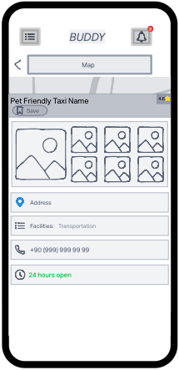
Figure 32

What is Wrong with My Pet Section
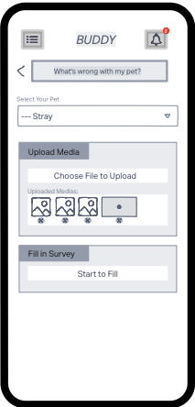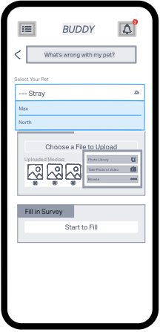
Figure 33 Figure 34
Title | What’s Wrong with My Pet Page
Select Your Pet | A dropdown menu displays registered pets (e.g., Max, North) or the option.
Upload Media | Pet owners can upload visuals or videos related to the health issue to provide more detailed information.
Choose File to Upload | The pet owner chooses how to upload media using this button.
Photo Library | A button that selects media from the device's gallery.
Take Photo or Video | A button that captures new media using the camera.
Browse | A button that browses files on the device and select one.
Uploaded Medias | A section displays the media files uploaded by the user. Users can delete any media if needed.
Fill in Survey | The "Start to Fill" button is in this section. The user can provide detailed information about their pet's health issue by filling out a survey.
Start to Fill | A button that redirects pet owners to the Fill Survey Page
Functionality | Users can upload visuals and information about their selected pet's health condition. Then, they fill out a survey to provide detailed information. This data is saved in the system for evaluation by AI or a veterinarian.

Fill Survey Page
Title | Fill Survey Page
Questions | A list of survey questions is displayed on this page, each designed to gather information about the pet's health condition.
Functionality | This page presents a series of questions aimed at assessing the pet's health status. The pet owner answers these questions, providing detailed information about the pet's condition. The responses help in evaluating the situation and assisting with diagnosis or recommendations.
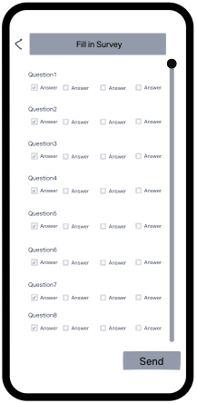
Figure 35

Granted Permission Pop-up
Title | Granted Permission Pop-up
Info Message | A message explaining the need for access to the user's camera.
Allow one time | Grants temporary access to the camera for a single use.
Allow while using the application | Permits access to the camera whenever the application is in use.
Don’t allow | Denies access to the camera.
Don’t ask again | Denies access and prevents the app from asking for camera permissions in the future.
Functionality | This pop-up requests the user's permission to access the device's camera. A confirmation question is displayed, and the user can choose from the following options: Allow One Time, Allow While Using the Application, Don’t Allow, or Don’t Ask Again. These options determine the level of access the app will have to the camera.
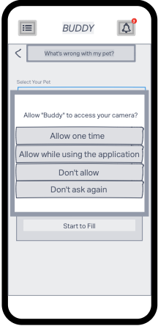
Figure 36

Media Interaction Pages
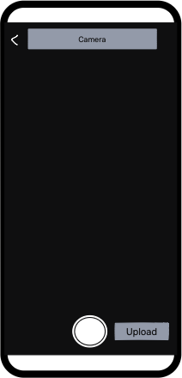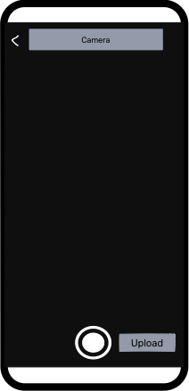
Figure 37 Figure 38
Title | Media Interaction Pages
Photo (Figure 37) | A page with a camera interface that includes a photo capture button for taking pictures.
Video (Figure 38) | A page with a camera interface that includes a video capture button for recording videos.
Upload | A button next to the capture buttons, used for uploading the captured media.
Functionality | These are two separate pages, one for taking photos and the other for recording videos. The photo page features a photo shutter button, while the video page has a video shutter button. Both pages include an upload button adjacent to the shutter button, enabling users to upload the captured media directly.

AI Diagnosis Results Pages
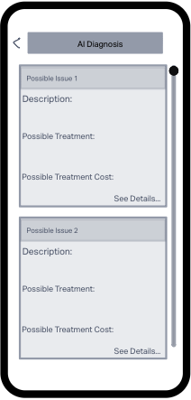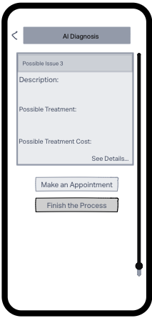
Figure 39 Figure 40
Title | AI Diagnosis Results Pages
AI Diagnosis | A section where the AI displays a list of possible issues based on the survey responses and uploaded media content.
Possible Issue | Represents the potential diagnosis made by the AI using survey and media content. Pet owners can click on a possible issue to view more detailed information.
Make an Appointment | By clicking this button, pet owners are redirected to the "Get Appointment" page to schedule an appointment for their pet.
Finish the Process | This button allows pet owners to end the "What's Wrong with My Pet" process without booking an appointment. Once clicked, a record is created and saved to the pet's profile.
Functionality | This page is the final step in the "What's Wrong with My Pet" process. It presents AI-generated potential issues and allows pet owners to either proceed with scheduling an appointment or complete the process. After this step, a record is created and stored in the pet's profile.

Web Interfaces
The Buddy Web Application provides veterinarians and administrators with robust tools for managing pet care and operational requirements. The interfaces include:

Start Page
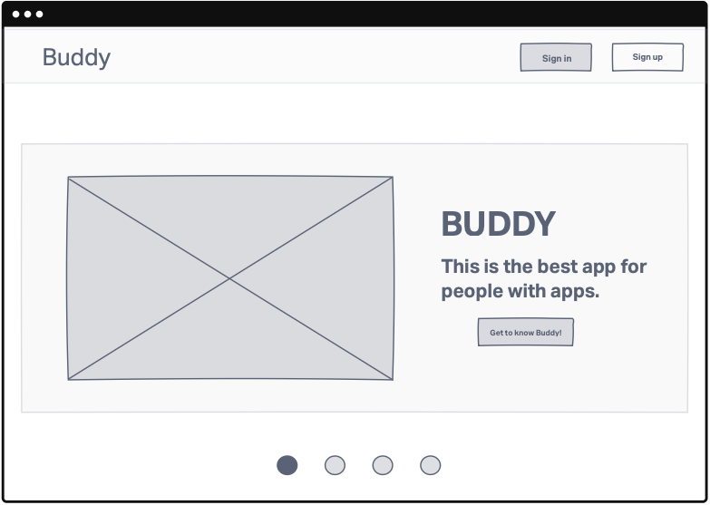
Figure 41
Title | Start Page
Sign in | A button labeled "Sign In" redirects user to the Login Page.
Sign up | A button labeled "Sign Up" redirects user to the Sign-Up Page.
Slide | A slide section displaying the application's features and benefits. This section introduces users to the app’s functionality and provides a visual overview of its purpose and advantages.
Functionality | The Sign In and Sign Up buttons ensure clear navigation, guiding users to the appropriate pages based on their status (new or returning user). The Slide Section communicates key information about the app, helping users understand its features and how it can assist them effectively.

Login Page
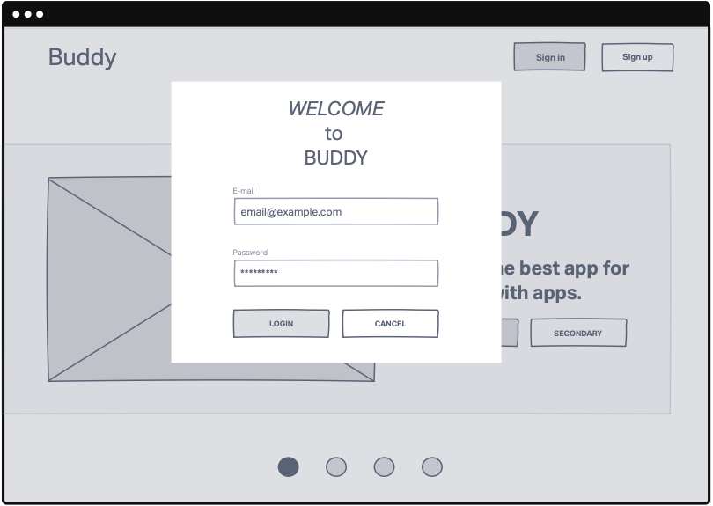
Figure 42
Title | Login Pop-up
E-mail | A text input field designed to collect the user's registered email address.
Password | A secure text input field where the user enters their account password.
Login | A button that verifies the email and password entered by the user. Upon successful validation, it grants the user access to their account and redirects them to the home page.
Functionality | The E-mail and Password fields work together to collect the necessary login credentials from the user. The Login Button processes these credentials, ensuring only authorized users can access the system.

Sign up Page
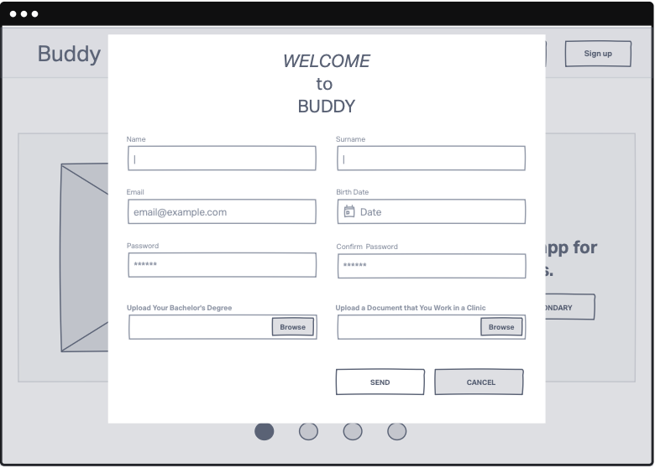
Figure 43
Title | Sign up Pop-up
Name | A text input field for the user to enter their first name.
Surname | A text input field for the user to enter their last name.
E-mail | A text input field where the user provides their professional email address.
Birth Date | A date picker or input field where the user enters their date of birth.
Password | A secure text input field where the user sets their account password.
Confirm Password | A secondary field requiring the user to re-enter their password. Verifies that the password was entered correctly.
Upload bachelor’s degree | A file upload button for the user to submit a digital copy of their veterinary degree. Ensures only qualified veterinarians can register on the platform.
Upload a Document that You Work in a Clinic | A file upload button for the user to submit proof of employment in a clinic. Provides an additional layer of verification to confirm professional credentials.
Functionality | This Sign-Up Page is tailored specifically for veterinarians. It collects personal and professional information to verify the user's identity and qualifications. Uploaded documents (Bachelor’s Degree and proof of clinic employment) ensure that only certified professionals can access the app's features.

Home Pages
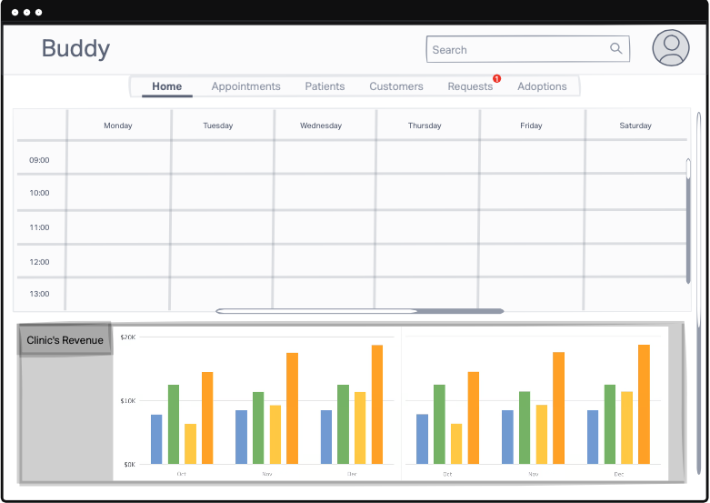
Figure 44
Title | Home Page
Search | A search bar allowing the veterinarian to quickly find specific information, such as appointments, patients, or customers within the system. Provides quick and efficient access to specific data.
Profile Icon | An icon, typically in the top corner, providing quick access to the veterinarian’s profile settings, account information, or logout option.
Tab Menu | A navigation menu with tabs labeled Home, Appointments, Patients, Customers, Requests, and Adoptions. Allows the veterinarian to easily switch between different sections of the application for streamlined workflow management.
Weekly Schedule | A section displaying the veterinarian’s schedule for the week, including appointments, surgeries, or other important tasks. Helps the veterinarian plan and manage their time effectively.
Weekly Average Temperature | A section showing the average temperature for the week.
Clinic’s Revenue | A dedicated area showing revenue data for the clinic, including daily, weekly, or monthly earnings.
Functionality | The Tab Menu serves as the central navigation tool, enabling veterinarians to switch effortlessly between core sections of the app. The Clinic’s Revenue section offers a clear snapshot of financial performance, aiding in strategic planning. Other features like the Search Bar, Weekly Schedule, and Temperature Widget ensure that the veterinarian has easy access to critical information, making their daily tasks more manageable and organized.

Navigation Bar
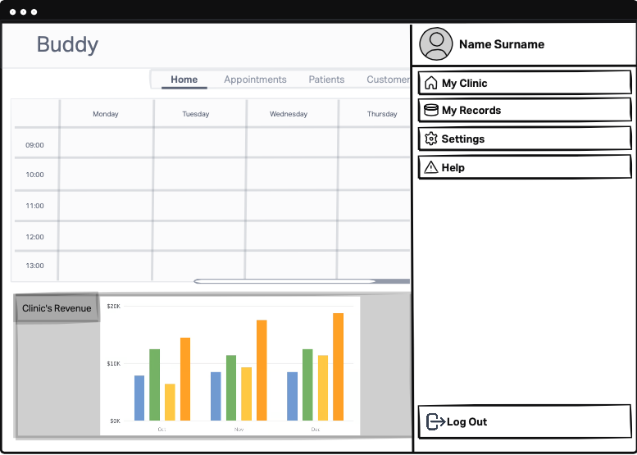
Figure 45
Title | Navigation Bar
Name Surname | Displays the veterinarian's full name at the top of the navigation bar.
My Clinic | A navigation button labeled "My Clinic" that redirects the user to the My Clinic Page.
My Records | A button labeled "My Records" that redirects the user to the My Records Page.
Settings | A button labeled "Settings" that redirects the user to the Settings Page.
Help | A button labeled "Help" that provides the user with access to FAQs, customer support, or instructional resources. Ensures veterinarians can quickly resolve any issues or get assistance.
Log Out | A button that securely logs the user out of the application.
Functionality | The My Clinic, My Records, and Settings buttons are key navigation tools, allowing veterinarians to access specific sections of the app efficiently. The Help button ensures that users have a resource for guidance, enhancing overall usability. The Log Out button prioritizes security, ensuring that sensitive data is protected when the user exits the application.

Appointments Page
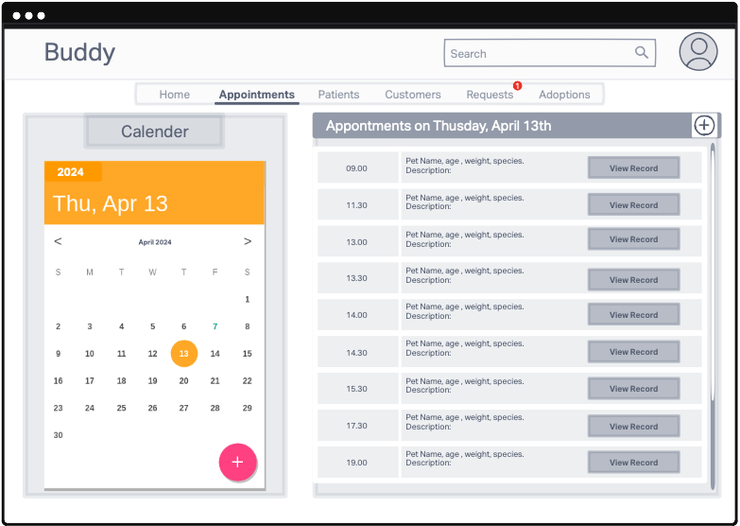
Figure 46
Title | Appointments Page
Search | A general search bar allowing the veterinarian to search for appointments, patients, or related information across the system. Provides quick and efficient access to specific data.
Calendar | A calendar view displaying the veterinarian’s schedule, including appointments, surgeries, and other events.
Appointments List | A chronological list of all the veterinarian’s appointments, sorted by date and time. Ensures easy navigation and allows the veterinarian to review their upcoming appointments.
Appointment | A detailed view of a selected appointment, including information such as the patient’s name, the reason for the visit, and the time and date of the appointment.
View Record | A button that redirects the veterinarian to the Record Page of the selected patient.
Functionality | The Search Bar provides a comprehensive tool for quickly locating information within the system. The Calendar and Appointments List work together to help veterinarians plan and manage their schedules effectively. The Appointment Section offers detailed insights into specific appointments, while the View Record Button allows easy access to patients record.

Patients Page
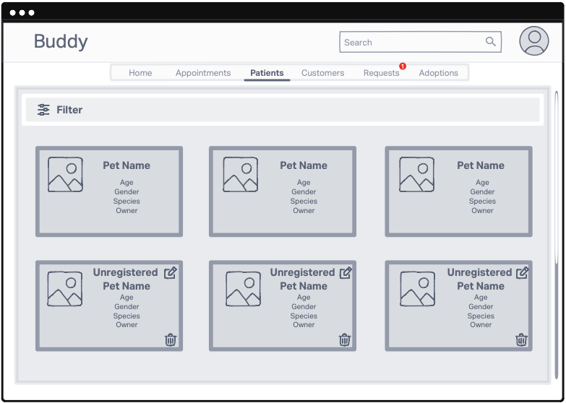
Figure 47
Title | Patients Page
Search | A general search bar allowing the veterinarian to search for appointments, patients, or related information across the system. Provides quick and efficient access to specific data.
Filter | A filtering tool that allows the veterinarian to refine search results based on specific criteria, such as pet type, breed, age, or owner details. Simplifies the search process and helps locate information faster.
Pets List | A comprehensive list displaying all the registered pets in the system.
Pet | Displays brief, essential details about each pet, such as name, species, age, and owner information.
Functionality | The Filter Option enhances the search experience by allowing veterinarians to narrow down their queries effectively.  The Pets List offers an organized view of all registered pets, while the Pet Section provides quick insights into individual pets, ensuring efficient patient management.  This layout ensures veterinarians can quickly find, filter, and access pet-related information.

Customers Page
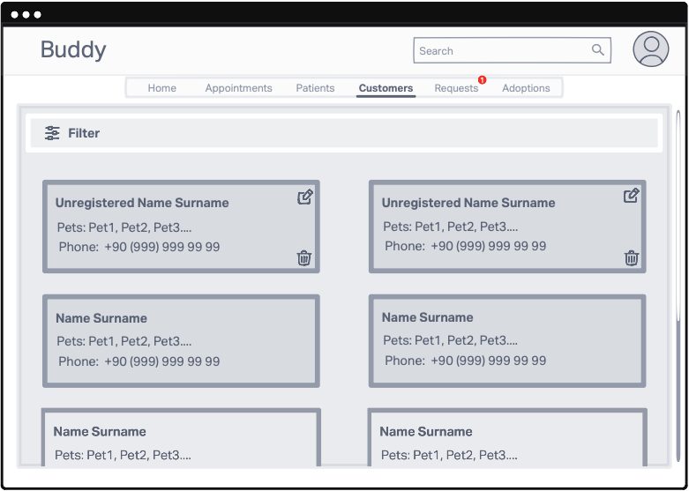
Figure 48
Title | Costumers Page
Search | A general search bar allowing the veterinarian to search for appointments, patients, or related information across the system. Provides quick and efficient access to specific data.
Filter | A filtering tool that allows the veterinarian to refine search results based on specific criteria, such as pet type, species, age, or owner details. Simplifies the search process and helps locate information faster.
Costumers List | A comprehensive list displaying all pet owners (registered in the system, not registered in the system) associated with the veterinary clinic.
Costumer | Displays detailed information about each pet owner, such as name, contact details, registration status, and their associated pets.
Functionality | The Customers List offers a complete view of registered and unregistered pet owners, enabling the veterinarian to keep track of all clients. The Customer Section provides detailed insights into individual pet owners, making it easier to manage relationships and offer personalized care.

Appointment Requests Page
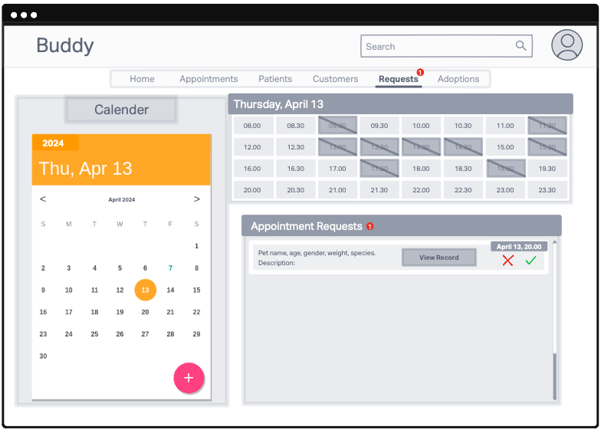
Figure 49
Title | Appointment Requests Page
Search | A general search bar allowing the veterinarian to search for appointments, patients, or related information across the system. Provides quick and efficient access to specific data.
Calendar | A calendar view displaying the veterinarian’s schedule, including appointments, surgeries, and other events.
Daily schedule | Displays the veterinarian's schedule for the day, including the list of confirmed appointments and any other scheduled tasks. It allows the veterinarian to see their availability.
Appointment Requests | Shows a list of appointment requests waiting for the veterinarian's approval. This section allows the veterinarian to review and decide whether to approve or reject each request.
Appointment Request | Appointment request section contains detailed information for each pending appointment request, including patient details, the requested time, and any additional information. The veterinarian can approve or decline the request from this section.
View Record | A button that redirects the veterinarian to the Record Page of the selected patient.
Functionality | The Appointment Requests Page provides a complete overview of the veterinarian’s daily schedule and pending appointment requests, enabling efficient management of time and client interactions. The Appointment Request Section offers detailed information about each request.

Pet Profile Page
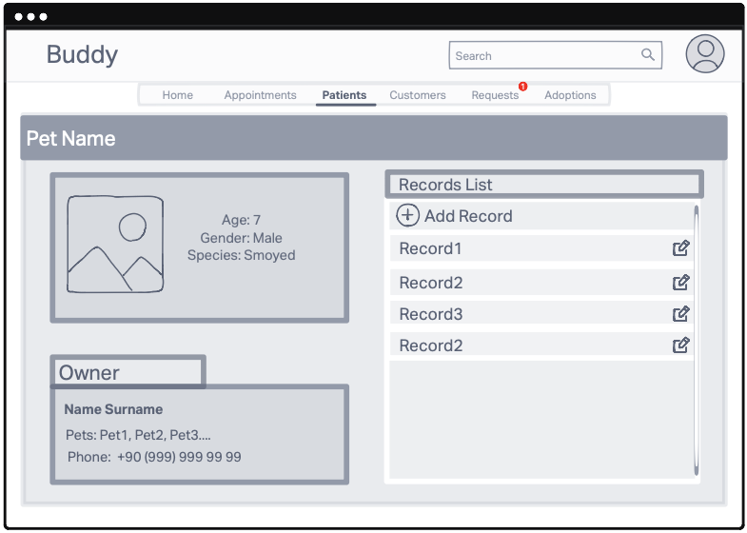
Figure 50
Title | Pet Profile Page
Search | A general search bar allowing the veterinarian to search for appointments, patients, or related information across the system. Provides quick and efficient access to specific data.
Pet Card | Displays key details about the pet, such as its name, species, age, medical history summary, and any other relevant information. This section provides a concise overview of the pet for easy reference.
Owner Card | Displays detailed information about the pet owner, including their name, contact details. This ensures the veterinarian can easily contact the owner or verify their details.
Records List | A list of all records associated with the pet.
Add Record | A button that enables the veterinarian to create a new record for the pet. This facilitates the documentation of recent treatments, diagnoses, or any other medical notes.
Record | Enables the veterinarian to redirect to a specific record's page for detailed information. The record can also be edited using the provided edit icon to update details as needed.
Functionality | The Pet Profile Page provides the veterinarian with a centralized view of the pet's essential details, including general information, owner contact details, and a complete list of medical records. From this page, the veterinarian can access specific records, edit them, or add new entries as required, ensuring seamless management of the pet's health and medical history.

Pet Record Page
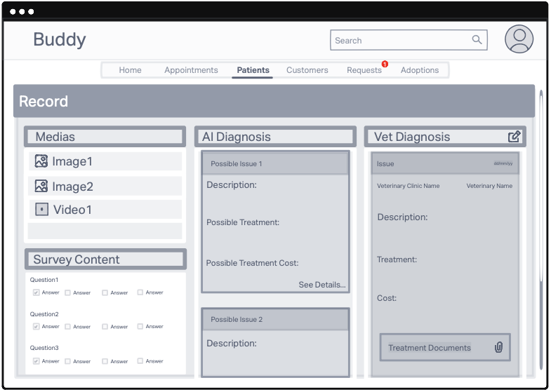
Figure 51
Title | Pet Record Page
Search | A general search bar allowing the veterinarian to search for appointments, patients, or related information across the system. Provides quick and efficient access to specific data.
Medias | Displays a list of photos and videos uploaded during the creation of the record, providing visual context for the pet's condition and supporting the veterinarian’s diagnosis
Survey Content | Contains the details of the survey filled out when the record was created. This section helps the veterinarian review the responses provided by the pet owner for better understanding of the pet's condition.
AI Diagnosis | Lists the potential issues identified by the AI during record creation. This section provides a preliminary analysis to assist the veterinarian in forming a diagnosis.
Possible Issue | Displays detailed insights into the potential diagnoses suggested by the AI. This section includes additional information or context related to the identified issues.
Vet Diagnosis | Contains the veterinarian's detailed diagnosis.
Issue | Contains the veterinarian's detailed diagnosis, providing a professional and final evaluation of the pet's condition. This section allows the veterinarian to document their findings clearly.
Treatment Documents | A button that provides access to all documents related to the pet’s treatment for the diagnosis. This includes prescriptions, test results, and other relevant files.
Functionality | The Pet Record Page offers a detailed and organized view of the pet's medical record. Veterinarians can review photos, videos, survey responses, AI-generated diagnoses, and their own professional evaluations. Additionally, they can access all treatment-related documents to ensure a comprehensive understanding of the pet’s medical history and current condition.

Vet Profile Page
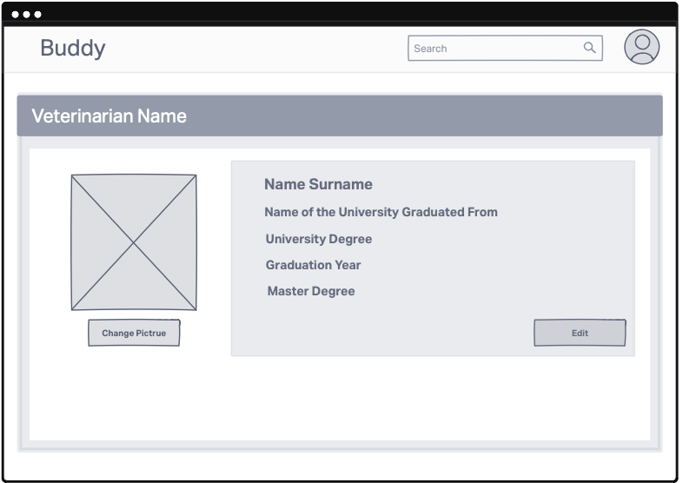
Figure 52
Title | Pet Profile Page
Search | A general search bar allowing the veterinarian to search for appointments, patients, or related information across the system. Provides quick and efficient access to specific data.
Veterinarian Name | Displays the name of the veterinarian, providing a clear identification of the profile owner.
Profile Picture | Displays the veterinarian's profile picture, offering a visual representation on the profile page.
Change Picture | A button that allows the veterinarian to update or change their profile picture, ensuring the profile remains current and personalized.
Info Card | Contains detailed information about the veterinarian, such as contact details, qualifications, and any other relevant professional information.
Edit | A button that allows the veterinarian to update or edit their personal and professional information displayed on the profile page.
Functionality | The Veterinarian Profile Page serves as a centralized hub for viewing and managing the veterinarian’s professional details. It provides essential information about the veterinarian and allows them to update their profile picture or edit their personal details as needed. This ensures their profile remains accurate and professional.

My Records Page
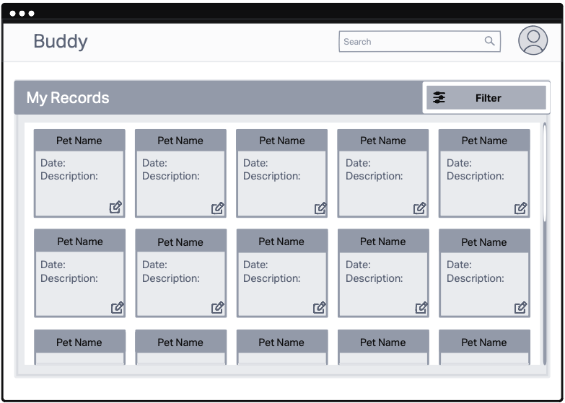
Figure 53
Title | My Records Page
Search | A general search bar allowing the veterinarian to search for appointments, patients, or related information across the system. Provides quick and efficient access to specific data.
Filter | A filtering tool that allows the veterinarian to refine search results based on specific criteria, such as pet type, breed, age, or owner details. Simplifies the search process and helps locate information faster.
My Records | Displays a list of all records created by the veterinarian. Each entry provides an overview of the associated pet and the corresponding record details.
Pet | Shows which pet each record is associated with and provides a summary of the record. Veterinarians can edit the records using the edit icon or click on a specific record to navigate to the detailed Record Page.
Functionality | The My Records Page displays all the records created by the veterinarian for different pets. It allows veterinarians to access, edit, and manage their records efficiently. The page also features a filter option to refine the list of records based on specific criteria, making it easier to locate and manage records effectively.

My Clinic Page
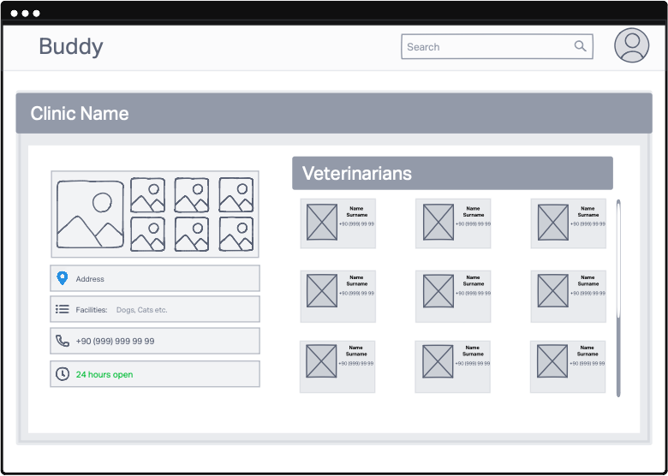
Figure 54
Title | My Clinic Page
Search | A general search bar allowing the veterinarian to search for appointments, patients, or related information across the system. Provides quick and efficient access to specific data.
Clinic Name | Displays the name of the clinic, offering a clear identification of the workplace.
Photos | Shows a collection of photos associated with the clinic, providing a visual representation of the clinic’s facilities and environment.
Address | Displays the full address of the clinic, making it easy to locate or share its location with clients.
Facilities | Lists the facilities available at the clinic, such as diagnostic equipment, specialized services, or other amenities, highlighting the clinic's capabilities.
Phone | Shows the clinic’s contact number, enabling easy communication with clients or external services.
Working Hours | Displays the clinic’s working hours, helping veterinarians and clients plan visits and appointments effectively.
Veterinarians | Lists all veterinarians working at the clinic, providing an overview of the clinic’s team and their availability.
Veterinarian | Displays individual profiles for each veterinarian, including their photo and general information, such as their name, specialization, and contact details.
Functionality | The My Clinic Page provides comprehensive information about the veterinary clinic, including its name, address, contact details, working hours, and facilities. It also showcases the clinic's team, allowing easy access to the profiles of individual veterinarians.

Clinic’s Adoption Page
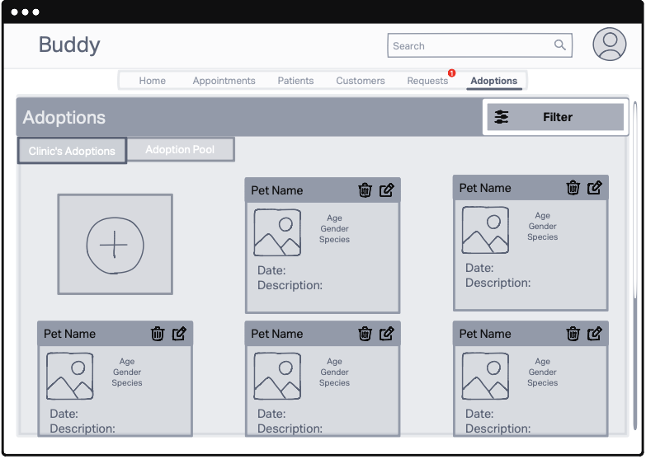
Figure 55
Title | Clinic’s Adoption Page
Search | A general search bar allowing the veterinarian to search for appointments, patients, or related information across the system. Provides quick and efficient access to specific data.
Filter | A filtering tool that allows the veterinarian to refine search results based on specific criteria, such as pet type, breed, age, or owner details. Simplifies the search process and helps locate information faster.
Clinic’s Adoption- Adoption Pool | A tab section that allows the veterinarian to switch between the clinic’s adoption list and the adoption pool, providing flexible access to adoption data.
Add Button | A button that enables the veterinarian to create a new adoption entry, adding pets available for adoption to the clinic’s list.
Pets List | Displays a list of pets available for adoption at the clinic, providing an overview of all adoptable pets under the clinic’s care.
Pet | Shows brief information about each pet listed for adoption, including their name, species, and age. Veterinarians can use the delete icon to remove pets from the list or the edit icon to update their details. When the veterinarian clicks on a specific pet, they are redirected to the Adoption Profile Page of that adoption.
Functionality | The Clinic’s Adoption Page serves as a dedicated space for managing pets available for adoption at the clinic. Veterinarians can view a list of adoptable pets, add new pets to the list using the "Add" button, and update or remove entries with edit and delete icons. The page also provides seamless navigation between the clinic’s adoption list and the adoption pool, making it easier to track and manage adoptions efficiently. When the veterinarian clicks on a specific pet, they are redirected to the Adoption Profile Page of that adoption.

Adoption Pool Page
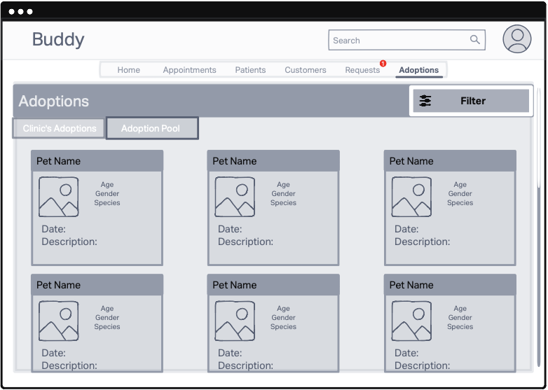
Figure 56
Title | Adoption Pool Page
Search | A general search bar allowing the veterinarian to search for appointments, patients, or related information across the system. Provides quick and efficient access to specific data.
Filter | A filtering tool that allows the veterinarian to refine search results based on specific criteria, such as pet type, breed, age, or owner details. Simplifies the search process and helps locate information faster.
Clinic’s Adoption- Adoption Pool | A tab section that allows the veterinarian to switch between the clinic’s adoption list and the adoption pool, providing flexible access to adoption data.
Pets List | A section that displays the complete list of all pets available for adoption within the system
Pet | Shows brief information about each pet listed for adoption, including their name, species, and age. When the veterinarian clicks on a specific pet, they are redirected to the Adoption Profile Page of that adoption.
Functionality | This page lists all adoptions registered in the system. In the pet section, brief information about each pet is provided. When the veterinarian clicks on a specific pet, they are redirected to the Adoption Profile Page of that adoption.

Adoption Profile Page
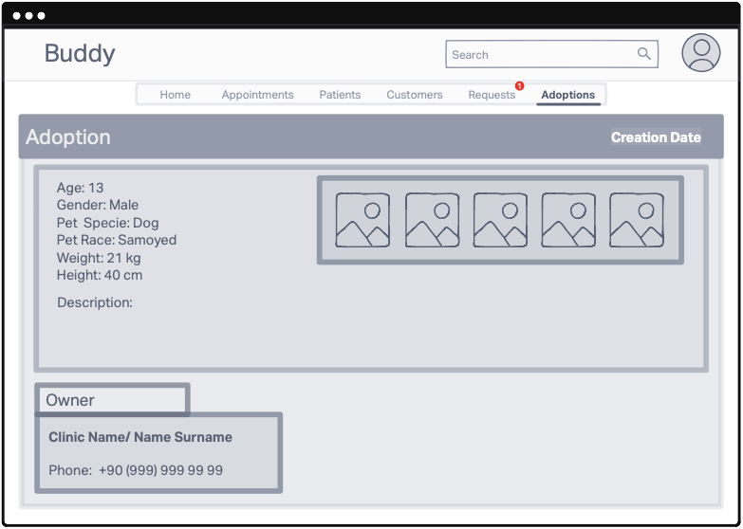
Figure 57
Title | Adoption Profile Page
Search | A general search bar allowing the veterinarian to search for appointments, patients, or related information across the system. Provides quick and efficient access to specific data.
Creation Date | Displays the date when the adoption entry was created, providing a reference for record-keeping and tracking
Pet Info | Contains detailed information about the pet, such as name, species, breed, age, and any other relevant details.
Photos | Displays photos of the pet to provide a visual reference, enhancing the adoption profile.
Owner | Provides information about the pet's owner, including their name and contact details.
Functionality | The Adoption Profile Page is the dedicated page for a specific pet listed in the adoption pool. It provides all the details about the pet and the adoption, including creation date, pet information, photos, and owner details, ensuring the veterinarian has comprehensive access to relevant adoption data.

Admin Dashboard
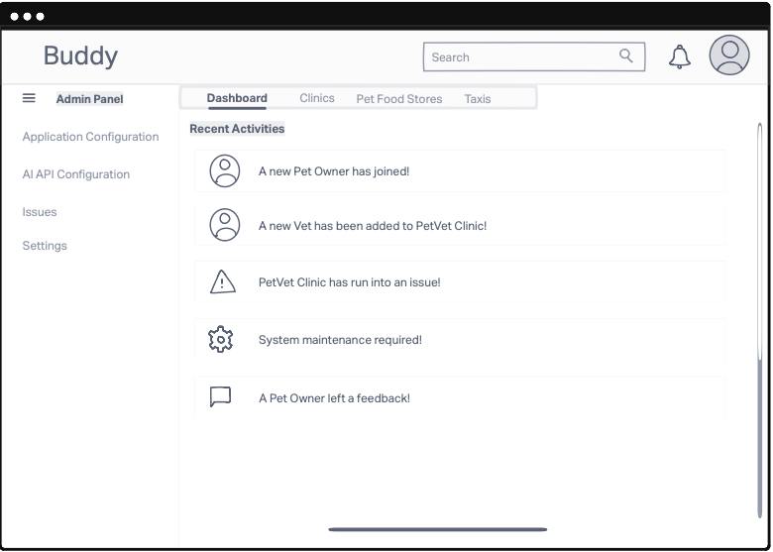
Figure 58
Title | Admin Dashboard
Search | A general search bar allowing the admin to search to specific data.
Dashboard- Clinics- Pet Food Store- Taxis | Dashboard- Clinics- Pet Food Store- Taxis tabs that enable the admin to navigate between different pages as needed.
Admin Panel | Incudes such as Application Configuration, AI API Configuration, Issues, Settings
Application Configuration | Redirects to the Application Configuration page.
AI API Configuration | Redirects to the AI API Configuration page.
Issues | Redirects to the Issues.
Settings | Redirects to the Settings.
Functionality | Provides the admin with various tools and configurations to manage and monitor the system effectively.

Admin Application Configuration Page
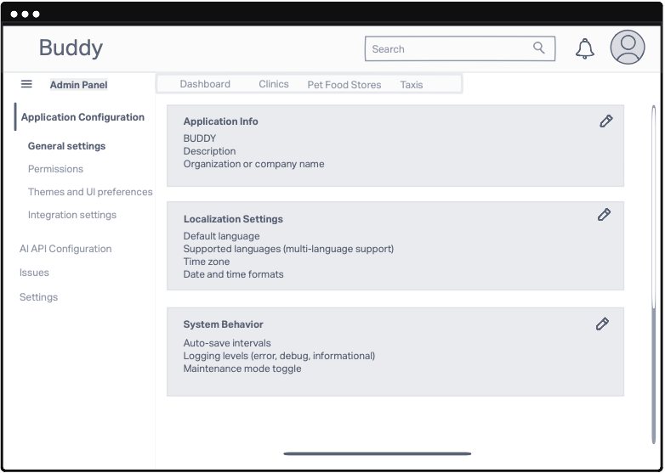
Figure 59
Title | Application Configuration
Search | A general search bar allowing the admin to search to specific data.
Dashboard- Clinics- Pet Food Store- Taxis | Dashboard- Clinics- Pet Food Store- Taxis tabs that enable the admin to navigate between different pages as needed.
Admin Panel | Incudes such as Application Configuration, AI API Configuration, Issues, Settings
Application Configuration | Redirects to the Application Configuration page.
AI API Configuration | Redirects to the AI API Configuration page.
Issues | Redirects to the Issues.
Settings | Redirects to the Settings.
Functionality | This page allows the admin to manage configurations related to the application.

Admin API Configuration Page
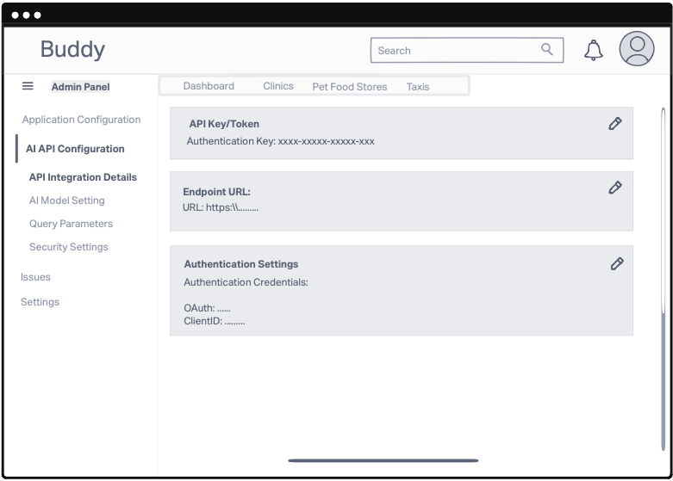
Figure 60
Title | AI API Configuration
Search | A general search bar allowing the admin to search to specific data.
Dashboard- Clinics- Pet Food Store- Taxis | Dashboard- Clinics- Pet Food Store- Taxis tabs that enable the admin to navigate between different pages as needed.
Admin Panel | Incudes such as Application Configuration, AI API Configuration, Issues, Settings
Application Configuration | Redirects to the Application Configuration page.
AI API Configuration | Redirects to the AI API Configuration page.
Issues | Redirects to the Issues.
Settings | Redirects to the Settings.
Functionality | This page allows the admin to manage configurations related to the AI API.

Admin Clinics Page
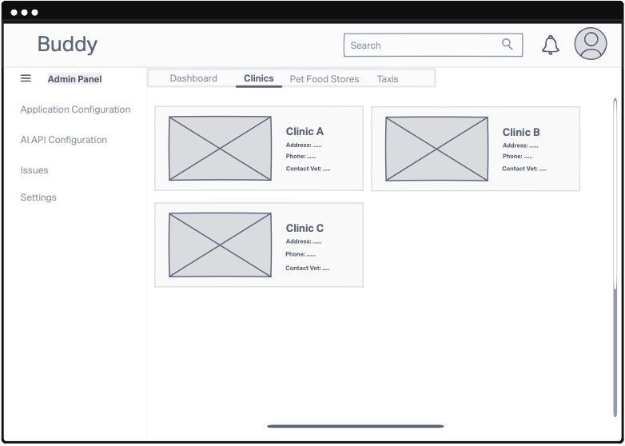
Figure 61
Title | Application Configuration
Search | A general search bar allowing the admin to search to specific data.
Dashboard- Clinics- Pet Food Store- Taxis | Dashboard- Clinics- Pet Food Store- Taxis tabs that enable the admin to navigate between different pages as needed.
Admin Panel | Incudes such as Application Configuration, AI API Configuration, Issues, Settings
Application Configuration | Redirects to the Application Configuration page.
AI API Configuration | Redirects to the AI API Configuration page.
Issues | Redirects to the Issues.
Settings | Redirects to the Settings.
Functionality | This page lists the clinics registered in the system.

Both platforms are designed with user-centric functionality and a consistent, synchronized database to ensure smooth operations and data management across mobile and web applications.

High Level Design
Web
Server
Mobile
Database
AI
Rest API
Rest API
AI Diagnosis
Appointment Management
User Management

Web Module
- The Web module represents the web-based interface used by veterinarians and pet owners.
- It sends requests to the Server module through REST APIs.
- Key functionalities include:
  - Appointment Management: Booking, canceling, and rescheduling appointments.
  - Diagnostic Access: Viewing AI-driven diagnostic results and recommendations.

Mobile Module
- The Mobile module is the mobile application for pet owners, providing similar functionalities to the Web module but optimized for mobile devices.
- It communicates with the Server module via REST APIs.
- Additional functionalities include:
  - Media Uploads: Sending images or videos for AI analysis.
  - Notifications: Real-time updates on appointment statuses and diagnostic results.

AI Module
- The AI module performs AI-driven diagnostics and predictive analytics based on inputs (e.g., pet health data, uploaded media).
- It connects to the Server module through REST APIs for data exchange.
- Responsibilities include:
  - Processing Inputs: Analyzing user-provided data and generating diagnostic insights.
  - Returning Results: Sending predictions and confidence scores back to the server.

Server Layer
- The Server module is the core backend component managing data flow, business logic, and system operations.
- It acts as the intermediary between the Web, Mobile, AI modules, and the Database.
- Key functionalities:
  - Request Handling: Processes requests from Web and Mobile modules.
  - AI Integration: Routes diagnostic data to the AI module and returns results.
  - Database Management: Handles data retrieval and updates from/to the Database.

Database
- The Database module stores all persistent data for the system.
- It directly interacts with the Server module for:
  - Storing user information, pet profiles, and medical records.
  - Saving appointment schedules and diagnostic results.
  - Maintaining system logs for traceability and auditing.

Low Level Design

AI Diagnosis Module
Description: Processes user-submitted images, videos, and survey data to generate preliminary diagnoses using AI models.
Interacts with:
- Survey Analysis Model
- Photo and Video Analysis Models

Step-by-step Description:
- User Submits Media and Survey:
- Users upload media files (images/videos) and fill out a survey describing their pet’s symptoms.
- The system validates the input (e.g., file size, supported formats, and survey completion).
- Data Preprocessing:
- Media Files:
Images are resized, and videos are processed into frames for efficient analysis.
- Survey Data:
Text responses are tokenized, cleaned, and formatted for natural language processing.
- Data Passed to AI Models:
- Photo/Video Analysis Models:
Media files are analyzed for visual indicators of health issues (e.g., inflammation, unusual behavior).
- Survey Analysis Model:
Text responses are processed using a symptom-diagnosis correlation model.
- AI Models Return Ranked Predictions:
- Predictions include potential health issues, each with a confidence score.
- Results are aggregated if multiple models contribute to the final output.
- Predictions Are Displayed to the User:
- The system shows possible conditions along with explanations (e.g., "This condition is likely due to symptoms A and B").
- Recommendations (“Schedule an appointment with a vet”) are also provided.
- Users can save the diagnosis to their pet’s health record.
- Error Handling:
- If media is corrupted or unsupported, the system prompts the user to re-upload.
- If AI models fail to return results, a fallback message (“Unable to process your request, please consult a vet directly”) is displayed.

Appointment Management Module
Description: Manages vet clinic scheduling and user appointments through a map interface.

Step-by-step Description:
- User Selects a Clinic on the Map:
- Users view clinics in their area using a map interface.
- Clinics can be filtered by distance, ratings, or availability.
- Available Slots Are Retrieved:
- The system queries the clinic's schedule in real time.
- Slots that conflict with existing appointments are removed from the list.
- User Confirms a Slot:
- Users select a time slot and provide additional details for the appointment.
- The system verifies the user’s submission.
- Appointment Is Sent to the Clinic’s "Request Page":
- The request is added to the veterinarian's dashboard in their web application.
- The clinic sees the pet's details, reason for the appointment, and requested slot.
- Veterinarian Accepts/Rejects the Appointment:
- Approval:
  - The veterinarian confirms the appointment, and the user receives a notification.
  - The confirmed appointment is saved to the database.
- Rejection:
  - The veterinarian declines the request, providing a reason if needed.
  - The user is notified and prompted to choose a different slot.
- System Saves Final Appointment State to Database:
- The database is updated with the final status.
- Appointment history is added to the user’s profile for future reference.
- Notifications and Feedback:
- Users and veterinarians receive real-time notifications about appointment status updates.
- Cancellation and Rescheduling:
- Users can cancel or reschedule appointments through their respective interfaces.
- Canceled slots are made available in the clinic's schedule.
- Error Handling:
- If the clinic is unavailable, users are informed and advised to try again later.
- Conflicts in scheduling trigger an error message.

User Management Module
Description: Manages the profiles and authentication of pet owners and veterinarians, ensuring secure access to the system and personalized experiences.

Step-by-step Description:
- User Registration:
- Pet Owners:
  - Users provide basic details (e.g., name, email, phone number) and information about their pets (e.g., name, species, breed, age).
  - Optional: Profile photos for pet and owner can be uploaded.
- Veterinarians:
  - Veterinarians register with their professional details (e.g., name, clinic, license number).
  - Verification may involve uploading credentials for admin review.
- Authentication and Login:
- Users log in using their email and password or an alternative method such as Single Sign-On (SSO) or social login.
- The system enforces secure authentication with mechanisms like two-factor authentication (2FA).
- Profile Management:
- Pet Owners:
  - Users can update their contact information, change passwords, and add or edit pet profiles.
  - Pet details include vaccination records, medical history, and health notes.
- Veterinarians:
  - Veterinarians can manage their clinic details, availability, and professional credentials.
- Role-Based Access Control:
- Ensures that users only access features relevant to their role (e.g., pet owners cannot access veterinarian dashboards).
- Data Synchronization and History Tracking:
- User activity is logged for record-keeping (e.g., appointments, past diagnoses, and system interactions).
- Changes to profiles or settings are synchronized in real time.
- Account Recovery:
- If users forget their credentials, they can reset passwords securely via email verification or another recovery method.
- Veterinarians may need additional verification steps for account recovery.
- Notifications and Preferences:
- Users can manage notification settings, choosing how they want to receive updates (e.g., email, SMS, push notifications).
- Error Handling and Support:
- The system provides clear messages for common issues (e.g., "Email already in use" or "Invalid password").
- A support interface allows users to report issues or seek help.
- Deactivation or Deletion of Accounts:
- Users can request account deactivation or deletion, with an option to download their data before deletion.
- The system ensures compliance with data privacy regulations during this process.
- Admin Interface:
- Admins oversee account activities, handle veterinarian verification, and resolve flagged issues.
This module ensures a seamless, secure, and user-friendly experience for all types of users interacting with the system.

Database Design
The database for the Buddy Platform serves both the Mobile and Web Applications, ensuring synchronized and consistent data management across the system. It is designed to store and manage data related to pet owners, pets, veterinarians, appointments, AI diagnoses, and other features. This section provides an E-R diagram and detailed descriptions of each table in the database.

ER Diagram
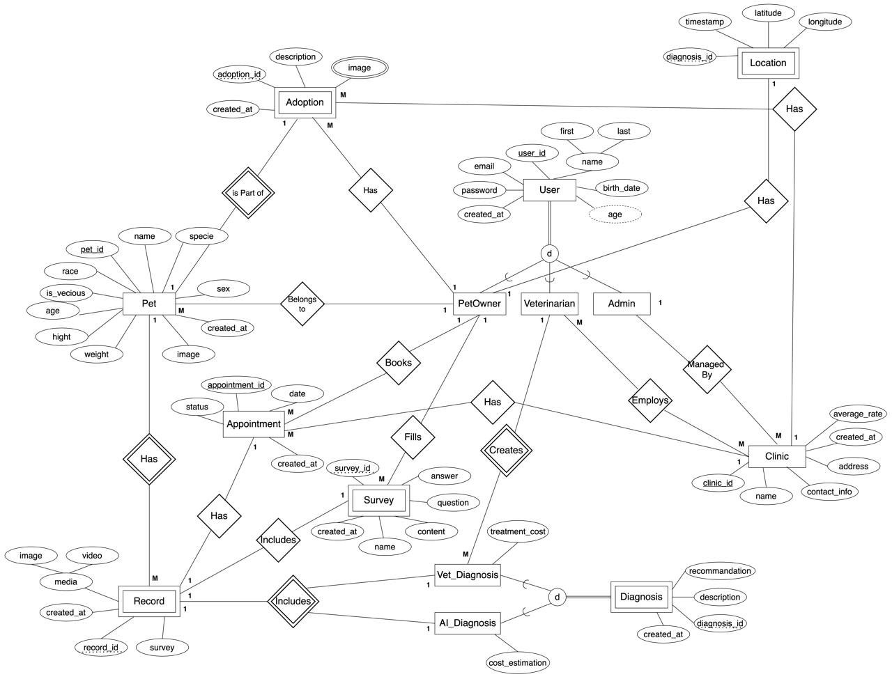
Figure 62
The Entity-Relationship (E-R) diagram represents the logical structure of the Buddy database, illustrating the relationships between the key entities: Users, Pets, Records, Diagnoses, Appointments, and Clinics.

Class Diagram
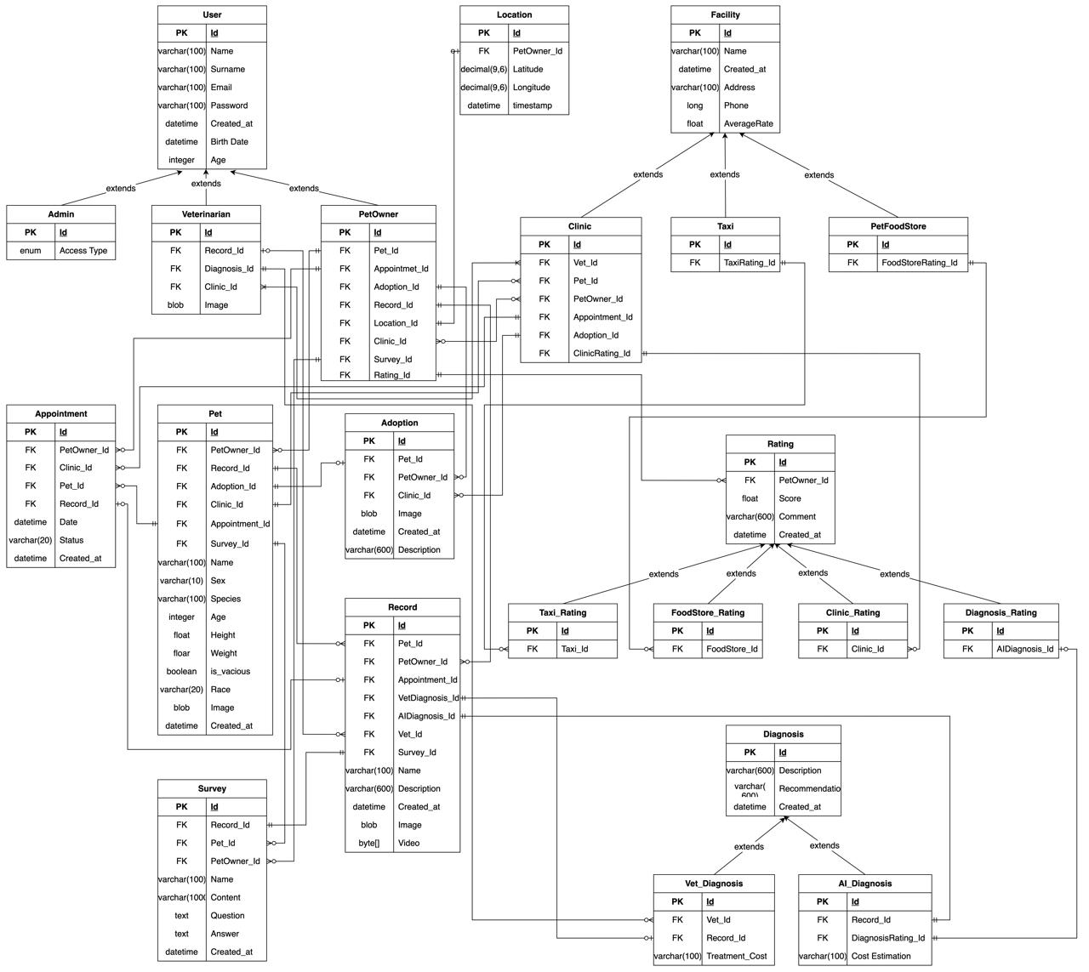
Figure 63
The class diagram represents the logical structure of the Buddy database, illustrating the key classes (entities) such as Users, Pets, Records, Diagnoses, Appointments, and Clinics. It shows the attributes and methods associated with each class and defines the relationships between them, including associations, inheritance, and dependencies. The diagram helps to visualize how data is organized within the system, how different entities interact, and how their attributes and behaviors are structured to support the functionality of the database.

Tables

User Table

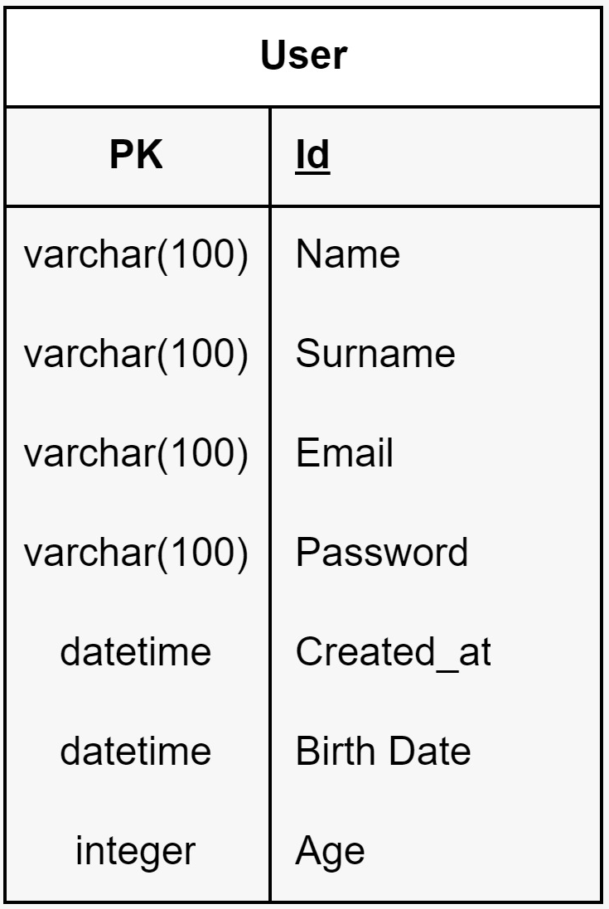
Figure 64

- Admin, PetOwner and Veterinarian classes extend the user class.
- ID: A unique identifier for each user. It's the primary key (PK) in the table, ensuring that each record in the table can be uniquely identified.
- Name: Define as varchar with 100 characters.
- Surname: Define as varchar with 100 characters.
- Email: Define as varchar with 100 characters.
- Password: Define as varchar with 100 characters.
- Created_at: Define as datetime.
- Birth Date: define as datetime
- Age: define as integer.

Admin Table

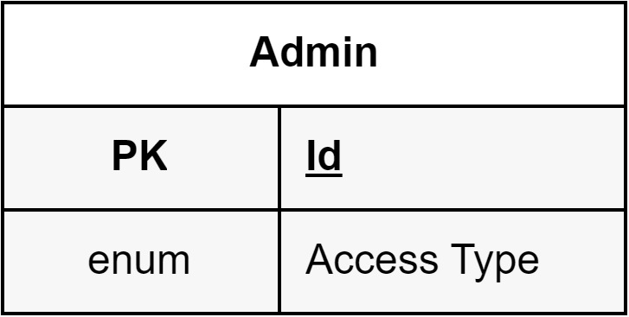
Figure 65
- ID: A unique identifier for each user. It's the primary key (PK) in the table, ensuring that each record in the table can be uniquely identified.
- Access Type: Define as enum.

PetOwner Table

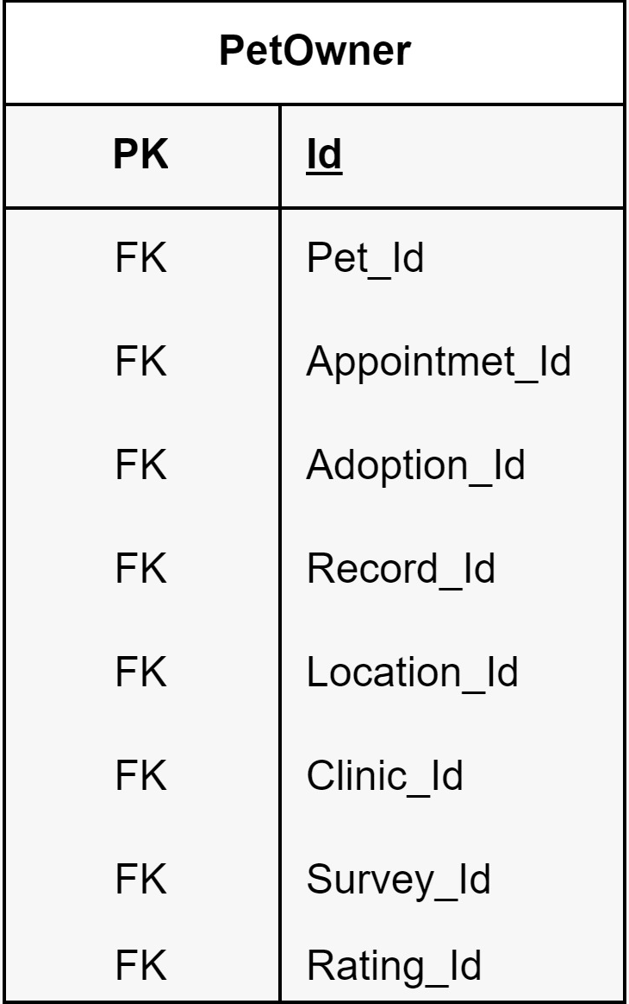
Figure 66
- PetOwner table has relationship with Pet, Appointment, Adoption, Record, Location, Clinic, Survey, Rating tables.
- Id: A unique identifier for each user. It's the primary key (PK) in the table, ensuring that each record in the table can be uniquely identified.

Veterinarian Table

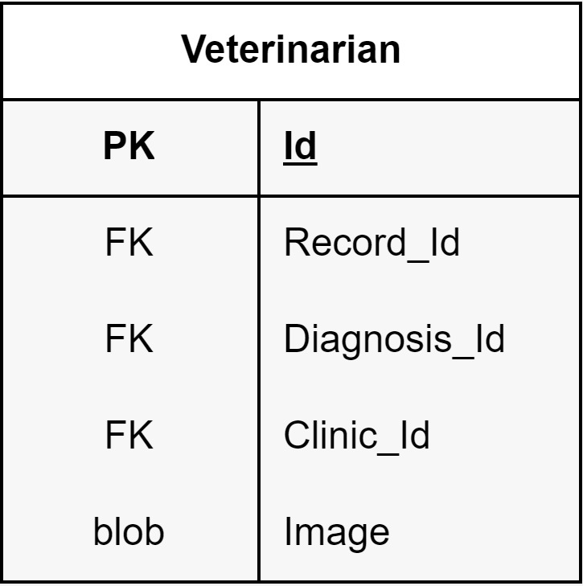
Figure 67
- Veterinarian table has relationship with Record, Diagnosis, Clinic tables.
- Id: A unique identifier for each user. It's the primary key (PK) in the table, ensuring that each record in the table can be uniquely identified.
- Image: Define as blob.

Adoption Table

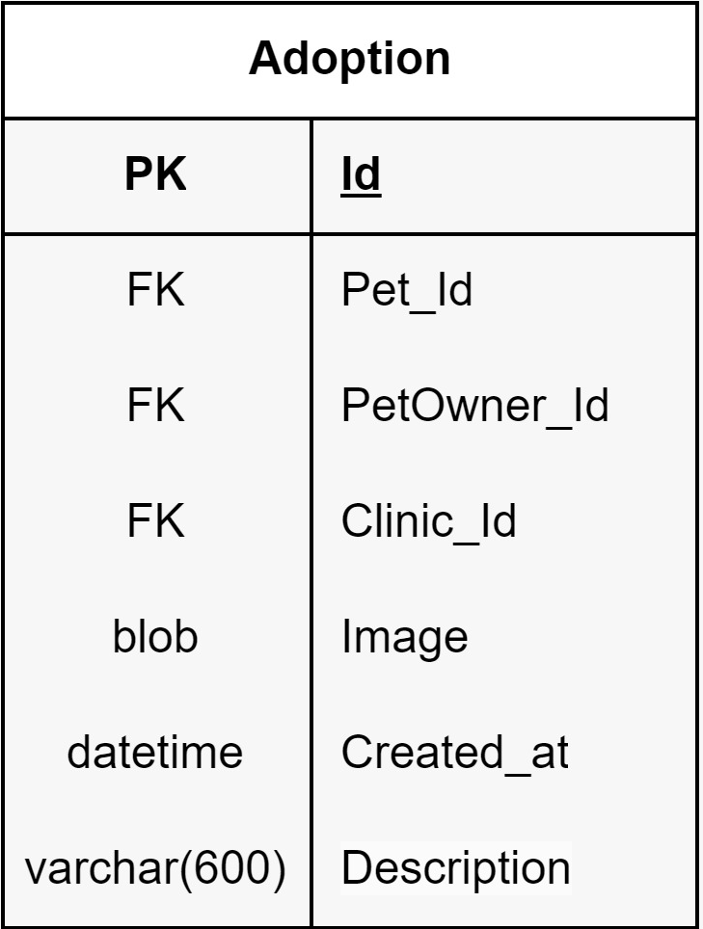
Figure 68
- Adoption table has relationship with Pet, PetOwner, Clinic tables.
- Id: A unique identifier for each user. It's the primary key (PK) in the table, ensuring that each record in the table can be uniquely identified.
- Image: Define as byte.
- Created_at: Define as datetime.
- Description: Define as varchar with 600 characters.

Appointment Table

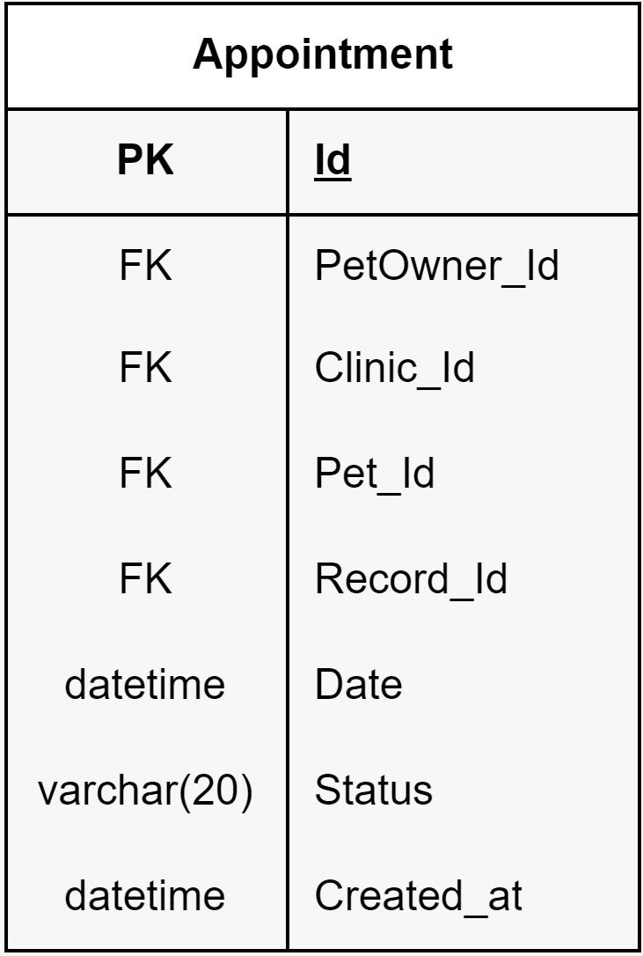
Figure 69
- Appointment table has relationship with PetOwner, Clinic, Pet, Record tables.
- Id: A unique identifier for each user. It's the primary key (PK) in the table, ensuring that each record in the table can be uniquely identified.
- Date: Define as datetime.
- Status: Define as varchar with 20 characters.
- Created_at: Define as datetime.

Pet Table

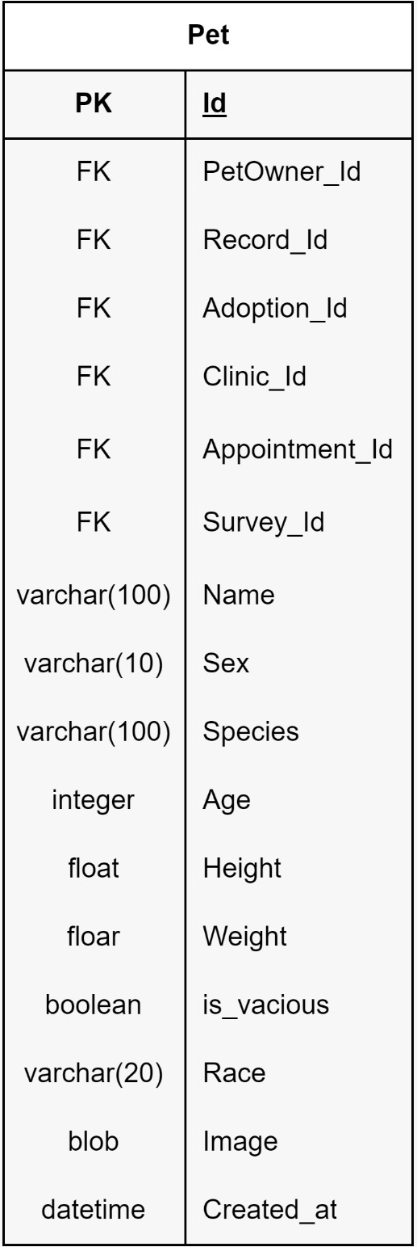
Figure 70
- Pet table has relationship with PetOwner, Record, Adoption, Clinic, Appointment, Survey tables.
- Id: A unique identifier for each user. It's the primary key (PK) in the table, ensuring that each record in the table can be uniquely identified.
- Name: Define as varchar with 100 characters.
- Sex: Define as varchar with 10 characters.
- Species: Define as varchar with 100 characters.
- Age: Define as integer.
- Height: Define as integer.
- Weight: Define as float.
- is_vacious: Define as float.
- Race: Define as varchar with 20 characters.
- Image: Define as blob.
- Created_at: Define as datetime.

Survey Table

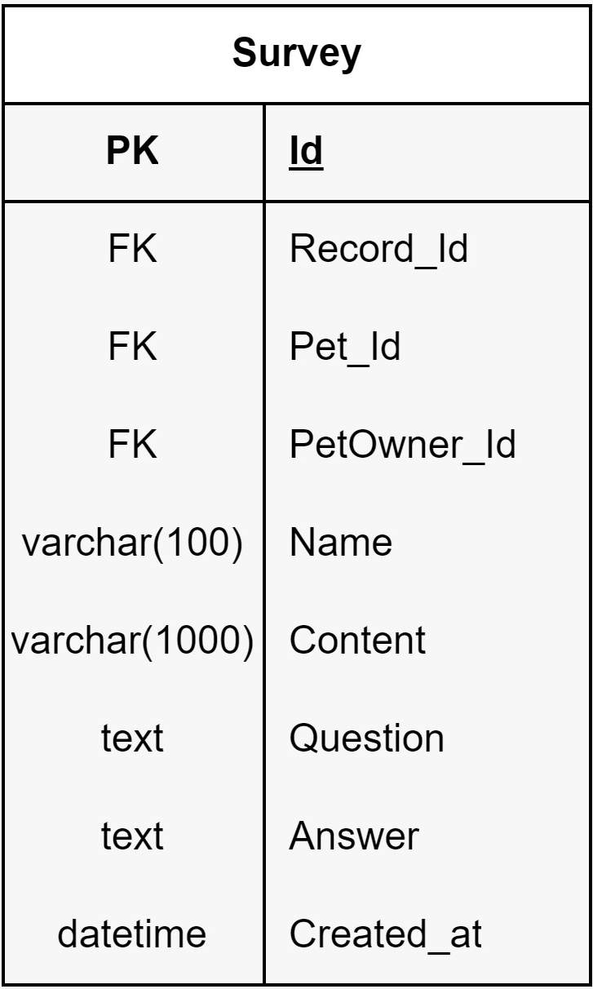
Figure 71
- Survey table has relationship with Record, Pet, PetOwner tables.
- Id: A unique identifier for each user. It's the primary key (PK) in the table, ensuring that each record in the table can be uniquely identified.
- Name: Define as varchar with 100 characters.
- Content: Define as varchar with 100 characters.
- Question: Define as text.
- Answer: Define as text.
- Created_at: Define as datetime.

Record table

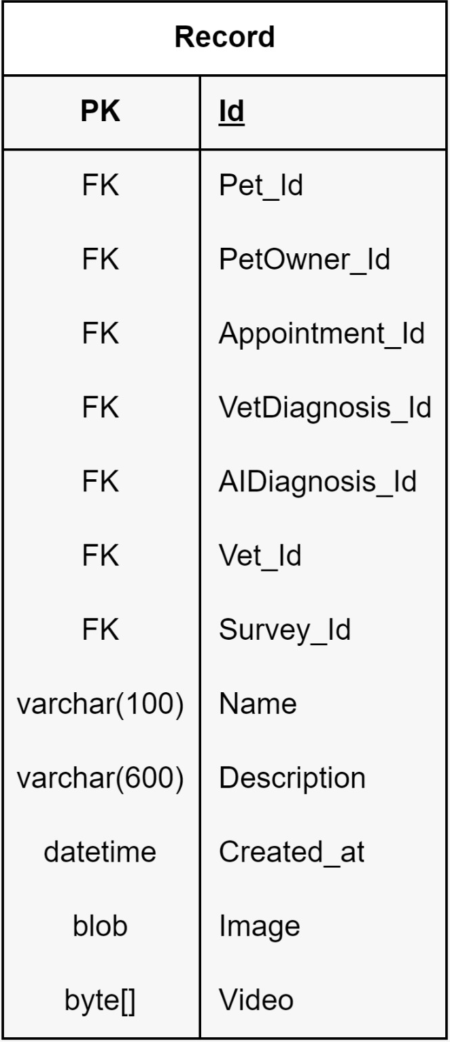
Figure 72
- Record table has relationship with Pet, PetOwner, Appointment, Vet_Diagnosis, AI_Diagnosis, Veterinarian, Survey tables.
- Id: A unique identifier for each user. It's the primary key (PK) in the table, ensuring that each record in the table can be uniquely identified.
- Name: Define as varchar with 100 characters.
- Description: Define as varchar with 600 characters.
- Created_at: Define as datetime.
- Image: Describe as blob.
- Video: describe as byte array.

Diagnosis Table

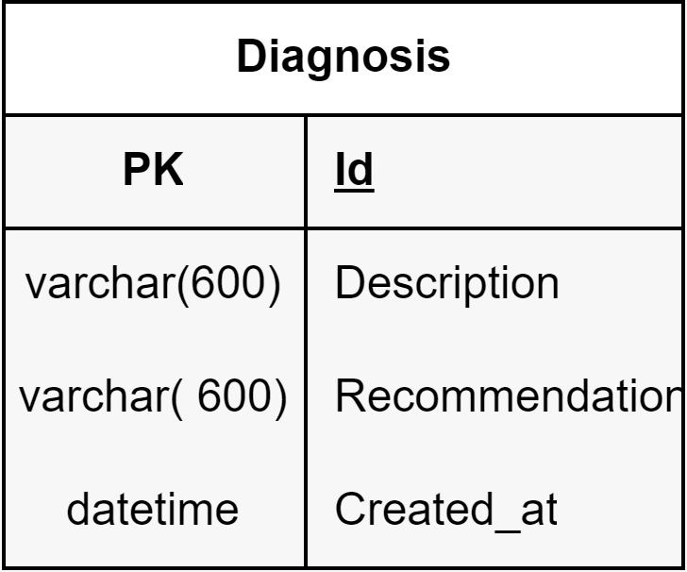
Figure 73

- Vet_Diagnosis and AI_Diagnosis classes extend the Diagnosis class.
- Id: A unique identifier for each user. It's the primary key (PK) in the table, ensuring that each record in the table can be uniquely identified.
- Description: Define as varchar with 100 characters.
- Recommendation: Define as varchar with 100 characters.
- Created_at: Define as datetime.

Vet_Diagnosis Table

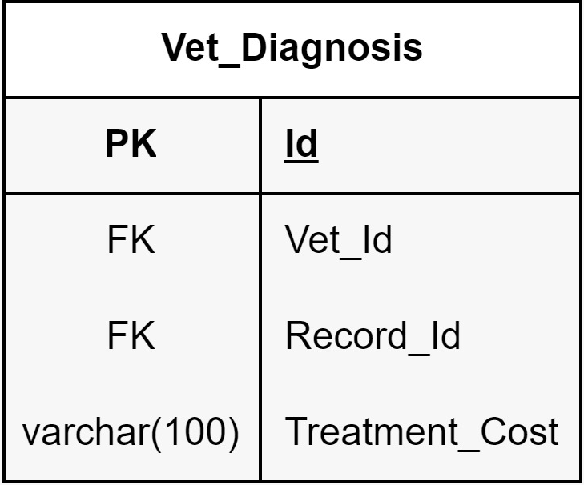
Figure 74

- Vet_Diagnosis table has relationship with Veterinarian and Record tables.
- Id: A unique identifier for each user. It's the primary key (PK) in the table, ensuring that each record in the table can be uniquely identified.
- Treatment Cost: Define as varchar with 100 characters.

AI_Diagnosis Table

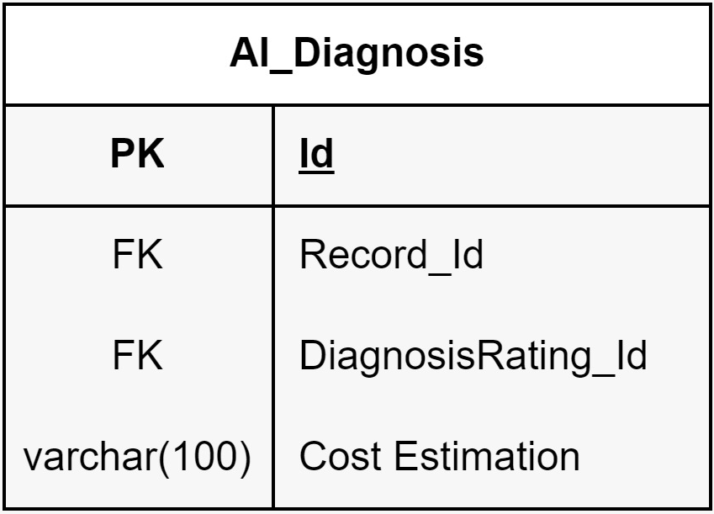
Figure 75

- AI_Diagnosis table has relationship with Record, Diagnosis_Rating tables.
- Id: A unique identifier for each user. It's the primary key (PK) in the table, ensuring that each record in the table can be uniquely identified.
- Cost Estimation: Define as varchar with 100 characters.

Rating Table

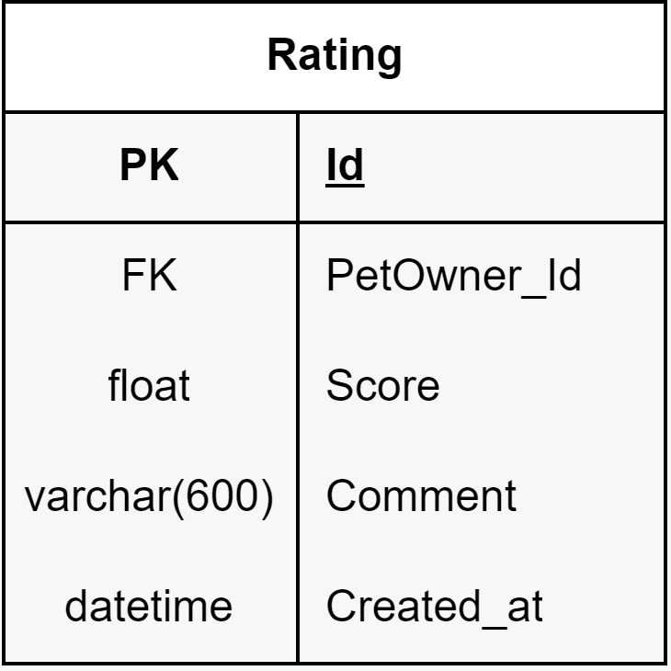
Figure 76
- Taxi_Rating, FoodStore_Rating, Clinic_Rating and Diagnosis_Rating classes extend the Rating class.
- Rating table has relationship with PetOwner table.
- Id: A unique identifier for each user. It's the primary key (PK) in the table, ensuring that each record in the table can be uniquely identified.
- Score: Define as float.
- Comment: Define as varchar with 600 characters.
- Created_at: Define as datetime.

Taxi_Rating Table

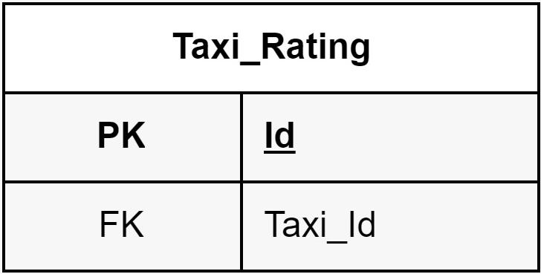
Figure 77
- Taxi_Rating table has relationship with Taxi table.
- Id: A unique identifier for each user. It's the primary key (PK) in the table, ensuring that each record in the table can be uniquely identified.

FoodStore_Rating Table

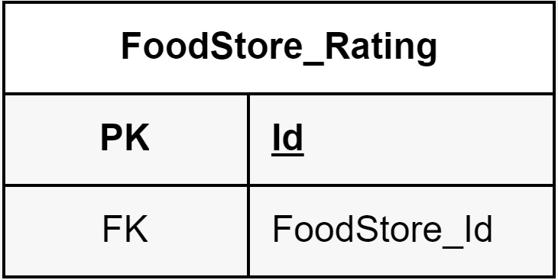
Figure 78
- FoodStore_Rating table has relationship with PetFoodStore table.
- Id: A unique identifier for each user. It's the primary key (PK) in the table, ensuring that each record in the table can be uniquely identified.

Clinic_Rating

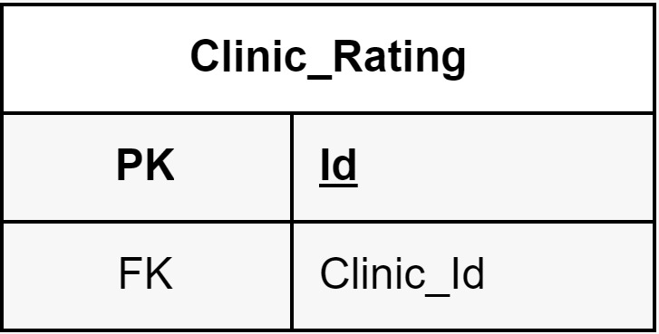
Figure 79
- Clinic_Rating table has relationship with Clinic table.
- Id: A unique identifier for each user. It's the primary key (PK) in the table, ensuring that each record in the table can be uniquely identified.

Diagnosis Rating

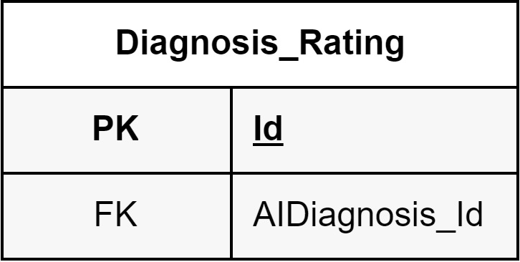
Figure 80
- Diagnosis_Rating table has relationship with AI_Dignosis table.
- Id: A unique identifier for each user. It's the primary key (PK) in the table, ensuring that each record in the table can be uniquely identified.

Facility Table

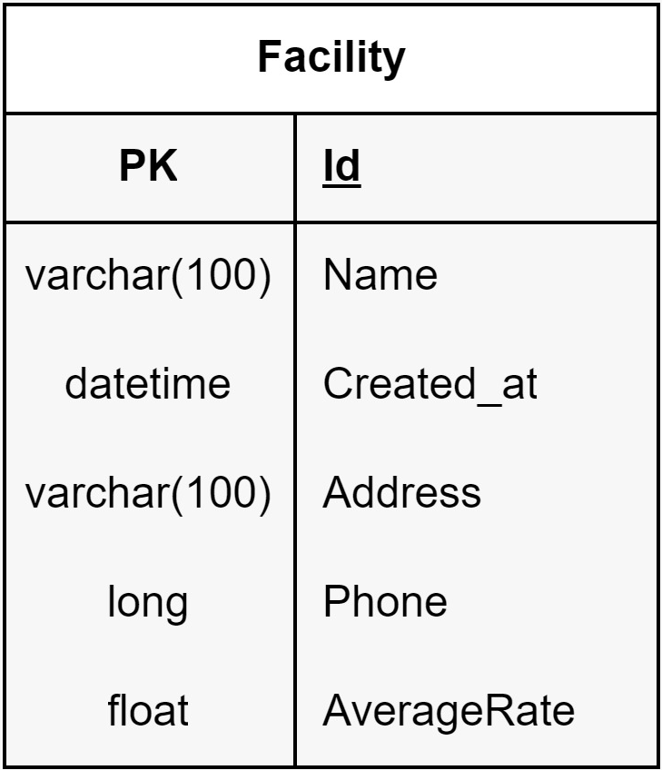
Figure 81
- Clinic, Taxi and PetFoodStore classes extend the Facility class.
- Id: A unique identifier for each user. It's the primary key (PK) in the table, ensuring that each record in the table can be uniquely identified.
- Name: Define as varchar with 100 characters.
- Created_at: Define as datetime.
- Address: Define as varchar with 100 characters.
- Phone: Define as long.
- Average Rate: Define as float

Clinic Table

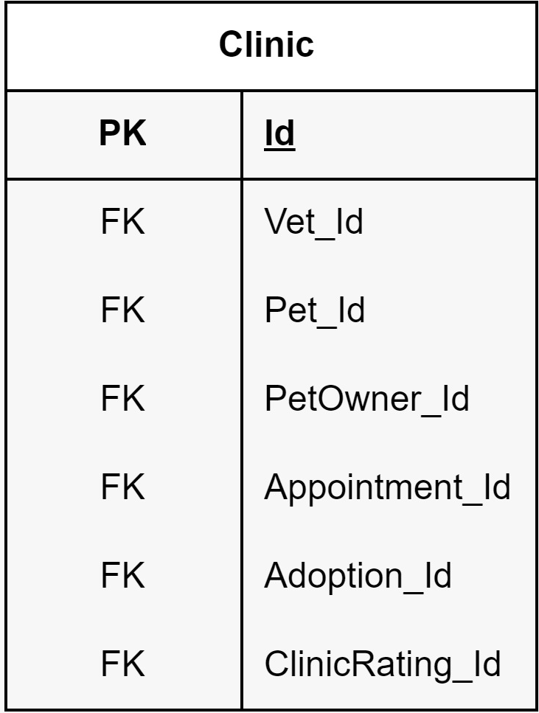
Figure 82
- Clinic table has relationship with Veterinarian, Pet, PetOwner, Appointment, Adoption, Clinic_Rating tables.
- Id: A unique identifier for each user. It's the primary key (PK) in the table, ensuring that each record in the table can be uniquely identified.

Taxi Table

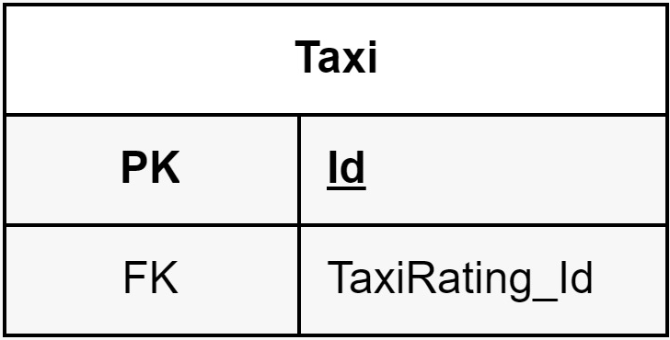
Figure 83

- Taxi table has relationship with Taxi_Rating table.
- Id: A unique identifier for each user. It's the primary key (PK) in the table, ensuring that each record in the table can be uniquely identified.

PetFoodStore Table

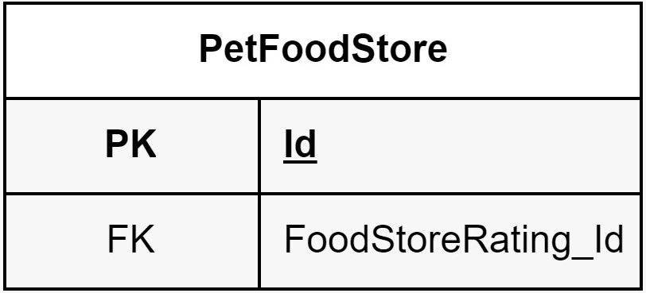
Figure 84
- PetFootStore table has relationship with FoodStore_Rating table.
- Id: A unique identifier for each user. It's the primary key (PK) in the table, ensuring that each record in the table can be uniquely identified.

Location Table

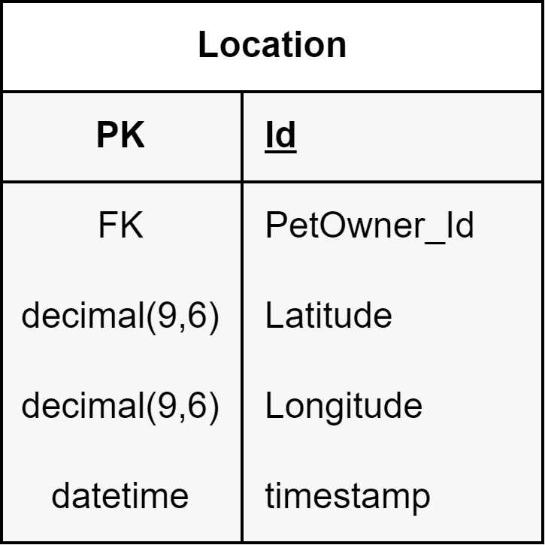
Figure 85
- Location table has relationship with PetOwner table.
- Latitude: Define as decimal (9,6).
- Longitude: Define as decimal (9,6).
- Timestamp: Define as datetime.

Work Breakdown Structure
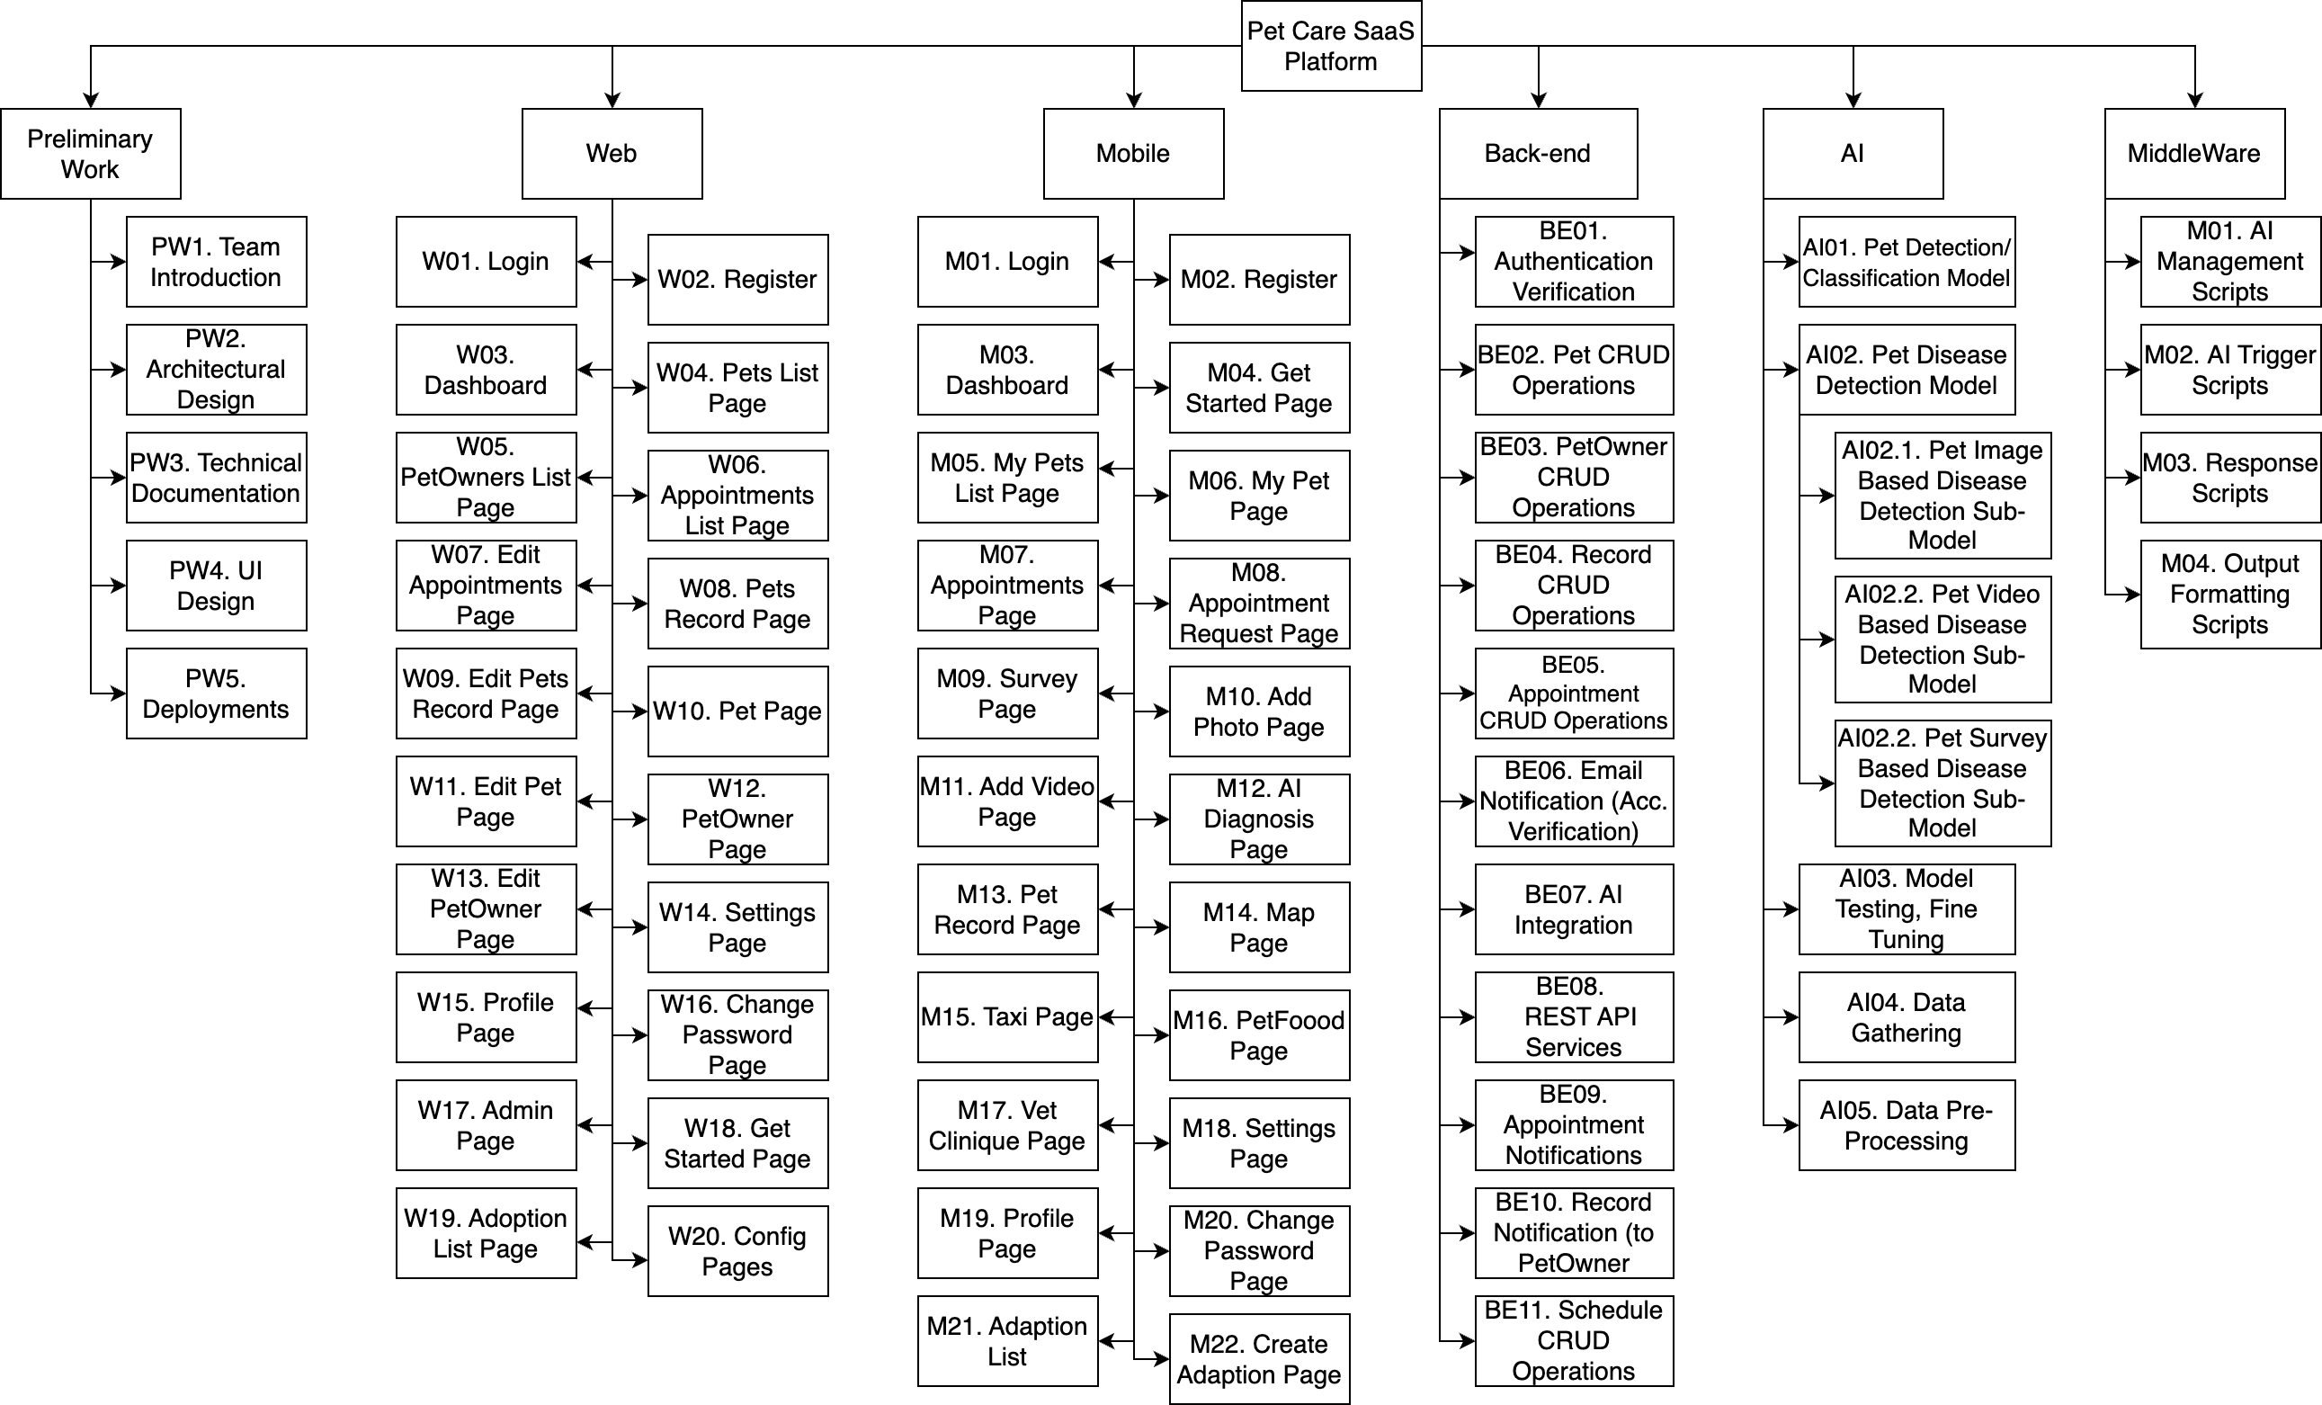
Figure 86- Work Breakdown Structure

References
The resources used to produce this document should be listed here and referenced in the relevant text of this document.
[1] Software Engineering Department, "Graduation Projects," SENG, [Online]. Available: https://seng.cankaya.edu.tr/graduation-projects/. [Accessed 28 June 2024].
[2] IEEE Standard 830-1998 - IEEE Recommended Practice for Software Requirements Specifications: This standard was used as a guideline for structuring and formatting the SRS document.
[3] ISO/IEC 9126 - Software Engineering - Product Quality: This international standard was consulted to ensure the quality attributes and characteristics of the mobile app are properly defined and addressed.
[4] Software Requirements Specification Document for Buddy (Version 1.1, December 1, 2024)

