Istanbul Technical University- Fall 2009

BLG381E, Advanced Data Structures

Report for Homework 1
Name: Ali Çağatay
LastName: Yüksel
Student ID: 040050220
Email: yuksela@itu.edu.tr
Date: 15.11.09
Instructor: Sanem Kabadayı

Q1) The order of the functions’ growth rates, from the biggest to the smallest, is as follows:
- n^5n has the biggest growth rate because it is an exponential function. It’s base is also ‘n’.
- 3^2n is also an exponential function.
- 2^3n is an exp. function as well. The reason that its growth rate is smaller than the prior one is that its base is smaller than that.
- n^log(n) is an exponential function with a logarithmic power and ‘n’ base.
- e^log(n) is an exponential function with a logarithmic power but a constant base.
- n^1000 log(n) is the smallest growing one because it is a polynomial function with a logarithmic product.
Q2)

Description of how your program should be compiled and run:
The program is written based on the compiling instruction given in the assignment paper (no additional header files created) so the compilation should be like there.

ASSIGNMENT d)

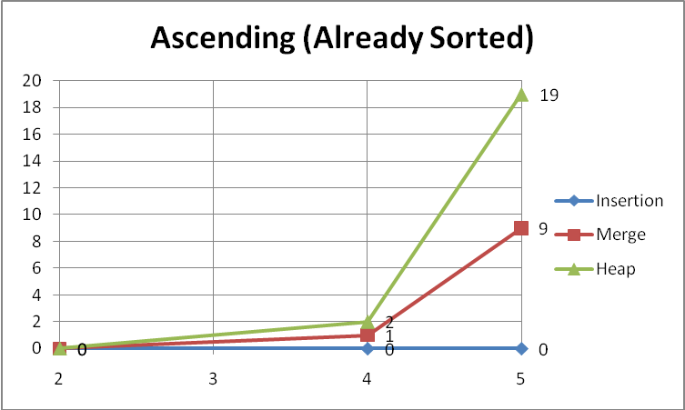
As seen in the graph, insertion sort takes almost no time to run as this is its best case situation. Heap and Merge algorithms needs some cycles to run their default operations .
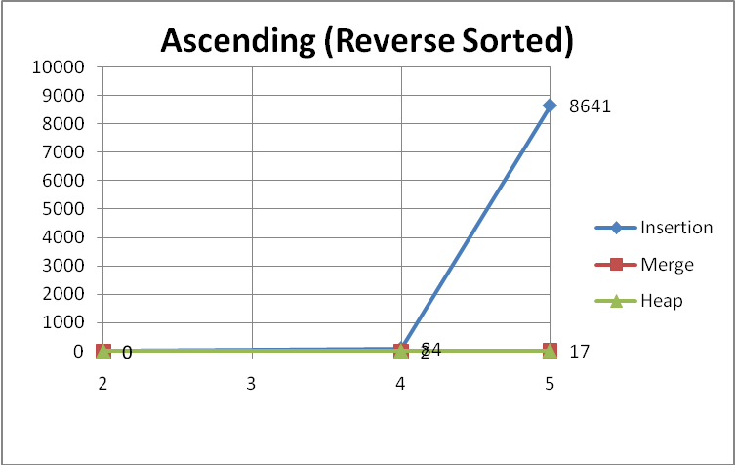
Worst case for insertion sort, not much change for heap and merge.
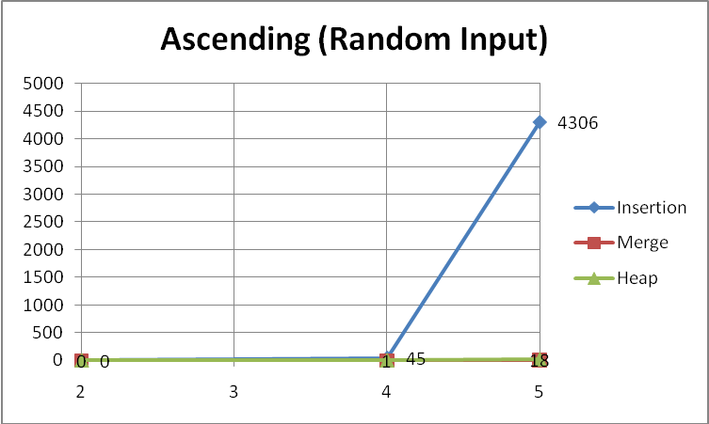
Average case for insertion sort. Merge and heap remains almost same.
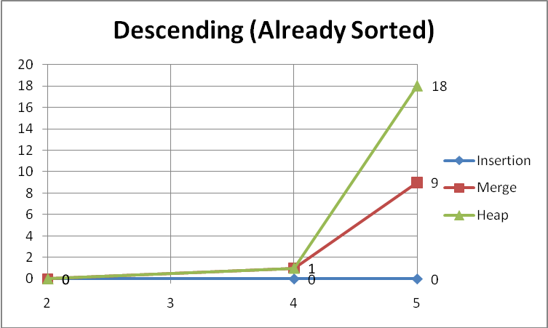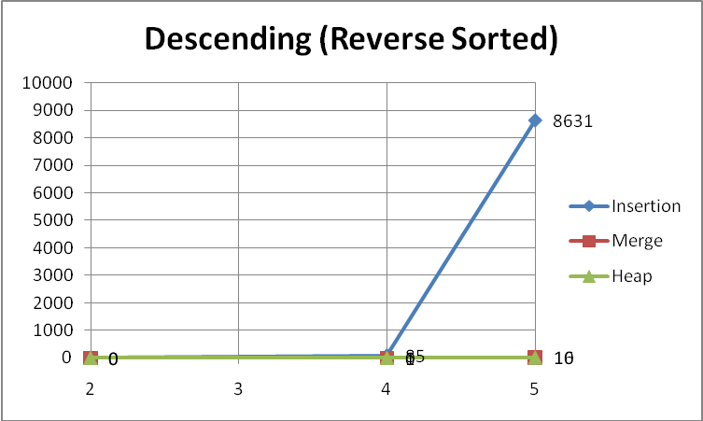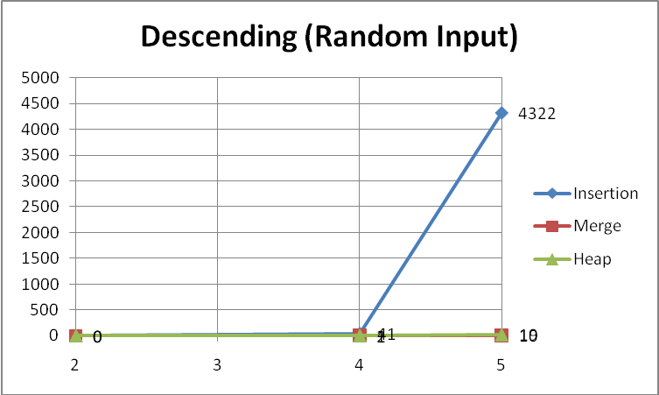

As we have seen in the graphs, insertion sort’s running time is highly effected by the order of the inputs and much higher at growth rate in contrast to merge and heap algorithms. Merge algorithm takes shorter than heap sort to complete but heap sort does its job in place and more memory efficient. Every sane person will want to use merge or heap unless they are sure that their inputs are already sorted and actually don’t need to be sorted at all.

