**CENG3004: Software Engineering**

*SMART TRANSPORTATION SYSTEM*

**Software Requirements Specification Document**

**05/03/2018**

**Team Members:**

ÇAĞATAY ŞENTURCA

ASLI YAVUZ

MELİKE KAŞAN

# **1-Overview**

**WHO IS THE CUSTOMER?**

Our system customer could be anyone who wants to use oublic transportation.

**WHAT IS THE SYSTEM , WHAT DOES IT DO, WHY DO YOU DO IT?**

This system helps the people in transport from one point to another by using public transportation. More specificly, someone wants to go to a place from his location. At this point , our project helps this person at finding the best option like ; How many buses he needs to change? What time is he going to arrive the location where he wants to go? What time he needs to leave his home to go to bus stop?

In this project ,we are willing to make people save their time by using transport and if you are stranger at the city this project is the best for you. We are offering them to save time, comfortable transport.

# 

# **2.Requirements**

## **2.1 Functional Requirements**

|  |  |  |  |
| --- | --- | --- | --- |
| **Requirement Identifier** | **Source (e.g. Interview with XX on DD/MM/YYYY)** | **Priority**  **(High/**  **Medium/**  **Low)** | **Description** |
| FR-1 |  | HIGH | *.*  Users must be able to get location of vehicle. |
| FR-2 |  | MEDIUM | Users must be able to find the closest stop. |
| FR-3 |  | LOW | Users must be able to see the density of vehicle. |
|  |  |  |  |

## **2.2 Nonfunctional Requirements**

|  |  |  |  |
| --- | --- | --- | --- |
| **Requirement Identifier** | **Source (e.g. Interview with XX on DD/MM/YYYY)** | **Priority**  **(High/**  **Medium/**  **Low)** | **Description** |
| NR-1 |  | MEDIUM | Available 24 hours a day. |
| NR-2 |  | HIGH | The device of user shall be connect to the Internet. |
|  |  |  |  |
|  |  |  |  |

**1-USE CASE DİAGRAM**

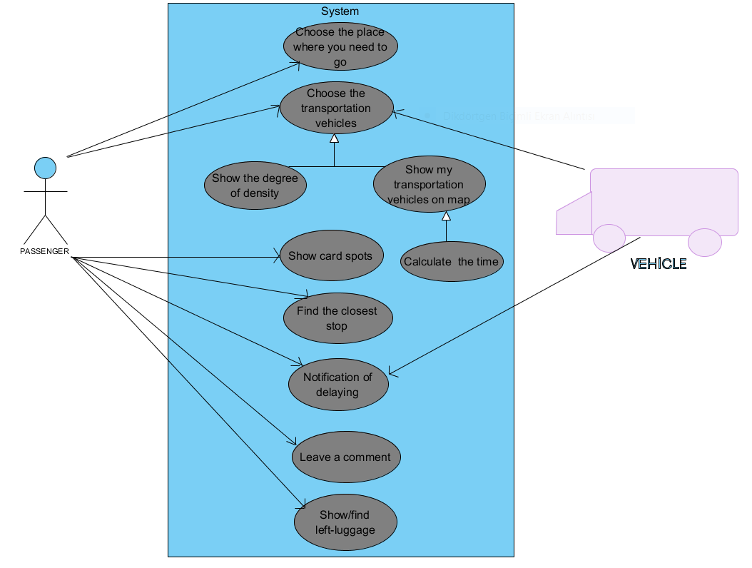

**2-CLASS DİAGRAM**

