ConceptNet: A Practical
Commonsense Reasoning Toolkit
Hugo Liu and Push Singh
Media Laboratory
Massachusetts Institute of Technology
Cambridge, MA 02139, USA
{hugo,push}@media.mit.edu

Abstract. We describe ConceptNet, a freely available semantic network presently consisting of over 250,000 elements of commonsense knowledge. Inspired by Cyc, ConceptNet includes a wide range of commonsense concepts and relations, and inspired by WordNet, it is structured as a simple, easy-to-use semantic network. ConceptNet supports many of the same applications as WordNet, such as query expansion and determining semantic similarity, but it also allows simple temporal, spatial, affective, and several other types of inferences. This paper is structured as follows. We first discuss how ConceptNet was built and the nature and structure of its contents. We then present the ConceptNet toolkit, a reasoning system designed to support textual reasoning tasks by providing facilities for spreading activation, analogy, and path-finding between concepts. Third, we provide some quantitative and qualitative analyses of ConceptNet. We conclude by describing some ways we are currently exploring to improve ConceptNet.
1 Introduction to ConceptNet
There is a thirst in the AI community for large-scale semantic knowledge bases. Semantic knowledge improves the performance of information retrieval, data mining, and natural language processing (NLP) systems and enables new kinds of AI-based intelligent systems. WordNet (Fellbaum, 1998) is arguably the most popular and widely used semantic resource in the community today. Essentially, it is a database of words, primarily nouns, verbs and adjectives, organized into discrete “senses,” and linked by a small set of semantic relations such as the synonym relation and “is-a” hierarchical relations. One of the reasons for its success and wide adoption is its ease of use. As a simple semantic network with words at the nodes, it can be readily applied to any textual input for query expansion, or to determine semantic similarity.
WordNet’s synonym and “is-a” relations have been applied to countless problems in information retrieval, data mining, and NLP. Its popularity has even spun off “word nets” for different languages (cf. EuroWordNet). With all the popularity, we often forget that WordNet was only conceived as a semantic lexicon with the chief function of dictionary and thesaurus. As researchers attack textual understanding problems of growing sophistication they will need a far richer semantic resource whose scope extends beyond lexical knowledge to encompass general world knowledge, or commonsense knowledge. We treat these two terms as being loosely synonymous, and meaning: the practically useful everyday knowledge often described as the “common sense” possessed by people.
The Cyc project, begun in 1984 by Doug Lenat, is a notable related work that tries to formalize commonsense knowledge into a logical framework. To use Cyc to reason about some text, it is necessary to first map into its proprietary logical representation, described by its own sophisticated language CycL. However, this mapping process is very complex because all of the inherent ambiguity in natural language must be resolved to produce the unambiguous logical formulation required by CycL. The difficulty of applying Cyc to practical textual reasoning tasks, and the unavailability of its full content to the public make it a prohibitively difficult option for most textual understanding tasks.
Motivated by a desire to expand upon the scope of WordNet to include more general and practical world knowledge, and to maintain its ease-of-use, we built ConceptNet, a semantic network of over 250,000 items of commonsense knowledge, accompanied by high-level tools for doing some practical commonsense reasoning over text. Generated automatically from a massive corpus of commonsense facts called the Open Mind Commonsense Corpus (Singh et al., 2002), ConceptNet is far from a perfect or complete commonsense knowledgebase; nonetheless, it for the first time freely offers the AI community world knowledge on a large scale, and an easy way to apply the knowledge to textual reasoning problems.

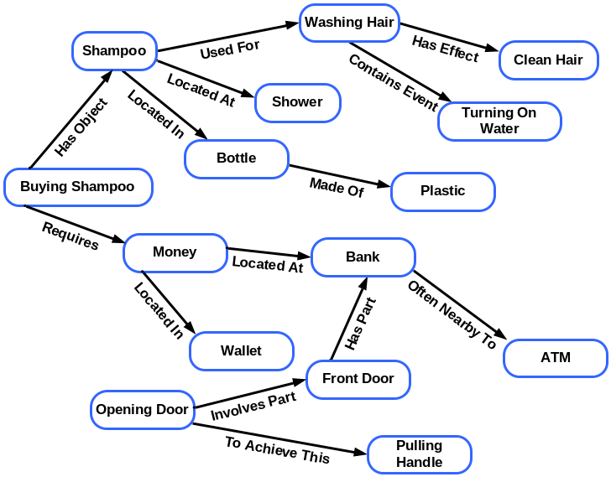

Fig 1. An excerpt from ConceptNet’s semantic network of commonsense knowledge. Relation names are expanded here for clarity.
ConceptNet can best be seen as a semantic resource that is structurally similar to WordNet, but whose scope of contents is general world knowledge along the same vein as Cyc. We have taken the simple WordNet framework and extended it in three principle ways. First, we extend WordNet’s notion of a node in the semantic network from lexical items (main words and simple phrases) to higher-order concepts such as compound phrases (e.g. “adventure books”) and verb-argument compounds (e.g. “buy food”). This allows us to represent and author knowledge around a greater range of concepts found in everyday life, such as “activities” (e.g. “buy food,” “throw baseball,” “cook dinner”). On the flipside, because the corpus from which ConceptNet gets generated is not word-sense-tagged, ConceptNet does not currently distinguish between word senses (there is an affiliated project called OMCSNet-WNLG (Turner, 2003) that is sense-disambiguating ConceptNet nodes). Second, we extend WordNet’s repertoire of semantic relations from the triplet of synonym, is-a, and part-of, to a present repertoire of twenty semantic relations including inter alia, effect-of (causality), first-step-of (a procedure), capable-of (function), property-of, made-of, and desires-event (motivations & goals). Third, when compared to WordNet, the knowledge in ConceptNet is of a more informal, defeasible and practically valued nature. For example, WordNet knows that “dog” is-a “canine,” which is-a “carnivore,” which is-a “placental mammal;” but it cannot make the practically oriented association that “dog” is-a “pet.” Unlike WordNet, ConceptNet also contains a lot of knowledge that is defeasible, meaning it describes something that is often, but not always true (e.g. has-effect(“fall off bicycle”, “get hurt”)). This is a useful kind of knowledge because a great deal of our practical everyday world knowledge is defeasible in nature.
The rest of the paper is structured as follows. First, we discuss how ConceptNet was built, how it is structured, and the nature of its contents. Second, we present some high-level practical commonsense reasoning methods provided in the ConceptNet toolkit that can be applied to textual reasoning tasks. Third, we reflect on some quantitative and qualitative analyses of ConceptNet, and on how ConceptNet is now being used by AI practitioners. We conclude with a summary of contributions, and present some directions for future work.
2 Building ConceptNet
In this section, we first explain the origins of ConceptNet in the Open Mind Commonsense corpus; then we demonstrate how knowledge is extracted to produce the semantic network; and third, we describe the structure and semantic content of the network. The ConceptNet Knowledge Base, Knowledge Browser, and Practical Reasoning API are available for download (Liu & Singh, 2003).
2.1 History of ConceptNet
Building large-scale databases of commonsense knowledge is not a trivial task. One problem is scale. It has been estimated that the scope of common sense may involve many tens of millions of pieces of knowledge (Mueller, 2001). Unfortunately, common sense cannot be easily mined from dictionaries, encyclopedias, the web, or other corpora because it consists largely of knowledge obvious to a reader, and thus omitted. Indeed, it likely takes much common sense to even interpret dictionaries and encyclopedias. Until recently, it seemed that the only way to build a commonsense knowledge base was through the expensive process of hiring an army of knowledge engineers to hand-code each and every fact.
However, in recent years we have been exploring a new approach. Inspired by the success of distributed and collaborative projects on the Web, Singh et al. turned to volunteers from the general public to massively distribute the problem of building a commonsense knowledgebase. Three years ago, the Open Mind Commonsense (OMCS) web site (Singh et al. 2002) was built, a collection of 30 different activities, each of which elicits a different type of commonsense knowledge—simple assertions, descriptions of typical situations, stories describing ordinary activities and actions, and so forth. Since then the website has gathered over 675,000 items of commonsense knowledge from over 13,000 contributors from around the world, many with no special training in computer science. The OMCS corpus now consists of a tremendous range of different types of commonsense knowledge, expressed in natural language.
The earliest use of the OMCS corpus made use of its knowledge not directly, but by first extracting into semantic networks only the types of knowledge they needed. For example, the ARIA photo retrieval system (Liu & Lieberman, 2002) extracted taxonomic, spatial, functional, causal, and emotional knowledge from OMCS to improve information retrieval. This suggested a new approach to building a commonsense knowledgebase. Rather than directly engineering the knowledge structures used by the reasoning system, as is done in Cyc, OMCS encourages people to provide information clearly in natural language, and then from this semi-structured English sentence corpus, we are able to extract more usable knowledge representations and generate useable knowledge bases. We build a semantic network called OMCSNet by reformulated the knowledge in OMCS into a system of binary relations which constitute a semantic network. This allows us to apply graph-based methods when reasoning about text. We have since renamed OMCSNet to ConceptNet to invite comparison with WordNet and to emphasize their differences, i.e., dealing with concepts versus lexical items).
  - Generating ConceptNet from the OMCS corpus
The current ConceptNet is produced by an automatic process, which applies a set of ‘commonsense extraction rules’ to the semi-structured English sentences of the OMCS corpus. The key to being able to do this is that the OMCS website already elicits knowledge in a semi-structured way by prompting users with fill-in-the-blank templates (e.g. “The effect of [falling off a bike] is [you get hurt]”). A pattern matching parser uses roughly 40 mapping rules to easily parse semi-structured sentences into an ontology of predicate relations, and arguments which are short fragments of English. These arguments are then normalized. Certain stop-words and stop-parts-of-speech are filtered out, and the verb and nouns are reduced to their canonical base form. To regularize the acceptable types of arguments, we define three syntactic classes: Noun Phrases (things, places, people), Attributes (modifiers), and Activity Phrases (actions and actions compounded with a noun phrase or prepositional phrase, e.g.: “turn on water,” “wash hair.”). A small part-of-speech tag –driven grammar filters out non-compliant text fragments (thus only a subset of the OMCS knowledge is used in ConceptNet) to ensure all arguments conform to these syntactic constraints.
When all is done, the cleaned relations and arguments are linked together into the ConceptNet semantic network. Arguments map to nodes, and relations map to edges. Adopting a simple semantic network knowledge representation allows us to use graph reasoning methods like spreading activation (Collins & Loftus, 1975), structure mapping (Gentner, 1983), and network traversal. And because nodes are structured English fragments, it is easy to map natural language into this representation using information extraction and fuzzy text matching. In contrast, recall that mapping natural language into Cyc’s underlying logical representation is actually quite complex because it requires complete meaning disambiguation up-front.
  - Structure and Semantic Content of ConceptNet
At present ConceptNet consists of the 19 binary relations shown below in Table 1. These relations were chosen because the original OMCS corpus was built largely through its users filling in the blanks of templates like ‘a hammer is for _____’. Thus the relations we chose to extract largely reflect the original choice of templates used on the OMCS web site.

Table 1. Semantic Relation Types currently in ConceptNet
Category | Semantic Relations – (and an explanation)
Things | IsA – (corresponds loosely to hypernym in WordNet)  PropertyOf – (e.g. (PropertyOf “apple” “healthy”))  PartOf – (corresponds loosely to holonym in WordNet)  MadeOf – (e.g. (MadeOf “bottle” “plastic”))
Events | FirstSubeventOf – (e.g. (FirstSubeventOf “act in play” “learn script”))  LastSubeventOf – (e.g. (LastSubeventOf “act in play” “take bow“))  EventForGoalEvent – (e.g. (EventForGoalEvent “drive to grocery store” “buy food”))  EventForGoalState – (e.g. (EventForGoalState “meditate” “enlightenment”))  EventRequiresObject – (e.g. (EventRequiresObject “apply for job” “resume”))
Actions | EffectOf – (e.g. (EffectOf “commit perjury” “go to jail”))  EffectOfIsState – (e.g. (EffectOfIsState “commit perjury” “criminal prosecution”))  CapableOf – (e.g. (CapableOf “police officer” “make arrest”))
Spatial | OftenNear – (e.g. (OftenNear “sailboat” “marina”))  LocationOf – (e.g. (LocationOf “money” “in bank account”))
Goals | DesiresEvent – (e.g. (DesiresEvent “child” “be loved”))  DesiresNotEvent – (e.g. (DesiresNotEvent “person” “die”))
Functions | UsedFor – (e.g. (UsedFor “whistle” “attract attention”))
Generic | CanDo – (e.g. (CanDo “ball” “bounce”))  ConceptuallyRelatedTo – (e.g. (ConceptuallyRelatedTo “wedding” “bride” “groom” “bridesmaid” “flowers” “gazebo”))

As illustrated by the examples in Table 1, the semantics of the predicate relations in ConceptNet are quite informal. Even for a particular semantic relation, the syntactic and/or semantic type of the arguments are not formally constrained, though some predicate names imply some typing (e.g. EventForGoalEvent, EventForGoalState, EventRequiresObject). In general, the usage and scope of each semantic relation can be best and most intuitively ascertained by looking at the original choice of templates used on the OMCS web site (At: http://openmind.media.mit.edu)
Comparing the coverage of the semantic relations in ConceptNet to that of WordNet, it’s clear that the two semantic resources only partially overlap each other. ConceptNet does not have lexically motivated relations like synonym and antonym. ConceptNet’s IsA and PartOf relations are likely to cover mostly defeasible knowledge and knowledge about events, while WordNet’s corresponding hypernym and holonym relations cover more linguistically formal knowledge. That they only partially overlap is a good thing because it means that both resources can be used in conjunction. Elliot Turner has a project related to ConceptNet called OMCSNet-WNLG, which effectively combines the two resources (Turner, 2003).
Looking through these examples, it is easy to imagine that there may be many different ways to describe the same concept, even when we have constrained the syntactic structure of each argument. We have identified three main sources of variation in the natural language expressions: synonym, granularity, and action/state. The two concepts “bike” and “bicycle” are synonyms, and so are the verbs in “purchase food” and “buy food.” We can use a thesaurus (like WordNet!) to reconcile these variations if our reasoning mechanisms need each pair of nodes to resolve to the same node, though there is no harm, and indeed, some good to be had in keeping these variations around. Expressing the same thing in different ways affords ConceptNet the ability to match concepts in inputted natural language text more thoroughly because there are more known surface variations of a concept to match against.
A second source of variation is how a concept gets described is granularity. For example, “buy food” and “purchase groceries” can be thought of as describing the same event-concept but at different granularities. “Buy” and “purchase” are near synonyms, and “groceries” implies “food,” but carries an additional context of a “grocery store;” thus, “purchase groceries” is arguably more specific than “buy food.” Depending upon the context that a textual reasoning mechanism is operating under, it may want to treat these two concepts as different or the same. To reconcile the nodes as one and the same, it is easy enough to apply a synonym list and/or an is-a hierarchy to reduce them to the same node. Representing knowledge in English affords us this flexibility. Rather than eliminating ambiguity with a formal framework, ConceptNet maintains the ambiguity and manages the ambiguity with the help of synonym lists and is-a hierarchies.
The third source of variation we identified is action/state. Suppose we have the two nodes “relax” and “feel relaxation.” They are both describing the same concept but one poses the event as an action (verb) while the other poses it as a state (noun). To reconcile them we need a derivational morphological analyzer. Unfortunately we will run the risk here of wrongly overgeneralizing because certain derivational morphologies are semantically close (e.g. “relax” and “relaxation) while others are semantically further apart (e.g. “establish” and “establishment”). Still it is possible to make some reconciliations under simplifying heuristic assumptions; for example: “foo” (verb), and “foo”+tion (state) are generally semantically close.
Unlike Cyc’s logical formalization scheme, ConceptNet’s English knowledge representation contains ambiguities such as the aforementioned, but this is not necessarily a bad thing. Inputted natural language is inherently ambiguous, and rather than eliminating ambiguity altogether, having many linguistic variations of the same knowledge in ConceptNet makes the conceptual matching more thorough and robust. And all our reasoning is also done in a constrained natural language framework. We manage the ambiguity of the English fragment nodes with methods for reconciling different nodes through heuristic lexical similarity. In the next section we discuss how ConceptNet can be applied for reasoning about text.
3 Practical Commonsense Reasoning with ConceptNet
Having posed commonsense concepts as English fragment nodes and commonsense knowledge as the semantic relation edges, which connect these nodes, we have set ourselves up for a very simple graph-based reasoning, with simple being the intended property. Logical reasoning frameworks excel at precise conclusions, whereas graph-based reasoning excels at fuzzier kinds of inference such as determining context, and semantic similarity. We have built a set of graph-based methods called the ConceptNet Practical Reasoning API. The goal was to formalize some of the most basic and popular functionality of ConceptNet so that the Toolkit can be even simpler to use.
  - Contextual Neighborhoods
One task useful across many textual reasoning applications is determining the context around a concept, or around the intersection of several concepts. The GetContext() feature in the API makes this easy. Figure 2 shows the contextual neighborhood for the concepts “living room” and “go to bed.”
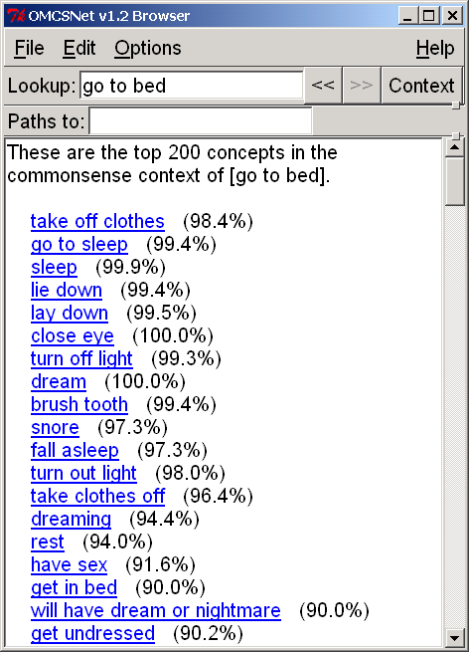
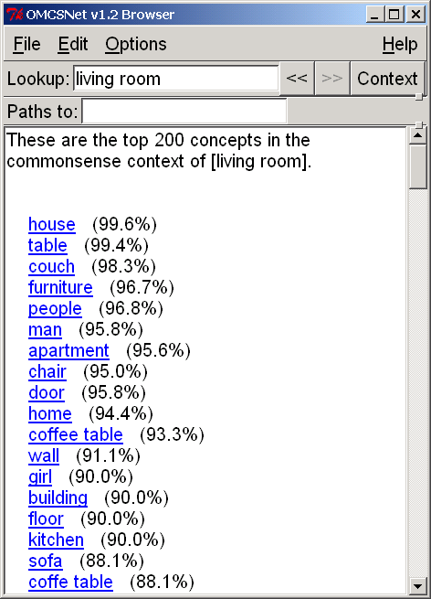
Fig. 2. The results of two GetContext() queries are displayed in the ConceptNet Knowledge Browser.
The contextual neighborhood around a node is found by performing spreading activation from that source node, radiating outwardly to include other concepts. The relatedness of any particular node is not just a function of the number of links away it is, but also considers how many paths there are from that node to the source node, and the directionality of the edge. Typically in spreading activation (cf. (Collins & Loftus, 1975)) the semantics of all the edges are the same, but in ConceptNet, features like directionality matter. For example, if we followed all the forward EffectOf edges, we would arrive at possible next states; but if we instead followed all these EffectOf edges in reverse, we would arrive at possible previous states. To recognize that each semantic relation has a different relevance to a given task or application domain, the numerical value of each edge can be manipulated (by default, it is equal to 1.0). In the ARIA Photo Agent, Liu & Lieberman (2002) heuristically weighted each semantic relation type based on their perceived importance to the photo retrieval domain, and then further trained the numerical weights of each edge on a sample domain corpus. These two GetContext() queries shown in Figure 2 are made without any biases, so all semantic relations are considered equally. It is also useful to only get temporal, spatial, or action -only neighborhoods of concepts. For example, getting only the temporally forward conceptual expansions would be equivalent to imagining possible next states from the current state.
It is also useful to determine the contextual neighborhood at the intersection of multiple concepts. Suppose we use GetContext() to get all the temporal next states from the current state. Feeding another concept into this function creates a bias on the results. For example, “be hungry” can result in many possible next states such as “buy food” or “cook dinner” or “order food.” Given the additional context bias of “restaurant,” results that are more relevant to that concept will be preferred and “order food” will be considered more likely to be contextual relevant in the results.
Taking the conceptual intersection to an extreme, suppose we feed in all the concepts in a particular passage of natural language into GetContext(). GetContext() used in this way serves as a “topic spotter” of sorts. Eagle et al. (2003) used ConceptNet and this method to gist conversation topics from overheard conversations. Previously researchers in text summarization such as Hovy & Lin have recognized the need for symbolic general world knowledge in topic detection, which is a key component of summarization. In SUMMARIST (1997), Hovy & Lin give the example that the presence of the words “gun”, “mask”, “money”, “caught”, and “stole” together would indicate the topic of “robbery”. However, they reported that WordNet and dictionary resources were relationally too sparse for robust topic detection. ConceptNet excels at this type of natural language contextual task because it is relationally richer and contains practical rather than dictionary-like knowledge.
The reverse of topic spotting, topic generation is also useful. Musa et al.’s GloBuddy system (2003) is a dynamic Berlitz phrase book that uses ConceptNet’s GetContext() feature to generate a collection of phrases paired with their translations on a given topic. For example, entering “restaurant” would return phrases like “order food” and “waiter” and “menu,” and their translations into the target language.
  - Semantic Similarity and Analogy-Making
Another useful task is determining the semantic similarity of pairs of concepts and making simple analogies between them. In the ConceptNet Practical Reasoning API, there is a GetAnalogousConcepts() feature that can return a list of semantically similar concepts given a source concept. By similarity here we mean structural similarity, and not just semantic distance. For example, “wedding” and “bride” are semantically close but structurally unlike. Structurally, a “funeral” is much more like a “wedding.”
Here is another example. Typing “couch” into the GetAnalogousConcepts(), examples of top results returned include “sofa,” “chair,” “bed,” “seat” because they share similar properties and have similar functions. We are employing structure-mapping methods (Gentner, 1983) over the ConceptNet graph to generate these simple conceptual analogies. Just like we’ve done with the GetContext() feature, it is also easy to contextually bias the GetAnalogousConcepts() feature. We can prefer to see analogous concepts which fall within a particular domain (defined by another GetContext()), or by biasing the numerical weights of particular semantic relations, we can emphasize functional similarity versus object attribute similarity versus temporal similarity.
Liu et al. are using this same idea of finding what concepts have in common to augment the Emotus Ponens system (2003) which performs affective text classification using a slightly different representation than ConceptNet. In the domain of affective text classification, increased recognition of affective concepts in the text improves performance. The basic idea of this augmentation is that certain kinds of structural similarity, such as concepts sharing PropertyOf’s, IsA’s, and UsedFor’s, can be predictive of affective similarity. They hope that expanding concepts with analogous concepts can expand the coverage of the system and thus improve the performance of the affective classification.
3.3 Graphical Inference Chains
A third basic type of inference that can be done on a graph is building inference chains: Traversing the graph from one node to another node via some path of connectedness. This is not logical inference per se but a simplification of modus ponens transitive reasoning. The FindPathsBetween() feature in the ConceptNet Practical Reasoning API supports building inference chains. Liu et al.’s aforementioned Emotus Ponens system uses essentially this method for assessing the affect of a concept. Consider that a small subset of the concepts in ConceptNet are first affectively classified into one of six affect categories (happy, sad, angry, fearful, disgusted, surprised). The affect of any unclassified concept can be assessed by finding all the paths which lead to each of these six affectively known categories, and then judging the strength and frequency of each set of paths. This is graph-based equivalent to a k-nearest-neighbor classifier.
Having discussed some methods for practical commonsense reasoning over text included in the ConceptNet toolkit, we now turn attention to some analytical evaluation of the ConceptNet knowledge and give reflection on how ConceptNet is currently being used in research projects by AI practitioners.
4 Characteristics, Quality, and Uses of the Knowledgebase
Large knowledge bases of commonsense knowledge like ConceptNet are inherently difficult to evaluate. What is and is not “common sense?” How does one assess the goodness of knowledge that is defeasible and expressed in varying ways? How much commonsense about a topic or concept constitutes completeness? These are all difficult questions that we cannot provide definitive answers for. One important criteria driving the evolution of ConceptNet has been, is it useable and how is it improving the behavior of the intelligent system in which it is being applied? In this section, we try to better characterize the knowledgebase through various analyses to help the reader gain a better intuition for the coverage and capabilities of ConceptNet. We also invite readers to download the knowledgebase for a personal evaluation.
  - Characteristics of the Knowledgebase
ConceptNet is constantly rebuilt as the Open Mind Commonsense Website continues to collect knowledge. At present, there are 675,000 sentences in the Open Mind Commonsense Corpus. There are roughly 45,000 concept nodes in ConceptNet, connected by roughly 280,000 pieces of knowledge (i.e. edges). First, we give a broad comparison of ConceptNet to other large-scale semantic knowledge bases on the basis of statistics alone (Table 2). A more extensive review and comparison of the different knowledge bases can be found in a related technical report (Liu & Singh, 2003).
Table 4. Relative sizes of large-scale semantic knowledge bases. Adapted with permission from Mueller (1999)).

Name | Concepts | ako/isa | part-of | Other
Cyc (Lenat, 1995) | 30,000 | ~375,000 | ~525,000 | ~600,000
ThoughtTreasure (Mueller, 2000) | 27,093 | 28,818 | 666 | 21,821
WordNet 1.6 (Fellbaum, 1998) | 99,642 | 78,446 | 19,441 | 42,700
MindNet (Richardson et al., 1998) | 45,000 | 47,000 | 14,100 | 32,900
ConceptNet (Liu & Singh, 2004) | 45,000 | 30,000 | 7,000 | 243,000

Because ConceptNet is generated from data collected through the Open Mind Commonsense website, the popularity of certain knowledge-entry activities over others will cause a certain uneven distribution of knowledge across the semantic relations, shown in Figure 3.
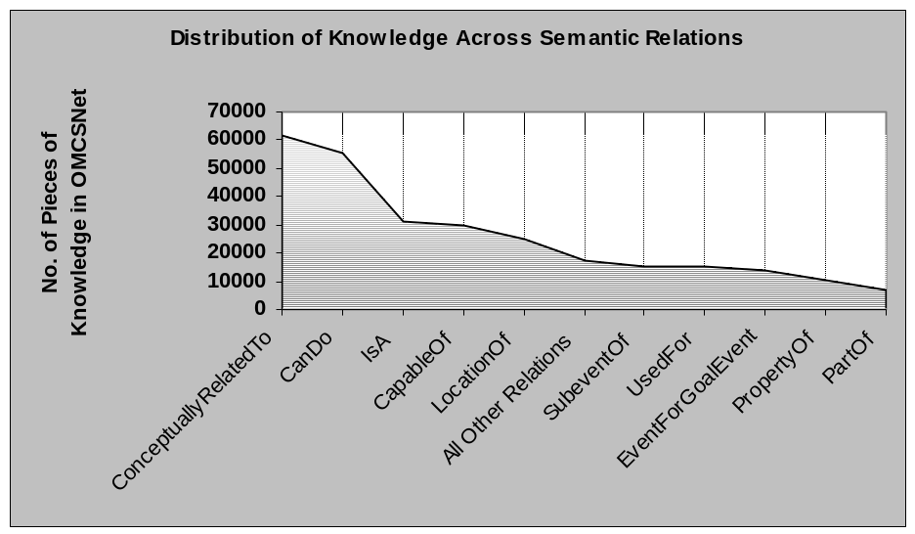
Fig. 3. The popularity of certain activities on the OMCS website generation an uneven distribution of knowledge across semantic relations in ConceptNet.

The two rather generic relations “ConceptuallyRelatedTo” and “CanDo” account for much of the total knowledge in ConceptNet. On the website, users seemed to prefer these activities more because they allowed rather unrestricted knowledge entry (most flexible templates). Though they are generic, they are not without use. “ConceptuallyRelatedTo” generates neighborhoods of context, while “CanDo” is a resource than can be used as a database of selectional preferences, among other things.
Another interesting characteristic of the knowledgebase is revealed by examining the edge-density of nodes, also known as branching factor. This is shown in Figure 4.
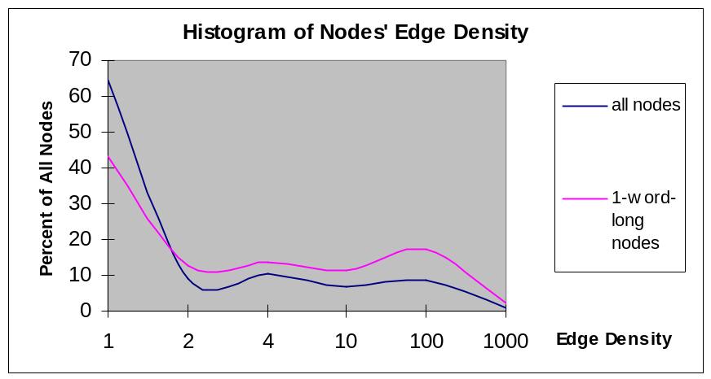
Fig. 4. The edge-density of the nodes. Both edges and back-edges are counted.
Considering that nodes are expressed in semi-structured natural language, and considering the possibilities for varied expression in natural language, it is not surprising that about 65% of all nodes and 43% of one-word-long nodes have only 1 edge and are terminal, or leaf, nodes. What’s interesting in this graph is that there are just as many nodes with 10-100 edges as there are with 2-4 edges or 4-10 edges. Harder to see on the graph is that there are some 300 nodes (out of 45,000) with 100-1000 edges.
  - Quality of the Knowledgebase
Since ConceptNet derives from the Open Mind Commonsense Corpus, it is relevant to know about the quality of that body of knowledge. The original OMCS corpus was previously evaluated by Singh et al. (2002). Human judges evaluated a sample of the corpus and rated 75% of items as largely true, 82% as largely objective, 85% as largely making sense, and 84% as knowledge someone would have by high school.
We have also evaluated the knowledge in ConceptNet. We conducted an experiment with five human judges and asked each judge to rate 100 concepts in ConceptNet. 10 concepts were common to all judges (for correlational analysis), 90 were of their choice. If a concept produced no results, they were asked to duly note that and try another concept. Concepts were judged along these 2 dimensions, each on a Likert 1 (strongly disagree) to 5 (strongly agree) scale:
1) Results for this concept are fairly comprehensive.
2) Results for this concept include incorrect knowledge, nonsensical data, or non-commonsense information.
To account for inter-judge agreement, we normalized scores using the 10 common concepts, and produced the re-centered aggregate results shown below in Table 3.
Table 3. Two dimensions of quality of ConceptNet, rated by human judges
 | Mean Score | Std. Dev. | Std. Err.
Comprehensiveness | 3.40 / 5.00 | 1.24 | 1.58
Noisiness | 1.24 / 5.00 | 0.99 | 1.05
% Concepts attempted, that were not in KB | 11.3% | 6.07% | 0.37%

These results can be interpreted as follows. Judgment of comprehensiveness of knowledge in ConceptNet on average, was several relevant concepts, but varied significantly from a few concepts to almost all of the concepts. Noisiness was little noise on average, and did not vary much. % of KB misses was very consistently 11%. We consider these to be very optimistic results. Comprehensiveness was moderate but varied a lot indicating still patchy coverage, which we hope this will improve as OMCS grows. Noisiness was surprisingly low, lending support to the idea that a relatively clean KB can be elicited from public acquisition. % of KB misses was more than tolerable considering that ConceptNet has only 45,000 natural language concepts—a fraction of that possessed by people.
  - Applications
It is quite difficult to produce useful standalone objective evaluations of knowledgebase quality. Ultimately we are interested in whether or not the research community finds the knowledgebase to be relevant to solving interesting problems, and what the performance of the knowledgebase is, in the context of an application domain.
We and others at our lab have developed a host of applications using early versions of ConceptNet. We survey these applications in (Lieberman et al., 2004). These seem to be entirely new kinds of applications, in that it is difficult to imagine how they could possibly be built without making use of a substantial database of commonsense knowledge. Many of these projects are evaluated and we invite the reader to follow the literature if he/she is interested in these in-context evaluations of ConceptNet.
5 Future Work
We are presently exploring a number of ways to improve ConceptNet:
Increase the number of link types. The current set of 19 relation types in ConceptNet is small compared to the wide array of assertion types that exist in the OMCS corpus. We wish to employ a broad coverage parser that can extract a wider range of knowledge from the corpus.
Integrate with WordNet. We are working on integrating ConceptNet and WordNet, as started Turner (2003). The major problem is disambiguating the ConceptNet concepts to WordNet synsets. The Open Mind Word Expert web site (Chklovski and Mihalcea, 2002) allows users to disambiguate the senses of the words in the OMCS corpus, and we are looking into making use of the data they are collecting to build a disambiguated ConceptNet.
Use probabilistic representations. The semantics of our spreading activation scheme is not clear, and so we have been considering ways to interpret ConceptNet as a probabilistic model over which engage in loopy belief propagation, as we have done in our work on LifeNet (Singh and Williams, 2003).
Map into the Cyc ontology. We are exploring mapping ConceptNet into the CycL ontology (Cycorp, 2003). It may be possible to produce from ConceptNet a commonsense knowledge base more like Cyc, while at the same time retaining its ease of use, if we can disambiguate not just the nodes of ConceptNet into more precise terms but also the ConceptNet links into precise and well-formulated axioms.
Collecting more knowledge. We are considering new designs for Open Mind sites that focus specifically on growing the ConceptNet knowledge base, and including special activities for elaborating, validating, and repairing items of knowledge, as done in the Open Mind Experiences web site (Singh & Barry, 2003).
6 Conclusions
ConceptNet is presently the largest freely available database of commonsense knowledge. It comes with a browser and a preliminary set of tools to support basic semantic processing tasks, and is being used in a number of applications.
ConceptNet is designed to be especially easy to use; it has the simple structure of WordNet and its underlying representation is based on natural language fragments, which makes it particularly well suited to textual reasoning problems. However, the content of ConceptNet reflects a far richer set of concepts and semantic relations than those available in WordNet, and motivated by the range of concepts available in the Cyc commonsense knowledge base.
While the coverage of ConceptNet’s knowledge is still spotty in comparison to what people know, our analysis has shown it to be surprisingly clean, and it has proven more than large enough to enable experimenting with entirely new ways to tackle traditional semantic processing tasks.
We hope that this paper has encouraged the reader to consider using ConceptNet within their own projects, and to discover the benefits afforded by such large scale semantic resources.
Acknowledgements
We would like to thank the many people at the Media Lab who have used ConceptNet in their projects, especially Barbara Barry, Nathan Eagle, Henry Lieberman, and Austin Wang. We would also like to thank the students in Henry Lieberman’s ‘Common Sense Reasoning for Interactive Applications’ course for putting up with early versions of the ConceptNet toolkit. Finally, we would like to thank the nearly 14,000 users of the Open Mind Common Sense web site for contributing their time and effort to our project.
References
- Chklovski, T. and Mihalcea, R. (2002). Building a Sense Tagged Corpus with Open Mind Word Expert. Proceedings of the Workshop on Word Sense Disambiguation: Recent Successes and Future Directions, ACL 2002.
- Collins, A. and Loftus, E. (1975). A Spreading-Activation Theory of Semantic Processing. Psychological Review, 82(6):407-428.
- Cycorp (2003). The Upper Cyc Ontology. Available at http://www.cyc.com
- Eagle, N., Singh, P., and Pentland, A. (2003). Common sense conversations: understanding casual conversation using a common sense database. Proceedings of the Artificial Intelligence, Information Access, and Mobile Computing Workshop (IJCAI 2003).
- Fellbaum, C. (Ed.).: WordNet: An electronic lexical database. MIT Press (1998).
- Gentner, D. (1983). Structure-mapping: A theoretical framework for analogy. Cognitive Science, 7, pp 155-170.
- Lenat, D.B. (1995). CYC: A large-scale investment in knowledge infrastructure. Communications of the ACM, 38(11)
- Lieberman, H., Liu, H., Singh, P., Barry, B. (2004). Beating Some Common Sense Into Interactive Applications. Submitted to AI Magazine.
- Liu, H. and Lieberman, H. (2002). Robust photo retrieval using world semantics. Proceedings of LREC2002 Workshop: Using Semantics for IR, Canary Islands, 15-20
- Liu, H., Lieberman, H., Selker, T. (2003). A Model of Textual Affect Sensing using Real-World Knowledge. In Proceedings of IUI 2003. Miami, Florida.
- Liu, H., Singh, P. (2003a). OMCSNet: A Commonsense Inference Toolkit. MIT Media Lab Technical Report SOM03-01. At: http://web.media.mit.edu/~push/OMCSNet.pdf
- Liu, H., Singh, P. (2003b). OMCSNet v1.2. Knowledge Base, tools, and API available at: http://web.media.mit.edu/~hugo/omcsnet/
- Mueller, E. (1999). Prospects for in-depth story understanding by computer. arXiv:cs.AI/0003003 http://www.signiform.com/erik/pubs/storyund.htm.
- Mueller, E. (2000). ThoughtTreasure: A natural language/commonsense platform. Retrieved from http://www.signiform.com/tt/htm/overview.htm
- Mueller, E. T. (2001): Commonsense in humans. Available: http://www.signiform.com/erik/pubs/cshumans.htm
- Musa, R., Scheidegger, M., Kulas, A., Anguilet, Y. (2003) GloBuddy, a Dynamic Broad Context Phrase Book. In Proceedings of CONTEXT 2003, pp. 467-474. LNCS. Springer.
- Richardson, S. D., Dolan, B., and Vanderwende, L. (1998). MindNet: Acquiring and structuring semantic information from text. In COLING-ACL'98.
- Singh, P. et al. (2002). Open Mind Common Sense: Knowledge acquisition from the general public. In Proceedings of ODBASE’02. LNCS. Heidelberg: Springer-Verlag
- Singh, P. and Barry, B. (2003). Collecting commonsense experiences. Proceedings of the Second International Conference on Knowledge Capture. Florida, USA.
- Singh, P. and Williams, W. (2003). LifeNet: a propositional model of ordinary human activity. Proceedings of the Workshop on Distributed and Collaborative Knowledge Capture (DC-KCAP) at K-CAP 2003. Sanibel Island, Florida.
- Turner, E. (2003). OMCSNet-WNLG Project. Website at: eturner.net/omcsnetcpp/wordnet.

