Twitter Analysis

*Insights from @WeRateDogs account*

by Cagla Odabasi

Social media analysis is one of the hottest topic as tonnes of data are collected every moment. Twitter is one of the biggest data source and it provides a data from all over the world. In this post, some insights from @WeRateDogs account will be given.

@WeRateDogs is an official account on twitter where people post humorous comments about their dog and rate them.WeRateDogs has over 4 million followers and has received international media coverage. The dataset belonged to this account was provided by Udacity and these analyses are a part of Udacity Data Analyst Nanodegree Program.

Let's start sharing some insights!

What are the most common breed types?

As tonnes of posts are shared each day, it is impossible to say which breed type is posted in common. After analyzing data, I found that the tweets on golden retriever were posted more than other breed types.

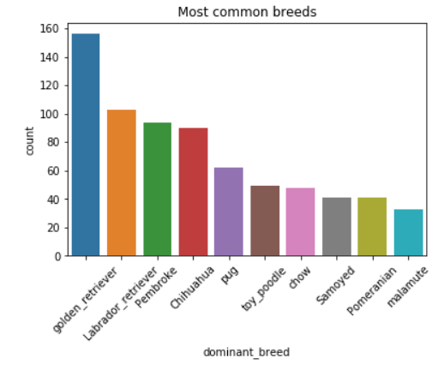

At which stage of the dog is the most commonly tweeted, older ones or younger ones?

A similar analysis was performed for the stages of dogs and dogs at pupper stage were shared more.

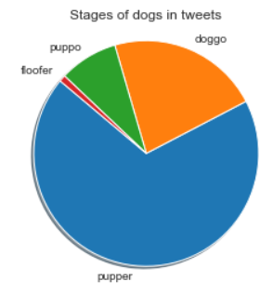

Also, which names were used more for dogs? What are the most common dog names?

According to the analysis, I found that names Oliver, Charlie and Cooper were the most common dog names.

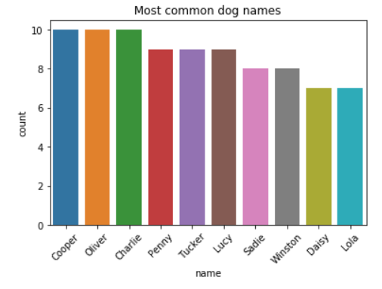

Let's dig in more math! What are the relations between variables, can we have some insight from numerical variables?

For this purpose, I created a heat map showing all correlation. According to plot, favourite and retweet counts of tweets are highly correlated with each other with 0.93 correlation coefficient. The correlation of other variables were less than 0.70, hence I did not investigate them.

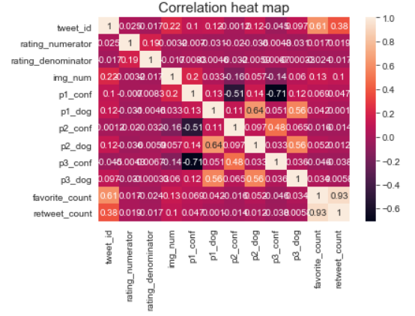

What is the relation between retweet and favourite counts?

In order to show the relation mentioned above, I plot a scatter plot to show the strong positive correlation.

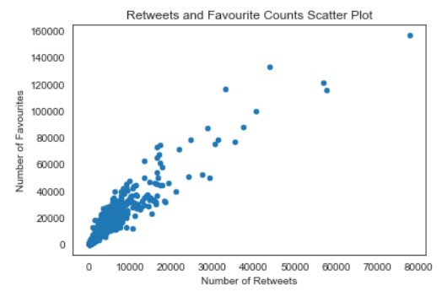

These preliminary insights are useful but there are tonnes of analysis to be performed. Hope you liked it :)