**COME209**

**Introduction to Signals and Systems**

**Homework 2**

**Submission deadline: 11.12.2022**

You will implement a program which performs the following tasks:

* Given two input matrices M1 and M2, you will traverse M1 in iterations. At each iteration, you will multiply corresponding elements of M2 and the part of M1 which overlaps with M2. You will sum the result of multiplications and write the result to the corresponding element of the output matrix.
* The example is given below:

Input matrices:

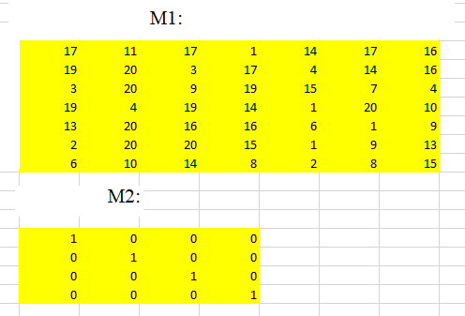

Overlap at iteration 1:

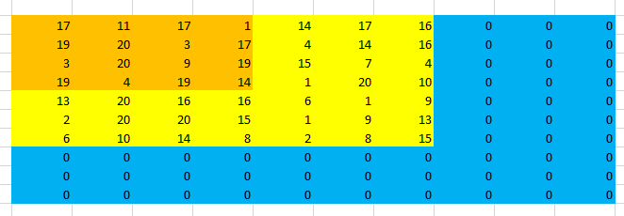

Output matrix after iteration 1:

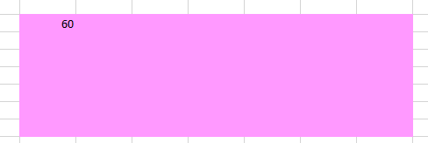

Overlap at iteration 2:

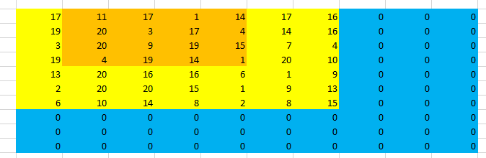

Output matrix after iteration 2:

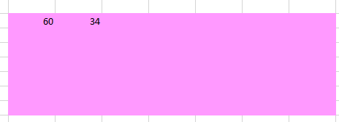

After the following iterations:

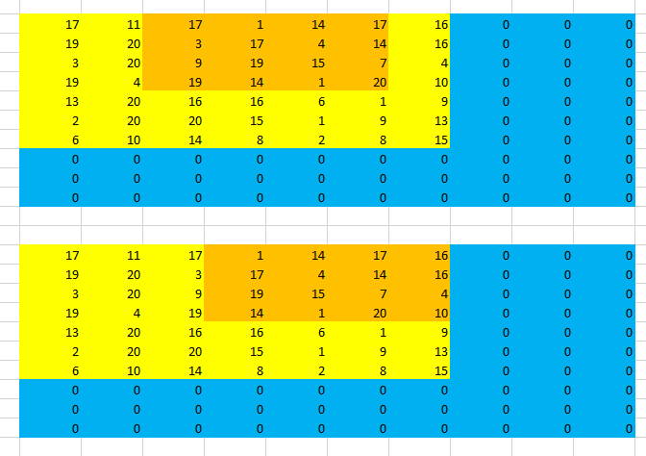

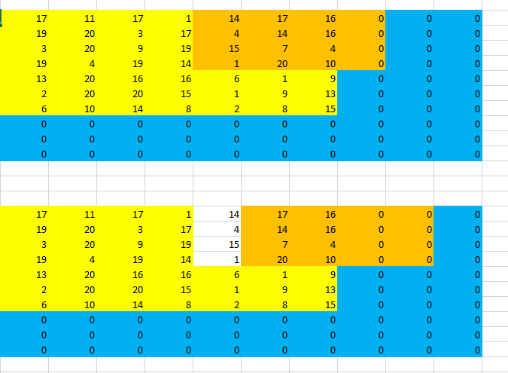

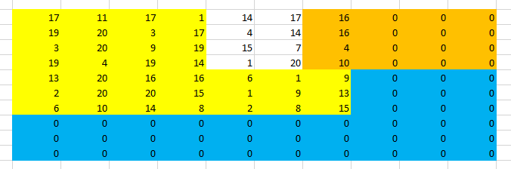

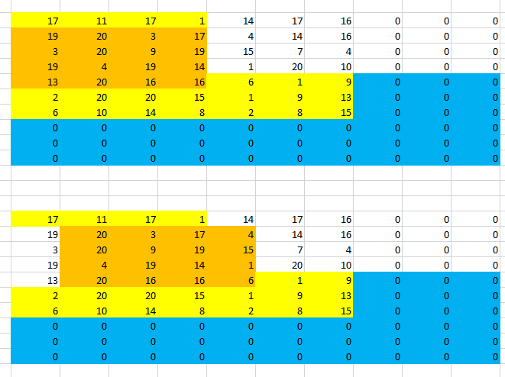

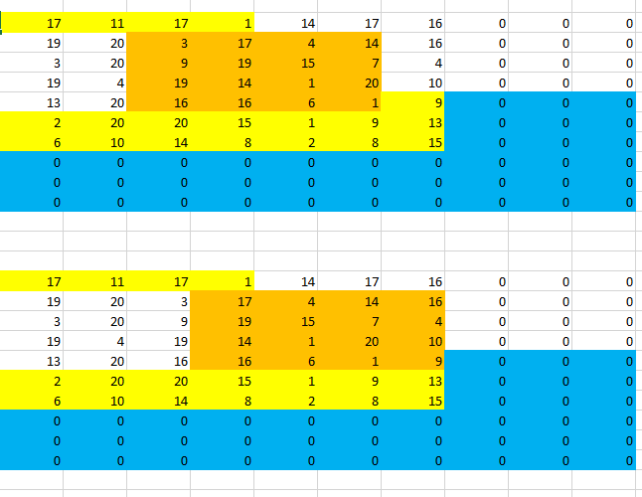

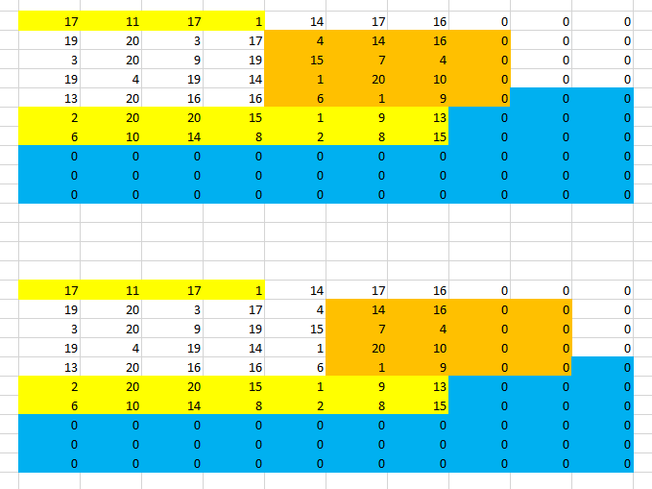

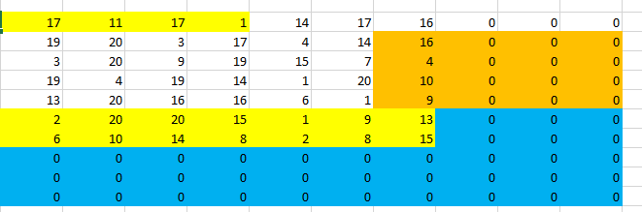

The contents of the output matrix are as follows:

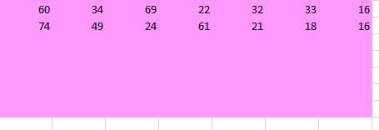

* Your implementation will fill in all the elements of the output matrix.
* In the example given above, M2 is given as the identity matrix for helping you understand the problem. However, your implementation should also be able to work correctly when M2 is composed of random numbers.