**EXPLANATION**

The application will take as input a distance in mega lights (MGLT).

The output should be a collection of all the star ships and the total amount of stops required to make the distance between the planets.

 All other application details are at your own discretion.

“Sample output for 1000000:

Y-wing: 74

Millennium Falcon: 9

Rebel Transport: 11”

**Requirements**

1) The completed code should be submitted along with

2) Accompanying documentation

3) Tests and instructions on the usage of the application.

**INSTRUCTIONS**

1. An ASP.NET (Web Application) project was made by using Visual Studio 2019.

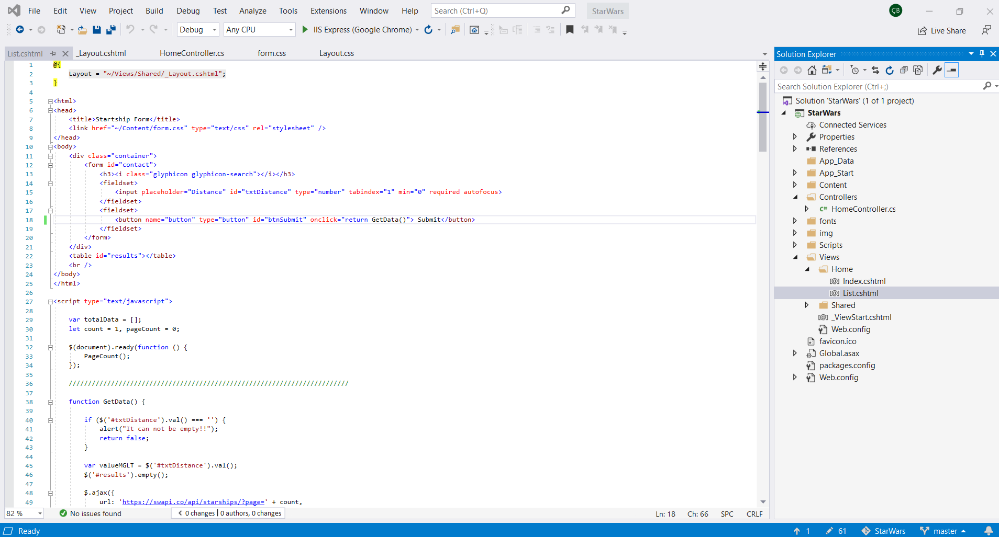

1. When we start the project, we will see a homepage.

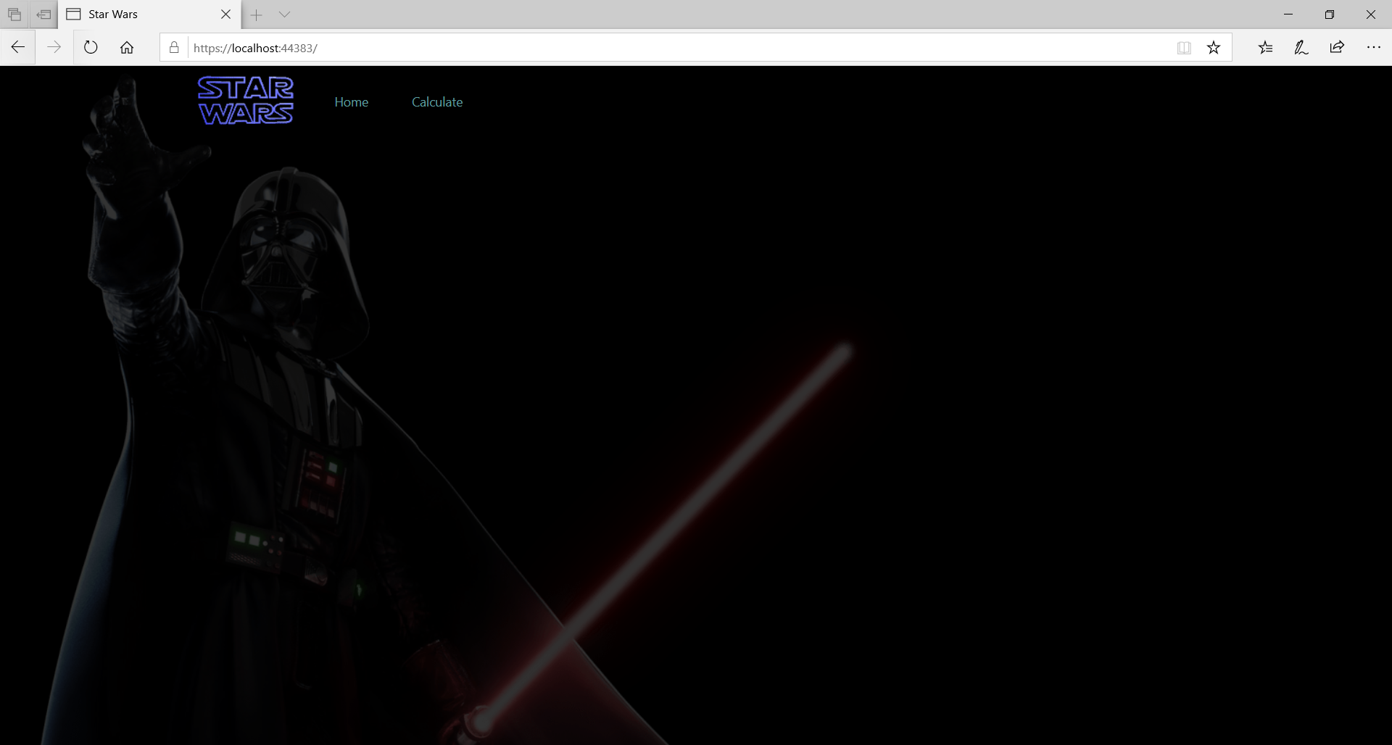

1. By clicking on Calculate from the menu on the home page, you will go to the page where the calculation will be made.

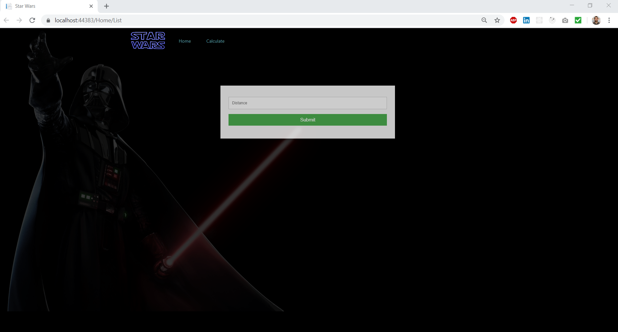

1. The value is entered in the Distance field and the submit button is clicked.

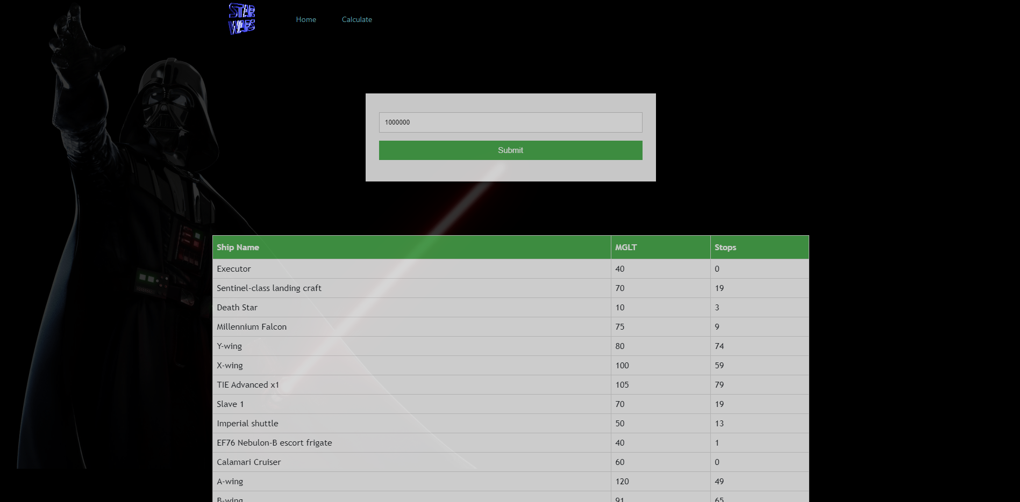

1. If a different distance is wanted to be calculated, a new entry is made in the distance field and the submit button is clicked.