CAG Audit Management System
Production Release Document (Government Submission Copy)
Field | Value
Document ID | CAG-AMS-REL-1.0
Version | 1.0
Release Date | 09 April 2026
Prepared For | Comptroller and Auditor General of India (CAG)
System | Audit Management System - Irrigation Audit Wing
Prepared By | Application Engineering Team

1. Document Control
Field | Value
Document Type | Production Release Note and Screen Register
Classification | Internal Government Use
Target Environment | Production
Application Stack | Streamlit + Python + PostgreSQL
Release Scope | Operator and Administrator workflows

2. Release Summary
1. Secure authentication and role-based access.
2. Operator-side estimate creation and section-wise data entry.
3. Administrator-side review, user creation, and permission management.
4. Draft and submission lifecycle support with module-wise progress tracking.

3. Validation Summary (Release Readiness Evidence)

3.1 Functional and Unit Validation
1. Unit and integration test suite executed: 57/57 PASSED.
2. Authentication, user management, submission creation, and section save flows validated.

3.2 Concurrent Load Validation
1. Target requested: 300 users at a time.
2. Validation command executed: python load_test.py --users 300 --concurrency 300 --module contract_management --fill-scope first --cleanup --fail-on-errors --json-out .tmp\loadtest_300_fixed.json
3. Result: 300 success, 0 failure, 100% success rate.

4. Deployment and Configuration Notes

4.1 Mandatory Runtime Settings
1. DB_HOST, DB_NAME, DB_USER, DB_PASSWORD, DB_PORT
2. COOKIE_PASSWORD (minimum 16 characters)

4.2 Connection Pool Tuning Parameters
1. DB_POOL_MINCONN (default 1)
2. DB_POOL_MAXCONN (default 80)
3. DB_POOL_WAIT_TIMEOUT (default 30 seconds)
4. DB_POOL_WAIT_POLL_INTERVAL (default 0.05 seconds)

5. User Roles in Scope
1. Operator: Create estimates, fill sections, save drafts, submit applications.
2. Administrator: Review applications, create users, revoke/grant access, update module permissions.

6. Screen Register With Release Screenshots

6.1 Login Page
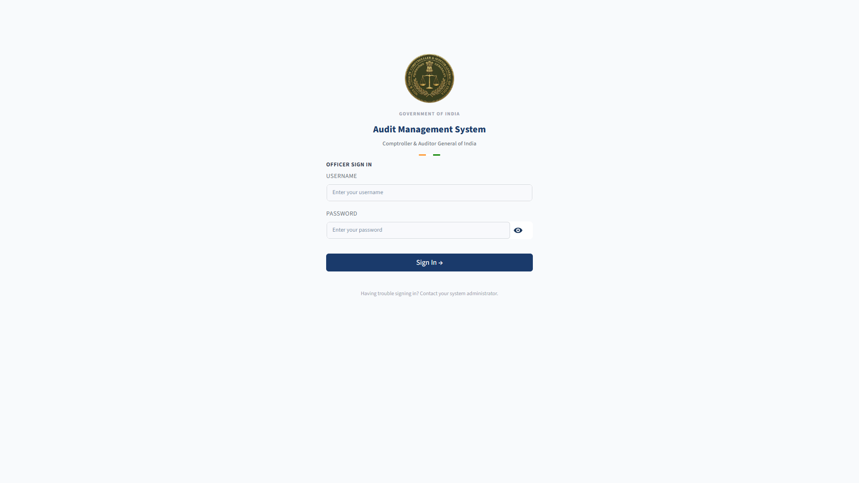

6.2 Operator Dashboard
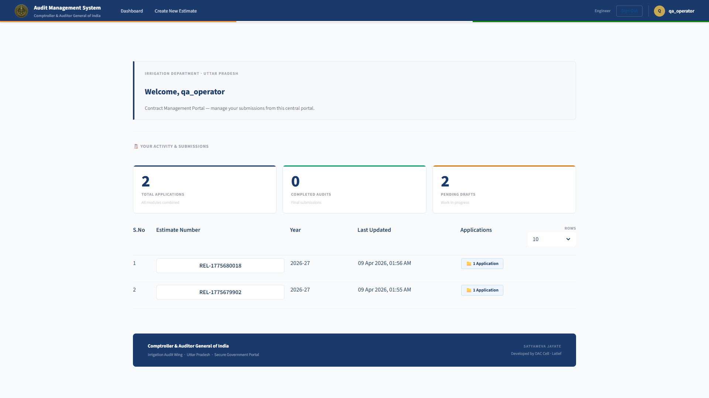

6.3 New Estimate Dialog (Blank)
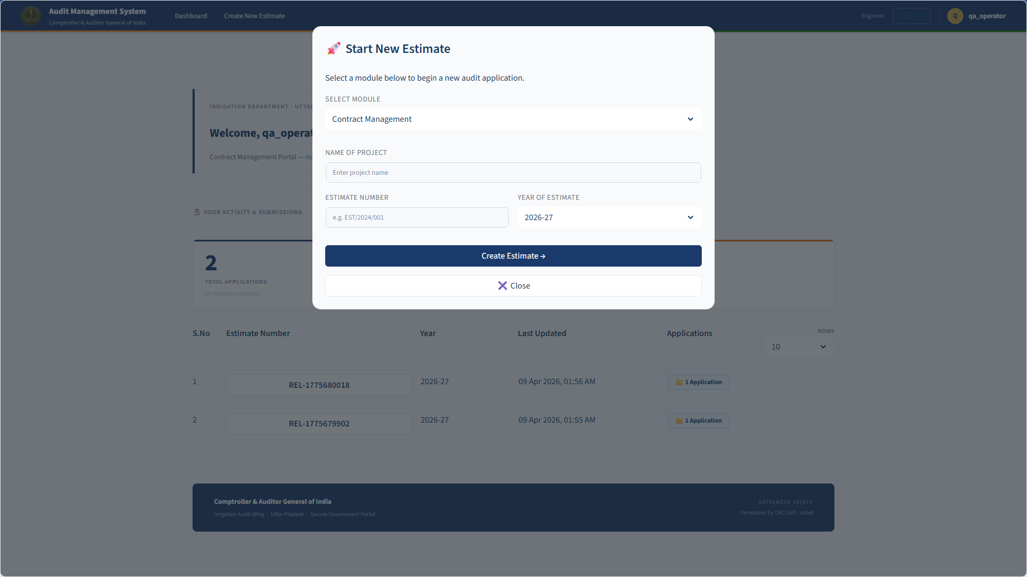

6.4 New Estimate Dialog (Filled)
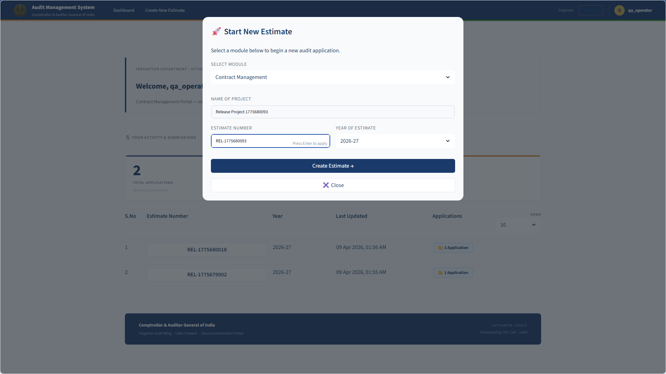

6.5 Contract Management Module - Overview
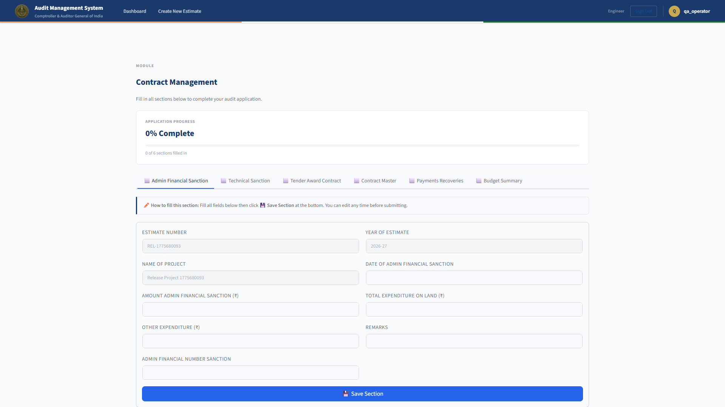

6.6 Tab: Admin Financial Sanction


6.7 Tab: Technical Sanction
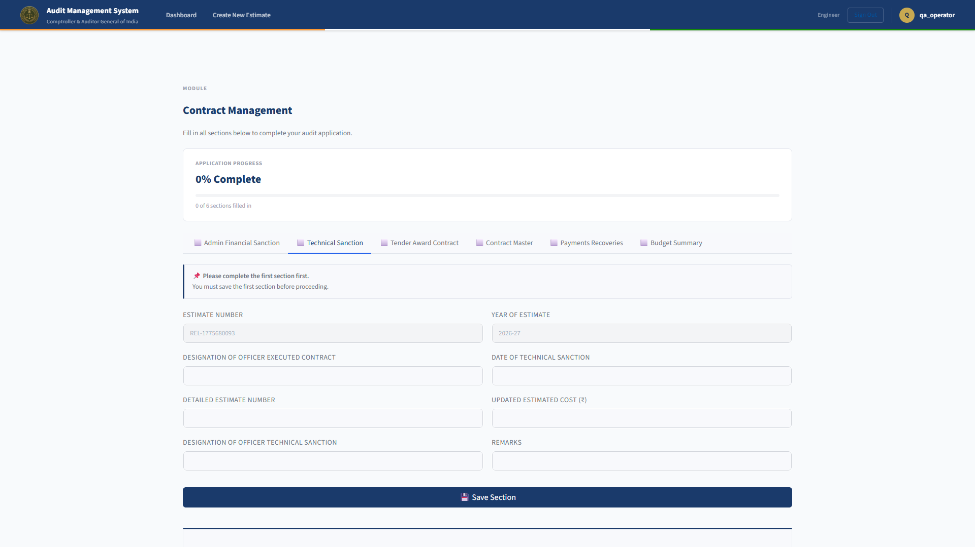

6.8 Tab: Tender Award Contract
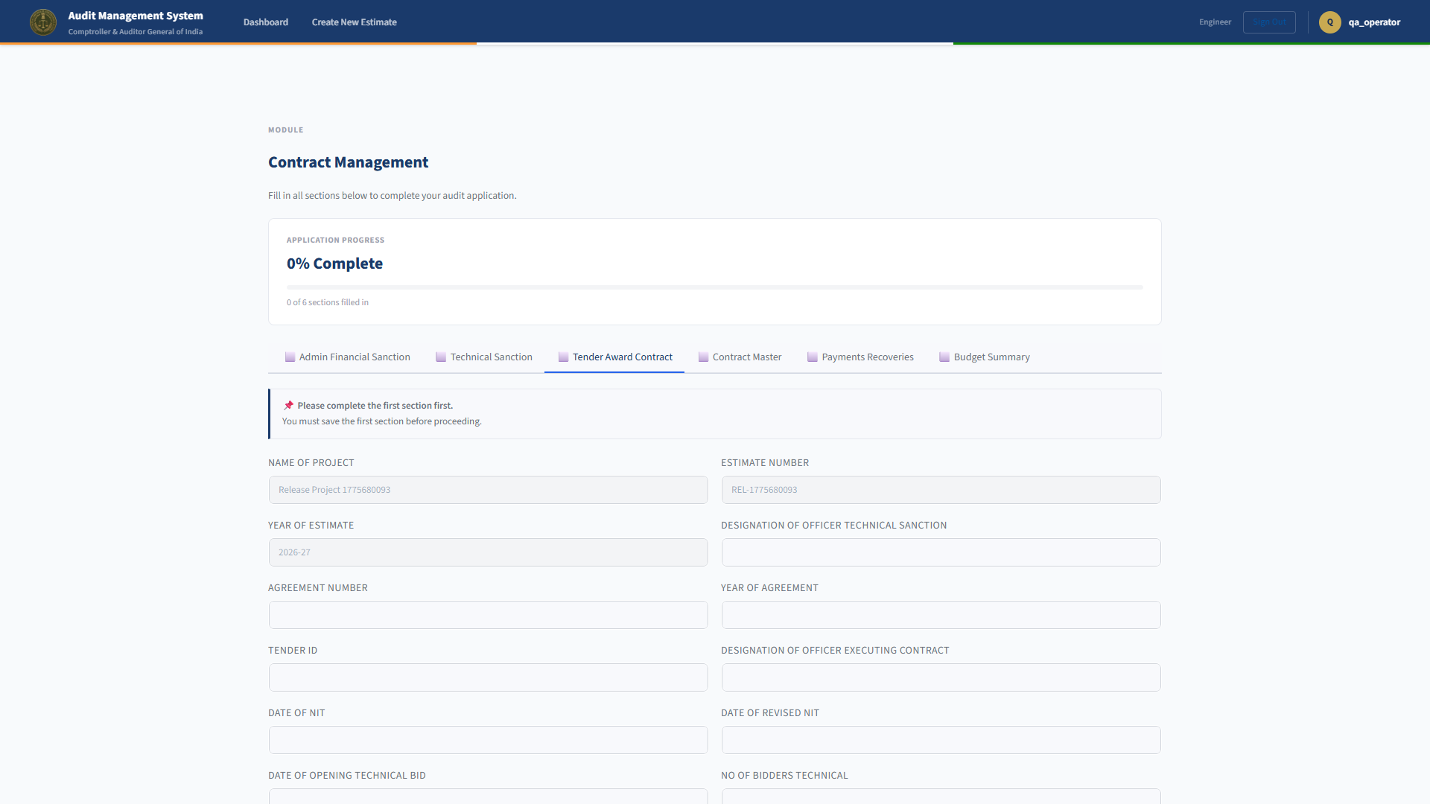

6.9 Tab: Contract Master
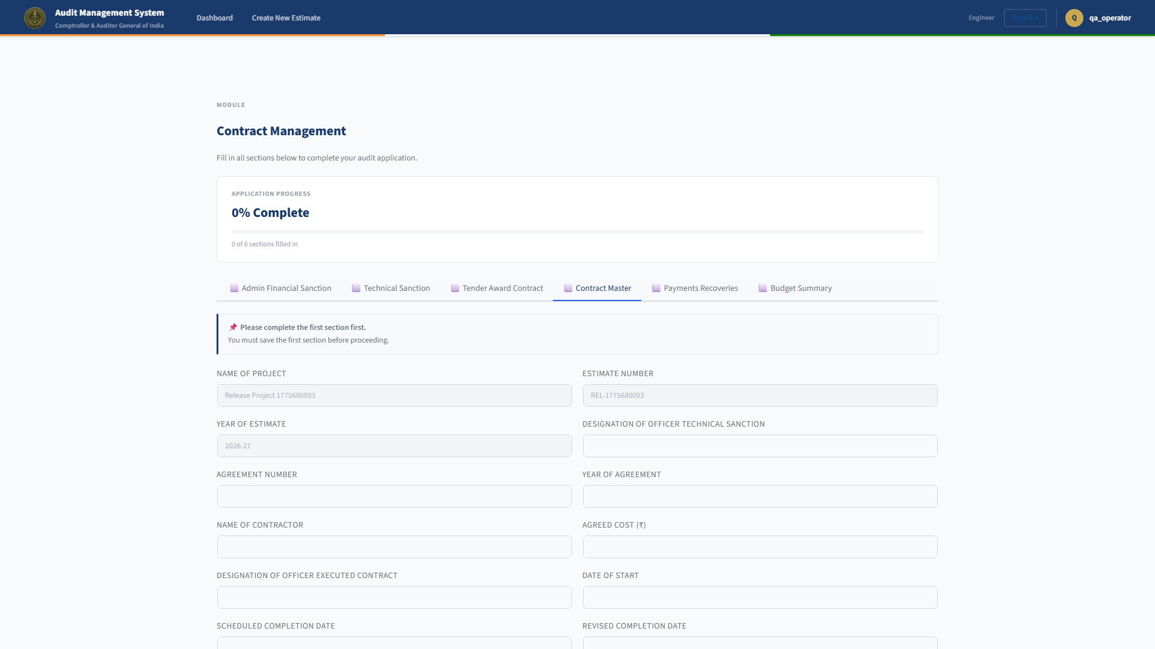

6.10 Tab: Payments Recoveries
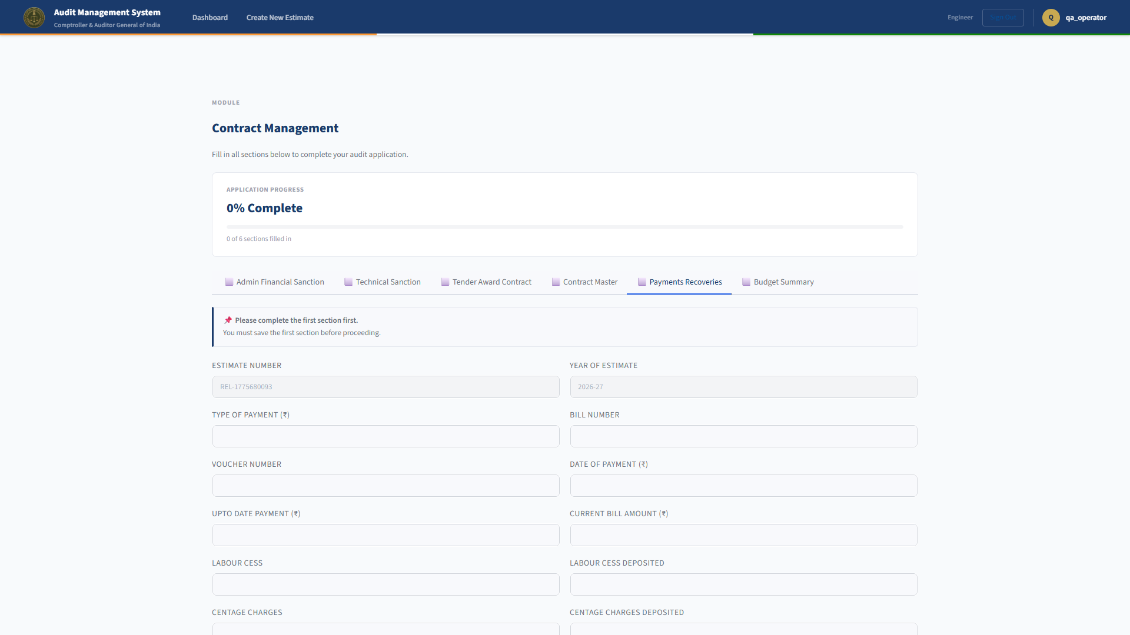

6.11 Tab: Budget Summary
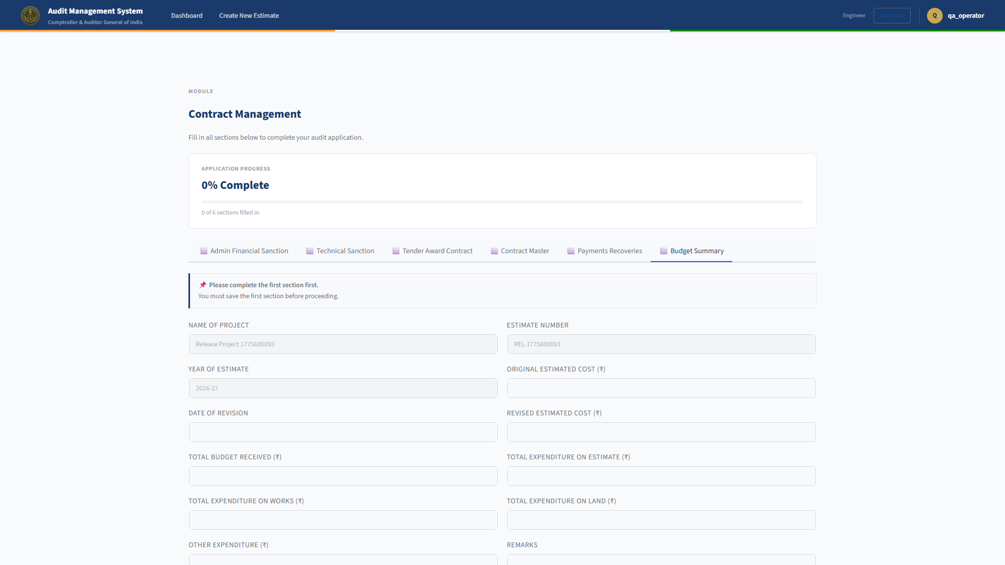

6.12 Post Logout Screen


6.13 Admin Panel: Review Applications
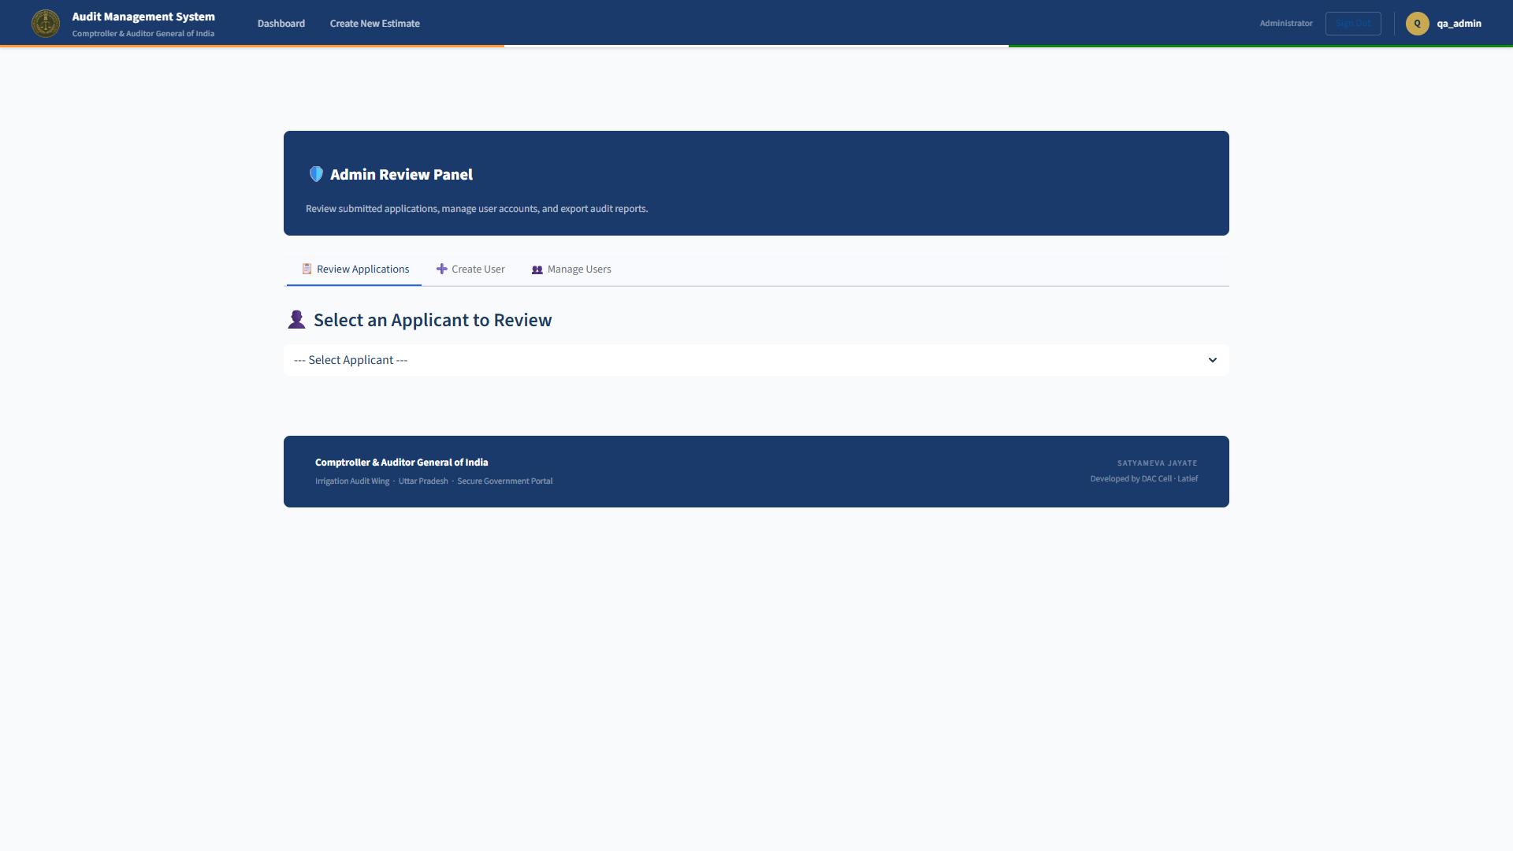

6.14 Admin Panel: Create User
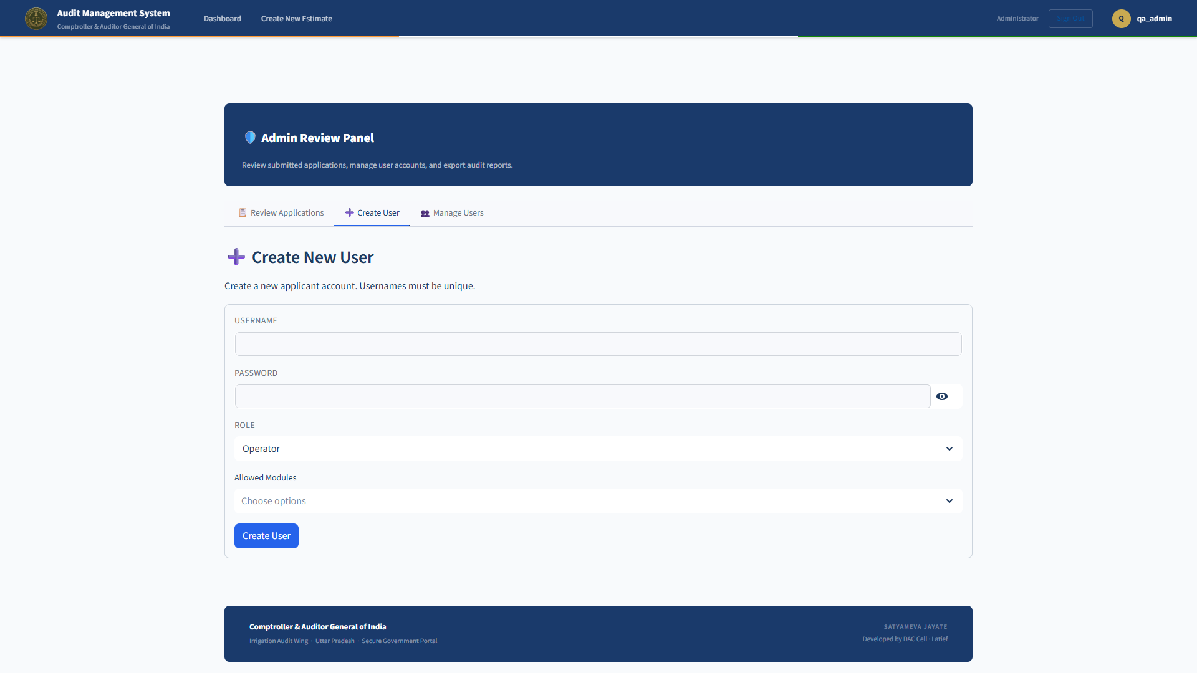

6.15 Admin Panel: Manage Users
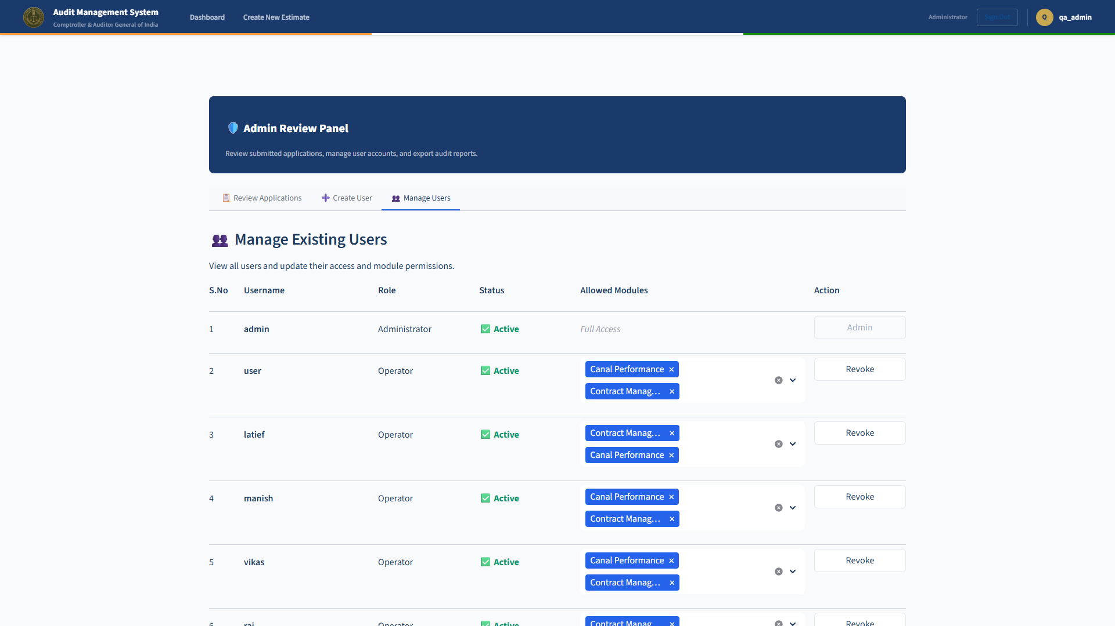

6.16 Admin Panel: Review Applications (All Users)
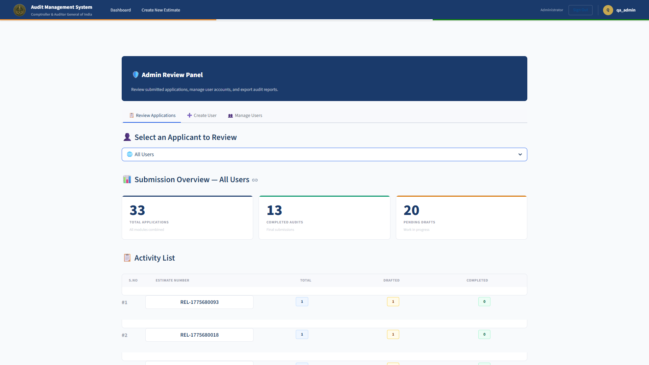

6.17 Operator Estimate Dialog
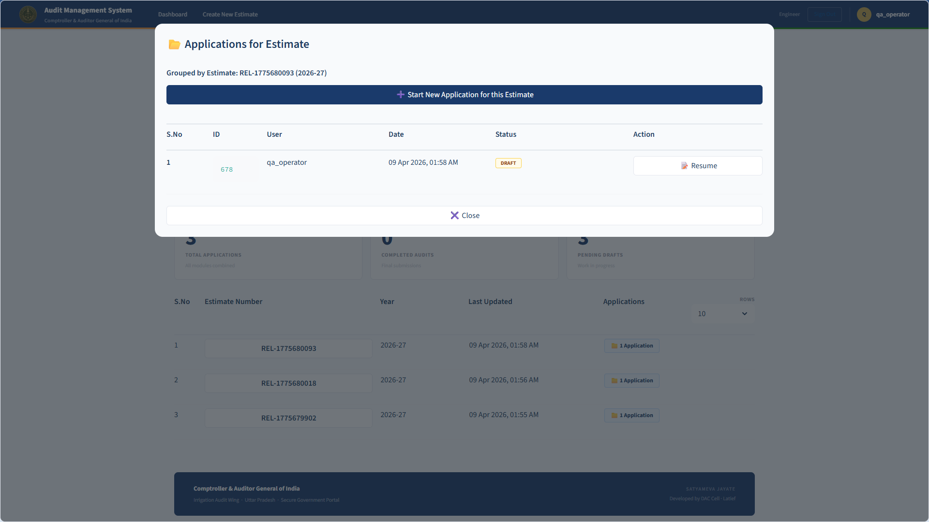

7. Operational Runbook
1. Start command: streamlit run app.py
2. Verify login, operator data save, and admin review pages.
3. Use previous release package and DB backup for rollback when required.

8. Security and Governance Checklist
1. Role-based access controls validated.
2. Password hashing and verification enabled.
3. Cookie secret policy enforced.
4. Connection pool controls added for concurrency resilience.
5. Release evidence includes functional and load validation outputs.

9. Sign-off Section
Field | Value
Project Owner
Application Administrator
Information Security Officer
Deployment Authority

10. Release Package Contents
1. Source application files (app.py, auth.py, crud.py, supporting assets)
2. Release documentation files in release/
3. Screen evidence in release/screenshots/
4. Load validation evidence in .tmp/loadtest_300_fixed.json

