**AGLMIX**

**Description/Purpose:** Thistool will return values using either a layer or a height defined by an above ground layer (AGL). For temperatures, the tool finds a value at a specified height AGL and brings it down to the surface using the desired lapse rate. For dewpoints, an average mixing ratio from the surface to the desired height is calculated. A new dewpoint value is calculated from this average mixing ratio. The intention of this tool is to help mitigate the effects of sloping terrain, and also help enhance temperature forecasts by easily allowing terrain effects to be placed in the grids. Since this tool uses GFE topography, it will actually have higher resolution terrain details than the model, as coarser model values are fitted to the terrain. To help illustrate the purpose of tool the following image shows the height in dm of the H85 level across the area.

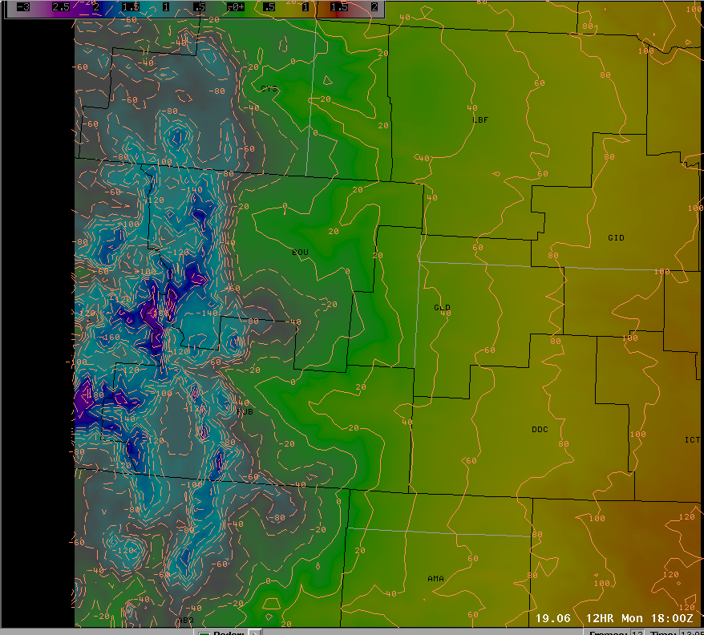

Notice that the height of this level varies from 80 dm (800 m) at KHLC to 20 dm (200m) at KYMA. If you were to assign a uniform temperature at this level, say 10C this would be the following result of “mixing down” temperatures from a constant pressure level, assuming a dry adiabatic lapse rate of 9.8 C/km.

KYMA

sfct = (9.8 (C/km) * .2 km) + 10.0 C = 11.96C (53.53 F)

KHLC

sfct = (9.8 (C/km) * .8 km) + 10.0 C = 17.84C (64.11 F)

Not only due large differences in temperatures occur using the constant pressure level, but this level means two different things for each location with respect to mixing. At YMA this level is very near the ground, and in most cases would easily be mixed to this point. At HLC this level is significantly higher, and may never be reached if other conditions inhibit deep mixing. This tool will take some of these problems out of the equation, as 1 km AGL may be nearly H7 at KYMA, H75 at KGLD and H85 at KHLC, yet running one tool will show the values from all these pressure levels. For dewpoints the problem is even more amplified as using one pressure level may be very shallow in the west, but very deep in the east.

**Grids Edited :** T and Td

**Assumptions:** When sounding intersections fall in between model levels, all variables (except pressure) are assumed to be linear. If pressure needs to be calculated, the hypsometric equation is used. Also assumes moist adiabatic lapse rate is constant at 6.5 C/Km.

**Running the Tool:** With either a T or Td selected, right click in the grid editor and select AGLMIX. The following GUI will then appear :

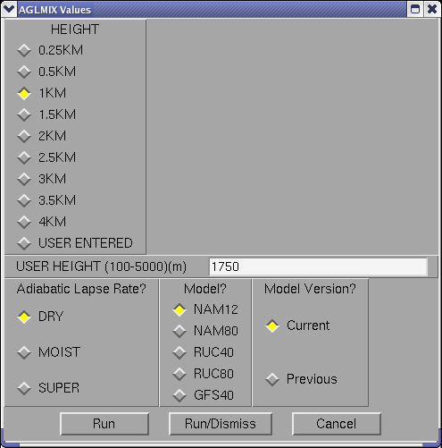

Height : This variable sets the height that the tool will use for its calculations. For instance if 2KM is selected when running tool on a T grid, then the tool will first figure out the value of T at 2 km AGL in the model data at each point.

User Height : If the USER ENTERED option is selected, you can select a value between 100 and 5000 m to use as a mixing height. This value is in meters NOT kilometers.

Adiabatic Lapse Rate : Selecting DRY will use 9.8 C/km to bring temperatures down to the surface, MOIST will use 6.5 C/km and SUPER uses 11 C /km. This variable does nothing when calculating dewpoints.

Model: Chooses a model to use for calculations.

Model Version? : Selects the desired model version.

**Known Issues/Bugs:**

Tool sometimes will create small pixels of bad data, when very shallow mix depths are used. This is particularly true over the mountains. Recent improvements in the interpolation scheme have improved this greatly but it does happen every once and a while.

A constant mixing height is not always representative, as values can range significantly. For example, on either side of a dryline large differences in mixing height can occur. This is not a problem with the tool, but forecasters should realize this limitation.

Although no formal studies of verifying this method have been done, but from personal use of the tool it seems to do well at forecasting afternoon temperatures but is generally a few degrees cool on the actual maximum value. This may be a function of a slight super adiabatic layer forming in the afternoon, or just model errors.

Determining an optimal depth for mixing an afternoon Td is still very uncertain. Local research would suggest that using a height based on the maximum 3 hourly temperature provides the best result, but converting this to an AGL height operationally is difficult. Also several other factors go into the dewpoint temperature, and horizontal advection may totally overwhelm vertical mixing.

Some operational models, especially the NAM can have very bad surface dewpoint values. While this tool tries to correct these fields, the surface data does get into the averaging and could skew the results. Be aware that the tool may give values that are too high if models are greatly overestimating the dewpoint before mixing takes place. A future upgrade to this is to allow forecasters to override the surface values with something more representative.