|  |  |  |
| --- | --- | --- |
| **Student ID** | **Name** | **Lastname** |
| 21COMP1066 | Çağrı | ÇIBUK |
| 20SOFT1018 | Selen | ERK |

Our project's performance significantly varied with different thread counts. Based on the results collected in matrix_benchmark_results.csv, increasing the number of threads from 1 to 4 provided the most substantial improvement. Execution time dropped from 2529 ms (single-threaded) to 944 ms at 4 threads, which was the best-performing configuration. This clearly indicates that the “sweet spot” for our system was 4 threads. However, beyond this point, performance gains diminished. For example, using 10 threads resulted in a higher execution time (1324 ms) compared to 4 threads. This behavior was consistent across multiple benchmark runs and confirms that blindly increasing parallelism does not guarantee better results.

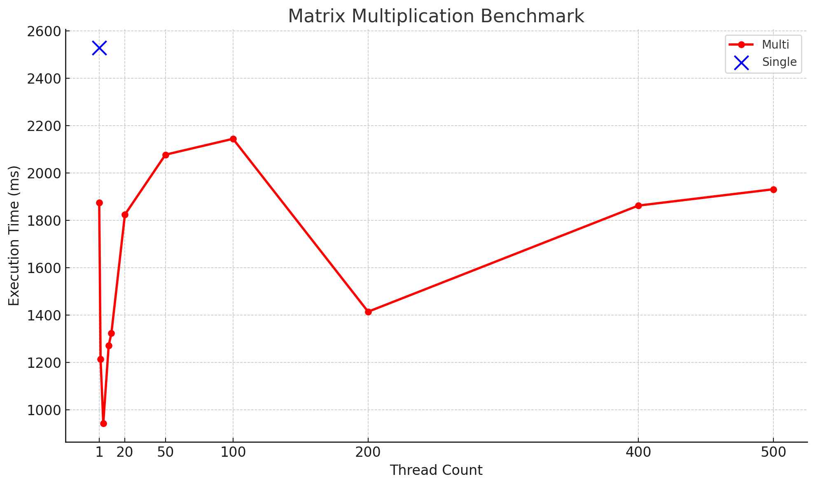

The performance degradation beyond 4 threads is closely related to the number of CPU cores on the system. Our test environment included an Intel® Core™ i5-9300H processor with 4 physical cores and 8 logical threads. While hyper-threading allows more logical threads, physical core limitations still dominate the actual parallel execution capability. Once the number of threads exceeded the number of physical cores, the CPU had to time-share threads using context switching, which introduced overhead. This is why execution time increased when using 8, 10, or more threads, even though more threads were technically active. These results highlight the importance of tuning parallelism based on actual hardware capabilities rather than assuming that more threads always lead to faster performance.

Matrix A was partially read from the file by each thread, whereas Matrix B was fully loaded into memory at the beginning. This design choice was made to optimize memory efficiency. Matrix A can be extremely large depending on its dimension, and reading only the required rows per thread reduces memory usage and avoids storing unused data. Matrix B, on the other hand, is used by all threads for every multiplication operation, so preloading it once avoids repeated file I/O and ensures consistent access. If both matrices were fully loaded for each thread, it would consume large amounts of memory and possibly lead to resource exhaustion in systems with limited RAM.

To measure execution time, we used System.currentTimeMillis(). While this method offers only millisecond-level granularity and can be affected by system background processes, it was sufficient for our benchmarking purposes. We ran the test script multiple times and consistently observed the same performance trends. The matrix_benchmark_results.csv file captured these results, and although minor fluctuations occurred between runs, the overall outcomes were reliable. For high-precision measurements, tools such as System.nanoTime() or external profilers could be used. However, for our use case of comparing thread-based performance scaling, System.currentTimeMillis() was an appropriate and practical choice.