**Class Work #10**

* Decide if 3 colors are sufficient to color G1 and G2

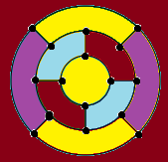 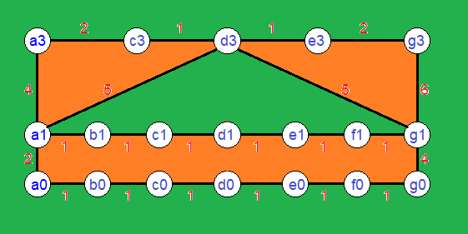

G1:3 colors are not enough G2: 3 colors enough

* Find a minimum spanning tree in G1 and G2

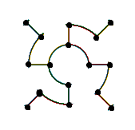 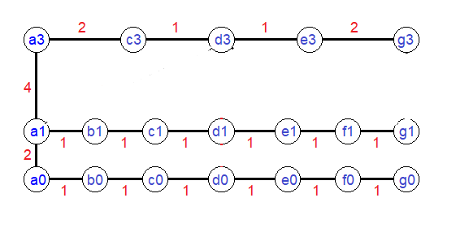

* Find a Hamiltonian circuit (cycle) in G1 and G2

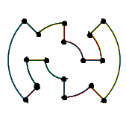 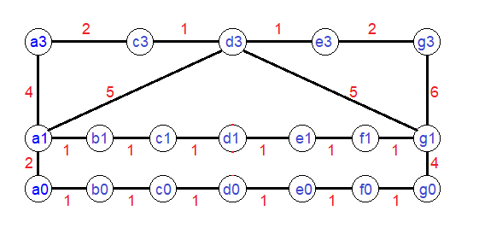

G1: There is Hamilton circuit G2: There is no Hamilton circuit

* Decide if G1 and G2 contain an Eulerian circuit

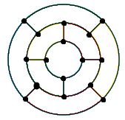 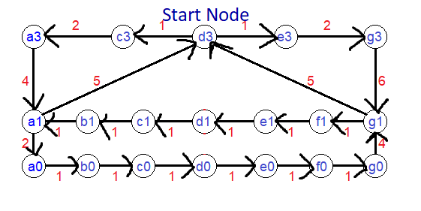

G1: There is no Eulerian circuit G2: d3-e3-g3-g1-f1-e1-d1-c1-b1-a1-a0-b0-c0-d0-e0-f0-g0-g1-d3-c3-a3-a1-d3