|  |
| --- |
| NEEScomm IT |
| **RDV 2.0 User’s Guide** |

|  |
| --- |
| RajeshThyagarajan  9/10/2010 |

**Table of Contents**

***1*** ***Document Versioning***

***2*** ***Overview***

**2.1** **Getting Started**

***3*** ***Features and Use***

**3.1** **Panels**

**3.2** **Importing Data**

**3.3** **Exporting Data**

***4*** ***Menu Options***

***5*** ***Obtaining the Source Code***

# Document Versioning

|  |  |  |  |
| --- | --- | --- | --- |
| **Version** | **Date** | **Author** | **Description of Changes** |
| 2.0.0 | 9/10/2010 | Rajesh Thyagarajan | Initial Version |
| 2.0.1 | 1/29/2014 | Julius Benson | Added new steps for launching without Webstart |
| 2.0.2 | 3/6/2014 | Michael Boldischar | Added steps for configuring Java Path and cleaned up the TOC. |

# Overview

The Real-time Data Viewer (RDV) provides an interface for viewing and analyzing live or archived time-synchronized data either locally or streamed across a network from a Data Turbine server. RDV is capable of displaying textual and numerical data, still images, and video. The playback rate can be adjusted so data is presented slower or faster than real time to aid in analysis. This document provides information about the features and functionality of RDV. System administrators should refer to the RDV 2.0 Admin Guide to learn how to host a customized version of RDV.

## Getting Started

**System Requirements**

RDV no longer utilizes Java Web Start. Instead, all files needed to run RDV will be included with the program.

The latest version of RDV requires the latest version 7.x of the Java Runtime Environment. RDV requires that Java is included in the “PATH” environment variable. Note: If Java is not properly configured in the “PATH”, running the scripts will not properly start RDV. On Windows, the script will pop-up and close quickly.

**Configuring the Path for Windows**

Here are the steps to properly configure the “PATH” environment variable on Windows:

1. Click the “Computer” item in the Windows “Start Menu”.
2. Navigate to “bin” directory inside the directory where Java is installed on your computer.  
   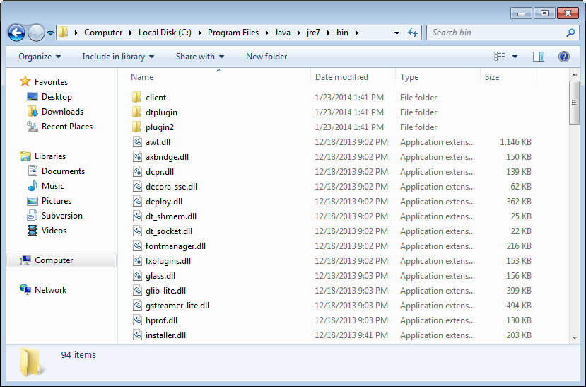
3. Select the current path from the Window and copy the contents to the Windows clipboard (Ctrl+C to copy).  
   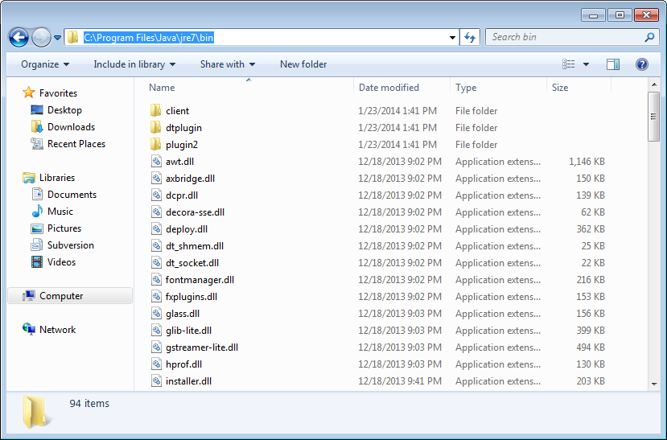
4. Right click on “Computer” in the Windows “Start Menu” and choose “Properties”.  
   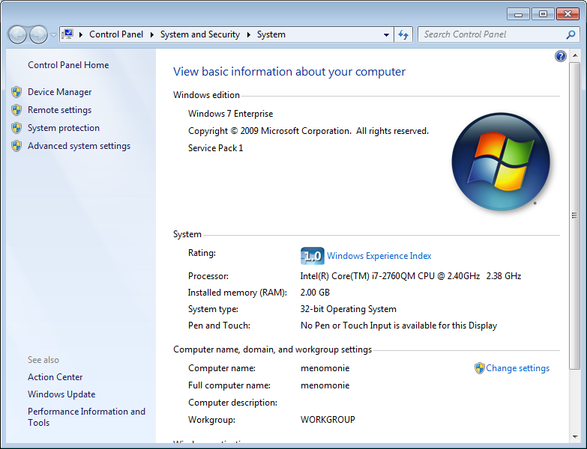
5. In the “System” window, click the “Advanced system settings” link on the right side of the window.  
   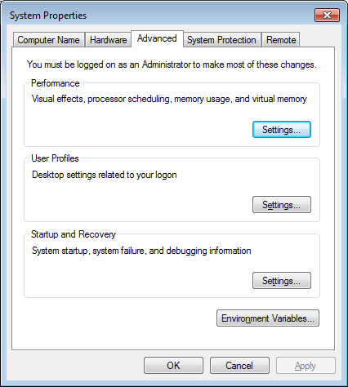
6. On the “Advanced” tab of the “System Properties” window, click the “Environment Variables” button.
7. In the “System Variables” section of the “Environment Variables” window, scroll down and select “Path” from the list.  
   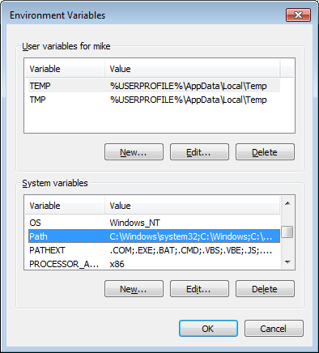
8. Click the “Edit…” button to start editing the “Path”.
9. In the “Variable Value” text field of the “Edit System Variable” window, scroll to the furthest position to the right (or press the “End” button on your keyboard).
10. Insert a semicolon “;” using your keyboard.
11. Paste the path to the Java bin folder you copied (use Ctrl+v to paste).  
    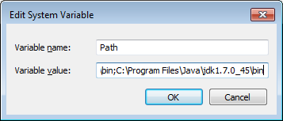
12. Hit “OK” on the “Edit System Variable” window.
13. Hit “OK” on the “Environment Variables” window.
14. Hit “OK” on the “System Properties” window.
15. Test the “Path” by starting a “Command Prompt” and typing “java -version”. You will see a Java version appear if your “Path” is properly configured. You will see an error if the path is not configured properly.  
    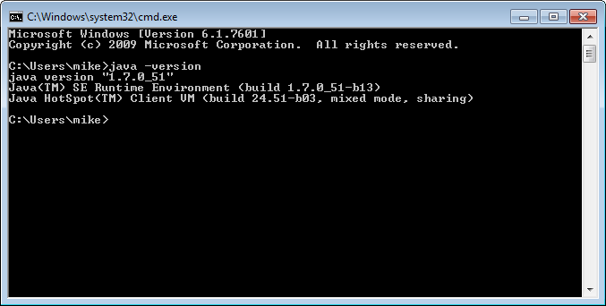

**Configuring the Path for Linux**

1. Open a terminal.
2. Locate the path to your Java install.
3. Update your “PATH” environment variable to include “bin” directory for Java by running the command:  
   export PATH=${PATH}:/opt/jdk/bin

**Launching RDV for Windows**

To start RDV, double-click the “rdv.bat” file. A console will appear, and the RDV application will start. Do not close the console window! By doing so, RDV will close immediately, and you may lose any unsaved information.

**Launching RDV for Linux**

Open a terminal, navigate to the folder containing the “rdv.sh” script file, and enter the command “./rdv.sh”. The RDV application will start.

**Connecting to a Data Turbine Server**

To ensure you are using the latest version of RDV, you can launch RDV from the NEEShub and manually connect to an equipment site's Data Turbine server. To do this, you'll need to know the name and port number of the Data Turbine server to which you want to connect. Alternatively, equipment sites may make downloadable RDV configuration files available to users before an experiment takes place.

# Features and Use

## Panels

The image on the right shows the different parts of RDV's user interface. Click on a highlighted element to learn more.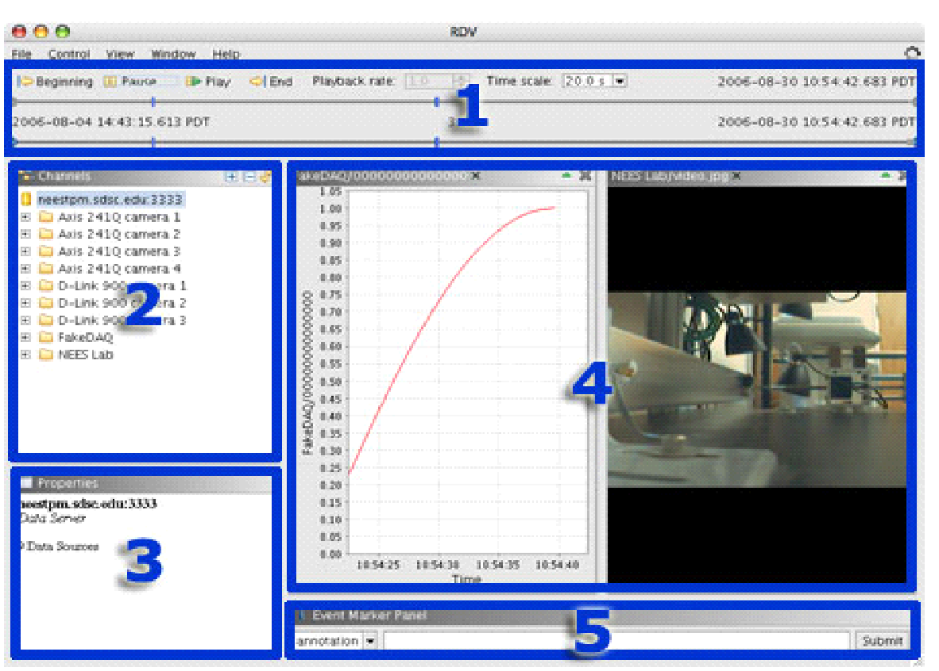

**Control Panel**

The control panel allows users to control the playback of both real-time and historic data. Two timelines (shown below) are used to enable users to "zoom in" on interesting events.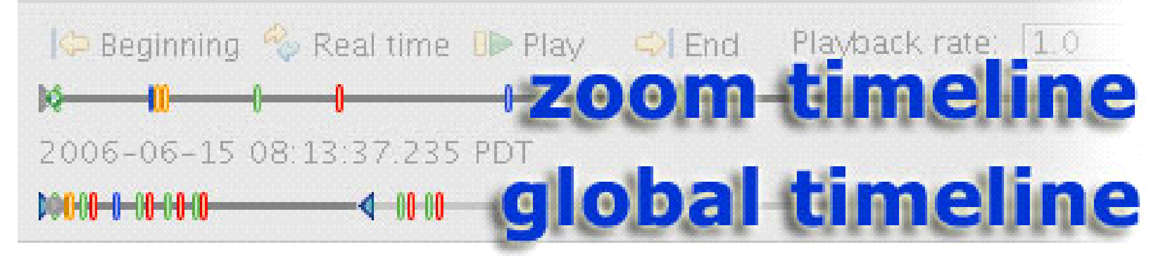

The bottom, or global, timeline always represents the period of time covered by all currently available data channels. The top timeline provides a "zoomed in" view of the area bounded by the two blue triangles  on the global timeline. The date and time represented by the location of the left-hand bounding triangle is translated to the left-hand edge of the zoom timeline. Similarly, the date and time represented by the location of the right-hand bounding triangle is translated to the right-hand edge of the zoom timeline.

The distance between the bounding triangles always expands to fill the entire length of the zoom timeline; the closer the bounding triangles are to each other, the greater the "zoom" effect. The dates and times associated with the starting and ending points of the zoom timeline are displayed below the zoom timeline to the left and right, respectively. The amount of time represented by the entire length of the zoom timeline is displayed in the center. To change the bounds of the zoom timeline, simply drag the blue bounding triangles to new locations along the global timeline.

The date and time displayed above the zoom timeline in the upper right corner of the control panel corresponds to the location of the green playback indicator  on the zoom timeline. The playback indicator indicates the position from which playback commences when the *Play* button is pressed. 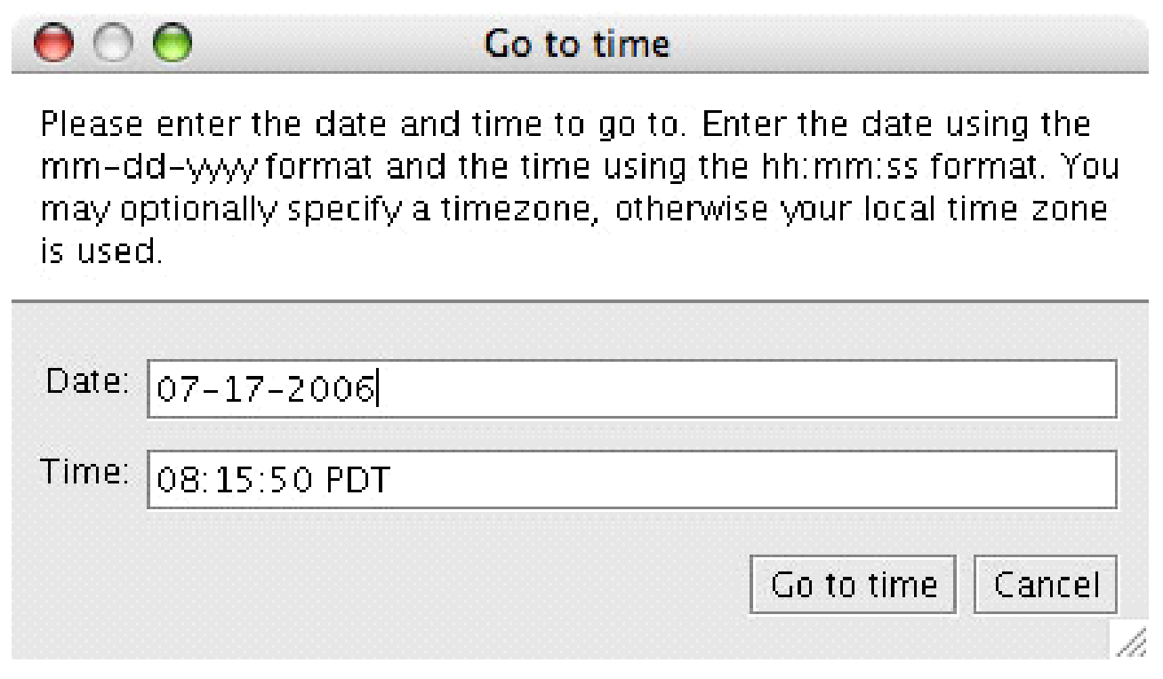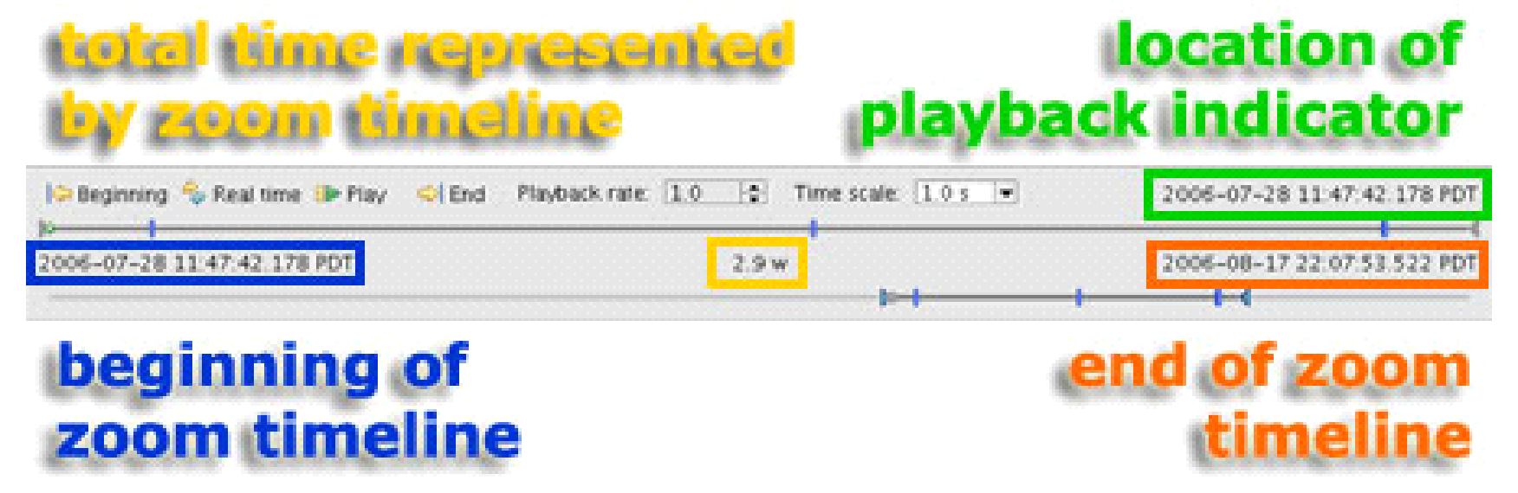

To change the location of the playback indicator, use your mouse to drag it to a new location or just click anywhere on the zoom timeline to cause the indicator to jump to that point. Alternatively, to immediately jump to a precise location, click on the playback date and time (outlined in green in the above picture) to bring up the *Go To Time* dialog box. The dialog is also accessible from the *Control* menu.



The buttons labeled ***Beginning***, ***Real time***, ***Play***, and ***End*** have the following effects when clicked:

* ***Beginning*:** Moves the playback indicator all the way to the left, to the beginning of the zoom timeline.
* ***Real time*:** Show live data at the scale defined by the *Time Scale* control.
* ***Play*:** Begin playback of archived data at the time indicated by the playback indicator  and at the rate and scale defined by the *Playback Rate* and *Time Scale* controls, respectively.
* ***End*:** Moves the playback indicator all the way to the right, to the end of the zoom timeline.

When clicked, the ***Real time*** and ***Play***buttons toggle to say ***Pause***. Clicking the button when it says ***Pause*** causes data playback to stop and the button's label will change back to either ***Real-time*** or ***Play***.

The ***Playback rate*** control sets the rate at which data is played back when viewed in playback mode. The value is a scaling factor that represents the number of seconds of data displayed per 1.0 second of actual time. Values range from 0.0010 on the low end to 1000.0 on the high end. Setting a value less than 1.0 causes the data being played to be displayed in slow motion, while choosing a value greater than 1.0 causes it to be displayed in fast motion.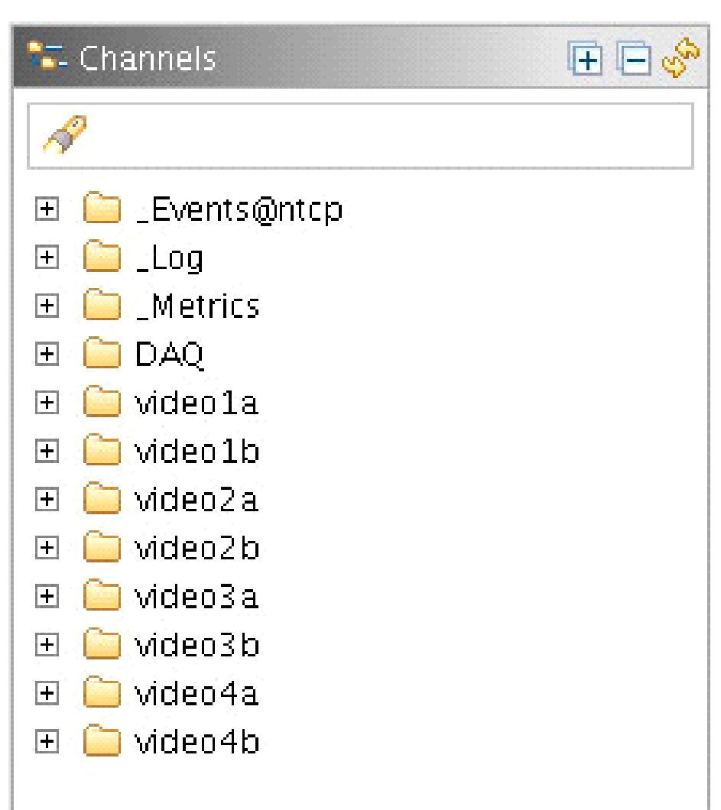

The ***Time scale*** control sets the amount of time represented by the length of the X axis of a data plot. Predefined values range from 1.0 millisecond to 1.0 week. You may type in a different value, such as 37 ms, to customize the time scale.

**Channel List**

By default, the channel list displays only the visible sources available from the Data Turbine server to which you are currently connected. To **display all sources -** including those that are hidden - choose ***Show Hidden Channels*** from the ***View*** menu. Hidden sources have names that begin with an underscore, such as _Log. Each source may have multiple channels associated with it. For example, clicking on the plus sign next to the ***FakeDAQ*** source folder to expand it reveals a total of 500 channels.

**Double-clicking a channel** opens a new data panel appropriate to the type of information carried by the channel and displays the data. Some types of data panels can display multiple channels in one plot. See section 4.4 for further information about the different types of data panels and how to use them.

To **filter the channel list**, enter text in the search box located at the top of the channel list. You may use the wildcard character (*) in your search string. The channel list is filtered as you type, revealing only those channels whose names contain the characters entered in the search box. To cancel the filter, click the icon on the right side of the search box, press ESC, or simply delete any remaining text.

You can **use the icons in the upper right corner** of the channel list to perform common actions. Clicking the expand icon causes all of the source folders in the channel list to expand, allowing you to see all currently visible available channels at once. Conversely, clicking the collapse icon  causes all of the source folders in the channel list to collapse, hiding the channel information and allowing you to only see the source folders. Finally, clicking the refresh icon causes RDV to query the Data Turbine server for an updated list of channels.

**Right-clicking on a source or channel** reveals a contextual menu that allows you to open a new data panel relevant to the type of data in which the data is displayed. The contextual menu also allows you to unsubscribe from a source or channel that is currently in use.

**Multiple channels may be selected** by shift-clicking (to select contiguous channels) or control-clicking (to select non-contiguous channels). Although the **⌘** key is typically used on Macintosh computers to select multiple non-contiguous items, the control key should be used within RDV. A contextual menu will pop up when control-clicking, but you can still select multiple items.

**Virtual Channels**

The virtual channels feature allows 'local' channels to be created in RDV which are functions of one or more standard channels. At times, data from a single channel is not very meaningful in and of itself. In these cases, it is often the arithmetic combination of two or more channels which proves to be more meaningful. RDV provides support for creating ***virtual channels*** on the fly. 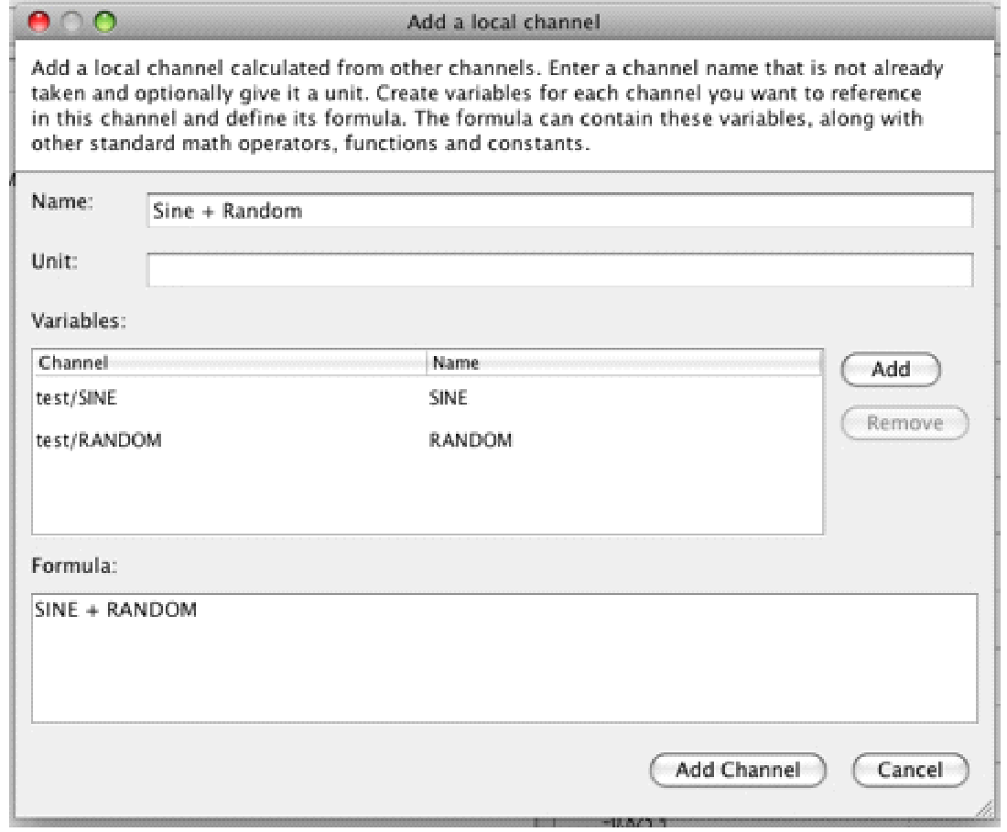

To create a virtual or 'local' channel, from the *File* menu, select

***Add a channel***; this will bring up the *Add a channel* dialog box:

Within the dialog box, first name your new channel, and optionally set a units value. In order to make a channel available for use in a local channel, it must first be added to the Variables window and be assigned a variable name. For example, in the image above, two channels named ***SINE*** and ***RANDOM*** are part of the ***TEST*** source and have been added to the dialog by using the ***Add*** button. These two channels have been assigned the variable names ***SINE***and ***RANDOM***; it's these variable names which you will use in the formula box below to create your local channel.

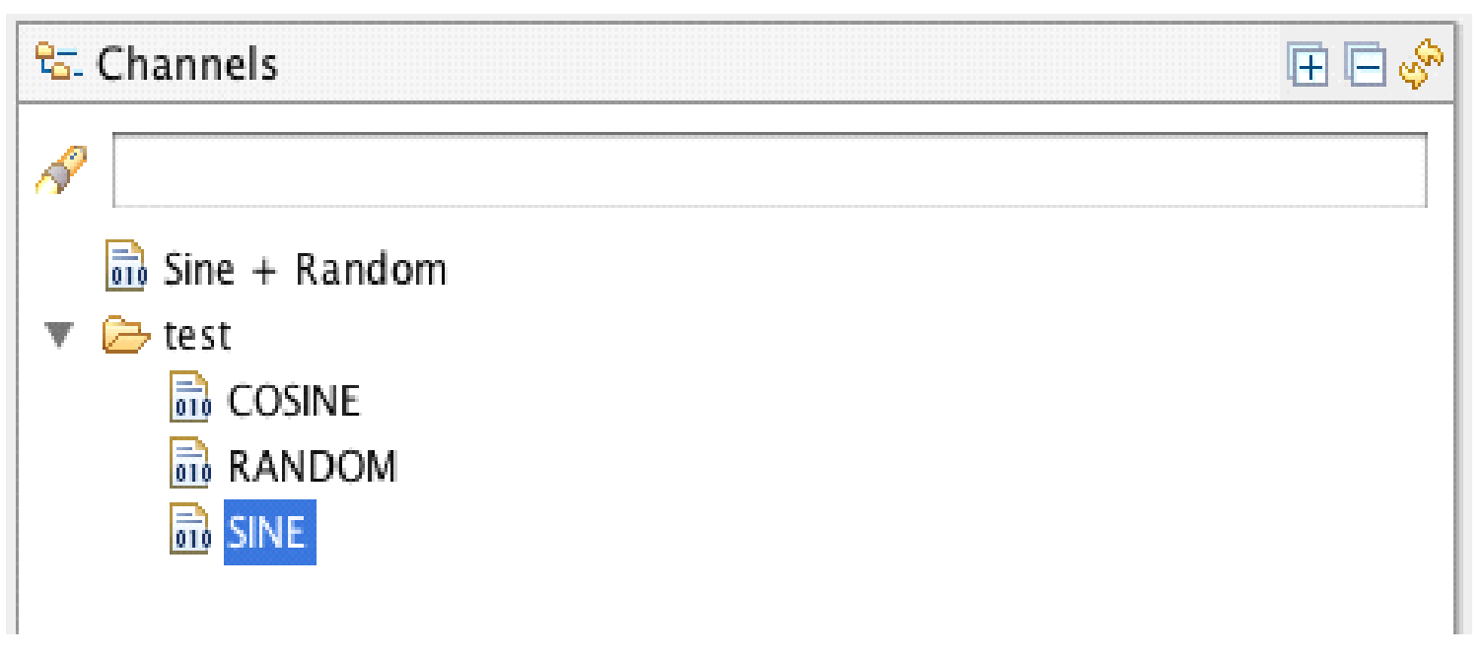

The formula box can accept any of the following functions in addition to the +,-, /,*, and ^ operators: *ArcCos, ArcSin, Ceil, Cos, Cosh, Exp, Floor, Sign, Sin, Sinh, Sqrt, Tan, Tanh, ArcTan(a), ArcTan(y,x), Log(a), Log(base, a), Max(a,b), and Min(a,b).* Function parameters must be enclosed in *brackets []* as opposed to parenthesis (). Parenthesis () may still be used to describe order of operations. For example, **Sin[SINE] + Cos [RANDOM]** is a valid formula. In addition, the following constants may be used: *Degree, E, Pi, Random, False, and True*

After a valid formula has been added, the ***Add Channel*** button will enable. Once the button is pressed and the channel added, it will appear at the top of the ***Channels*** box on the left-hand side of RDV.

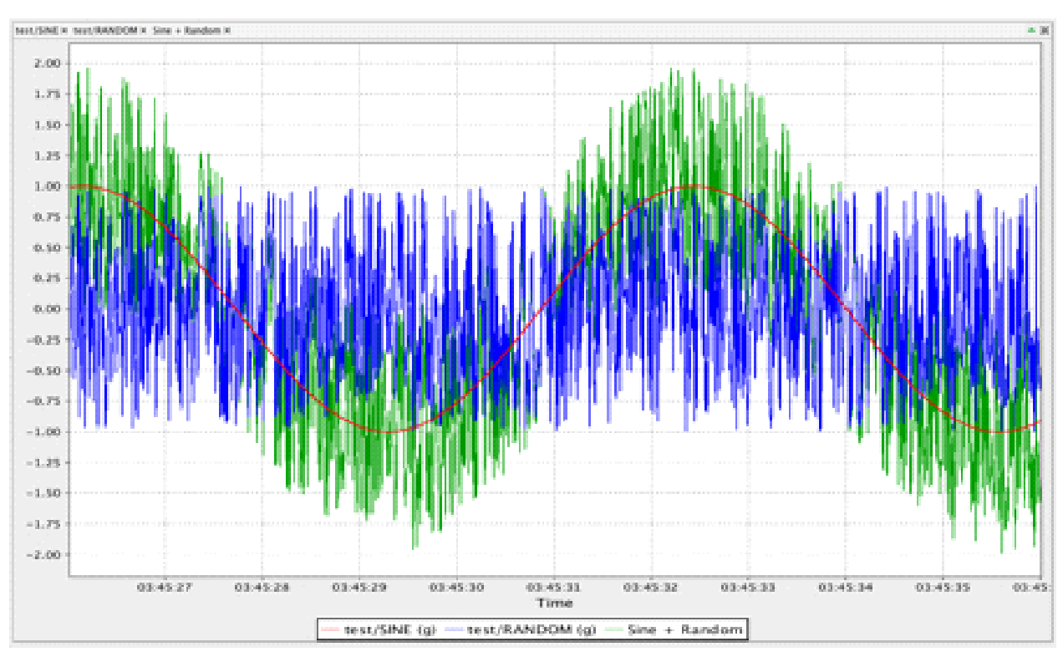

For example, in this case the channel *Sine + Random* has been successfully added as a local channel.

You can right-click on a local channel or use the panels’ context menu to open a view for the local channel just as you would a regular channel. This context menu also allows you to edit the channel.

You can also combine local channels into a single view just as you normally would with regular channels. For example, in the image above a time-series graph of a sine wave (red), some random noise (blue), and the Sine + Random local channel (green) are easily viewable.

**Properties Panel**

The properties panel displays metadata associated with whichever source or channel is highlighted in the channel list and includes the source or channel's name, the type of data it stores, the earliest time for which data is available, the amount of historical data available, and the size of each "frame" of data.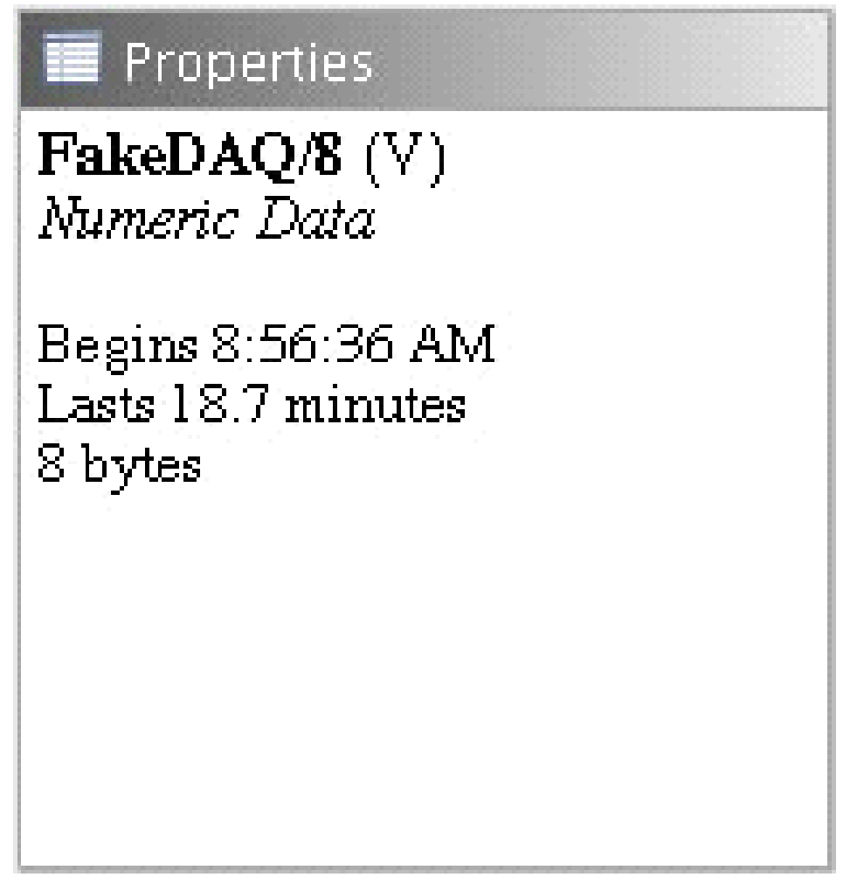



**Data Panels**

Data panels can be viewed either by double-clicking on a channel, or by selecting the type of data panel you want from the *Window* menu and then dragging the desired channel(s) to the empty window.

**Video/Photo Data Panel**

The video/photo data panel displays streaming video or still images. Some cameras may have pan-tilt-zoom (PTZ) functionality enabled. Facility administrators determine who is authorized to control the cameras at their site, and in some cases PTZ camera control is limited to certain users who are logged in to their NEES account.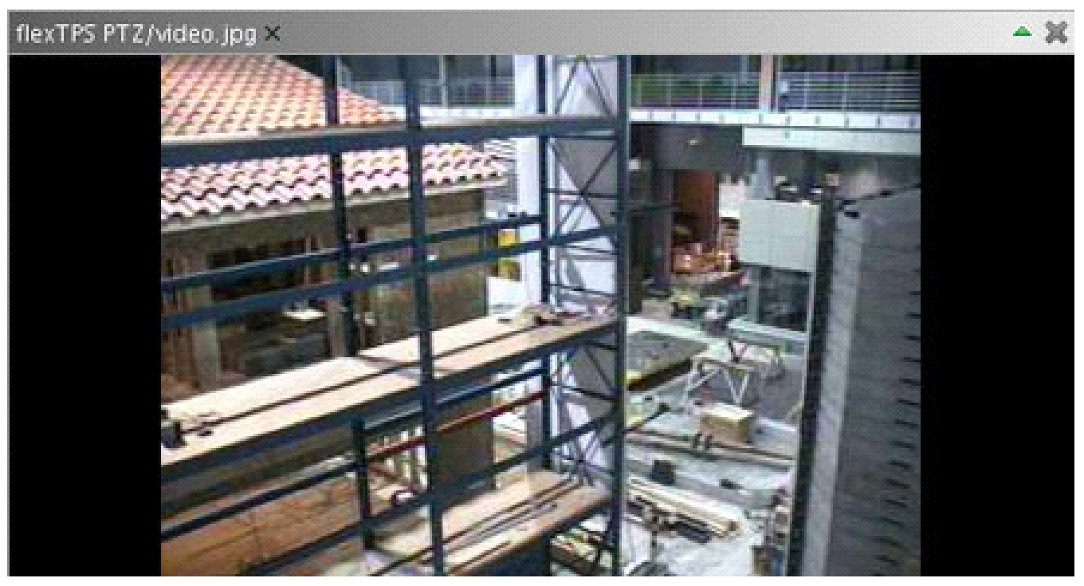

Limiting camera control prevents cameras from being repositioned during experiments or at other critical times.

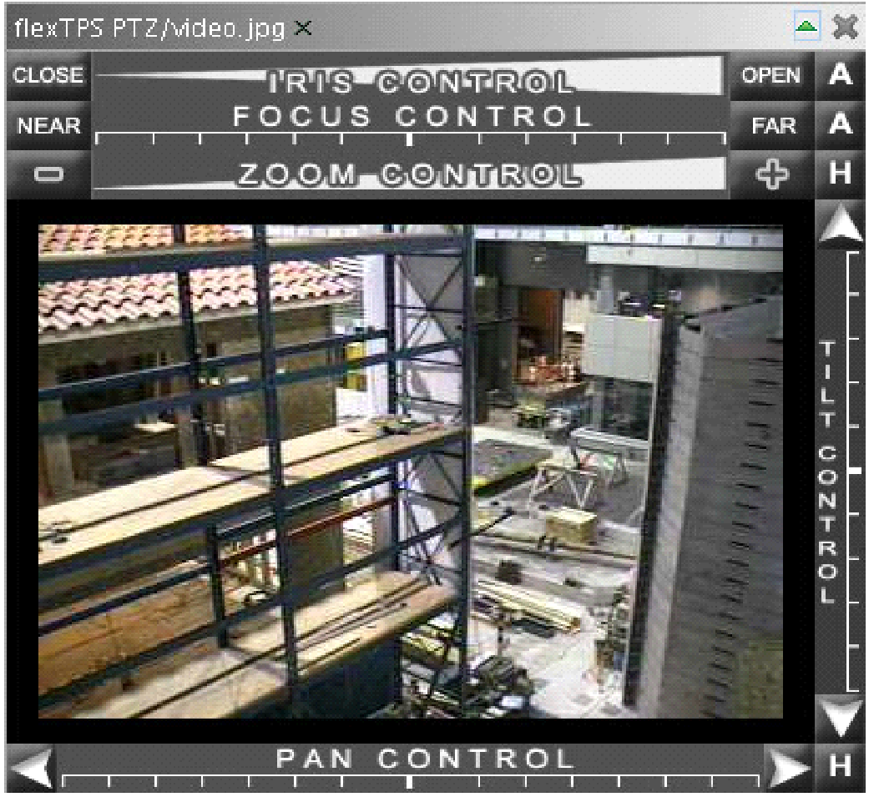

PTZ functions are available only when RDV is in real time mode. The PTZ interface is the same as that used by **flexTPS** and is shown below. Some cameras may not support all of the PTZ functions; in these cases only the applicable controls will be displayed.

If a NEEShub login is required to access the PTZ controls, you must log in using the ***Login*** function in the *File* menu. Once you've logged in, enter real time mode to see the PTZ controls. All PTZ controls operate similarly in that each specific control has an automatic or "home" setting that can be adjusted either instantaneously by clicking somewhere on the continuum bearing the name of the control, or incrementally by clicking on one of the buttons located on either side of the continuum.

* **Iris Control:** Clicking the ***Open*** or ***Close*** button incrementally opens or closes, respectively, the camera's iris, which allows more or less light into the camera and affects the video's brightness. Clicking the *A* next to the *Open* button automatically adjusts the brightness to a reasonable setting. Clicking anywhere on the bar labeled ***Iris Control***instantaneously adjusts the diameter of the camera's iris.
* **Focus Control:** Clicking the *Near* or *Far* button incrementally adjusts the camera's focal point. Clicking the *A* next to the *Far* button automatically adjusts the focus. Clicking anywhere on the bar labeled ***Focus Control*** instantaneously adjusts the camera's focal point.
* **Zoom Control:** Clicking the + or – button incrementally causes the camera to zoom in or out, respectively. Clicking the *H* next to the *–* button automatically resets the zoom level to a preprogrammed "home" setting. Clicking anywhere on the bar labeled ***Zoom Control***instantaneously adjusts the amount of zoom.
* **Pan Control:** Clicking the ← or → button incrementally rotates the camera to the left or right, respectively, about its Z-axis. Clicking the *H* in the lower right hand corner of the window automatically resets the camera's pan and tilt settings to a preprogrammed "home" location. Clicking anywhere on the bar labeled ***Pan Control*** instantaneously adjusts the direction of the camera's horizontal gaze.
* **Tilt Control:** Clicking the ↑ or ↓ button incrementally rotates the camera up or down, respectively, about its X-axis. Clicking the *H* in the lower right hand corner of the window automatically resets the camera's pan and tilt settings to a preprogrammed "home" location. Clicking anywhere on the bar labeled ***Tilt Control*** instantaneously adjusts the direction of the camera's vertical gaze.

**High Definition Video**

Some equipment sites may have high definition video streams available for viewing. To view such a stream an external application called VLC is needed. To obtain VLC, go to<http://www.videolan.org/vlc/> and click on the link for your operating system (e.g. Windows). Download the VLC installer by clicking on one of the download links. Once the installer has been downloaded, run it and follow the on-screen prompts to install VLC.

Once VLC has been downloaded and installed, check your network connection by going to <http://detective.internet2.edu/>. You may either download or install the Internet2 Detective application by following the instructions given on the page or you may run the applet from within your web browser. (Java is required to run the applet.) Use the Internet2 Detective to determine whether your network connection is capable of handling the large amounts of data generated by high definition video.

Once you have installed VLC and tested your network connection you are ready to view high definition video. Equipment site personnel may make an RDV configuration file available before a test, or they may give you the URL of a simple web page created for the test. If you are given an RDV configuration file (*.rdv), follow the directions in Section 3.7 to load it.

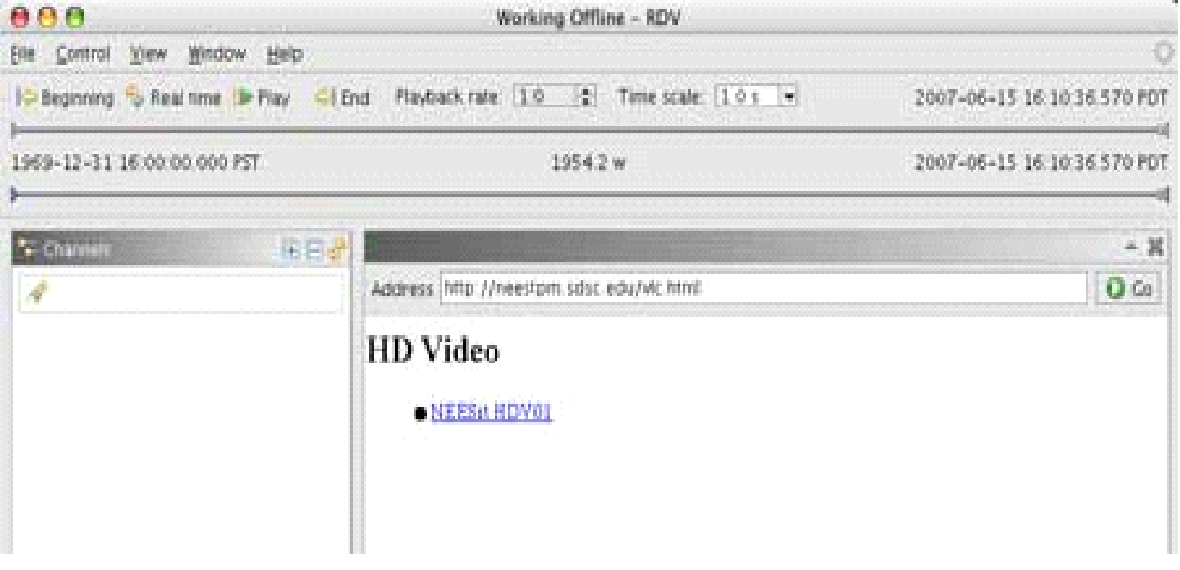

If you are given the URL of a web page, open a Web Data Panel Section 3.4.6 and enter the URL in the location bar. In both cases you should see a simple web page with links to different high definition video streams. Clicking a link will cause VLC to launch and the video will be shown in a new window external to RDV.

Note: If the video is not formatted properly try setting your aspect ratio to *16:9* in the ***Video*** →***Aspect-ratio* menu**.

**Time Series Data Panel**

The time series data panel displays numerical data as a function of time. Multiple channels can be displayed in the same plot.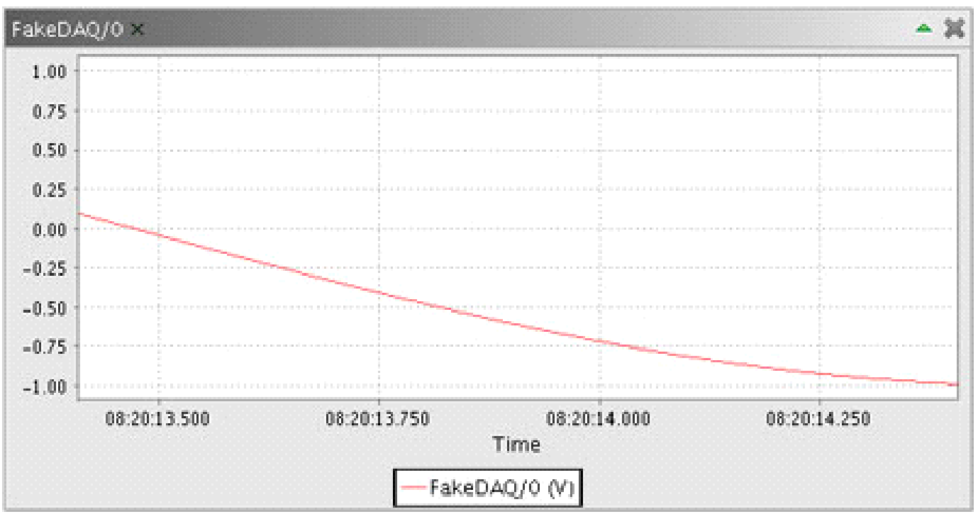

**XY Data Panel**

The XY data panel displays pairs of channels of numerical data by plotting Y-component of the first channel against Y-component of the second channel with respect to time. Multiple pairs of channels can be displayed in the same plot.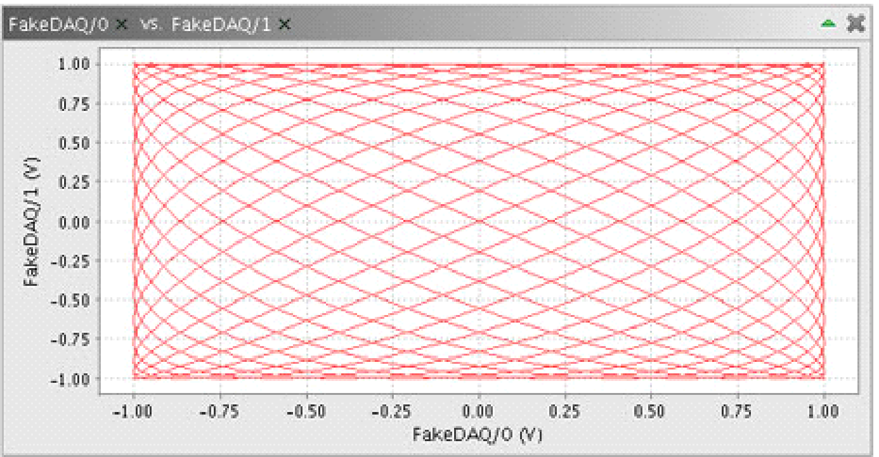

**Tabular Data Panel**

The tabular data panel displays one or more channels of numerical data in table form. By default the table displays each channel's name, current value, and units. Right-clicking and selecting ***Show min/max columns*** and ***Show threshold columns***displays additional information as seen below. 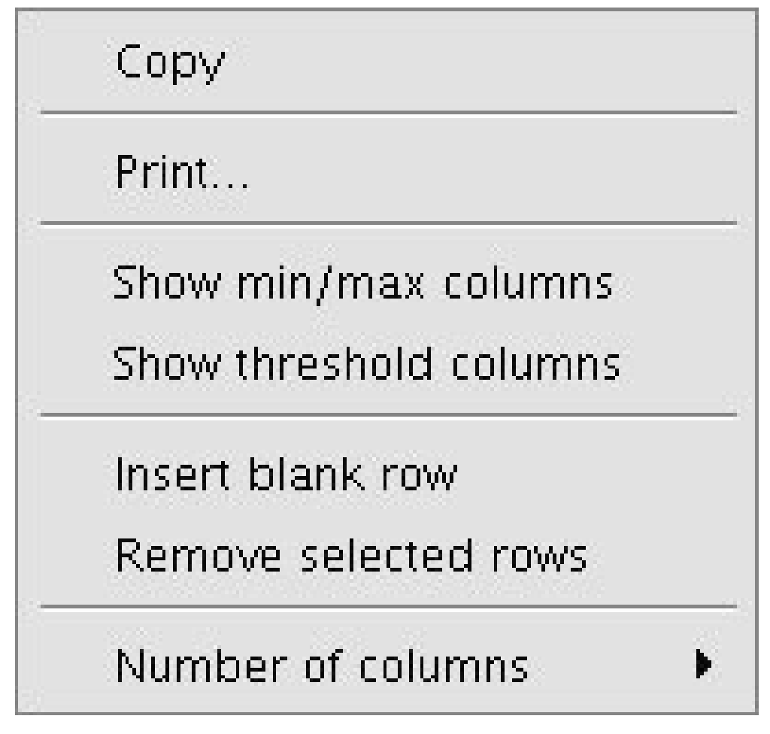

Clicking the buttons labeled ***Decimal* and *Engineering*** switches the display of values in the ***Value***, ***Min***, and ***Max*** columns between decimal and engineering notation. Clicking the ***Take Offsets***button causes RDV to "zero" all entries in the ***Values***column.

This feature is intended to be used at the beginning of a test to correct for miscalibrated equipment whose output is off by a constant amount. Unchecking the ***Use Offsets*** checkbox makes RDV ignore any offsets previously taken and displays the verbatim values coming from the sensor. The offsets, however, are stored in memory and checking the ***Use Offsets*** checkbox reapplies them to the ***Values***column.

For real-time and playback mode, the minimum and maximum values shown in the ***Min*** and ***Max*** columns are those that have occurred since entering real-time mode or starting playback. When stepping through data by moving the playback indicator, the minimum and maximum values are not calculated and are identical to whatever value is shown in the ***Value*** column.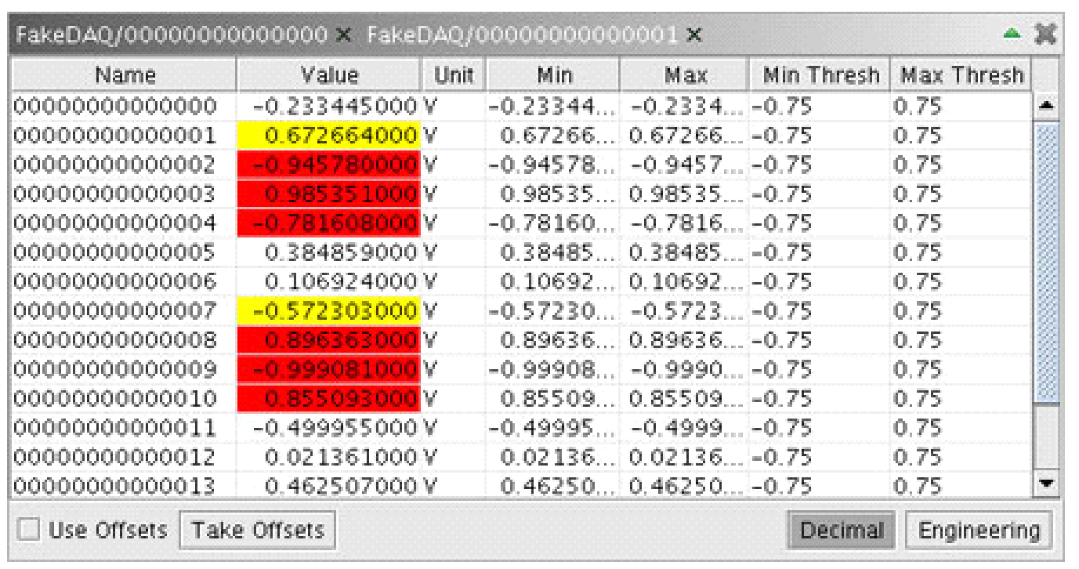

The values entered in ***Min Thresh*** and ***Max Thresh*** columns control the background color of corresponding Valuecell. If both a minimum and a maximum threshold value are present, the following calculations are made:

**warningThreshold = 0.25 × (maximumThreshold − minimumThreshold)**

**criticalThreshold = 0.10 × (maximumThreshold − minimumThreshold)**

***Value* ≤ minimumThreshold + criticalThreshold**

*Value* cell background turns red.

***Value* ≤ minimumThreshold + warningThreshold**

*Value* cell background turns yellow.

***Value* ≥ maximumThreshold − warningThreshold**

*Value* cell background turns yellow.

***Value* ≥ maximumThreshold − criticalThreshold**

*Value* cell background turns red.

If only one of the thresholds is specified, no calculations are performed and the background of the *Value* cell turns red only when the threshold is exceeded.

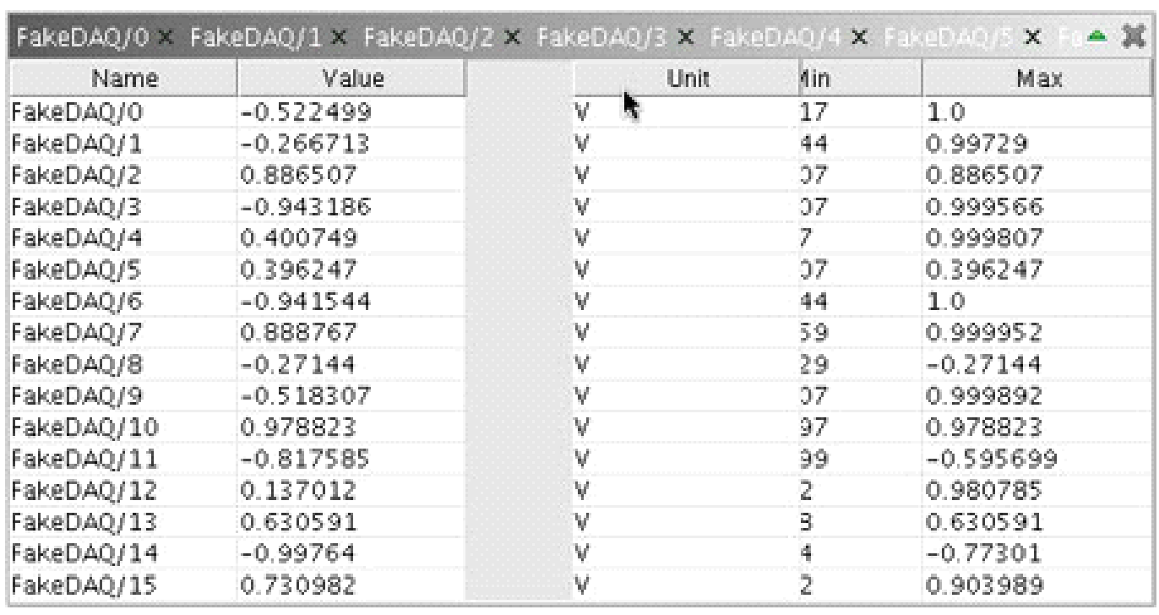

Each table may contain up to ten data sets, with each data set capable of displaying up to 40 channels. To add additional data set columns to your table, use the *Number of columns*function in the contextual menu. Note that channels may not be repeated within the same table.

This means if channel XYZ is in data set 1, channel XYZ cannot also be in data set 2. If you need to see the same channel in multiple data sets you should create a new table instead of adding additional columns. You may add blank rows to your table to aid in visually organizing your display. Choosing *Insert blank row* from the contextual menu adds one blank row to the bottom of the data set. Choosing *Remove selected rows* deletes any highlighted rows from the column over which the contextual menu was activated. The order of the table's columns may be rearranged by dragging a column's heading to a new location.

**Dial Data Panel**

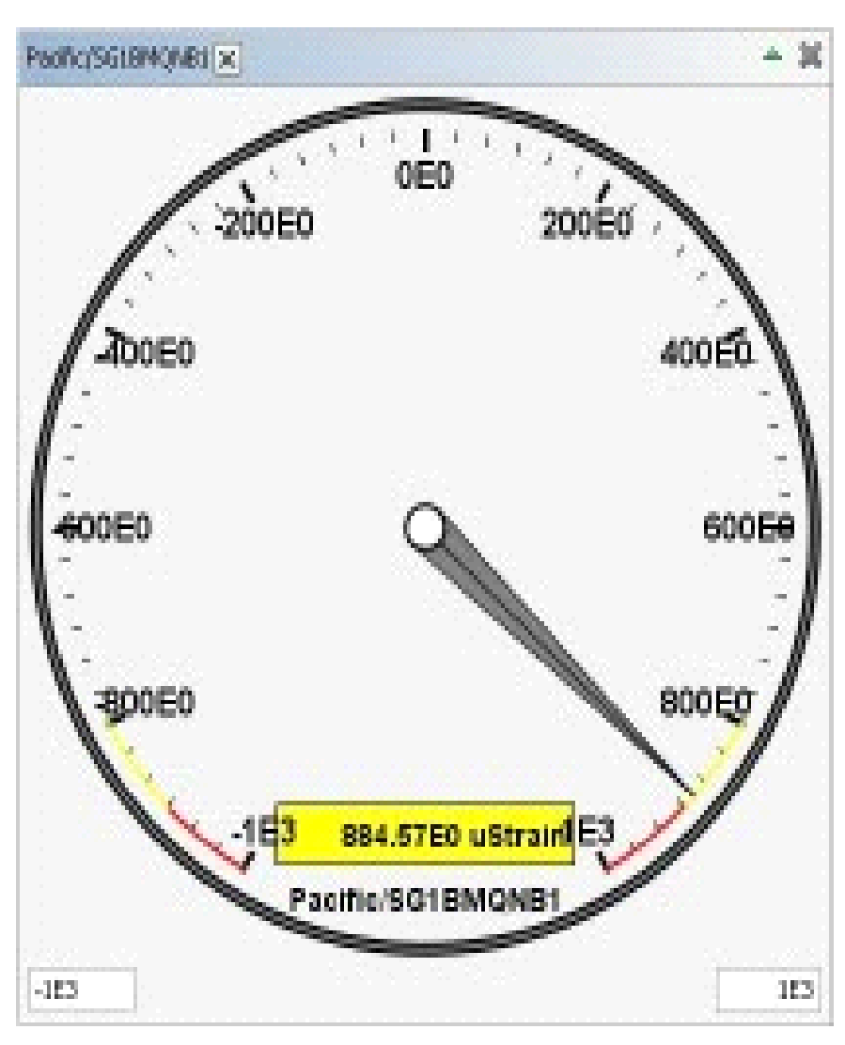

The ***DialView*** data panel displays numerical data in a virtual analog dial.

**Text Data Panel**

The text data panel displays textual data.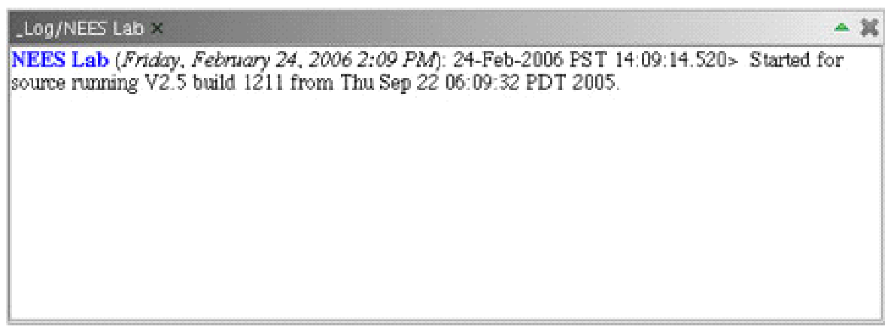

**Web Data Panel**

The web data panel displays basic HTML web pages. Equipment facilities or researchers may produce a simple web page with information and links to documents relevant to a particular experiment. The web data panel is not, nor is it intended to be, a full browser implementation and therefore supports only the most basic of HTML. The web data panel uses external applications like Adobe Reader and Firefox to open documents and links. The external application launching mechanism does not work correctly on Mac OS at this time.

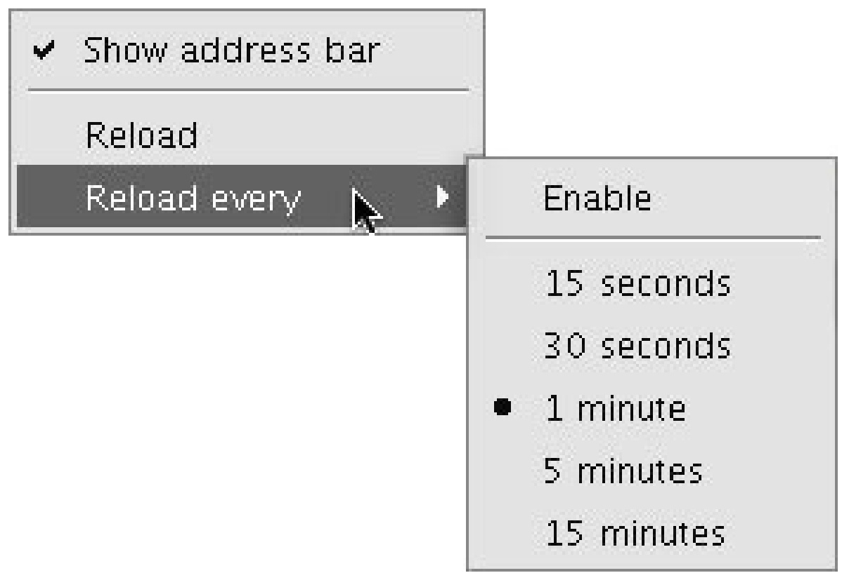

The contents of a web data panel can be reloaded by right-clicking and selecting ***Reload***. Additionally, the web data panel can be set to periodically reload itself by selecting a time interval from the *Reload every* option. Unchecking ***Enable*** turns off the automatic reload functionality, but the time interval you set is retained (until you quit RDV). Simply select *Enable* again to resume automatically refreshing the web page.

**Data Panel Icons**

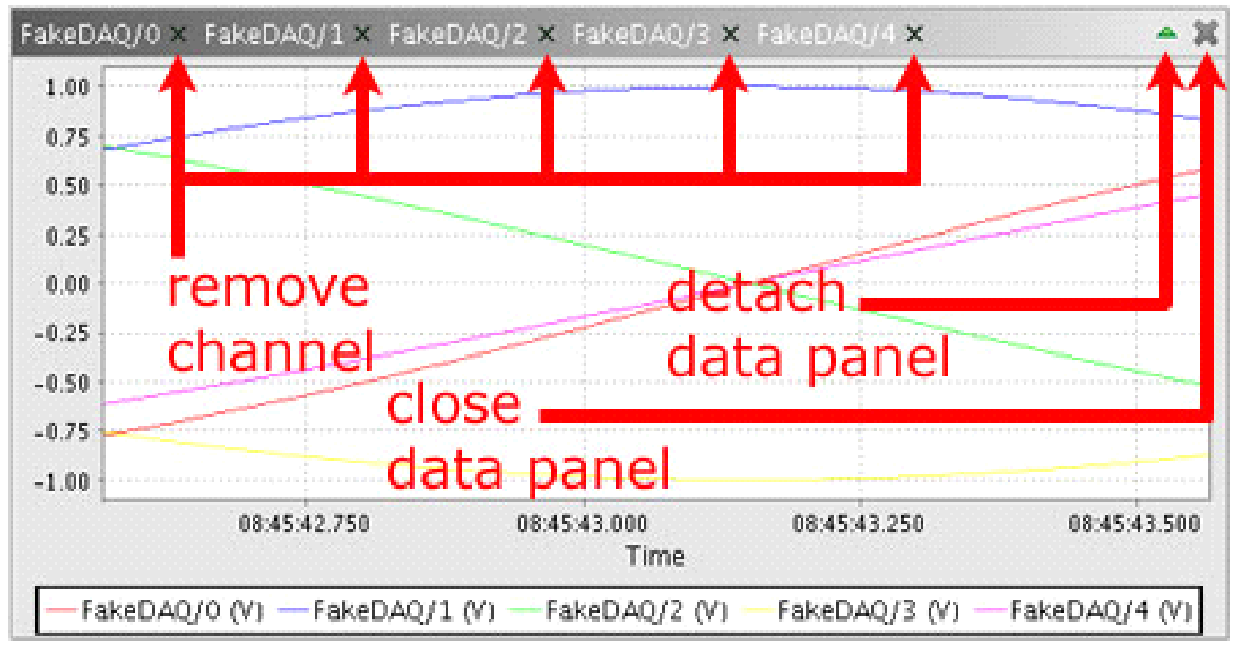

*The right side of the title bar of each data panel contains a set of common icons. Clicking the grey "X" close icon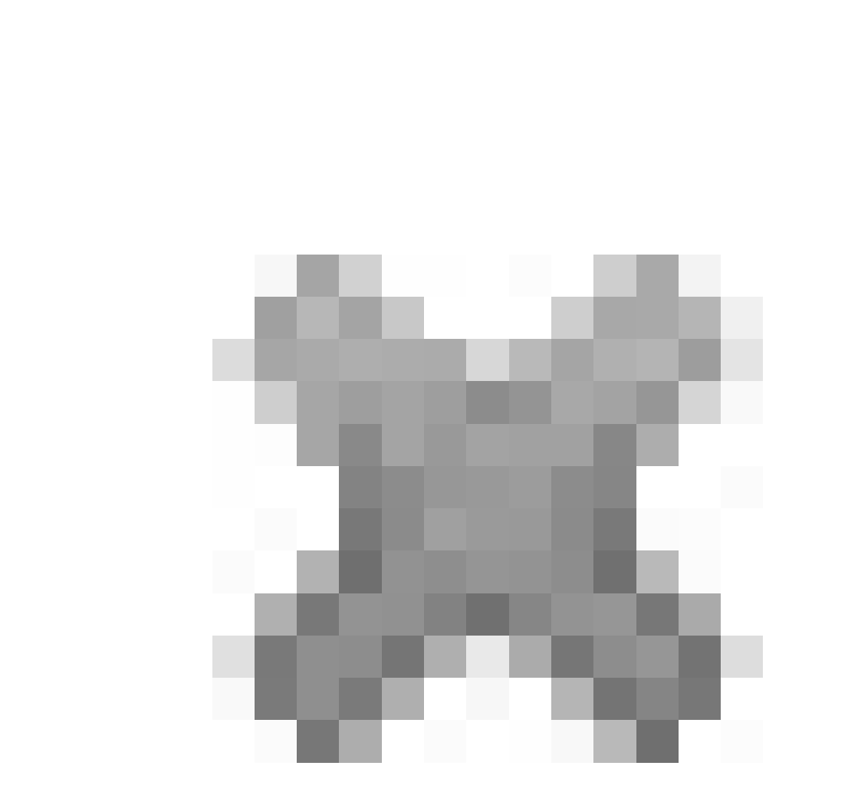 causes the data panel to close. Clicking the green triangular detach icon*  *causes the data panel to become detached from the main RDV application window. Once a data panel has been detached, it can be reattached to the RDV application window by clicking the blue triangular reattach icon*  *that appears in* place of the detach icon.

The left side of the title bar of each data panel displays the name of each channel providing data. Clicking the black "X" close icon to the immediate right of a channel's name removes that channel from the data panel's display.

**Data Panel Contextual Menu Options**

Right-clicking on a data panel's title bar displays a contextual menu that is common to all data panels.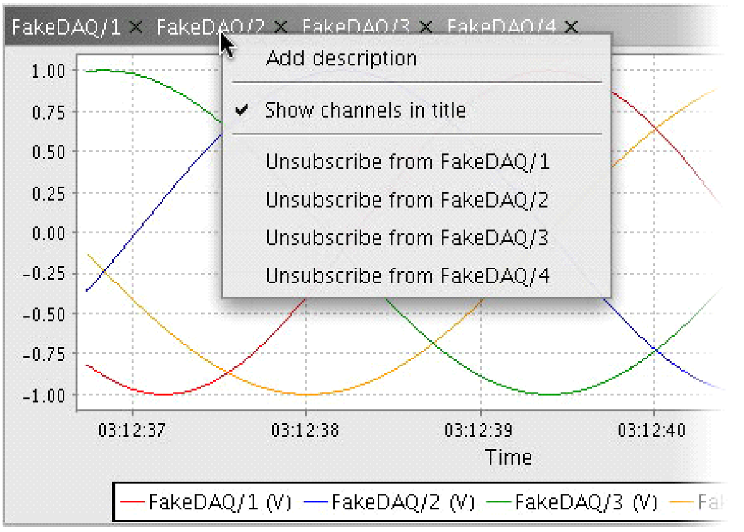

Clicking on ***Add description*** allows you to label your data panel. Once added, a description can be edited or removed by right-clicking and selecting ***Edit description*** or ***Remove description*** (not shown in above picture). Unchecking ***Show channels in title*** hides the channel names in the data panel's title bar. Selecting ***Unsubscribe from <XXX>*** (where "<XXX>" represents the name of a channel) removes that channel from the data panel's display.

Right-clicking on the main part of a numerical data panel displays a different contextual menu. Note: Textual data panels do not have this contextual menu.) Menu items common to all data panels include *Copy*, *Save As...*, and *Print...*.

***Copy*** places a picture of the data panel's contents on your operating system's clipboard, making it possible to subsequently paste the image into another program such as Microsoft Word or PowerPoint.

***Save As...*** is similar to *Copy* in that it captures a picture of the data panel's contents. However, instead of placing the image on the clipboard, you are presented with a dialog that allows you to save the image as a file.

***Print...*** is also similar to ***Copy*** and ***Save As****...*. You are presented with a standard printer dialog and the image is sent to the chosen device. When printed, the image is scaled to fill as much of the page as possible.

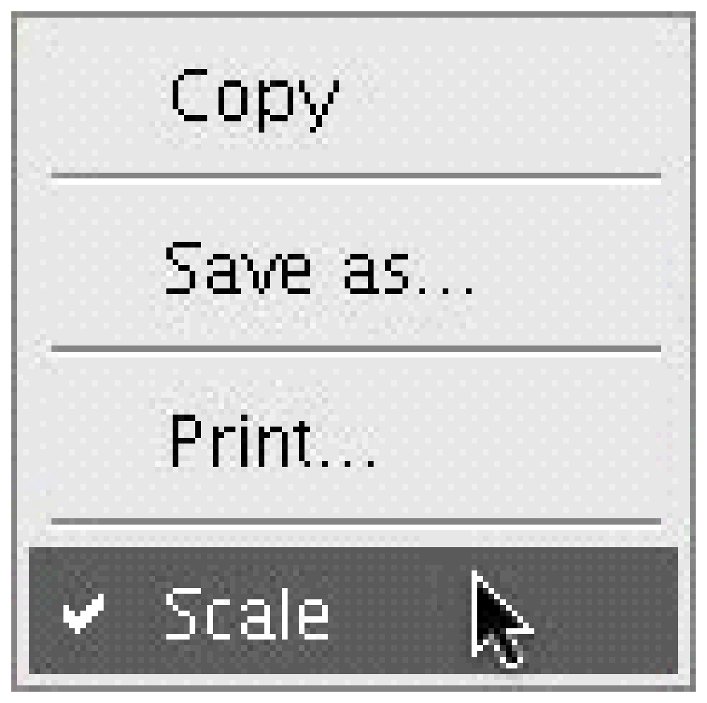

***Scale*** is present only in the video/image data panel contextual menu. When checked, this option causes the picture to be scaled to fit the size of the data panel in which it is being viewed. Unchecking the *Scale* option displays the data at full resolution. When large videos or images are not scaled, part of the picture may not be visible. To see the entire picture, detach the data panel from the RDV application window and resize as necessary.

The ***Properties...*** menu option is available from any data panel that is capable of displaying numerical data. Specifically, they are the time series and XY data panels.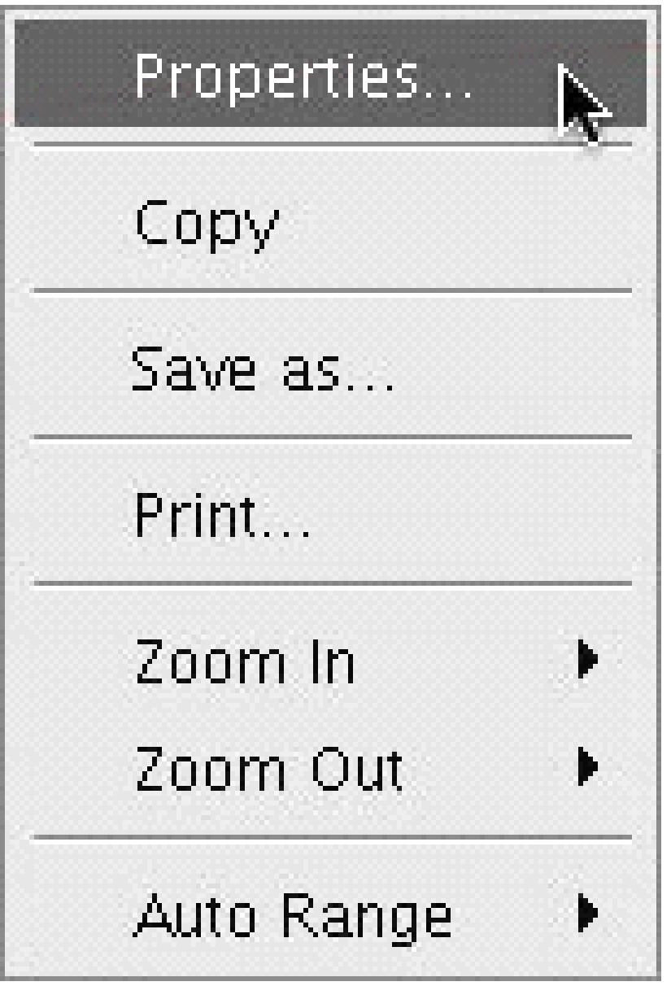

The ***Title*** tab of the *Properties...* dialog, shown below, allows you to customize the display of title text for your data plot. Clicking the checkbox next to ***Show Title*** toggles between showing and hiding a title in the data panel display. Because the default title is "Title," *Show Title* is off by default. Type the title's text in the box labeled ***Text***. 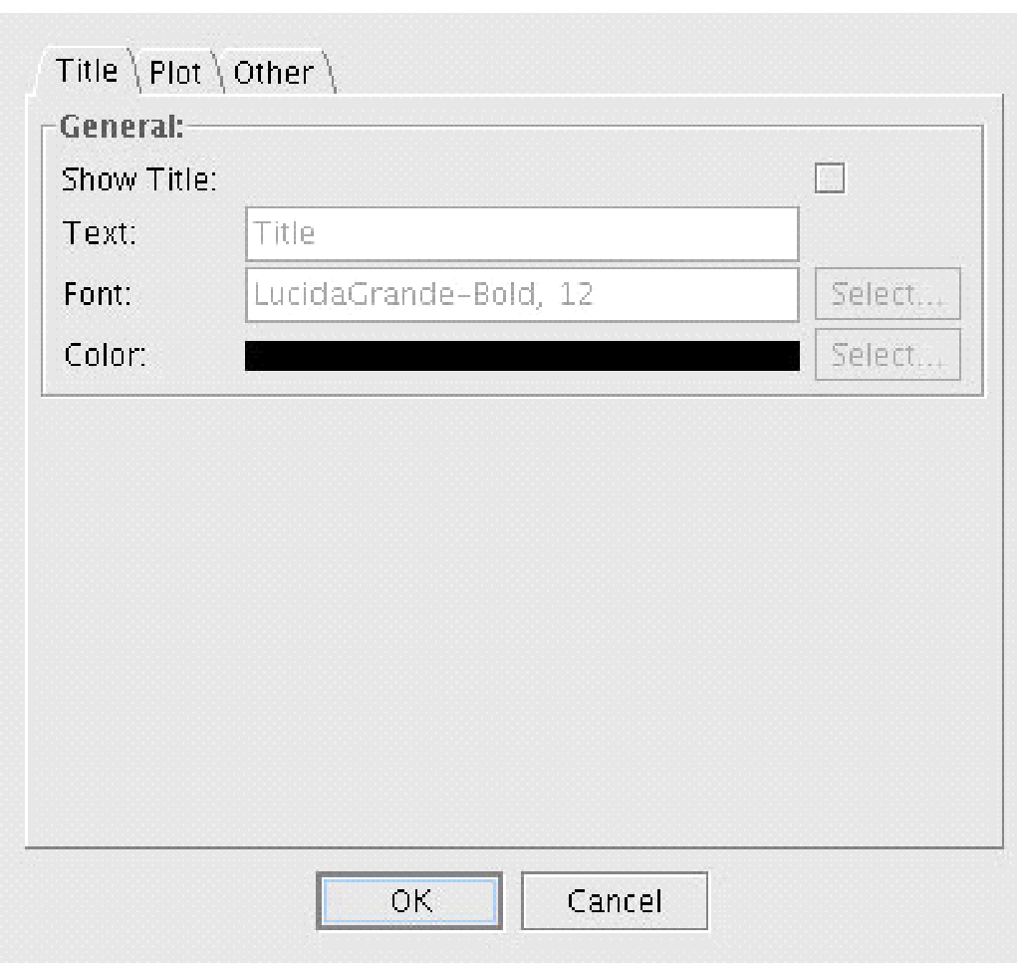

The name, weight, and size of the font used to display the title are shown in the box next to ***Font***. Clicking the *Select...* button allows you to change the settings.

Finally, the font color is displayed next to the ***Color*** label. Choose a different color by clicking the *Select...*button and picking one of the swatches.

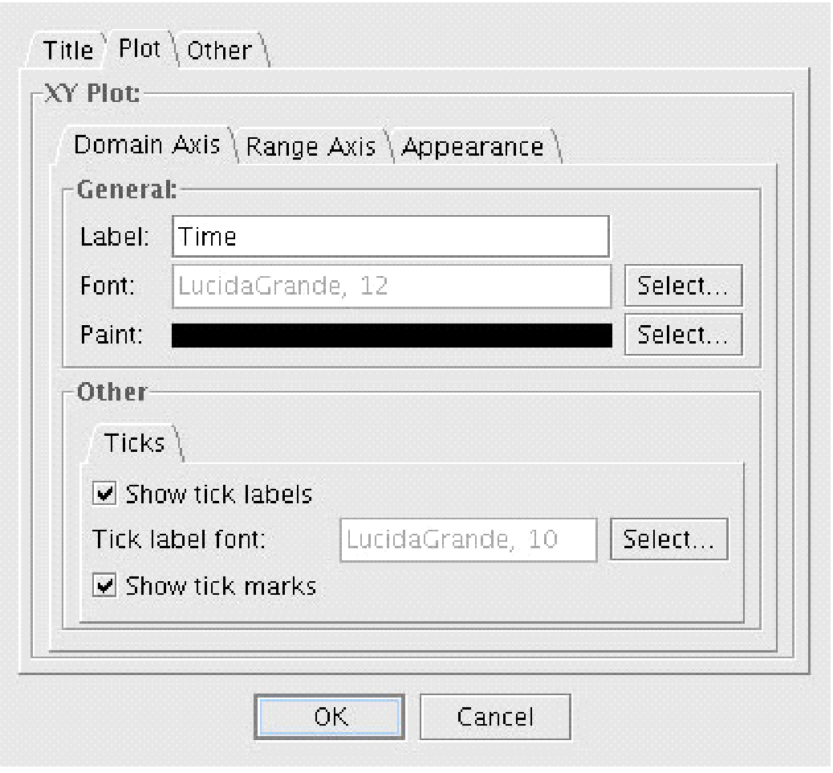

The ***Plot*** tab of the *Properties...* dialog, shown below, allows you to customize the display of data within your data plot. ***Domain******Axis*****and** ***Range Axis*** subtabs contain identical options. The ***Label***, ***Font***, and ***Paint*** options work in the same manner as the *Text*, *Font*, and *Color* options on the *Title* tab, described on the left.

Checking the ***Show tick labels*** checkbox displays unit labels below or to the left of each tick mark along the axis. The ***Tick label font*** is the font used to display the labels and can be changed by clicking the *Select...* button. Checking the ***Show tick marks*** checkbox displays a small tick mark below or to the left of the axis. Tick marks and tick labels are shown by default.

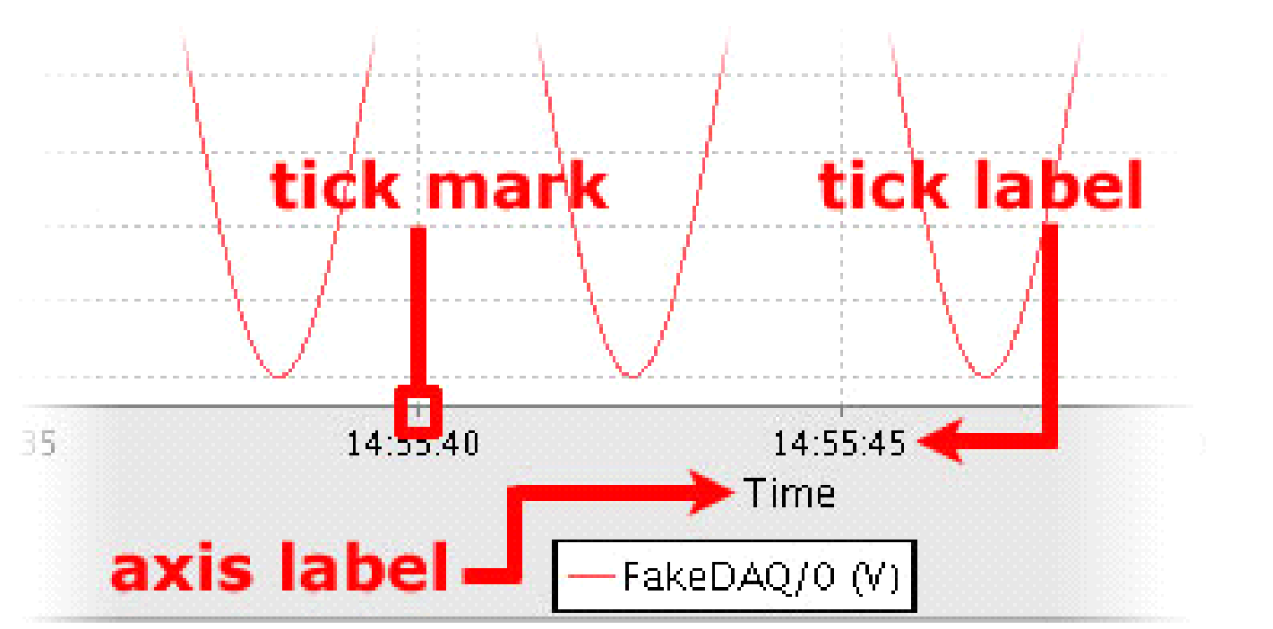

The ***Appearance*** subtab, shown below, lets you customize the appearance of the data plot. The ***Outline stroke*** and ***Outline paint*** options determine the width and color, respectively, of the line drawn around the data plot. The default is a thin black line.

The ***Background paint*** color is the color used to fill the background of the data plot. ***Orientation*** determines the axis on which the dependent variable (i.e., range) is plotted. The default background color is white. If ***Draw Lines*** is checked, lines that interpolate between discrete data points are drawn to give the data a smoother appearance. If ***Draw Shapes*** is checked, each discrete data point is shown as a small square. By default, *Draw Lines* is on and *Draw Shapes* is off.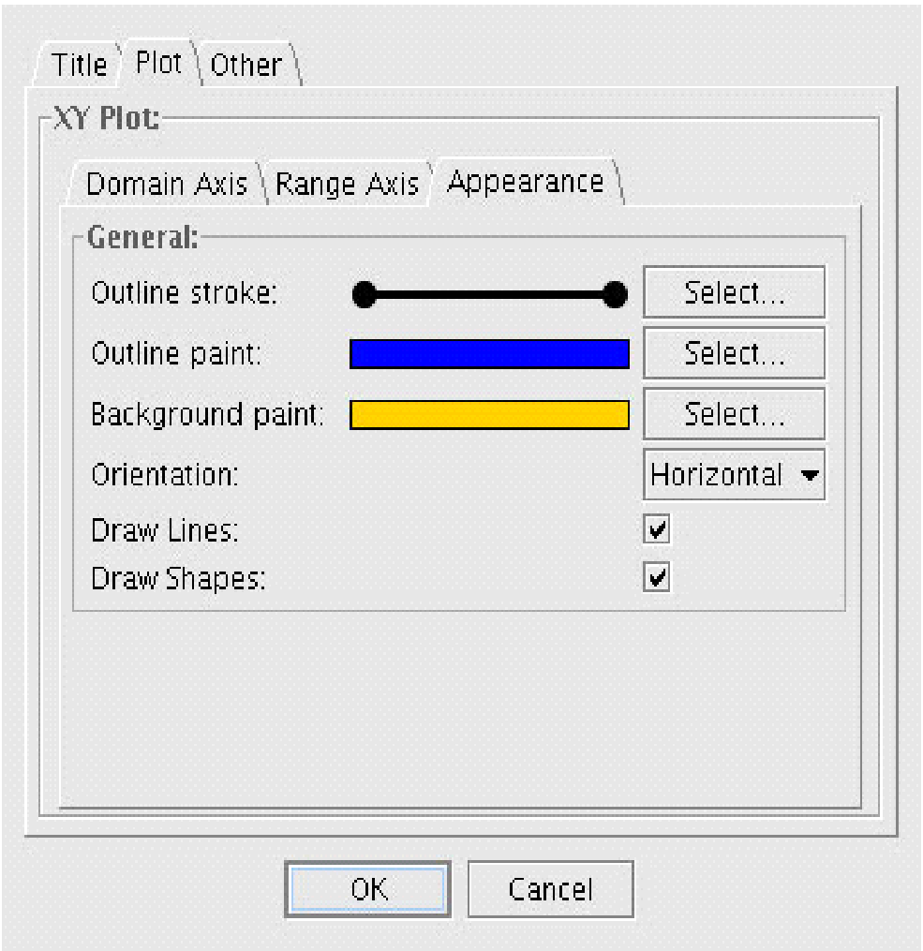

Using the ***Appearance*** settings shown above results in the data plot shown below. Note that when the mouse pointer is placed over a discrete data point, a tool tip pops up and displays the channel name (FakeDAQ/0), units of measurement (V), domain value (2006-04-28 15:23:20.889), and range value (-0.649). The *Draw Shapes* checkbox does not need to be checked to use this feature. It is, however, much easier to discriminate between data points if the *Draw Shapes* checkbox is checked.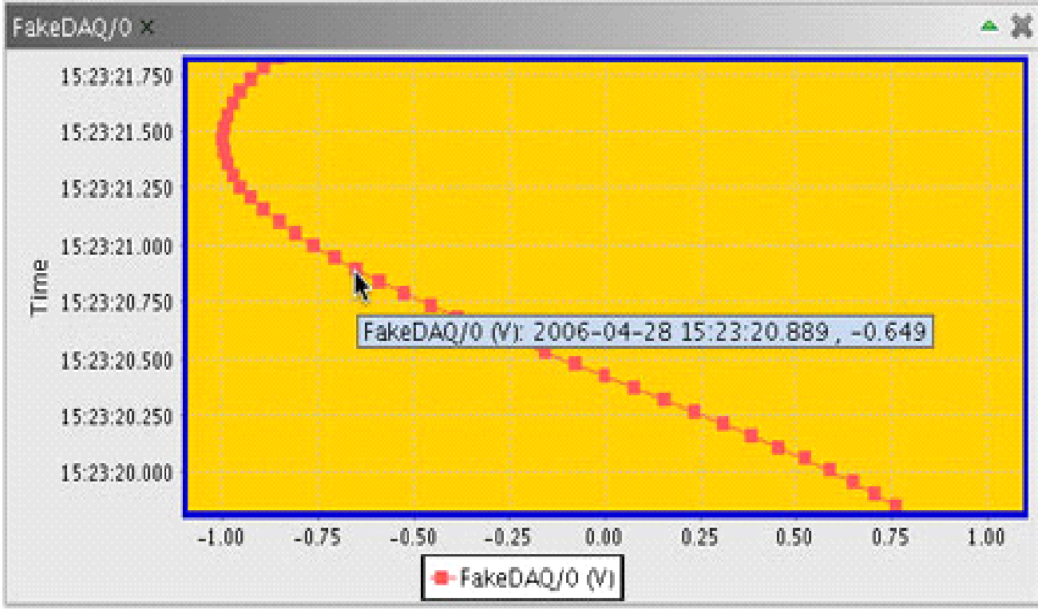

The ***Other*** tab of the *Properties...* dialog, shown below, allows you to further customize the display of your data plot.

Checking the ***Draw anti-aliased*** checkbox causes the on-screen data to have a smoother appearance. Anti-aliasing is off by default. The ***Background paint*** color fills the space outside of the coordinate system and is grey by default. The ***Series*** options are not implemented at this time. The effect of the *Draw anti-aliased* and *Background paint* options selected above are shown below.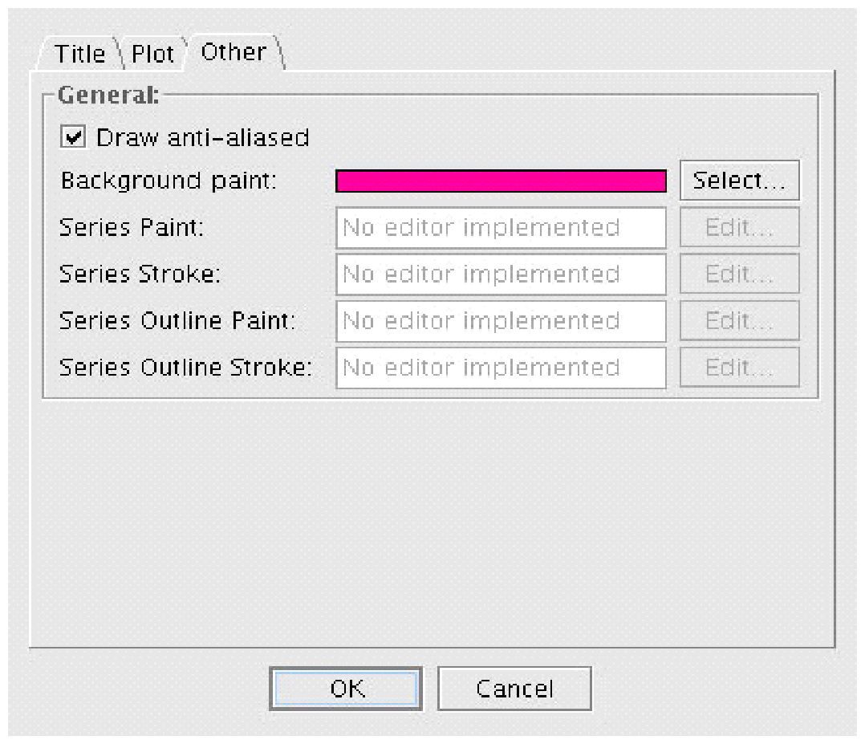

The ***Zoom In***, ***Zoom Out***, and ***Auto Range*** menu items allow you to control the scale of the data plot. The axes may be scaled together, independently of each other, or automatically. ***Both Axes*** applies the appropriate function to both the domain and the range axes. ***Domain Axis*** applies the function to only the domain axis. Similarly, ***Range Axis*** applies the function to only the range axis.

The *Auto Range* functions automatically determine the scale that allows all data to be shown in one window. The ***Add local series...*** option, only available for X vs. Y plots, is used to load data from a local file (e.g., simulation data).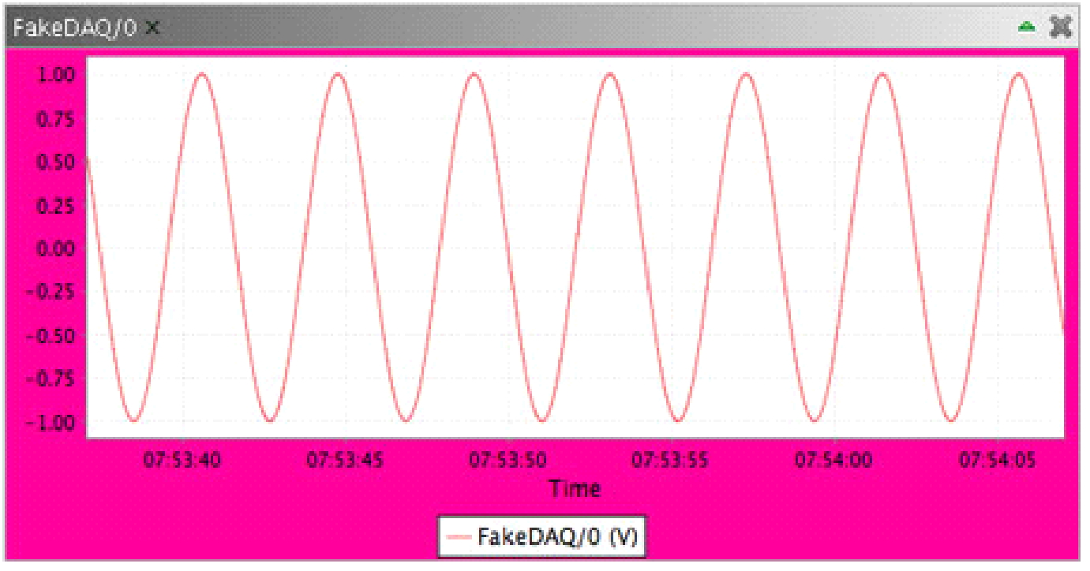

To quickly zoom in on an area, drag a box (shown below) around the desired location from upper left to lower right. To quickly auto range, click and drag the mouse in any direction other than diagonally down and right. If the grey zoom selection box appears, try dragging your mouse to the left for better results.

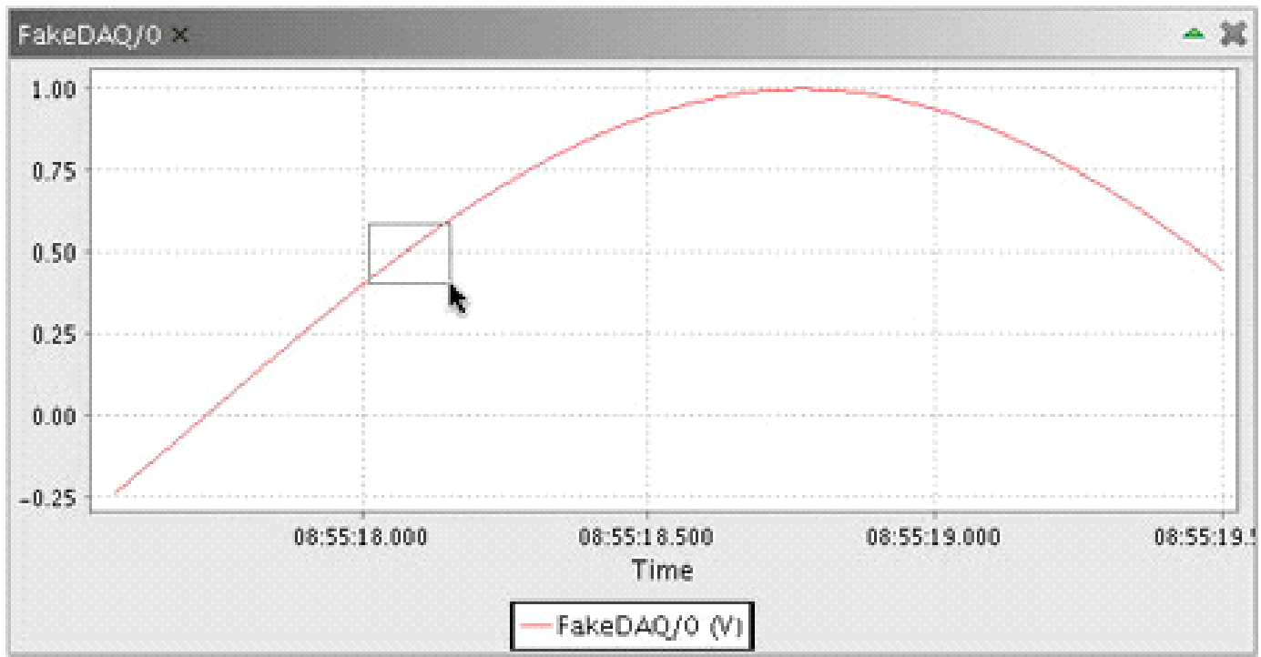

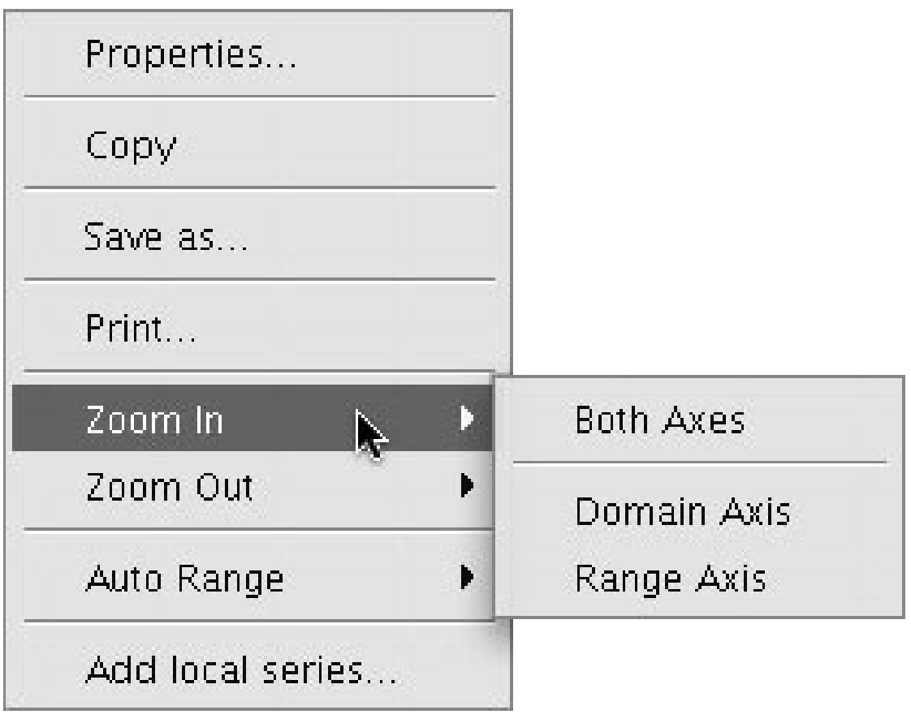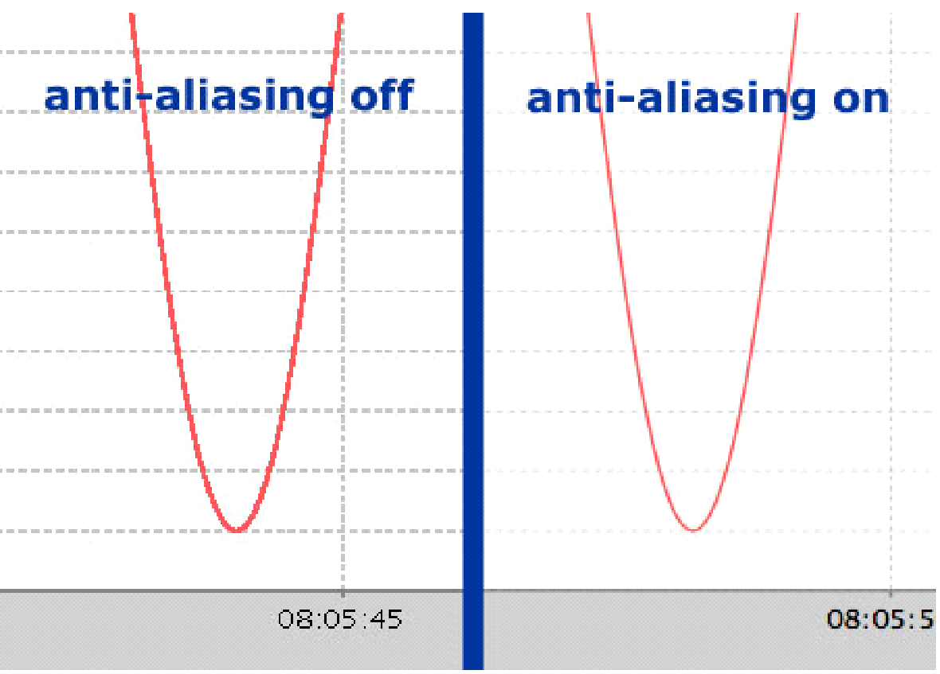

**Audio Panel**

The audio panel is a small panel above the Marker panel with a simple text box for entering the URL of an audio stream. Press the Play/Pause button to start and stop the audio stream.

**Spectrum Analyzer Panel**

The spectrum analyzer panel displays the spectral composition of a single channel. More specifically, RDV performs this by computing the discrete Fourier transform of the channel’s waveform, transforming it into the components of its frequency spectrum.

In addition, the spectrum analyzer panel can also display the power spectrum of the channel’s waveform. The power spectrum, or power spectral density (PSD) describes how the power of a signal or time series is distributed with its frequency. Here, power is defined as the squared value of the signal.

Currently, the *Sample Rate* of the waveform must be known to obtain the correct spectral composition. In the future, the sample rate will be extracted from the channel’s metadata, if present. *Number of Points* represents the number of samples to use as input. Given that data visualized in RDV may be acquired in real-time, the spectrum analyzer panel uses a windowing technique to obtain a spectral composition for that window, verses the entire set of data. Hamming is set as the default windowing method, although experienced users can select from a range of windowing methods using the Window selector. *Size* represents the size of the segments used to generate the spectral composition, while *Overlap* represents the amount by which those segments should overlap. Lastly, the spectral composition (FFT) or the power spectrum (PSD) can be calculated, using the *Selector* selector.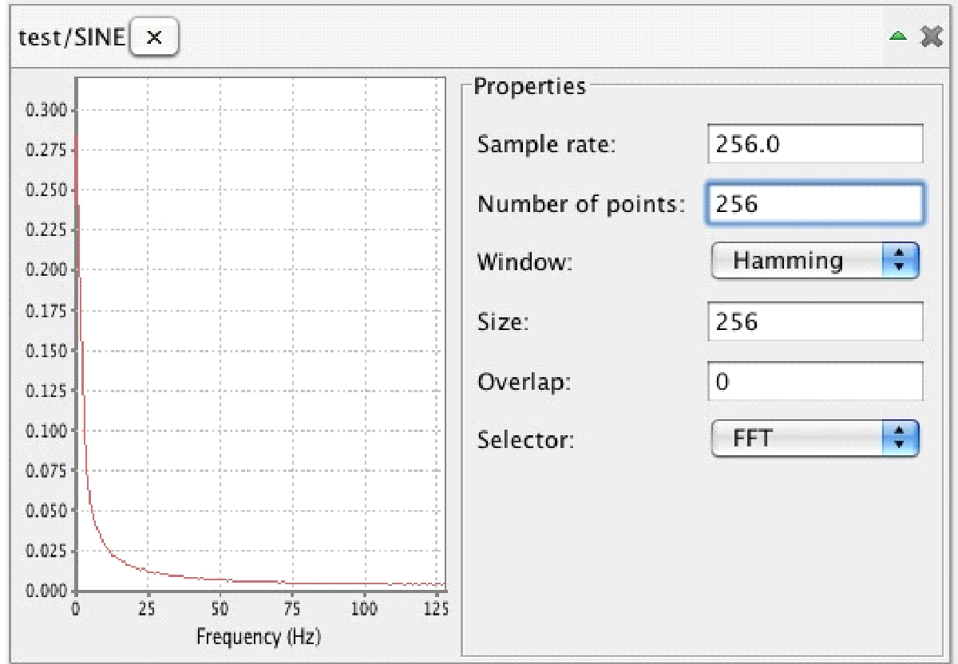

**Event Marker Panel**

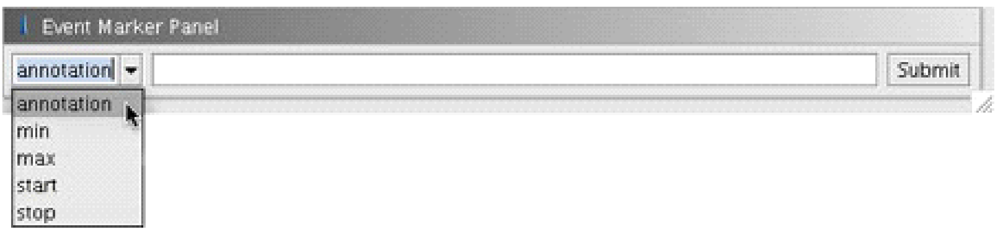

The event marker panel, shown below, allows you to mark significant occurrences, such as minimums and maximums, and make notes about other important events (e.g., a crack begins to form). Once added, markers are displayed on the global timeline and are visible to others, which make it possible to quickly point out "interesting" data points to colleagues. Additionally, the use of start and stop markers allows for times with no significant data to be excluded from playback.

To **add an event marker**, move the playback indicator to the desired location along the zoom timeline, choose the predefined type of marker you would like to create from the drop down menu in the event marker panel or create your own type, add your comments in the adjacent text box, then press the *Submit* button. Once created, an icon representing your event marker will be added to the global timeline in the control panel. Your marker will also be visible on the zoom timeline when appropriate. There are five different predefined types of event markers:

|  |  |  |
| --- | --- | --- |
| **Predefined Type** | **Timeline Icon** | **Description** |
| Annotation |  | Used to make free-form comments such as, "Concrete begins to crack." |
| Min |  | Used to mark a minimum in numerical data. |
| Max |  | Used to mark a maximum in numerical data. |
| Start |  | Used to mark the beginning of an "interesting" section of data. When *Hide time with no data* is selected from the *View* menu, only the times between a start and a stop marker are shown. All other times are hidden from view. This feature is most useful when there are long periods of time between relevant data points.  ***Note:*** *Start* and *Stop* markers must occur in pairs. If an uneven number of markers are present, RDV assumes the earliest *Start* marker is paired with the next earliest *Stop* marker. A *Start* marker should always be present before a *Stop* marker. |
| Stop |  | Used to mark the end of an "interesting" section of data. See description of *Start* marker for more information. |

You may also create your own marker types by entering text into the drop down menu on the left side of the event marker panel. User-defined marker types are displayed with the yellow/orange icon.

To **view the notes and time associated with an event marker**, position your mouse pointer over the marker's icon and wait for the pop-up description window to appear. Right-clicking on the zoom timeline will cause the playback indicator to jump to the nearest marker.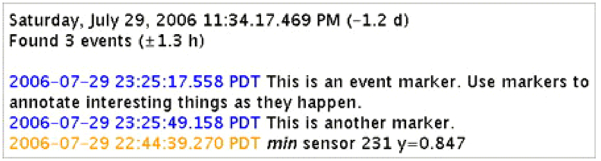

The date and time associated with the mouse pointer's current location is displayed at the top of the description window. Following in parentheses is the difference in time between the location of the mouse pointer and the green playback indicator. In the above example, the mouse pointer is positioned 1.2 days before (to the left of) the green playback indicator. The second line describes the number of event markers found within the period of time bounded by adding and subtracting the amount of time shown in the parentheses to and from the time associated with the current location of the mouse pointer. Finally, the notes associated with each event marker are displayed. The timestamps are color-coded to match the color of the event marker's timeline icon.

## Importing Data

Data and video can be imported and exported from RDV from local sources for viewing without having to connect to an external Data Turbine server.

**Importing Data Files**

To import data files, choose *Import data file* from the *File* → *Import* menu. The *File* → *Import* menu is only active when *File* → *Work Offline* is checked. A file selector window will appear, allowing you to locate and select a file to import. The selected file may be a plain text file or a text file compressed as a *.zip, *.gz, or *.bz2 file.

The input file should begin with a metadata header that describes the active channels and their units. Each line following the metadata header represents a single point in time (always in UTC) and contains the value of each channel at that point in time. Times should be reported in ISO8601 format: YYYY-MM-DDTHH:MM:SS.NNNZ. The ending Z may be omitted and there can be a variable number of sub second digits. Values are separated by tab characters (\t) and missing values are indicated with a sequence of two tabs in a row with no intervening spaces (i.e., \t\t). Note the use of scientific notation for the values. Below is a short sample file. To use the file for test purposes, replace all \t's with actual tab characters before importing it into RDV.

Active channels: ATL1,ATT1,ATL3,ATT3  
Channel units: g,g,in,kip  
  
Time**\t**ATL1**\t**ATT1**\t**ATL3**\t**ATT3  
2002-11-13T15:48:55.26499**\t**2.71828E0**\t**3.1415E0**\t**0.0000E0**\t**6.6600E2  
2002-11-13T15:48:55.41499**\t**8.67531E6**\t**6.0200E23**\t**1.0000E0**\t**4.2000E1

Alternatively, the time column can be given as the number of seconds elapsed since the start time. In this case the start time must be indicated in the header, as shown below.

Active channels: ATL1,ATT1,ATL3,ATT3  
Channel units: g,g,in,kip  
Start time: 2006-02-20T11:45:12.015Z  
  
Time**\t**ATL1**\t**ATT1**\t**ATL3**\t**ATT3  
0**\t**2.71828E0**\t**3.1415E0**\t**0.0000E0**\t**6.6600E2  
0.1**\t**8.67531E6**\t**6.0200E23**\t**1.0000E0**\t**4.2000E1

**Importing JPEG Images**

A folder containing sequential JPEG images may be imported as video into RDV by selecting *Import JPEG files* from the *File* → *Import* menu. The *File* → *Import* menu is only active when *File* → *Work Offline* is checked. A file selector window will appear, allowing you to locate and select a folder containing sequential time stamped JPEG images.

The filename of each image must contain the image's timestamp in ISO8601 format. Each JPEG file must be named according to one of the following conventions:

*NAME*_*YYYY*-*MM*-*DD*T*HH*.*MM*.*SS*.*NNN*Z.jp(e)g or*NAME*_*YYYYMMDD*T*HHMMSSNNN*.jp(e)g

where *NAME*_ is optional and will be ignored. The same naming scheme must be used for all files; do not mix and match. All timestamps are assumed to be in UTC.

*3.6.3. Importing From NEEScentral*

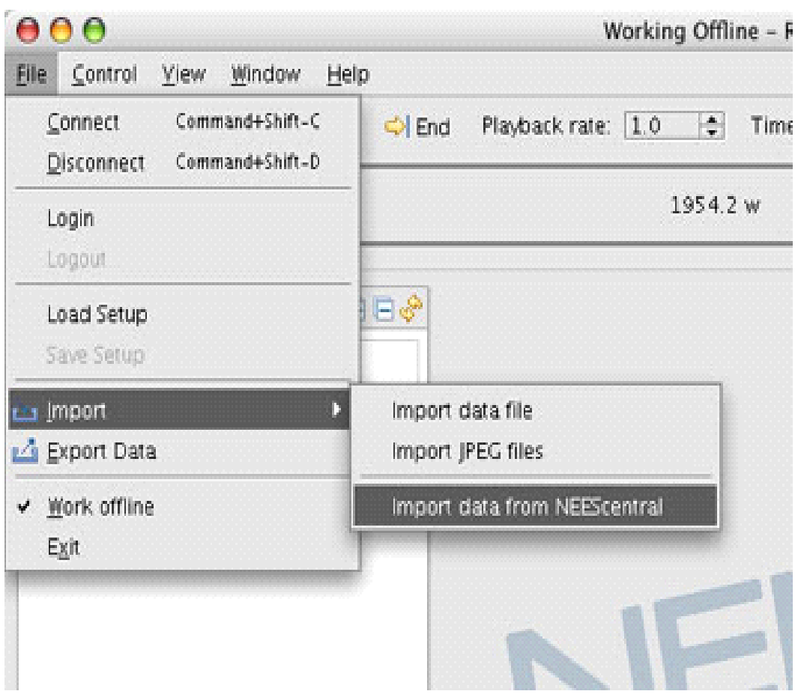

Data files in the format described in [Section 3.6.1](https://ee-stg.neeshub.org/research/dl_detail/rdv_2.0_users_guide/#3.6.1) may be imported from NEEScentral by selecting *Import data from NEEScentral* from the *File* → *Import* menu. The *File* → *Import*menu is only active when *File* → *Work Offline* is checked. If you are not already logged into your NEEScentral account you will be prompted for your username and password. Once you have logged in a file selector window will appear. The top half contains a tree view of all of the NEEScentral projects in which you have membership. Note that loading information from NEEShub can be time consuming; please be patient while data loads.

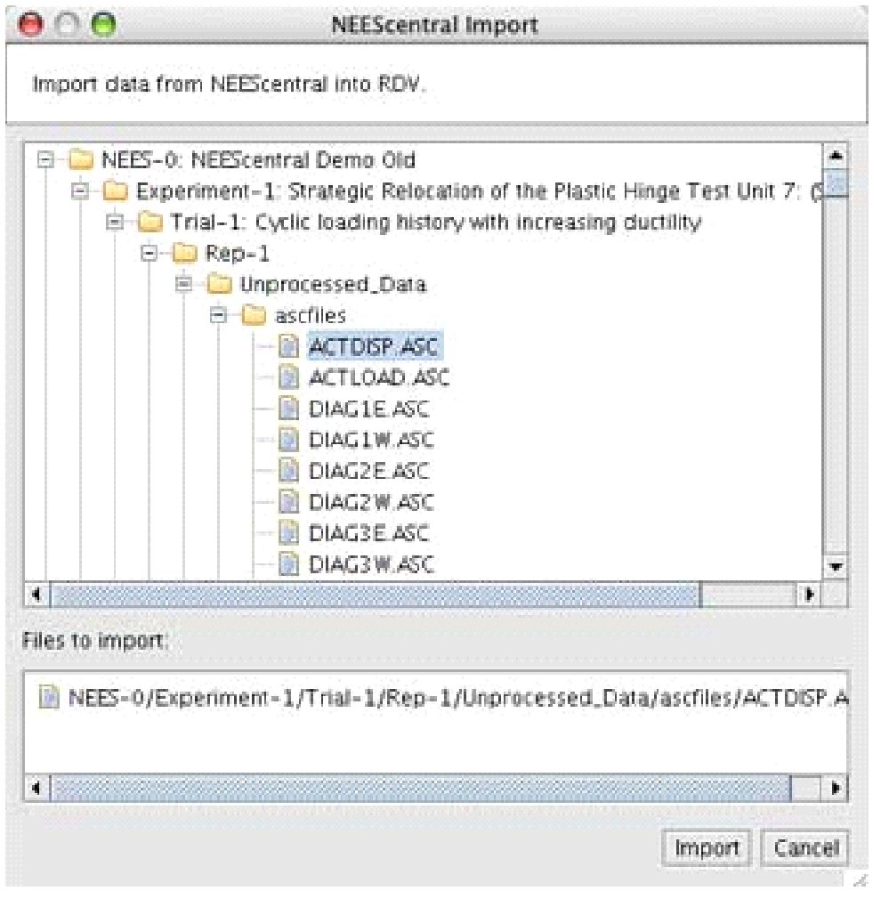

As you navigate the tree you can either double click on data files or drag them to the lower half of the window, labeled *Files to import*, to prepare to load them into RDV. Once you have selected all of the data files you want to load, click the *Import* button.

## Exporting Data

From the file menu, the Export submenu provides two options: ***Export Data*** and ***Export Video***. 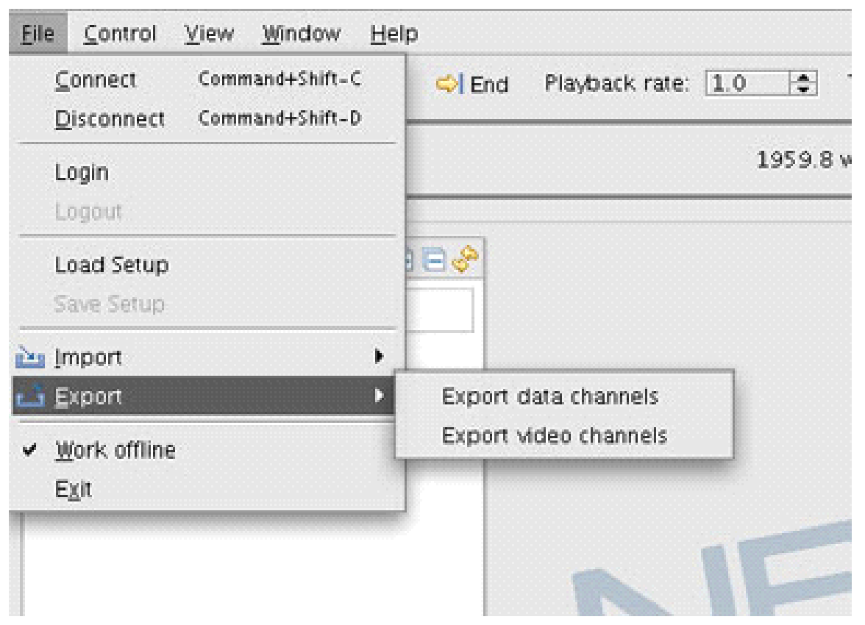

Unlike the Import Data options, these options are available even in offline mode.

The data channels of one or more sources can be exported. Select the name and location of the target file and a text file will be created with the data from the selected RBNB channels. The data format conforms to the standard file format specified in [Section 3.6.1](https://ee-stg.neeshub.org/research/dl_detail/rdv_2.0_users_guide/#3.6.1).

The ***Event Marker*** option can be used to specify the time range for export. The start and end times can be selected by clicking the time range links. If no data is available for a given time, the user will receive an error and be asked to select a different time.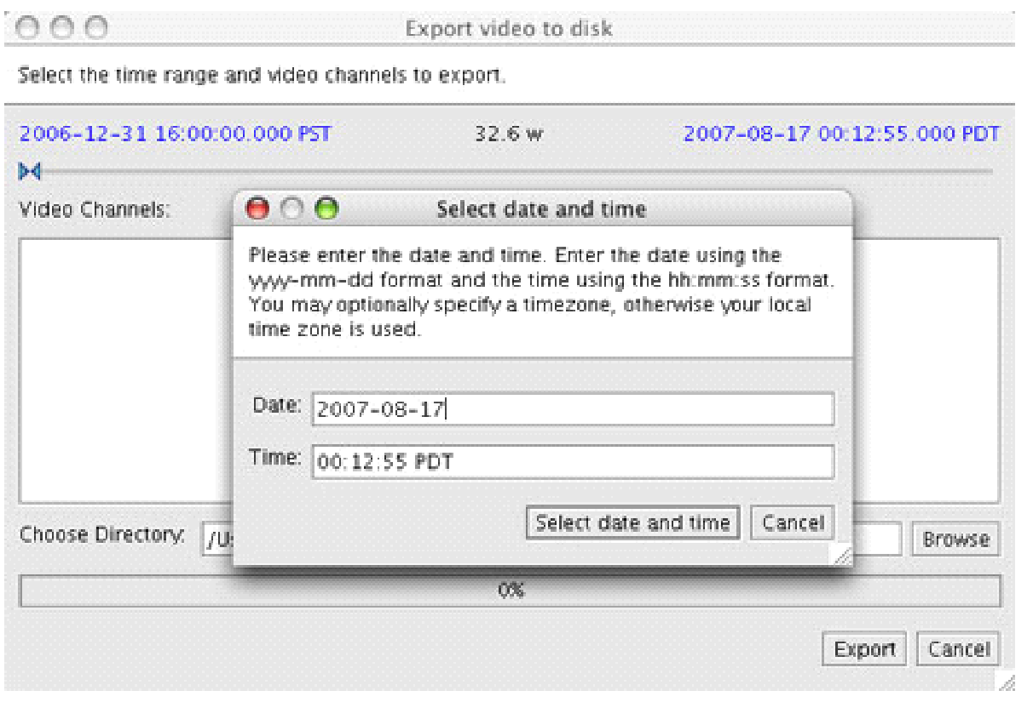

**Exporting Video**

The video channels of any video source can be exported to a local directory. The exported video will be made up of a series of time stamped JPEG files corresponding the frames of the video source. The exported data can be used to import the images back into RDV to reconstruct the original movie. Similar to exporting data, the Event Marker and date time selector are available to specify the period of video to export.

Warning: All images of an exported video are saved in a single directory without a date/time hierarchy. If more than one video channel is selected to export, the JPEG's exported from each video channel will overwrite each other if they have overlapping time stamps. For each time point, the last overlapping JPEG file will copy over the preceding file and the data will effectively be lost.

**Sharing Interfaces during a Test**

Researchers and equipment facilities can create and distribute saved configurations to aid collaborators in quickly loading a synchronized display of data in RDV. The person wishing to distribute a shared interface should first set up RDV in the desired manner, and then use the [*Save Setup*](https://ee-stg.neeshub.org/research/dl_detail/rdv_2.0_users_guide/#saveSetup) command in the ***File*** menu to save the configuration. The *.rdv configuration file that is created can then be emailed or posted on a web page. Collaborators receiving the file should use the [*Load Setup*](https://ee-stg.neeshub.org/research/dl_detail/rdv_2.0_users_guide/#loadSetup) command in the ***File*** menu to load the configuration.

Alternatively, RDV can be launched from the command line with the configuration file's URL supplied as an argument:

$ java -jar RDV.jar http://nees.some-university.edu/config.rdv

Note: ***Save Setup*** is not available when working in offline mode because offline data is purged when RDV quits. When RDV starts again, users must manually import their data before it becomes available.

A setup saved when working in offline mode would result in empty data panels when that setup was reloaded because no data would be available during the restoration process.

# Menu Options

**File Menu**

|  |  |  |
| --- | --- | --- |
| **Option** | **Keyboard Shortcut** | **Description** |
| Connect | ctrl-shift-C (PC) ⌘-shift-C (Mac) | Opens a dialog to specify the name and port number of a Data Turbine server. |
| Disconnect | ctrl-shift-D (PC) ⌘-shift-D (Mac) | Disconnects RDV from the currently connected Data Turbine server. |
| Login | none | Opens a dialog to specify your NEES account username and password, which is the same as used on NEEScentral. |
| Logout | none | Logs you out of your NEES account. |
| Load Setup | none | Retrieves configuration information from a *.rdvfile. |
| Save Setup | none | Saves RDV's current configuration to a *.rdv file. Disabled when working in offline mode. |
| Import → Import data from file | none | Import data from a *.txt, *.zip, *.gz, or *.bz2file stored on the local computer. Available only when *Work offline* is checked. |
| Import → Import JPEG files | none | Import a folder containing sequential time stamped JPEG images stored on the local computer. Available only when *Work offline* is checked. |
| Export → Export Data channels | none | Export data from RBNB, list of channel(s) to be exported. User provides the location and file name for the export. |
| Export → Export Video channels | none | Export video channel(s) to series of JPEG images. User specifies the location to be stored on the local computer. |
| Work offline | none | Use a local Data Turbine server to store data. |
| Exit | none | Exits the RDV application. |

**Control Menu**

|  |  |  |
| --- | --- | --- |
| **Option** | **Keyboard Shortcut** | **Description** |
| Real Time | ctrl-R (PC) ⌘-R (Mac) | View live data. |
| Play | ctrl-P (PC) ⌘-P (Mac) | Play back data at the time, rate, and time scale defined by the sliders. |
| Pause | ctrl-S (PC) ⌘-S (Mac) | Stop playing data. |
| Go to Beginning | ctrl-B (PC) ⌘-B (Mac) | Move to the beginning of the buffer. |
| Go to End | ctrl-E (PC) ⌘-E (Mac) | Move to the end of the buffer. |
| Go to Time | ctrl-T (PC) ⌘-T (Mac) | Jump to a specific point in the buffer. The date and time must be entered relative to the date and time used by the Data Turbine server. The server's current date and time can be ascertained by entering real time mode and consulting the status panel. |
| Update Channel List | F5 (PC/Mac) | Query the Data Turbine server for a list of channels. |
| Drop Data | none | Used only when viewing data from the buffer. Does not apply when viewing data in real-time mode.  **Checked**  If necessary, RDV drops data to keep up with the rate specified by the "Playback Rate" slider.  **Unchecked**  RDV displays all data but, if necessary, may show it at a rate slower than that specified by the "Playback Rate" slider. |

**View Menu**

|  |  |  |
| --- | --- | --- |
| **Option** | **Keyboard Shortcut** | **Description** |
| Show Channels | none | Toggles between showing and hiding the channel list. |
| Show Properties | none | Toggles between showing and hiding the properties window. |
| Show Control Panel | none | Toggles between showing and hiding the control panel. |
| Show Audio Player | ctrl-A | Toggles showing and hiding the audio panel. This is a small panel above the Marker panel with a simple text box for entering the URL of an audio stream, as well as a play/pause button. |
| Show Marker Panel | none | Toggles between showing and hiding the event marker panel. |
| Show Hidden Channels | ctrl-H (PC) | Toggles between showing and hiding hidden channels in the channel list. |
| Hide time with no data | none | Only the times between a start and a stop marker are shown on the timeline. All other periods of time are hidden from view.  See [section 4.5](https://ee-stg.neeshub.org/research/dl_detail/rdv_2.0_users_guide/#4.5) to learn more about event markers. |
| Full Screen | F11 | Causes the RDV window to expand to fill your monitor.  Note: This item does not work on Mac OS X. |

**Window Menu**

|  |  |  |
| --- | --- | --- |
| **Option** | **Window Shortcut** | **Description** |
| Add Video/Photo Data Panel | none | Creates an empty window for video or still image data. Populate the window by dragging a video or still image channel from the channel list onto the video/photo window. |
| Add Time Series Data Panel | none | Creates an empty plot for numerical time series data. Populate the window by dragging numerical channels from the channel list onto the time series plot. |
| Add XY Data Panel | none | Creates an empty plot for numerical XY data. Populate the window by dragging two numerical channels from the channel list onto the XY data panel. The first channel you drag is assigned to the X axis and the second is assigned to the Y axis. |
| Add Tabular Data Panel | none | Creates an empty table for numerical time series data. Populate the window by dragging numerical channels from the channel list onto the table. |
| Add Text Data Panel | none | Creates an empty window for text data. Populate the window by dragging a text channel from the channel list onto the text window. |
| Add Web Data Panel | none | Creates an empty window for HTML web pages. Populate the window by typing a URL into the address bar and clicking the *Go* button. |
| Close all data panels | none | Closes all video/photo, time series, XY, tabular, text, and event marker data panels. |
| Arrange **→**Horizontal Data Panel Orientation | none | Arranges data windows to maximize their area horizontally.  Note: This menu option is only useful when there are exactly two open data windows of any type. |
| Arrange **→**Vertical Data Panel Orientation | none | Arranges data windows to maximize their area vertically.  Note: This menu option is only useful when there are exactly two open data windows of any type. |

**Help Menu**

|  |  |  |
| --- | --- | --- |
| **Option** | **Keyboard Shortcut** | **Description** |
| RDV Help | F1 (PC) | Opens a link to the RDV user’s guide in a new browser window. Note: This item does not work on Mac OS X. |
| RDV Support | none | Opens a link to NEEScomm IT support page in a new browser window. Note: This item does not work on Mac OS X. |
| Release Notes | none | Opens a link to the RDV release notes in a new browser window. Note: This item does not work on Mac OS X. |
| About RDV | none | Displays information about RDV. |

# Obtaining the Source Code

The source code for RDV is freely available from NEEScomm IT Subversion code repository.

<https://nees.org/tools/rdv/wiki>

The last stable release is in the branches directory, while the latest developments are available in the trunk directory. RDV Source code is also hosted at Google Code.

<http://rdv.googlecode.com/svn>