First of all, I wrote a c code to convert mips. Because I thought If I make a code, My job will be easier.

To take input, at the beginning, I try to take array size but we have constraint in assignment pdf.

To make this constraint, I use 2 instructions. These are nested. First instruction is branch less equal (ble) and other one is branch greater equal (bge). If ble is false it goes first condition. If bge is false it goes firstCondition. Thanks to this, I made something like a loop.

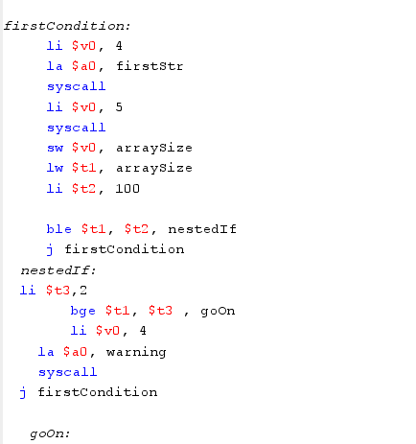

In above Picture. We got size of array. Second input is our divisible part. I did the same thing above.

If ble is false it goes goOn. If bge is false it goes goOn. Thanks to this, I made something like a loop.

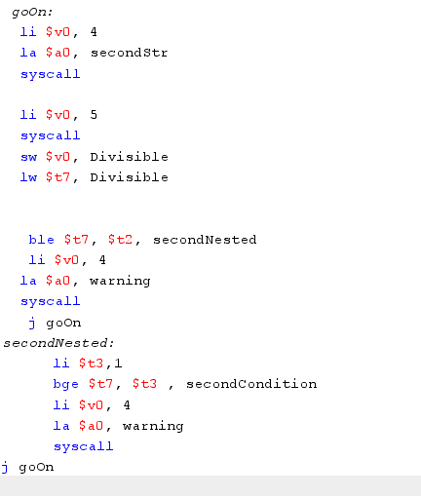

The last part there is a loop and 2 nested instructions to take elements of array

metin içeren bir resim

Açıklama otomatik olarak oluşturuldu