CA4003 - Compiler Construction
Assignment 1:
Lexical and Syntax Analyser for CCAL Language

Name: Alexander Cahill
Student Number: 15321711

Section 1: Options
This section only has one option set, declaring that the language will not be case sensitive.
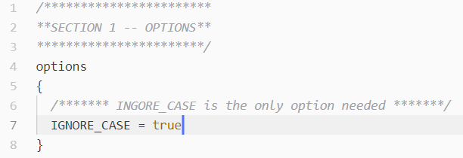

Section 2: User Code
This section initialises the reading of the input files, the input files can be either read in as a command line argument or if no file is supplied as a command line argument then it can be read from standard input.
If the specified file cannot be found or the user does not enter a file then the user will be shown how to use the program.
The program will also tell the user if the input has been successfully parsed or if an error has occured.

Section 3: Token Definitions
In this section tokens that can be consumed by the parser are defined.
Whitespace, tabs, newlines and return carriages are all skipped by the parser along with comments denoted by “//” for single line comments or “/* */” for multi-line comments.
As shown by the code snippet below, nested comments are dealt with by having a counter that is incremented whenever the parser meets a “/*” and decremented when it meets a “*/”.
“commentsNestLvl” is an integer defined earlier in section 3.
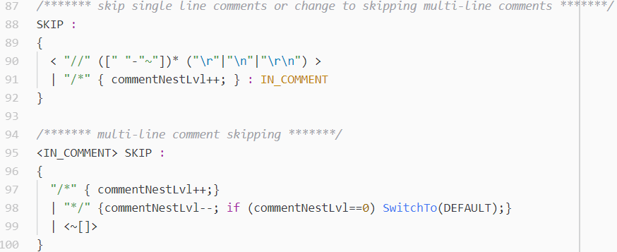

Section 4: The Grammar
As I started implementing the production rules as described in the CCAL Language documentation (CCAl.pdf), this caused Left Recursion errors and choice conflicts within my grammar.

In the examples below I will show how I dealt with these problems by using both refactoring of the code and by using lookaheads.

