CA4003 Assignment 2
Alexander Cahill – 15321711
Declaration of Plagarism:

Abstract Syntax Tree
The first step that I took towards creating my Abstract Syntax Tree (AST) was to refactor my previous definition for an <ID> token to be a funcntion, “idt()” and to start adding decorators for simpler production rules that I thought wouldnt need much refactoring in the future or only had 1 child for example the rules for main, declarations, numbers and type.
Straight away this allowed me to see what tokens my parser was taking in and in what order.
Below you can see this demonstrated, after decorating the declaration rule “decl()” with #Decl and the variable declaration rule “VarDecl()” with #VarDecl(2).
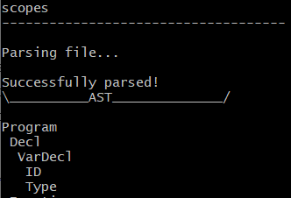
This visual representation of the AST also helped me to wrap my head around how many child nodes to define for each decorator thanks to the indentation.
Despite this help I still had some problems with my AST but this is mostly down to how I wrote the grammar. The main problem I had was “if … else ...” statements being recognised as function calls.
The code snippet below and resulting AST demonstrates this.
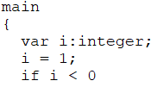
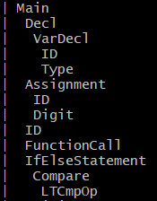

Symbol Table
After working through the AST as best I could I started on the Symbol Table(ST).
I decided to implement the ST as a hashstable as most of the resources I found online showed implemented them in this way and also due to it’s efficiency(with O(1) complexity for insertions and retrievals).
Initially I started with 2 methods for the Symbol Table object; insert() and printST(). This was so I could see if the scopes were being properly tacked by the parser and inserted correctly into the table.
The insert function takes in: id- the name of the token.
type – the type of token.
val – the value of the token(“func”, “var”, “const”).
scope – what the scope of the token is.
The scope for each variable is passed along with it when it is being inserted into the ST. By default the “scope” string variable is set to “global”, when a main or function is encountered, “scope” is changed to reflect that. The following code snippet demonstrates how this happens, the updating of the scope and insertion into the table.
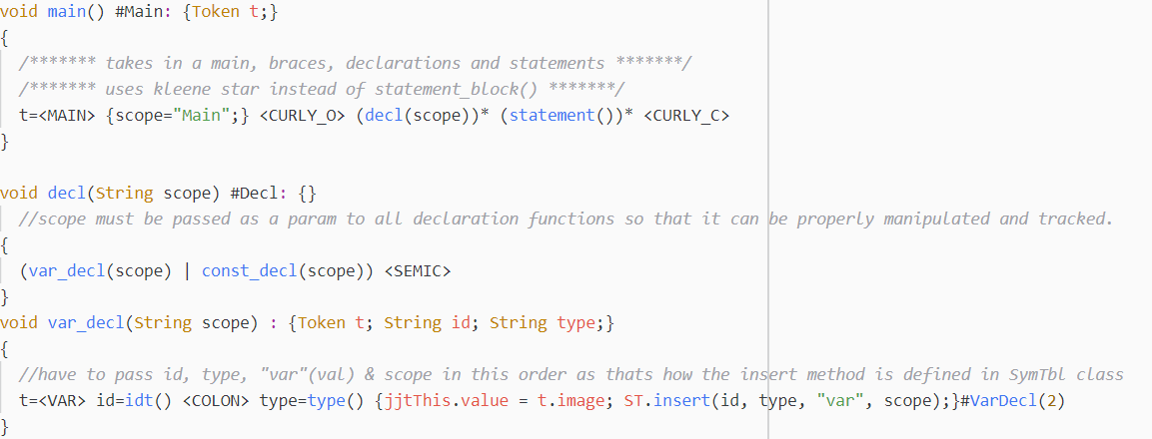
This allows for proper tracking of scope across the program.

Semantic Checks

Three Address Code

