** This document contains the general outline that you should adopt for your Functional Specification **
Multi-User Boids Game
Alexander Cahill – 15321711
Liam Ó Cearbhaill - 15384941
Functional Specification Contents

0. Table of contents
A table of contents with page numbers indicated for all sections / headings should be included.

1. Introduction
  - Overview
Provides a brief overview of the system / product to be developed. It should include a description of the need for the system, briefly describe its functions and explain how it will work with other systems (if appropriate).
The system to be developed is a multi-user game with boids making up the main component the users interact with. The aim of the game is to chase flocks of boids from your screen/environment to the other player’s screen/environment.

Users will access the game through their web browser and be connected to each other through a web-socket server. The server will host the source code for the game and the client’s (user’s) machine will be responsible for rendering the graphics, namely the environment and the boids.
No rendering will take place server-side. The sever is responsible for connecting the clients and listening for relevant messages from the clients.
Clients will send a message when a boid from their environment crosses the boundary to their opponent’s environment. This is the main message the server is listening for, after it receives one, it will tell the other client that a boids has crossed over and that it needs to take responsibility for its rendering.

This client -> server -> client interaction will be the crux of the system.

  - Business Context
Provides an overview of the business organization sponsoring the development of this system / product or in which the system / product will / could be deployed. Note - may not be applicable to all projects

  - Glossary
Define and technical terms used in this document. Only include those with which the reader may not be familiar.

2. General Description
2.1 Product / System Functions
Describes the general functionality of the system / product.

2.2 User Characteristics and Objectives
Describes the features of the user community, including their expected expertise with software systems and the application domain. Explain the objectives and requirements for the system from the user's perspective. It may include a "wish list" of desirable characteristics, along with more feasible solutions that are in line with the business objectives.
Many of the user community will be other students in DCU and examiners. We anticipate that they will be able to access the game using either their own pc/tablet or a lab machine. A low level of technical expertise will be required to access and play the game but a short explanation of how to play and how it works will be included on the site.

2.3 Operational Scenarios
This section should describe a set of scenarios that illustrate, from the user's perspective, what will be experienced when utilizing the system under various situations.
In the article Inquiry-Based Requirements Analysis (IEEE Software, March 1994), scenarios are defined as follows:
In the broad sense, a scenario is simply a proposed specific use of the system. More specifically, a scenario is a description of one or more end-to-end transactions involving the required system and its environment. Scenarios can be documented in different ways, depending up on the level of detail needed. The simplest form is a use case, which consists merely of a short description with a number attached. More detailed forms are called scripts.
2.4 Constraints
Lists general constraints placed upon the design team, including speed requirements, industry protocols, hardware platforms, and so forth.

Performance: One of the constraints we may have is the capacity of the users to render the graphics. Since all the rendering will be done client side we cannot fully anticipate the hardware the capabilities of the users. To tackle this, we will decide on an assumed baseline of computing power similar to or slightly less than the lab machines.
Our aim is to achieve stable rendering for these machines firstly then work on optimisation for lower spec devices (such as tablets or smartphones).

The servers’ capability to listen for messages from the clients may be a constraint, depending on where we decide to host it and the optimisation of our code. The server will have to recognise relevant messages and deliver them to the client in a timely fashion so that there is little or no noticeable latency. We hope to alleviate some of the latency issues by using an AWS EC2 instance as their reliability and speed is reputable.

Game Design: One of worries is that we spend too much time designing and implementing the game rules. If they are too complicated we may sucked into trying to get them to work rather than focusing on the functionality of the system. To overcome this we plan to implement a simple set of mechanics; that the users must chase they boids from their environment to their opponent’s and that after 90 seconds the user with the most boids on their screen loses. After we meet this baseline we can start added more complexity such as different types of boids/animals or changing environment types.

Time: The timeline is an obvious constraint that we are aware of, as we have winter and summer exams concious of balancing study, other project work and work on our final year project.

3. Functional Requirements
This section lists the functional requirements in ranked order. Functional requirements describe the possible effects of a software system, in other words, what the system must accomplish. Other kinds of requirements (such as interface requirements, performance requirements, or reliability requirements) describe how the system accomplishes its functional requirements.

As an example, each functional requirement could be specified in a format similar to the following:
- Description - A full description of the requirement.
- Criticality - Describes how essential this requirement is to the overall system.
- Technical issues - Describes any design or implementation issues involved in satisfying this requirement.
- Dependencies with other requirements - Describes interactions with other requirements.
- Others as appropriate
Web Socket Server
Description – The web socket server is the central part of the system that facilitates communication between the clients. It listens out for messages from clients telling the server that a boid has crossed over a border to outside of their environment. The client will have to send the coordinates (x, y, z) to the server, which will then send these coordinated to the other client.

Criticality – Very Important. This component of the system is critical to its functioning as the project is multiplayer focused and depends on bi-directional communication between the server and clients.

Technical Issues – A technical issue we may run into is the amount of messages the server can handle and process on time.

Dependencies with other requirements – Much of the other components on the system rely on the server’s functionality, namely the users’ ability to access the game and the clients’ ability to communicate with each other so that crossovers to and from environments are properly rendered.
Others as appropriate – TODO
Boids Algorithm
Description – The boids algorithm describes the movement of the flocks to be rendered in the clients’ environments. The algorithm is an artificial life algorithm and mimics the flocking behaviour of animals (like birds). The boids will have to be able to flock towards a common heading as a group. Individual boids will have to be able to join large flocks as they encounter them. They will also have to be able to avoid obstacles, in the case of the game this will be some of the walls of a clients’ environment and a client’s cursor.

Criticality – Very Important. This component of the system is critical to its functioning as it is a central aspect of the game and the flock’s movement

Technical Issues – TODO

Dependencies with other requirements – TODO

Others as appropriate – TODO
Graphical Rendering
Description – The boids will modelled using JavaScript and the Three.js external library. They will be 3D entities whose behaviour is controlled by the boids algorithm and rendered by the clients in their respective environment.

Criticality – Very Important. The graphical rendering of the boids is also critical to the functionality of the game. Without the rendering the users will have nothing to interact with.

Technical Issues – The graphical rendering may present some technical issues to us depending on the computing power of the clients. There may up to a couple of dozen boids required to be rendered in each of the clients’ environments at any one time. If the rendering is not stable enough we will have to do optimisation of the rendering by decreasing the polygons and quality of the modelling of the boids. Way may also have to limit the number of boids that spawn throughout the game.

Dependencies with other requirements – TODO

Others as appropriate – TODO

4. System Architecture
This section describes a high-level overview of the anticipated system architecture showing the distribution functions across (potential) system modules. Architectural components that are reused or 3rd party should be highlighted.
The only 3rd party architectural components we plan to utilise will be an AWS EC2 instance to host the server code.
We do not plan to use any other AWS tools, nor do we plan to use any AWS tools to create the operational logic.

HAVE TO PUT IN SOME SYS ARCH DIAGRAMS IN HERE

5. High-Level Design
This section should set out the high-level design of the system. It should include one or more system models showing the relationship between system components and the systems and its environment. These might be object-models, DFD, etc.

The below system architecture diagram shows the interaction between the clients and servers as described in the overview. The AWS EC2 instance will simply be used for hosting the code.
The diagram shows how the users will use their browsers to access the game through their pc/tablet and how the server will listen and send relevant messages between them.
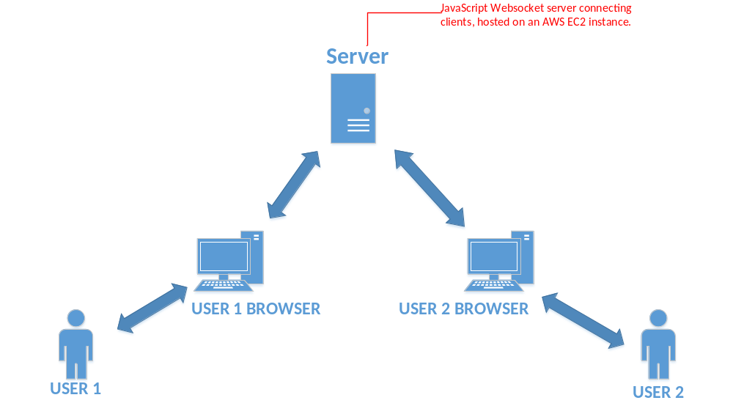

6. Preliminary Schedule
This section provides an initial version of the project plan, including the major tasks to be accomplished, their interdependencies, and their tentative start/stop dates. The plan also includes information on hardware, software, and wetware resource requirements. The project plan should be accompanied by one or more PERT or GANTT charts.

7. Appendices
Specifies other useful information for understanding the requirements.

