**CLIENT SIDE MODULE**

# CONTENTS

## This module has the following files:

1. MODULE_CLIENT_SIDE.doc
2. MODULE_CLIENT_SIDE_MEDIA.zip

INTRODUCTION

You are asked to develop a game called **Virus Slayer** using HTML and CSS and develop client-side programming using JavaScript. Some media files are available to you in a zip file. You can create more media and modify anything in the media if you want. Your game needs to be developed in a tablet resolution (960x600 pixels). In bigger resolution, the game must be centred in the screen both horizontally and vertically.

# DESCRIPTION OF PROJECTS AND TASKS

This is a module of 3 hours. Your first 1 hours must be used to create the design of the game in three PNG images and the initial layout using HTML/CSS. Your layout should follow the design that you created. The final 2 hours you will create the functionality of the game using JavaScript that allows the game to work correctly in different web browsers.

**Piano** game screen should have meet these requirements below:

1. Game title
2. 4 lane block
3. Vaccine keys in the bottom
4. Danger area
5. A border between keys and lane
6. Total time elapsed
7. Total score
8. Timer
9. Player Name
10. Random Moving Virus

**Design and Initial layout**

1. **Deliver at least 3 PNG images that present:**
   1. Game instruction: The first screen of the game presents the game icon, instructions of gameplay, a field for input username, and the Play button.
   2. Game screen: It must present all the elements described above in the game screen.
   3. Game icon which represents the game immediately.
2. **Develop the initial markup (HTML + CSS) of your game application.** Overall screen must be within 1024x1024 pixels and centered on the screen.
3. **You are free to decorate** the game screen design as long as it meets the requirements.
4. **The HTML and CSS** code must be valid in the W3C standards for HTML5 and CSS3 rules in accordance with the WCAG and standard ARIA (Accessible Rich Internet Applications Suite)

**Game functionalities**

1. **Show the game icon** as a favicon.
2. **Show game instruction** in the centre after page are loaded.
3. **Player can start game** after fill username fielld and click “Play” button at the bottom of game instruction.
4. **The “Play” button should be disabled** if the user did not input username.
5. **Show countdown for three seconds in the center of screen** after user clicked the play button before the game started playing.
6. **Virus should move and hit** the border at the exact given time.
7. **Virus should show random** in 4 block every 1 second.
8. **To click the keys**, player can use “DFJK” keys with the following (from the left key):
   1. ‘D’ for the first key
   2. ‘F’ for the second key
   3. ‘J’ for the third key
   4. ‘K’ for the fourth key
9. **The score will be increased** if player click the keys when the virus is in the danger area.
10. **Score** is served from total virus after being destroyed.
11. **Fail** is served from total virus that is not destroyed when in the danger area
12. **The virus will be vanished** when player clicked at the right timing or it passed the border without clicked.
13. **Lights appeared above the border** when player clicked the key. The light should be appeared which is a gradient from transparent to solid color vertically. The light is located above the border which the key is clicked.
14. **Game Over** if the fail score has reached 5.
15. **Show alert after game over** to display the player username, time, score and restart button.
16. **Maintain your HTML/CSS and JavaScript code organized and clean to facilitate future maintenance**. Use correct indentation and comments. Use meaningful variable names and document your code as much as possible so another developer would be able to modify your work in the future.
17. The game needs to work correctly in **Google Chrome** and **Mozilla Firefox.**
18. **Player can pause** the game
19. **Press Esc** to open the pause popup. The game should be in paused state when opening the popup.
20. **Press Esc again** to continue or click the continue button.
21. **Restart button is exists in the popup** for user to restart the game.
22. **Display countdown from 3 at the center of screen** before playing after user continue or restart the game.

**Example**

These following images are for example purpose only. You may design your own game layout.

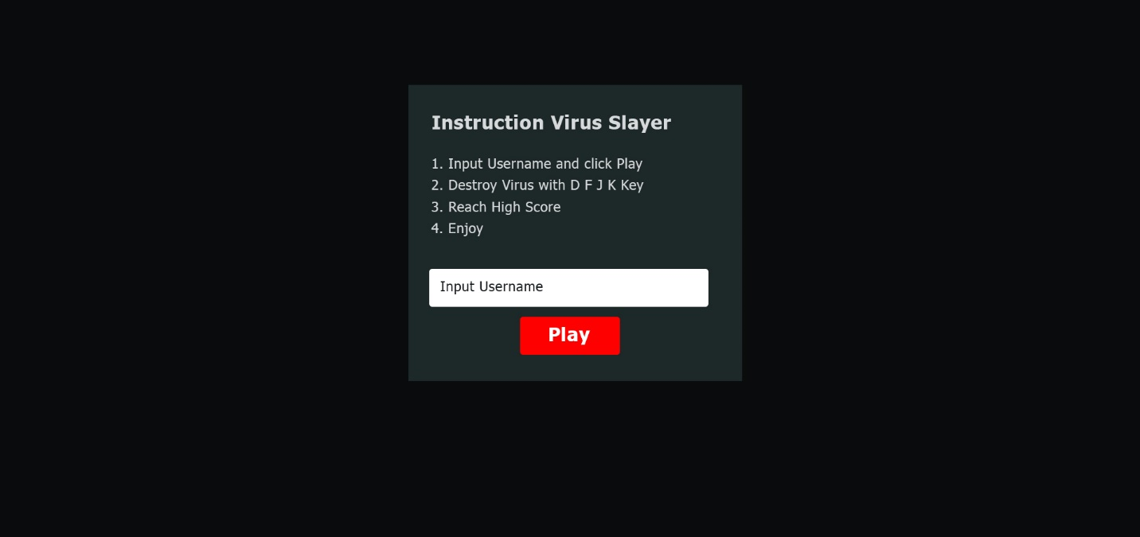

*Figure 1 Instruction Example*

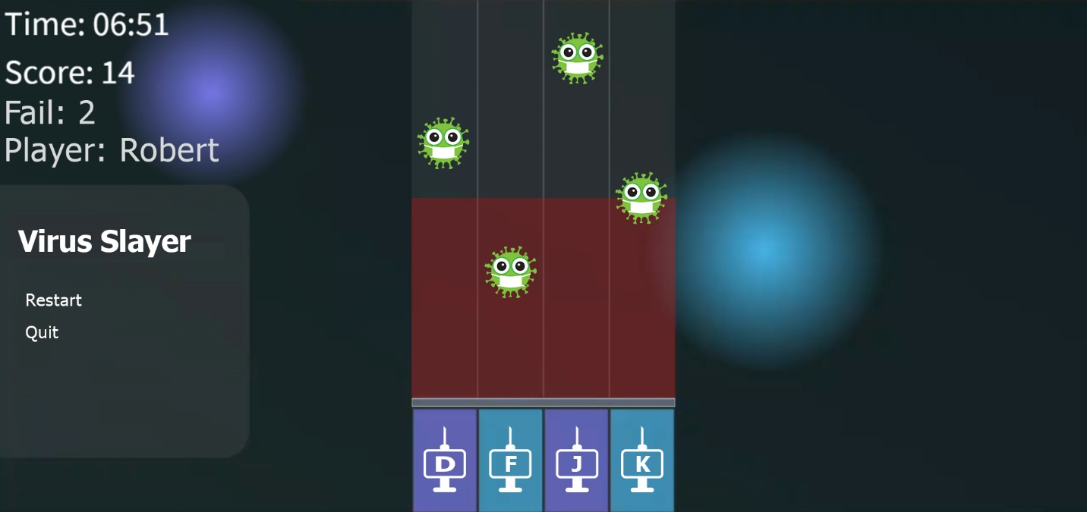

*Figure 2 Gameplay Example*

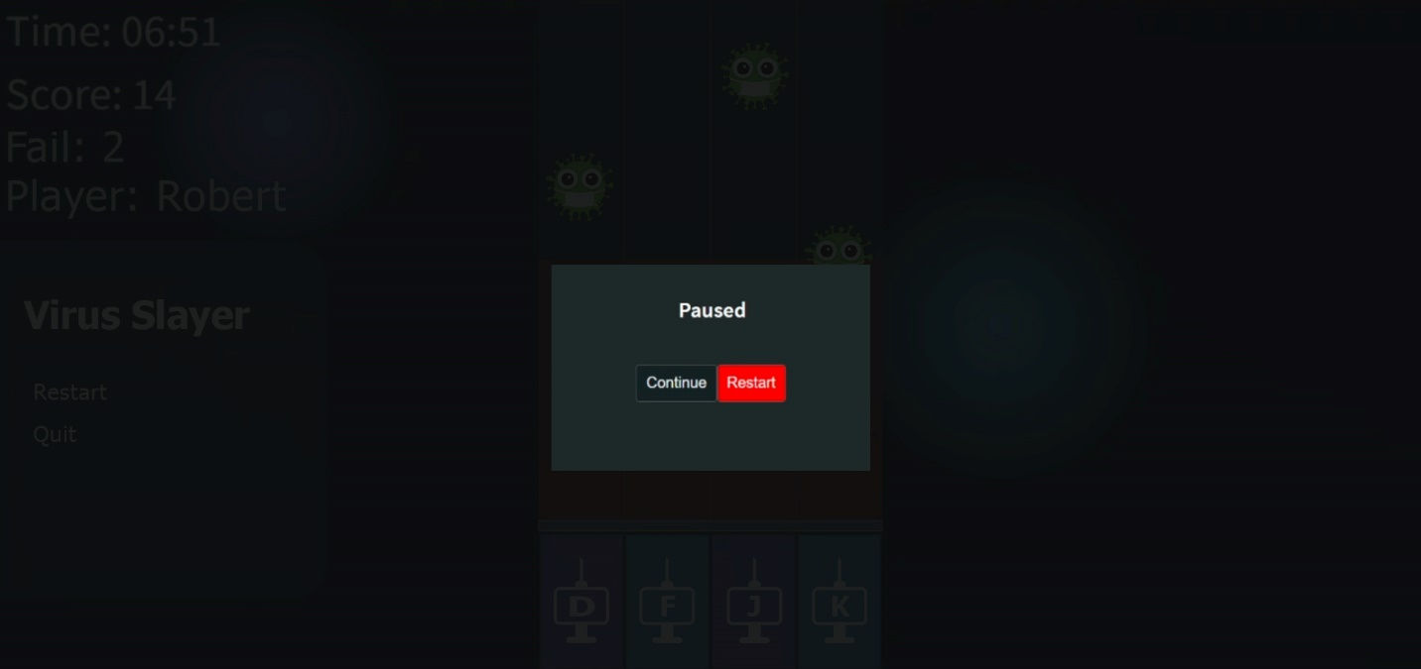

*Figure 3 Pause Example*

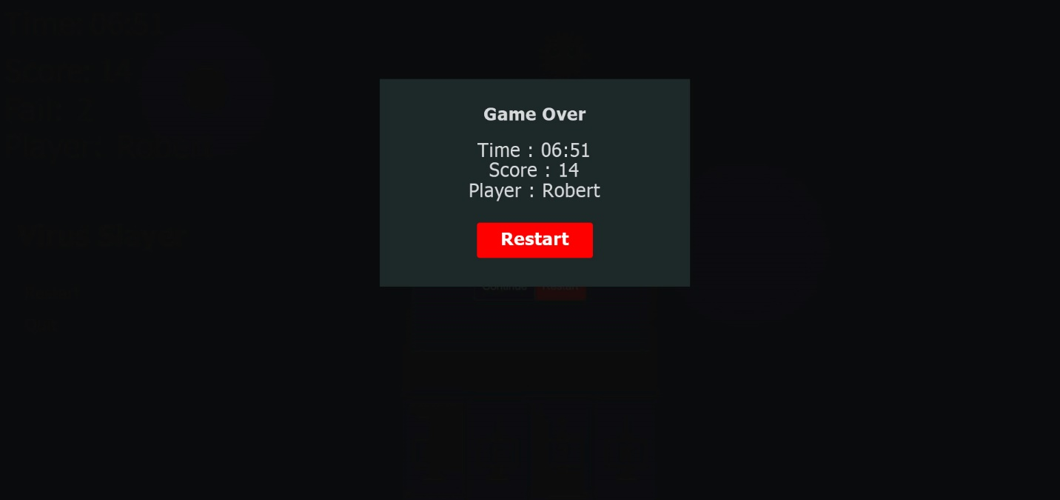

*Figure 4 Restart Example*

# INSTRUCTION FOR COMPETITORS

1. The media files are available in the ZIP file. You can modify the supplied files and create new media files to ensure the correct functionality and improve the application.
2. Save your design files in a folder called "**XX_module_client_side/design**".
3. The entry file should be ‘**XX_module_client_side /index.html’**
4. You should create additional images for each of the requested resolutions to highlight hidden elements, animations, interactions, or any additional information that will assist in the presentation of the game design.
5. Save the working game to the directory on the server named " **XX_module_client_side**". Be sure that your main file is called index.html.
6. You are responsible for the time management in your development. If you finalize some tasks you can continue to other tasks.

Note : **XX** is competitor number.