<https://iraq-visa.com/faq>

Please remove this button

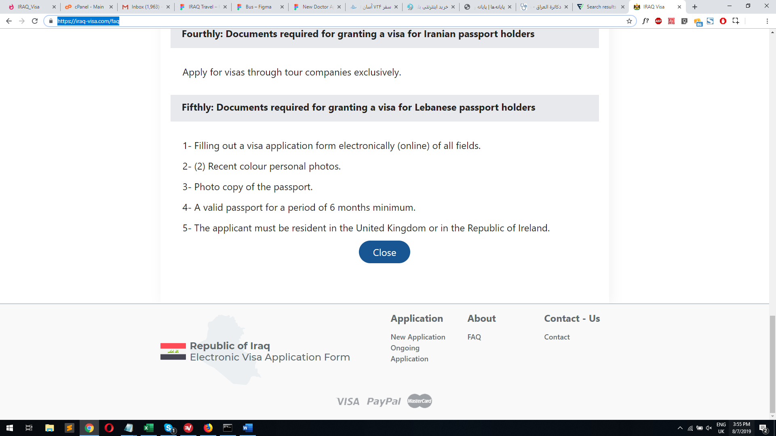

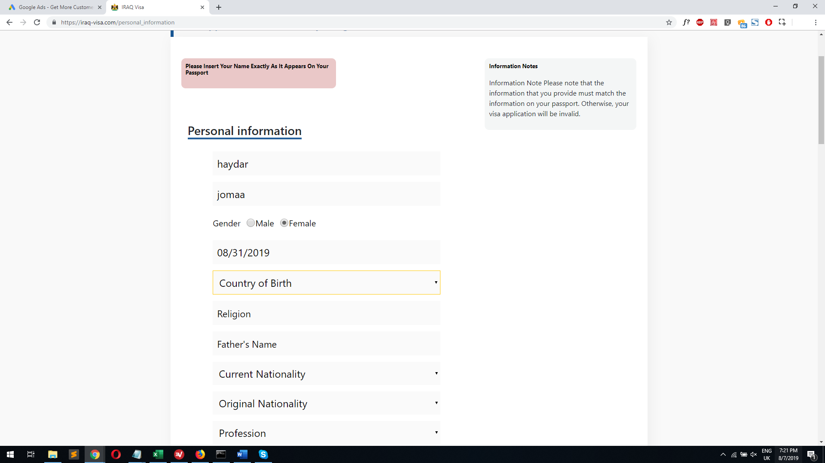  
Same with current nationality and original nationality and passport issue country

As mentioned This need to list the countries and can be typed for autofill

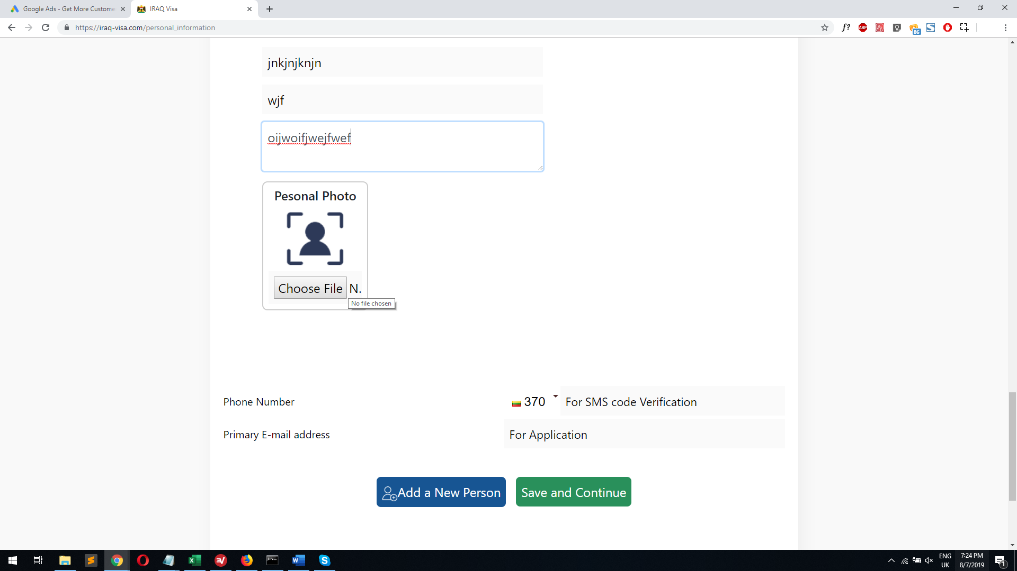

Larger Flag and default country Is USA

Remove N.