Project Proposal:

Inventory Management System
  - Team members: Christopher Ibarra & Salvador Rodriguez
GitHub URL: https://github.com/caibarra5/Group2_CSCE5350_FA26

Problem & Users
The database system will store data about inventory and orders. It will be used by any business that sells goods.

Main Information
These entities are the main types of information the database needs to remember to effectively provide customers with products.

Inventory
For the entire system to know what we have to sell, the Inventory entity will hold this information:
- Product Name
- Product Amount
- Category
- Consumable
- Expiration Date

Customer
The customer that makes the purchase must have the following so they can receive their product:
- Customer ID
- Name
- Email
- Phone number
- Shipping address

Provider
To know where we get information, the Provider entity has this information:
- Provider Name
- Product Name (what they sell)

Customer Order
The customer makes Customer Orders that include this information so they can get their product:
- Customer ID
- Order ID
- Product Name
- Product Amount

Retailer Shipment
To satisfy the customer order, the Retailer Shipment entity has this information:
- Customer ID
- Order ID
- Shipping Address
- Product Name
- Date of Arrival

Retailer Order
The Inventory must restock itself and to do so, the Retailer Order entity needs to have:
- Provider Name
- Order ID
- Product Name
- Product Amount

Provider Shipment
To keep a paper trail, the Provider Shipment entity has this information stored:
- Provider Name
- Order ID
- Product Name
- Product Amount
- Date of Arrival

Main Operations
- Updating the quantity in stock of a product.
- Updating the status of an individual unit of a product as shipped or in stock.
- Updating the status of an order such as unit reserved, unit ready to be shipped, unit in transit, etc.

Questions & Reports
If the database can answer these questions, it is complete:
- How much stock do we have?
- When is the next shipment coming in?
- What orders are we shipping?
- Which stock is expiring soon?
- Who provides what stock?
- What do we need to order?

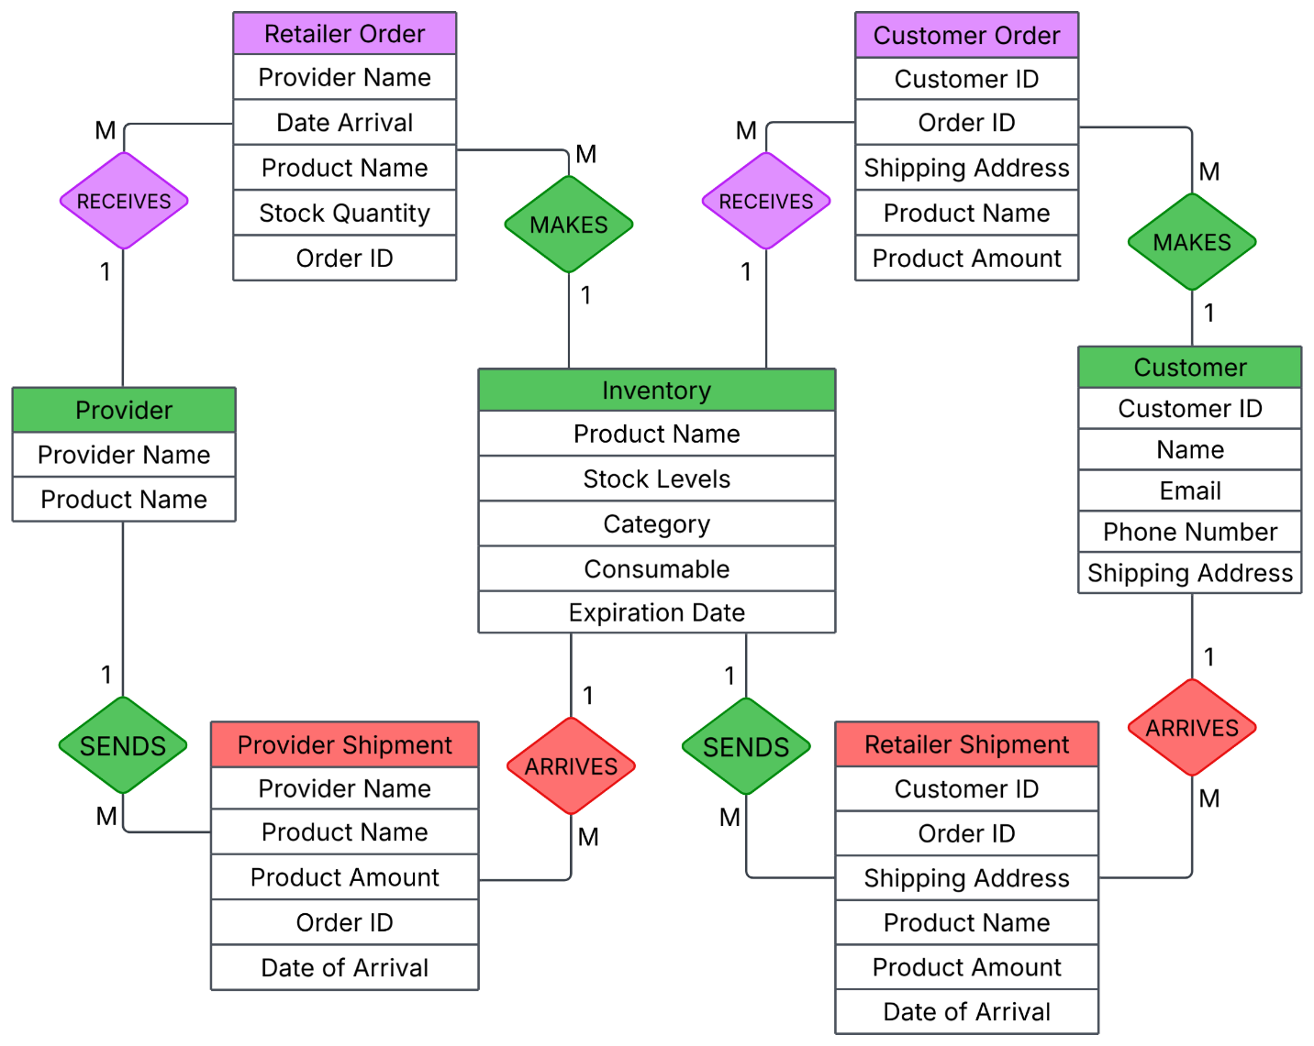
Preliminary ER Diagram

Business Rule
An important rule for our inventory and order system is that an individual unit of a product cannot be reserved for shipping to more than one customer at a time.

Planned Tools
Database System: PostgreSQL
Interface Language: PHP, Python, HTML, CSS, JavaScript
Environment: Web-based

Next Steps

Member | Task
Salvador | Make a finalized version of the ER diagram.
Chris | Create a relational schema from the ER diagram.
Chris & Salvador | Create an initial database in PostgreSQL and at least the empty tables with tentative attributes.

