多通道校准方法：

Hi Abama,

HF compensation corrections are applied in |Z| and Angle form. The |Z| correction is derived from the 100R resistor. The Angle (Theta) correction is derived from the 100pF capacitor.

***********************************************************************************

|Z| correction:

It is assumed that for the resistor, |Z| is constant over the frequency range.

Method

1) Measure |Z| of the resistor at 10kHz = Zref

2) Measure |Z| of the resistor at other frequencies (f) = Zhf(f)

Correction factor Zc at f = Zhf(f)/Zref e.g if Zref = 100 and Zhf(f) = 111 , Zc(f) = 1.11

Apply this to the measured value Zm to give the displayed reading Zd

Zd = Zm / Zc(f)

Note: these are all magnitudes.

***********************************************************************************

***********************************************************************************

Theta correction:

It is assumed that for the capacitor, the D value is a constant (0.0005) over the frequency range.

Method

1) At frequency 'f', convert 'D' to angle  = Theta_ref(f)

2) Measure the actual angle at 'f' = Theta_hf(f)

Correction factor 'Theta_c' at f = Theta_hf(f) -Theta_ref(f)  e.g  Theta_ref = 0.0005 rads and Theta_hf(f) = 0.01 , Theta_c(f) = 0.0095 rads

Apply this to the measured value 'Theta_m(f)' to give the displayed reading Theta_d(f)

Theta_d(f) = Theta_m(f) - Theta_c(f)

***********************************************************************************

Note: If the fixture has quite large residual impedances, i.e if the untrimmed o/c and s/c values are large, then applying these corrections is likely to change the o/c and s/c trim values. It is a case of try it and see what happens.

Best Regards,

Ian

**From:** Abama Cai [<mailto:abama.cai@waynekerr.net>]   
**Sent:** 23 November 2016 12:54  
**To:** Ian Page  
**Subject:** RE: multi-channel switch box calibration

Hi  Ian,

We have build the scanner system like picture blow, I want to do calibration or compensation for each channel.

I already can do the golden sample load for single frequency test.

I want it can take measurement for high frequency maybe it can work upto 10MHz.

As mentioned last email, how can I Use 100R 100F impedance value to calculate the DUT value.,

Best regards,

Abama

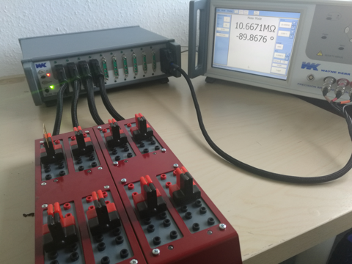

Sent from [Mail](https://go.microsoft.com/fwlink/?LinkId=550986) for Windows 10

**From:** [Ian Page](mailto:Ian.Page@wayne-kerr.co.uk)  
**Sent:** 2016年11月23日 20:43  
**To:** ['Abama Cai'](mailto:abama.cai@waynekerr.net)  
**Subject:** RE: multi-channel switch box calibration

Hi Abama,

I'm not sure if this is the same as you are suggesting but we have been working on a cal box to replace the existing design. See attached photo. This is temperature controlled, it can be controlled via the front panel or via USB. It has all the existing cal box standard values (except the inductors) plus some transfer standards. The calibrated values are displayed on the front panel. It is mounted in a 4300 case which makes it easily transportable.

We have one working unit but it still needs work on it before it becomes a usable product. At the moment we only work part-time on this because of other work we need to do.

Best Regards,

Ian

**From:** Abama Cai [<mailto:abama.cai@waynekerr.net>]   
**Sent:** 23 November 2016 08:53  
**To:** Ian Page  
**Subject:** multi-channel switch box calibration

Hi Ian,

We build a switch box for6440 6500 and the future will support 5400.

My idea is: make one switch box can work frequency up to 10MHz.

I have write a program with load Compensation (Golden sample), just support single test frequency.

If I want to do something like 6500 with 100R and 100PF Compensation frequency to 10MHz for each channel , I don’t know how to use these values(Z100R Z100p) to calculate Zdut. And which frequency need to do compensation.

Thanks for your help.

Best Regards.

Abama

Sent from [Mail](https://go.microsoft.com/fwlink/?LinkId=550986) for Windows 10