Hi Jurgen

Thanks for your work. Since the boards and other parts delay,  I think I have time to write some code with the PIC Usb demo board.

<http://www.microchip.com/DevelopmentTools/ProductDetails.aspx?PartNO=dm320003-2>

In the future, I plan change RS232 to USB, because RS232 works quit slow and It is not good for multi thread programing with the nature QT serial port control.

By the way, today I go to customer side, to check the every detail of the product, need to do test. Actually they test 3 small inductors of impedance(Z),

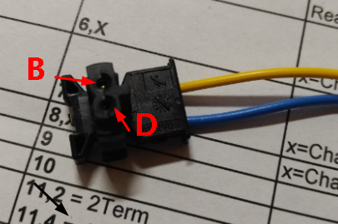

Figure 1 Bottom Test points

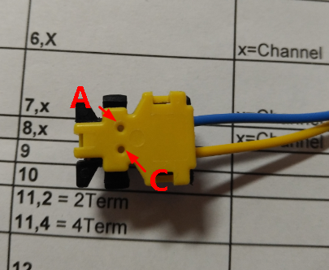

Figure 2 Top Test points

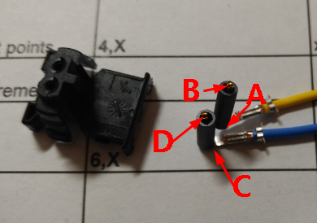

Figure 3 Test Points

Test item LAB, LCD, LAB+LCD(that means AC need short), test condition: 10MHz 1V serial, the impedance > 42Ohm, Angle < 52 deg. 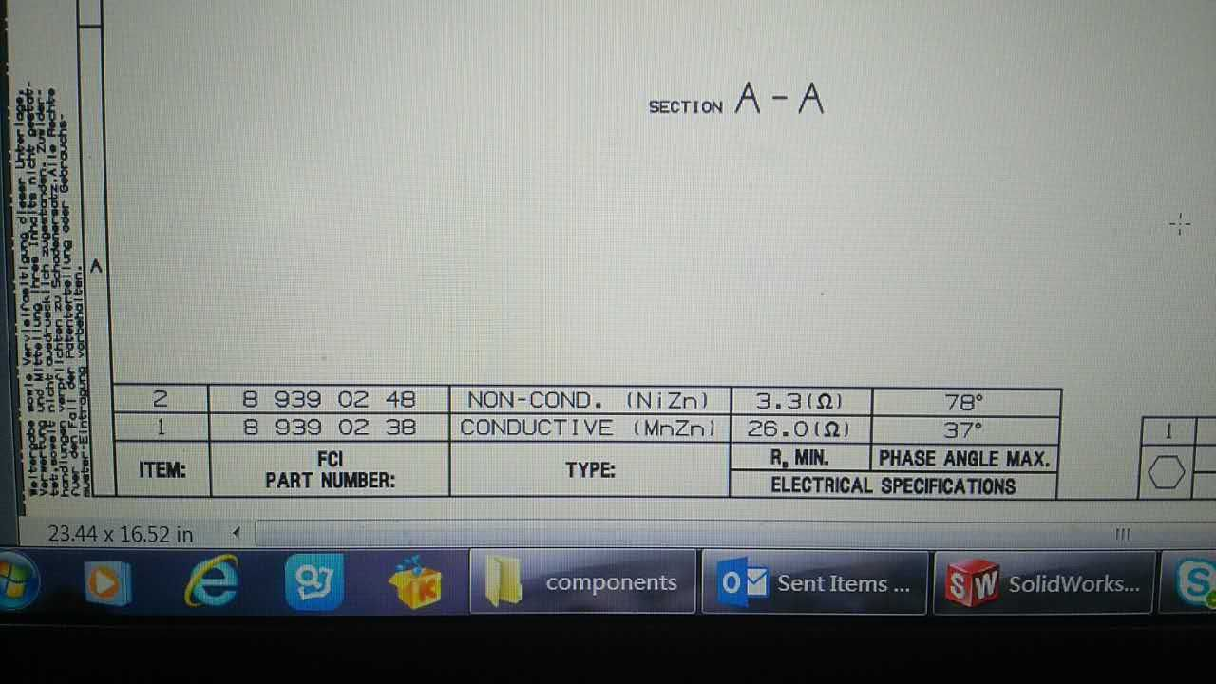

And then use HV BD resistor. Make sure AC points not shorted.

Also jurgen you are right, we need short AC very close the dut, please prepare that short relay that can bare 500V dc.

Hello Abama,

For the external open short relay is the best way to use the relay that I use for the relay matrix inside. Those you can use with the round  Din connector on the backside of  the case.

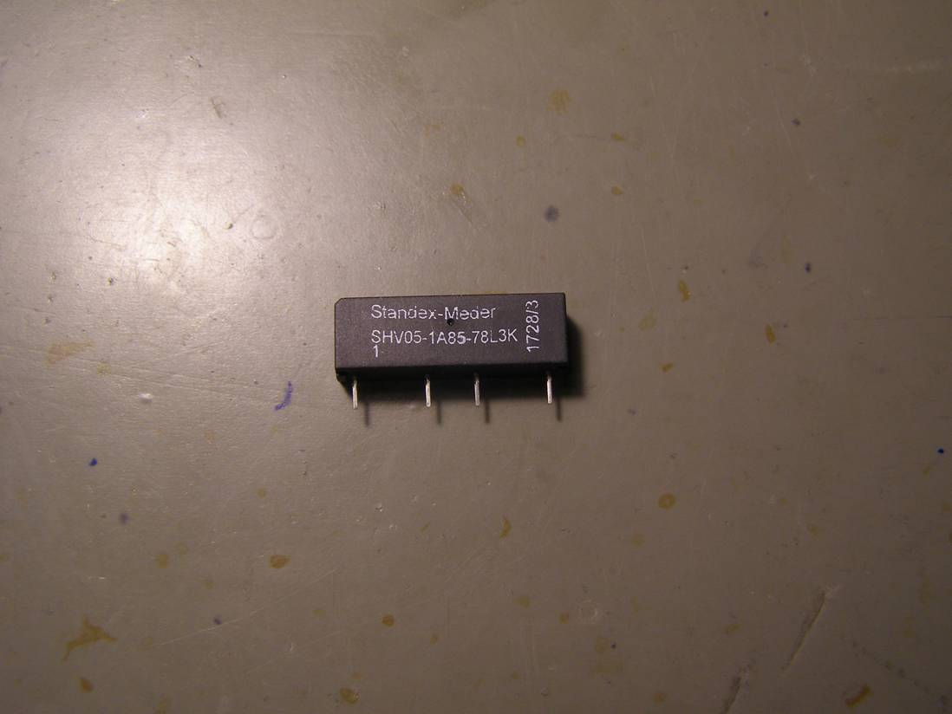

Has the customer an fixture to measure his cable. I think to integrate the external relay in those fixture is the best way.