# 跨链服务层API

跨链服务层API旨面向合作开发者，辅助其将区块链更方便快捷的接入到跨链系统。

### 名词解释

API_key：开发者的身份ID，可用于获取跨链服务层API的调用凭证（Access_token），然后通过接口调用凭证来访问跨链服务层的API接口。

API_secret：开发者身份ID对应的密钥，配合API_key使用能够获取接口调用凭证，同时为了安全起见这个密钥需要妥善保管。

Access_token：所有API接口的调用凭证，通过API_key和API_secret调用相关接口获得，具有时效性，有效时间为2小时，过期后需要重新获取否则会调用接口失败，因为凭证获取的接口有调用次数限制，所以建议妥善保存并管理。

### 服务层API架构

### 1.init

平台初始化，并创建管理员API key，只能调用一次。

*接口输入参数*

|  |  |  |  |  |  |
| --- | --- | --- | --- | --- | --- |
| ***字段名称*** | ***字段描述*** | ***类型*** | ***约束*** | ***具体check点*** | ***备注*** |

*接口输出参数*

|  |  |  |  |  |  |
| --- | --- | --- | --- | --- | --- |
| ***字段名称*** | ***字段描述*** | ***类型*** | ***约束*** | ***具体check点*** | ***备注*** |
| *apikey* | *API key* | *string* | *必填* | *非空，非null* |  |
| *apiSecret* | *API secret* | *string* | *必填* | *非空，非null* |  |
| *userId* | *管理员bid* | *string* | *必填* | *非空，非null* |  |
| *status* | *状态* | *string* | *非必填* |  |  |
| *remark* | *备注* | *string* | *非必填* |  |  |

### 2.applyApiKey

区块链运营者申请API_key和API_secret，用于获取调用凭证（Access_token）。对于跨链服务层API的管理员，其API_key和API_secret在服务初始化时进行内置。

*接口输入参数*

|  |  |  |  |  |  |
| --- | --- | --- | --- | --- | --- |
| ***字段名称*** | ***字段描述*** | ***类型*** | ***约束*** | ***具体check点*** | ***备注*** |
| *userId* | *运营者id，采用bid形式* | *string* | *必填* | *非空，非null* | *1-64字符长度* |
| *information* | *申请描述信息* | *string* | *必填* | *非空，非null* | *1-512字符长度* |
| *remark* | *备注* | *string* | *非必填* |  | *1-512字符长度* |

*接口输出参数*

|  |  |  |  |  |  |
| --- | --- | --- | --- | --- | --- |
| ***字段名称*** | ***字段描述*** | ***类型*** | ***约束*** | ***具体check点*** | ***备注*** |
| *applyNo* | *申请编号* | *string* | *必填* | *非空，非null* |  |

### 3.getAccessToken

令牌（Access_token）是调用API接口的凭据。令牌的获取是有限制的，每个令牌的有效期为 10小时，请自行做好令牌的管理，在令牌快过期时（比如9小时50分），重新调用接口获取。区块链运营者和API管理员获取令牌的端口不一样，进行区分来保护管理员的账户安全。

*接口输入参数*

|  |  |  |  |  |  |
| --- | --- | --- | --- | --- | --- |
| ***字段名称*** | ***字段描述*** | ***类型*** | ***约束*** | ***具体check点*** | ***备注*** |
| *apikey* | *API_key* | *string* | *必填* | *非空，非null* | *1-16字符长度* |
| *apiSecret* | *API_secret* | *string* | *必填* | *非空，非null* | *1-40字符长度* |
| *userId* | *运营者id* | *string* | *必填* | *非空，非null* | *1-64字符长度* |

*接口输出参数*

|  |  |  |  |  |  |
| --- | --- | --- | --- | --- | --- |
| ***字段名称*** | ***字段描述*** | ***类型*** | ***约束*** | ***具体check点*** | ***备注*** |
| *accessToken* | *令牌，请做好保存管理* | *string* | *必填* | *非空，非null* |  |
| *expireIn* | *有效时间* | *string* | *必填* | *非空，非null* |  |

### 4.auditApply

跨链API服务层管理员审核API_key的申请。

*接口输入参数*

***header***

|  |  |  |  |  |  |
| --- | --- | --- | --- | --- | --- |
| ***字段名称*** | ***字段描述*** | ***类型*** | ***约束*** | ***具体check点*** | ***备注*** |
| *accessToken* | *管理员的access token* | *string* | *必填* | *非空，非null* |  |

***body***

|  |  |  |  |  |  |
| --- | --- | --- | --- | --- | --- |
| ***字段名称*** | ***字段描述*** | ***类型*** | ***约束*** | ***具体check点*** | ***备注*** |
| *applyNo* | *申请编号* | *string* | *必填* | *非空，非null* | *1-64字符长度* |
| *reason* | *结果说明* | *string* | *必填* | *非空，非null* | *1-512字符长度* |
| *status* | *审核状态（2代表通过，3代表不通过）* | *int* | *必填* | *非空，非null* | *2或者3* |

*接口输出参数*

|  |  |  |  |  |  |
| --- | --- | --- | --- | --- | --- |
| ***字段名称*** | ***字段描述*** | ***类型*** | ***约束*** | ***具体check点*** | ***备注*** |
| *apikey* | *API_key* | *string* | *非必填* |  |  |
| *apiSecret* | *API_secret* | *string* | *非必填* |  |  |
| *userId* | *用户id* | *string* | *非必填* |  |  |
| *status* | *审核结果* | *int* | *必填* | *非空，非null* |  |
| *remark* | *备注* | *string* | *必填* | *非空，非null* |  |

### 5.getApikey

区块链运营者查询API_key和API_secret。

*接口输入参数*

|  |  |  |  |  |  |
| --- | --- | --- | --- | --- | --- |
| ***字段名称*** | ***字段描述*** | ***类型*** | ***约束*** | ***具体check点*** | ***备注*** |
| *applyNo* | *申请编号* | *string* | *必填* | *非空，非null* | *1-64字符长度* |

*接口输出参数*

|  |  |  |  |  |  |
| --- | --- | --- | --- | --- | --- |
| ***字段名称*** | ***字段描述*** | ***类型*** | ***约束*** | ***具体check点*** | ***备注*** |
| *apikey* | *API_key* | *string* | *非必填* |  |  |
| *apiSecret* | *API_secret* | *string* | *非必填* |  |  |
| *userId* | *用户id* | *string* | *非必填* |  |  |
| *status* | *审核结果* | *int* | *非必填* |  |  |
| *remark* | *备注* | *string* | *非必填* |  |  |

### 6.applyDomainName

区块链运营者发起域名申请。

*接口输入参数*

***header***

|  |  |  |  |  |  |
| --- | --- | --- | --- | --- | --- |
| ***字段名称*** | ***字段描述*** | ***类型*** | ***约束*** | ***具体check点*** | ***备注*** |
| *accessToken* | *区块链运营者的access token* | *string* | *必填* | *非空，非null* |  |

***body***

|  |  |  |  |  |  |
| --- | --- | --- | --- | --- | --- |
| ***字段名称*** | ***字段描述*** | ***类型*** | ***约束*** | ***具体check点*** | ***备注*** |
| *domainName* | *区块链域名* | *string* | *必填* | *非空，非null* | *1-32字符长度* |
| *publicKey* | *公钥* | *string* | *必填* | *非空，非null* | *1-128字符长度* |

*接口输出参数*

|  |  |  |  |  |  |
| --- | --- | --- | --- | --- | --- |
| ***字段名称*** | ***字段描述*** | ***类型*** | ***约束*** | ***具体check点*** | ***备注*** |
| *applyNo* | *申请编号* | *string* | *必填* | *非空，非null* |  |

### 7.getDomainNameCert

区块链运营者获取域名证书。

*接口输入参数*

***header***

|  |  |  |  |  |  |
| --- | --- | --- | --- | --- | --- |
| ***字段名称*** | ***字段描述*** | ***类型*** | ***约束*** | ***具体check点*** | ***备注*** |
| *accessToken* | *区块链运营者的access token* | *string* | *必填* | *非空，非null* |  |

***body***

|  |  |  |  |  |  |
| --- | --- | --- | --- | --- | --- |
| ***字段名称*** | ***字段描述*** | ***类型*** | ***约束*** | ***具体check点*** | ***备注*** |
| *domainName* | *区块链域名* | *string* | *必填* | *非空，非null* | *1-32字符长度* |

*接口输出参数*

|  |  |  |  |  |  |
| --- | --- | --- | --- | --- | --- |
| ***字段名称*** | ***字段描述*** | ***类型*** | ***约束*** | ***具体check点*** | ***备注*** |
| *credential* | *证书序列化后的结果* | *string* | *必填* | *非空，非null* |  |

### 8.addBlockchainAnchor

区块链运营者将区块链注册到中继，并将路由信息上传至链上Relay管理合约中。

*接口输入参数*

***header***

|  |  |  |  |  |  |
| --- | --- | --- | --- | --- | --- |
| ***字段名称*** | ***字段描述*** | ***类型*** | ***约束*** | ***具体check点*** | ***备注*** |
| *accessToken* | *区块链运营者的access token* | *string* | *必填* | *非空，非null* |  |

***body***

|  |  |  |  |  |  |
| --- | --- | --- | --- | --- | --- |
| ***字段名称*** | ***字段描述*** | ***类型*** | ***约束*** | ***具体check点*** | ***备注*** |
| *domainName* | *区块链域名* | *string* | *必填* | *非空，非null* | *1-32字符长度* |
| *product* | *区块链类型* | *string* | *必填* | *非空，非null* | *1-32字符长度* |
| *confFile* | *配置文件* | *string* | *必填* | *非空，非null* | *由于配置文件可能存在加密证书，故不限制长度，只校验非空* |

*接口输出参数*

|  |  |  |  |  |  |
| --- | --- | --- | --- | --- | --- |
| ***字段名称*** | ***字段描述*** | ***类型*** | ***约束*** | ***具体check点*** | ***备注*** |
| *result* | *注册结果* | *bool* | *必填* | *非空，非null* |  |

### 9.startBlockchainAnchor

跨链服务层API管理者启动Relay对于该链的监听、转发等服务，统一称为Anchor服务。

*接口输入参数*

***header***

|  |  |  |  |  |  |
| --- | --- | --- | --- | --- | --- |
| ***字段名称*** | ***字段描述*** | ***类型*** | ***约束*** | ***具体check点*** | ***备注*** |
| *accessToken* | *管理员的access token* | *string* | *必填* | *非空，非null* |  |

***body***

|  |  |  |  |  |  |
| --- | --- | --- | --- | --- | --- |
| ***字段名称*** | ***字段描述*** | ***类型*** | ***约束*** | ***具体check点*** | ***备注*** |
| *domainName* | *区块链域名* | *string* | *必填* | *非空，非null* | *1-64字符长度* |

*接口输出参数*

|  |  |  |  |  |  |
| --- | --- | --- | --- | --- | --- |
| ***字段名称*** | ***字段描述*** | ***类型*** | ***约束*** | ***具体check点*** | ***备注*** |
| *result* | *注册结果* | *bool* | *必填* | *非空，非null* |  |

### 10.stopBlockchainAnchor

用于停止指定区块链的扫块服务，调用该接口后中继将会停止扫描指定区块链的区块，也就暂时不再支持链上合约部署交互或跨链交易等功能。

*接口输入参数*

***header***

|  |  |  |  |  |  |
| --- | --- | --- | --- | --- | --- |
| ***字段名称*** | ***字段描述*** | ***类型*** | ***约束*** | ***具体check点*** | ***备注*** |
| *accessToken* | *管理员的access token* | *string* | *必填* | *非空，非null* |  |

***body***

|  |  |  |  |  |  |
| --- | --- | --- | --- | --- | --- |
| ***字段名称*** | ***字段描述*** | ***类型*** | ***约束*** | ***具体check点*** | ***备注*** |
| *domainName* | *区块链域名* | *string* | *必填* | *非空，非null* | *1-64字符长度* |

*接口输出参数*

|  |  |  |  |  |  |
| --- | --- | --- | --- | --- | --- |
| ***字段名称*** | ***字段描述*** | ***类型*** | ***约束*** | ***具体check点*** | ***备注*** |
| *result* | *停止结果* | *bool* | *必填* | *非空，非null* |  |

### 11.getBlockchainContracts

启动Anchor服务之后，Relay会调用插件实现系统合约的部署和初始化，可以查看合约的状态和地址。

*接口输入参数*

***header***

|  |  |  |  |  |  |
| --- | --- | --- | --- | --- | --- |
| ***字段名称*** | ***字段描述*** | ***类型*** | ***约束*** | ***具体check点*** | ***备注*** |
| *accessToken* | *区块链运营者的access token* | *string* | *必填* | *非空，非null* |  |

***body***

|  |  |  |  |  |  |
| --- | --- | --- | --- | --- | --- |
| ***字段名称*** | ***字段描述*** | ***类型*** | ***约束*** | ***具体check点*** | ***备注*** |
| *domainName* | *区块链域名* | *string* | *必填* | *非空，非null* | *1-64字符长度* |

*接口输出参数*

|  |  |  |  |  |  |
| --- | --- | --- | --- | --- | --- |
| ***字段名称*** | ***字段描述*** | ***类型*** | ***约束*** | ***具体check点*** | ***备注*** |
| *inforJson* | *合约信息，包括合约地址和状态* | *string* | *必填* | *非空，非null* |  |

### 12.getBlockchainHeights

启动的区块链，Relay会对其启动Anchor服务，扫描注册之后的每个高度，可以查看当前扫描的高度。

*接口输入参数*

***header***

|  |  |  |  |  |  |
| --- | --- | --- | --- | --- | --- |
| ***字段名称*** | ***字段描述*** | ***类型*** | ***约束*** | ***具体check点*** | ***备注*** |
| *accessToken* | *区块链运营者的access token* | *string* | *必填* | *非空，非null* |  |

***body***

|  |  |  |  |  |  |
| --- | --- | --- | --- | --- | --- |
| ***字段名称*** | ***字段描述*** | ***类型*** | ***约束*** | ***具体check点*** | ***备注*** |
| *domainName* | *区块链域名* | *string* | *必填* | *非空，非null* | *1-64字符长度* |

*接口输出参数*

|  |  |  |  |  |  |
| --- | --- | --- | --- | --- | --- |
| ***字段名称*** | ***字段描述*** | ***类型*** | ***约束*** | ***具体check点*** | ***备注*** |
| *inforJson* | *合约信息，包括合约地址和状态* | *string* | *必填* | *非空，非null* |  |

### 13.getIpList

查询链的出口ip列表

*接口输入参数*

***header***

|  |  |  |  |  |  |
| --- | --- | --- | --- | --- | --- |
| ***字段名称*** | ***字段描述*** | ***类型*** | ***约束*** | ***具体check点*** | ***备注*** |
| *accessToken* | *区块链运营者的access token* | *string* | *必填* | *非空，非null* |  |

***body***

|  |  |  |  |  |  |
| --- | --- | --- | --- | --- | --- |
| ***字段名称*** | ***字段描述*** | ***类型*** | ***约束*** | ***具体check点*** | ***备注*** |

*接口输出参数*

|  |  |  |  |  |  |
| --- | --- | --- | --- | --- | --- |
| ***字段名称*** | ***字段描述*** | ***类型*** | ***约束*** | ***具体check点*** | ***备注*** |
| *inforJson* | *查询结果* | *string* | *必填* | *非空，非null* |  |

## 错误码说明

|  |  |  |
| --- | --- | --- |
| 0 | SUCCESS | success |
| 1 | PARAM_ERROR | invalid param |
| 101 | SYS_ERROR | system error |
| 102 | RELAY_GRPC_ERROR | relay grpc error |
| 103 | NOT_EXIST | not exist |
| 104 | PLATFORM_REPEATED_INIT | api platform repeated init |
| 105 | API_KEY_NOT_EXIST | api-key not exist |
| 106 | API_KEY_ERROR | api-key error |
| 107 | ACCESS_TOKEN_INVALID | access token invalid |
| 108 | USER_ID_ERROR | user id and manager are the same |
| 109 | CREDENTIAL_APPLY_NOT_EXIST | cert apply record not exist |
| 110 | APPLY_AUDITED | apply has been audited |
| 111 | API_KEY_IS_EXISTED | user id only can has one api key |

### 时序图

#### 1.申请API_key

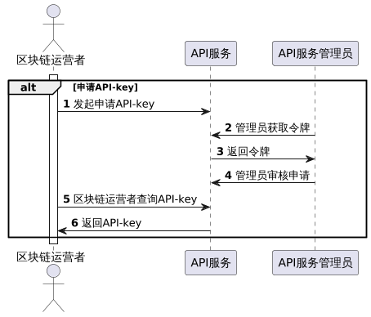

#### 2.申请区块链域名

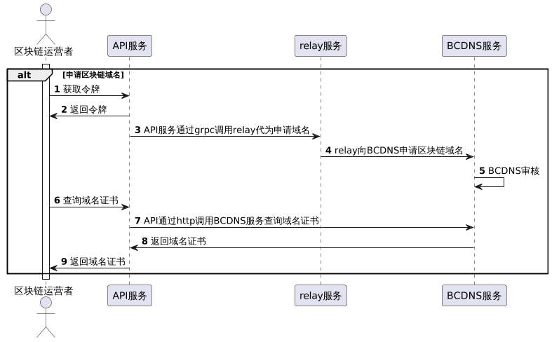

#### 3.注册区块链到中继

