

**Cambridge International**

**AS and A Level Biology (9700)**

Practical booklet 4

Substrate concentration and enzyme activity

**Introduction**

Practical work is an essential part of science. Scientists use evidence gained from prior observations and experiments to build models and theories. Their predictions are tested with practical work to check that they are consistent with the behaviour of the real world. Learners who are well trained and experienced in practical skills will be more confident in their own abilities. The skills developed through practical work provide a good foundation for those wishing to pursue science further, as well as for those entering employment or a non-science career.

The science syllabuses address practical skills that contribute to the overall understanding of scientific methodology. Learners should be able to:

1. plan experiments and investigations
2. collect, record and present observations, measurements and estimates
3. analyse and interpret data to reach conclusions
4. evaluate methods and quality of data, and suggest improvements.

The practical skills established at AS Level are extended further in the full A Level. Learners will need to have practised basic skills from the AS Level experiments before using these skills to tackle the more demanding A Level exercises. Although A Level practical skills are assessed by a timetabled written paper, the best preparation for this paper is through extensive hands-on experience in the laboratory.

The example experiments suggested here can form the basis of a well-structured scheme of practical work for the teaching of AS and A Level science. The experiments have been carefully selected to reinforce theory and to develop learners’ practical skills. The syllabus, scheme of work and past papers also provide a useful guide to the type of practical skills that learners might be expected to develop further. About 20% of teaching time should be allocated to practical work (not including the time spent observing teacher demonstrations), so this set of experiments provides only the starting point for a much more extensive scheme of practical work.

© Cambridge International Examinations 2014

**Practical 4 – Guidance for teachers**

**Substrate concentration and enzyme activity**

**Aim**

To investigate the effect of substrate concentration on the activity of the enzyme catalase.

**Outcomes**

Syllabus section 3.1 (d) and 3.2 (a)

**Skills included in the practical**

|  |  |
| --- | --- |
| **AS Level skills** | **How learners develop the skills** |
| MMO decisions | Carry out a simple dilution of hydrogen peroxide solution and suggest a suitable control experiment |
| MMO collection | Tally count the number of bubbles in a minute |
| PDO recording | Record quantitative results appropriately in a table |
| PDO layout | Draw a graph to show how rate of production of bubbles varies with substrate concentration |
| ACE analysis | Describe the trend shown in the graph |
| CE conclusions | Explain the trend shown in the graph using an understanding of how enzymes work |
| ACE evaluation | Identify the significant source of error in the experiment and suggest a modification to increase the accuracy of the results  Suggest how to extend the investigation to answer a new question |

**Method**

**Safety glasses must be worn when preparing the slide.**

* Hydrogen peroxide is a harmful waste product of metabolic processes. It is broken down by the enzyme catalase into water and oxygen.
* During this investigation learners will study the effect of the concentration of hydrogen peroxide solution on the activity of catalase by counting the number of bubbles of oxygen produced in a set time.
* Learners should be provided with about 100 cm3 of 20 vol hydrogen peroxide solution in a beaker, labelled 100% hydrogen peroxide solution, and the same volume of distilled water in a separate beaker, labelled distilled water.
* They will carry out a simple dilution of this hydrogen peroxide solution to provide 6 concentrations ranging between 100% and 50%. They will need 20 cm3 of each concentration. This task gives learners the opportunity to make decisions about which concentrations they should select and the volumes of hydrogen peroxide solution and distilled water that they need in order to make these solutions.
* The solutions can be made directly into large test-tubes (boiling tubes) which have been labelled by the learner, or in separate beakers, which can then be used as stock solutions.
* Using beakers in this way provides the opportunity to repeat the experiment and assess the reliability of the results. Learners should be asked to process the results they collect and calculate means. If stock solutions are made in beakers, learners will have to transfer 20 cm3 of each solution into a labelled test-tube and the method will need to be amended accordingly.
* The test-tubes should then be put into a water-bath at 37 °C to equilibrate for 5 minutes. The water-bath could be a thermostatically controlled water-bath or one made by learners using hot and cold water. The use of the water-bath can be discussed. It ensures that the enzymes are working at or close to the optimum temperature and so the number of bubbles produced is measurable. Leaving the test-tubes in the water-bath for 5 minutes ensures that they are all at the same temperature during the investigation.
* The potato provides the source of catalase. Learners will cut 6 cylinders from a fresh potato; each should be 5 cm long. This could be done using a cork borer or rectangular pieces could be cut using a sharp knife. It is important that the surface area of the potato cylinders is constant and that the potato skin has been removed.
* One potato cylinder or rectangle will be added to the test-tube with the highest concentration of hydrogen peroxide solution, a bung and delivery tube inserted and the number of bubbles produced in one minute should be counted and recorded. This procedure can then be repeated for each of the other concentrations of hydrogen peroxide solution. The diagram below shows how the apparatus should be set up for this experiment.

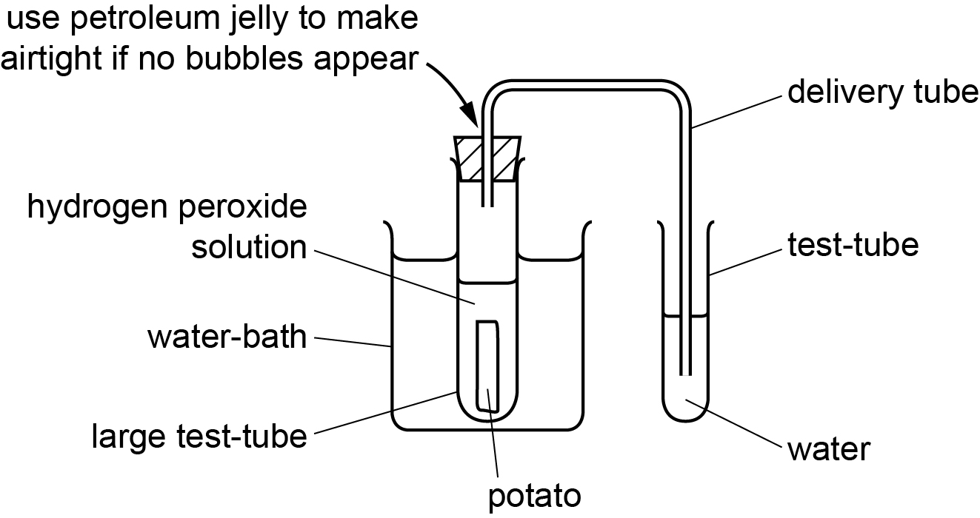

**Results**

Learners should record their results in a table and they should be reminded that they should:

* + draw a table which includes lines separating each of the columns and rows
  + put the independent variable in the first column
  + use descriptive column headings include units in column headings, not next to each result recorded in the table.

**Interpretation and evaluation**

* Learners will plot a graph to show the relationship between substrate concentration and rate of reaction. They then use this graph to describe and explain the relationship. This provides an opportunity to emphasise the difference between a *description* and an *explanation*.
  + A description should state the relationships seen on the graph and use data taken from the graph to support each statement.
  + An explanation should include scientific reasons which explain **why** the relationship between the variables has occurred.
* The experiment also provides the opportunity to discuss the idea of a control experiment. Suitable control experiments should be discussed, such as replacing the hydrogen peroxide solution with an equal volume of distilled water to show the results are due to the presence of the hydrogen peroxide solution and not some other factor.
* There is an opportunity to identify possible sources of error and how they may affect the trend and accuracy of the results. The most significant error in this investigation is the fact that the bubbles produced may be of different size. Learners could then suggest how the experiment should be improved to reduce this error, for example by collecting the oxygen in a measuring cylinder or burette using the downward displacement of water.
* As an extension activity learners can design an experiment that uses this method but investigates the effect of temperature on the rate of catalase activity. They should identify that the substrate concentration must be standardised and the temperature of the thermostatically controlled water-bath changed. They should be able to suggest at least 5 suitable temperatures to investigate and these should be chosen from both sides of the optimum used in their investigation.

**Practical 4 – Information for technicians**

**Substrate concentration and enzyme activity**

**Each learner will require:**

|  |  |  |
| --- | --- | --- |
|  | (a) | safety glasses |
| **[H]** | (b) | at least 100 cm3 hydrogen peroxide solution (20 vol) in a beaker, labelled **100% hydrogen peroxide solution** |
|  | (c) | at least 50 cm3 distilled water |
|  | (d) | six large test-tubes (boiling tubes) |
|  | (e) | one test-tube rack to hold large test-tubes |
|  | (f) | one marker pen |
|  | (g) | two 5 cm3 syringes |
|  | (h) | one potato |
|  | (i) | one cork borer |
|  | (j) | one white tile |
|  | (k) | one knife |
|  | (l) | one test-tube |
|  | (m) | one delivery tube with a bung that fits into the top of the test-tube |
|  | (n) | one stopwatch |

**Additional instructions**

Learners are required to set the apparatus up as shown in the diagram. The bung must make an airtight seal both with the test-tube and the delivery tube to allow the collection of oxygen.



**Hazard symbols**

|  |  |
| --- | --- |
| **C** = corrosive substance | **F** = highly flammable substance |
| **H** = harmful or irritating substance | **O** = oxidising substance |
| **N** = harmful to the environment | **T** = toxic substance |

**Practical 4 – Worksheet**

**Substrate concentration and enzyme activity**

**Aim**

To investigate the effect of substrate concentration on the activity of the enzyme catalase.

**Method**

**Safety glasses must be worn when carrying out this investigation**

1. Decide the volumes of distilled water and hydrogen peroxide solution you will need to make 20 cm3 of each concentration of hydrogen peroxide solution shown in the table below.
2. Complete the table.

|  |  |  |
| --- | --- | --- |
| **percentage concentration of hydrogen peroxide solution** | **volume of distilled water**  **/ cm3** | **volume of 100% Hydrogen peroxide solution / cm3** |
| 100 |  |  |
| 90 |  |  |
| 80 |  |  |
| 70 |  |  |
| 60 |  |  |
| 50 |  |  |

1. Label test-tubes with these concentrations.
2. Prepare these concentrations of hydrogen peroxide solution in the test-tubes.
3. Put the test-tube containing the 100% hydrogen peroxide solution into a water-bath at 37 °C and leave for 5 minutes to equilibrate.
4. Cut a cylinder or rectangle of potato 5 cm long using a cork borer or knife.
5. Put the potato cylinder or rectangle into the test-tube and quickly add the bung and delivery tube as shown on the diagram below.
6. Put the delivery tube into a test-tube containing water and count the number of bubbles given off in 1 minute.



1. Repeat steps **5** to **8** for each concentration of hydrogen peroxide solution you have prepared.
2. Record your results in a table.

**Results**

Record your results in an appropriate table. When drawing a results table remember that you should:

* + put the independent variable in the first column
  + use descriptive column headings
  + include units in column headings.

**Interpretation and evaluation**

1. Plot a graph to show the relationship between substrate concentration and rate of reaction.
2. Use the graph to describe the relationship between the concentration of hydrogen peroxide solution and the rate of reaction.
3. Use the graph to explain the relationship between the concentration of hydrogen peroxide solution and the rate of reaction.
4. Describe how you would set up a control for this experiment.
5. State the main source of error in this investigation.
6. Describe how you could improve the investigation and therefore the accuracy of your results.

**Extension**

Describe how you would modify this experiment to investigate the effect of temperature on the activity of the enzyme catalase.