

**Cambridge International**

**AS and A Level Biology (9700)**

Practical booklet 5

Investigating the progress of an enzyme-catalysed reaction by measuring the rate of disappearance of a substrate

**Introduction**

Practical work is an essential part of science. Scientists use evidence gained from prior observations and experiments to build models and theories. Their predictions are tested with practical work to check that they are consistent with the behaviour of the real world. Learners who are well trained and experienced in practical skills will be more confident in their own abilities. The skills developed through practical work provide a good foundation for those wishing to pursue science further, as well as for those entering employment or a non-science career.

The science syllabuses address practical skills that contribute to the overall understanding of scientific methodology. Learners should be able to:

1. plan experiments and investigations
2. collect, record and present observations, measurements and estimates
3. analyse and interpret data to reach conclusions
4. evaluate methods and quality of data, and suggest improvements.

The practical skills established at AS Level are extended further in the full A Level. Learners will need to have practised basic skills from the AS Level experiments before using these skills to tackle the more demanding A Level exercises. Although A Level practical skills are assessed by a timetabled written paper, the best preparation for this paper is through extensive hands-on experience in the laboratory.

The example experiments suggested here can form the basis of a well-structured scheme of practical work for the teaching of AS and A Level science. The experiments have been carefully selected to reinforce theory and to develop learners’ practical skills. The syllabus, scheme of work and past papers also provide a useful guide to the type of practical skills that learners might be expected to develop further. About 20% of teaching time should be allocated to practical work (not including the time spent observing teacher demonstrations), so this set of experiments provides only the starting point for a much more extensive scheme of practical work.

© Cambridge International Examinations 2014

**Practical 5 – Guidance for teachers**

**Investigating the progress of an enzyme-catalysed reaction by measuring the rate of disappearance of a substrate**

**Aim**

To determine the rate of hydrolysis of starch using the enzyme amylase.

**Outcomes**

Syllabus section 3.1 (d)

**Skills included in the practical**

|  |  |
| --- | --- |
| **AS Level skills** | **How learners develop the skills** |
| MMO decisions | Describe an appropriate control experiment |
| MMO collection | Make qualitative observations about colour changes |
| PDO recording | Collect quantitative results, time for a colour change |
| ACE concluding | Record qualitative observations and quantitative results in appropriately in a table |
| PDO display | Explain the reason for the change in the colour of the iodine solution over the course of the experiment |
| ACE analysis | Calculate a mean and calculate the rate of the reaction showing every step in the calculation |
| ACE evaluation | Modify the procedure to investigate the new question, how temperature affects the rate of hydrolysis of starch by amylase |

**Method**

**Safety glasses must be worn when preparing the slide.**

* Learners should be familiar with the structure of starch, and the breakage of glycosidic bonds in polysaccharides. They should also have an understanding of the mode of action of enzymes.
* Starch is a polysaccharide made up of many α-glucose molecules joined by glycosidic bonds. The enzyme amylase hydrolyses starch to produce the disaccharide maltose.
* During this investigation learners will follow the course of this reaction using iodine solution. The practical follows the disappearance of starch as it is hydrolysed by amylase. The intensity of the blue colour produced when samples of starch and amylase solutions are added to iodine solution is recorded regularly over a set period of time. As starch is broken down the blue-black colour will become less intense and eventually disappear.
* A spotting tile should be prepared with a drop of **iodine solution** placed in every cavity.

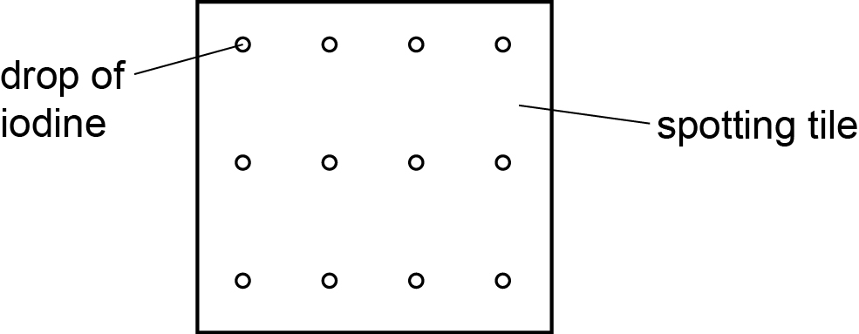

solution

* Learners are provided with a 1% amylase solution and a 1% starch solution. They should put 10 cm3 of the 1% starch solution into a large test-tube and 2 cm3 of 1% amylase solution into a second large test-tube.
* A beaker with warm water (about 37 °C) should be prepared to act as a water-bath. This should be used to equilibrate the starch and amylase solutions. The two test-tubes should be left in the warm water-bath for 5 minutes. The purpose of this is to equilibrate both the substrate and enzyme to the same temperature. The use of a thermometer in each tube as well as one in the water-bath can be discussed as a more accurate way of determining that the equilibration is complete.
* The starch solution should be poured into the amylase solution and mixed with a glass rod and a stop clock started immediately. After 15 seconds a drop of liquid can be removed from the mixture using a glass rod and placed into the iodine solution in one of the cavities in the spotting tile. This will be repeated every 15 seconds, and a drop of the starch amylase mixture added to the next cavity in the spotting tile.
* At the start of the experiment the drop of iodine solution should turn blue-black because starch is present. As the amylase hydrolyses the starch to maltose the samples should turn the iodine solution a less intense blue-black colour until eventually the drop of iodine solution remains orange-brown. This is the end-point of the experiment and the time taken for the complete hydrolysis of starch will be recorded. Learners may need more than one spotting tile to follow the reaction to its endpoint.
* To act as a control, the experiment should be repeated with 2 cm3 of water in place of the amylase solution. The experiment should be stopped after a maximum of 5 minutes as without the amylase the starch will not break down and an end point will not be reached. This is a simple experiment to reinforce the purpose of a control experiment.

The experiment is repeated twice more, to allow a mean to be calculated. This allows the reliability of the experiment to be discussed.

**Results**

* Learners record their results in a table. The colour of the drop of iodine solution will be recorded every 15 seconds. This can be done using adjectives such as ‘dark’ or ‘pale’. Alternatively they can use the symbol, + with a key to represent the degrees of colour e.g. +++++ very dark blue to + very pale blue.

|  |  |
| --- | --- |
| **time after the enzyme and substrate are mixed / s** | **colour of iodine solution** |
| 0 |  |
| 15 |  |
| 30 |  |
| etc. |  |

**Interpretation and evaluation**

* Learners calculate the mean time taken to reach the end-point of the experiment. This allows the opportunity to discuss the accuracy of observing colour change.
* Learners calculate the rate of hydrolysis of starch using the formula: rate = 1 / time. The need to consider the number of significant figures the answer is given to can be emphasised.
* This calculation is based on the assumption that the rate of hydrolysis will be constant. This assumption is incorrect and can be discussed.
* Learners are asked to consider how they would modify this experiment to investigate the effect of temperature on the rate of hydrolysis of starch. They should identify the need to change the temperature of the water-bath and be able to suggest 5 temperatures to investigate, including temperatures both above and below the one used in this investigation. The concentration of the starch and amylase solutions should be kept constant.

**Practical 5 – Information for technicians**

**Investigating the progress of an enzyme-catalysed reaction by measuring the rate of disappearance of a substrate**

**Each learner will require:**

|  |  |  |
| --- | --- | --- |
|  | (a) | safety glasses |
| **[H]** | (b) | at least 10 cm3 iodine in potassium iodide solution, labelled **iodine solution** |
| **[H]** | (c) | 6 cm3 of 1% amylase solution |
|  | (d) | 30 cm3 1% starch solution |
|  | (e) | one dropping pipette |
|  | (f) | two spotting tiles |
|  | (g) | one 400 cm3 beaker to be used as a water-bath (at approximately 35-40 °C) |
|  | (h) | one glass rod |
|  | (i) | paper towels |
|  | (j) | one stop clock |
|  | (k) | two large test-tubes |
|  | (l) | one test-tube rack |
|  | (m) | two 5 cm3 syringes |
|  | (n) | at least one thermometer, three if available |

**Hazard symbols**

|  |  |
| --- | --- |
| **C** = corrosive substance | **F** = highly flammable substance |
| **H** = harmful or irritating substance | **O** = oxidising substance |
| **N** = harmful to the environment | **T** = toxic substance |

**Practical 5 – Worksheet**

**Investigating the progress of an enzyme-catalysed reaction by measuring the rate of disappearance of a substrate**

**Aim**

To determine the rate of hydrolysis of starch using the enzyme amylase.

**Method**

Starch is a polysaccharide made up of many α-glucose molecules joined by glycosidic bonds. The enzyme amylase hydrolyses starch to produce the disaccharide maltose.

You will follow the course of this reaction using iodine solution. The practical follows the disappearance of starch as it is hydrolysed by amylase. Over a set period of time you will regularly record the intensity of the blue colour produced when samples of starch and amylase solution are added to iodine solution. As starch is broken down the blue-black colour will become less intense and eventually disappear.

**Safety glasses must be worn when preparing the slide.**

1. Add a drop of iodine solution to every cavity on the spotting tile as shown below.



solution

1. Add 10 cm3 of 1% starch solution into a large test-tube and label it accordingly.
2. Add 2 cm3 of 1% amylase solution into a second large test-tube and label it accordingly.
3. Prepare a beaker with warm water (about 37 °C). This will act as a water-bath and will be used to equilibrate the starch and amylase solutions to the same temperature. Leave the two test-tubes in the warm water-bath for approximately 5 minutes. Use a thermometer to determine when the contents of the tubes have reached the required temperature.
4. Pour the 1% starch solution into the test-tube containing the 1% amylase solution and mix with the glass rod. Start the stop clock immediately.
5. After 15 seconds a drop of liquid can be removed from the mixture using a glass rod and placed into the iodine solution in the first cavity of the spotting tile. Record the colour of the mixture and its intensity in a results table.
6. Repeat step **6** every 15 seconds, placing a drop of the starch-amylase mixture into the iodine solution in the next cavity on the spotting tile.
7. You will need to determine when the end-point of the experiment has been reached.
8. Repeat steps **1** – **8** twice more.
9. Decide what would be an appropriate control experiment to perform. Your teacher may allow you to carry this out if time allows.

**Results**

Record your results in an appropriate table. When drawing a results table remember that you should:

* + put the independent variable in the first column
  + use descriptive column headings
  + include units in the column headings only.

**Interpretation and evaluation**

1. Calculate the mean time to reach the end-point of the experiment.
2. Calculate the rate of hydrolysis of starch using the formula below. Consider the number of significant figures carefully.

Rate of hydrolysis = 1 / time

1. How could you modify this experiment to investigate the effect of temperature on the rate of hydrolysis of starch?