

**Cambridge International**

**AS and A Level Biology (9700)**

Practical booklet 6

Using a potometer

**Introduction**

Practical work is an essential part of science. Scientists use evidence gained from prior observations and experiments to build models and theories. Their predictions are tested with practical work to check that they are consistent with the behaviour of the real world. Learners who are well trained and experienced in practical skills will be more confident in their own abilities. The skills developed through practical work provide a good foundation for those wishing to pursue science further, as well as for those entering employment or a non-science career.

The science syllabuses address practical skills that contribute to the overall understanding of scientific methodology. Learners should be able to:

1. plan experiments and investigations
2. collect, record and present observations, measurements and estimates
3. analyse and interpret data to reach conclusions
4. evaluate methods and quality of data, and suggest improvements.

The practical skills established at AS Level are extended further in the full A Level. Learners will need to have practised basic skills from the AS Level experiments before using these skills to tackle the more demanding A Level exercises. Although A Level practical skills are assessed by a timetabled written paper, the best preparation for this paper is through extensive hands-on experience in the laboratory.

The example experiments suggested here can form the basis of a well-structured scheme of practical work for the teaching of AS and A Level science. The experiments have been carefully selected to reinforce theory and to develop learners’ practical skills. The syllabus, scheme of work and past papers also provide a useful guide to the type of practical skills that learners might be expected to develop further. About 20% of teaching time should be allocated to practical work (not including the time spent observing teacher demonstrations), so this set of experiments provides only the starting point for a much more extensive scheme of practical work.

© Cambridge International Examinations 2014

**Practical 6 – Guidance for teachers**

**Using a potometer**

**Aim**

To determine the uptake of water by a leafy shoot and investigate how leaf area affects this.

**Outcomes**

Syllabus learning objective 1.1 (c)

**Skills included in the practical**

|  |  |
| --- | --- |
| **AS Level skills** | **How learners develop the skills** |
| MMO decisions | Measure the area of a leaf using a grid |
| MMO collection | Collect quantitative results - distance moved by bubble in the potometer |
| PDO recording | Record quantitative results in an appropriate table |
| PDO layout | Draw a graph to show the relationship between surface area of leaves removed and rate of transpiration |
| ACE analysis | Identify anomalous results  Describe the trend shown in the graph drawn |
| ACE conclusions | Explain the trend shown in the graph using scientific understanding of the factors that affect the rate of transpiration |

**Method**

* Learners should be familiar with the movement of water through a plant and the loss of water from the leaves by transpiration.
* A potometer will need to be provided for each group of students as shown in the diagram below. To set up the potometer the rubber tubing must be attached to the capillary tube and the water reservoir to the T piece. The reservoir, capillary tube and rubber tubing should be filled with water. This can be done by placing them under water and gently squeezing the rubber tubing until all the air has been removed.
* A leafy shoot can be cut at an angle underwater and the cut end inserted into the rubber tubing of the potometer while it is also still under water. This ensures that there are no air bubbles trapped in the xylem, which will prevent the transport of water. The tap on the water reservoir can then be closed and the apparatus removed from the water and attached to a clamp stand or support. The leaves should be allowed to dry before the apparatus is used to measure the rate of transpiration.

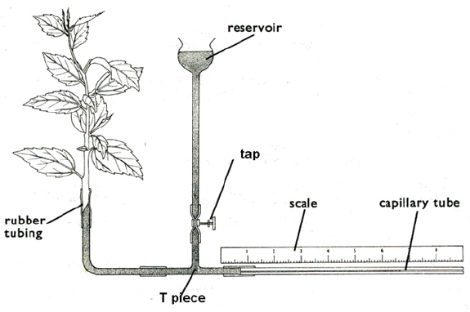

* A simple potometer could be used if the above apparatus is not available. This would consist of a piece of glass capillary tube and the rubber tubing. This can be put under water to fill with water and the rubber tubing can be squeezed to remove air bubbles from the apparatus. The leafy shoot can then be inserted into the simple potometer as described above. A single air bubble is introduced into the potometer and the rate of movement of this bubble is taken as an indication of the rate of transpiration.
* A ruler is placed along the capillary tubing. Learners will measure the distance a bubble in the capillary tube moves in one minute. Repeat readings are taken.
* To investigate the effect of leaf area on the rate of transpiration, the experiment is repeated and a leaf removed from the shoot. The distance the bubble travels in one minute is recorded. Several repeats can be taken. This experiment repeated, removing a second and third leaf etc. until sufficient data has been collected to draw a graph (at least 5 values of the independent variable should be investigated). Alternatively individual leaves could be covered in petroleum jelly so that the stomata are blocked to prevent transpiration.

As each leaf is removed it needs to be labelled and its surface area determined. This can be done by tracing round each leaf onto squared paper and then counting the number of squares within the leaf outline to determine the area. Squares that are half or more covered by the leaf should be counted as whole squares and those squares that are less than half covered should not be counted.

**Results**

* Learners record their raw data in tables.
* For the first experiment they will record the distance the bubble moves after each minute.

|  |  |
| --- | --- |
| **trial** | **distance bubble moves in one minute / mm** |
|  |  |
|  |  |

* For the second experiment the table of results should show the number of leaves removed from the shoot and the distance the bubble moved in one minute.

|  |  |
| --- | --- |
| **number of leaves removed** | **distance bubble moves in one minute / mm** |
|  |  |
|  |  |

* Learners can be reminded of the need to put the independent variable in the first column and the dependent variable in the second column. They can also be reminded of the need for descriptive column heading with units in the column headings rather than next to each result in the table.
* The surface area of each leaf removed should be recorded in a table. Then the total surface area of the leaves removed for each experiment can be calculated by adding the surface area of all the leaves removed before the experiment begins.
* A table showing these processed results and the results for the dependent variable should be produced.

|  |  |
| --- | --- |
| **total surface area of leaves removed / mm2** | **distance bubble moves in one minute / mm** |
|  |  |
|  |  |

**Interpretation and evaluation**

* The processed data will be used to plot a graph. The graph can be used to identify any anomalous results. Learners are asked to describe the relationship shown on the graph. They can be reminded of the need to use data from the graph to support each statement made in their description.
* The experiment provides the opportunity to discuss different types of errors which may affect the accuracy of the results.
* Learners can use their understanding of transpiration and the factors which affect it to explain the shape of the graph.

**Practical 6 – Information for technicians**

**Using a potometer**

**Each learner will require:**

There are no specific hazards for this investigation.

|  |  |
| --- | --- |
| (a) | one freshly cut leafy shoot that has been put immediately into fresh water |
| (b) | one potometer set up as shown in the diagram below. |
| (c) | ruler with mm scale to place alongside the capillary tube |
| (d) | stop watch or clock |
| (e) | petroleum jelly (optional) |
| (f) | one marker pen |

**Additional instructions**

Set the equipment up as shown below

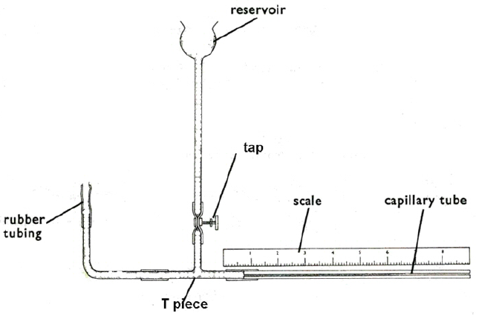

**Practical 6 – Worksheet**

**Using a potometer**

**Aim**

To determine the uptake of water by a leafy shoot and investigate how leaf area affects this.

**Method**

You will be provided with a potometer which has been set up for you as shown below.



**Experiment 1**

1. Place a ruler along the capillary tubing and note the position of the air bubble.
2. Measure the distance the bubble in the capillary tube moves in 1 minute. Record your results.
3. Repeat steps **1** and **2** several times. Record your results.

**Experiment 2**

1. Remove one leaf from the shoot and label it **leaf 1**. You must not remove the shoot from the potometer when you do this.
2. Place a ruler along the capillary tubing and note the position of the air bubble.
3. Measure the distance the bubble in the capillary tube moves in 1 minute.
4. Repeat steps **2** and **3** several times.
5. Record your results in a results table.
6. Remove a second leaf from the shoot and label it **leaf 2**.
7. Repeat steps **2** – **5**.
8. Continue the process above until you have removed a total of 5 leaves from the shoot.
9. Determine the surface area of each leaf removed from the shoot by tracing round each leaf onto squared paper.
10. Count the number of squares within the leaf outline to determine the area. Squares that are half or more covered by the leaf should be counted as whole squares and those squares that are less than half covered should not be counted.
11. Record your results in a table.

**Results**

1. Record your results in appropriate tables. When drawing a results table remember that you should:

* put the independent variable in the first column
* use descriptive column headings
* include units in the column headings only.

You should have:

* one table recording the number of leaves removed from the shoot and the distance the bubble moved in one minute
* one table recording the surface area of each removed leaf.

1. Calculate the total surface area of the leaves removed for each experiment.
2. Record these processed results and the results for the distance the bubble moved in 1 minute in a new table.

**Interpretation and evaluation**

1. Plot a graph to show the relationship between the total surface area of leaves removed and the distance the bubble moved in one minute.
2. Describe the relationship shown on the graph.
3. Explain the trend shown in the graph by using your understanding of transpiration and the factors which may affect it.
4. Identify any results you think are anomalous.
5. List the possible errors which may have occurred when collecting your data. How might they have affected the trend and accuracy of your results?