

**Cambridge International**

**AS and A Level Chemistry (9701)**

Practical booklet 2

Gas volume measurement

**Introduction**

Practical work is an essential part of science. Scientists use evidence gained from prior observations and experiments to build models and theories. Their predictions are tested with practical work to check that they are consistent with the behaviour of the real world. Learners who are well trained and experienced in practical skills will be more confident in their own abilities. The skills developed through practical work provide a good foundation for those wishing to pursue science further, as well as for those entering employment or a non-science career.

The science syllabuses address practical skills that contribute to the overall understanding of scientific methodology. Learners should be able to:

1. plan experiments and investigations
2. collect, record and present observations, measurements and estimates
3. analyse and interpret data to reach conclusions
4. evaluate methods and quality of data, and suggest improvements.

The practical skills established at AS Level are extended further in the full A Level. Learners will need to have practised basic skills from the AS Level experiments before using these skills to tackle the more demanding A Level exercises. Although A Level practical skills are assessed by a timetabled written paper, the best preparation for this paper is through extensive hands-on experience in the laboratory.

The example experiments suggested here can form the basis of a well-structured scheme of practical work for the teaching of AS and A Level science. The experiments have been carefully selected to reinforce theory and to develop learners’ practical skills. The syllabus, scheme of work and past papers also provide a useful guide to the type of practical skills that learners might be expected to develop further. About 20% of teaching time should be allocated to practical work (not including the time spent observing teacher demonstrations), so this set of experiments provides only the starting point for a much more extensive scheme of practical work.

© Cambridge International Examinations 2014

**Practical 2 – Guidance for teachers**

**Gas volume measurement**

**Aim**

To determine the molar gas volume, *V*m, at room temperature and pressure by adding magnesium to sulfuric acid then collecting and measuring the final volume of hydrogen given off.

**Outcomes**

Syllabus section 1.5(a), 1.5(b)(ii), 4.1(b) and (c) as well as experimental skills 2, 3 and 4

Further work: syllabus section 8.1(b), 8.2(b) and 8.3(b)(iii), show in *italics* below.

**Skills included in the practical**

|  |  |
| --- | --- |
| **AS Level skills** | **How learners develop the skills** |
| MMO collection | set up and use the apparatus successfully to obtain a volume of gas |
| PDO recording | record mass of Mg and volume of H2, with headings and units:  *tabulate volume of gas with time* |
| PDO display | show working in the calculation and use suitable significant figures that show the precision of the measuring cylinder / balance |
| PDO layout | *accurately plot a graph of gas volume against time using suitable scales and drawing a curve of best fit* |
| ACE analysis | calculate molar gas volume, *V*m, and percentage error |
| ACE conclusions | *identify the effect of changing concentration or temperature on rate of reaction* |
| ACE improvements | identify a significant source of error in the experimental procedure and suggest a modification to increase accuracy of the results |

**Method**

* **Learners must wear eye protection for this investigation.**
* Learners should be able to set up and use the apparatus provided (see diagram) to collect and measure the volume of a gas.
* It is necessary that the acid is used in excess, so that the magnesium reacts completely. Learners should be shown how to carry out calculations to demonstrate that this is the case for the quantities used. This will involve revision of the equations needed to calculate the numbers of moles being used (*n* = *m*/*A*r and *n* = *cV*).
* Quantities must be chosen so that a suitable volume of gas is collected. The solubility of hydrogen in water is very low, so error caused by solubility of this gas is negligible.
* Measurements should be made to appropriate levels of accuracy, which means to the nearest half a scale division for graduated apparatus. Balances used to weigh the solid should read to two decimal places: a one decimal place balance introduces a very large percentage error.
* Data should be recorded in suitable tables, with appropriate headings, and units. The appropriate number of significant figures can be discussed. In this experiment, answers to 2 or 3 sf are appropriate because of the precision of the measuring instruments and the concentration of acid is only quoted to 2 sf.
* A number of reactions can be studied using this apparatus. Examples include the reaction of magnesium with other dilute acids, of lithium or calcium with water, of metal carbonates with dilute acids and the catalytic decomposition of hydrogen peroxide.
* This method can be used for **further work** when studying reaction kinetics.
* The technique could also be used at A Level as the basis of a planning exercise to determine, for example, the relative formula mass of a metal carbonate. Learners would need to consider issues such as quantities and concentrations of materials to use so that the acid was in excess and a suitable volume of gas was collected. They would also have opportunity to plan and implement improvements to the basic procedure described in this booklet.

**Results**

* Learners should record the mass of magnesium and volume of hydrogen produced with unambiguous headings and units shown as / g or (g), / cm3 or (cm3), as specified in the syllabus.

**Interpretation and evaluation**

* Mg(s) + 2H+(aq) → Mg2+(aq) + H2(g)

The ionic equation can be used for a discussion of ‘spectator’ ions.

* Errors in the procedure and in the apparatus used can be discussed to determine which is likely to be the most significant. Gas loss before the bung is inserted is the main error. In this procedure, this error has been reduced by using magnesium ribbon instead of magnesium turnings.

Methods of reducing this error can be discussed. These include use of a divided flask or placing the Mg in a small tube inside the flask, before replacing the bung and mixing the reagents.

* Larger than expected volumes of gas collected may be explained due to some air displaced when the bung is put on. Also, unless the water level in the tub is raised to the level in the measuring cylinder, the volume of gas collected is not measured at atmospheric pressure.
* A planning exercise could be carried out to investigate an “unknown” metal carbonate by reaction with an acid (instead of using magnesium). Learners would aim to determine the number of moles of gas produced and then calculate the *M*r of the metal carbonate. Given the formula as either **M**2CO3 or **M**CO3, learners could then calculate the *A*r of the metal, **M**, and suggest its identity from the Periodic Table.

There is rapid effervescence of carbon dioxide when a metal carbonate is added to acid, leading to a greater loss of gas before the bung is inserted and also the solubility of CO2 in water is greater than that of H2. The effect these factors would have on the volume of gas collected and the percentage error in the value of *V*m can be discussed. (Both factors lead to lower volume of gas collected.)

Subsequently, ways of improving the procedure to gain more accurate results could be discussed. To overcome the error due to solubility, the gas could be collected over hot water, as it is less soluble in hot water. Use of a gas syringe for collection is an alternative. However, most syringes are of 100 cm3 capacity so this would have the disadvantage that a smaller mass of metal carbonate would need to be used, leading to greater percentage errors in balance readings.

**Specimen results Calculation**

Mass of magnesium / g = 0.19 Moles of H2SO4 = 2.5 x 10–2 mol

Volume of hydrogen / cm3 = 198 Moles of Mg = 7.82 x 10–3 mol = moles of H2

*V*m = 25.3 dm3

error = 5.4%

**Further work (reaction kinetics)**

**Method**

* Different learners/groups of learners can be given different concentrations of acid or be asked to carry out the experiment at different temperatures.
* Learners should record the volumes of hydrogen obtained at regular intervals during the experiment.

**Results**

* Learners should plot volume of hydrogen against time using over half the available grid area. The points should be plotted accurately with a sharp pencil and the curve of best fit drawn. Any anomalous points should be indicated by ringing or labelling them.

**Interpretation and evaluation**

* Learners can calculate the initial rate of their reaction by calculating the gradient of the line at/close to the start of their experiment. Discussion can take place about size of the triangle drawn to calculate the initial gradient.
* If several values of concentration or temperature are used within the group of learners, the results can be shared so that the learners can plot a rate against concentration or a rate against temperature graph. Discussion can then take place to decide whether the results show proportionality (straight line), direct proportionality (straight line through the origin) or some other relationship.

**Additional further work (catalysis)**

* Aqueous hydrogen peroxide can be decomposed to oxygen gas using (a) manganese(IV) oxide, and (b) an aqueous solution of catalase, in order to investigate the effects of heterogeneous and homogeneous catalysts on the rate of decomposition.

**Practical 2 – Information for technicians**

**Gas volume measurement**

**Each learner will require:**

|  |  |  |
| --- | --- | --- |
|  | (a) | Eye protection |
|  | (b) | 1 x 250 cm3 plastic or glass measuring cylinder |
|  | (c) | 1 x stand, clamp and boss (for holding inverted measuring cylinder) |
|  | (d) | 1 x side-arm conical flask or conical flask with suitable bung and delivery tube (which may be rubber or plastic) |
|  | (e) | 1 x tub suitable for acting as trough (for collecting gas over water) |
|  | (f) | 1 x 25 cm3 measuring cylinder |
|  | (g) | Paper towel |
|  | (h) | Access to a balance reading to 2 dp.  (If a balance reading to 1 dp is used the errors in the mass will be significantly greater for this procedure.) |
| **[F]** | (i) | 0.20 ± 0.02 g of magnesium ribbon, cleaned with sandpaper to remove any surface corrosion. (This is approximately a 13.5 cm length of ribbon. Lengths are easier to supply than small masses.) |
| **[H]** | (j) | 30 cm3 1.0 mol dm–3 sulfuric acid |
|  | (k) | Access to a tap for filling the tub and large measuring cylinder |

**Diagram of apparatus**

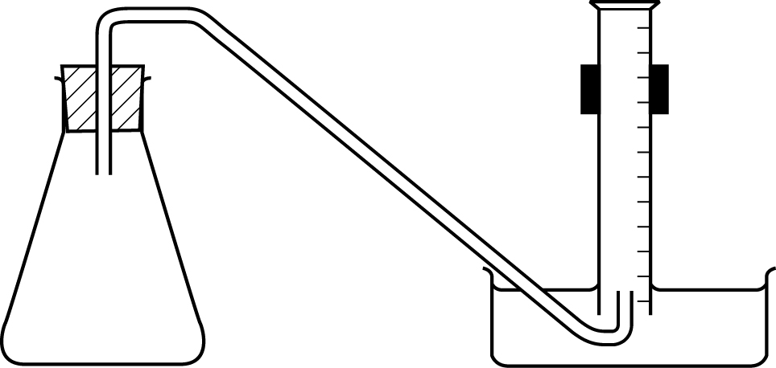

**Hazard symbols**

|  |  |
| --- | --- |
| **C** = corrosive substance | **F** = highly flammable substance |
| **H** = harmful or irritating substance | **O** = oxidising substance |
| **N** = harmful to the environment | **T** = toxic substance |

**Practical 2 – Worksheet**

**Gas volume measurement**

**Aim**

To determine the molar gas volume, *V*m, at room temperature and pressure by adding magnesium to sulfuric acid then collecting and measuring the final volume of hydrogen given off.

**Method A**

|  |  |  |
| --- | --- | --- |
| **Safety:**   * Wear eye protection. * 1.0 mol dm–3 sulfuric acid **[H]**   **Hazard symbols**   |  |  | | --- | --- | | **H** = harmful or irritating substance |  | |

1. Fill the tub with water to a depth of at least 5 cm.

2. Fill the 250 cm3 measuring cylinder completely with water. Hold a piece of paper towel firmly over the top, invert the measuring cylinder and place the open end into the tub.

3. Remove the paper towel and clamp the inverted measuring cylinder so the open end is just above the base of the tub. There should be no air in the measuring cylinder.

4. Use the 25 cm3 measuring cylinder to transfer 25 cm3 of 1.0 mol dm–3 sulfuric acid into the reaction flask.

5. Set up the apparatus as shown in the diagram below. Check that the bung fits tightly in the neck of the reaction flask, and lower the inverted measuring cylinder (if necessary) to ensure that the end of the delivery tube will stay under it. Remove the bung from the reaction flask.

6. Weigh the strip of magnesium ribbon and record the mass.

7. Drop the magnesium into the acid and replace the bung immediately. Swirl the flask to mix the contents.

8. Measure and record the final volume of hydrogen in the measuring cylinder, when the reaction is complete.

9. Repeat the whole experiment twice.

**Extension**

10. Record the temperature of the lab and the atmospheric pressure.

**Diagram of apparatus**



**Results**

Record **all** your observations.

Record the mass of magnesium and volume of hydrogen produced with unambiguous headings and units shown as / g or (g), / cm3 or (cm3), as specified in the syllabus.

**Interpretation and evaluation**

**Calculation**

1. Calculate the number of moles of sulfuric acid added to the reaction flask.

2. Calculate the number of moles of magnesium weighed out.

3. Write the equation for the reaction between magnesium and sulfuric acid. Include state symbols. From your answers to 1 and 2, deduce which reagent is in excess.

4. Deduce the number of moles of hydrogen produced in the reaction.

5. Use your answer to 4 and your results to calculate the volume occupied by one mole of hydrogen, *V*m, under room conditions.

6. The molar gas volume, *V*m, under room conditions, according to the syllabus, is 24 dm3 mol–1.

Calculate the percentage error in your value of *V*m.

**Extension**

7. Use your answer to 5 and the room temperature and pressure to calculate the molar gas volume of hydrogen under standard conditions of 273 K and 101 kPa

**Points to consider**

1. What is the main source of error in this experiment?

How could the method be improved to reduce this error?

2. A metal carbonate could have been used instead of expensive magnesium ribbon. This would lead to a value for the molar volume, *V*m, of carbon dioxide. (This value should be the same as that for hydrogen.)

Suggest two disadvantages of using a metal carbonate, rather than magnesium ribbon, to determine the molar volume, *V*m, of a gas.

For one of your disadvantages, suggest a change in the procedure that would improve the accuracy of the experiment.

**Further work (reaction kinetics)**

**Method B**

Additional equipment

* Stop clock

Carry out steps 1 to 6 as described in Method A.

7. Drop the magnesium into the acid, replace the bung immediately and start the stop clock as soon as possible. Swirl the flask to mix the contents.

8. Record the volume of gas in the measuring cylinder every half-minute until the reaction is complete.

Plot a graph of gas volume against time.