

**Cambridge International**

**AS and A Level Chemistry (9701)**

Practical booklet 6

The chemical properties of ethanol

**Introduction**

Practical work is an essential part of science. Scientists use evidence gained from prior observations and experiments to build models and theories. Their predictions are tested with practical work to check that they are consistent with the behaviour of the real world. Learners who are well trained and experienced in practical skills will be more confident in their own abilities. The skills developed through practical work provide a good foundation for those wishing to pursue science further, as well as for those entering employment or a non-science career.

The science syllabuses address practical skills that contribute to the overall understanding of scientific methodology. Learners should be able to:

1. plan experiments and investigations
2. collect, record and present observations, measurements and estimates
3. analyse and interpret data to reach conclusions
4. evaluate methods and quality of data, and suggest improvements.

The practical skills established at AS Level are extended further in the full A Level. Learners will need to have practised basic skills from the AS Level experiments before using these skills to tackle the more demanding A Level exercises. Although A Level practical skills are assessed by a timetabled written paper, the best preparation for this paper is through extensive hands-on experience in the laboratory.

The example experiments suggested here can form the basis of a well-structured scheme of practical work for the teaching of AS and A Level science. The experiments have been carefully selected to reinforce theory and to develop learners’ practical skills. The syllabus, scheme of work and past papers also provide a useful guide to the type of practical skills that learners might be expected to develop further. About 20% of teaching time should be allocated to practical work (not including the time spent observing teacher demonstrations), so this set of experiments provides only the starting point for a much more extensive scheme of practical work.

© Cambridge International Examinations 2014

**Practical 6 – Guidance for teachers**

**The chemical properties of ethanol**

**Aim**

To investigate the reactions of ethanol by carrying out a range of different experiments.

**Outcomes**

Syllabus section 17.1 (a) (c); 15.2 (a)(ii) (b); 18.1 (d); 19.1 (a) (b)(i)(ii), as well as experimental skills 2 and 3

**Skills included in the practical**

|  |  |
| --- | --- |
| **AS Level skills** | **How learners develop the skills** |
| MMO collection | set up apparatus according to instructions and use it to obtain the expected results |
| PDO layout | observations clearly recorded |
| ACE analysis | describe and summarise the key points of a set of observations |
| ACE conclusions | draw conclusions from interpretations of observations  make scientific explanations of the observations they have described |

**Method**

* Learners must wear eye protection for these investigations. Gloves should also be available.
* A number of experiments are described in this booklet:

**Set 1.** Test tube reactions of ethanol;

**Set 2.** Dehydration of ethanol: collection of and tests on the ethane produced;

**Set 3.** Oxidation of ethanol: collection of and tests on the aqueous ethanal produced;

**Set 4.** Synthesis of ethanoic acid from ethanol.

* Learners should become familiar with using the type of glass-jointed apparatus often used for organic synthesis; see **Method** (**Set 4**). Centres may not have enough apparatus for all learners to carry out the same experiment at the same time, in which case a ‘circus’ of experiments should be devised, where each experiment is set up in a different part of the lab so that all learners have experience of all the types of apparatus. Considerable manual dexterity and team-work in pairs will be needed to set up some of the apparatus used.
* Learners should become confident in handling hazardous chemicals, such as sodium and concentrated sulfuric acid.
* **Set 1.** While learners are using these hazardous materials they should be closely supervised by a teacher.
* **Set 2.** In this experiment there is a risk of cold water being sucked back into a very hot test tube. Learners should be warned to be alert for this, and to remove the delivery tube from the beaker of water immediately if there is any sign of this happening. They should not prolong the heating, once all the ethanol has reacted.
* **Set 3.** In this experiment, the ethanol produced is very volatile and flammable, so it is essential that iced water is used to surround the test tube in which the ethanol is collected.
* **Set 4.** In some Centres, it may be necessary for this experiment to be demonstrated by the teacher. While the reflux stage is taking place, other aspects of the experiments can be discussed.
* All observations during tests should be clearly recorded. Learners should note any colours changes, the state of the products and the vigour of reactions taking place. Precipitates should be identified as such, when appropriate. In general, if gases are produced (such as carbon dioxide) they should be identified by their normal tests.

**Interpretation and evaluation**

* The main reactions of ethanol are covered in this practical work. The reasons for the slower reactions – and why heating is needed – of organic compounds compared with inorganic compounds can be discussed. This may be used to revise bond types, bond energies and reaction kinetics.

**Set 1**

* Discussion can take place to suggest why the flame of burning ethanol is blue and non-smoky.
* The reason for not testing the gas evolved directly with a lighted splint can be discussed. Learners can suggest how to collect the gas for safe testing.
* Learners can be reminded of the reaction of metal carbonates with acid, and the significance of negative results.
* The reason for the low solubility of triiodomethane in water can be discussed.
* The esterification reaction can be extended to prepare other esters.

**Set 2**

* The reason for using the safety flask and the reason for removing the delivery tube from the water before stopping the heating can be discussed. (Both prevent the risk of suck-back of cold water onto the hot glass boiling tube.)
* The addition reactions of alkenes can be introduced or revised.

**Set 3**

* The reason for using anti-bumping granules can be discussed. (These help form small bubbles on boiling and reduce risk of reactants ‘bumping’ over into delivery tube.)
* The oxidation reactions of aldehydes can be introduced. (Sandell’s reagent may be used instead of Fehling’s.) The two tests can also be used with a ketone such as propanone.

**Set 4**

* The reasons for refluxing the reactants can be discussed.
* The use of sodium carbonate to test the product can be discussed. (The product could also be tested with more acidified potassium manganate(VII) or Fehling’s solutions or Tollens’ reagent to show it cannot be oxidised further.)

**Practical 6 – Information for technicians**

**The chemical properties of ethanol**

**Set 1**

**Each learner will require:**

|  |  |  |
| --- | --- | --- |
|  | (a) | Eye protection and gloves |
|  | (b) | Bunsen burner |
|  | (c) | heat proof mat |
|  | (d) | small evaporating dish |
|  | (e) | 3 x test-tube |
|  | (f) | 1 x boiling tube |
|  | (g) | 1 x teat/dropping pipette |
|  | (h) | 1 x 100 cm3 beaker (or smaller) |
|  | (i) | 1 x white tile |
|  | (j) | 1 x test-tube holder |
|  | (k) | 1 x forceps |
|  | (l) | 1 x knife or scalpel |
|  | (m) | filter paper |
|  | (n) | 1 x test-tube rack |
| **[F][C]** | (o) | Sodium, stored in oil |
| **[C]** | (p) | 1 cm3 glacial ethanoic acid |
| **[F][H]** | (q) | 5 cm3 ethanol |
|  | (r) | 50 cm3 0.2 mol dm–3 sodium carbonate |

**Hazard symbols**

|  |  |
| --- | --- |
| **C** = corrosive substance | **F** = highly flammable substance |
| **H** = harmful or irritating substance | **O** = oxidising substance |
| **N** = harmful to the environment | **T** = toxic substance |

**Set 2**

**Each learner will require:**

|  |  |  |
| --- | --- | --- |
|  | (a) | Eye protection and gloves |
|  | (b) | Bunsen burner |
|  | (c) | heat proof mat |
|  | (d) | 1 x boiling tube |
|  | (e) | 4 x test-tube with cork or rubber bung |
|  | (f) | 1 x 250 cm3 beaker (or larger beaker or small tub) |
|  | (g) | 2 x teat/dropping pipette |
|  | (h) | 1 x stand and clamp |
|  | (i) | 1 x conical flask (to act as safety trap) *- optional as it makes successful collection of ethene gas far more difficult.* |
|  | (j) | bungs and delivery tubes (as shown in the diagram)  (the delivery tube from the conical flask to the beaker may be glass, plastic or rubber) |
|  | (k) | 1 x forceps |
|  | (l) | broken pumice (or unglazed pottery) or aluminium oxide |
| **[F][H]** | (m) | 2 cm3 ethanol |
| **[H]** | (n) | 1 cm3 aqueous bromine (0.005 - 0.01 mol dm–3) |
| **[H]** | (o) | 1 cm3 acidified aqueous potassium manganate(VII) |
|  | (p) | mineral or ceramic wool |

**Diagram of apparatus**

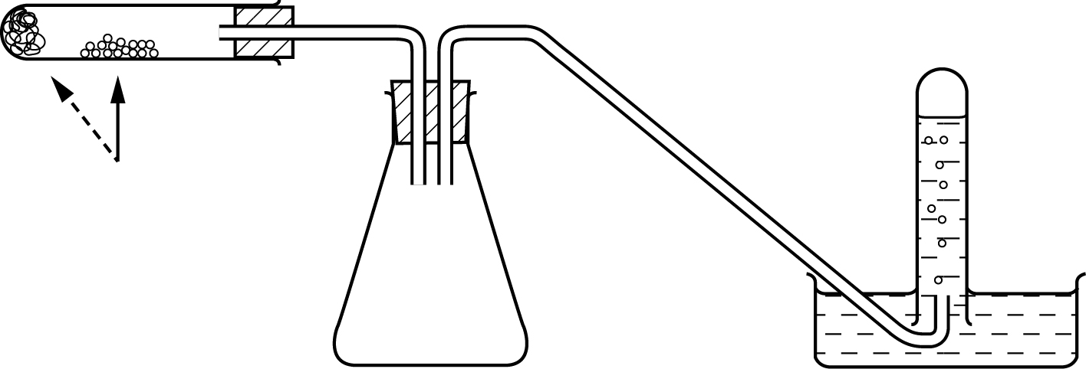

**Hazard symbols**

|  |  |
| --- | --- |
| **C** = corrosive substance | **F** = highly flammable substance |
| **H** = harmful or irritating substance | **O** = oxidising substance |
| **N** = harmful to the environment | **T** = toxic substance |

**Set 3**

**Each learner will require:**

|  |  |  |
| --- | --- | --- |
|  | (a) | Eye protection and gloves |
|  | (b) | 1 x Bunsen burner |
|  | (c) | 1 x heat proof mat |
|  | (d) | 1 x 25 cm3 measuring cylinder |
|  | (e) | access to balance weighing to at least 1 dp |
|  | (f) | 1 x weighing boat or small beaker |
|  | (g) | 1 x boiling tube |
|  | (h) | 1 x stand and clamp |
|  | (i) | 1 x 250 cm3 beaker |
|  | (j) | bung and delivery tube (as shown in the diagram) |
|  | (k) | 3 x test-tube |
| **[F][H]** | (l) | 5 cm3 ethanol |
| **[C]** | (m) | access to Fehling’s A and Fehling’s B solution (**or** Sandell’s reagent **[H]**) |
|  | (n) | 1 cm3 aqueous silver nitrate |
| **[C]** | (o) | 1 cm3 aqueous sodium hydroxide |
|  | (p) | 1 cm3 aqueous ammonia |
| **[H]** | (q) | 10 cm3 dilute sulfuric acid |
| **[H][O][N]** | (r) | 2.5 g potassium manganate (VII) |

**Diagram of apparatus**

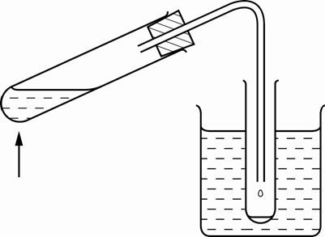

**Hazard symbols**

|  |  |
| --- | --- |
| **C** = corrosive substance | **F** = highly flammable substance |
| **H** = harmful or irritating substance | **O** = oxidising substance |
| **N** = harmful to the environment | **T** = toxic substance |

**Set 4**

**Each learner will require:**

|  |  |  |
| --- | --- | --- |
|  | (a) | Eye protection and gloves |
|  | (b) | 1 x Bunsen burner |
|  | (c) | 1 x heat proof mat |
|  | (d) | 1 x 25 cm3 measuring cylinder |
|  | (e) | access to balance weighing to at least 1 dp |
|  | (f) | 1 x weighing boat or small beaker |
|  | (g) | 1 x tripod and gauze |
|  | (h) | 2 x stand and 3 x clamp |
|  | (i) | 1 x 50 cm3 or 100 cm3 pear-shaped (or round-bottomed) flask |
|  | (j) | 1 x Liebig condenser with suitable tubes from tap and to sink, and bung if needed |
|  | (k) | 1 x adaptor to connect flask and condenser for distillation |
|  | (l) | 1 x thermometer holder (or bung to hold thermometer) |
|  | (m) | 1 x thermometer (–10 ºC to +110 ºC at 1 ºC) |
|  | (n) | 1 x small beaker |
| **[F][H]** | (o) | 1 cm3 ethanol |
| **[H][O][N]** | (p) | 2.5 g potassium manganate (VII) |
| **[H]** | (q) | 10 cm3 dilute sulfuric acid |
| **[C]** | (r) | 2 cm3 concentrated sulfuric acid |
|  | (s) | 2 cm3 0.2 mol dm–3 sodium carbonate |

**Additional Instructions (diagrams)**

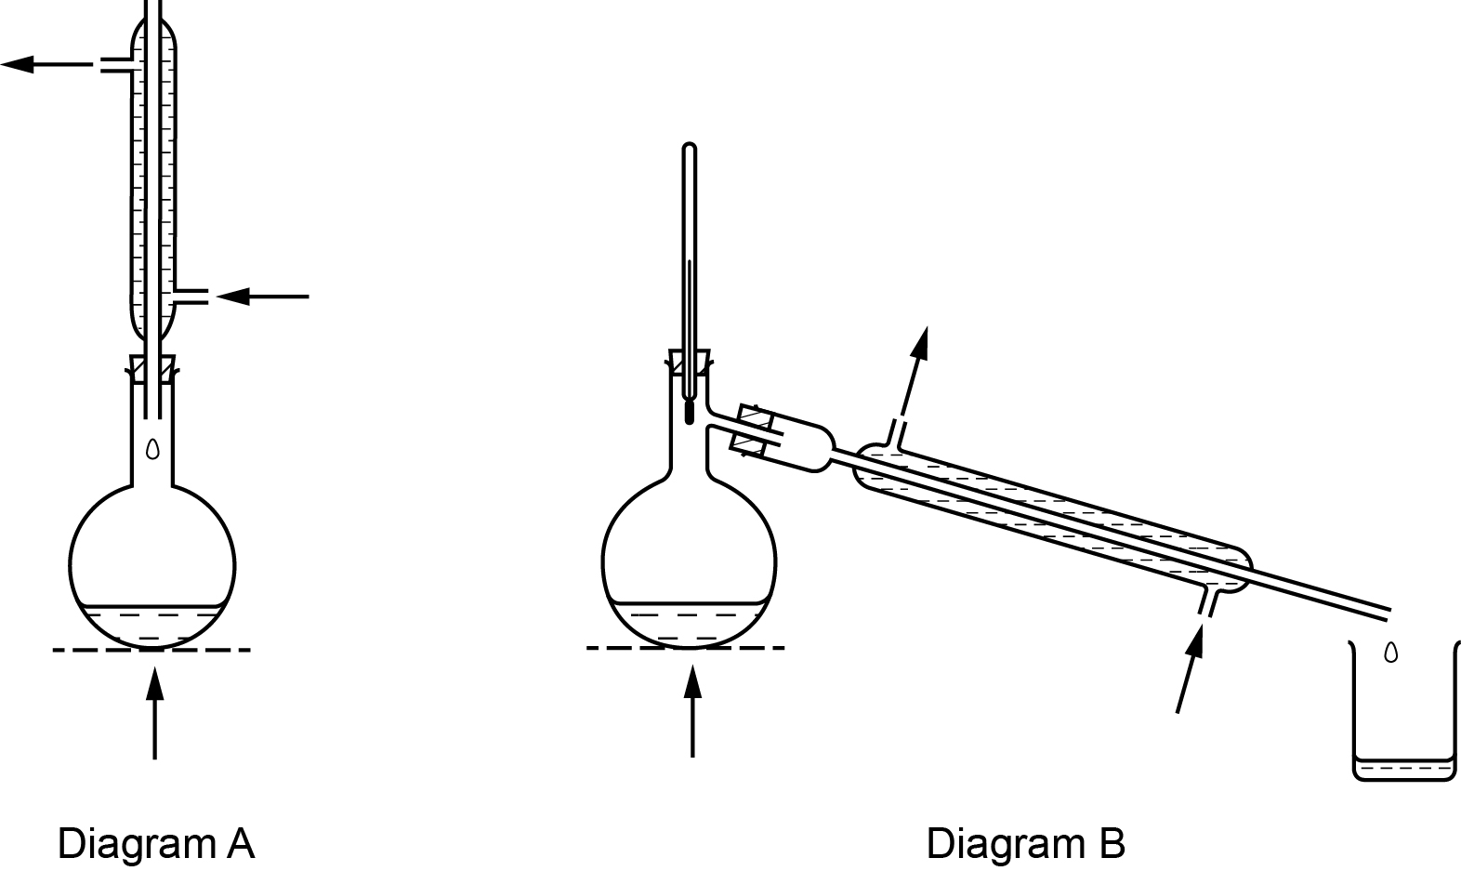

**Hazard symbols**

|  |  |
| --- | --- |
| **C** = corrosive substance | **F** = highly flammable substance |
| **H** = harmful or irritating substance | **O** = oxidising substance |
| **N** = harmful to the environment | **T** = toxic substance |

**Practical 6 – Worksheet**

**The chemical properties of ethanol**

**Aim**

To investigate the reactions of ethanol by carrying out a range of different experiments.

**Set 1. Test-tube experiments with ethanol.**

**Method**

|  |  |  |  |  |
| --- | --- | --- | --- | --- |
| **Safety:**   * Wear eye protection * Gloves may be worn * Ethanol **[F] [H]** * Sodium **[F] [C]** * Glacial ethanoic acid **[C]** * Concentrated sulfuric acid **[C]** * 2 mol dm–3 sodium hydroxide **[C]**   **Hazard symbols**   |  |  | | --- | --- | | **C** = corrosive substance | **F** = highly flammable substance | | **H** = harmful or irritating substance |  | |

**Experiment 1**

1. Use a dropper to place 5 drops of ethanol in a small evaporating dish on a heat proof mat.

2. Use a lighted splint to ignite the ethanol.

3. Observe the flame and any residue.

**Experiment 2**

1. Pour about 1 cm3 of ethanol into a test-tube. Place it in a test-tube rack.

2. **With teacher supervision**, use forceps to place a small lump of sodium on a piece of filter paper on a white tile. Use a knife to cut (approximately) a 1 mm cube of sodium and replace the rest of the lump in its bottle (under oil).

3. Use filter paper to wipe any excess oil off the small piece of sodium. **Do not touch the sodium with your fingers.**

4. Use forceps to transfer the small piece of sodium into the test-tube containing ethanol.

(If any sodium remains after the reaction is complete, add more ethanol until all the sodium has reacted.)

**Experiment 3**

1. Pour a 1 cmdepth of ethanol into a test-tube.

2. Add an equal volume of aqueous sodium carbonate.

**Experiment 4**

1. Pour a 1 cm depth of ethanol into a test-tube.

2 Add about 1 cm3 of aqueous iodine.

3. Add aqueous sodium hydroxide drop by drop, with shaking, until the brown colour of the iodine just disappears. Record your observations and cautiously smell the product.

(Dispose of the product down the sink with plenty of water.)

**Experiment 5**

1. Pour about 1 cm3 of ethanol into a boiling tube.

2. Add several drops of ethanoic acid **[C]** followed by 2 or 3 drops of concentrated sulfuric acid **[C]**. Carefully, shake the tube to mix the reactants.

3. Half fill a small beaker with aqueous sodium carbonate.

4. Use a holder for the boiling tube. Warm its contents gently and carefully over a low Bunsen flame whilst shaking gently.

5. When the mixture starts to boil, tip the contents of the boiling tube into the beaker.

6. Cautiously smell the product.

**Results**

Record **all** your observations.

**Interpretation**

Explain what is occurring in each experiment.

**Set 2. Dehydration of ethanol.**

**Method**

|  |  |  |
| --- | --- | --- |
| **Safety:**   * Wear eye protection * Ethanol **[F] [H]** * Acidified aqueous potassium manganate(VII) **[H]** * aqueous bromine **[H]**   **Hazard symbols**   |  |  | | --- | --- | | **H** = harmful or irritating substance | **F** = highly flammable substance | |

1. Use forceps to push mineral wool down to the bottom of the boiling tube as shown in the diagram. Add about 2 cm3 of ethanol and add more mineral wool if not all the ethanol has soaked in.

2. Clamp the boiling tube horizontally and place broken pumice (or aluminium oxide) into the middle of tube as shown in the diagram.

3. Half fill a large beaker or small tub with water. Fill 4 test-tubes with water and place them upside down in the beaker. Make sure you have corks or bungs that fit the test-tubes ready to use.

4. Set up the apparatus as shown in the diagram. Clamp the boiling tube at its mouth.

5. Heat the pumice (or aluminium oxide) strongly and occasionally move the flame for a very short period to gently heat the mineral wool to drive the ethanol vapour across the very hot pumice. Do not stop heating the pumice.

6. Collect the gas in the inverted test-tubes. Cork each tube when it fills.

7. When no more gas is produced, remove the delivery tube from the water then stop heating the pumice.

8. Carry out the following tests on the gas collected in three test-tubes.

* Add a few drops of aqueous bromine, re-cork the tube and shake it.
* Add a few drops of acidified aqueous potassium manganate(VII), re-cork the tube and shake it.
* Bring a lighted splint to the mouth of the test tube.

(Why might the gas collected in the first tube not react?)



**Results**

Record **all** your observations.

**Interpretation**

Explain what is occurring in each part of the experiment.

Give equations for all reactions.

**Set 3. Partial oxidation of ethanol.**

**Method**

|  |  |  |  |  |
| --- | --- | --- | --- | --- |
| **Safety:**   * Wear eye protection * Ethanol **[F] [H]** * Potassium manganate(VII) **[H] [O] [N]** * 1 mol dm–3 sulfuric acid **[H]**   **Hazard symbols**   |  |  | | --- | --- | | **H** = harmful or irritating substance | **F** = highly flammable substance | | **N** = harmful to the environment | **O** = oxidising substance | |

1. Use a measuring cylinder to transfer 10 cm3 of dilute sulfuric acid into a boiling tube.

2. Use the weighing boat or small beaker to weigh out about 2.3 g of potassium manganate(VII) and add the solid to the boiling tube.

3. Swirl the tube to dissolve the potassium manganate(VII) in the acid. Add 2 or 3 anti-bumping granules.

4. Add about 4 cm3 of ethanol a little at a time to the boiling tube. Shake the tube carefully after each addition.

5. Half-fill a beaker with iced water. This will act as a condenser.

6. Set up the apparatus as shown in the diagram.



7. Warm the reaction mixture gently and collect the product in the test-tube.

8. Carry out the following tests on portions of the product.

* Cautiously smell the product and compare the smell with that of ethanol.
* Transfer about a 1 cm depth of the product into a test-tube. Add several drops of Fehling’s A solution followed by enough Fehling’s B solution to make a deep blue solution. Place the tube in a beaker half-full of water and heat the water. (This acts as a hot water bath.)
* To a 1 cm depth of aqueous silver nitrate in a **clean** test-tube add 1 or 2 drops of aqueous sodium hydroxide and shake the tube. A brown precipitate will form. Add aqueous ammonia drop by drop with shaking until the brown precipitate **just** dissolves. You have now made Tollens’ reagent. Now add about a 1 cm depth of the product, shake the tube to mix the reactants. Place the test-tube in the hot water bath. (Dispose of the contents of the tube down the sink with plenty of water as soon as the reaction is complete.)

The preparation of the product may be carried out using the apparatus for distillation shown in diagram B of the Set 4 method. However, the test tube used to collect the product must be surrounded by iced water, as shown above.

**Results**

Record **all** your observations.

**Interpretation**

Explain what is occurring in each part of the experiment.

**Set 4. Further oxidation of ethanol.**

**Method**

|  |  |  |  |  |  |  |
| --- | --- | --- | --- | --- | --- | --- |
| **Safety:**   * Wear eye protection * Gloves may be worn * Ethanol **[F] [H]** * Potassium manganate(VII) **[H] [O] [N]** * 1 mol dm–3 sulfuric acid **[H]** * concentrated sulfuric acid **[C]**   **Hazard symbols**   |  |  | | --- | --- | | **C** = corrosive substance | **F** = highly flammable substance | | **H** = harmful or irritating substance | **O** = oxidising substance | | **N** = harmful to the environment | **T** = toxic substance | |

1. Use a measuring cylinder to transfer 10 cm3 of dilute sulfuric acid into a pear-shaped (or round-bottomed) flask.
2. Use the weighing boat or small beaker and weigh out about 2.3 g of potassium manganate(VII) and add the solid to the flask. Swirl the flask to dissolve the potassium manganate(VII) in the acid.

3. Add 2 or 3 anti-bumping granules. Add 2 cm3 of concentrated sulfuric acid **[care]** in **small** portions while cooling the mixture under the tap or in a beaker of cold water.

4. Set up the apparatus for refluxing as shown in diagram A.



5. Run water from the tap through the outer tubing of the condenser. Add 1 cm3 of ethanol a few drops at a time down the middle of the condenser into the pear-shaped flask.

6. Heat the reaction mixture carefully until it boils. Adjust the flame so that there is a steady drip-back of reactants into the flask from the condenser and vapour does not escape from the top. Reflux the mixture for about 20 minutes then switch off the Bunsen burner and allow the flask to cool.

7. Remove the condenser and set up the apparatus for distillation as shown in diagram B.

8. Distil off a few cm3 of product.

* Smell the product cautiously.
* Add about 1 cm3 of aqueous sodium carbonate to the product.

**Results**

Record **all** your observations.

**Interpretation**

Explain what is occurring in each part of the experiment.