

**Cambridge International**

**AS and A Level Chemistry (9701)**

Practical booklet 10

Amide hydrolysis

**Introduction**

Practical work is an essential part of science. Scientists use evidence gained from prior observations and experiments to build models and theories. Their predictions are tested with practical work to check that they are consistent with the behaviour of the real world. Learners who are well trained and experienced in practical skills will be more confident in their own abilities. The skills developed through practical work provide a good foundation for those wishing to pursue science further, as well as for those entering employment or a non-science career.

The science syllabuses address practical skills that contribute to the overall understanding of scientific methodology. Learners should be able to:

1. plan experiments and investigations
2. collect, record and present observations, measurements and estimates
3. analyse and interpret data to reach conclusions
4. evaluate methods and quality of data, and suggest improvements.

The practical skills established at AS Level are extended further in the full A Level. Learners will need to have practised basic skills from the AS Level experiments before using these skills to tackle the more demanding A Level exercises. Although A Level practical skills are assessed by a timetabled written paper, the best preparation for this paper is through extensive hands-on experience in the laboratory.

The example experiments suggested here can form the basis of a well-structured scheme of practical work for the teaching of AS and A Level science. The experiments have been carefully selected to reinforce theory and to develop learners’ practical skills. The syllabus, scheme of work and past papers also provide a useful guide to the type of practical skills that learners might be expected to develop further. About 20% of teaching time should be allocated to practical work (not including the time spent observing teacher demonstrations), so this set of experiments provides only the starting point for a much more extensive scheme of practical work.

© Cambridge International Examinations 2014

**Practical 10 – Guidance for teachers**

**Amide hydrolysis**

**Aim**

To hydrolyse an aromatic amide, purify the product, calculate a percentage yield and determine the melting point.

**Outcomes**

Syllabus section 20.2 as well as experimental skills 2, 3, and 4

**Skills included in the practical**

|  |  |
| --- | --- |
| **A Level skills** | **How learners develop the skills** |
| Analysis | calculate theoretical yield and percentage yield of product |
| Evaluation | identify the most significant sources of error in the experiment  suggest ways to improve the accuracy of the procedure |
| Conclusions | draw conclusions from interpretations of observations, data and calculated values  make scientific explanations of the data, observations and conclusions that they have described |

This practical provides an opportunity to build on essential skills introduced at AS Level.

|  |  |
| --- | --- |
| **AS Level skills** | **How learners develop the skills** |
| MMO collection | follow instructions given in the form of written instructions or diagrams  set up and use apparatus suitable for an organic synthesis |
| PDO display | show their working in calculations, and the key steps in their reasoning  use the correct number of significant figures for calculated quantities |

**Methods A, B and C**

This experiment is suitable for learners to work in pairs or small groups.

* **Learners must wear eye protection for these investigations**.
* In Method A, learners work in pairs or small groups to prepare benzenecarboxylic acid (benzoic acid, C6H5COOH) by alkaline hydrolysis of benzenecarboxamide (benzamide, C6H5CONH2) under reflux. The first stage of the reaction (steps 7 – 9) produces sodium benezenecarboxylate.
* This salt is then converted into benzenecarboxylic acid by an acid displacement reaction using HC*l* in step 10. Benzenecarboxylic acid has a low solubility in cold water, due to its benzene ring, so the product precipitated is separated and collected by Buchner (reduced-pressure) filtration.
* In Method B, learners purify their product by recrystallization. It is important to use the minimum volume of hot solvent to dissolve the organic solid, otherwise much more of it than necessary is lost during the purification step. Since the impurities are present in low quantity in the impure product, they do not form a saturated solution, so they remain in solution when the saturated solution is cooled.
* In Method C, learners will determine the melting point of their purified solid. Impurities lower the melting point of a solid and also cause the melting point to take place over a wider range As a result, they will assess the purity of their final sample
* As a result of carrying out these experiments, learners should become familiar with common techniques used in organic synthesis and purification. They should also become confident in assembling and using this type of apparatus.

**Results**

* Learners should draw up a table for their results which includes the masses of benzenecarboxamide (benzamide) and benzenecarboxylic acid (benzoic acid).
* Their recorded balance readings should be to a consistent number of decimal places.
* They should note the colours of reactant and product and also any change in the colours of the litmus papers.

**Interpretation and evaluation**

* Other examples of hydrolysis can be revised (esters, acyl chlorides as having a similar group – and their relative reactivity towards hydrolysis).
* The correct way of showing reaction mechanisms can be revised (curly arrow from a lone pair on OH– to δ+ C of –COO– group).
* If the learners fail to detect the ammonia from the condenser, the likely products of the reaction can be discussed.
* The calculation of percentage yield can be revised. The number of significant figures will depend on the precision of the balance used. (Syllabus: Calculated quantities should be given to the same number of significant figures as (or one more than) the measured quantity of least accuracy.)
* The percentage yield can be collected from each group and compared. This can form the basis for brainstorming the possible reasons why the yield must be less than 100% and discussion of ways to maximise the yield.

(Yield: the cold solution will be saturated with benzenecarboxamide so 100% yield is impossible. If the water is evaporated to obtain more crystals then any soluble impurity will also solidify and the purity of the product will decrease. Other factors may include insufficient refluxing so not all the benzenecarboxamide is hydrolysed – reflux for longer (until no more ammonia is detected); some benzenecarboxylic acid remains in (alkaline) solution – add more acid; some product will be held in the pores of the filter papers.)

* The melting point range can be collected from each group and compared. This can form the basis for discussing the possible reasons for impurities to be present.

(Impurities: may include insufficient refluxing so some benzenecarboxamide still present; presence of impurity in benzenecarboxamide which behaves in a similar way to benzenecarboxylic acid.)

**Typical results**

mass benzenecarboxamide / g = 2.98

mass benzenecarboxylic acid / g = 2.39

% yield = (0.0196/0.0246) x 100 = 79.7%

mp / ºC = 119–121 ºC

**Practical 10 – Information for technicians**

**Amide hydrolysis**

**Each learner will require:**

|  |  |  |
| --- | --- | --- |
|  | (a) | Eye protection |
|  | (b) | 1 x 250 cm3 beaker (or larger) |
|  | (c) | 3 or 4 x 100 cm3 beaker * |
|  | (d) | 1 x 25 cm3 measuring cylinder |
|  | (e) | 1 x 50 cm3 or 100 cm3 pear-shaped or round-bottomed flask |
|  | (f) | 1 x Liebig condenser with plastic or rubber tubing to go to the tap and sink |
|  | (g) | 1 x stand and 2 x clamp |
|  | (h) | 1 x Bunsen burner |
|  | (i) | 1 x heat proof mat |
|  | (j) | 1 x tripod and gauze |
|  | (k) | access to 1 x Buchner funnel and filter papers ** |
|  | (l) | access to 1 x Buchner (side-arm) flask ** |
|  | (m) | access to1 x filter pump (water pump) ** with tubing to fit onto the tap |
|  | (n) | 1 x sample bottle (or other small container suitable for weighing product) |
|  | (o) | 1 x thermometer reading to 250 ºC or 360 ºC |
|  | (p) | 1 x melting point tube (glass capillary tube) |
|  | (q) | metal stirrer *** (see diagram C) |
|  | (r) | 1 x small piece of rubber tubing or rubber band |
|  | (s) | 1 x large watch glass or evaporating dish |
| **[H]** | (t) | 3.5 g benzenecarboxamide (benzamide) |
| **[C]** | (u) | 25 cm3 2 mol dm–3 sodium hydroxide |
| **[C]** | (v) | 10 cm3 concentrated hydrochloric acid |
| **[F][H]** | (w) | 5 cm3 ethanol |
|  | (x) | 50 cm3 distilled water |
|  | (y) | ice |
|  | (z) | 40 cm3 paraffin oil (liquid paraffin) *** |
|  | (aa) | access to balance weighing to at least 1 decimal place |
|  | (bb) | paper towel |

**Additional instructions**

*One 100 cm3 beaker may be replaced with a weighing boat, another with a small conical flask (about 100 cm3 capacity).

** If this apparatus is not available then each group of learners will require 1 x filter funnel (stemless is preferable) and filter papers, 1 x conical flask.

*** If melting point apparatus is available then it should be used in place of the paraffin oil bath.

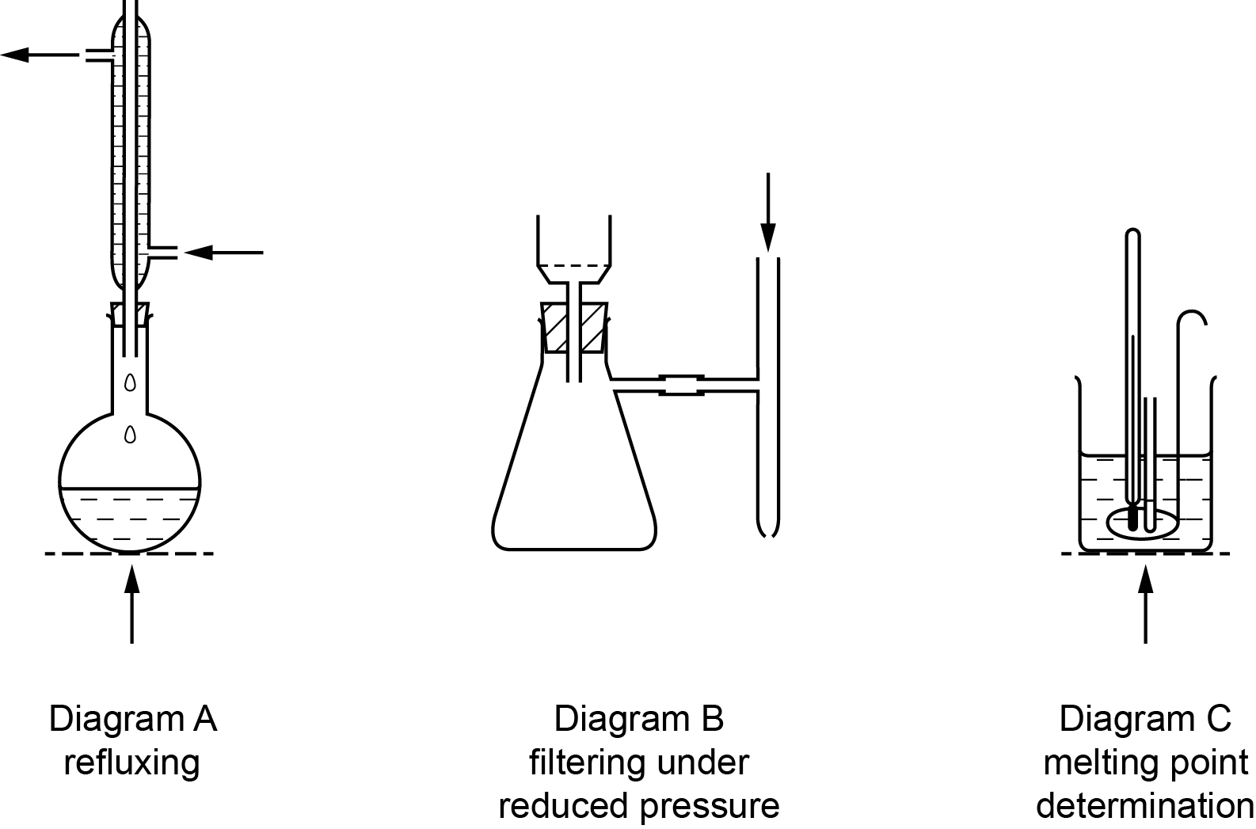

**Hazard symbols**

|  |  |
| --- | --- |
| **C** = corrosive substance | **F** = highly flammable substance |
| **H** = harmful or irritating substance | **O** = oxidising substance |
| **N** = harmful to the environment | **T** = toxic substance |

**Practical 10 – Worksheet**

**Amide hydrolysis**

**Aim**

To hydrolyse an aromatic amide, purify the product, calculate a percentage yield and determine the melting point.

**Method**

|  |  |  |  |  |
| --- | --- | --- | --- | --- |
| Safety:   * Wear eye protection. * benzenecarboxamide **[H]** * 2 mol dm–3 sodium hydroxide **[C]** * concentrated hydrochloric acid **[C]** * ethanol **[F] [H]** * product of reaction **[H]**   **Hazard symbols**   |  |  | | --- | --- | | **C** = corrosive substance | **F** = highly flammable substance | | **H** = harmful or irritating substance |  | |

**Part A. Hydrolysis of the amide**

1. Weigh a small beaker or weighing boat. Record the balance reading.
2. Add between 2.9 and 3.1 g of benzenecarboxamide (benzamide) and record the new balance reading.
3. Use a filter funnel to help transfer the benzenecarboxamide into a pear-shaped or round-bottomed flask.
4. Reweigh the small beaker or weighing boat with any residual benzenecarboxamide. Record the balance reading and the mass of benzenecarboxamide transferred to the flask.
5. Use a measuring cylinder to transfer 20 cm3 of 2.0 mol dm–3 sodium hydroxide **[C]** into the flask with the benzenecarboxamide.
6. Clamp the flask above a Bunsen burner and attach a condenser vertically to the flask as shown in diagram A.
7. Run water through the condenser then start heating the flask **gently**. Test for any gas or vapour coming out of the top of the condenser with pieces of damp red and blue litmus paper.
8. Adjust the flame so that there is a steady drip-back of reactants into the flask from the condenser. (This technique is called refluxing.)
9. Reflux the contents of the flask for about 20 minutes then switch off the Bunsen burner and allow the apparatus to cool.
10. Tip the cooled contents of the flask into a 100 cm3 beaker and use a dropper to add concentrated hydrochloric acid **[C]** until no further reaction is visible.
11. Filter the solid product **[H]**. If possible filter the product under reduced pressure using a Buchner funnel, Buchner (side-arm) flask and a filter pump (attached to the cold tap). (See diagram B.)
12. When you set up the Buchner funnel, place one piece of filter paper (it should just fit the funnel over the grid) and dampen it with a little distilled water. Then add a second piece of the filter paper and dampen it again. The funnel is now ready for use. When you filter the product make sure that there is a good seal between the funnel and the flask. Do not turn off the tap operating the filter pump before removing the funnel or, at least, breaking the seal so that water does not enter the flask.

**Part B: purifying the product [H]**

1. Rinse the solid product with a few cm3 of **cold** distilled water and then about 2 cm3 of ethanol. If you are using a filter pump, suck air through the solid to help dry it.
2. Scrape the impure product into a small clean conical flask or beaker with a spatula. Place the container with the impure product in a hot water bath. (This may be a larger beaker heated over a Bunsen burner.)
3. Heat about 40 cm3 of **distilled** water in a clean 100 cm3 beaker until it is very hot.
4. Add the very hot **distilled** water in approximately 1 cm3 portions to the impure product and stir to dissolve it. Use the minimum volume of very hot **distilled** water for the all solid to dissolve.

If some solid appears to be insoluble in the hot distilled water then you will need to carry out hot filtration to remove the solid impurity. In this case you need to prevent the desired product from crystallising in the funnel. You can do this by running very hot water through the filter paper before filtering. This time the material you will need to keep is in the filtrate so check that there is no water in your filter flask. (Some product is likely to solidify in the cold filter flask.)

1. Cool the container with the hot solution by placing it in an ice bath until crystals form. (If you had to carry out hot filtration then this will be the filter flask.)
2. Filter off the crystals (preferably under reduced pressure) and rinse them with about 2 cm3 of distilled water followed by 2 cm3 of ethanol. Place the filter paper with the crystals on a large watch glass or evaporating dish. Allow the crystals to dry, either by leaving them overnight or by heating for a short time in an oven at about 70 ºC.
3. Weigh a sample bottle (or clean weighing boat or small beaker) and record the mass. Carefully tip the (cooled) dry crystals into the weighed container and reweigh. Record the new mass and the mass of purified product.

**Part C: checking the purity of the product [H] by melting point determination**

1. Seal one end of a melting point tube (glass capillary tube) by rotating the end in the hot part of the Bunsen flame. Let the glass cool.
2. Press the open end of the tube carefully into the dry crystals of product. Hold the tube vertically with the sealed end down and tap the outside of the top of the tube so the crystals fall to the bottom. Keep adding crystals until the depth is about 1 cm.
3. Attach the melting point tube to a thermometer reading to either 250 ºC or 360 ºC with a small piece of rubber tubing or rubber band. The end of the melting point tube containing the crystals should be level with the bulb of the thermometer.
4. Clamp the thermometer in a 100 cm3 beaker about half full of paraffin oil. Make sure that the open end of your melting point tube is above the oil level. (See diagram C.)
5. Heat the oil and use a stirrer to ensure the temperature is approximately uniform. When the temperature reaches about 100 ºC heat the oil gently so the temperature rises by about 2 ºC per minute. (Keep stirring the oil.)
6. Note the temperature at which the crystals start to melt and the temperature when all the crystals have melted. This is the melting point range of your product.



**Results**

Record **all** your observations.

Draw a table for your results which includes the masses of benzenecarboxamide (benzamide) and benzenecarboxylic acid (benzoic acid).

Your recorded balance readings should be to a consistent number of decimal places.

Note the colours of reactant and product and also any change in the colours of the litmus papers.

**Interpretation and evaluation**

For data required, refer to the Periodic Table.

1. The formula of benzenecarboxamide is C6H5CONH2. Calculate the number of moles of benzenecarboxamide you placed in the flask.
2. Explain the observation you made whilst refluxing and testing for vapours.
3. Sodium hydroxide and benzenecarboxamide react in a 1 : 1 mole ratio.

(i) Complete the equation for the reaction taking place during the reflux.

C6H5CONH2 + NaOH → +

(ii) Show by calculation that the sodium hydroxide is in excess

(iii) Use ‘curly arrows’ to draw the mechanism for the hydrolysis of benzenecarboxamide.

1. A strong acid will displace a weaker one from its salt.

Name, and give the formula of, the crystalline product of the reactions in step 10 of method A.

1. Calculate the theoretical yield of your crystalline product. (If you are not sure of its identity, ask your teacher for assistance.)

Calculate the percentage yield of crystalline product you obtained.

Suggest reasons why this yield is unlikely to be close to 100%.

1. Impurities in the product will reduce its melting point and will cause it to melt over a range of temperatures. This temperature range decreases as the purity of the product increases.

The melting point of the product when pure is 122 ºC.

Comment on the purity of your crystalline product.