

**Cambridge International**

**AS and A Level Physics (9702)**

Practical booklet 1

Determination of the spring constant *k* of a spring using the principle of moments

**Introduction**

Practical work is an essential part of science. Scientists use evidence gained from prior observations and experiments to build models and theories. Their predictions are tested with practical work to check that they are consistent with the behaviour of the real world. Learners who are well trained and experienced in practical skills will be more confident in their own abilities. The skills developed through practical work provide a good foundation for those wishing to pursue science further, as well as for those entering employment or a non-science career.

The science syllabuses address practical skills that contribute to the overall understanding of scientific methodology. Learners should be able to:

1. plan experiments and investigations
2. collect, record and present observations, measurements and estimates
3. analyse and interpret data to reach conclusions
4. evaluate methods and quality of data, and suggest improvements.

The practical skills established at AS Level are extended further in the full A Level. Learners will need to have practised basic skills from the AS Level experiments before using these skills to tackle the more demanding A Level exercises. Although A Level practical skills are assessed by a timetabled written paper, the best preparation for this paper is through extensive hands-on experience in the laboratory.

The example experiments suggested here can form the basis of a well-structured scheme of practical work for the teaching of AS and A Level science. The experiments have been carefully selected to reinforce theory and to develop learners’ practical skills. The syllabus, scheme of work and past papers also provide a useful guide to the type of practical skills that learners might be expected to develop further. About 20% of teaching time should be allocated to practical work (not including the time spent observing teacher demonstrations), so this set of experiments provides only the starting point for a much more extensive scheme of practical work.

© Cambridge International Examinations 2014

**Practical 1 – Guidance for teachers**

**Determination of the spring constant *k* of a spring using the principle of moments**

**Aim**

To apply Hooke’s Law and the principle of moments to a practical situation.

**Outcomes**

Syllabus sections 1.2e, 2.1a, 5.2a, 5.3a, 9.1b

**Skills included in the practical**

|  |  |
| --- | --- |
| **AS Level skills** | **How learners develop the skills** |
| MMO collection | Balance a loaded metre rule  Measure the length of a spring using a ruler  Measure mass using a balance |
| MMO values |
| MMO quality of data |
| PDO table | Collect and record data in a table |
| PDO recording |
| PDO graph | Draw a graph and determine the gradient and *y*-intercept |
| ACE interpretation | Interpret the gradient and *y*-intercept |
| ACE conclusions | Determine the spring constant |
| ACE limitations | Identify the limitations of the experimental procedure |
| ACE improvements | Identify possible improvements to the experimental procedure |

**Theory**

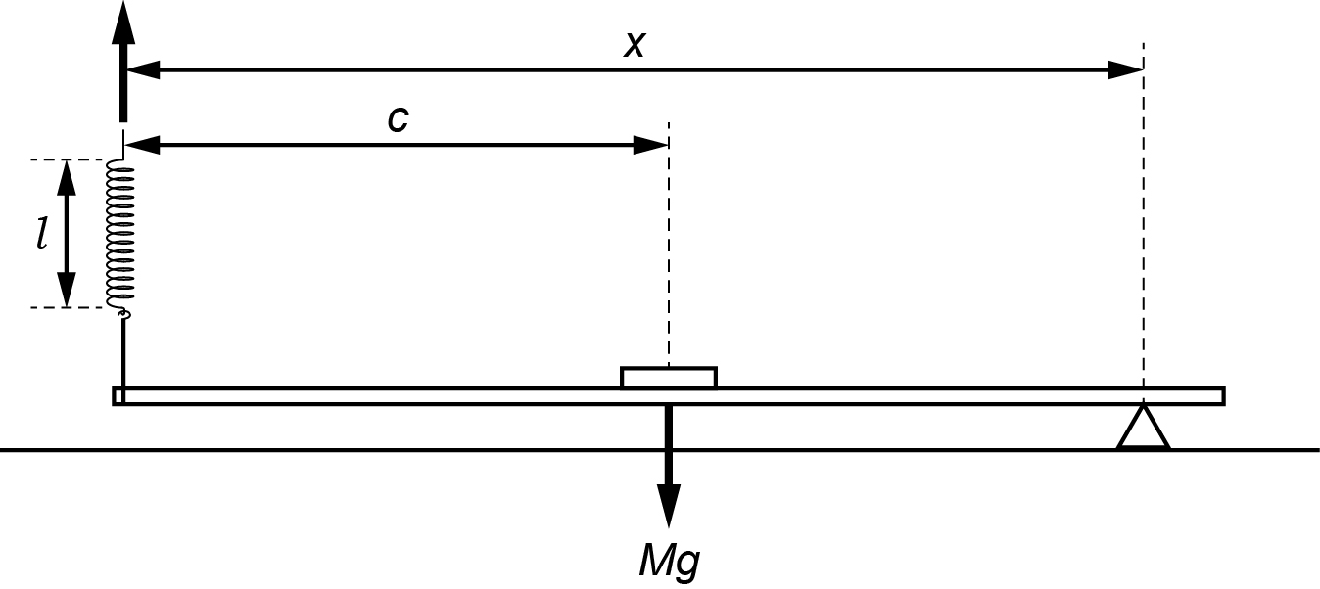

A 100 g mass is attached to the mid-point of a metre rule. This makes the rule artificially heavier so that appreciable changes in the length of the spring can be measured later. Learners have to consider the irregular shape of a slotted mass when attaching it to the centre of the rule.

The combined mass of the rule and 100 g mass is *M*.

The loaded metre rule is supported by the pivot and the spring. The rule is horizontal and the spring is vertical. Assuming that the string is at the end of the rule, then taking moments about the pivot:

Clockwise moment = *k*(*l* – *l* 0)*x* where *l* 0 is the unstretched length of the coiled part of the spring.

Anticlockwise moment = *Mg*(*x* – *c*)

So, *Mg*(*x* – *c*) = *k*(*l* – *l*0)*x* when the rule is balanced

$$Mgx-Mgc=klx-kl_{0}x$$

$$klx=-Mgc+Mgx+kl_{0}x$$

$$klx=-\frac{Mgc}{kx}+\frac{Mg}{k}+l_{0}$$

$$l=-\frac{Mgc}{kx}+\frac{Mg}{k}+l_{0}$$

$$l=-\frac{Mgc}{k}∙\frac{1}{x}+\left(\frac{Mg}{k}+l_{0}\right)$$

$$l=-\frac{A}{x}+B$$

If the pivot is moved to a new position (*x*), the height of the spring must be changed for the rule to return to a horizontal position and so the length (*l*) of the stretched part of the spring changes.

If six sets of readings are taken and a graph is plotted of *l* on the *y*-axis against 1/*x* on the *x*-axis, the gradient = –*A* and the *y*-intercept = *B.*

Since $A=\frac{Mgc}{k}$ and $B=\frac{Mg}{k}+l_{0}$, two values of *k* can be determined knowing values for *M*, *c*, *g* and *l*0.

If the graph line through the plotted points is not close to the *y*-axis, the *y*-intercept has to be calculated using the equation of straight line *y* = *mx* + *c*. This could mean that one value of *k* is more reliable than the other.

A more direct method for determining *k* is to find the gradient of a force-extension graph.

Some physical quantities are often determined in an indirect method e.g. the mass of the Sun is not measured directly but calculated from other measurements such as the time periods of planets.

**Method**

* Learners balance the metre rule as shown and note the reading *c* of the rule directly above the pivot.

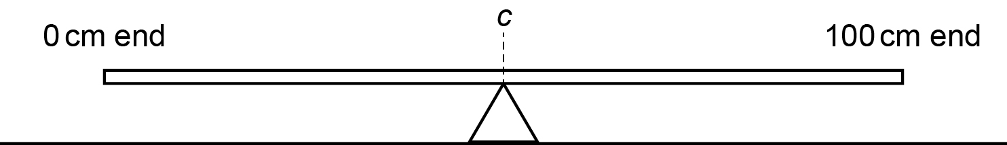

* They then place the 100 g mass over the centre of the rule so that it still balances at *c* and then they tape the mass to the rule as shown.

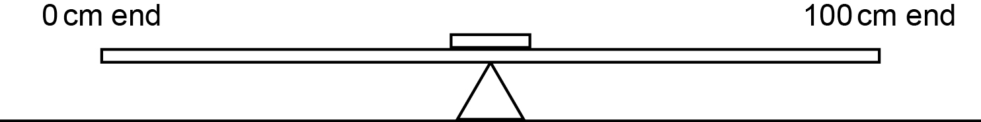

* Using an electronic balance, learners will determine the mass *M* in kg of the combined mass of the rule and the attached mass.
* They then measure and record the length *l*0 of the coiled section of the unstretched spring.
* Learners then set up the apparatus as shown with the rule horizontal and the spring vertical. The string should be as close to the end of the rule as possible.

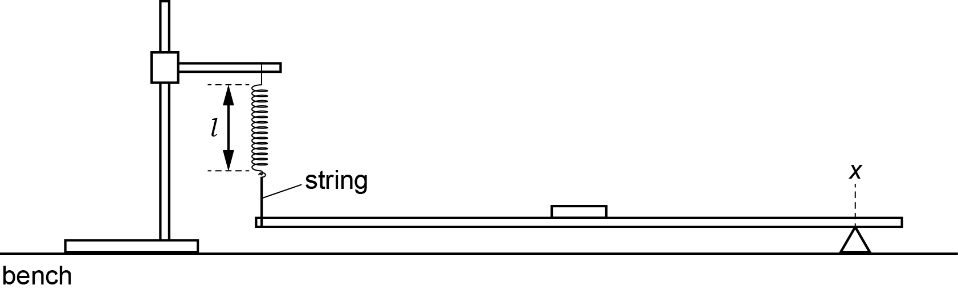

* Learners need to note the reading at *x* and the length *l* of the coiled part of the spring.

**Results**

Learners need to vary the position of the pivot until they have six sets of values of *x* and *l* and enter them in a table like that below, including values of 1/*x*. All values should be in SI units because later on in the analysis the value of *g* is given in SI units.

All raw values of *x* and *l* should be to the same number of decimal places, i.e. to the nearest mm allowed by the rule.

The number of significant figures for 1/*x* should be the same as, or one more than, the number of significant figures for the corresponding value of *x.*

|  |  |  |
| --- | --- | --- |
| ***x*/m** | ***l*/m** | **(1/*x*)/m–1** |
|  |  |  |
|  |  |  |
|  |  |  |
|  |  |  |
|  |  |  |
|  |  |  |

Learners then plot a graph of *l* on the *y*-axis against 1/*x* on the *x*-axis and draw the line of best fit

**Interpretation and evaluation**

Learners

* determine the gradient and the *y*-intercept of their graph line

$\text{gradient}=\frac{Mgc}{k}$ where *k* is the spring constant and *g* = 9.81 m s–2

* use their values of *M*, *c*, *l*0, gradient and *y*-intercept to determine values for *k*
* include an appropriate unit for *k*
* discuss whether one determination of *k* is more reliable than the other and explain why
* describe the main sources of uncertainty in this investigation*
* describe how they could improve the investigation.

*values of *c* and *x* assume that the bottom of the rubber band is at the 0 cm mark

*the coils of the spring are tilted when *l* is measured.

**Practical 1 – Information for technicians**

**Determination of the spring constant *k* of a spring using the principle of moments**

**Each learner will require:**

|  |  |
| --- | --- |
| (a) | one retort stand |
| (b) | one clamp |
| (c) | one boss |
| (d) | one spring |
| (e) | string |
| (f) | one metre rule with a millimetre scale |
| (g) | one 100 g mass |
| (h) | one small roll of adhesive tape |
| (i) | one triangular glass prism or small triangular pivot |
| (j) | one 30 cm ruler with a millimetre scale |
| (k) | access to an electronic balance |

**Practical 1 – Worksheet**

**Determination of the spring constant *k* of a spring using the principle of moments**

**Aim**

To apply Hooke’s Law and the principle of moments to a practical situation.

**Method**

1. Balance the metre rule as shown and note the reading *c* of the rule directly above the pivot.



1. Place the 100 g mass over the centre of the rule so that it still balances at *c* and tape the mass to the rule as shown.



1. Use the electronic balance to find the mass *M* in kg of the combined mass of the rule and the attached mass.
2. Measure and record the length *l*0 of the coiled section of the unstretched spring.

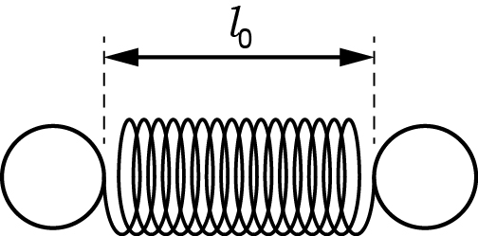

1. Set up the apparatus as shown with the rule horizontal and the spring vertical. The string should be as close to the end of the rule as possible.



1. Note the reading at *x* and the length *l* of the coiled part of the spring.
2. Change the position of the pivot until you have six sets of values of *x* and *l*.
3. Include values of 1/*x* in the table.

**Results**

Record all of your results in a table.

|  |  |  |
| --- | --- | --- |
| ***x*/m** | ***l*/m** | **(1/*x*)/m–1** |
|  |  |  |
|  |  |  |
|  |  |  |
|  |  |  |
|  |  |  |
|  |  |  |

**Note**

* All values will be in SI units because later on in the analysis the value of *g* is used.
* All raw values of *x* and *l* should be to the same number of decimal places i.e. to the nearest mm.
* The number of significant figures for 1/*x* should be the same as or one more than the number of significant figures for the corresponding value of *x*.

**Interpretation and evaluation**

1. Plot a graph of *l* on the *y*-axis against 1/*x* on the *x*-axis.
2. Draw the line of best fit through your points.
3. Find the gradient of your graph.
4. Find the *y*-intercept of your graph.
5. Theory suggests that *l* and *x* are related by the equation $l=-\frac{A}{x}+B$ where *A* and *B* are constants.
6. Use your results for the gradient and y-intercept to find values for *A* and *B*. Include appropriate units.
7. $A=\frac{Mgc}{k}$,where *k* is the spring constant and *g* = 9.81 ms-2

Use your values of *M*, *c*, *l*0, *A* and *B* to determine values for *k*. Include an appropriate unit for *k*.

1. Discuss whether one determination of *k* is more reliable than the other and explain why.
2. Describe the main sources of uncertainty in this investigation.
3. Describe how you could improve the investigation.