

**Cambridge International**

**AS and A Level Physics (9702)**

Practical booklet 2

How the torsional motion of a disc depends on its mass and diameter

**Introduction**

Practical work is an essential part of science. Scientists use evidence gained from prior observations and experiments to build models and theories. Their predictions are tested with practical work to check that they are consistent with the behaviour of the real world. Learners who are well trained and experienced in practical skills will be more confident in their own abilities. The skills developed through practical work provide a good foundation for those wishing to pursue science further, as well as for those entering employment or a non-science career.

The science syllabuses address practical skills that contribute to the overall understanding of scientific methodology. Learners should be able to:

1. plan experiments and investigations
2. collect, record and present observations, measurements and estimates
3. analyse and interpret data to reach conclusions
4. evaluate methods and quality of data, and suggest improvements.

The practical skills established at AS Level are extended further in the full A Level. Learners will need to have practised basic skills from the AS Level experiments before using these skills to tackle the more demanding A Level exercises. Although A Level practical skills are assessed by a timetabled written paper, the best preparation for this paper is through extensive hands-on experience in the laboratory.

The example experiments suggested here can form the basis of a well-structured scheme of practical work for the teaching of AS and A Level science. The experiments have been carefully selected to reinforce theory and to develop learners’ practical skills. The syllabus, scheme of work and past papers also provide a useful guide to the type of practical skills that learners might be expected to develop further. About 20% of teaching time should be allocated to practical work (not including the time spent observing teacher demonstrations), so this set of experiments provides only the starting point for a much more extensive scheme of practical work.

© Cambridge International Examinations 2014

**Practical 2 – Guidance for teachers**

**How the torsional motion of a disc depends on its mass and diameter**

**Aim**

To investigate the torsional motion of a disc and how this motion depends on the dimensions of the disc. This experiment involves using a stopwatch to measure intervals of time, including the period of an oscillating system by timing an appropriate number of consecutive oscillations.

**Outcomes**

Syllabus sections 1.2e, 2.1a, 2.2c

**Skills included in the practical**

|  |  |
| --- | --- |
| **AS Level skills** | **How learners develop the skills** |
| MMO collection | Measure the radius of a mass hanger using a ruler  Measure mass using a balance  Measure times using a stopwatch |
| MMO values |
| MMO quality of data |
| PDO table | Collect and record data in a table |
| PDO recording |
| ACE conclusions | Draw conclusions relating to the validity, or otherwise, of a given relationship |
| ACE estimating uncertainties | Estimate the uncertainty in the radius of the disc |
| ACE limitations | Identify the limitations of the experimental procedure |
| ACE improvements | Identify possible improvements to the experimental procedure |

**Theory**

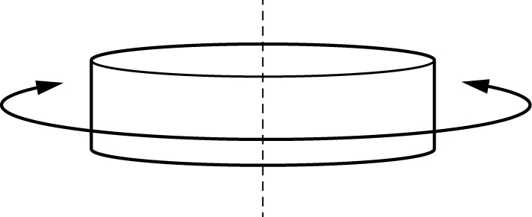

When a disc of mass *m* and radius *R* undergoes torsional oscillations about a vertical axis the period *T* is proportional to or

*T*2= *kmR*2 where *k* is a constant.

The theory is beyond AS Level but relationships like these can be used for AS investigations because they involve measurements that AS students will be expected to make under exam conditions.

During this investigation, learners will suspend a mass hanger of mass *m* and radius *R* and note the time period *T* for rotational oscillations.

They will do this for two mass hangers of different mass and diameter and investigate the relationship between *T*, *m* and *R*.

Since two results are insufficient to draw a graph, you may wish to encourage learners to plan and carry out further experiments using the modelling clay as an improvement to this experiment.

**Method**

* For both the 50 g and 100 g mass hangers, learners measure the mass *m* and the radius *R* at the widest point.
* They then suspend the 100 g mass hanger from a rubber band and determine the time period *T* for rotational oscillations, then repeat this for the 50 g mass hanger.
* Learners then investigate the validity of the relationship *T*2 = *kmR*2 where *k* is a constant.

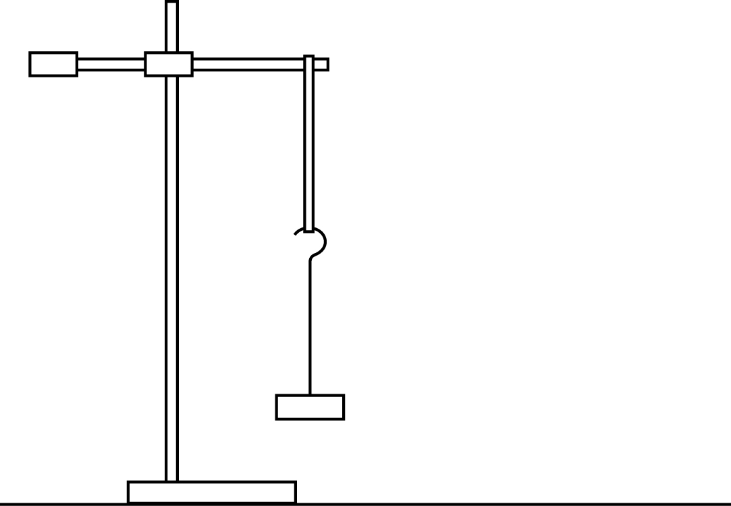

**Results**

Learners should record their results in a table like the one below.

|  |  |  |  |  |  |  |  |
| --- | --- | --- | --- | --- | --- | --- | --- |
|  |  |  | **Time for 10 cycles** | |  |  |  |
| ***m*/kg** | ***R*/m** | ***R*2/m2** | ***t*1/s** | ***t*2/s** | ***T*/s** | ***T*2/s2** | ***k*/s2kg–1m–2** |
|  |  |  |  |  |  |  |  |
|  |  |  |  |  |  |  |  |

**Interpretation and evaluation**

* The validity of the relationship depends on the percentage uncertainty in *k.*
* Percentage uncertainty in *k* = (2*T*/*T* + *m*/*m* + 2*R*/*R*) × 100%
* When the percentage uncertainty is not calculated as above, a statement linking the validity of a relationship to whether the two values are within an arbitrary percentage, e.g. 10% of each other, is sufficient.
* Statements such as ‘the relationship is invalid because the two *k* values are different’ are insufficient.

**Practical 2 – Information for technicians**

**How the torsional motion of a disc depends on its mass and diameter**

**Each learner will require:**

|  |  |
| --- | --- |
| (a) | one stand |
| (b) | one boss |
| (c) | one clamp |
| (d) | one 100 g mass hanger |
| (e) | one 50 g mass hanger |
| (f) | one metre rule with a millimetre scale |
| (g) | one rubber band |
| (h) | one stopwatch reading to 0.1 s or better |
| (i) | access to an electronic balance |
| (j) | 50 g of modelling clay (e.g. Plasticine) |

**Practical 2 – Worksheet**

**How the torsional motion of a disc depends on its mass and diameter**

**Aim**

To use a stopwatch to measure intervals of time, including the period of an oscillating system by timing an appropriate number of consecutive oscillations.

**Method**

1. Determine the radius *R* of the 100 g mass at its widest point.
2. Estimate the percentage uncertainty in *R*.
3. Determine the mass *m* of the 100 g mass.
4. Suspend the rubber band from the stand and hang the 100 g mass hanger from the rubber band as shown.



1. Twist the mass hanger through about half a turn and release it.
2. Measure the time for ten complete cycles and determine the time *T* for one complete cycle.
3. Calculate *mR*2.
4. Repeat for the 50 g mass hanger.

**Results**

Record all of your results in a table.

|  |  |  |  |  |  |  |  |
| --- | --- | --- | --- | --- | --- | --- | --- |
|  |  |  | **Time for 10 cycles** | |  |  |  |
| ***m*/kg** | ***R*/m** | ***R*2/m2** | ***t*1/s** | ***t*2/s** | ***T*/s** | ***T*2/s2** | ***k*/s2kg–1m–2** |
|  |  |  |  |  |  |  |  |
|  |  |  |  |  |  |  |  |

**Note**

* All raw values of *m* should be to the same number of decimal places i.e. to the nearest g or 0.1 g.
* All raw values of *R* should be to the same number of decimal places i.e. to the nearest mm.
* All raw values of *t* should be to the same number of decimal places i.e. to the nearest 0.1 s or 0.01 s.
* The number of significant figures for *R*2 should be the same as or one more than the number of significant figures for the corresponding value of *R*.
* The number of significant figures for *T*2 should be the same as or one more than the number of significant figures for the corresponding values of *t*.

**Interpretation and evaluation**

Investigate the validity of the relationship *T*2 = *kmR*2 where *k* is a constant.

The relationship is valid if the two values of *k* are the same within the bounds of experimental uncertainty.

The percentage uncertainty in *k* = (2*T*/*T* + *m*/*m* + 2*R*/*R*) × 100%

1. Calculate the percentage uncertainty in *k*.

When the percentage uncertainty is not calculated as above, a statement linking the validity of a relationship to whether the two values are within an arbitrary percentage, e.g. 10% of each other, is sufficient. Statements such as ‘the relationship is invalid because the two *k* values are different’ are insufficient.

1. Explain whether your results support the relationship.
2. Justify the number of significant figures that you have given for your values of *k*.
3. Describe two sources of uncertainty or limitations of the experiment.
4. Describe two improvements that could be made to this experiment. You may suggest the use of other apparatus or different procedures.

**Note**

* A source of uncertainty is measuring *R* with a metre rule. An improvement would be to use Vernier calipers instead of a metre rule.
* Measuring radius directly is uncertain. Measuring diameter and halving it to get radius reduces uncertainty. Do not simply state ‘measuring radius’ as a source of uncertainty because you can reduce this uncertainty yourself without additional equipment.