



**Cambridge International**

**AS and A Level Physics (9702)**

Practical booklet 3

Determination of the acceleration of free fall *g* using the motion of two connected masses

**Introduction**

Practical work is an essential part of science. Scientists use evidence gained from prior observations and experiments to build models and theories. Their predictions are tested with practical work to check that they are consistent with the behaviour of the real world. Learners who are well trained and experienced in practical skills will be more confident in their own abilities. The skills developed through practical work provide a good foundation for those wishing to pursue science further, as well as for those entering employment or a non-science career.

The science syllabuses address practical skills that contribute to the overall understanding of scientific methodology. Learners should be able to:

1. plan experiments and investigations
2. collect, record and present observations, measurements and estimates
3. analyse and interpret data to reach conclusions
4. evaluate methods and quality of data, and suggest improvements.

The practical skills established at AS Level are extended further in the full A Level. Learners will need to have practised basic skills from the AS Level experiments before using these skills to tackle the more demanding A Level exercises. Although A Level practical skills are assessed by a timetabled written paper, the best preparation for this paper is through extensive hands-on experience in the laboratory.

The example experiments suggested here can form the basis of a well-structured scheme of practical work for the teaching of AS and A Level science. The experiments have been carefully selected to reinforce theory and to develop learners’ practical skills. The syllabus, scheme of work and past papers also provide a useful guide to the type of practical skills that learners might be expected to develop further. About 20% of teaching time should be allocated to practical work (not including the time spent observing teacher demonstrations), so this set of experiments provides only the starting point for a much more extensive scheme of practical work.

© Cambridge International Examinations 2014

**Practical 3 – Guidance for teachers**

**Determination of the acceleration of free fall *g* using the motion of two connected masses**

**Aim**

To apply Newton’s laws of motion and the equations of uniformly accelerated motion to a practical situation.

**Outcomes**

Syllabus sections 1.2e, 2.1a, 3.1g, 3.1h, 4.1b, 5.1c

**Skills included in the practical**

|  |  |
| --- | --- |
| **AS Level skills** | **How learners develop the skills** |
| MMO collection | Measure the height of a mass above the floor using a ruler  Measure times using a stopwatch |
| MMO values |
| MMO quality of data |
| PDO table | Collect and record data in a table |
| PDO recording |
| ACE interpretation | Relate results to AS theory |
| ACE conclusions | Draw conclusions relating to the validity, or otherwise, of a given relationship |
| ACE estimating uncertainties | Estimate uncertainty in times |
| ACE limitations | Identify the limitations of the experimental procedure |
| ACE improvements | Identify possible improvements to the experimental procedure |

**Theory**

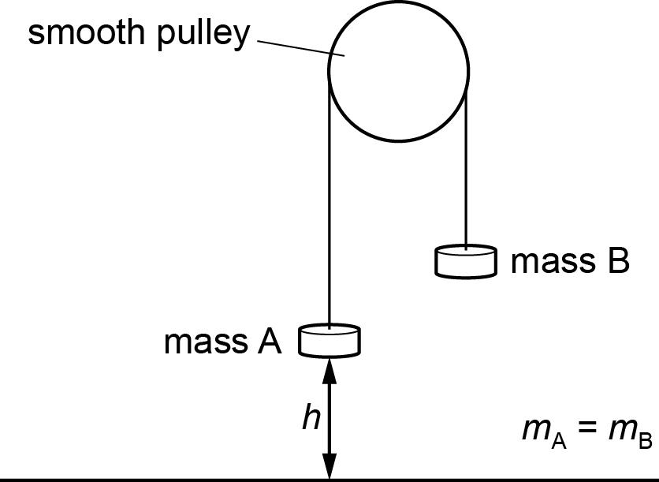

When mass A of mass *m*A is released it will fall through a distance *h* to the floor and mass B of mass *m*B will move upwards. Both masses will have an acceleration of *a*. The tension in the string is *T*.

Applying Newton’s laws to mass A and to mass B

*m*A*g* – *T* = *m*A*a* .…(i)

*T* – *m*B*g*= *m*B*a* ….(ii)

where *T* is the tension in the string.

Since *s* = *ut* + ½*at*2 and *u* = 0 it follows that *h* = ½*at2* and therefore *a* = 2*h*/*t*2.

Adding (i) and (ii) and substituting for *a*: (*m*A – *m*B)*g* = 2*h*(*m*A + *m*B)/*t*2.

So(*m*A – *m*B) = *k*/*t*2 where *k* is a constantand*k* =2*h*(*m*A + *m*B)/*g*.

The value of *g* is given by *g* =2*h*(*m*A + *m*B)/*k*.

The calculated value of *g* will be less than 9.81 m s–2 due to friction in the pulley.

**Method**

Learners

* set up the apparatus as shown.

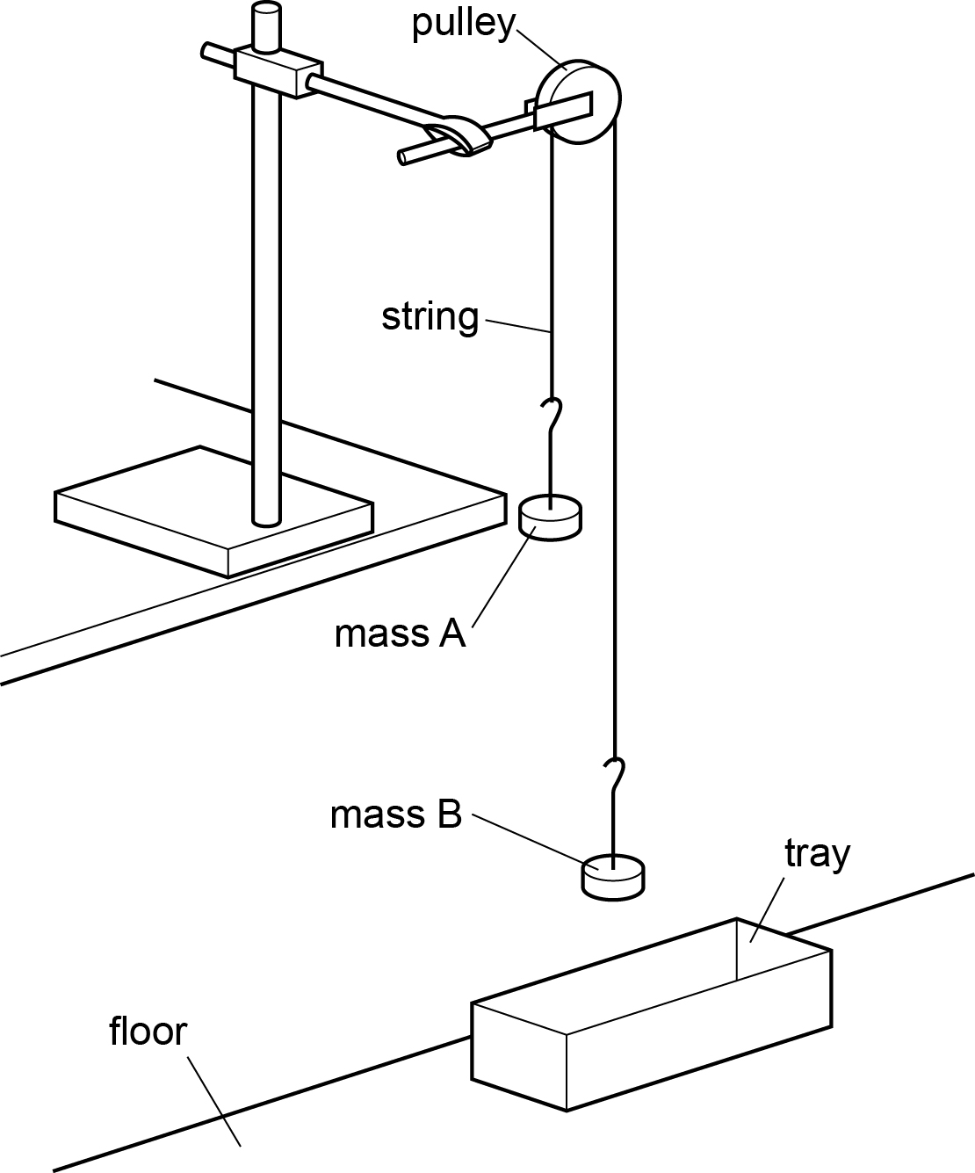

* make both the mass *m*A of A and the mass *m*B of Bequal to 100 g. It must be possible to transfer masses from Bto A.
* adjust the height of the apparatus so that the distance *h* between the bottom of mass A and the floor is approximately 1 metre.
* transfer 10 g from mass B to mass A
* record the mass *m*A of mass A and the mass *m*B of mass B.
* calculate the difference in mass (*m*A – *m*B ).
* release mass A from height *h*and determine the time *t* it takes to reach the floor.
* estimate the percentage uncertainty in their value of *t*.
* transfer another 10 g from mass B to mass A and repeat

It is suggested that the relationship between (*m*A – *m*B) and *t* is

$$\left(m_{\text{A}}-m_{\text{B}}\right)=\frac{k}{t^{2}}$$

where *k* is a constant.

**Interpretation and evaluation**

* Learners use their value of *k* to determine *g* using *k* = 2*h*(*m*A – *m*B)/*g.*
* They then comment on any difference between their value for *g* and the accepted value of 9.81 m s–2.
* Learners should then explain this difference in terms of the experimental conditions, e.g. friction in the pulley or air resistance.

**Practical 3 – Information for technicians**

**Determination of the acceleration of free fall *g* using the motion of two connected masses**

**Each learner will require:**

|  |  |
| --- | --- |
| (a) | one 100 g mass hanger |
| (b) | one 50 g mass hanger |
| (c) | five 10 g slotted masses which must be able to fit onto both mass hangers |
| (d) | stand |
| (e) | boss |
| (f) | clamp |
| (g) | pulley |
| (h) | metre rule |
| (i) | string |
| (j) | stopwatch |
| (k) | shallow tray |
| (l) | access to a balance |

**Practical 3 – Worksheet**

**Determination of the acceleration of free fall *g* using the motion of two connected masses**

**Method**

1. Set up the apparatus as shown.



1. Make both the mass *m*A of A and the mass *m*B of Bequal to 100 g. It must be possible to transfer masses from Bto A.
2. Adjust the height of the apparatus so that the distance *h* between the bottom of mass A and the floor is approximately 1 metre.
3. Transfer 10 g from mass B to mass A.
4. Record the mass *m*A of mass A and the mass *m*B of mass B.
5. Calculate the difference in mass (*m*A – *m*B).
6. Release mass A from height *h*and determine the time *t* it takes to reach the floor.
7. Estimate the percentage uncertainty in your value of *t*.
8. Transfer another 10 g from mass B to mass A and repeat 3, 4, 5, 6 and 7.

**Results**

Record your results.

|  |  |  |  |  |  |  |
| --- | --- | --- | --- | --- | --- | --- |
| ***m*A** | ***m*B** | ***m*A – *m*B** | ***t*1/s** | ***t*2/s** | ***t*average/s** | ***t*2/s2** |
|  |  |  |  |  |  |  |
|  |  |  |  |  |  |  |

**Interpretation and evaluation**

1. It is suggested that the relationship between (*m*A – *m*B) and *t* is $\left(m_{\text{A}}-m_{\text{B}}\right)=\frac{k}{t^{2}}$

where *k* is a constant.

* Investigate the validity of the relationship by calculating two values of *k*.
* The relationship is valid if the two values of *k* are the same within the bounds of experimental uncertainty.
* When the percentage uncertainty is not calculated as above, a statement linking the validity of a relationship to whether the two values are within an arbitrary percentage, e.g. 10% of each other is sufficient. Statements such as ‘the relationship is invalid because the two *k* values are different’ are insufficient.

1. Explain whether your results support the relationship.
2. Justify the number of significant figures that you have given for your values of *k*.
3. $k=\frac{2h\left(m_{\text{A}}+m_{\text{B}}\right)}{g}$ so $g=\frac{2h\left(m_{\text{A}}+m_{\text{B}}\right)}{k}$. Calculate *g*.
4. Calculate the percentage uncertainty in *g*.
5. Comment on your value of *g* compared to the accepted value of 9.81 m s–2.
6. If your value of *g* is not within the percentage uncertainty of 9.81, suggest why your value is different.

**Planning**

One source of uncertainty is that only two results are obtained. This is insufficient evidence and no graph can be drawn.

Using the apparatus provided, collect sufficient results so that the following graph can be drawn: (*m*A – *m*B) against 1/*t*2

If the relationship is valid then the graph should be a straight line through the point (0,0).

**Note**

* For every set of readings (*m*A + *m*B) must be constant
* As (*m*A – *m*B) increases the values of *t* may become too small to measure. Could the range of the experiment be extended by using 5 g msses instead of 10 g masses?