

**Cambridge International**

**AS and A Level Physics (9702)**

Practical booklet 4

Determination of the resistivity of a metal

**Introduction**

Practical work is an essential part of science. Scientists use evidence gained from prior observations and experiments to build models and theories. Their predictions are tested with practical work to check that they are consistent with the behaviour of the real world. Learners who are well trained and experienced in practical skills will be more confident in their own abilities. The skills developed through practical work provide a good foundation for those wishing to pursue science further, as well as for those entering employment or a non-science career.

The science syllabuses address practical skills that contribute to the overall understanding of scientific methodology. Learners should be able to:

1. plan experiments and investigations
2. collect, record and present observations, measurements and estimates
3. analyse and interpret data to reach conclusions
4. evaluate methods and quality of data, and suggest improvements.

The practical skills established at AS Level are extended further in the full A Level. Learners will need to have practised basic skills from the AS Level experiments before using these skills to tackle the more demanding A Level exercises. Although A Level practical skills are assessed by a timetabled written paper, the best preparation for this paper is through extensive hands-on experience in the laboratory.

The example experiments suggested here can form the basis of a well-structured scheme of practical work for the teaching of AS and A Level science. The experiments have been carefully selected to reinforce theory and to develop learners’ practical skills. The syllabus, scheme of work and past papers also provide a useful guide to the type of practical skills that learners might be expected to develop further. About 20% of teaching time should be allocated to practical work (not including the time spent observing teacher demonstrations), so this set of experiments provides only the starting point for a much more extensive scheme of practical work.

© Cambridge International Examinations 2014

**Practical 4 – Guidance for teachers**

**Determination of the resistivity of a metal**

**Aim**

To set up a circuit including an ammeter, voltmeter and resistors in series and use Ohm’s Law.

**Outcomes**

Syllabus sections 1.2e, 2.1a, 2.1b, 19.3b, 19.3e, 20.1b, 20.2d

**Skills included in the practical**

|  |  |
| --- | --- |
| **AS Level skills** | **How learners develop the skills** |
| MMO collection | Construct a circuit from a circuit diagram  Use an ammeter and a voltmeter  Use a micrometer screw gauge  Measure length using a metre rule |
| MMO values |
| MMO quality of data |
| PDO table | Collect and record data in a table |
| PDO recording |
| PDO graph | Draw a graph and determine the gradient and *y*-intercept |
| ACE interpretation | Interpret the gradient and *y*-intercept |
| ACE conclusions | Determine the resistivity of the metal |

**Theory**

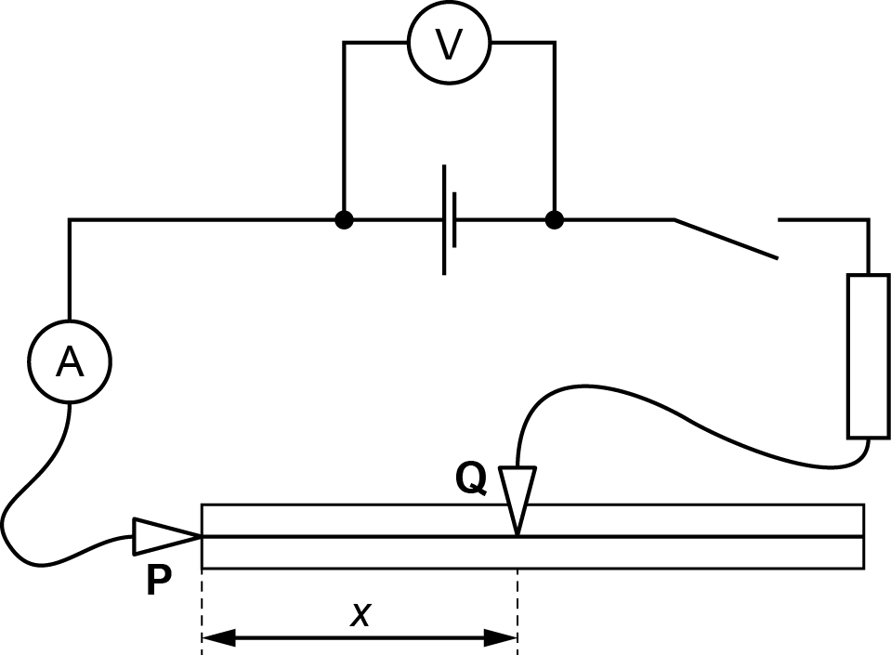

**P** and **Q** are the crocodile clips

Diameter of constantan wire = *d,* so cross section area of wire = *d*2/4

Voltmeter reading = *V;* Ammeter reading = *I*

Distance between crocodile clips along wire = *x*

Resistance of resistor = *R*

Resistance of wire between crocodile clips = *x*/*A*

where ** = resistivity of constantan, and *A* = cross-sectional area of constantan wire

Total resistance in series = *R* + *x*/*A*

Using Ohm’s Law:

$$\frac{V}{I}=R+\frac{ρx}{A}$$

so

$$\frac{1}{I}=\frac{ρx}{AV}+\frac{R}{V}$$

Therefore $\frac{1}{I}=Mx+N$ where $M=\frac{ρ}{AV}$ and $N=\frac{R}{V}$.

A graph of 1/*I*on the *y*-axis against *x* on the *x*-axis will have a gradient = *M* and y‑intercept = *N*.

**Method**

Learners

* measure the diameter *d* of the wire using the micrometer screw gauge.
* calculate the cross-sectional area *A* of the wire.
* connect the circuit with the crocodile clip **Q** half way along the wire.
* close the switch and read *V*, *I* and *x.*
* increase *x* and note *I* until they have six sets of values of *x* and *I.*

**Results**

* Learners should record values of *x* to the same number of decimal places, i.e. to the nearest mm allowed by the rule, and *I* to the precision allowed by the ammeter. They should include values of 1/*I* in the table. Appropriate units should be added to the column headings.
* The number of significant figures for 1/*I* should be given to the same as, or one more than, the number of significant figures for the corresponding value of *I*.

|  |  |  |
| --- | --- | --- |
| *x* | *I* | 1/*I* |
|  |  |  |
|  |  |  |
|  |  |  |
|  |  |  |
|  |  |  |
|  |  |  |

* Learners then plot a graph of 1/*I*on the *y*-axis against *x* on the *x*-axis and draw the line of best fit.

**Interpretation and evaluation**

Learners

* determine the gradient and *y*-intercept of the graph line
* use the gradient and values of *A* and *V* to determine **
* use the *y*-intercept and *V* to determine *R*
* compare their value of ** with the accepted value of 4.9 × 10–7 m2
* compare their value of *R* with 10 

**Note**

* Any of the wires in the table are suitable:

|  |  |  |  |
| --- | --- | --- | --- |
| material | swg | diameter/mm | resistivity/ m |
| constantan | 32 | 0.27 | 4.9 × 10–7 |
| constantan | 34 | 0.23 | 4.9 × 10–7 |
| constantan | 36 | 0.19 | 4.9 × 10–7 |
| nichrome | 26 | 0.46 | 1.5 × 10–6 |
| nichrome | 28 | 0.38 | 1.5 × 10–6 |
| nichrome | 30 | 0.32 | 1.5 × 10–6 |

* Learners are asked to increase *x*. For very small values of *x* the resistance of the connecting wires is significant and the graph is not linear.
* Allow learners to use any unit e.g. A or mA or cm or m and discuss at the end if their value of ** is consistent with the value of ** in SI units.
* The theory assumes that *V* remains constant. If the results deviate from a straight line graph it could be because *V* has decreased because the dry cell has remained connected for a long period or that the cell has significant internal resistance.

**Practical 4 – Information for technicians**

**Determination of the resistivity of a metal**

**Each learner will require:**

|  |  |
| --- | --- |
| (a) | 1.5 V dry cell |
| (b) | ammeter |
| (c) | voltmeter |
| (d) | switch |
| (e) | seven connecting leads |
| (f) | two crocodile clips |
| (g) | metre rule |
| (h) | 110 cm of constantan wire swg 34* |
| (i) | 10 Ω resistor |
| (j) | access to a micrometer screw gauge |

**Additional instructions**

* any of the following wires would be suitable:

constantan 32, 34, 36 swg

nichrome 26, 28, 30 swg

* the wire should be taped to the metre rule as shown in the diagram:



**Practical 4 – Worksheet**

**Determination of the resistivity of a metal**

**Aim**

To set up a circuit including an ammeter, voltmeter and resistors in series, take readings from the circuit and use Ohm’s Law.

**Method**

1. Use the micrometer to measure the diameter *d* of the thin wire that is attached to the metre rule. You should be able to use the short length at each end on the other side of the tape.
2. Calculate the cross section area *A* of the wire using the equation *d*2/4.
3. Set up the circuit shown:



1. Connect crocodile clip **P** to the short length of wire overhanging the metre rule.
2. Connect crocodile clip **Q** to the wire about half way along it (close to the 50 cm mark)
3. Close the switch and record values of

* length *x*
* ammeter reading *I*
* voltmeter reading *V*.

1. Increase *x* until you have six sets of values for *x* and *I*.

**Results**

Record your results. Include values of 1/*I*, and each column heading should have a suitable unit

|  |  |  |
| --- | --- | --- |
| *x* | *I* | 1/*I* |
|  |  |  |
|  |  |  |
|  |  |  |
|  |  |  |
|  |  |  |
|  |  |  |

**Interpretation and evaluation**

1. Plot a graph of 1/*I*on the *y*-axis against *x* on the *x*-axis.
2. Draw the line of best fit through your points.
3. Find the gradient of your graph.
4. Find the *y*-intercept of your graph.
5. Theory suggests that *I* and *x* are related by the equation 1/*I* = *Mx* + *N* where *M* and *N* are constants.
6. Use your results from to find values for *M* and *N*. Include appropriate units.

where ** is the resistivity of the material of the wire

and $N=\frac{R}{V}$ where *R* is the resistance of the resistor R in the circuit.

1. Use your values of *M*, *N*,*A* and *V* to determine values for ** and *R*. Include appropriate units.