

**Cambridge International**

**AS and A Level Physics (9702)**

Practical booklet 5

How the loss of gravitational potential energy of a rolling ball depends on its initial height

**Introduction**

Practical work is an essential part of science. Scientists use evidence gained from prior observations and experiments to build models and theories. Their predictions are tested with practical work to check that they are consistent with the behaviour of the real world. Learners who are well trained and experienced in practical skills will be more confident in their own abilities. The skills developed through practical work provide a good foundation for those wishing to pursue science further, as well as for those entering employment or a non-science career.

The science syllabuses address practical skills that contribute to the overall understanding of scientific methodology. Learners should be able to:

1. plan experiments and investigations
2. collect, record and present observations, measurements and estimates
3. analyse and interpret data to reach conclusions
4. evaluate methods and quality of data, and suggest improvements.

The practical skills established at AS Level are extended further in the full A Level. Learners will need to have practised basic skills from the AS Level experiments before using these skills to tackle the more demanding A Level exercises. Although A Level practical skills are assessed by a timetabled written paper, the best preparation for this paper is through extensive hands-on experience in the laboratory.

The example experiments suggested here can form the basis of a well-structured scheme of practical work for the teaching of AS and A Level science. The experiments have been carefully selected to reinforce theory and to develop learners’ practical skills. The syllabus, scheme of work and past papers also provide a useful guide to the type of practical skills that learners might be expected to develop further. About 20% of teaching time should be allocated to practical work (not including the time spent observing teacher demonstrations), so this set of experiments provides only the starting point for a much more extensive scheme of practical work.

© Cambridge International Examinations 2014

**Practical 5 – Guidance for teachers**

**How the loss of gravitational potential energy of a rolling ball depends on its initial height**

**Aim**

To determine the gravitational potential energy of an object and the efficiency of a system.

**Outcomes**

Syllabus sections 1.2e, 2.1a, 6.2c, 6.2d, 6.3f

**Skills included in the practical**

|  |  |  |
| --- | --- | --- |
| **AS Level skills** | **How learners develop the skills** | |
| MMO collection | | Measure the height of an object above the bench with a ruler |
| MMO values | |
| MMO quality of data | |
| PDO table | | Collect and record data in a table |
| PDO recording | |
| PDO graph | | Draw a graph to investigate a relationship |
| ACE limitations | | Identify the limitations of the experimental procedure |
| ACE improvements | | Identify possible improvements to the experimental procedure |

**Theory**

When an object of mass *m* is at a height *h* above the bench its gravitational potential energy is given by

*E*GPE = *mgh* where *g* is the gravitational field strength.

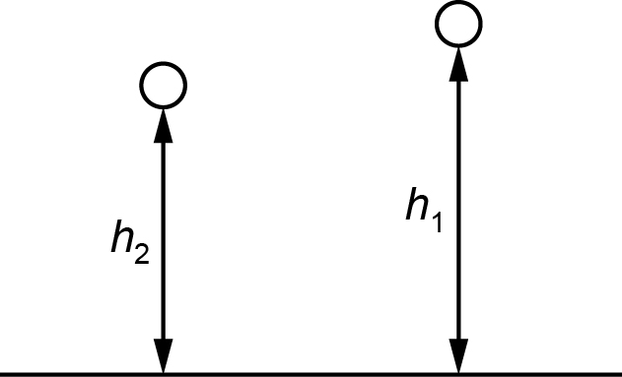

If the object is at a height of *h*1 before a collision and *h*2 after the collision, the efficiency of the system is

$$\text{efficiency}=\frac{\text{remaining} E_{\text{GPE}}}{\text{original} E_{\text{GPE}}}=\frac{mgh_{2}}{mgh_{1}}=\frac{h_{2}}{h_{1}}$$

**Method**

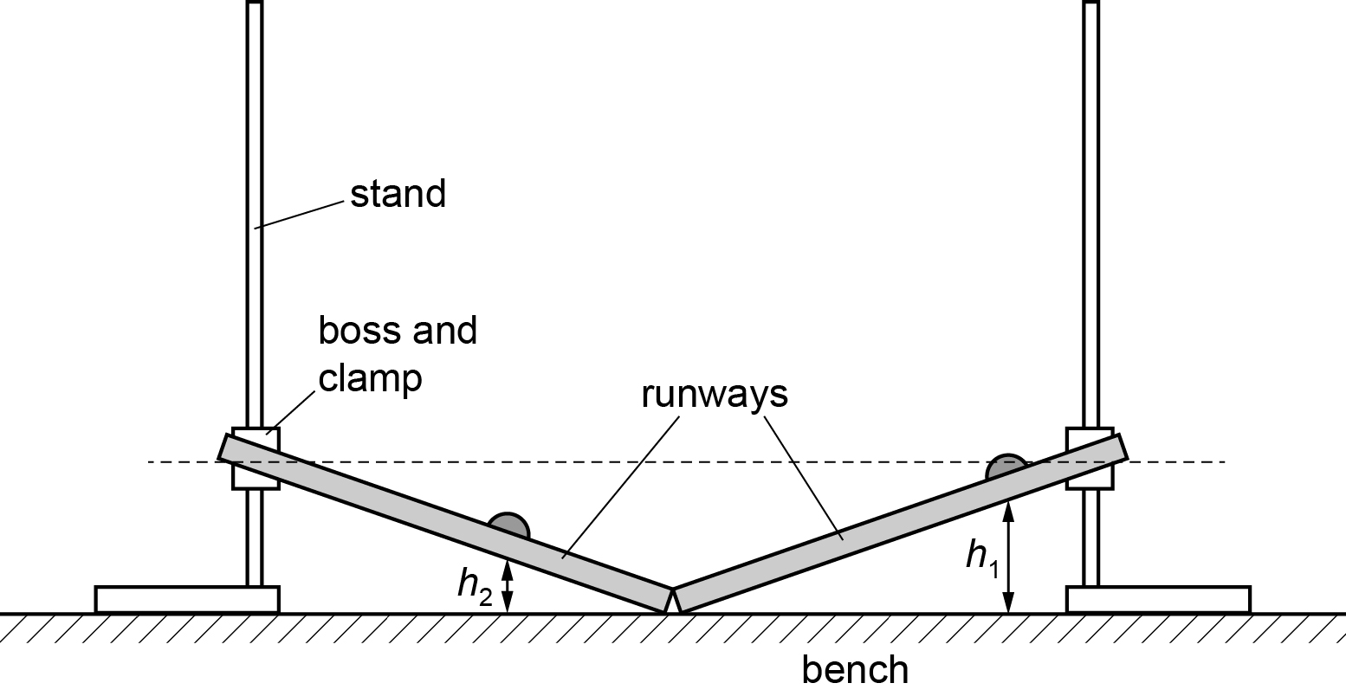

Learners set up the runways as shown and place a marble near the top of one runway, measuring the height *h*1 of the bottom of the marble above the bench.

They release the marble then measure the height *h*2 to the bottom of the marble when it reaches its maximum height on the other runway.

Learners then estimate the percentage uncertainty in their value of *h*2.

This is then repeated using a different value of *h*1.

**Results**

Learners record all of their results

|  |  |  |  |  |  |
| --- | --- | --- | --- | --- | --- |
| *h*1/cm | *h*2/cm | *h*2/cm | *h*2/cm | *h*2 average/cm | *h*2/*h*1 |
|  |  |  |  |  |  |
|  |  |  |  |  |  |

**Interpretation and evaluation**

* Learners should consider how reliable their measurements are.
* The runways might move between readings and therefore will not be lined up correctly.
* The measurement to the bottom of the ball is difficult.
* A graph could be drawn of *h*2/*h*1against *h*1 to observe any trend.
* There is scope for further investigation.
* Learners could repeat the investigation with the runways inclined at a different angle or use a marble with a different mass.

**Practical 5 – Information for technicians**

**How the loss of gravitational potential energy of a rolling ball depends on its initial height**

**Each learner will require:**

|  |  |
| --- | --- |
| (a) | Two stands |
| (b) | Two bosses |
| (c) | Two clamps |
| (d) | One marble |
| (e) | Two rigid runways of approximate length 40 cm with a V-shaped groove. It should be possible for the marble to roll easily along the groove |
| (f) | One metre rule |
| (g) | Access to a balance |

**Practical 5 – Worksheet**

**How the loss of gravitational potential energy of a rolling ball depends on its initial height**

**Aim**

To calculate the gravitational potential energy of an object and the efficiency of a system.

**Method**

1. Set up the apparatus as shown. The marble should be able to roll down one runway and up the other one.



1. Place the marble so that the bottom of the marble is at a height *h*1 above the bench. Record *h*1 andremove the marble from the track.
2. Measure the mass *m* of the marble and calculate the change in gravitational potential energy *E* of the marble when it is raised from the bench to its position on the track. Use the equation *E* = *mg**h*.
3. Replace the marble on the track and measure *h*1.
4. Release the marble. Measure and record the maximum height *h*2 that the marble reaches on the other track.
5. Change *h*1 and repeat.

**Results**

Record your results

|  |  |  |  |  |  |
| --- | --- | --- | --- | --- | --- |
| *h*1/cm | *h*2/cm | *h*2/cm | *h*2/cm | *h*2 average/cm | *h*2/*h*1 |
|  |  |  |  |  |  |
|  |  |  |  |  |  |

**Interpretation and evaluation**

If the marble rolled up the same height as it was released from (i.e. *h*2 = *h*1) then it would not have lost any energy and the process would be ‘100% efficient’.

The value of *h*2/*h*1 represents the efficiency of the process.

1. Complete the table with calculated values of *h*2/*h*1.
2. Do you notice a trend?
3. Consider a range of readings and draw a graph of *h*2/*h*1against *h*1.
4. What are the sources of uncertainty in the experiment?
5. Can you suggest and perform further investigations? For example, use a marble with a different mass, change the angle of the runways.