

**Cambridge International**

**AS and A Level Physics (9702)**

Practical booklet 6

Determination of the centre of gravity of a shape

**Introduction**

Practical work is an essential part of science. Scientists use evidence gained from prior observations and experiments to build models and theories. Their predictions are tested with practical work to check that they are consistent with the behaviour of the real world. Learners who are well trained and experienced in practical skills will be more confident in their own abilities. The skills developed through practical work provide a good foundation for those wishing to pursue science further, as well as for those entering employment or a non-science career.

The science syllabuses address practical skills that contribute to the overall understanding of scientific methodology. Learners should be able to:

1. plan experiments and investigations
2. collect, record and present observations, measurements and estimates
3. analyse and interpret data to reach conclusions
4. evaluate methods and quality of data, and suggest improvements.

The practical skills established at AS Level are extended further in the full A Level. Learners will need to have practised basic skills from the AS Level experiments before using these skills to tackle the more demanding A Level exercises. Although A Level practical skills are assessed by a timetabled written paper, the best preparation for this paper is through extensive hands-on experience in the laboratory.

The example experiments suggested here can form the basis of a well-structured scheme of practical work for the teaching of AS and A Level science. The experiments have been carefully selected to reinforce theory and to develop learners’ practical skills. The syllabus, scheme of work and past papers also provide a useful guide to the type of practical skills that learners might be expected to develop further. About 20% of teaching time should be allocated to practical work (not including the time spent observing teacher demonstrations), so this set of experiments provides only the starting point for a much more extensive scheme of practical work.

© Cambridge International Examinations 2014

**Practical 6 – Guidance for teachers**

**Determination of the centre of gravity of a shape**

**Aim**

To determine the centre of gravity of a shape. Learners will consider the range of an investigation and practise using a trigonometric function.

**Outcomes**

Syllabus sections 1.2e, 2.1a, 5.d

**Skills included in the practical**

|  |  |
| --- | --- |
| **AS Level skills** | **How learners develop the skills** |
| MMO collection | Measure length using a ruler  Measure angle using a protractor |
| MMO values |
| MMO quality of data |
| PDO table | Collect and record data in a table |
| PDO recording |
| PDO graph | Draw a graph and determine the gradient |
| ACE interpretation | Interpret the gradient |

**Theory and method**

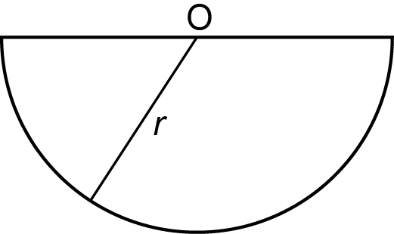

The cardboard shape is a semicircle with radius *r* and the centre of the circle is at O.

The centre of gravity of the shape can be found by:

* placing a pin through a hole in the shape close to a corner
* suspending the shape and a plumbline from the pin
* drawing a line along the plumbline on the shape
* repeating from the other corner
* noting the point where the two lines cross

Learners should be familiar with this experiment. A fun way of introducing this topic to beginners is to use an atlas to cut out shapes of different countries (photocopy or trace and cut out the shape, don’t cut up the atlas) and find the name of the place that is at its centre of gravity. Some capital cities are at the centre of gravity of their country.

The result will be that the centre of gravity is at distance *y* from O.

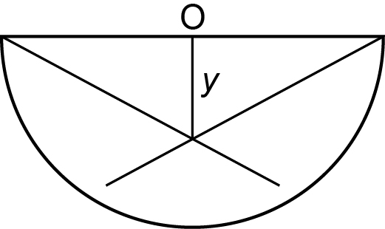

If the card is cut to the shape shown below and the experiment is repeated, the relationship between *y* and ** is

where ** is in degrees.

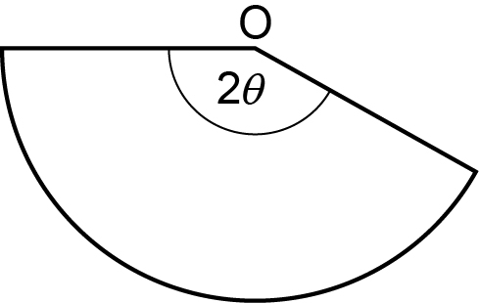

**Results**

Learners record all of their results.

|  |  |  |  |
| --- | --- | --- | --- |
| 2** | ** | sin ** | (sin **) /** |
|  |  |  |  |
|  |  |  |  |
|  |  |  |  |
|  |  |  |  |
|  |  |  |  |
|  |  |  |  |

A graph of *y* against $\frac{\sin{θ}}{θ}$ should be a straight line through (0,0) with $\text{gradient}=\frac{120r}{π}$.

Learners can then see if the measured value of *r* is consistent with the value calculated from their gradient.

**Note**

* The shape will end up with a lot of lines on it and care must be taken to use the correct lines for the measurement of *y* for a particular value of *.*
* Learners are expected to plan an experiment so that at least six sets of readings are taken at regular intervals over a reasonable range.
* Learners have to decide what the smallest value of 2** to use is.
* Once the card is cut it will not be possible to go back to an intermediate angle or repeat readings for the larger angles.
* Learners should have access to a new card if they make a mistake early on.
* The graph should be a straight line through (0,0) but the plotted points will not be close to (0,0).

**Practical 6 – Information for technicians**

**Determination of the centre of gravity of a shape**

**Each learner will require:**

|  |  |
| --- | --- |
| (a) | Semi-circular card of radius 145 mm and thickness 0.2 mm |
| (b) | Scissors |
| (c) | 30 cm ruler |
| (d) | Optical pin |
| (e) | Stand |
| (f) | Boss |
| (g) | Clamp |
| (h) | Protractor |
| (i) | 50 cm length of thin thread with a loop at one end and a 10 g mass attached to the other end |

**Practical 6 – Worksheet**

**Determination of the centre of gravity of a shape**

**Aim**

To determine the centre of gravity of a shape.

**Method**

1. Measure the radius *r* of the semi-circular card.
2. Use the pin to make a hole close to a corner of the card. The hole should be big enough for the card to be able to swing freely when the card is suspended from the pin
3. Clamp the pin and suspend the card and plumbline from the pin.
4. Draw a line on the card along the line of the plumbline.
5. Repeat 1, 2 and 3 using a hole close to the other corner of the card.
6. The point where the lines cross is the centre of gravity of the card.
7. Measure the distance *y* between the centre of gravity and the centre of the semicircle O as shown.



1. Cut the card as shown.



1. Note the value of 2** and calculate *.*
2. Repeat all the steps so that you have a new value for *y* the distance between O and the centre of gravity of the new shape
3. Change the shape of the card so that you have a set of values for *y* and **
4. Calculate values for sin ** and (sin **)/**

**Results**

Record all of your results.

|  |  |  |  |
| --- | --- | --- | --- |
| 2** | ** | sin ** | (sin **)/** |
|  |  |  |  |
|  |  |  |  |
|  |  |  |  |
|  |  |  |  |
|  |  |  |  |
|  |  |  |  |

**Interpretation and evaluation**

1. *y* and ** are related by the expression

where ** is in degrees.

1. Plot a graph of *y* on the *y*-axis against $\frac{\sin{θ}}{θ}$ on the *x*-axis.
2. The graph should be a straight line through (0,0) although your plotted points will not be close to (0,0).
3. Determine the gradient of your graph line and use the expression for gradient 120*r*/ to calculate a value for *r*. Compare this value to your measured value.