

**Cambridge International**

**AS and A Level Physics (9702)**

Practical booklet 7

Discharge of a capacitor through a resistor

**Introduction**

Practical work is an essential part of science. Scientists use evidence gained from prior observations and experiments to build models and theories. Their predictions are tested with practical work to check that they are consistent with the behaviour of the real world. Learners who are well trained and experienced in practical skills will be more confident in their own abilities. The skills developed through practical work provide a good foundation for those wishing to pursue science further, as well as for those entering employment or a non-science career.

The science syllabuses address practical skills that contribute to the overall understanding of scientific methodology. Learners should be able to:

1. plan experiments and investigations
2. collect, record and present observations, measurements and estimates
3. analyse and interpret data to reach conclusions
4. evaluate methods and quality of data, and suggest improvements.

The practical skills established at AS Level are extended further in the full A Level. Learners will need to have practised basic skills from the AS Level experiments before using these skills to tackle the more demanding A Level exercises. Although A Level practical skills are assessed by a timetabled written paper, the best preparation for this paper is through extensive hands-on experience in the laboratory.

The example experiments suggested here can form the basis of a well-structured scheme of practical work for the teaching of AS and A Level science. The experiments have been carefully selected to reinforce theory and to develop learners’ practical skills. The syllabus, scheme of work and past papers also provide a useful guide to the type of practical skills that learners might be expected to develop further. About 20% of teaching time should be allocated to practical work (not including the time spent observing teacher demonstrations), so this set of experiments provides only the starting point for a much more extensive scheme of practical work.

© Cambridge International Examinations 2014

**Practical 7 – Guidance for teachers**

**Discharge of a capacitor through a resistor**

**Aim**

To investigate the characteristics of exponential decay and calculate the charge stored in a capacitor.

**Outcomes**

Syllabus sections 1.2e, 2.1a, 2.1b, 18.1a, 18.1b, 19.1d, 19.3b, 26.4d, 26.4f

**Skills included in the practical**

|  |  |
| --- | --- |
| **A Level skills** | **How learners develop the skills** |
| Planning | Consider further investigations with different components |
| Analysis | Collect and record data in a table |
| Conclusions | Determine and interpret the gradient of a graph |

This practical provides an opportunity to build on essential skills introduced at AS Level.

|  |  |
| --- | --- |
| **AS Level skills** | **How learners develop the skills** |
| MMO collection | Set up a set up a circuit from a circuit diagram  Use an ammeter to measure current |
| MMO values |
| MMO quality of data |

**Theory**

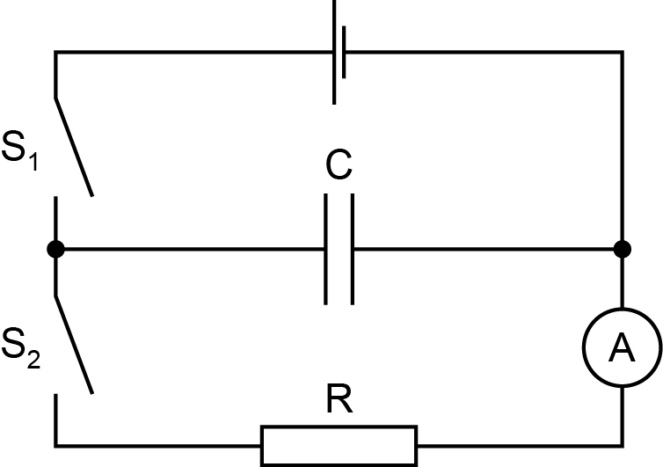

The discharge of the capacitor through the resistor is exponential since the rate of flow of charge from the capacitor is proportional to the charge on the capacitor.

$I=\frac{V}{R}$ and $Q=CV$

Therefore $I=\frac{dQ}{dt}∝Q$ since *R* and *C* are constant.

This leads to $I=I_{0}e^{-t/RC}$ from which $\ln{I=\ln{I_{0}-\frac{t}{RC}}}$ where *I*0 is the current at *t*=0.

A graph of ln *I* against *t*

* has gradient = –1/*RC* and *y*-intercept = ln *I*0

A graph of *I* against *t*

* will show an exponential decay from which ‘half-life’ can be found
* enables *Q* (= *CV*) to be found from the area under the curve

Similarities with radioactive decay:

Radioactive decay follows $x=x_{0}e^{-λt}$ where $λ=\frac{0.693}{t_{1/2}}$

so $\frac{1}{RC}=λ=\frac{0.693}{t_{1/2}}$

The quantity 1/*RC* is analogous to the decay constant in radioactive decay, and is related to the decay half-life.

**Method**

Learners set up the circuit. First they close S1 and take readings, then open S1 and close S2 and take readings.

**Results**

Learners record values of current *I* and time *t* and include values of In *I* in their table

**Interpretation and evaluation**

* draw a graph of ln *I* against *t* which will have gradient = –1/*RC* and *y*-intercept = ln *I*0
* draw a graph of *I* against *t* and find the area under the graph, which is the charge *Q*

**Further work**

Using a *smaller* resistor, e.g. 47 kΩ, will result in:

* bigger *I*0 because *I* = V/*R*
* smaller ‘half-life’ because *t*½ ∝ *CR*
* same area under graph because *Q* = *CV*

Using a *bigger* resistor, e.g. 220 kΩ, will result in:

* smaller *I*0 because *I* = V/*R*
* bigger ‘half-life’ because *t*½ ∝ *CR*
* same area under graph because *Q* = *CV*

**Practical 7 – Information for technicians**

**Discharge of a capacitor through a resistor**

**Each learner will require:**

|  |  |
| --- | --- |
| (a) | 1.5 V dry cell |
| (b) | 1000 μF capacitor |
| (c) | 100 kΩ resistor |
| (d) | 0-200 μA ammeter |
| (e) | two switches |
| (f) | eight connecting leads |
| (g) | stopwatch |

**Practical 7 – Worksheet**

**Discharge of a capacitor through a resistor**

**Aim**

To investigate the characteristics of exponential decay and calculate the charge stored in a capacitor.

**Method**

1. Connect the circuit shown.



1. Close switch S1 to charge the capacitor C.
2. Open S1 and close S2 to discharge the capacitor through the resistor R.
3. Record values of current *I* with time *t.*

**Results**

Record all of your results.

|  |  |  |
| --- | --- | --- |
| *t*/s | *I*/μA | In (*I*/μA) |
|  |  |  |
|  |  |  |
|  |  |  |
|  |  |  |
|  |  |  |
|  |  |  |

**Interpretation and evaluation**

* Include values of ln *I* in the table.
* From $I=I_{0}e^{-t/RC}$, $\ln{I=\ln{I_{0}-\frac{t}{RC}}}$ where *I*0 is the current at time *t* = 0.
* Draw a graph of ln *I* against *t*, and use the gradient to determine *RC*. Compare this with the nominal values from the components.
* Draw a graph of *I* against *t* and find the area under the graph.
* The area under the *I*-*t* graph represents the charge *Q* (= *It*) stored on the plates of the capacitor.
* Consider what will happen to the characteristics of both graphs if the experiment is repeated with a 47 kΩ resistor replacing the 100 kΩ resistor.