

**Cambridge International**

**AS and A Level Physics (9702)**

Practical booklet 8

Investigating how the force between magnetic poles depends on their separation

**Introduction**

Practical work is an essential part of science. Scientists use evidence gained from prior observations and experiments to build models and theories. Their predictions are tested with practical work to check that they are consistent with the behaviour of the real world. Learners who are well trained and experienced in practical skills will be more confident in their own abilities. The skills developed through practical work provide a good foundation for those wishing to pursue science further, as well as for those entering employment or a non-science career.

The science syllabuses address practical skills that contribute to the overall understanding of scientific methodology. Learners should be able to:

1. plan experiments and investigations
2. collect, record and present observations, measurements and estimates
3. analyse and interpret data to reach conclusions
4. evaluate methods and quality of data, and suggest improvements.

The practical skills established at AS Level are extended further in the full A Level. Learners will need to have practised basic skills from the AS Level experiments before using these skills to tackle the more demanding A Level exercises. Although A Level practical skills are assessed by a timetabled written paper, the best preparation for this paper is through extensive hands-on experience in the laboratory.

The example experiments suggested here can form the basis of a well-structured scheme of practical work for the teaching of AS and A Level science. The experiments have been carefully selected to reinforce theory and to develop learners’ practical skills. The syllabus, scheme of work and past papers also provide a useful guide to the type of practical skills that learners might be expected to develop further. About 20% of teaching time should be allocated to practical work (not including the time spent observing teacher demonstrations), so this set of experiments provides only the starting point for a much more extensive scheme of practical work.

© Cambridge International Examinations 2014

**Practical 8 – Guidance for teachers**

**Investigating how the force between magnetic poles depends on their separation**

**Aim**

Using a log-log graph to investigate the relationship between two variables.

**Outcomes**

Syllabus sections 1.2e, 2.1a, 22.1a

**Skills included in the practical**

|  |  |
| --- | --- |
| **A Level skills** | **How learners develop the skills** |
| Analysis | Investigate a relationship by drawing a log-log graph |
| Conclusions | Determine and interpret the gradient of a graph |

This practical provides an opportunity to build on essential skills introduced at AS Level.

|  |  |
| --- | --- |
|  | **How learners develop the skills** |
| MMO collection | Measure lengths using a micrometer  Measure force using a newton-meter (force meter) |
| MMO values |
| MMO quality of data |
| ACE limitations | Identify the limitations of the experimental procedure |
| ACE improvements | Identify possible improvements to the experimental procedure |

Learners will be familiar with the inverse square law that applies to forces between point masses (syllabus 8.2b) and point charges (syllabus 17.3b).

If the force of attraction *F* between two magnets depends on their separation *d* according to

*F* = *kdn*

and the inverse square law is obeyed then *n* = –2.

Since lg *F* = *n* lg *d* + lg *k*,a graph of lg *F* against lg *d* has a gradient of *n*.

The *y*-intercept is lg *k* so *k* = 10*y*-intercept.

Values of *n* and *k* can be used to find the force at a distance outside the experimental range, e.g. for *d* = 20 cm.

The uncertainty about the existence and location of a ‘point magnetic pole’ means that the situation is more complicated than it is for electric and gravitational forces.

**Method**

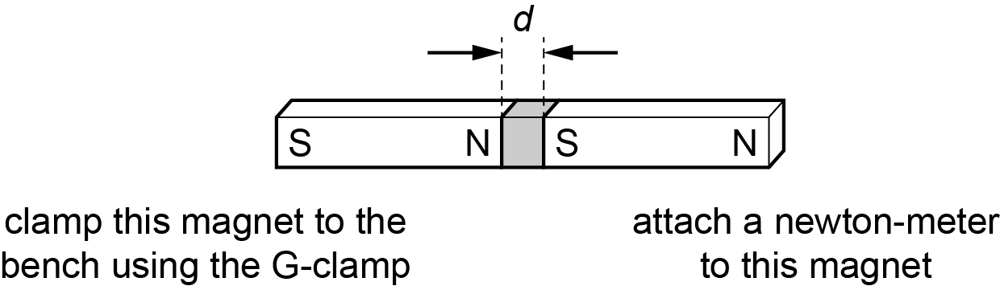

* Learners set up the magnets as above, using the cards to separate the magnets and then measure the distance *d* of that separation.
* They then gently pull the newton-meter (force meter) until the magnets separate and record the maximum reading *F* on the newton-meter.
* This is repeated for different separations.

**Results**

Learners record all of their results in a table, such as that below.

|  |  |  |  |
| --- | --- | --- | --- |
| *d*/m | *F*/N | lg(*d*/m) | lg(*F*/N) |
|  |  |  |  |
|  |  |  |  |
|  |  |  |  |
|  |  |  |  |
|  |  |  |  |
|  |  |  |  |

**Interpretation and evaluation**

With the results, learners plot a graph of lg *F* on the *y*-axis against lg *d* on the *x*-axis to find the gradient = *n*.

A more sensitive method might use a precision digital balance that can measure to 0.1 g or 0.01 g.

One magnet is fixed vertically on the balance and the other magnet is clamped vertically above it with a known separation. This time the magnets repel so that the two magnets do not come into contact.

Readings from the balance indicate the force of repulsion and can be converted from g to N.

The power law governing the force and the separation varies for different regions of separation.

**Practical 8 – Information for technicians**

**Investigating how the force between magnetic poles depends on their separation**

**Each learner will require:**

|  |  |
| --- | --- |
| (a) | two bar magnets |
| (b) | newton meter (force meter) |
| (c) | micrometer screw gauge |
| (d) | six cards 2 cm × 2 cm × 1mm |
| (e) | string |
| (f) | tape |
| (g) | G-clamp |
| (h) | log-log graph paper |

**Practical 8 – Worksheet**

**Investigating how the force between magnetic poles depends on their separation**

**Aim**

Using a log-log graph to investigate the relationship between two variables.

**Method**

1. Use the micrometer screw gauge to measure the thickness *d* of one of the cards.
2. Clamp one of the magnets to the bench.
3. Use string and tape to attach a newton-meter (force meter) to the other magnet.
4. Place the card between the magnets.
5. Gently pull the newton-meter until the magnets separate.
6. Read the maximum value of force *F* at separation.
7. Change the separation using more cards.
8. Repeat for further values of *d* and *F*.

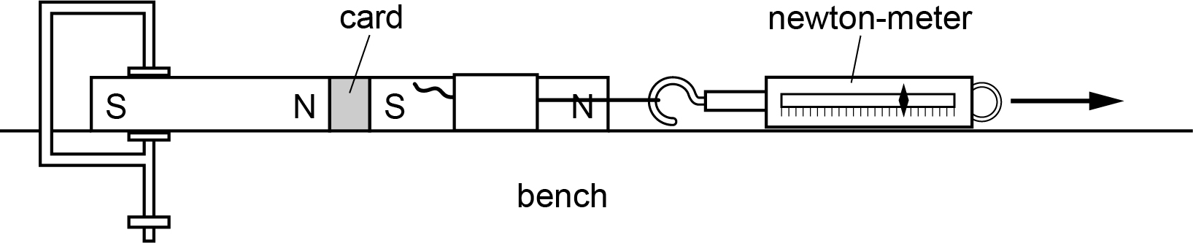

**Results**

Record all of your results

|  |  |  |  |
| --- | --- | --- | --- |
| *d*/m | *F*/N | lg (*d*/m) | lg (*F*/N) |
|  |  |  |  |
|  |  |  |  |
|  |  |  |  |
|  |  |  |  |
|  |  |  |  |
|  |  |  |  |

**Interpretation and evaluation**

Investigate the relationship *F* = *kdn* (lg *F* = *n*lg *d* + lg *k*).

1. Plot a graph with lg *F* on the *y*-axis against lg *d* on the *x*-axis.
2. The gradient = *n*.
3. The *y*-intercept = lg*k* so *k* = 10*y*-intercept.
4. Use your values of *n* and *k* to calculate *F* when *d* = 20 cm.
5. Describe the main sources of uncertainty in this investigation.
6. Describe how you could improve this investigation.