

**Cambridge International**

**AS and A Level Physics (9702)**

Practical booklet 9

Determination of the spring constant *k* of a spring using an oscillating system

**Introduction**

Practical work is an essential part of science. Scientists use evidence gained from prior observations and experiments to build models and theories. Their predictions are tested with practical work to check that they are consistent with the behaviour of the real world. Learners who are well trained and experienced in practical skills will be more confident in their own abilities. The skills developed through practical work provide a good foundation for those wishing to pursue science further, as well as for those entering employment or a non-science career.

The science syllabuses address practical skills that contribute to the overall understanding of scientific methodology. Learners should be able to:

1. plan experiments and investigations
2. collect, record and present observations, measurements and estimates
3. analyse and interpret data to reach conclusions
4. evaluate methods and quality of data, and suggest improvements.

The practical skills established at AS Level are extended further in the full A Level. Learners will need to have practised basic skills from the AS Level experiments before using these skills to tackle the more demanding A Level exercises. Although A Level practical skills are assessed by a timetabled written paper, the best preparation for this paper is through extensive hands-on experience in the laboratory.

The example experiments suggested here can form the basis of a well-structured scheme of practical work for the teaching of AS and A Level science. The experiments have been carefully selected to reinforce theory and to develop learners’ practical skills. The syllabus, scheme of work and past papers also provide a useful guide to the type of practical skills that learners might be expected to develop further. About 20% of teaching time should be allocated to practical work (not including the time spent observing teacher demonstrations), so this set of experiments provides only the starting point for a much more extensive scheme of practical work.

© Cambridge International Examinations 2014

**Practical 9 – Guidance for teachers**

**Determination of the spring constant *k* of a spring using an oscillating system**

**Aim**

To apply simple harmonic theory and use error bars, best straight lines and worst acceptable straight lines.

**Outcomes**

Syllabus sections 1.2e, 2.1a, 13.1a, 13.1b, 13.1c, 13.1d

**Skills included in the practical**

|  |  |
| --- | --- |
| **A Level skills** | **How learners develop the skills** |
| Analysis | Collect and record data in a table  Draw a graph with error bars |
| Conclusions | Determine and interpret the gradient and *y*-intercept of a graph with both a line of best fit and a worst acceptable line |
| Evaluation | Determine uncertainties using best and worst acceptable straight lines |

This practical provides an opportunity to build on essential skills introduced at AS Level.

|  |  |
| --- | --- |
| **AS Level skills** | **How learners develop the skills** |
| MMO collection | Time oscillations using a stopwatch |
| MMO values |
| MMO data |

**Theory**

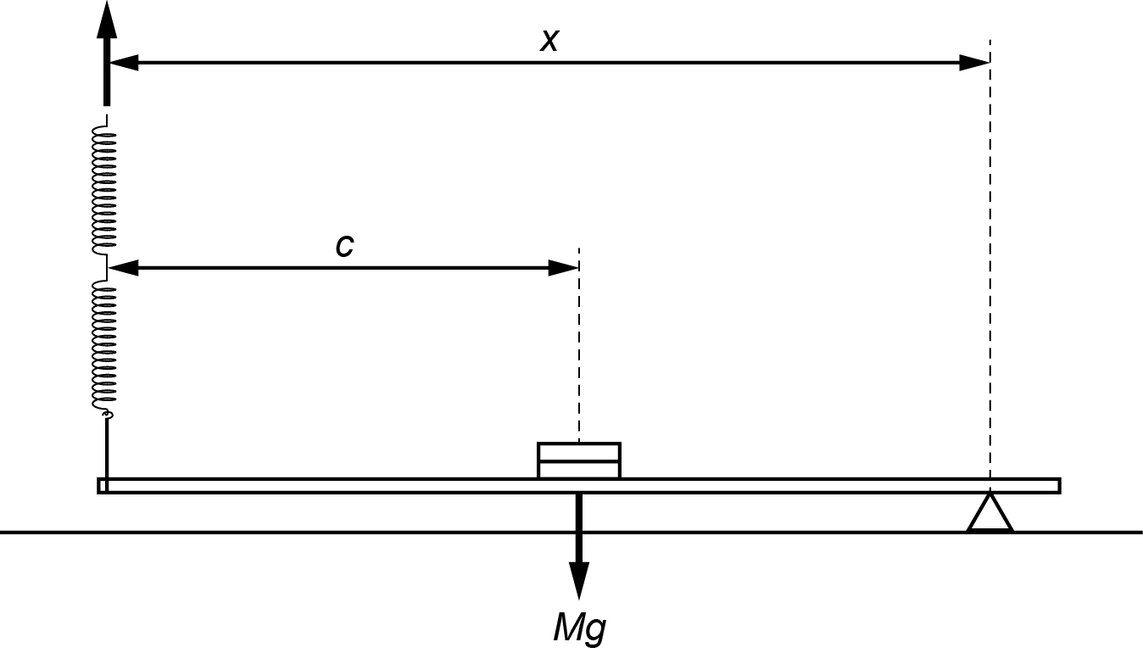

This has similar apparatus and theory to Practical 1. This time the left-hand end of the metre rule is pulled down and released and the period *T* of the oscillations is measured.

To obtain values of *T* that are large enough to measure, it is necessary to increase *T* by

* using two springs
* adding another 100 g mass to the centre of the metre rule

Two 100 g masses are attached to the mid-point of a metre rule. This makes the rule artificially heavier so that appreciable values of *T* can be measured later. Learners have to consider the irregular shape of a slotted mass when attaching it to the centre of the rule. The combined mass of the rule and two 100 g masses is *M*.

The loaded metre rule is supported by the pivot and the springs. The rule is horizontal and the springs are vertical. Assuming that the string is at the end of the rule, then taking moments about the pivot:

Clockwise moment = *k*(*l* – *l* 0)*x* where *l* 0 is the unstretched length of the coiled part of the spring.

Anticlockwise moment = *Mg*(*x* – *c*)

So, *Mg*(*x* – *c*) = *k*(*l* – *l*0)*x* when the rule is balanced.

$$\left(l-l_{0}\right)=\frac{Mg(x-c)}{kx}$$

The period *T* is given by $T=2π\sqrt{\frac{l-l_{0}}{g}}$.

$$T^{2}=\frac{4π^{2}Mg(x-c)}{kgx}=\frac{4π^{2}Mgx}{kgx}-\frac{4π^{2}Mc}{kgx}$$

$$T^{2}x=\frac{4π^{2}M}{k}x-\frac{4π^{2}Mc}{k}=Ax+B$$

If a graph is plotted of *T*2*x* against *x*, the gradient = *A* and the *y*-intercept = *B*.

Since $A=\frac{4π^{2}M}{k}$ and $B=-\frac{4π^{2}Mc}{k}$ two values of *k* can be found knowing values of *M* and *c* (or use *B*/*A* = ­–*c* and determine both *c* and *k*).

**Further graph work**

Learners should be able to:

* include error bars with each plotted point
* draw a best straight line (BSL) through their plotted points
* draw a worst acceptable straight line (WASL) through their points
* determine the uncertainty in their value of gradient
* determine the uncertainty in their value of *y*-intercept.

Error bars can be connected with the variable on the *x*-axis or *y*-axis or both.

A simple way to deal with error bars in this experiment is to suppose that there is an uncertainty of 2 mm in each value of *x* so that a point plotted at *x* = 72.0 cm would be a horizontal line spreading from 71.8 cm to 72.2 cm.

A more challenging task would be to draw the error bars for *T*2*x*.

The uncertainties in *M* and *c* could also be considered.

The BSL should be the best line through the points regardless of error bars.

The WASL should be the most extreme line that still passes through all the error bars.

**Method**

* Learners balance the metre rule as shown and record the reading *c* of the rule directly above the pivot.

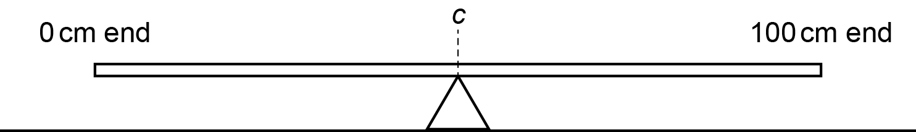

* They then place two 100 g masses over the centre of the rule so that it still balances at *c* and then tape the masses to the rule as shown.

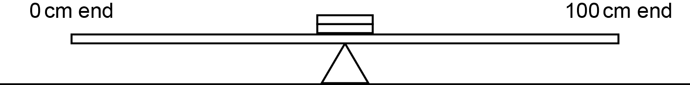

* Using an electronic balance, learners then determine the mass *M* in kg of the combined mass of the rule and the attached masses.
* Learners then set up the apparatus as shown below with the rule horizontal and the springs vertical. The string should be as close to the end of the rule as possible.

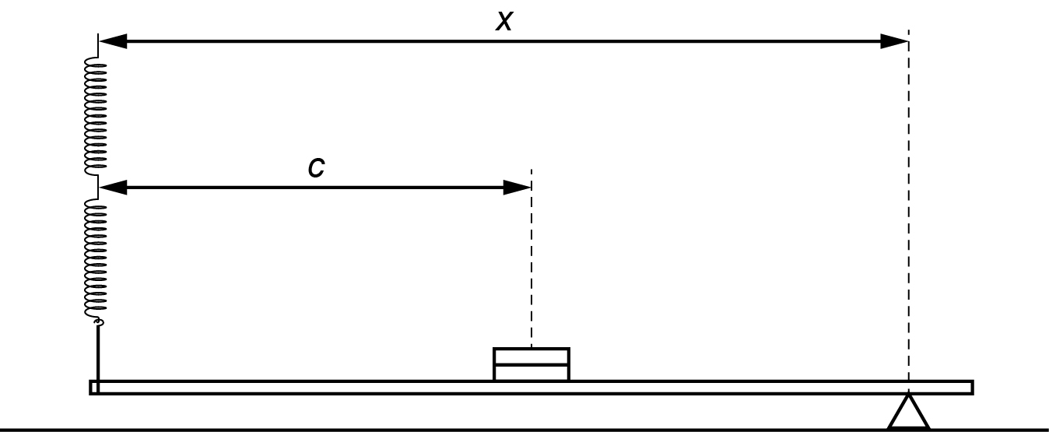

* They then place the pivot, measure *x*, pull down the left hand end of the rule and determine the period *T* of the oscillations.
* This is repeated with different values of *x*.

**Results**

Learners record the different measures of *x* and the corresponding *T* period of oscillation, and also include values of *T2x* in the table.

|  |  |  |  |  |  |
| --- | --- | --- | --- | --- | --- |
|  | Time for 10 cycles | |  |  |  |
| *x*/m | *t*1/s | *t2*/s | *t*average/s | *T*/s | *T*2*x*/ s2m |
|  |  |  |  |  |  |
|  |  |  |  |  |  |
|  |  |  |  |  |  |
|  |  |  |  |  |  |
|  |  |  |  |  |  |
|  |  |  |  |  |  |

**Interpretation and evaluation**

Learners plot a graph of *T2x* on the *y*-axis against *x* on the *x*-axis, and include error bars (as previously mentioned).

They then draw the BSL and WASL and find both gradient and y-intercept and their uncertainties

$\text{gradient}=\frac{4π^{2}M}{k}$ and $\text{y-intercept}=-\frac{4π^{2}Mc}{k}$

They then use their values of *M*, *c*, gradient and *y*-intercept to determine values for *k,* andfind the uncertainty in *k* in each case.

**Practical 9 – Information for technicians**

**Determination of the spring constant *k* of a spring using an oscillating system**

**Each learner will require:**

|  |  |
| --- | --- |
| (a) | one retort stand |
| (b) | one clamp |
| (c) | one boss |
| (d) | two springs |
| (e) | string |
| (f) | one metre rule with a millimetre scale |
| (g) | two 100 g masses |
| (h) | one small roll of Sellotape |
| (i) | one triangular glass prism or small triangular pivot |
| (j) | stopwatch |
| (k) | access to an electronic balance |

**Practical 9 – Worksheet**

**Determination of the spring constant *k* of a spring using an oscillating system**

**Aim**

To apply simple harmonic theory and use errors bars, best straight lines and worst acceptable straight lines.

**Method**

1. Balance the metre rule as shown and will note the reading *c* of the rule directly above the pivot.



1. Place two 100 g masses over the centre of the rule so that it still balances at *c* and tape the masses to the rule as shown.



1. Using an electronic balance, determine the mass *M* in kg of the combined mass of the rule and the attached masses.
2. Set up the apparatus as shown below with the rule horizontal and the springs vertical.

Use the stand, boss and clamp to support the top spring.

The string should be as close to the end of the rule as possible.



1. Measure *x*.
2. Pull down the left hand end of the rule and determine the period *T* of the oscillations.
3. Change the position of the pivot and take six sets of readings for *x* and *T.*
4. Include values of *T*2*x* in the table.

**Results**

Learners record the different measures of *x* and the corresponding *T* period of oscillation, and also include values of *T2x* in the table.

|  |  |  |  |  |  |
| --- | --- | --- | --- | --- | --- |
|  | Time for 10 cycles | |  |  |  |
| *x*/m | *t*1/s | *t2*/s | *taverage*/s | *T*/s | *T*2*x*/ s2m |
|  |  |  |  |  |  |
|  |  |  |  |  |  |
|  |  |  |  |  |  |
|  |  |  |  |  |  |
|  |  |  |  |  |  |
|  |  |  |  |  |  |

**Interpretation and evaluation**

1. Plot a graph of *T*2*x* on the *y*-axis against *x* on the *x*-axis.
2. Include error bars for *x* (± 2 mm).
3. Draw the best straight line (BSL) and the worst acceptable straight line (WASL) and find both gradient and *y*-intercept and their uncertainties.
4. Use your values of *M*, *c*, gradient and *y*-intercept to determine values for *k.*

$\text{gradient}=\frac{4π^{2}M}{k}$ and $\text{y-intercept}=-\frac{4π^{2}Mc}{k}$

1. Find the uncertainty in *k* in each case.